First question:
Scientist and engineers frequently perform experiments designed to
provide measurements of two variables X and Y. They often compute
measures of central tendency (such as the mean) and measures of
dispersion (such as standard deviation)for these variables, and then
attempt to decide whether or not there is any relationship in terms of an
equation. If there is a relationship between X and Y that is describe
using a linear equation of the form

Y = aX + b

The data collected is said to fit a linear curve.

For example, the ACE computing company made a study relating
aptitude-test scores to programming productivity of new personnel. The 6
pairs of scores shown below were obtained by testing 6 randomly selected
applicants and later measuring their productivity.

Aptitude score Productivity
Applicant variable X Varia
1 X1 = 9 Y1 = 46
2 X2 = 17 Y2 = 70
3 X3 = 20 Y3 = 58
4 X4 = 19 Y4 = 66
5 X5 = 20 Y5 = 86
6 X6 = 23 Y6 = 64

ACE wants to find the equation of the line which they can use to predict
the productivity of workers tested in the future. They are also
interested in obtaining means and standard deviations for the variables X
and Y. The required computations can be performed as follows:

1. Compute SUMX = X1 + X2 + X3 + ......... + X6

SUMY = Y1 + Y2 + Y3 + ......... + Y6

SUMXY = X1Y1 + X2Y2 + ......... + X6Y6

SUMXSQ = X1X1 + X2X2 + ........ + X6X6

SUMYSQ = Y1Y1 + Y2Y2 + ........ + Y6Y6

2. Compute MEANX = SUMX/N where N is the total number of X or Y

MEANY = SUMY/N

3. Compute STDDVX = Square root of ( SUMXSQ/N - MEANX^2)
STDDVY = Square root of ( SUMYSQ/N - MEANY^2)

4. Compute "a" and "b" in "Y = aX + b" using the following equation

a = (SUMXY-N.(MEANX).(MEANY))/(SUMXSQ - N*MEANX^2)
b = MEANY - a.(MEANX)

Please write a C program using your desire operating system to calculate a and b
of the option 4 above and your output should only displays " Y = aX + b".

Draw the flow chart.

Second question:
Consider the loads F₁ ,F₂ , …………, F_{N} and their locations D₁ ,D₂ , …………, D_{N} as elements of the arrays F and D. Feed all the elements F_{J} and D_{J} into the computer.
Note: Refer to figure as shown to obtain values for the elements F_{J} and D(J). An applied load F_{J} is to be considered positive if it acts toward the beam, negative if it acts away from the beam.

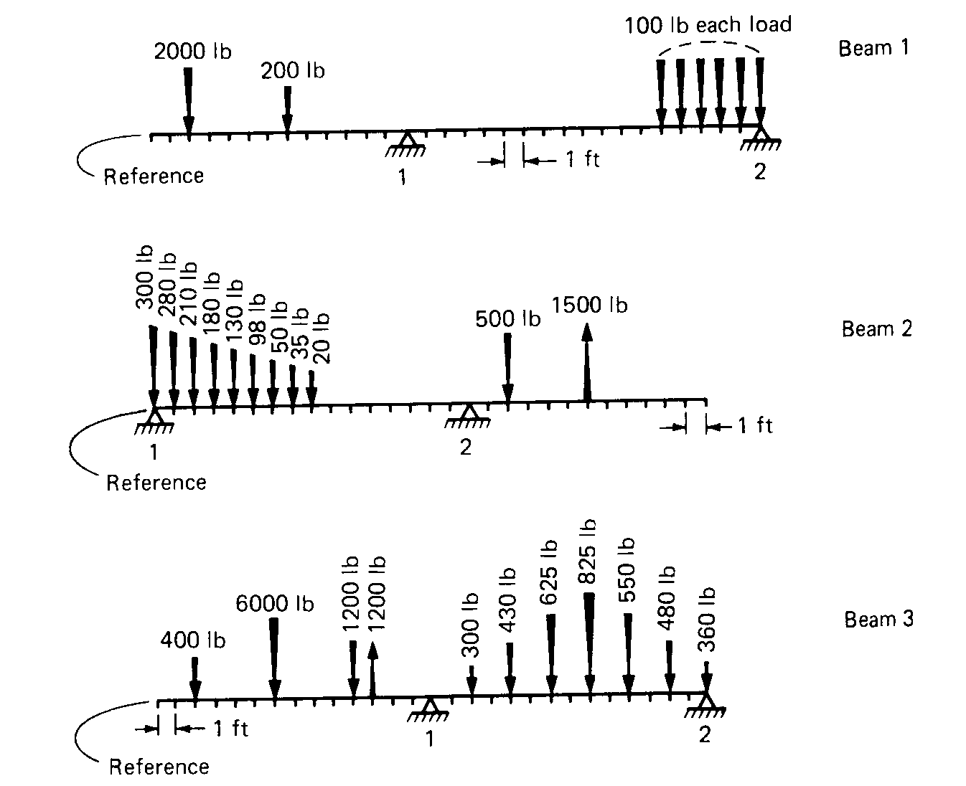

Write an Ansi C program to compute beam reaction (R) for each case using one-dimensional arrays.

Definition of terms:

F₁ ,F₂ , …………, F_{N} Loads applied to the beam

D₁ ,D₂ , …………, D_{N} Location of applied loads

N Maximum number of applied loads
R₁ ,R₂ Beam reactions at the simple supports

L₁ ,L₂ locations of the reactions R₁ and R₂ from the
reference

Please draw a flow chart of your program and use a proper out-put formatting to display your interactive output.

