Chef:Configuration management tool.

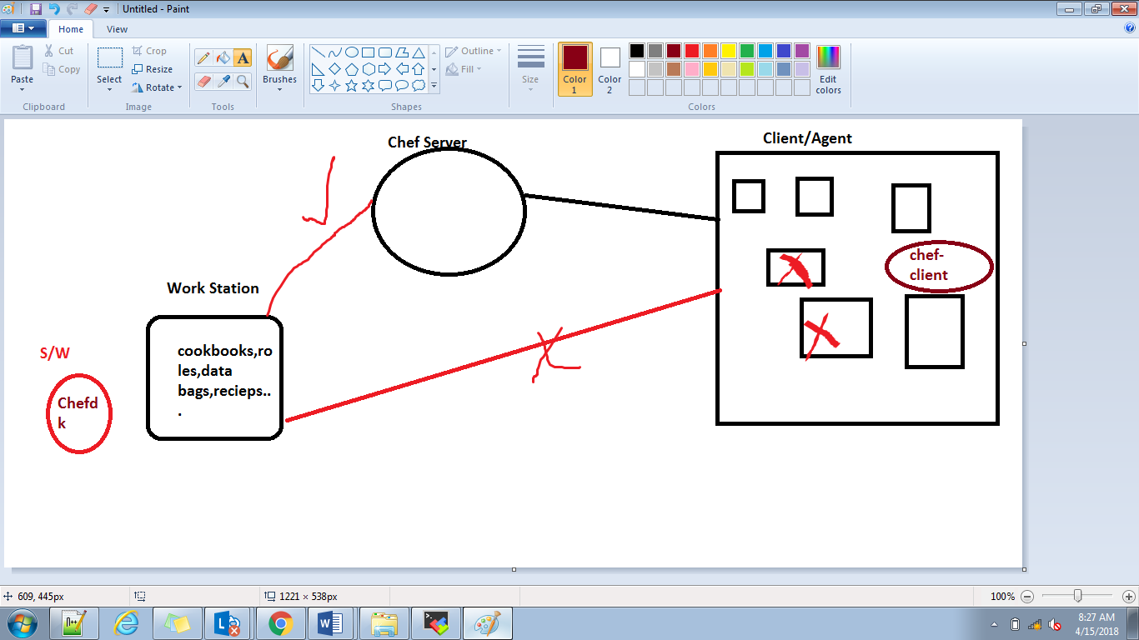

Chef dk:chef development kit.

For chef server we have to create one account in chef.manage.io.

Their we will manage nodes ,cookbooks,roles,administration,Organization.

In chef server🡪administration🡪particular organization🡪Starter Kit🡪download starter kit.

Starter kit(server details,url,ip,pem).

Power shell🡪almost equal to linux terminal.

Ntp error🡪time difference between instances.

Open power shell 🡪go to starter kit installed path>.chef directory.

From here we will use commands to interact with server and from server to it will interact with clients.

Reciepe->no.of tasks.

Chef🡪ruby based.(file.rb)

File “devops” do

Action :create

End

In power shell type command to create a file name with devops in local machine.

Chef-apply file.rb

F:\che-25\chef-repo devops

To delete a file

File “devops” do

action :delete

end

to wirte into file

file “devops” do

action :create

content :”hello 123”

end

to write into existing file

file “devops” do

content :”syam 123”

chef-apply file.rb

to create a directory in file.rb

directory “devopsdirector” do

action :create

end

main chef contain chefdk server and client.we will create create cookbooks and cook books conatins recipes folder and recieps conatin ruby files(recipe files.).

creating cook books.

F:\che-25\chef-repo\Cookbooks\chef generate cookbook sample1

Whenever we r creating this by defulat some file are coming internally like recipes folder

Sample1

.git,.delivery,recieps……………..

In recipes we have one defult ruby file.

Defulat.rb

File “/opt/devops12” do

action :create

end

We will open that file we will create one file.

And we will check cook book without having any ssyntax errors

Knife cookbook test sample1.

Knife cookbook upload sample1.

The sample1 cookbook is uploaded into server.how it will go means

Whener we r installing toolkit it is having server pem file url and everything

In server , policy🡪cookbooks.

It will display sample1.

We are creating devops123 in client.but now we uploaded file into server ,now we need to run that cookbook and it will create devops123 file in /opt directory in client machine.

Now goto server 🡪go to particular client machine🡪edit run list🡪available cookbooks🡪drag and drop cookbooks sample1

Now goto client machine type chef-client

Now it will run whatever we are added cookbooks into this this machinelike sample1.

And it will create file devops12 in /opt directory.

This is big process to do evrying in manual.

Cron jobs.

In clinet machine

Cd /etc/cron.d

Vi chef-client

* /2 * * * * root chef-client

Evry day every 2 mins evry week it will execute chef-client with root user.

After uploading we will got ui and we r doing operations but in command line we can do everytihing.

Knife node run_list add node1 “reciepe[sample3]”

We are scheduleded already in client machine cron job so automatically it will execuyte chef-client .

Cd chef-repo/cookbooks

Chef generate cookbook sample1

Cd sample1🡪reciesps🡪defualt.rb(new file creation)

Knife cookbook test sample1

Knife cookbook upload sample1

Chef🡪server🡪node1 run –list

Chef-cliet🡪chef-client

2) Cd sample1🡪reciesps🡪defualt.rb(new file creation)

Knife cookbook test sample2

Knife cookbook upload sample2

Knife node run_list add node_1 “reciepe[sample2]”

Client cd /etc/cron.d

Vi Chef-client

* /2 * * * * root chef-client

Ansible:

Chef🡪chef community,ruby language.

Ansible🡪developed by red hat.,python AND YAML LAUGUAGE.

Puppet🡪puppet labs.

=====Ansible===============

Open source.(but in chef if we using more that 5 servers we need to pay)

No work station in Ansible(in puppet also).everything in ansible server.

Agent less or client less.(means no need to install client s/w)it will communicate with secure shell.

High scalable.

Easy installation and configurations.

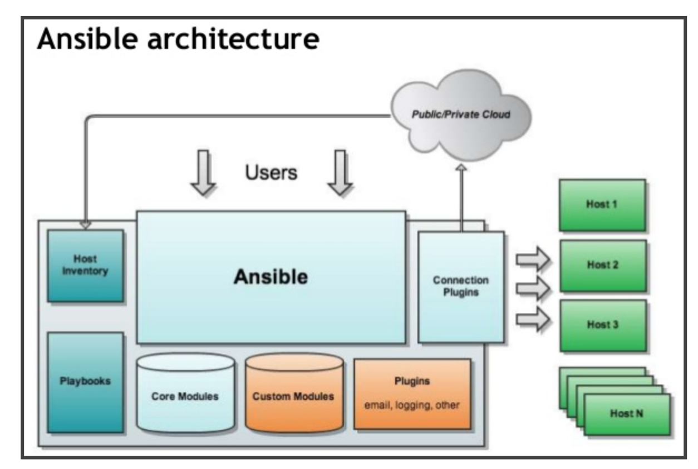

In Visudo file if we want to acts as a sudo then in this file we should add permissions.in linux systems first time if we hit a command it will ask password,suppose after 15 mins we didn’t enter any command ,again after 15 mins it will ask ,password.so to avoid this we should add this user in sudo file set NOPASSWD=ALL

Visudo

Under root user we should add this user.

Ansible ALL=(ALL) NOPASSWD:ALL

Not only ansible any user we can add.

Password less authentication:whenever we are creating communication b/w two servers If we want allow password less then we will create ssh key in one machine and we will add that public key in another machine authorized keys.

1)Now we generating ssh-keygen in master,and in slaves we should copy entire .ssh directory to slave machine.

Ssh-copy-id ansible@192.138.1.143

2)same ssh-keygenerate and in slave machine .ssh/authorizedkeys🡪open authorized keys and paste master pub id into here.

Ansible in AWS:

I took Ubuntu ec2 instance.

I logined to this Ubuntu machine with mobaxterm ssh.

Now im installing ansible in this machine,so it will acts as master.from this machine we can control all slave machines or clinet machines.

Sudo Apt-add-repository ppa:ansible/ansible

Sudo apt-get update –y

Sudo apt-get install ansible –y

Now we will check version

Ansible –version.

Python –version.

Ansible is developed by python.

Now in one folder is created in /etc/ with ansible name.

Cd /etc/ansible

ubuntu@ip-10-138-1-150:~$ cd /etc/ansible/

ubuntu@ip-10-138-1-150:/etc/ansible$ ls

ansible.cfg hosts roles

ubuntu@ip-10-138-1-150:/etc/ansible$ ls -la

total 36

drwxr-xr-x 3 root root 4096 Apr 15 08:24 .

drwxr-xr-x 94 root root 4096 Apr 15 08:24 ..

-rw-r--r-- 1 root root 19315 Mar 23 06:24 ansible.cfg

-rw-r--r-- 1 root root 1016 Mar 23 06:24 hosts

drwxr-xr-x 2 root root 4096 Mar 23 06:28 roles

in server or main machine I modiefied /etc/ansible/ansible.cfg

I uncommented inventory and sudo users section and roles

2)i took one more instance with same Ubuntu os and I installed python into it.because ansible developed by python so in client machine also python need to install to interact.

sudo add-apt-repository ppa:deadsnakes/ppa

sudo apt-get update

sudo apt-get install python2.7

**sudo apt-get install python-minimal**

**and then check python version.**

**ubuntu@ip-10-138-3-86:~$ python --version**

**Python 2.7.12**

**Now I added this client machine ip 10-138-3-8 in host file in master server.**

**And this is for ansible.but we need to provide password less authentication between these two machines.so I generated ssh-kegen in master.**

**I coopied id_rsa.pub code and pasted into slave ip .ssh/authorized_keys folder.**

**Now im checking in master whether im able to login to slave machine or not.**

**ubuntu@ip-10-138-1-150:~/.ssh$ ssh -i id_rsa** [**ubuntu@10.138.3.86**](mailto:ubuntu@10.138.3.86)

**ubuntu@ip-10-138-1-150:~/.ssh$ ansible -m ping all**

**[DEPRECATION WARNING]: DEFAULT_SUDO_USER option, In favor of Ansible Become, which is a generic framework. See become_user. , use become**

**instead. This feature will be removed in version 2.8. Deprecation warnings can be disabled by setting deprecation_warnings=False in**

**ansible.cfg.**

**10.138.3.86 | SUCCESS => {**

**"changed": false,**

**"ping": "pong"**

**}**

**So now im able to ping from master through ansible.**

netstat -tulpn | grep :80

**now we create one yml file called nginx.yml in master.**

**---**

**- hosts: webservers**

**become: yes**

**tasks:**

**- name: Installs nginx web server**

**apt: pkg=nginx state=installed update_cache=true**

**notify:**

**- start nginx**

**handlers:**

**- name: start nginx**

**service: name=nginx state=started**

**- name: restart nginx**

**service: name=nginx state=restarted**

**now in cli type below commsnd to execute above yml file**

**ansible-playbook nginx.yml**

**modules in Ansible:**

**ansible-doc –l**

**list of modules available in ansible.like docker,aws,cloudwatch etc…….**

**if we want to check specific module.**

**Ansible-doc –s yum**

**Ansible-doc –s docker**

**ubuntu@ip-10-138-1-150:/etc/ansible$ ansible webservers(specific group) -m ping**

**[DEPRECATION WARNING]: DEFAULT_SUDO_USER option, In favor of Ansible Become, which is a generic framework. See become_user. , use become**

**instead. This feature will be removed in version 2.8. Deprecation warnings can be disabled by setting deprecation_warnings=False in**

**ansible.cfg.**

**10.138.3.86 | SUCCESS => {**

**"changed": false,**

**"ping": "pong"**

**}**

If we want to check all groups

**ansible all -m ping**

**to check shell module**

ubuntu@ip-10-138-1-150:/etc/ansible$ ansible all -m shell -a "uname -a;df -h"

[DEPRECATION WARNING]: DEFAULT_SUDO_USER option, In favor of Ansible Become, which is a generic framework. See become_user. , use become

instead. This feature will be removed in version 2.8. Deprecation warnings can be disabled by setting deprecation_warnings=False in

ansible.cfg.

10.138.3.86 | SUCCESS | rc=0 >>

Linux ip-10-138-3-86 4.4.0-1052-aws #61-Ubuntu SMP Mon Feb 12 23:05:58 UTC 2018 x86_64 x86_64 x86_64 GNU/Linux

Filesystem Size Used Avail Use% Mounted on

udev 488M 0 488M 0% /dev

tmpfs 100M 3.0M 97M 4% /run

/dev/xvda1 7.7G 1.1G 6.7G 14% /

tmpfs 496M 0 496M 0% /dev/shm

tmpfs 5.0M 0 5.0M 0% /run/lock

tmpfs 496M 0 496M 0% /sys/fs/cgroup

tmpfs 100M 0 100M 0% /run/user/1000

by using modules also we can configure some softwares or copying files to all clients.

ubuntu@ip-10-138-1-150:/etc/ansible$ sudo touch syam

ubuntu@ip-10-138-1-150:/etc/ansible$ ansible all -m copy -a "src=/etc/ansible/syam dest=~/" –vvv

copying syam file to all clients.

If we want to install packages we use yum package

ansible all -m yum -a "name=httpd state=present" –s

to start a service

sudo ansible all -m service -a "nam=httpd state=started"

Roles in Ansible:

Ansible consists of many playbooks.which is similar to modules in puppet and cookbooks in chef.

Roles are a way to group multiple tasks together into one container to do the automation in very effective manner with clean directory structures.

Roles are set of tasks and additional files for a certain role which allow you to break up the configurations.

It can be easily reuse the codes by anyone if the role is suitable to someone.

It can be easily modify and reduce the errors.

By using ansible-galaxy we can create roles.