SRINAMO FARMS
AUTOMATED OCCUPANCY & REVENUE ENGINE
₹0 Paid Marketing — Sales, Partnerships, CRM & Automation

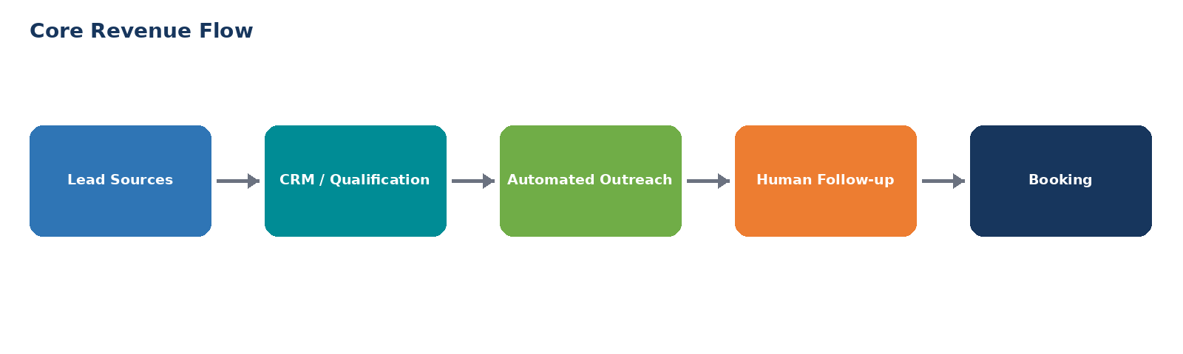
90-day objective: build a repeatable demand → booking → review → referral engine.
Operating principle
Do not automate the relationship. Automate the repetitive work around the relationship.

1. Executive Summary
The objective is to increase Srinamo Farms' occupancy and total property revenue without relying on paid advertising. The model combines B2B corporate sales, B2C organic demand, partnerships, WhatsApp qualification, CRM discipline and automated follow-up.
Revenue Engine | Primary Goal | Automation Role
B2B Corporate | Team outings, offsites, family days, meetings | Prospecting, sequencing, follow-up, lead scoring
B2C | Stay, day-out, couple, family, celebration bookings | Lead capture, qualification, reminders, reactivation
Partnerships | Travel agents, event planners, wedding planners, MICE | Partner pipeline, onboarding, follow-up
Retention | Reviews, referrals, repeat visits | Post-stay workflows, review requests, referral triggers

The management model
Rahul manages the revenue system and exceptions; automation handles repetitive touches, data movement and reminders.

The goal is not to create more activity for its own sake. Every workflow should move a lead closer to a booking or create another booking opportunity from an existing guest/partner.
2. Automation Architecture
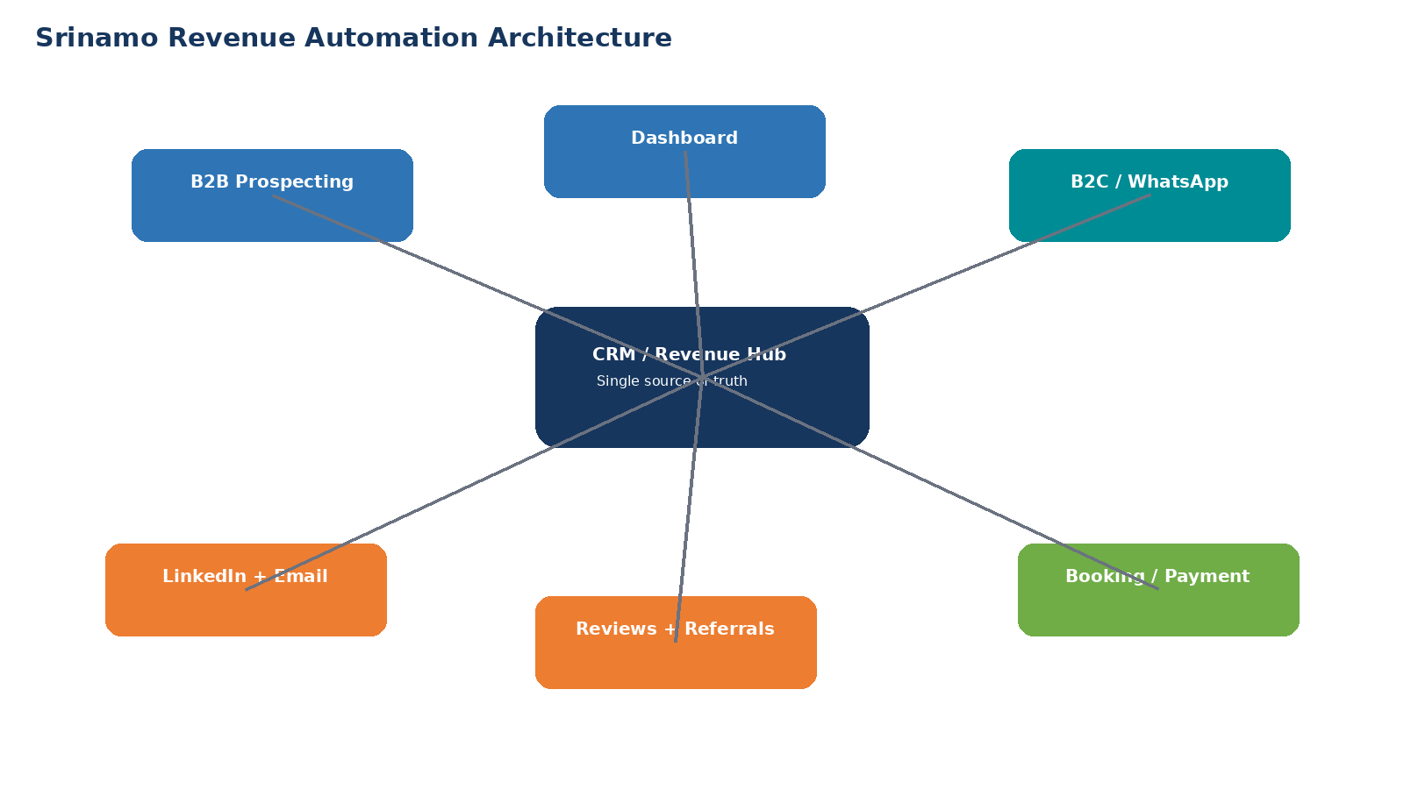
The CRM becomes the single source of truth. Every lead, company, partner, enquiry, booking and follow-up should have a defined status. External tools should feed the CRM rather than creating separate spreadsheets that nobody trusts.
Layer | Recommended Function
Lead Generation | Sales Navigator, LinkedIn, email lists, Google Business, referrals, organic social
Outreach | Dripify for LinkedIn; Smartlead for outbound email
CRM | HubSpot or equivalent pipeline
Automation | Make or n8n for triggers, routing and task creation
WhatsApp | Business/API workflow for enquiry qualification and follow-up
Booking | Existing Srinamo booking/payment process
Reporting | CRM dashboard + occupancy/revenue sheet

3. Lead-to-Revenue Funnel
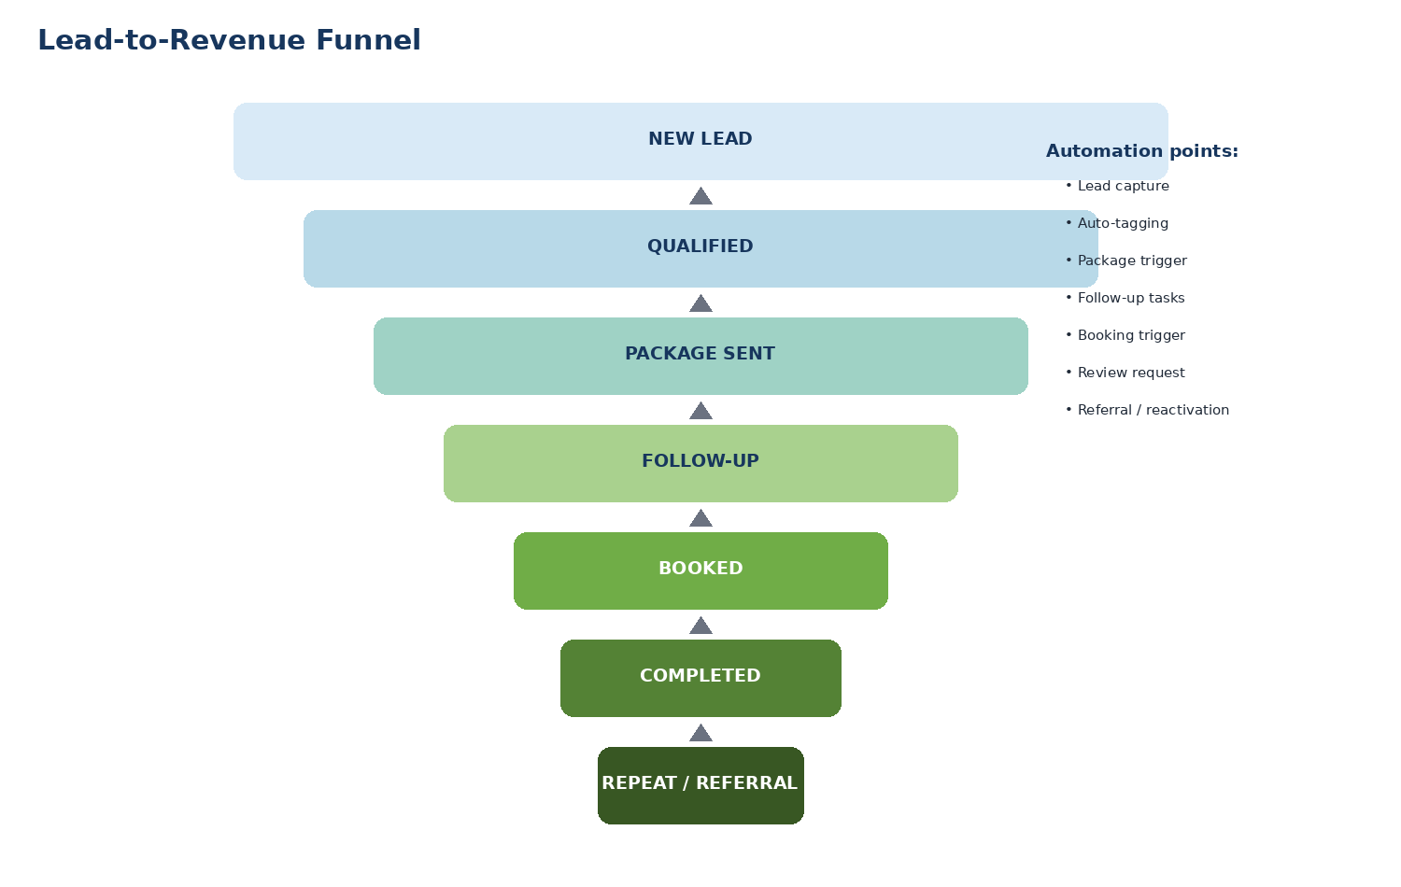
Stage | Definition | Automation
New Lead | Any new enquiry/prospect | Create record + source + timestamp
Qualified | Date, group size and requirement known | Score automatically
Package Sent | Relevant package/quote delivered | Create follow-up sequence
Follow-up | No booking yet | Tasks/reminders triggered
Booked | Payment/confirmation received | Stop sales automation; start guest workflow
Completed | Stay/event finished | Trigger review request
Repeat / Referral | Guest can buy again or refer | Reactivation workflow

4. B2B Corporate Automation
The B2B engine targets companies in and around the Chennai market with roughly 20–500 employees, prioritizing HR, Admin, People & Culture, Founders, Office Managers and Operations.
Automation | Trigger | Action | Human Owner
New company added | ICP qualified | Create company + contacts + campaign tag | Rahul
Outbound starts | Contact has valid email | Enroll in Smartlead + LinkedIn workflow | Automation
Positive reply | Reply intent detected | Stop sequence + create high-priority task | Rahul
Meeting booked | Calendar event created | Move to Discovery | Automation
Proposal sent | Quote/package sent | Create 24h/48h/5d follow-ups | Automation
Booking confirmed | Payment/confirmation | Move to Booked + remove from prospecting | Automation

B2B campaign split
Corporate Day Out | Corporate Overnight Offsite | Employee Family Day | Corporate Meeting / Workshop

The pitch should sell a ready-made corporate outcome, not simply a venue. The automation should route the prospect to the package that matches group size, date and event type.
5. B2C + WhatsApp Automation
B2C should be designed around immediate qualification. The first automated interaction should identify what the customer wants, when they want it and the size of the group.
Question | Example Options
Requirement | Family stay | Day outing | Couple | Birthday | Corporate | Wedding/Event
Date | Preferred date
Group size | Adults / children / total
Duration | Day outing | 1 night | 2+ nights
Package | Recommended automatically based on requirement

Example WhatsApp first response:
Welcome
Hi! Welcome to Srinamo Farms 🌿
What are you planning?
1. Family stay
2. Day outing
3. Couple stay
4. Birthday/celebration
5. Corporate outing
6. Wedding/event

Once the customer selects a category, the workflow asks only the minimum questions needed to qualify the enquiry and routes the lead to a human when there is purchase intent.
6. Lead Scoring & Priority Routing
Signal | Points
Preferred date within 30 days | +3
20+ people | +3
Asked for price/package | +2
Asked for availability | +2
Date within 90 days | +1
No date / browsing only | 0

Score | Status | Action
8–10 | HOT | Human response immediately; call/WhatsApp
5–7 | WARM | Same-day response + structured follow-up
1–4 | NURTURE | Automated nurture / offer / seasonal follow-up
0 | COLD | Low-priority database; reactivation later

7. Post-Booking Revenue Flywheel
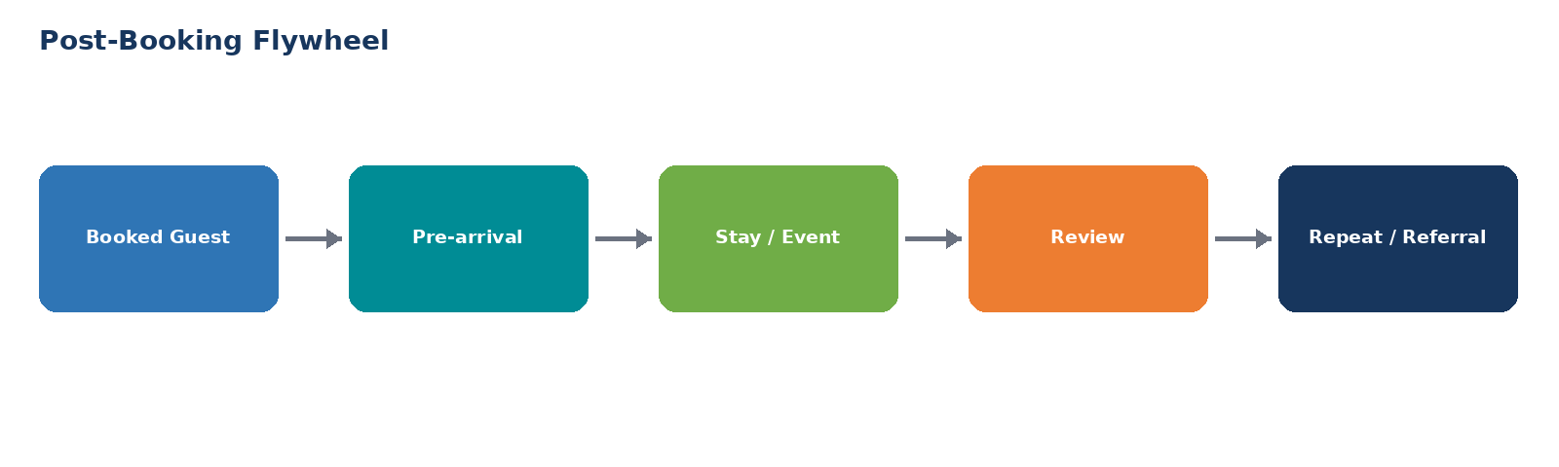
Timing | Automated Message / Action
Immediately after booking | Confirmation + arrival details
2 days before | Reminder + directions + what to bring
During stay/event | Experience check-in
1 day after checkout | Thank-you + feedback
1–3 days after | Google review request
15–30 days | Referral / repeat-stay offer
45–90 days | Seasonal reactivation

Why this matters
A completed booking should not be the end of the CRM record. It should become the starting point for reviews, referrals and repeat revenue.

8. Partner Acquisition Automation
Create a separate partner pipeline for travel agents, event planners, wedding planners, corporate event companies, MICE companies and local tour operators.
Partner Stage | Trigger / Action
Prospect | Add qualified partner + contact
Contacted | Email + LinkedIn sequence
Interested | Send partner deck / rates / packages
Meeting | Create call/site-visit task
Onboarded | Tag as Active Partner
First Booking | Track booking source and commission
Active | Monthly partner follow-up

The partner message should be commercial: “You bring the customer; Srinamo provides the venue and experience; you earn on confirmed bookings.”
9. CRM Structure
Object | Critical Fields
Lead / Contact | Name, phone, email, source, requirement, date, group size, score, owner, status
Company | Industry, employees, location, HR/Admin contact, corporate potential
Booking | Package, date, rooms, guests, value, payment status, source
Partner | Partner type, contact, rate/commission, status, bookings, revenue
Activity | Last contact, next task, channel, response, notes

Mandatory rule: every lead must have a source, a current stage and a next action. No orphan leads.
10. Implementation Roadmap
Phase | Timeline | Deliverables
Phase 1 — Foundation | Days 1–7 | Packages, pricing, CRM, fields, pipelines, WhatsApp script, templates, source tracking
Phase 2 — Outbound | Days 8–21 | B2B lists, partner lists, LinkedIn/email sequences, qualification, lead scoring
Phase 3 — Booking Automation | Days 15–30 | Follow-up triggers, booking status, payment confirmation, reminders
Phase 4 — Retention | Days 22–45 | Review, referral and repeat workflows
Phase 5 — Optimization | Days 46–90 | Conversion analysis, channel scoring, package optimization, scale winners

11. Management Dashboard
Daily | Weekly | Monthly
New leads | B2B accounts contacted | Total enquiries
Hot leads | Partner prospects | Confirmed bookings
Follow-ups due | Corporate replies | Room occupancy %
Bookings | Corporate meetings | ADR
Revenue booked | Partner meetings | Revenue by source
Available rooms | Packages sold | Repeat/referral bookings

Daily management question
Where is the bottleneck today — not enough leads, poor response, slow follow-up, weak package conversion, availability, or payment friction? Fix that bottleneck first.

12. Lean Technology Stack
Function | Recommended Tool | Use
Prospecting | LinkedIn Sales Navigator | Build B2B company/contact lists
LinkedIn automation | Dripify | Connection and first-touch sequencing
Email | Smartlead | Outbound campaigns and follow-ups
CRM | HubSpot | Single pipeline and customer history
Automation | Make or n8n | Connect CRM, email, WhatsApp and tasks
WhatsApp | WhatsApp Business / API | Qualification and booking conversations
Reporting | HubSpot + spreadsheet dashboard | Occupancy, revenue and funnel reporting

Start with the minimum viable stack. Add tools only when a real bottleneck appears.
13. 30 / 60 / 90-Day Execution
0–30 Days — Build & Attack | 31–60 Days — Optimize | 61–90 Days — Scale
Create packages | Kill low-converting sequences | Scale winning ICPs
Build CRM | Optimize follow-up timing | Expand partner network
Build 500+ corporate account list | Identify best package by segment | Build recurring corporate accounts
Build partner database | Improve WhatsApp conversion | Launch systematic reactivation
Launch outbound | Track source-to-booking conversion | Forecast occupancy
Launch review workflow | Refine scoring | Automate more exceptions

14. Automation Rules — Non-Negotiables
- Positive reply = stop automated prospecting immediately.
- Booking confirmed = remove from sales sequences and start guest workflow.
- No lead without a next action.
- No quote without a follow-up date.
- No completed stay/event without a review request.
- No partner without a source and booking attribution.
- Do not automate high-value negotiation or relationship conversations.
- Measure revenue by source, not likes or message volume.
- Use ₹0 paid marketing until organic, outbound and partnership conversion data shows where paid acquisition could profitably scale.

