Linux
- kernel is the heart of the Linux.
- to intract with it we use shell prompt and give commands.

- Linux basic commands:

- to creat folder : mkdir *foldername*
- to display file : ls
- to display date and time when folder was created : ls -l
- present working directory : pwd
- to create new file inside folder : touch *name of file*

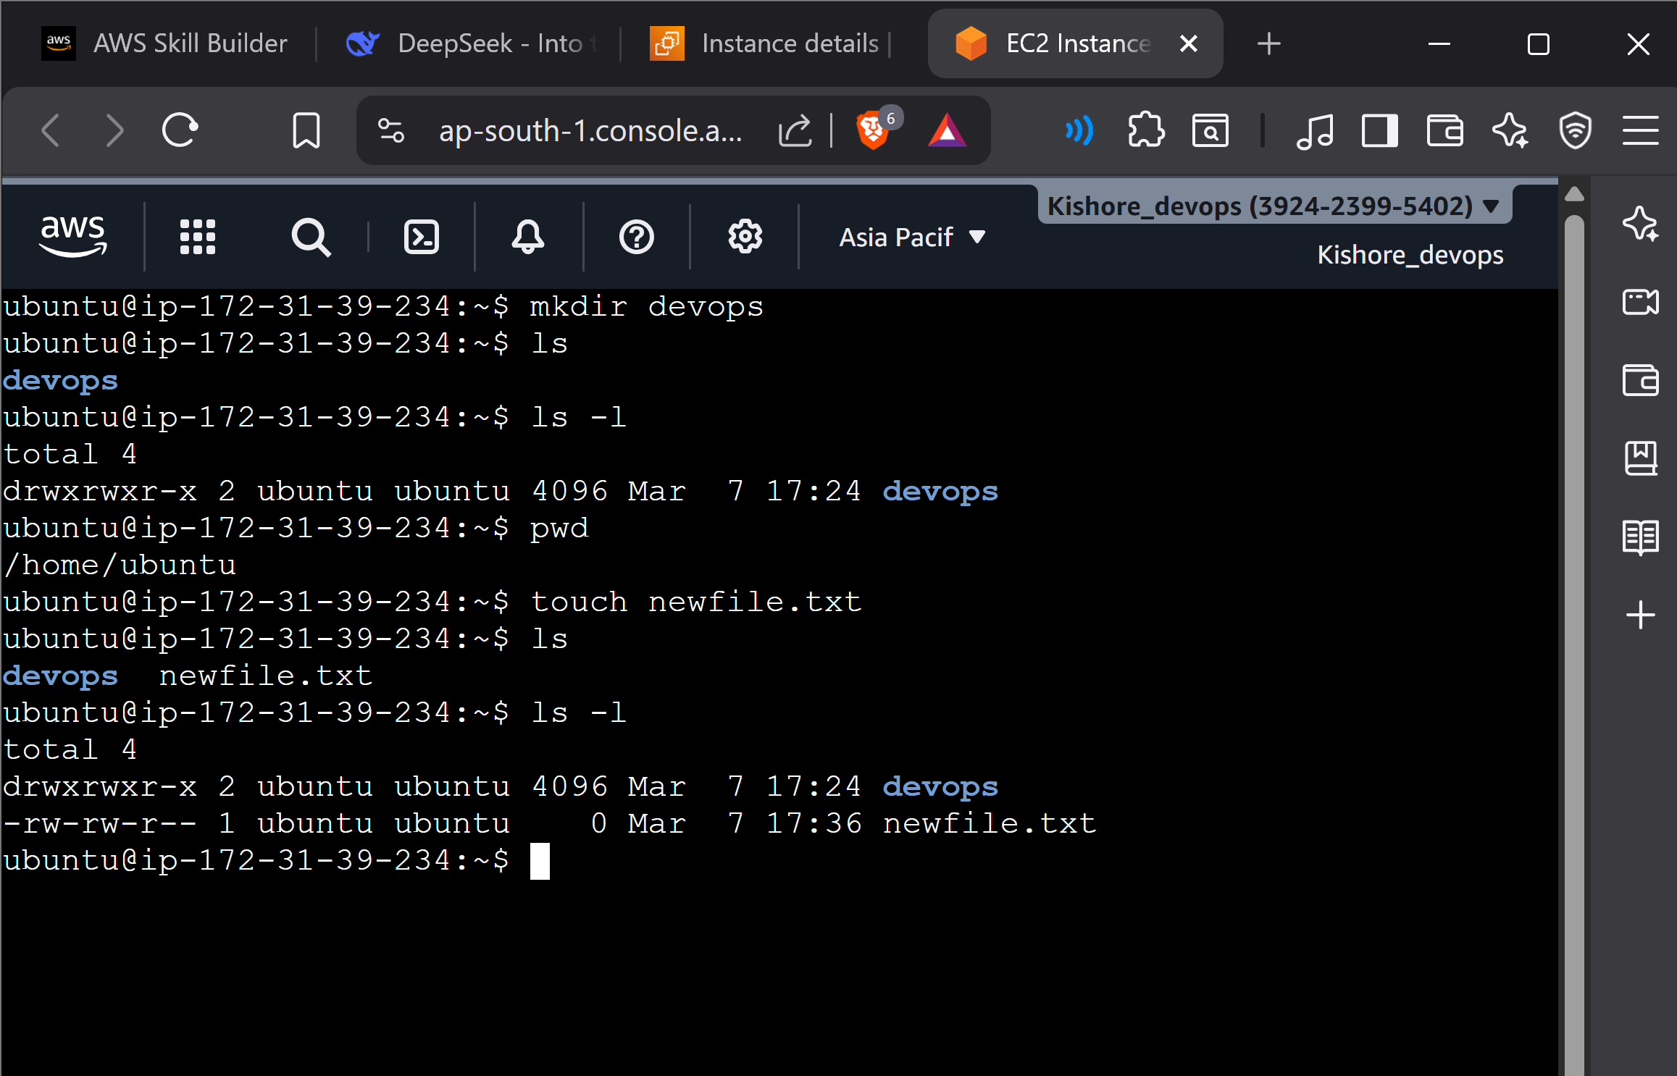

- Change directory : cd *file name *
- To come out of pwd : cd ..
- To remove the file we use : rm -r *file_name*/
- To open the file : cat *file name *
- ubuntu@ip-172-31-39-234:~$ echo "hello kishore"
- hello kishore {op}
- ubuntu@ip-172-31-39-234:~$ echo "hello kishore" > demofile.txt {redirect to display this hello kishore inside demofile.txt }
- to display the file / to opean file : cat demofile.txt
- inside the file to display the lines from top we use : head *file name *
- to print from down : tail *file name *
- to display the lines from top in order after new lines entered update : tail -f *file name*
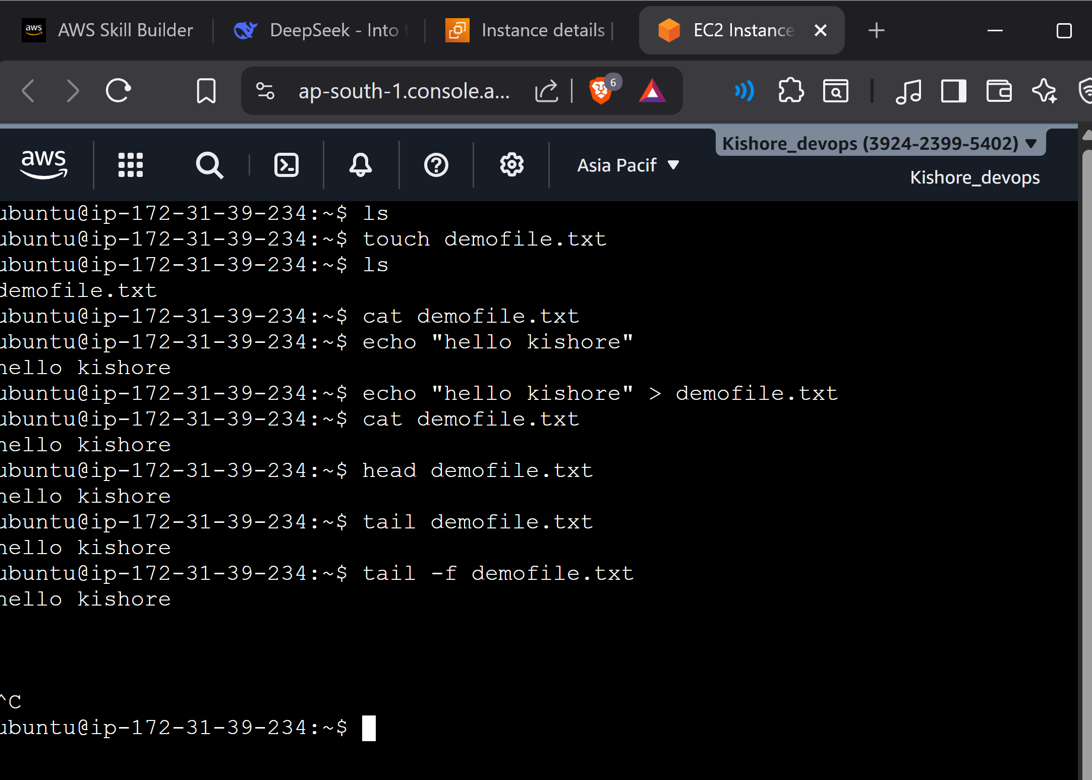
- To show less lines in the file page by page : less *file name*
- Similarly we have more , tail , head helps in big file reading \

- To copy one file to the other folder : cp demofile.txt devops/

- Cp(copy ) *source file* *destination file*/(inside this root folder)

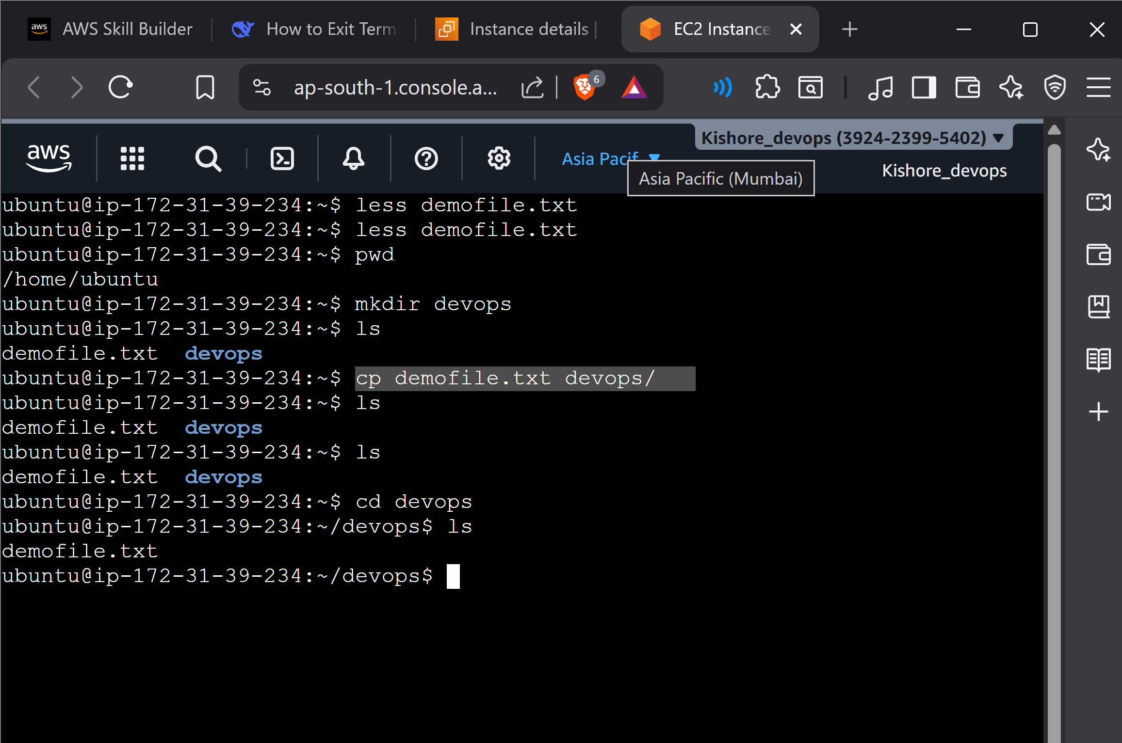
There was no demofile.txt inside the devops folder now it is copied inside this folder by using cp demofile.txt devops/

- Recessively to do something we use : -r
- We can move the file by using : mv
- If we use .. it move back
- To rename the folder we can use : mv
- To like the file we use the command to make hard link : ln
- To make file a soft link we use this : ln -s (soft link)

File permission:

- Types of permisiion
- Types of users
- To change the permission
- To list permission

Types of permission:
1.read(r) - represented by 4
2. write (w)- represented by 2
3. execute(x) - represented by 1

If it shows 7 all rwx
6 – rw
3 -wx
5-rx
Types of users :

- Owners / users – represented by letter ‘u’
- Group user - represented by letter ‘g’
- others - represented by letter 'o’

to create user : sudo usedadd *user name *
to display all user : cat/etc/passwd
to find id : id *user name*
to deleate user - sudo userdel *user name*
to create group : sudo groupadd *group name *
to display all group : cat /etc/group
to add a user to the group (to move to the group): sudo usermod -aG *group name* *user name*
ubuntu@ip-172-31-45-19:~$ sudo chown :devops project {give the devops the project permission}
ubuntu@ip-172-31-45-19:~$ sudo chmod 770 project {giving permisssion}
to mount storage:
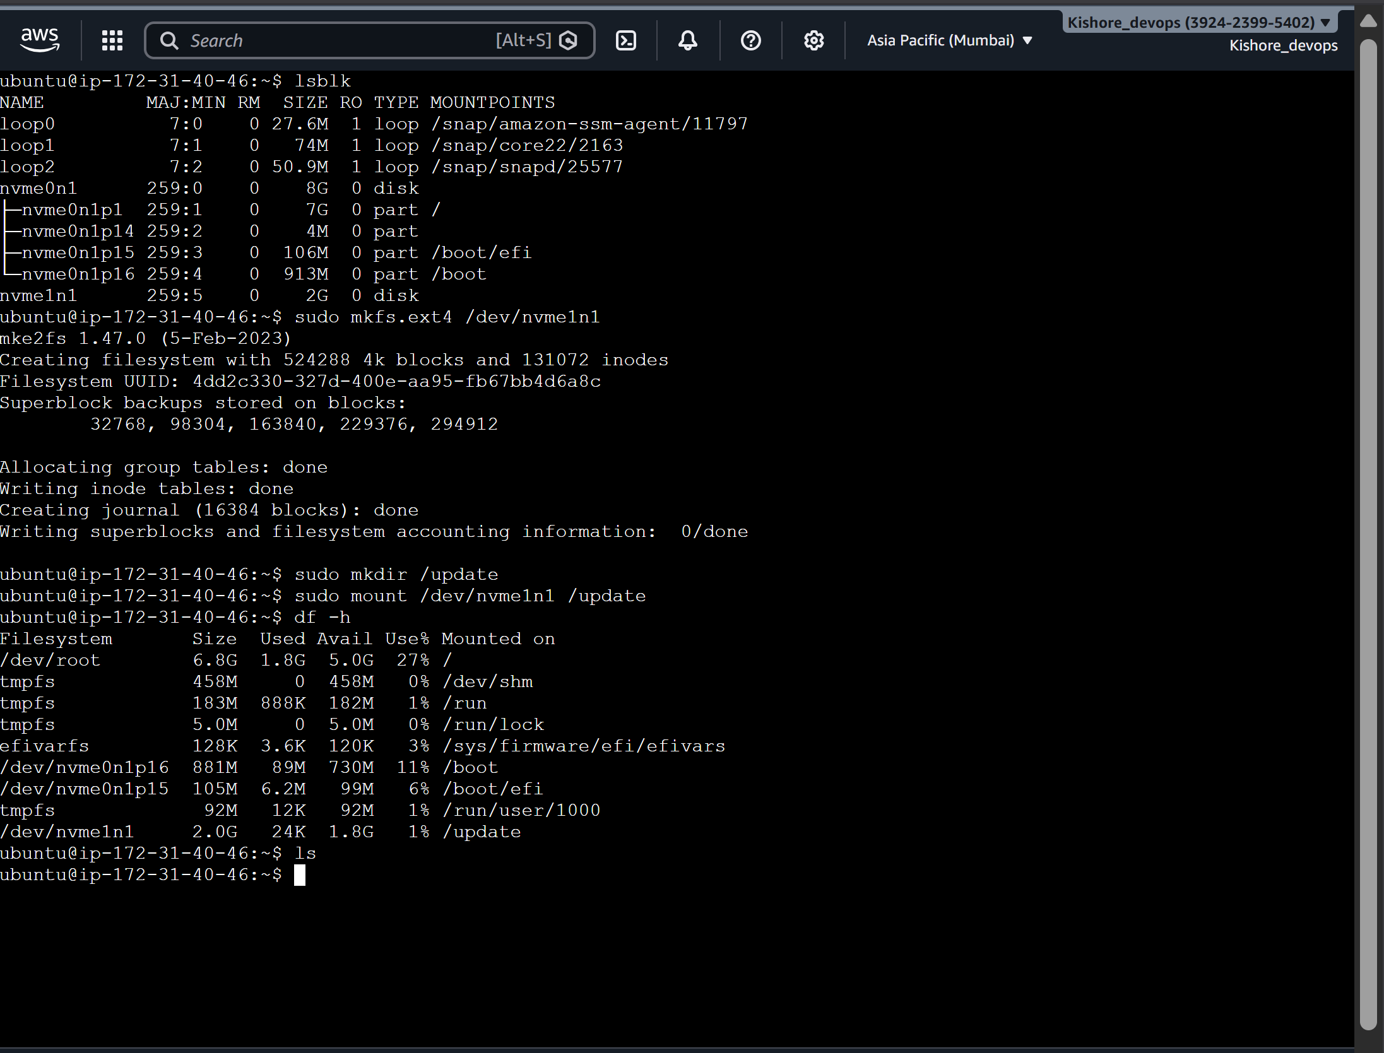
After creating the volume of X gb and add it to the storage in the ACTION ->STORAGE->ADD VOLUME-> launch it :
In the shell :
First : lsblk {check the volume attached in it }
Sudo mkfs.ext4 /dev/nvme1n1 {to create file system}
Sudo mkdir /*file name*
Sudo mount /dev/nvme1n1 /*file name*
Df -h {to check the volume is mount or not }
sudo umount /update {TO UNMOUNT}
PROJECT TO CREAT EC2 INSTANCE AND RUN STATIC WEB PAGE AND ATTACH BALANCE LODER :
6 sudo apt update && sudo apt install -y nginx zip
7 nginx -v
8 -v
9 zip -v
10 sudo apt install zip
11 zip -v
12 zip-v
13 which zip
14 which nginx
15 wget -O app.zip https://templatemo.com/download/templatemo_610_aurum_gold
16 ls
17 unzip app.zip
18 ls
19 sudo cp -r ./templatemo_610_aurum_gold/* /var/www/html
20 systemctl status nginx

To create asg:
In actions > image and template > create image
Launch template
Target group > load balancer >auto scaling group > go to aws created instance > install stress (to stress the cpu)> stress --cpu 2 --timeout 400

