Prerequisities:
Kafka servers – Only one Kafka server
Zoo keeper server – Up and running
Spark-master – Up and running
Slave – Only One slave running

Kafka : version 2.10.0
MySQL: any latest version

Understanding steps:
1. Start an instance of zookeeper server, which is required by kafka:
cd ${KAFKA_HOME}
bin/zookeeper-server-start.sh config/zookeeper.properties
Replace ${KAFKA_HOME} with path where you have installed kafka
..
………………..
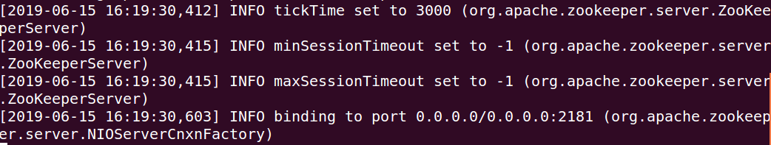
2. Start an instance of kafka broker:
cd ${KAFKA_HOME}
bin/kafka-server-start.sh config/server.properties
Replace ${KAFKA_HOME} with path where you have installed kafka

3. Create a kafka topic (with retention period of 60 minutes):

Checking whether the topic already exsist:
>>bin/zookeeper-shell.sh localhost:2181
>>ls /

Remove topic if already exists
>> rmr /brokers/topics
If not create the topic with the below command
cd ${KAFKA_HOME}
bin/kafka-topics.sh --zookeeper localhost:2181 --create --topic temp_log \
--partitions 1 --replication-factor 1 \
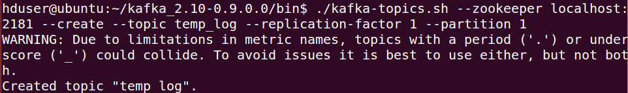
4. Start an instance of spark server:
${SPARK_HOME}/sbin/start-master.sh
Replace ${SPARK_HOME} with path where you have installed spark . Check log , you will find the spark master is at ‘spark://ubuntu:7077’
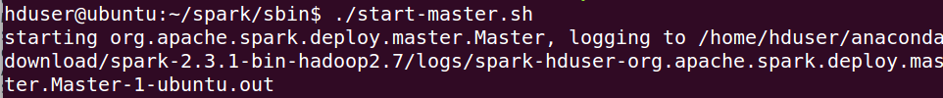

5. Start an instance of worker locally:
${SPARK_HOME}/sbin/start-slave.sh ${SPARK_URL}
where, SPARK_URL=" spark://ubuntu:7077", replace that with your instance of spark server
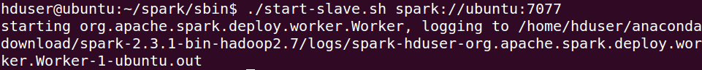

6. Work with mysql to create tables:
CREATE TABLE mysql.cold
(
Date DATE,
Time TIME,
Year YEAR,
TimeStamp TIMESTAMP,
Temparature FLOAT
);

CREATE TABLE mysql.warm
(
Date DATE,
Time TIME,
Year YEAR,
TimeStamp TIMESTAMP,
Temparature FLOAT
);

CREATE TABLE mysql.aggregate
(
Date DATE,
Time TIME,
Year YEAR,
TimeStamp TIMESTAMP,
Temparature FLOAT
);

Aggregate function:
SELECT Temparature as tmp FROM mysql.warm WHERE TimeStamp >= DATE_SUB(NOW(), interval 1 hour)
union
SELECT Temparature as tmp FROM mysql.cold WHERE TimeStamp >= DATE_SUB(NOW(), interval 1 hour);
And finally adding all the rows with tmp column values

7. Whole setup to program in java for kafka
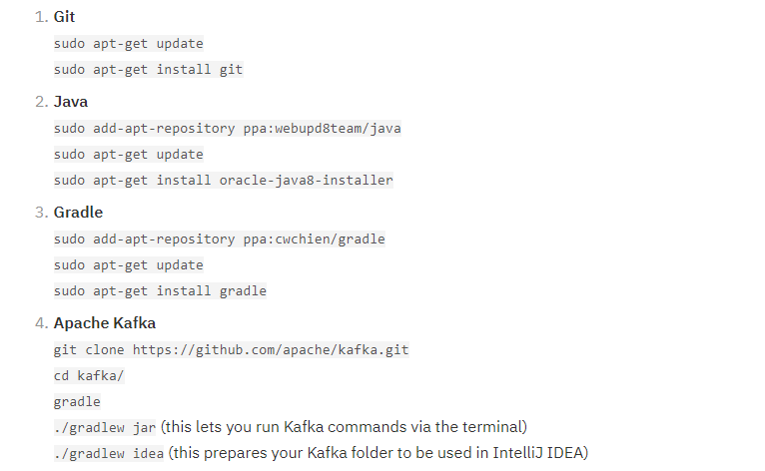

chmod 755 random.sh
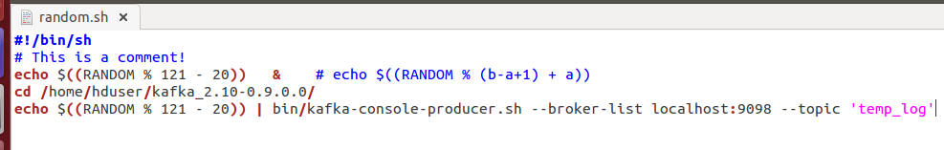

8. Run the java program → Producer_temp.java
9. Execute the scala file →Temp_streaming.scala

References:-
https://www.jetbrains.com/help/idea/creating-and-running-your-first-java-application.html
https://developer.ibm.com/opentech/2017/11/02/how-to-develop-for-apache-kafka-using-intellij-idea/
https://dzone.com/articles/kafka-producer-and-consumer-example

