ABSTRACT
DineFlow: A Database-Driven Restaurant Order Management System
A restaurant depends on many people working on the same data at the same moment: customers ordering and reserving, cooks following a queue, cashiers collecting money and managers watching stock and sales. When such a system is built carelessly, tables are double-booked, dishes are oversold, bills do not match the order and users see data that is not theirs. DineFlow is a web-based Restaurant Order Management System, built as a Database Management Systems mini project, that shows how database concepts remove these problems. It uses PostgreSQL 16 on Supabase, a Node.js and Express API on Render, and a plain HTML, CSS and JavaScript front end for customers, kitchen staff and the administrator. The schema has 17 tables, mapped from an ER/EER model and normalised up to BCNF, with 4NF and 5NF demonstrated. Business rules live inside the database: constraints, 15 triggers, functions, an explicit-cursor end-of-day procedure, a status-flow table that controls the order life cycle, and an exclusion constraint that makes double booking of a table impossible. Each order is one ACID transaction with row locking and a fixed lock order, so the last dish cannot be sold twice and deadlocks are avoided. Four least-privilege database roles, GRANT and REVOKE, row-level security and automatic session expiry ensure that a customer can never read another customer's orders. Indexes were verified with EXPLAIN ANALYZE on 50,000 orders: a filter query fell from 3.699 ms to 0.233 ms. Reservations follow strict rules (no overlap, three upcoming bookings per customer, automatic no-show clean-up), the administrator can add dishes from the website, and a backup script and a live floor map complete the system. Automated tests run 65 database checks, 23 security checks and 63 end-to-end API checks, and all of them pass.
Keywords: DBMS, PostgreSQL, ER/EER model, normalization, triggers, transactions, row locking, row-level security, indexing, EXPLAIN ANALYZE, Node.js.

TABLE OF CONTENTS
S.No | Section | Page No.
1 | Introduction | 1
2 | Objectives | 3
3 | Tools and Technologies | 4
4 | Architecture Diagram | 6
5 | Methodology | 20
6 | Results | 41
7 | Conclusion | 65
8 | References | 66

1. Introduction

1.1 Background
Restaurants have moved from paper order slips and shouted tickets to digital ordering. A modern system must let many people work at the same time, keep prices and stock correct, record payments and give the owner reliable sales figures. All of this depends on a well-designed database. If the data layer is weak, problems appear quickly: two customers are given the same table, a dish is sold after the kitchen has run out, an order is billed before it was served, or the printed bill does not match the items ordered.

1.2 Problem Statement
Manual and poorly designed restaurant systems suffer from the following problems:
- Redundant and inconsistent data: the same price, table size or customer name stored in many places.
- Double booking: two customers reserve or occupy the same table at the same moment.
- Overselling: limited stock is not reduced with every order, so a dish is sold twice.
- No control over the order life cycle: an order can jump from "placed" to "paid" without being cooked or served.
- Bills that do not match the order: discounts, coupons and GST are calculated by hand or in scattered code.
- Weak access control: every user can see and change everything, including other customers' orders and password hashes.
- Slow reports once the order history grows large, and no easy way to recover data after a mistake.

1.3 Proposed System
DineFlow is a web-based Restaurant Order Management System. Customers register, browse the menu, reserve tables, place dine-in or takeaway orders, apply coupon codes, pay by UPI, card or cash, split the bill between diners, track the order status and rate dishes. Kitchen staff see a live queue with delay colours and a live floor map. The administrator manages orders, confirms cash payments, restocks dishes, edits prices and reads sales reports and the end-of-day settlement. The focus of the project is the database: the schema, the rules, the transactions, the security and the optimisation are the core of the work, and the website only exposes them.

1.4 Scope
The system covers customers, staff, addresses, dining tables, reservations, categories, menu items with stock, coupons, orders, order lines, payments, bill splits, reviews, an audit log and a daily settlement. A real payment gateway (a simulated one is used), e-mail and SMS notification, and delivery tracking are outside the current scope and are listed as future work.

1.5 Existing System versus Proposed System
Aspect | Manual or basic system | DineFlow
Order taking | Paper slips or a spreadsheet; items copied by hand | One database transaction creates the order, lines, stock change and payment together
Stock | Counted at the end of the day | Reduced inside the same transaction; a CHECK constraint forbids negative stock
Table booking | Phone calls and a diary; double booking is common | Exclusion constraint makes overlapping bookings impossible
Bill | Calculated by hand; GST and discounts may be wrong | Trigger recomputes subtotal, coupon discount, 5% GST and total on every change
Order life cycle | Informal; an order can be marked paid without being served | Status-flow table and trigger allow only legal moves by the right role
Access control | Everyone sees everything | Four database roles, column privileges and row-level security
Reports | Manual totals at closing time | Views, a dynamic-SQL report and an end-of-day cursor procedure
Recovery | None | Compressed backup, restore into a scratch database and row-count verification

1.6 Feasibility Study
Technical feasibility. Every component is open source and well documented: PostgreSQL, Node.js, Express and plain browser JavaScript. The database features needed by the syllabus (triggers, cursors, locking, indexing, roles, row-level security) are all available in PostgreSQL 15 and later, so no additional product is needed. The project was built and tested end to end on PostgreSQL 16 and Node.js 22.
Economic feasibility. Development needs only a laptop. Hosting uses the free tiers of Supabase (database) and Render (web service), whose limits can change, so the current plans should be checked before deployment. There is no licence cost.
Operational feasibility. The three user groups need no training beyond the on-screen labels: customers use a menu and a cart, kitchen staff see a queue and a floor map, and the administrator uses a few tables and reports. The user guide in Section 6 describes each screen.
Schedule feasibility. The work was organised in the order of the syllabus units: schema (Unit I), SQL programming (Unit II), normalisation (Unit III), transactions (Unit IV), optimisation and NoSQL (Unit V), then security, backup, the web layer and deployment. Each step was verified by an automated test before the next began.

1.7 Organisation of the Report
Section 2 states the objectives and the outcomes delivered. Section 3 lists the tools and technologies. Section 4 presents the architecture, the ER diagram, the order status flow, the order-placement sequence, the data dictionary of all 17 tables, the roles and the API. Section 5 explains the methodology unit by unit and lists the key source code. Section 6 gives the results: captured outputs, views, API requests and responses, every test case, the benchmark, the security checks, the backup demonstration and a user guide. Section 7 concludes with limitations, future scope and lessons learned. Section 8 lists the references.

2. Objectives
The objectives of the project, with the syllabus unit each one covers, are:
- Design an ER/EER diagram for customers, tables, menu, orders, order items, staff, payments and inventory, and map it to a relational schema with primary keys, foreign keys and constraints (Unit I).
- Implement the schema in SQL with constraints, views, sequences, cursors, procedures, functions, triggers, exception handling and dynamic SQL (Unit II).
- Apply functional dependencies and normalise the design from the unnormalised form up to BCNF, 4NF and 5NF, with lossless-join proofs (Unit III).
- Demonstrate the ACID properties with concurrent order placement and payment, using commit, rollback, savepoints, row locking and isolation levels (Unit IV).
- Optimise queries with indexes and EXPLAIN ANALYZE, build an end-of-day batch procedure for sales and tax, and compare the design with a MongoDB document model (Unit V).
- Protect the data with least-privilege database roles, GRANT and REVOKE, and row-level security, and provide backup and restore with verification.
- Build a role-based web application with a live floor map, deploy it as a public website, and verify everything with automated tests.

2.1 Expected Outcomes
Objective | Delivered | Evidence
ER/EER design and relational mapping (Unit I) | 17-table schema, ER diagram, data dictionary | db/01_schema_er.sql; Figure 4.2; Section 4.5
SQL programming (Unit II) | 15 triggers, 45 routines, 12 views, cursors, dynamic SQL, exception handling | db/03_sql_programming.sql; 34 database checks
Normalisation (Unit III) | UNF to 5NF with lossless-join queries; relational algebra | db/02_normalization.sql; Section 5.12 and 5.13
ACID and concurrency (Unit IV) | fn_place_order, savepoints, isolation levels, two-session demos | db/04_transactions.sql; 27 database checks; two API races
Optimisation and NoSQL (Unit V) | Indexes with plans, join comparison, settlement procedure, MongoDB script | db/05_optimization.sql, 05b_benchmark.sql; Section 6.7
Security and recovery | Roles, GRANT/REVOKE, row-level security, backup script | db/08_security.sql; 23 security checks; Section 6.8
Web application and deployment | Customer, kitchen and admin screens, live floor map, Render and Supabase deployment | server/ and public/; 63 API checks

3. Tools and Technologies
Layer | Technology | Purpose
Database | PostgreSQL 16 (hosted on Supabase) | Tables, constraints, triggers, PL/pgSQL, locking, roles, row-level security, EXPLAIN
Extensions | pgcrypto, btree_gist | bcrypt password hashing; exclusion constraint on time ranges
Back end | Node.js 18+, Express, pg, dotenv | REST API, signed tokens, one transaction per request
Front end | HTML, CSS, vanilla JavaScript | Customer, kitchen and admin screens using fetch
NoSQL | MongoDB shell script | Document model of an order, for comparison
Hosting | Supabase and Render (free tiers) | Public website: database and web service
Testing | fn_run_tests(), fn_run_security_tests(), Node test script | 65 database, 23 security and 63 API checks
Diagrams and version control | Graphviz, Mermaid, Git and GitHub | ER and architecture diagrams; source code management

PostgreSQL was chosen because it supports every feature the syllabus asks for: triggers, PL/pgSQL, explicit and implicit cursors, row-level locks, exclusion constraints, transactional DDL, roles with row-level security, JSONB and EXPLAIN ANALYZE. Express serves both the API and the static front end from one process, which keeps deployment simple.

3.1 Hardware and Software Requirements
Item | Requirement
Computer | Any laptop or desktop with 4 GB RAM or more and 1 GB of free disk space
Operating system | Windows, macOS or Linux (development and testing were done on Linux)
Database server | PostgreSQL 15 or newer (tested on 16) with the pgcrypto and btree_gist extensions
Runtime | Node.js 18 or newer (tested on 22)
Browser | A current version of Chrome, Edge, Firefox or Safari
Optional tools | psql, pg_dump and pg_restore for the SQL scripts and backups; MongoDB shell for the NoSQL script; Git

3.2 Technology Details
- PostgreSQL features used: ENUM types, identity columns and sequences, CHECK, UNIQUE and exclusion constraints (GiST with btree_gist), partial and composite B-tree indexes, PL/pgSQL functions and procedures, row- and statement-level triggers, deferred constraint triggers, explicit and implicit cursors, dynamic SQL with EXECUTE ... USING, SELECT FOR UPDATE with NOWAIT and SKIP LOCKED, savepoints, isolation levels, materialised views, security-invoker views, roles with GRANT and REVOKE, row-level security and EXPLAIN ANALYZE.
- Supabase: managed PostgreSQL with a SQL editor, connection strings and daily backups. The direct connection string is used for loading the SQL files and for pg_dump.
- Node.js and Express: a small REST API. Express also serves the static pages, so the whole site runs as one process.
- node-postgres (pg): a connection pool and parameterised queries. Every request runs in one transaction that sets the acting role and user id before any query.
- dotenv: reads DATABASE_URL, TOKEN_SECRET and the other settings from a .env file that is never committed to Git.
- HTML, CSS and vanilla JavaScript: a single-page front end without a framework; all text from the database is escaped before it is shown.
- MongoDB shell: a script that stores each order as one document, used to compare the document model with the relational model.
- Graphviz, Mermaid and matplotlib: used to draw the ER, architecture, status-flow and sequence diagrams and the benchmark chart.

4. Architecture Diagram

4.1 System Architecture
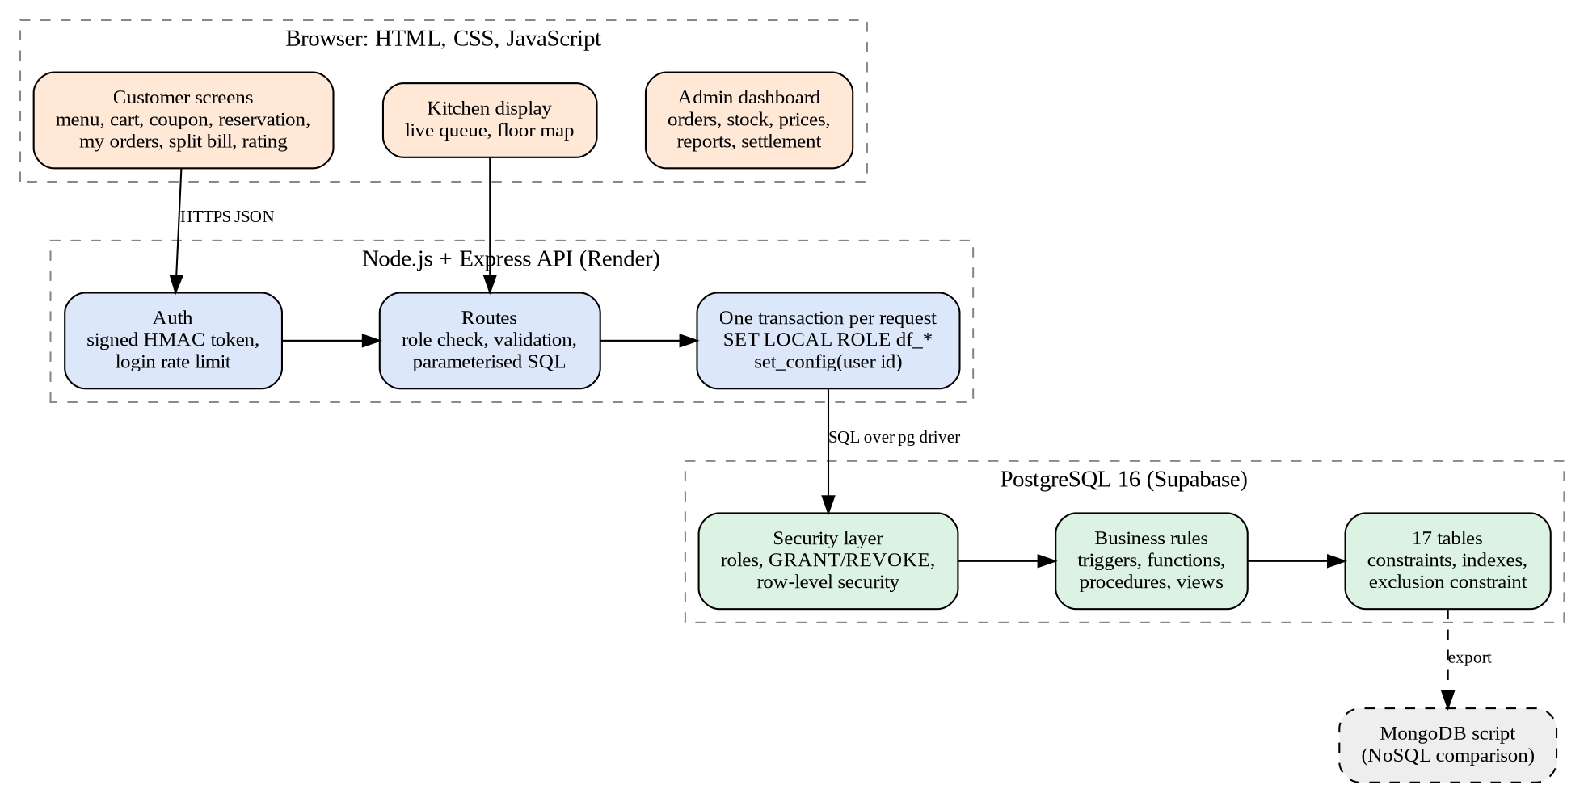
Figure 4.1 System architecture of DineFlow
The browser never talks to the database directly. Every request goes to the API, which verifies a signed token, checks the role, validates the input and then opens one database transaction. Inside that transaction the API tells PostgreSQL who is acting (set_config for the role and user id) and switches to a limited database role with SET LOCAL ROLE. The triggers read the same context, so a rule holds even if a client bypasses the web pages. Business rules therefore live in the database, not in the application code.

4.2 Enhanced Entity-Relationship Diagram
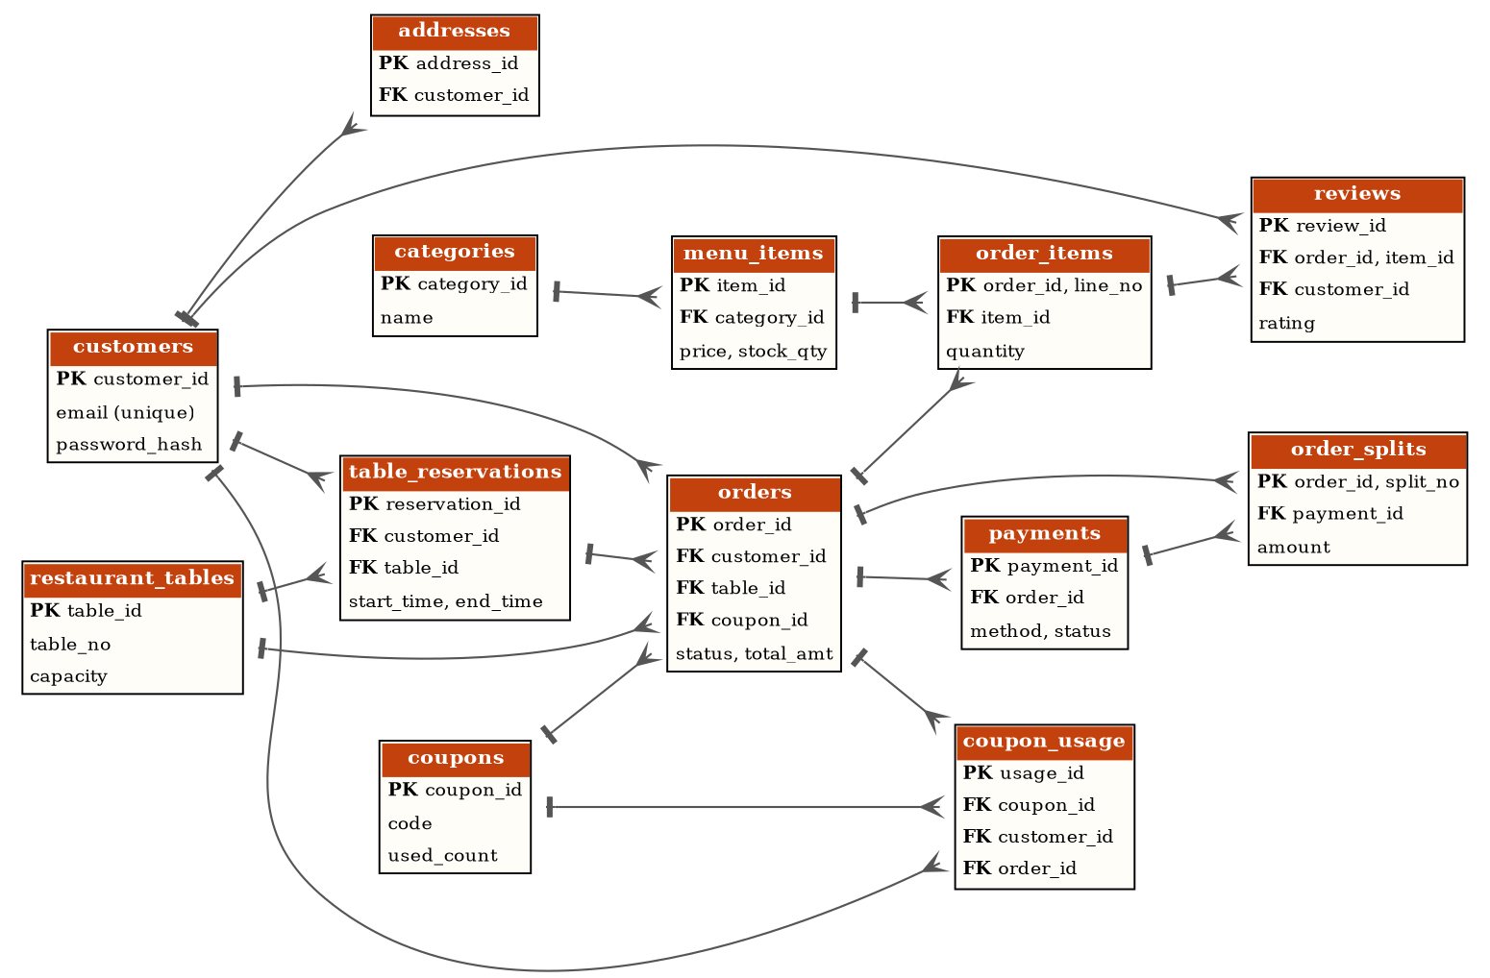
Figure 4.2 ER diagram of DineFlow mapped to relational tables (primary keys PK, foreign keys FK; crow's foot = many)
Customers and staff are separate entities because their attributes and login roles differ. The many-to-many relationship between orders and menu items is resolved by order_items with the composite key (order_id, line_no). Reviews reference order_items(order_id, item_id), so a review can only point at a dish that is really on that order. Payments belong to an order, and several payments per order, together with order_splits, give split bills. The tables staff, audit_log, daily_settlement and status_flow carry no foreign keys by design: staff sign in separately, the audit log must survive deletions, settlement rows are summaries, and status_flow stores the legal order life cycle as data.

4.3 Order Status Flow
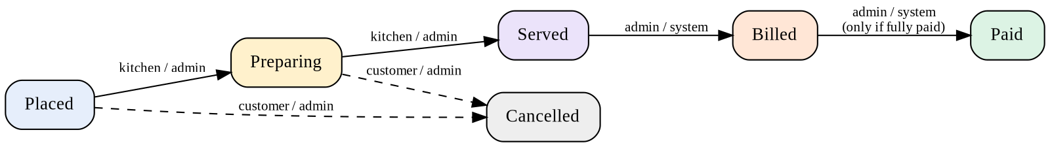
Figure 4.3 Legal order status changes stored in the status_flow table, with the roles allowed to make each move
An order moves only along the arrows. The status-flow table holds each legal move and the roles allowed to make it, so changing the workflow is a data change, not a code change. A trigger reads this table on every status update, refuses any other move, and writes the change to the audit log. An order can be cancelled only before it is served, by its owner or the administrator.

4.4 Order Placement Sequence
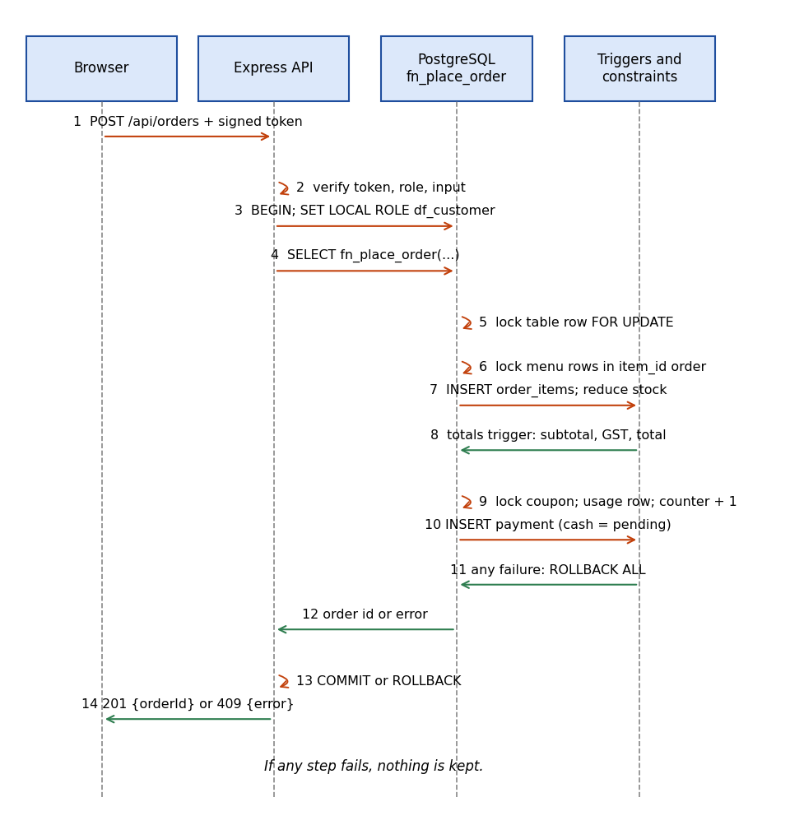
Figure 4.4 Sequence of placing an order: one transaction from the browser to the triggers
Steps 3 to 11 run inside one database transaction. The table row is locked first, the menu rows next (in ascending item_id order) and the coupon row last, so every order takes its locks in the same order and cannot deadlock with another order. The totals trigger fires on every inserted line. If the payment step is refused, for example a declined card, the error undoes the order, the stock reduction and the coupon use together.

4.5 Relational Schema and Data Dictionary
The relational schema produced from the ER diagram is listed below in the notation table(column, ...), where # marks a primary key column and ^ marks a foreign key column. Tables 4.1 to 4.17 then give the data dictionary of every relation, generated directly from the PostgreSQL catalogue of the running database, together with its check and exclusion constraints.
Listing 4.1 Relational schema of DineFlow (# primary key, ^ foreign key)
addresses(address_id#, customer_id^, label, line1, city, pincode, is_default)
audit_log(audit_id#, table_name, record_id, action, old_data, new_data, changed_by,
changed_at)
categories(category_id#, name, display_order)
coupon_usage(usage_id#, coupon_id^, customer_id^, order_id^, discount_given, used_at)
coupons(coupon_id#, code, discount_type, discount_value, min_order_amount, max_discount,
valid_from, valid_to, max_total_uses, used_count, per_customer_limit, is_active)
customers(customer_id#, full_name, email, phone, password_hash, is_active, created_at)
daily_settlement(settle_date#, orders_count, gross_sales, discount_total, tax_total,
net_sales, upi_total, card_total, cash_total, generated_at)
menu_items(item_id#, category_id^, name, description, price, is_veg, stock_qty,
reorder_level, is_sold_out, is_active)
order_items(order_id#^, line_no#, item_id^, quantity, unit_price, line_total, note)
order_splits(order_id#^, split_no#, payer_name, amount, payment_id^)
orders(order_id#, order_no, customer_id^, table_id^, reservation_id^, coupon_id^,
order_type, status, subtotal, discount_amt, tax_amt, total_amt, notes, created_at,
updated_at)
payments(payment_id#, order_id^, method, amount, status, upi_ref, card_last4, paid_at,
created_at)
restaurant_tables(table_id#, table_no, capacity, area, is_active)
reviews(review_id#, order_id^, item_id^, customer_id^, rating, comment, created_at)
staff(staff_id#, full_name, email, password_hash, role, is_active, created_at)
status_flow(from_status#, to_status#, allowed_roles)
table_reservations(reservation_id#, customer_id^, table_id^, party_size, start_time,
end_time, status, created_at)

Table 4.1 addresses
Delivery or contact addresses of a customer (one customer, many addresses; one default).
Column | Data type | Keys, constraints and default
address_id | int | PK; identity
customer_id | int | FK to customers; NOT NULL
label | varchar(20) | NOT NULL; default 'Home'
line1 | varchar(120) | NOT NULL
city | varchar(60) | NOT NULL
pincode | character(6) | NOT NULL
is_default | boolean | NOT NULL; default false
Check and exclusion constraints
addresses_pincode_check: CHECK (pincode ~ '^[0-9]{6}$')

Table 4.2 audit_log
Append-only history of order status changes, payments and price changes, written by triggers.
Column | Data type | Keys, constraints and default
audit_id | bigint | PK; identity
table_name | varchar(40) | NOT NULL
record_id | int | NOT NULL
action | varchar(10) | NOT NULL
old_data | jsonb
new_data | jsonb
changed_by | varchar(60) | NOT NULL; default 'system'
changed_at | timestamptz | NOT NULL; default now()
Check and exclusion constraints
audit_log_action_check: CHECK ((action) = ANY (({'INSERT', 'UPDATE', 'DELETE', 'STATUS'})))

Table 4.3 categories
Menu categories such as Starters, Mains and Desserts.
Column | Data type | Keys, constraints and default
category_id | int | PK; identity
name | varchar(40) | UNIQUE; NOT NULL
display_order | smallint | NOT NULL; default 0

Table 4.4 coupon_usage
Which customer used which coupon on which order; at most one coupon per order.
Column | Data type | Keys, constraints and default
usage_id | int | PK; identity
coupon_id | int | FK to coupons; NOT NULL
customer_id | int | FK to customers; NOT NULL
order_id | int | FK to orders, UNIQUE; NOT NULL
discount_given | numeric(10,2) | NOT NULL
used_at | timestamptz | NOT NULL; default now()
Check and exclusion constraints
coupon_usage_discount_given_check: CHECK (discount_given >= (0))

Table 4.5 coupons
Discount codes with validity dates, minimum bill, usage limits and a transaction-safe usage counter.
Column | Data type | Keys, constraints and default
coupon_id | int | PK; identity
code | varchar(20) | UNIQUE; NOT NULL
discount_type | dineflow.discount_type | NOT NULL
discount_value | numeric(8,2) | NOT NULL
min_order_amount | numeric(8,2) | NOT NULL; default 0
max_discount | numeric(8,2)
valid_from | timestamptz | NOT NULL
valid_to | timestamptz | NOT NULL
max_total_uses | int | NOT NULL
used_count | int | NOT NULL; default 0
per_customer_limit | smallint | NOT NULL; default 1
is_active | boolean | NOT NULL; default true
Check and exclusion constraints
ck_coupon_dates: CHECK (valid_to > valid_from)
ck_coupon_pct: CHECK ((discount_type <> 'PERCENT'::dineflow.discount_type) OR (discount_value <= (100)))
ck_coupon_used: CHECK ((used_count >= 0) AND (used_count <= max_total_uses))
coupons_code_check: CHECK ((code) = upper((code)))
coupons_discount_value_check: CHECK (discount_value > (0))
coupons_max_discount_check: CHECK ((max_discount IS NULL) OR (max_discount > (0)))
coupons_max_total_uses_check: CHECK (max_total_uses > 0)
coupons_min_order_amount_check: CHECK (min_order_amount >= (0))
coupons_per_customer_limit_check: CHECK (per_customer_limit > 0)

Table 4.6 customers
Registered customers; the password is stored only as a bcrypt hash.
Column | Data type | Keys, constraints and default
customer_id | int | PK; identity
full_name | varchar(80) | NOT NULL
email | varchar(120) | NOT NULL
phone | varchar(15) | NOT NULL
password_hash | text | NOT NULL
is_active | boolean | NOT NULL; default true
created_at | timestamptz | NOT NULL; default now()
Check and exclusion constraints
customers_email_check: CHECK ((email) ~* '^[^@\s]+@[^@\s]+\.[^@\s]+$')
customers_full_name_check: CHECK (length(TRIM(BOTH FROM full_name)) >= 2)
customers_phone_check: CHECK ((phone) ~ '^[0-9]{10}$')

Table 4.7 daily_settlement
One summary row per day produced by the end-of-day cursor procedure.
Column | Data type | Keys, constraints and default
settle_date | date | PK
orders_count | int | NOT NULL
gross_sales | numeric(12,2) | NOT NULL
discount_total | numeric(12,2) | NOT NULL
tax_total | numeric(12,2) | NOT NULL
net_sales | numeric(12,2) | NOT NULL
upi_total | numeric(12,2) | NOT NULL; default 0
card_total | numeric(12,2) | NOT NULL; default 0
cash_total | numeric(12,2) | NOT NULL; default 0
generated_at | timestamptz | NOT NULL; default now()
Check and exclusion constraints
daily_settlement_orders_count_check: CHECK (orders_count >= 0)

Table 4.8 menu_items
Dishes with price and stock; is_sold_out is maintained by a trigger.
Column | Data type | Keys, constraints and default
item_id | int | PK; identity
category_id | int | FK to categories; NOT NULL
name | varchar(80) | UNIQUE; NOT NULL
description | varchar(200)
price | numeric(8,2) | NOT NULL
is_veg | boolean | NOT NULL; default true
stock_qty | int | NOT NULL; default 0
reorder_level | int | NOT NULL; default 10
is_sold_out | boolean | NOT NULL; default false
is_active | boolean | NOT NULL; default true
Check and exclusion constraints
menu_items_price_check: CHECK (price > (0))
menu_items_reorder_level_check: CHECK (reorder_level >= 0)
menu_items_stock_qty_check: CHECK (stock_qty >= 0)

Table 4.9 order_items
Lines of an order; resolves the many-to-many link between orders and dishes; unit_price is a snapshot.
Column | Data type | Keys, constraints and default
order_id | int | FK to orders, PK, UNIQUE
line_no | smallint | PK
item_id | int | FK to menu_items, UNIQUE; NOT NULL
quantity | smallint | NOT NULL
unit_price | numeric(8,2) | NOT NULL
line_total | numeric(10,2) | generated: quantity::numeric * unit_price
note | varchar(100)
Check and exclusion constraints
order_items_quantity_check: CHECK ((quantity >= 1) AND (quantity <= 20))
order_items_unit_price_check: CHECK (unit_price > (0))

Table 4.10 order_splits
Shares of a split bill; the shares must add up to the order total (deferred constraint trigger).
Column | Data type | Keys, constraints and default
order_id | int | FK to orders, PK
split_no | smallint | PK
payer_name | varchar(60) | NOT NULL
amount | numeric(10,2) | NOT NULL
payment_id | int | FK to payments
Check and exclusion constraints
order_splits_amount_check: CHECK (amount > (0))
order_splits_split_no_check: CHECK ((split_no >= 1) AND (split_no <= 10))

Table 4.11 orders
One row per dine-in or takeaway order with computed totals and the current status.
Column | Data type | Keys, constraints and default
order_id | int | PK; identity
order_no | bigint | UNIQUE; NOT NULL; default nextval('dineflow.order_no_seq')
customer_id | int | FK to customers; NOT NULL
table_id | int | FK to restaurant_tables
reservation_id | int | FK to table_reservations
coupon_id | int | FK to coupons
order_type | dineflow.order_type | NOT NULL; default 'Dine-in'.order_type
status | dineflow.order_status | NOT NULL; default 'Placed'.order_status
subtotal | numeric(10,2) | NOT NULL; default 0
discount_amt | numeric(10,2) | NOT NULL; default 0
tax_amt | numeric(10,2) | NOT NULL; default 0
total_amt | numeric(10,2) | NOT NULL; default 0
notes | varchar(200)
created_at | timestamptz | NOT NULL; default now()
updated_at | timestamptz | NOT NULL; default now()
Check and exclusion constraints
ck_order_discount: CHECK (discount_amt <= subtotal)
ck_order_table: CHECK (((order_type = 'Dine-in'::dineflow.order_type) AND (table_id IS NOT NULL)) OR ((order_type = 'Takeaway'::dineflow.order_type) AND (table_id IS NULL)))
ck_order_total: CHECK (total_amt = ((subtotal - discount_amt) + tax_amt))
orders_discount_amt_check: CHECK (discount_amt >= (0))
orders_subtotal_check: CHECK (subtotal >= (0))
orders_tax_amt_check: CHECK (tax_amt >= (0))
orders_total_amt_check: CHECK (total_amt >= (0))

Table 4.12 payments
Payments for an order; several rows per order allow split bills.
Column | Data type | Keys, constraints and default
payment_id | int | PK; identity
order_id | int | FK to orders; NOT NULL
method | dineflow.payment_method | NOT NULL
amount | numeric(10,2) | NOT NULL
status | dineflow.payment_status | NOT NULL; default 'Pending'.payment_status
upi_ref | varchar(40)
card_last4 | character(4)
paid_at | timestamptz
created_at | timestamptz | NOT NULL; default now()
Check and exclusion constraints
ck_pay_card: CHECK ((card_last4 IS NULL) OR ((method = 'Card'::dineflow.payment_method) AND (card_last4 ~ '^[0-9]{4}$')))
ck_pay_time: CHECK ((status <> 'Success'::dineflow.payment_status) OR (paid_at IS NOT NULL))
ck_pay_upi: CHECK ((upi_ref IS NULL) OR (method = 'UPI'::dineflow.payment_method))
payments_amount_check: CHECK (amount > (0))

Table 4.13 restaurant_tables
Physical dining tables with seats and area.
Column | Data type | Keys, constraints and default
table_id | int | PK; identity
table_no | varchar(5) | UNIQUE; NOT NULL
capacity | smallint | NOT NULL
area | varchar(20) | NOT NULL; default 'Indoor'
is_active | boolean | NOT NULL; default true
Check and exclusion constraints
restaurant_tables_area_check: CHECK ((area) = ANY (({'Indoor', 'Outdoor', 'Family', 'Window'})))
restaurant_tables_capacity_check: CHECK ((capacity >= 1) AND (capacity <= 20))

Table 4.14 reviews
A rating of one dish on one paid order; the composite foreign key guarantees the dish was on the order.
Column | Data type | Keys, constraints and default
review_id | int | PK; identity
order_id | int | FK to order_items, UNIQUE; NOT NULL
item_id | int | FK to order_items, UNIQUE; NOT NULL
customer_id | int | FK to customers; NOT NULL
rating | smallint | NOT NULL
comment | varchar(300)
created_at | timestamptz | NOT NULL; default now()
Check and exclusion constraints
reviews_rating_check: CHECK ((rating >= 1) AND (rating <= 5))

Table 4.15 staff
Kitchen and admin accounts with bcrypt password hashes.
Column | Data type | Keys, constraints and default
staff_id | int | PK; identity
full_name | varchar(80) | NOT NULL
email | varchar(120) | NOT NULL
password_hash | text | NOT NULL
role | dineflow.staff_role | NOT NULL
is_active | boolean | NOT NULL; default true
created_at | timestamptz | NOT NULL; default now()
Check and exclusion constraints
staff_email_check: CHECK ((email) ~* '^[^@\s]+@[^@\s]+\.[^@\s]+$')

Table 4.16 status_flow
Data table listing every legal order status change and the roles allowed to make it.
Column | Data type | Keys, constraints and default
from_status | dineflow.order_status | PK
to_status | dineflow.order_status | PK
allowed_roles | text[] | NOT NULL
Check and exclusion constraints
ck_flow_diff: CHECK (from_status <> to_status)
ck_flow_roles: CHECK ((allowed_roles <@ {'customer', 'kitchen', 'admin', 'system'}) AND (cardinality(allowed_roles) > 0))

Table 4.17 table_reservations
Table bookings; an exclusion constraint forbids overlapping live bookings of one table.
Column | Data type | Keys, constraints and default
reservation_id | int | PK; identity
customer_id | int | FK to customers; NOT NULL
table_id | int | FK to restaurant_tables; NOT NULL
party_size | smallint | NOT NULL
start_time | timestamptz | NOT NULL
end_time | timestamptz | NOT NULL
status | dineflow.reservation_status | NOT NULL; default 'Booked'.reservation_status
created_at | timestamptz | NOT NULL; default now()
Check and exclusion constraints
ck_resv_max_len: CHECK ((end_time - start_time) <= '03:00:00'::interval)
ck_resv_time: CHECK (end_time > start_time)
ex_no_double_booking: EXCLUDE USING gist (table_id WITH =, tstzrange(start_time, end_time) WITH &&) WHERE (status = ANY ({'Booked'::dineflow.reservation_status, 'Seated'::dineflow.reservation_status}))
table_reservations_party_size_check: CHECK ((party_size >= 1) AND (party_size <= 20))

4.6 Actors, Roles and Use Cases
Actor | Main use cases | Database objects involved
Visitor (df_anon) | Browse the menu and ratings; register; sign in; search free tables | menu_items, v_dish_ratings, v_public_reviews, fn_register_customer, fn_login_customer, fn_available_tables
Customer (df_customer) | Order, apply coupons, reserve (rules: 10 minutes notice, 30 days ahead, 3 upcoming), pay, split the bill, cancel, rate | fn_place_order, fn_check_coupon, fn_reserve_table, fn_pay_order, fn_split_bill, fn_pay_split, fn_cancel_order, reviews
Kitchen (df_kitchen) | See the live queue and floor map; start cooking; mark served | v_kitchen_queue, v_floor_map, orders.status with the status-flow trigger
Admin (df_admin) | Confirm cash, add dishes and categories, hide dishes, manage stock and prices, read reports, run settlement, read the audit trail | fn_confirm_payment, fn_restock, fn_add_menu_item, fn_add_category, fn_set_item_active, v_restaurant_summary, fn_sales_by, sp_daily_settlement, v_order_audit

4.7 Modules and API Overview
Module | File | Responsibility
Web server | server/server.js | Starts Express, sets security headers and the 20 KB body limit, serves the static pages and the three route groups
Database access | server/db.js | Connection pool; one transaction per request; sets role and user id; SET LOCAL ROLE; retries on deadlock
Authentication | server/auth.js | HMAC-SHA256 signed tokens, role middleware, login rate limiter
Error mapping | server/util.js | Maps database error codes to short safe messages and HTTP status codes
Public routes | server/routes/public.js | Register, login, menu, free tables, public reviews
Customer routes | server/routes/customer.js | Coupons, reservations, orders, payments, bill split, reviews
Staff routes | server/routes/staff.js | Kitchen queue, status changes, floor map, admin orders, stock, reports, settlement
Front end | public/index.html, style.css, app.js | Single-page screens for customer, kitchen and admin

The table below lists every HTTP endpoint with the role that may call it and the database object that does the work.
Method | Path | Role | Database object
GET | /api/health | any | SELECT 1 (connection check)
POST | /api/auth/register | visitor | fn_register_customer
POST | /api/auth/login | visitor | fn_login_customer
POST | /api/auth/staff-login | visitor | fn_login_staff
GET | /api/auth/me | signed in | token only
GET | /api/menu | visitor | menu_items, v_dish_ratings
GET | /api/tables | visitor, customer | fn_free_tables; fn_tables_for_customer (flags own and reserved tables)
GET | /api/tables/available | visitor | fn_available_tables
GET | /api/reviews/dish/:id | visitor | v_public_reviews
POST | /api/coupons/check | customer | fn_check_coupon, fn_coupon_discount
POST | /api/reservations | customer | fn_reserve_table
GET | /api/reservations/mine | customer | table_reservations (RLS)
POST | /api/reservations/:id/cancel | customer | UPDATE table_reservations (RLS)
POST | /api/orders | customer | fn_place_order
GET | /api/orders/mine | customer | v_order_history (RLS)
GET | /api/orders/:id | customer | v_order_history, order_items, payments, order_splits, v_order_audit
POST | /api/orders/:id/cancel | customer | fn_cancel_order
POST | /api/orders/:id/pay | customer | fn_pay_order
POST | /api/orders/:id/split | customer | fn_split_bill
POST | /api/orders/:id/split/:no/pay | customer | fn_pay_split
POST | /api/reviews | customer | INSERT reviews (trigger and RLS)
GET | /api/kitchen/queue | kitchen, admin | v_kitchen_queue
POST | /api/kitchen/orders/:id/status | kitchen, admin | UPDATE orders (status-flow trigger)
GET | /api/floor | kitchen, admin | v_floor_map
GET | /api/admin/orders | admin | v_order_history, payments
POST | /api/admin/payments/:id/confirm | admin | fn_confirm_payment
GET | /api/admin/audit/:orderId | admin | v_order_audit
GET | /api/admin/low-stock | admin | v_low_stock
POST | /api/admin/restock | admin | fn_restock
POST | /api/admin/restock-low | admin | fn_restock_low_items
GET | /api/admin/menu | admin | menu_items (all dishes, also hidden)
GET | /api/admin/categories | admin | categories
POST | /api/admin/categories | admin | fn_add_category
POST | /api/admin/menu | admin | fn_add_menu_item
POST | /api/admin/menu/:id/active | admin | fn_set_item_active
PUT | /api/admin/menu/:id | admin | UPDATE menu_items (price audit trigger)
GET | /api/admin/reports/summary | admin | v_restaurant_summary, v_sales_last_7_days, v_top_dishes, v_peak_hours
GET | /api/admin/reports/by | admin | fn_sales_by (dynamic SQL)
GET | /api/admin/reports/item-sales | admin | mv_item_sales_daily
POST | /api/admin/reports/refresh | admin | fn_refresh_reports
POST | /api/admin/settlement | admin | sp_daily_settlement (cursors)
GET | /api/admin/settlements | admin | daily_settlement

4.8 Database Security Matrix
The matrix summarises what each database role may do after db/08_security.sql has been loaded. "Own rows" means that row-level security compares the row's customer with the user id taken from the signed token.
Object | df_anon | df_customer | df_kitchen | df_admin
menu_items, categories | SELECT | SELECT | - | ALL
restaurant_tables | - | SELECT | - | ALL
orders | - | SELECT own rows | SELECT status columns; UPDATE status of Placed or Preparing | ALL
order_items, payments, order_splits | - | SELECT own rows | - | ALL
table_reservations | - | SELECT and cancel own | - | ALL
reviews | - | SELECT and INSERT own | - | ALL
customers | - | own row, no password_hash | - | all rows, no password_hash
staff | - | - | - | no password_hash
coupons, coupon_usage, status_flow, daily_settlement | - | - | - | ALL
audit_log | - | own orders only | - | ALL
v_dish_ratings, v_public_reviews | SELECT | SELECT | - | ALL
v_order_history, v_order_audit | - | own rows (security invoker) | - | ALL
v_kitchen_queue, v_floor_map | - | - | SELECT | ALL
Functions | login, register, free tables | order, pay, split, cancel, coupon, reserve, tables for customer | clean up old bookings | ALL

5. Methodology
The project followed a step-by-step approach in which every stage is mapped to a database unit and to a script in the db folder (01 to 08).

5.1 Requirement Analysis
The actors are the visitor, the customer, the kitchen staff and the administrator. Visitors browse the menu. Customers need a cart with coupon and payment choices, table reservations, order tracking, bill splitting and ratings. Kitchen staff need a live queue and a floor map. The administrator needs order control, cash confirmation, stock, prices, reports and settlement. The business rules agreed at this stage were: totals always equal the sum of lines minus discount plus 5 percent GST; status moves only along the status flow; an order is one transaction; reviews only for paid orders; passwords hashed in the database; the customer id comes from the token.

5.2 Unit I: Database Design (01_schema_er.sql)
The EER model was converted to 17 relations. One-to-many relationships became foreign keys, with ON DELETE RESTRICT for business data so history is never lost. The many-to-many link between orders and dishes became order_items. The unit price is copied into every order line, so later price changes never alter old bills. Constraints protect the data at the source:
- NOT NULL, UNIQUE and CHECK: price above 0, stock not below 0, rating 1 to 5, party size 1 to 20, coupon dates and use limits, and the row rule total = subtotal - discount + tax.
- ENUM types for every status, and a sequence for human-friendly order numbers.
- Exclusion constraint (EXCLUDE USING gist on table_id and tstzrange) that forbids two live reservations overlapping on one table, and a partial unique index allowing only one live order per table. Both are declarative, so no application code can bypass them.

5.3 Unit II: SQL Programming (03_sql_programming.sql)
- Totals trigger: recomputes subtotal, coupon discount, GST and total whenever an order line changes.
- Status-flow trigger: looks the move up in status_flow, checks the actor's role, lets a customer cancel only their own order, and refuses Paid unless successful payments cover the bill; an AFTER trigger writes the audit log.
- Payment triggers: reject payments above the amount due and close the bill automatically (Served, Billed, Paid) when it is fully paid, including split bills. A cancel trigger returns stock in item order, releases the coupon and refunds payments.
- Reviews trigger, low-stock trigger and bill-split trigger: a review needs a paid order of the same customer; a dish is marked sold out when stock reaches 0; split shares must add up to the bill at commit (a deferred constraint trigger).
- Views: kitchen queue, dish ratings, 7-day sales, top dishes, peak hours, restaurant summary, order history, order audit, live floor map, and a synonym-equivalent view.
- Cursors: implicit cursors (FOR loops, FOUND, GET DIAGNOSTICS ROW_COUNT) and explicit cursors (OPEN, FETCH, CLOSE, one parameterised) in sp_daily_settlement.
- Exception handling and dynamic SQL: EXCEPTION WHEN unique, check, exclusion and raise exceptions give clean messages; fn_sales_by builds SQL with format(), whitelists the dimension and passes dates as bind parameters.
- Passwords: fn_register_customer and the login functions hash and verify with bcrypt (crypt and gen_salt) inside the database.
- Reservation rules: a booking must start at least 10 minutes ahead and at most 30 days ahead, a customer may hold 3 upcoming bookings and never two at the same time, and fn_expire_reservations turns old bookings into No-show or Completed. fn_tables_for_customer tells the website which tables are free, reserved by another guest, or the guest's own booking, and fn_place_order seats the owner's booking automatically.
- Menu management: fn_add_category, fn_add_menu_item and fn_set_item_active let the administrator add categories and dishes and hide or show a dish; each checks the role, validates the values and gives a clean message for duplicates.

5.4 Unit III: Relational Algebra and Normalisation (02_normalization.sql)
Relational algebra and tuple calculus examples (select, project, join, rename, union, intersection, difference, grouping and division) are in docs/relational_algebra.md. A flat receipt was normalised step by step with every functional dependency listed: F1 order_no determines the date, customer and table; F2 customer_id determines name and phone; F3 table_no determines capacity; F4 item_id determines name, category and price; F5 category_id determines the category name; F6 (order_no, item_id) determines quantity.
Form | Step taken
UNF | One bill per row with the dishes as a repeating group
1NF | Atomic values; one row per bill line; key (order_no, item_id)
2NF | Partial dependencies removed: order header, item and order line separated
3NF | Transitive dependencies removed: customer, dining table and category separated
BCNF | A counter-duty roster that is in 3NF but not BCNF is decomposed so every determinant is a key
4NF | Independent multivalued facts (dish allergens and meal times) split into two tables
5NF | A supplier-ingredient-dish join dependency needs a three-way split; a two-way split creates false rows

Each decomposition is proved lossless with queries that return no rows in both directions (original EXCEPT rejoined, rejoined EXCEPT original). Justified de-normalisation: the materialised view mv_item_sales_daily stores daily item sales, because closed days never change and the dashboard reads them often; the cost is that it is stale until refreshed.

5.5 Unit IV: Transactions and Concurrency (04_transactions.sql)
fn_place_order is one transaction. It locks the table row (SELECT FOR UPDATE), seats a reservation if given, creates the order, locks the menu rows in ascending item_id order, checks price and stock, inserts the lines, reduces stock, validates and locks the coupon and finally records the payment. The lock order is always table, then menu rows, then coupon, so concurrent orders cannot wait on each other in a circle and deadlock is impossible. If anything fails, for example a declined card, the whole order rolls back (Atomicity). Constraints and triggers give Consistency, row locks give Isolation and the write-ahead log gives Durability. The scripts also demonstrate SAVEPOINT and ROLLBACK TO SAVEPOINT, READ COMMITTED and REPEATABLE READ, NOWAIT and SKIP LOCKED. The API retries automatically on serialization failure or deadlock (SQLSTATE 40001 and 40P01).

5.6 Unit V: Optimisation and NoSQL (05_optimization.sql, 05b_benchmark.sql, nosql)
A benchmark that is rolled back after use loads 50,000 orders and 150,000 order lines, then compares plans with EXPLAIN and EXPLAIN ANALYZE for a single-column index, a composite index (customer_id, created_at DESC), a partial index for live orders, and the three join methods. The end-of-day procedure sp_daily_settlement stores gross sales, discounts, GST, net sales and the split by payment method in daily_settlement. A MongoDB script models an order as one document with embedded items and payments, creates indexes, runs aggregation pipelines and ends with an SQL versus MongoDB comparison. Because money, stock and status need ACID guarantees and constraints, PostgreSQL remains the system of record.

5.7 Security: Roles, GRANT/REVOKE and Row-Level Security (08_security.sql)
- Four NOLOGIN roles: df_anon (visitors), df_customer, df_kitchen and df_admin. The API connects as one user and runs SET LOCAL ROLE for each request, using a fixed whitelist.
- GRANT and REVOKE at column level: nobody can read customers.password_hash or staff.password_hash, not even the admin role; the kitchen role cannot read payments or any money column of an order.
- Row-level security on eight tables: a customer sees only rows whose customer_id matches the id in the signed token, including through the order-history and audit views (security_invoker views).
- SECURITY DEFINER routines with a pinned search_path: customers have no write access to tables; they change data only through functions such as fn_place_order, which run with the owner's rights.
- Application layer: HMAC-SHA256 signed tokens with an absolute session limit (60 minutes for customers and 30 minutes for staff, set by SESSION_MINUTES_CUSTOMER and SESSION_MINUTES_STAFF; the browser also signs out after 15 idle minutes and shows the minutes left), role checks on every route, login rate limit, 20 KB request limit, security headers, parameterised queries only, and no raw database errors sent to the browser.

5.8 Backup and Recovery (backup_restore.sh)
The script takes a compressed pg_dump of the dineflow schema, restores it into a separate scratch database, and verifies that every key table has the same row count. A demo mode simulates a disaster by deleting all orders on the copy, restores again and verifies again. Supabase also keeps its own daily backups; this script gives an independent copy that can be shown in the viva.

5.9 Back End and Front End
Express serves the REST API and the static pages. Customers use the menu and cart (with coupon preview and UPI, card or cash), reservations, my orders with a status tracker, bill splitting and ratings. Kitchen staff use a live queue coloured green, amber or red by waiting time. The administrator uses the orders table with cash confirmation and audit trail, a form to add dishes and categories, hide or show dishes, stock and price editing, reports and settlement. A live floor map shows every table as free, reserved within the next hour, or occupied with the order number, status and minutes seated, refreshing every five seconds from the view v_floor_map.

5.10 Deployment as a Website
- Create a free Supabase project and load the SQL files 01 to 08 in order (psql with the direct connection string, or the SQL editor).
- Push the project to GitHub (the .env file is git-ignored).
- Create a Render web service from the repository with build command "cd server && npm install" and start command "cd server && npm start".
- Set DATABASE_URL (the Supabase string) and TOKEN_SECRET (a long random text); keep USE_DB_ROLES on.
- Open the service URL; /api/health returns {"ok":true} when the database is connected.

5.11 Key Source Code
The listings below are taken unchanged from the project files. They show how each rule is written inside the database.

5.11.1 Schema: orders, reservations and the status-flow table
Listing 5.1 db/01_schema_er.sql: orders with its row-level total rule and one-live-order-per-table index
CREATE TABLE orders (
order_id INT GENERATED ALWAYS AS IDENTITY PRIMARY KEY,
order_no BIGINT NOT NULL UNIQUE DEFAULT nextval('order_no_seq'), -- sequence
customer_id INT NOT NULL REFERENCES customers(customer_id) ON DELETE RESTRICT,
table_id INT REFERENCES restaurant_tables(table_id) ON DELETE RESTRICT,
reservation_id INT REFERENCES table_reservations(reservation_id) ON DELETE SET
NULL,
coupon_id INT REFERENCES coupons(coupon_id) ON DELETE RESTRICT,
order_type order_type NOT NULL DEFAULT 'Dine-in',
status order_status NOT NULL DEFAULT 'Placed',
subtotal NUMERIC(10,2) NOT NULL DEFAULT 0 CHECK (subtotal >= 0),
discount_amt NUMERIC(10,2) NOT NULL DEFAULT 0 CHECK (discount_amt >= 0),
tax_amt NUMERIC(10,2) NOT NULL DEFAULT 0 CHECK (tax_amt >= 0), -- 5% GST
(trigger
total_amt NUMERIC(10,2) NOT NULL DEFAULT 0 CHECK (total_amt >= 0),
notes VARCHAR(200),
created_at TIMESTAMPTZ NOT NULL DEFAULT now(),
updated_at TIMESTAMPTZ NOT NULL DEFAULT now(),
-- Dine-in needs a table; takeaway must not have one.
CONSTRAINT ck_order_table CHECK ((order_type = 'Dine-in' AND table_id IS NOT NULL)
OR (order_type = 'Takeaway' AND table_id IS NULL)),
CONSTRAINT ck_order_discount CHECK (discount_amt <= subtotal),
-- RULE 1 at row level: total = subtotal - discount + GST
CONSTRAINT ck_order_total CHECK (total_amt = subtotal - discount_amt + tax_amt)
);

-- FEATURE B (second half): a table can have only ONE live order at a time.
CREATE UNIQUE INDEX uq_one_live_order_per_table ON orders (table_id)
WHERE table_id IS NOT NULL AND status NOT IN ('Paid','Cancelled');

Listing 5.2 db/01_schema_er.sql: reservations with the exclusion constraint
CREATE TABLE table_reservations (
reservation_id INT GENERATED ALWAYS AS IDENTITY PRIMARY KEY,
customer_id INT NOT NULL REFERENCES customers(customer_id) ON DELETE RESTRICT,
table_id INT NOT NULL REFERENCES restaurant_tables(table_id) ON DELETE RESTRICT,
party_size SMALLINT NOT NULL CHECK (party_size BETWEEN 1 AND 20),
start_time TIMESTAMPTZ NOT NULL,
end_time TIMESTAMPTZ NOT NULL,
status reservation_status NOT NULL DEFAULT 'Booked',
created_at TIMESTAMPTZ NOT NULL DEFAULT now(),
CONSTRAINT ck_resv_time CHECK (end_time > start_time),
CONSTRAINT ck_resv_max_len CHECK (end_time - start_time <= interval '3 hours'),
-- FEATURE B: the database itself refuses two live reservations that overlap on one table.
CONSTRAINT ex_no_double_booking EXCLUDE USING gist (
table_id WITH =,
tstzrange(start_time, end_time) WITH &&
) WHERE (status IN ('Booked','Seated'))
);

Listing 5.3 db/01_schema_er.sql: status_flow, the legal life cycle stored as data
CREATE TABLE status_flow (
from_status order_status NOT NULL,
to_status order_status NOT NULL,
allowed_roles TEXT[] NOT NULL,
PRIMARY KEY (from_status, to_status),
CONSTRAINT ck_flow_roles CHECK (allowed_roles <@
ARRAY['customer','kitchen','admin','system']
AND cardinality(allowed_roles) > 0),
CONSTRAINT ck_flow_diff CHECK (from_status <> to_status)
);
INSERT INTO status_flow VALUES
('Placed', 'Preparing', ARRAY['kitchen','admin']),
('Preparing', 'Served', ARRAY['kitchen','admin']),
('Served', 'Billed', ARRAY['admin','system']),
('Billed', 'Paid', ARRAY['admin','system']),
('Placed', 'Cancelled', ARRAY['customer','admin']), -- cancel only BEFORE Served
('Preparing', 'Cancelled', ARRAY['customer','admin']);

5.11.2 Totals and the status-flow trigger
Every change to an order line recalculates the order totals, so the stored total can never disagree with the lines. The status trigger reads status_flow, so illegal moves and moves by the wrong role are refused without any application code.
Listing 5.4 db/03_sql_programming.sql: order totals
CREATE OR REPLACE FUNCTION fn_recalc_order(p_order INT) RETURNS VOID LANGUAGE plpgsql AS $$
DECLARE v_coupon INT; v_sub NUMERIC(10,2); v_disc NUMERIC(10,2); v_tax NUMERIC(10,2);
BEGIN
SELECT coupon_id INTO v_coupon FROM orders WHERE order_id = p_order;
IF NOT FOUND THEN RETURN; END IF;
SELECT COALESCE(SUM(line_total), 0) INTO v_sub FROM order_items WHERE order_id = p_order;
v_disc := CASE WHEN v_coupon IS NULL THEN 0 ELSE fn_coupon_discount(v_coupon, v_sub) END;
v_tax := ROUND((v_sub - v_disc) * 0.05, 2);
UPDATE orders SET subtotal = v_sub, discount_amt = v_disc, tax_amt = v_tax,
total_amt = v_sub - v_disc + v_tax
WHERE order_id = p_order;
END $$;

CREATE OR REPLACE FUNCTION fn_order_items_recalc() RETURNS trigger LANGUAGE plpgsql AS $$
BEGIN
PERFORM fn_recalc_order(CASE WHEN TG_OP = 'DELETE' THEN OLD.order_id ELSE NEW.order_id
END);
RETURN NULL;
END $$;
DROP TRIGGER IF EXISTS trg_order_items_recalc ON order_items;
CREATE TRIGGER trg_order_items_recalc AFTER INSERT OR UPDATE OR DELETE ON order_items
FOR EACH ROW EXECUTE FUNCTION fn_order_items_recalc();

Listing 5.5 db/03_sql_programming.sql: status-flow guard trigger
CREATE OR REPLACE FUNCTION fn_orders_status_guard() RETURNS trigger LANGUAGE plpgsql AS $$
DECLARE v_roles TEXT[]; v_role TEXT := fn_ctx_role(); v_uid INT := fn_ctx_user(); v_paid
NUMERIC;
BEGIN
SELECT allowed_roles INTO v_roles FROM status_flow
WHERE from_status = OLD.status AND to_status = NEW.status;
IF NOT FOUND THEN
RAISE EXCEPTION 'Illegal status change: % -> %', OLD.status, NEW.status;
END IF;
IF NOT (v_role = ANY (v_roles)) THEN
RAISE EXCEPTION 'Role % may not move an order from % to %', v_role, OLD.status,
NEW.status;
END IF;
IF v_role = 'customer' AND v_uid IS DISTINCT FROM OLD.customer_id THEN
RAISE EXCEPTION 'Only the customer who placed the order (or an admin) can cancel it';
END IF;
IF NEW.status IN ('Preparing','Billed') AND NOT EXISTS (SELECT 1 FROM order_items WHERE
order_id = NEW.order_id) THEN
RAISE EXCEPTION 'An order with no items cannot move to %', NEW.status;
END IF;
IF NEW.status = 'Paid' THEN
SELECT COALESCE(SUM(amount), 0) INTO v_paid FROM payments WHERE order_id = NEW.order_id
AND status = 'Success';
IF v_paid < NEW.total_amt THEN
RAISE EXCEPTION 'Bill not fully paid: paid Rs % of Rs %', v_paid, NEW.total_amt;
END IF;
END IF;
NEW.updated_at := now();
RETURN NEW;
END $$;
DROP TRIGGER IF EXISTS trg_orders_status_guard ON orders;
CREATE TRIGGER trg_orders_status_guard BEFORE UPDATE ON orders
FOR EACH ROW WHEN (OLD.status IS DISTINCT FROM NEW.status)
EXECUTE FUNCTION fn_orders_status_guard();

5.11.3 Closing the bill and cancelling
Listing 5.6 db/03_sql_programming.sql: automatic Served, Billed, Paid when the bill is fully paid
CREATE OR REPLACE FUNCTION fn_try_close_order(p_order INT) RETURNS VOID LANGUAGE plpgsql AS
$$
DECLARE v_status order_status; v_total NUMERIC; v_paid NUMERIC; v_prev TEXT;
BEGIN
SELECT status, total_amt INTO v_status, v_total FROM orders WHERE order_id = p_order FOR
UPDATE;
IF NOT FOUND OR v_total <= 0 OR v_status NOT IN ('Served','Billed') THEN RETURN; END IF;
SELECT COALESCE(SUM(amount), 0) INTO v_paid FROM payments WHERE order_id = p_order AND
status = 'Success';
IF v_paid < v_total THEN RETURN; END IF;
v_prev := COALESCE(current_setting('dineflow.role', true), '');
PERFORM set_config('dineflow.role', 'system', true); -- closing the bill is a
system action
IF v_status = 'Served' THEN UPDATE orders SET status = 'Billed' WHERE order_id = p_order;
END IF;
UPDATE orders SET status = 'Paid' WHERE order_id = p_order;
PERFORM set_config('dineflow.role', v_prev, true);
END $$;

Listing 5.7 db/03_sql_programming.sql: cancel trigger returns stock, coupon use and payments
CREATE OR REPLACE FUNCTION fn_orders_on_cancel() RETURNS trigger LANGUAGE plpgsql AS $$
DECLARE r RECORD; v_n INT;
BEGIN
FOR r IN SELECT item_id, quantity FROM order_items WHERE order_id = NEW.order_id ORDER BY
item_id LOOP
UPDATE menu_items SET stock_qty = stock_qty + r.quantity WHERE item_id = r.item_id;
END LOOP;
IF NEW.coupon_id IS NOT NULL THEN
DELETE FROM coupon_usage WHERE order_id = NEW.order_id;
GET DIAGNOSTICS v_n = ROW_COUNT; -- implicit cursor attribute
IF v_n > 0 THEN UPDATE coupons SET used_count = used_count - 1 WHERE coupon_id =
NEW.coupon_id; END IF;
END IF;
UPDATE payments SET status = 'Refunded' WHERE order_id = NEW.order_id AND status =
'Success';
UPDATE payments SET status = 'Failed' WHERE order_id = NEW.order_id AND status =
'Pending';
RETURN NULL;
END $$;

5.11.4 Placing an order as one transaction
fn_place_order is the heart of Unit IV. The order of the locks (table, menu rows in item_id order, coupon) is what prevents deadlocks, and any raised exception rolls the whole function back.
Listing 5.8 db/04_transactions.sql: fn_place_order
CREATE OR REPLACE FUNCTION fn_place_order(
p_customer INT, p_order_type order_type, p_table_id INT, p_items JSONB,
p_coupon_code TEXT DEFAULT NULL, p_reservation_id INT DEFAULT NULL,
p_method payment_method DEFAULT 'Cash', p_upi_ref TEXT DEFAULT NULL, p_card_last4 TEXT
DEFAULT NULL,
p_notes TEXT DEFAULT NULL) RETURNS INT
LANGUAGE plpgsql AS $$
DECLARE
v_order INT; v_line INT := 0; r RECORD; m menu_items%ROWTYPE; t restaurant_tables%ROWTYPE;
v_sub NUMERIC; v_total NUMERIC; v_coupon INT;
BEGIN
IF p_items IS NULL OR jsonb_typeof(p_items) <> 'array' OR jsonb_array_length(p_items) = 0
THEN
RAISE EXCEPTION 'Add at least one dish to the order';
END IF;
PERFORM 1 FROM customers WHERE customer_id = p_customer AND is_active;
IF NOT FOUND THEN RAISE EXCEPTION 'Unknown or inactive customer'; END IF;

-- (1) the table row lock: two waiters/browsers on the same table queue up here
IF p_order_type = 'Dine-in' THEN
IF p_table_id IS NULL THEN RAISE EXCEPTION 'Choose a table for a dine-in order'; END IF;
SELECT * INTO t FROM restaurant_tables WHERE table_id = p_table_id FOR UPDATE;
IF NOT FOUND THEN RAISE EXCEPTION 'Table % does not exist', p_table_id; END IF;
IF NOT t.is_active THEN RAISE EXCEPTION 'Table % is out of service', t.table_no; END IF;
IF EXISTS (SELECT 1 FROM orders WHERE table_id = p_table_id AND status NOT IN
('Paid','Cancelled')) THEN
RAISE EXCEPTION 'Table % already has an active order', t.table_no;
END IF;
IF p_reservation_id IS NOT NULL THEN -- arriving guest takes their
reserved table
UPDATE table_reservations SET status = 'Seated'
WHERE reservation_id = p_reservation_id AND customer_id = p_customer AND table_id =
p_table_id
AND status = 'Booked' AND start_time - interval '30 minutes' <= now() AND end_time
> now();
IF NOT FOUND THEN RAISE EXCEPTION 'That reservation is not valid for this table right
now'; END IF;
ELSE -- no id sent: seat the
guest's own usable booking automatically
UPDATE table_reservations SET status = 'Seated'
WHERE reservation_id = (SELECT reservation_id FROM table_reservations
WHERE customer_id = p_customer AND table_id = p_table_id AND
status = 'Booked'
AND start_time - interval '30 minutes' <= now() AND
end_time > now()
ORDER BY start_time LIMIT 1 FOR UPDATE)
RETURNING reservation_id INTO p_reservation_id;
IF p_reservation_id IS NULL AND EXISTS (SELECT 1 FROM table_reservations
WHERE table_id = p_table_id AND status = 'Booked' AND customer_id <>
p_customer
AND tstzrange(start_time, end_time) && tstzrange(now(), now() +
interval '90 minutes')) THEN
RAISE EXCEPTION 'Table % is reserved by another guest around this time', t.table_no;
END IF;
END IF;
ELSE
p_table_id := NULL; -- takeaway has no table
p_reservation_id := NULL;
END IF;

INSERT INTO orders (customer_id, table_id, reservation_id, order_type, notes)
VALUES (p_customer, p_table_id, p_reservation_id, p_order_type, p_notes) RETURNING
order_id INTO v_order;

-- (2) menu rows: merge duplicate dishes, lock in item_id order, check price + stock,
insert, reduce stock
FOR r IN SELECT (x->>'itemId')::int AS item_id, SUM((x->>'qty')::int) AS qty,
MAX(x->>'note') AS note, MAX(x->>'price') AS price
FROM jsonb_array_elements(p_items) x GROUP BY 1 ORDER BY 1 LOOP
IF r.qty IS NULL OR r.qty < 1 OR r.qty > 20 THEN RAISE EXCEPTION 'Quantity of each dish
must be between 1 and 20'; END IF;
SELECT * INTO m FROM menu_items WHERE item_id = r.item_id FOR UPDATE;
IF NOT FOUND OR NOT m.is_active THEN RAISE EXCEPTION 'Menu item % is not available',
r.item_id; END IF;
IF m.is_sold_out OR m.stock_qty = 0 THEN RAISE EXCEPTION '% is sold out', m.name; END
IF;
IF m.stock_qty < r.qty THEN RAISE EXCEPTION 'Only % of % left', m.stock_qty, m.name; END
IF;
IF r.price IS NOT NULL AND r.price::numeric <> m.price THEN
RAISE EXCEPTION 'The price of % is now Rs %. Please refresh the menu.', m.name,
m.price;
END IF;
v_line := v_line + 1;
INSERT INTO order_items (order_id, line_no, item_id, quantity, unit_price, note)
VALUES (v_order, v_line, m.item_id, r.qty, m.price, left(r.note, 100));
UPDATE menu_items SET stock_qty = stock_qty - r.qty WHERE item_id = m.item_id; --
sold-out trigger fires at 0
END LOOP;

-- (3) coupon: validated and locked, counter bumped in the same transaction
IF p_coupon_code IS NOT NULL AND trim(p_coupon_code) <> '' THEN
SELECT subtotal INTO v_sub FROM orders WHERE order_id = v_order;
v_coupon := fn_check_coupon(p_coupon_code, p_customer, v_sub);
UPDATE orders SET coupon_id = v_coupon WHERE order_id = v_order;
PERFORM fn_recalc_order(v_order);
UPDATE coupons SET used_count = used_count + 1 WHERE coupon_id = v_coupon;
INSERT INTO coupon_usage (coupon_id, customer_id, order_id, discount_given)
SELECT v_coupon, p_customer, v_order, discount_amt FROM orders WHERE order_id = v_order;
END IF;

-- (4) payment: if the simulated gateway refuses, EVERYTHING above rolls back
SELECT total_amt INTO v_total FROM orders WHERE order_id = v_order;
PERFORM fn_record_payment(v_order, p_method, v_total, p_upi_ref, p_card_last4);
RETURN v_order;
EXCEPTION
WHEN unique_violation THEN RAISE EXCEPTION 'That table already has an active order';
WHEN check_violation THEN RAISE EXCEPTION 'The order could not be saved (a rule was
violated)';
END $$;

Listing 5.9 db/04_transactions.sql: simulated payment gateway
CREATE OR REPLACE FUNCTION fn_record_payment(p_order INT, p_method payment_method, p_amount
NUMERIC,
p_upi_ref TEXT, p_card_last4 TEXT) RETURNS INT LANGUAGE
plpgsql AS $$
DECLARE v_id INT;
BEGIN
IF p_method = 'UPI' THEN
IF p_upi_ref IS NULL OR p_upi_ref !~ '^[A-Za-z0-9._-]{2,}@[A-Za-z0-9]{2,}$' THEN RAISE
EXCEPTION 'Enter a valid UPI id such as name@okbank'; END IF;
IF upper(p_upi_ref) LIKE 'FAIL%' THEN RAISE EXCEPTION 'UPI payment failed, so the order
was not placed'; END IF;
INSERT INTO payments (order_id, method, amount, status, upi_ref) VALUES (p_order, 'UPI',
p_amount, 'Success', p_upi_ref) RETURNING payment_id INTO v_id;
ELSIF p_method = 'Card' THEN
IF p_card_last4 IS NULL OR p_card_last4 !~ '^[0-9]{4}$' THEN RAISE EXCEPTION 'Enter the
last 4 digits of the card'; END IF;
IF p_card_last4 = '0000' THEN RAISE EXCEPTION 'Card declined by the bank, so the order
was not placed'; END IF;
INSERT INTO payments (order_id, method, amount, status, card_last4) VALUES (p_order,
'Card', p_amount, 'Success', p_card_last4) RETURNING payment_id INTO v_id;
ELSE
INSERT INTO payments (order_id, method, amount, status) VALUES (p_order, 'Cash',
p_amount, 'Pending') RETURNING payment_id INTO v_id;
END IF;
RETURN v_id;
END $$;

Listing 5.10 db/04_transactions.sql: bill splitting
CREATE OR REPLACE FUNCTION fn_split_bill(p_order INT, p_actor INT, p_names TEXT[]) RETURNS
INT LANGUAGE plpgsql AS $$
DECLARE o orders; n INT := COALESCE(array_length(p_names, 1), 0); v_each NUMERIC; i INT;
BEGIN
IF n < 2 OR n > 10 THEN RAISE EXCEPTION 'A bill can be split between 2 and 10 diners'; END
IF;
o := fn_assert_order_payable(p_order, p_actor);
IF o.total_amt <= 0 THEN RAISE EXCEPTION 'Nothing to split'; END IF;
IF EXISTS (SELECT 1 FROM order_splits WHERE order_id = p_order)
OR EXISTS (SELECT 1 FROM payments WHERE order_id = p_order AND status = 'Success') THEN
RAISE EXCEPTION 'This bill already has payments or a split';
END IF;
UPDATE payments SET status = 'Failed' WHERE order_id = p_order AND status = 'Pending';
v_each := ROUND(o.total_amt / n, 2);
FOR i IN 1..n LOOP
INSERT INTO order_splits (order_id, split_no, payer_name, amount)
VALUES (p_order, i, left(trim(p_names[i]), 60), CASE WHEN i < n THEN v_each ELSE
o.total_amt - v_each * (n - 1) END);
END LOOP; -- the deferred trigger checks
the sum at COMMIT
RETURN n;
END $$;

5.11.5 Reservations, dynamic SQL and the settlement procedure
Listing 5.11 db/03_sql_programming.sql: fn_reserve_table with exception handling
CREATE OR REPLACE FUNCTION fn_reserve_table(p_customer INT, p_table INT, p_party INT,
p_start TIMESTAMPTZ, p_minutes INT DEFAULT 90)
RETURNS INT LANGUAGE plpgsql AS $$
DECLARE v_id INT;
BEGIN
PERFORM fn_expire_reservations();
INSERT INTO table_reservations (customer_id, table_id, party_size, start_time, end_time)
VALUES (p_customer, p_table, p_party, p_start, p_start + make_interval(mins => p_minutes))
RETURNING reservation_id INTO v_id;
RETURN v_id;
EXCEPTION
WHEN exclusion_violation THEN RAISE EXCEPTION 'That table is already booked for this
time. Please choose another slot or table.';
WHEN foreign_key_violation THEN RAISE EXCEPTION 'Unknown customer or table';
WHEN check_violation THEN RAISE EXCEPTION 'Invalid reservation time (a booking can
last at most 3 hours)';
END $$;

Listing 5.12 db/03_sql_programming.sql: dynamic SQL report with a whitelist and bind parameters
CREATE OR REPLACE FUNCTION fn_sales_by(p_dimension TEXT, p_from DATE, p_to DATE)
RETURNS TABLE (bucket TEXT, order_count BIGINT, sales_amount NUMERIC) LANGUAGE plpgsql AS $$
DECLARE v_key TEXT; v_measure TEXT := 'SUM(o.total_amt)'; v_from TEXT := 'orders o'; v_sql
TEXT;
BEGIN
CASE p_dimension
WHEN 'day' THEN v_key := 'to_char(o.updated_at, ''YYYY-MM-DD'')';
WHEN 'hour' THEN v_key := 'lpad(EXTRACT(HOUR FROM o.created_at)::int::text, 2, ''0'') ||
'':00''';
WHEN 'type' THEN v_key := 'o.order_type::text';
WHEN 'category' THEN
v_key := 'c.name::text'; v_measure := 'SUM(oi.line_total)';
v_from := 'orders o JOIN order_items oi ON oi.order_id = o.order_id '
|| 'JOIN menu_items m ON m.item_id = oi.item_id JOIN categories c ON
c.category_id = m.category_id';
ELSE RAISE EXCEPTION 'Unknown report dimension "%"', p_dimension
USING HINT = 'Use one of: day, hour, type, category';
END CASE;
v_sql := format('SELECT %s AS bucket, COUNT(DISTINCT o.order_id)::bigint, COALESCE(%s, 0)
'
'FROM %s WHERE o.status = ''Paid'' AND o.updated_at::date BETWEEN $1 AND
$2 '
'GROUP BY 1 ORDER BY 1', v_key, v_measure, v_from);
RETURN QUERY EXECUTE v_sql USING p_from, p_to;
END $$;

Listing 5.13 db/03_sql_programming.sql: end-of-day procedure with explicit cursors
CREATE OR REPLACE PROCEDURE sp_daily_settlement(p_date DATE) LANGUAGE plpgsql AS $$
DECLARE
c_orders CURSOR FOR
SELECT order_id, subtotal, discount_amt, tax_amt, total_amt FROM orders
WHERE status = 'Paid' AND updated_at::date = p_date ORDER BY order_id;
c_pay CURSOR (p_order INT) FOR
SELECT method, amount FROM payments WHERE order_id = p_order AND status = 'Success';
r_o RECORD; r_p RECORD;
v_cnt INT := 0;
v_gross NUMERIC := 0; v_disc NUMERIC := 0; v_tax NUMERIC := 0; v_net NUMERIC := 0;
v_upi NUMERIC := 0; v_card NUMERIC := 0; v_cash NUMERIC := 0;
BEGIN
OPEN c_orders;
LOOP
FETCH c_orders INTO r_o;
EXIT WHEN NOT FOUND;
v_cnt := v_cnt + 1;
v_gross := v_gross + r_o.subtotal; v_disc := v_disc + r_o.discount_amt;
v_tax := v_tax + r_o.tax_amt; v_net := v_net + r_o.total_amt;
OPEN c_pay(r_o.order_id);
LOOP
FETCH c_pay INTO r_p;
EXIT WHEN NOT FOUND;
CASE r_p.method
WHEN 'UPI' THEN v_upi := v_upi + r_p.amount;
WHEN 'Card' THEN v_card := v_card + r_p.amount;
ELSE v_cash := v_cash + r_p.amount;
END CASE;
END LOOP;
CLOSE c_pay;
END LOOP;
CLOSE c_orders;

INSERT INTO daily_settlement (settle_date, orders_count, gross_sales, discount_total,
tax_total, net_sales,
upi_total, card_total, cash_total, generated_at)
VALUES (p_date, v_cnt, v_gross, v_disc, v_tax, v_net, v_upi, v_card, v_cash, now())
ON CONFLICT (settle_date) DO UPDATE SET
orders_count = EXCLUDED.orders_count, gross_sales = EXCLUDED.gross_sales,
discount_total = EXCLUDED.discount_total, tax_total = EXCLUDED.tax_total, net_sales =
EXCLUDED.net_sales,
upi_total = EXCLUDED.upi_total, card_total = EXCLUDED.card_total, cash_total =
EXCLUDED.cash_total,
generated_at = now();
EXCEPTION WHEN OTHERS THEN
RAISE EXCEPTION 'Settlement for % failed: %', p_date, SQLERRM;
END $$;

5.11.6 Row-level security and privileges
Listing 5.14 db/08_security.sql: privileges per role
-- signed-in customer
GRANT SELECT ON menu_items, categories, restaurant_tables, orders, order_items, payments,
order_splits,
table_reservations, reviews, audit_log, v_dish_ratings, v_public_reviews,
v_order_history, v_order_audit TO df_customer;
GRANT SELECT (customer_id, full_name, email, phone, is_active, created_at) ON customers TO
df_customer; -- no password_hash
GRANT INSERT ON reviews TO df_customer;
GRANT UPDATE (status) ON table_reservations TO df_customer;
-- cancel own booking
SELECT pg_temp.grant_exec('df_customer', ARRAY['fn_ctx_role','fn_ctx_user','fn_place_order',
'fn_cancel_order','fn_pay_order','fn_split_bill',
'fn_pay_split','fn_check_coupon','fn_coupon_discount','fn_reserve_table','fn_available_tab
les','fn_free_tables']);

-- kitchen: sees order status and table, never money or customers
GRANT SELECT (order_id, order_no, table_id, order_type, status, created_at, updated_at,
notes) ON orders TO df_kitchen;
GRANT UPDATE (status) ON orders TO df_kitchen;
GRANT SELECT ON v_kitchen_queue, v_floor_map TO df_kitchen;
SELECT pg_temp.grant_exec('df_kitchen', ARRAY['fn_ctx_role','fn_ctx_user']);

Listing 5.15 db/08_security.sql: row-level security policies and security-invoker views
ALTER TABLE orders ENABLE ROW LEVEL SECURITY;
ALTER TABLE order_items ENABLE ROW LEVEL SECURITY;
ALTER TABLE payments ENABLE ROW LEVEL SECURITY;
ALTER TABLE order_splits ENABLE ROW LEVEL SECURITY;
ALTER TABLE table_reservations ENABLE ROW LEVEL SECURITY;
ALTER TABLE reviews ENABLE ROW LEVEL SECURITY;
ALTER TABLE customers ENABLE ROW LEVEL SECURITY;
ALTER TABLE audit_log ENABLE ROW LEVEL SECURITY;

DO $$ DECLARE t TEXT; BEGIN
FOREACH t IN ARRAY ARRAY['orders','order_items','payments','order_splits','table_reservati
ons','reviews','customers','audit_log'] LOOP
EXECUTE format('CREATE POLICY p_admin_all ON %I FOR ALL TO df_admin USING (true) WITH
CHECK (true)', t);
END LOOP;
END $$;

-- a customer sees ONLY rows that belong to them (fn_ctx_user() = id from the signed token)
CREATE POLICY p_cust_orders ON orders FOR SELECT TO df_customer USING
(customer_id = fn_ctx_user());
CREATE POLICY p_cust_items ON order_items FOR SELECT TO df_customer USING (EXISTS
(SELECT 1 FROM orders o WHERE o.order_id = order_items.order_id));
CREATE POLICY p_cust_pay ON payments FOR SELECT TO df_customer USING (EXISTS
(SELECT 1 FROM orders o WHERE o.order_id = payments.order_id));
CREATE POLICY p_cust_splits ON order_splits FOR SELECT TO df_customer USING (EXISTS
(SELECT 1 FROM orders o WHERE o.order_id = order_splits.order_id));
CREATE POLICY p_cust_resv_sel ON table_reservations FOR SELECT TO df_customer USING
(customer_id = fn_ctx_user());
CREATE POLICY p_cust_resv_upd ON table_reservations FOR UPDATE TO df_customer USING
(customer_id = fn_ctx_user()) WITH CHECK (customer_id = fn_ctx_user());
CREATE POLICY p_cust_rev_sel ON reviews FOR SELECT TO df_customer USING
(customer_id = fn_ctx_user());
CREATE POLICY p_cust_rev_ins ON reviews FOR INSERT TO df_customer WITH CHECK
(customer_id = fn_ctx_user());
CREATE POLICY p_cust_self ON customers FOR SELECT TO df_customer USING
(customer_id = fn_ctx_user());
CREATE POLICY p_cust_audit ON audit_log FOR SELECT TO df_customer USING
(table_name = 'orders' AND record_id IN (SELECT order_id FROM orders));
-- the kitchen reads live tickets and may update their status (the status trigger still
decides which moves are legal)
CREATE POLICY p_kit_sel ON orders FOR SELECT TO df_kitchen USING (true);
CREATE POLICY p_kit_upd ON orders FOR UPDATE TO df_kitchen USING (status IN
('Placed','Preparing')) WITH CHECK (true);

-- views that return per-user rows must run with the CALLER's rights, so RLS applies to them
ALTER VIEW v_order_history SET (security_invoker = true);
ALTER VIEW v_order_audit SET (security_invoker = true);

Listing 5.16 db/08_security.sql: all application routines run as definer with a pinned search_path
DO $$ DECLARE r RECORD; BEGIN
FOR r IN SELECT p.oid::regprocedure AS sig, p.prokind FROM pg_proc p JOIN pg_namespace n
ON n.oid = p.pronamespace
WHERE n.nspname = 'dineflow' AND p.proname !~ '^fn_run_' LOOP
EXECUTE format('ALTER %s %s SECURITY DEFINER SET search_path = dineflow, public,
extensions',
CASE r.prokind WHEN 'p' THEN 'PROCEDURE' ELSE 'FUNCTION' END, r.sig);
END LOOP;
END $$;

5.11.7 Application layer
Listing 5.17 server/db.js: one transaction per request, acting role, SET LOCAL ROLE and retry
// run(actor, fn): BEGIN; set search_path + actor; fn(client); COMMIT. Retries on
serialization/deadlock.
async function run(actor, fn) {
for (let attempt = 1; ; attempt++) {
const c = await pool.connect();
try {
await c.query('BEGIN');
await c.query(`SELECT set_config('search_path', 'dineflow, public, extensions', true),
set_config('dineflow.role', $1, true),
set_config('dineflow.user_id', $2, true)`,
[actor.role || 'anonymous', actor.id == null ? '' : String(actor.id)]);
if (USE_ROLES) await c.query(`SET LOCAL ROLE ${DB_ROLE[actor.role || 'anonymous'] ||
'df_anon'}`); // whitelist, never user input
const result = await fn(c);
await c.query('COMMIT');
return result;
} catch (e) {
try { await c.query('ROLLBACK'); } catch (_) { /* connection already gone */ }
if ((e.code === '40001' || e.code === '40P01') && attempt < 3) continue; // retry
safe failures
throw e;
} finally { c.release(); }
}
}

Listing 5.18 server/auth.js: signed tokens with constant-time comparison
function makeToken(user, ttlSeconds = 8 * 3600) {
const payload = b64(JSON.stringify({ id: user.id, role: user.role, name: user.name, exp:
Math.floor(Date.now() / 1000) + ttlSeconds }));
return `${payload}.${sign(payload)}`;
}
function readToken(token) {
const [payload, sig] = String(token || '').split('.');
if (!payload || !sig) return null;
const good = Buffer.from(sign(payload)), given = Buffer.from(sig);
if (good.length !== given.length || !crypto.timingSafeEqual(good, given)) return null;
// constant-time compare
try {
const p = JSON.parse(Buffer.from(payload, 'base64url').toString());
return p.exp > Date.now() / 1000 ? p : null;
} catch (_) { return null; }
}

Listing 5.19 server/routes/customer.js: the order route is one database call
router.post('/orders', wrap(async (req, res) => {
const b = req.body || {};
const type = b.orderType === 'Takeaway' ? 'Takeaway' : 'Dine-in';
if (!Array.isArray(b.items) || !b.items.length || b.items.length > 30) throw bad('Add at
least one dish');
const items = b.items.map((x) => ({ itemId: int(x.itemId, 'dish'), qty: int(x.qty,
'quantity'), note: x.note ? String(x.note).slice(0, 100) : undefined, price: x.price
}));
const method = ['UPI', 'Card', 'Cash'].includes(b.paymentMethod) ? b.paymentMethod :
'Cash';
const [r] = await query(actor(req), 'SELECT fn_place_order($1,$2,$3,$4::jsonb,$5,$6,$7,$8,
$9,$10) AS id', [
req.user.id, type, type === 'Dine-in' ? int(b.tableId, 'table') : null,
JSON.stringify(items),
b.couponCode ? String(b.couponCode).slice(0, 20) : null, b.reservationId ?
int(b.reservationId, 'reservation') : null,
method, b.upiRef ? String(b.upiRef).slice(0, 40) : null, b.cardLast4 ?
String(b.cardLast4).slice(0, 4) : null, b.notes ? String(b.notes).slice(0, 200) :
null]);
res.status(201).json({ orderId: r.id });
}));

5.11.8 Reservation rules and menu management
The reservation guard trigger enforces the booking limits for every insert, whichever program sends it. fn_tables_for_customer tells the website which tables a given guest can choose, and fn_add_menu_item shows how the administrator's new dish is validated inside the database.
Listing 5.20 db/03_sql_programming.sql: reservation guard trigger (notice, horizon, 3 upcoming, no overlap)
CREATE OR REPLACE FUNCTION fn_reservation_guard() RETURNS trigger LANGUAGE plpgsql AS $$
DECLARE v_cap SMALLINT; v_active BOOLEAN; v_n INT;
BEGIN
SELECT capacity, is_active INTO v_cap, v_active FROM restaurant_tables WHERE table_id =
NEW.table_id;
IF NOT FOUND THEN RETURN NEW; END IF; -- the foreign key reports it
IF NOT v_active THEN RAISE EXCEPTION 'This table is out of service'; END IF;
IF NEW.party_size > v_cap THEN RAISE EXCEPTION 'A party of % does not fit this table
(seats %)', NEW.party_size, v_cap; END IF;
IF TG_OP = 'INSERT' AND NEW.status = 'Booked' THEN
IF NEW.start_time < now() + interval '10 minutes' THEN RAISE EXCEPTION 'A reservation
must start at least 10 minutes from now'; END IF;
IF NEW.start_time > now() + interval '30 days' THEN RAISE EXCEPTION 'Reservations can be
made at most 30 days ahead'; END IF;
SELECT COUNT(*) INTO v_n FROM table_reservations WHERE customer_id = NEW.customer_id AND
status = 'Booked' AND end_time > now();
IF v_n >= 3 THEN RAISE EXCEPTION 'You already have 3 upcoming reservations. Cancel one
before booking another.'; END IF;
IF EXISTS (SELECT 1 FROM table_reservations WHERE customer_id = NEW.customer_id AND
status IN ('Booked','Seated')
AND tstzrange(start_time, end_time) && tstzrange(NEW.start_time,
NEW.end_time)) THEN
RAISE EXCEPTION 'You already have a booking at that time';
END IF;
END IF;
RETURN NEW;
END $$;

Listing 5.21 db/03_sql_programming.sql: clean-up of old reservations
CREATE OR REPLACE FUNCTION fn_expire_reservations() RETURNS INT LANGUAGE plpgsql AS $$
DECLARE v_n INT := 0; v_k INT;
BEGIN
UPDATE table_reservations SET status = 'No-show'
WHERE status = 'Booked' AND end_time < now() - interval '15 minutes';
GET DIAGNOSTICS v_k = ROW_COUNT; v_n := v_n + v_k;
UPDATE table_reservations r SET status = 'Completed'
WHERE r.status = 'Seated' AND EXISTS (SELECT 1 FROM orders o WHERE o.reservation_id =
r.reservation_id AND o.status IN ('Paid','Cancelled'));
GET DIAGNOSTICS v_k = ROW_COUNT; v_n := v_n + v_k;
RETURN v_n;
END $$;

Listing 5.22 db/03_sql_programming.sql: tables flagged for one customer
CREATE OR REPLACE FUNCTION fn_tables_for_customer(p_customer INT)
RETURNS TABLE (table_id INT, no TEXT, capacity INT, area TEXT, state TEXT, reservation_id
INT, booking_start TIMESTAMPTZ)
LANGUAGE plpgsql AS $$
BEGIN
PERFORM fn_expire_reservations();
RETURN QUERY
SELECT t.table_id, t.table_no::text, t.capacity::int, t.area::text,
(CASE WHEN mine.reservation_id IS NOT NULL THEN 'mine' WHEN other.reservation_id IS
NOT NULL THEN 'reserved' ELSE 'free' END)::text,
mine.reservation_id, COALESCE(mine.start_time, other.start_time)
FROM restaurant_tables t
LEFT JOIN LATERAL (SELECT r.reservation_id, r.start_time FROM table_reservations r
WHERE r.table_id = t.table_id AND r.customer_id = p_customer AND
r.status = 'Booked'
AND r.start_time - interval '30 minutes' <= now() AND r.end_time >
now() ORDER BY r.start_time LIMIT 1) mine ON TRUE
LEFT JOIN LATERAL (SELECT r.reservation_id, r.start_time FROM table_reservations r
WHERE r.table_id = t.table_id AND r.customer_id <> p_customer AND
r.status = 'Booked'
AND tstzrange(r.start_time, r.end_time) && tstzrange(now(), now()
+ interval '90 minutes') ORDER BY r.start_time LIMIT 1) other ON TRUE
WHERE t.is_active AND NOT EXISTS (SELECT 1 FROM orders o WHERE o.table_id = t.table_id
AND o.status NOT IN ('Paid','Cancelled'))
ORDER BY t.table_no;
END $$;

Listing 5.23 db/03_sql_programming.sql: add a dish (admin only)
CREATE OR REPLACE FUNCTION fn_add_menu_item(p_category INT, p_name TEXT, p_price NUMERIC,
p_veg BOOLEAN, p_stock INT,
p_description TEXT DEFAULT NULL, p_reorder INT
DEFAULT 10) RETURNS INT
LANGUAGE plpgsql AS $$
DECLARE v_id INT;
BEGIN
IF fn_ctx_role() NOT IN ('admin','system') THEN RAISE EXCEPTION 'Only the administrator
can change the menu'; END IF;
p_name := trim(p_name);
IF p_name IS NULL OR length(p_name) < 2 OR length(p_name) > 80 THEN RAISE EXCEPTION 'A
dish name needs 2 to 80 characters'; END IF;
IF p_price IS NULL OR p_price <= 0 OR p_price > 100000 THEN RAISE EXCEPTION 'The price
must be above 0 and at most 100000'; END IF;
IF p_stock IS NULL OR p_stock < 0 OR p_stock > 100000 THEN RAISE EXCEPTION 'The opening
stock must be between 0 and 100000'; END IF;
IF p_reorder IS NULL OR p_reorder < 0 THEN RAISE EXCEPTION 'The reorder level cannot be
negative'; END IF;
INSERT INTO menu_items (category_id, name, description, price, is_veg, stock_qty,
reorder_level)
VALUES (p_category, p_name, left(trim(p_description), 200), p_price, COALESCE(p_veg,
TRUE), p_stock, p_reorder)
RETURNING item_id INTO v_id;
RETURN v_id;
EXCEPTION
WHEN unique_violation THEN RAISE EXCEPTION 'A dish with this name already exists';
WHEN foreign_key_violation THEN RAISE EXCEPTION 'Unknown category';
END $$;

5.12 Normalisation Worked Example
The tables below are the real contents of the normalisation script. They show how the flat receipt is decomposed step by step. The final queries prove that joining the pieces gives back exactly the original rows.
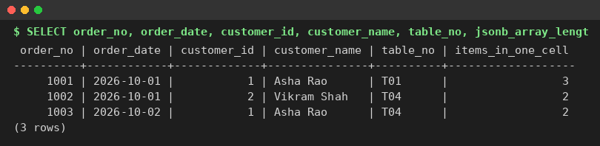
Figure 5.1 Unnormalised receipt: the dishes sit in one cell (repeating group)
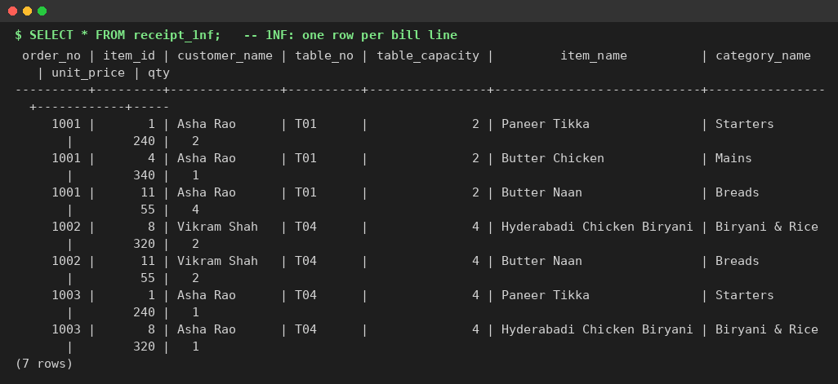
Figure 5.2 First normal form: atomic values, one row per bill line, key (order_no, item_id)
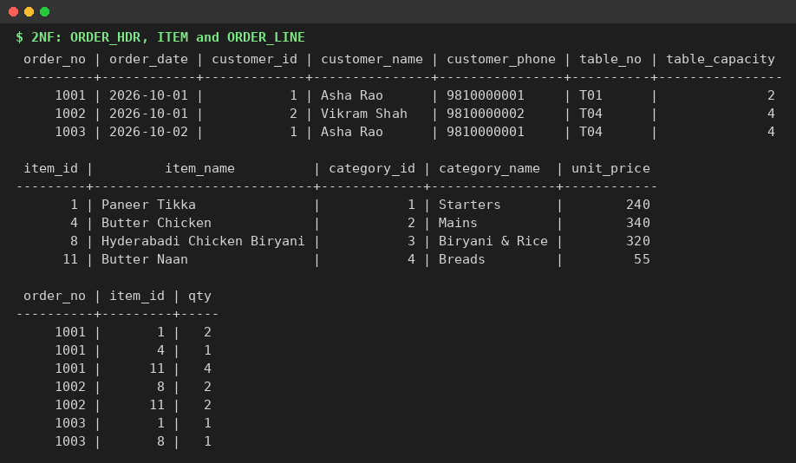
Figure 5.3 Second normal form: partial dependencies removed (order header, item, order line)
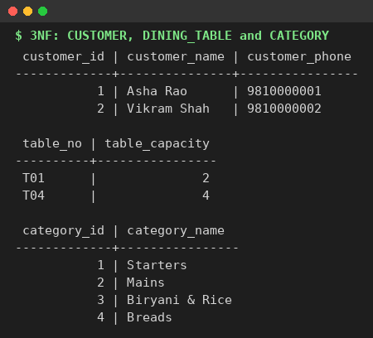
Figure 5.4 Third normal form: transitive dependencies removed (customer, dining table, category)
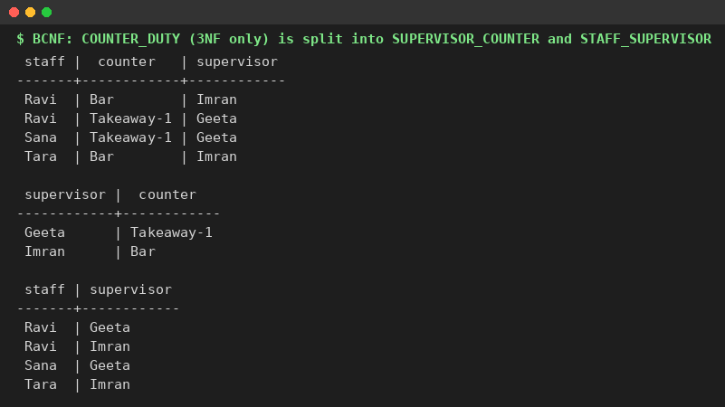
Figure 5.5 BCNF: a relation in 3NF that violates BCNF is decomposed
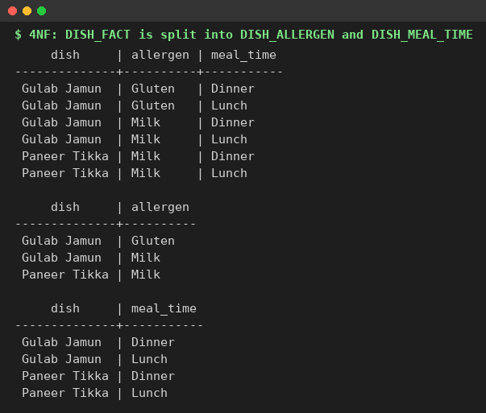
Figure 5.6 Fourth normal form: independent multivalued facts separated
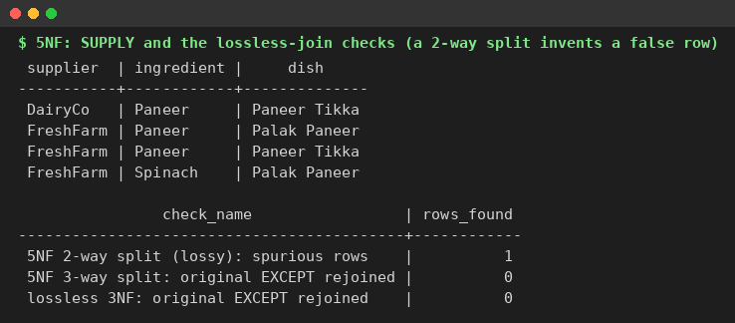
Figure 5.7 Fifth normal form: a join dependency needs a three-way split; the lossless-join checks return 0 rows

5.13 Relational Algebra Examples
Query | Relational algebra | SQL
Family tables with 4 or more seats | π table_no, capacity (σ capacity ≥ 4 ∧ area = Family (restaurant_tables)) | SELECT table_no, capacity FROM restaurant_tables WHERE capacity >= 4 AND area = 'Family'
Customers with a paid and a live order | π customer_id (σ status = Paid (orders)) ∩ π customer_id (σ status ∈ live (orders)) | SELECT customer_id FROM orders WHERE status = 'Paid' INTERSECT SELECT customer_id FROM orders WHERE status IN (live statuses)
Dishes never ordered | π item_id (menu_items) − π item_id (order_items) | SELECT item_id FROM menu_items EXCEPT SELECT item_id FROM order_items
Orders with table number | π order_id, table_no, status (ρ o (orders) ⋈ o.table_id = t.table_id ρ t (restaurant_tables)) | SELECT o.order_id, t.table_no, o.status FROM orders o JOIN restaurant_tables t USING (table_id)
Revenue per payment method on day d | method 𝒢 SUM(amount) (σ status = Success ∧ date(paid_at) = d (payments)) | SELECT method, SUM(amount) FROM payments WHERE status = 'Success' AND paid_at::date = d GROUP BY method
Orders in a kitchen state | σ status = Placed (orders) ∪ σ status = Preparing (orders) | SELECT * FROM orders WHERE status IN ('Placed','Preparing')
Customers who ordered every starter (division) | { c | c ∈ customers ∧ ∀m ∈ menu_items (m.category_id = 1 → ∃ order line of c for m) } | SELECT ... WHERE NOT EXISTS (starter m WHERE NOT EXISTS (order line of c for m))

5.14 Test Strategy
Testing was built in three layers so that every rule is checked where it lives. First, fn_run_tests() runs 65 checks inside the database; each check that expects an error also confirms the text of the error, so a test cannot pass for the wrong reason, and the whole function ends with a deliberate exception that undoes every change. Second, fn_run_security_tests() runs 23 checks while acting as the restricted database roles, using SET LOCAL ROLE. Third, a Node script sends 63 real HTTP checks to the running website (and a small unit test checks the session tokens), including two simultaneous requests for the last dish and for the same table. The complete lists of test cases are given in Section 6.

6. Results
The system was built and tested on PostgreSQL 16 and Node.js 22. The figures in this section are real outputs captured from the running system; the website screenshots must be inserted where marked.

6.1 Database Objects
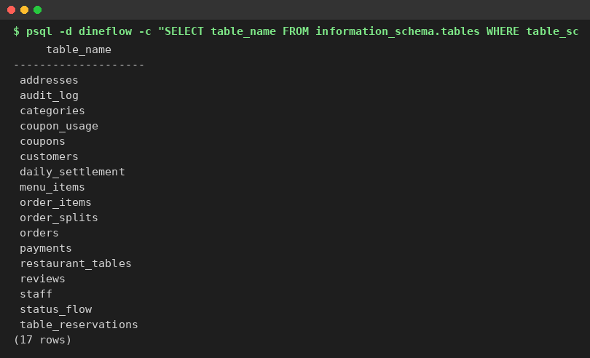
Figure 6.1 Tables created by 01_schema_er.sql (17 base tables)
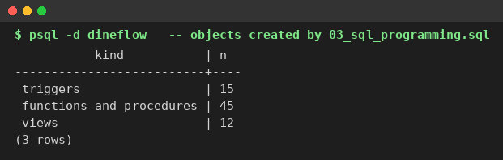
Figure 6.2 Triggers, functions, procedures and views created by 03_sql_programming.sql

6.2 Business Rules Enforced by the Database
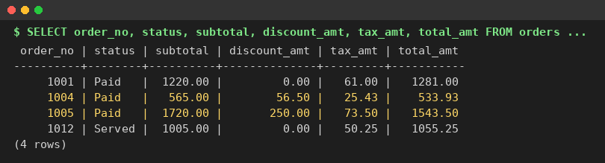
Figure 6.3 Totals computed by the trigger: order 1004 is 565.00 less 10% coupon (56.50) plus 5% GST (25.43) = 533.93
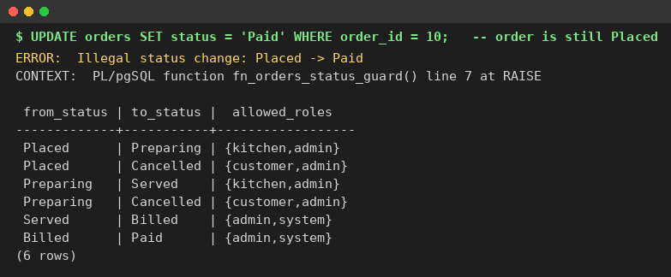
Figure 6.4 Illegal status change Placed to Paid rejected by the trigger, and the status_flow table
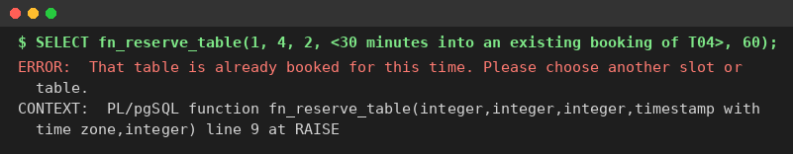
Figure 6.5 An overlapping reservation on table T04 rejected by the exclusion constraint
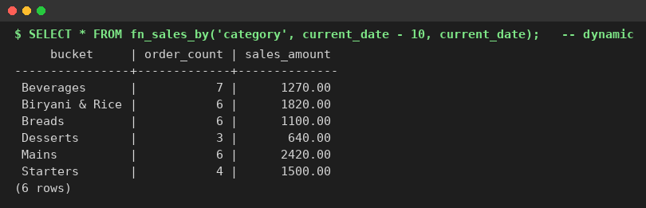
Figure 6.6 Dynamic SQL report fn_sales_by by category
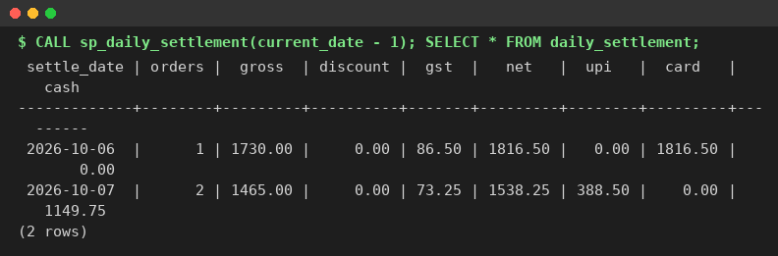
Figure 6.7 End-of-day settlement written by the explicit-cursor procedure

6.3 Web Application
[ Insert screenshot here ]
Capture: sign in as asha.rao@example.in, add 2 dishes, apply FLAT50 or FESTIVE15, show the Your order panel.
Figure 6.8 Menu and cart with coupon, payment choice and totals
[ Insert screenshot here ]
Capture: My orders after placing an order; open Details & rating.
Figure 6.9 My orders with the status tracker and order details
[ Insert screenshot here ]
Capture: Reserve a table, search tomorrow 20:00 for 4 guests, then try to book T04.
Figure 6.10 Table reservation page with free tables and the blocked overlapping booking message
[ Insert screenshot here ]
Capture: sign in as kitchen1@dineflow.in (Staff button) and open Kitchen display.
Figure 6.11 Kitchen display with delay colours
[ Insert screenshot here ]
Capture: sign in as admin@dineflow.in, open Orders and press Audit on one order.
Figure 6.12 Admin orders table with cash confirmation and audit trail
[ Insert screenshot here ]
Capture: Reports tab with the settlement table visible.
Figure 6.13 Admin reports: 7-day sales, top dishes and settlement
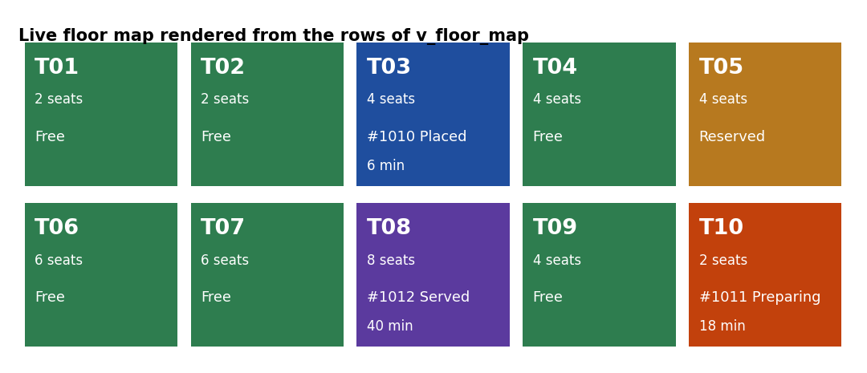
Figure 6.14 Live floor map rendered from the rows of v_floor_map (a screenshot of the Floor map tab can replace it)
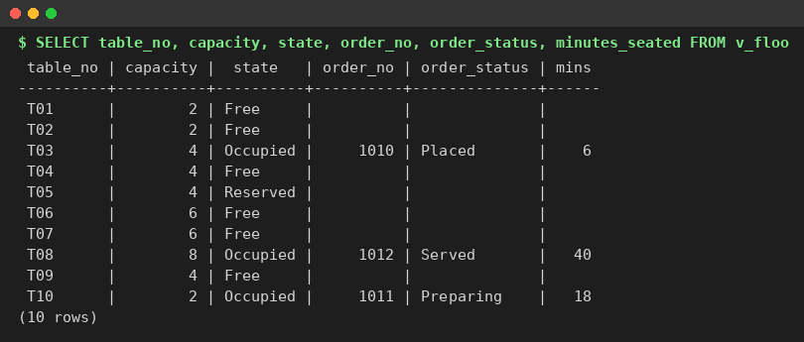
Figure 6.15 Output of the v_floor_map view used by the floor map screen

6.4 Automated Test Results
fn_run_tests() returns one row per check and undoes everything it changes. All 65 checks passed. fn_run_security_tests() runs 23 checks as the real restricted roles and all 23 passed. The API script server/test/api.test.js runs 63 end-to-end checks against the running website and all 63 passed. A separate unit test, server/test/auth.test.js, checks the session tokens (10 of 10 passed).
Test set | Checks | What it covers
Unit I | 4 | Seed data, CHECK constraints, dine-in rule
Unit II | 34 | Password hashing and login, totals and GST, status flow and roles, audit, reviews, low stock, reservations (notice, horizon, limit of 3, no double booking by one customer, no-show clean-up, tables per customer), admin menu (add category and dish, hide, role check), dynamic SQL and injection attempt, cursor settlement
Unit IV | 27 | place_order (merge, price snapshot, stock), atomicity, sold-out, stale price, failed card, four coupon rules, cancel side effects, prepaid and cash flows, split bills, reserved tables and automatic seating
Security | 23 | Row-level security, column privileges, kitchen and anonymous roles, add-dish privileges, SECURITY DEFINER functions
API | 63 | Sign-in and session length, role rejections, kitchen flow, reservations and their limits, admin menu management, floor map, injection attempt, two concurrency races

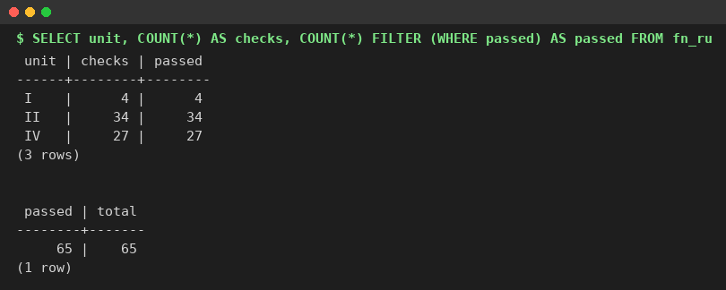
Figure 6.16 Database test results by unit: 65 of 65 checks passed
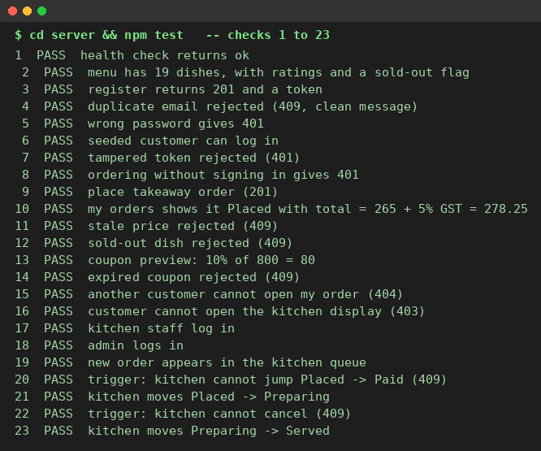
Figure 6.17 API test results (checks 1 to 23)
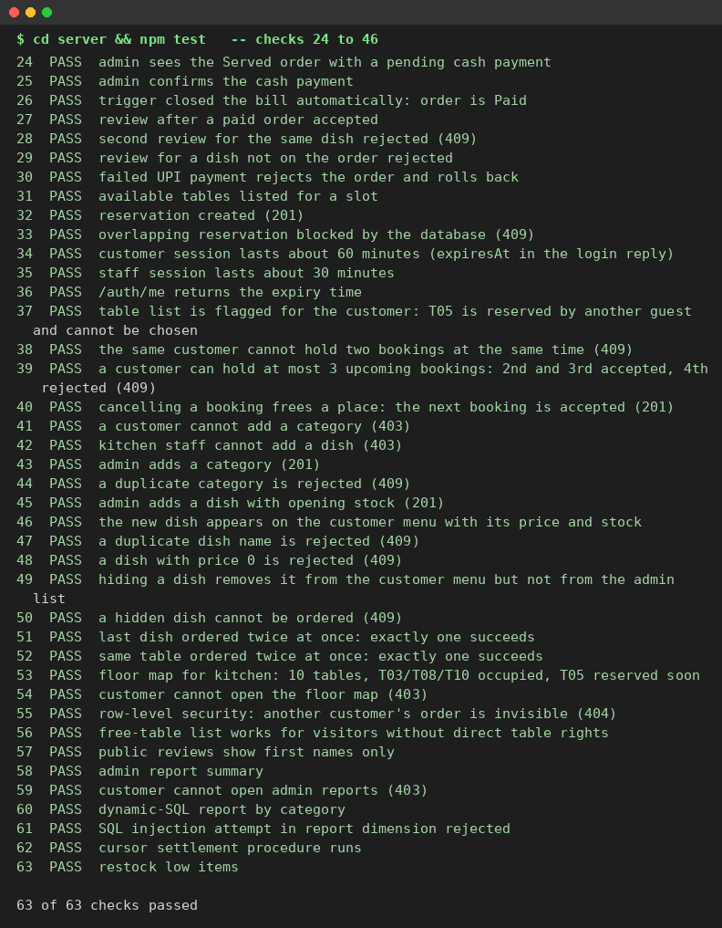
Figure 6.18 API test results (checks 24 to 63)

6.5 Concurrency Result
Two simultaneous HTTP requests for the last portion of a dish (Rasmalai, stock 1) from two different customers returned one success (201) and one rejection (409, "sold out"). Two simultaneous dine-in orders for table T02 also returned one 201 and one 409. Both appear in the API results above (checks 51 and 52). No table was double-booked, no dish was oversold and no deadlock occurred, because every order locks the table row first and the menu rows in item_id order.

6.6 Security Result
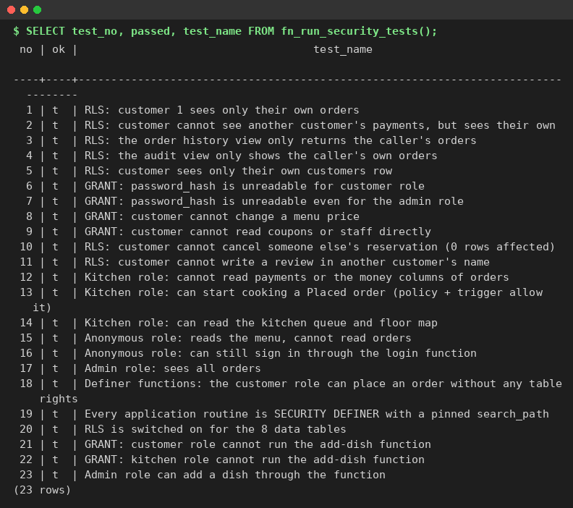
Figure 6.19 Security checks run as the restricted database roles: 23 of 23 passed
The checks show that a customer sees only their own orders, payments and audit trail; that password hashes are unreadable for every API role; that the kitchen role cannot read money columns; that a visitor can read the menu but not orders; and that the customer role can still place an order, only through a function.

6.7 Optimisation Result
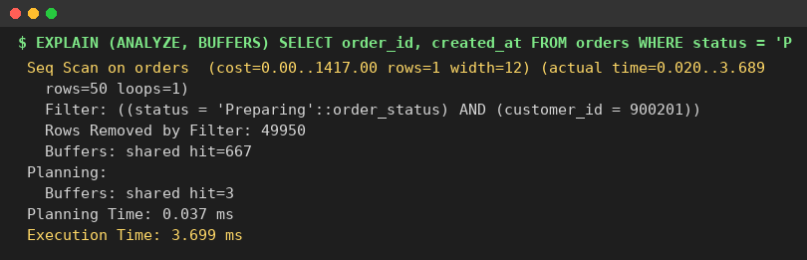
Figure 6.20 EXPLAIN ANALYZE before any index: sequential scan
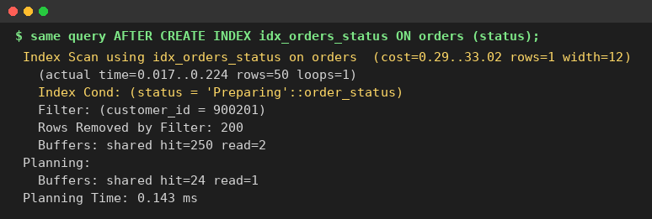
Figure 6.21 The same query after the index on status: index scan
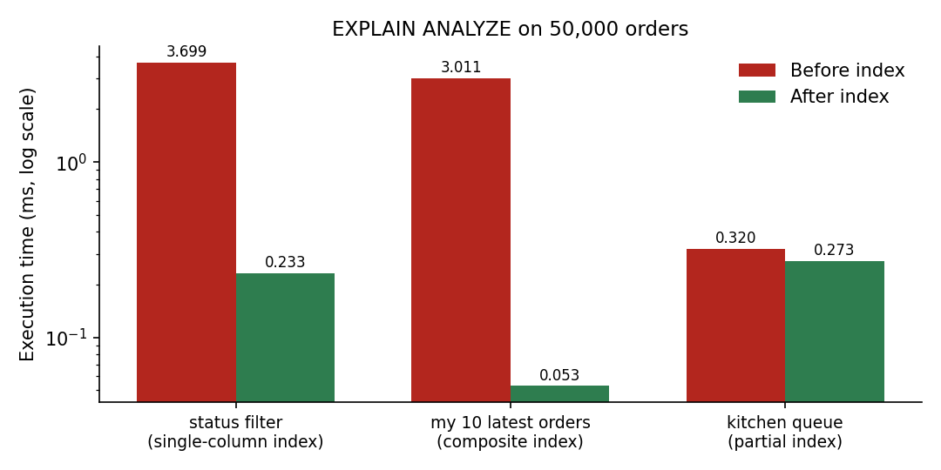
Figure 6.22 Execution time before and after each index on 50,000 orders (log scale)
Query | Before (ms) | After (ms) | Index used
Status filter for one customer | 3.699 | 0.233 | single-column B-tree (about 16 times faster)
My 10 latest orders | 3.011 | 0.053 | composite (customer_id, created_at DESC), about 57 times faster
Kitchen queue (live statuses) | 0.320 | 0.273 | partial index; small gain at this size, but the index is far smaller

For the three-table join the planner's own choice took 35.209 ms; forcing a nested loop took 20.688 ms, a merge join 18.714 ms and a hash join 34.920 ms. No method is always best; the result depends on data size and indexes. Timings come from one local PostgreSQL 16 server and will differ on other machines, but the change of plan type (sequential scan to index scan) is the stable result.

6.8 Backup and Recovery Result
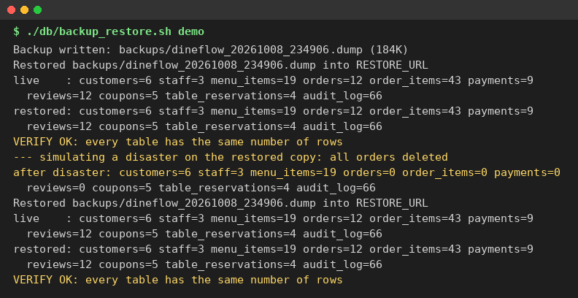
Figure 6.23 Backup, restore, simulated disaster (orders = 0), second restore and verification
After the simulated disaster the copy held 0 orders; the second restore brought back all 12 orders and every other table, and the row-count verification printed VERIFY OK.

6.9 Output of the Views
The views below were queried on the freshly seeded database. They are used directly by the kitchen display, the dish ratings on the menu and the admin reports.
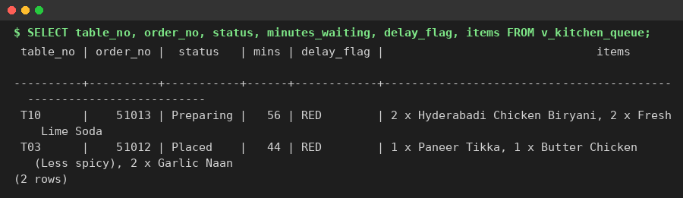
Figure 6.24 v_kitchen_queue: open tickets with waiting time and delay colour
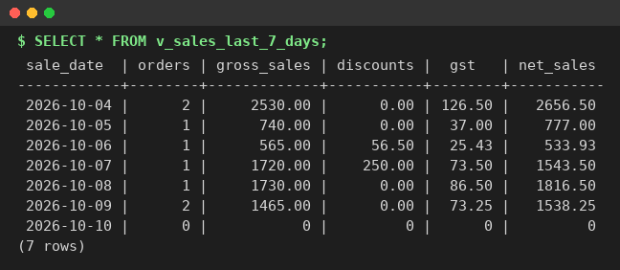
Figure 6.25 v_sales_last_7_days: daily sales for the last seven days (zero-filled)
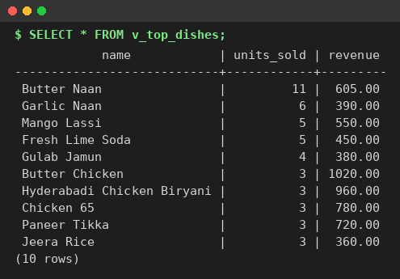
Figure 6.26 v_top_dishes: best-selling dishes by units
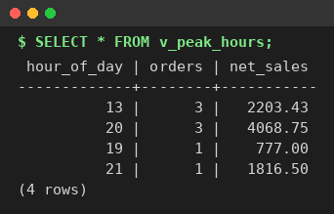
Figure 6.27 v_peak_hours: orders and sales by hour of day
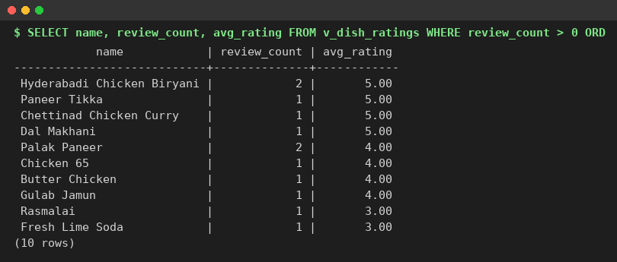
Figure 6.28 v_dish_ratings: average rating per dish
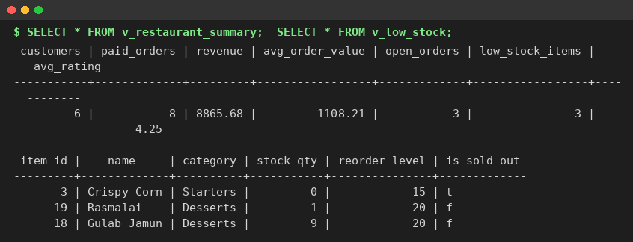
Figure 6.29 v_restaurant_summary and v_low_stock
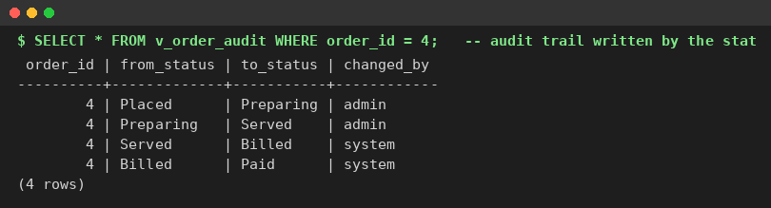
Figure 6.30 v_order_audit: the status-change history of order 4 written by the trigger
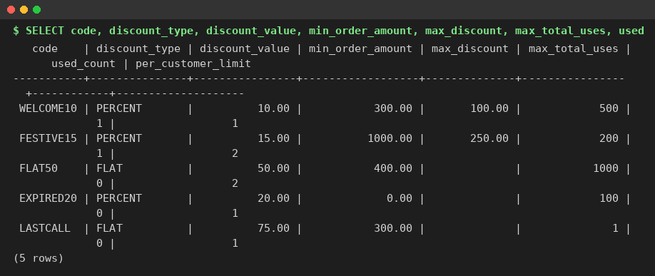
Figure 6.31 Coupons in the seed data: percentage, flat, expired and a single-use code

6.10 API Requests and Responses
The following exchanges were captured from the running API. They show the JSON used by the web pages and how the messages produced by the database reach the browser.
Listing 6.1 Customer sign-in
> POST /api/auth/login {"email":"asha.rao@example.in","password":"********"}
< HTTP 200
{
"token": "eyJpZCI6MSwicm9sZSI6ImN1...",
"user": {
"id": 1,
"role": "customer",
"name": "Asha Rao"
}
}

Listing 6.2 Menu (first 2 of 19 dishes)
> GET /api/menu
< HTTP 200
{
"items": [
{
"id": 2,
"name": "Chicken 65",
"description": "Spicy deep-fried chicken with curry leaves",
"price": 260,
"veg": false,
"soldOut": false,
"stock": 117,
"category": "Starters",
"order": 1,
"rating": 4,
"reviews": 1
},
{
"id": 3,
"name": "Crispy Corn",
"description": "Fried corn kernels tossed with pepper",
"price": 180,
"veg": true,
"soldOut": true,
"stock": 0,
"category": "Starters",
"order": 1,
"rating": null,
"reviews": 0
}
]
}

Listing 6.3 Place an order (one database transaction)
> POST /api/orders {"orderType":"Takeaway","items":[{"itemId":14,"qty":2,"price":50},{"item
Id":11,"qty":3}],"paymentMethod":"Cash"}
< HTTP 201
{
"orderId": 79
}

Listing 6.4 Order details
> GET /api/orders/79
< HTTP 200
{
"order": {
"order_no": 51095,
"status": "Placed",
"subtotal": 265,
"tax_amt": 13.25,
"total_amt": 278.25
},
"lines": [
{
"itemId": 11,
"name": "Butter Naan",
"quantity": 3,
"unitPrice": 55,
"lineTotal": 165,
"rating": null
},
{
"itemId": 14,
"name": "Masala Chai",
"quantity": 2,
"unitPrice": 50,
"lineTotal": 100,
"rating": null
}
],
"payments": [
{
"id": 67,
"method": "Cash",
"amount": 278.25,
"status": "Pending",
"paidAt": null
}
]
}

Listing 6.5 Stale price rejected by the database function
> POST /api/orders (price sent: 1)
< HTTP 409
{
"error": "The price of Masala Chai is now Rs 50.00. Please refresh the menu."
}

Listing 6.6 Illegal move rejected by the status-flow trigger
> POST /api/kitchen/orders/79/status {"status":"Paid"}
< HTTP 409
{
"error": "Illegal status change: Placed -> Paid"
}

Listing 6.7 Legal move accepted
> POST /api/kitchen/orders/79/status {"status":"Preparing"}
< HTTP 200
{
"status": "Preparing"
}

Listing 6.8 Live floor map (first 3 tables)
> GET /api/floor (kitchen token)
< HTTP 200
{
"tables": [
{
"id": 1,
"no": "T01",
"capacity": 2,
"area": "Window",
"state": "Free",
"orderNo": null,
"orderStatus": null,
"minutes": null,
"bookingStart": null,
"bookingParty": null
},
{
"id": 2,
"no": "T02",
"capacity": 2,
"area": "Indoor",
"state": "Free",
"orderNo": null,
"orderStatus": null,
"minutes": null,
"bookingStart": null,
"bookingParty": null
},
{
"id": 3,
"no": "T03",
"capacity": 4,
"area": "Indoor",
"state": "Occupied",
"orderNo": 51012,
"orderStatus": "Placed",
"minutes": 961,
"bookingStart": null,
"bookingParty": null
}
]
}

Listing 6.9 Row-level security: another customer's order is invisible
> GET /api/orders/2 (Asha asks for order 2, which belongs to Vikram)
< HTTP 404
{
"error": "Order not found"
}

Listing 6.10 Role check: a customer cannot open admin reports
> GET /api/admin/reports/summary (customer token)
< HTTP 403
{
"error": "You are not allowed to do this"
}

6.11 Complete List of Test Cases
Table 6.1 lists the 65 database checks, Table 6.2 the 23 security checks and Table 6.3 the 63 API checks. All of them passed.
Table 6.1 Database checks, fn_run_tests()
No | Unit | Test case | Result
1 | I | Seed data: 10 tables, 19 dishes, 6 customers, 12 orders | PASS
2 | I | CHECK: dish price must be above 0 | PASS
3 | I | CHECK: stock can never go below 0 | PASS
4 | I | Dine-in order without a table rejected (ck_order_table) | PASS
5 | II | Password stored as bcrypt hash, not plain text | PASS
6 | II | Login: correct password returns the customer | PASS
7 | II | Login: wrong password returns nothing | PASS
8 | II | Registration: duplicate email rejected with a clean message | PASS
9 | II | Rule 1: order 4 total = 565 - 10% coupon + 5% GST = 533.93 | PASS
10 | II | Rule 1: every order satisfies total = subtotal - discount + tax | PASS
11 | II | Rule 2: illegal move Placed -> Paid rejected by trigger | PASS
12 | II | Rule 2: a customer cannot start cooking (role check) | PASS
13 | II | Rule 2: a different customer cannot cancel someone else's order | PASS
14 | II | Rule 2: kitchen moves Placed -> Preparing and the audit log records it | PASS
15 | II | Rule 2: kitchen cannot cancel (only customer/admin may) | PASS
16 | II | Rule 4: review for an unpaid order rejected | PASS
17 | II | Rule 4: review for a dish that is not on that order rejected (FK) | PASS
18 | II | Rule 4: review for a paid order accepted | PASS
19 | II | View: v_dish_ratings gives Paneer Tikka an average of 5.00 | PASS
20 | II | Feature D: v_low_stock lists Rasmalai; Crispy Corn is auto-marked sold out | PASS
21 | II | Feature D: restocking clears the sold-out flag | PASS
22 | II | Feature B: fn_reserve_table rejects an overlapping booking | PASS
23 | II | Feature B: a non-overlapping slot on the same table is accepted | PASS
24 | II | Feature B: party larger than the table rejected | PASS
25 | II | Dynamic SQL: fn_sales_by rejects an unknown (injected) dimension | PASS
26 | II | Dynamic SQL: fn_sales_by('category') returns 6 categories | PASS
27 | II | Rule 6: cursor procedure sp_daily_settlement totals yesterday at 1538.25 | PASS
28 | IV | place_order succeeds on a free table and the order is Placed | PASS
29 | IV | place_order merges duplicate dishes (2 lines, Paneer qty 3) and snapshots price | PASS
30 | IV | place_order reduced stock by exactly 3 | PASS
31 | IV | Totals: 3 x 240 + 50 = 770, GST 38.50, total 808.50 | PASS
32 | IV | Cash payment created as Pending for the full total | PASS
33 | IV | Same table twice: second order rejected (one live order per table) | PASS
34 | IV | Direct INSERT on a busy table is blocked by the unique index | PASS
35 | IV | Atomicity: order above stock rejected, nothing left behind | PASS
36 | IV | Atomicity: failed order left Paneer stock, Gulab stock and table T02 untouched | PASS
37 | IV | Sold-out dish (Crispy Corn at 0) cannot be ordered | PASS
38 | IV | Stale client price rejected | PASS
39 | IV | Failed payment (card 0000) rolls the whole order back | PASS
40 | IV | Coupon WELCOME10 applied: discount > 0, counter +1, usage row written | PASS
41 | IV | Coupon per-customer limit: second use by the same customer rejected | PASS
42 | IV | Coupon expiry: EXPIRED20 rejected | PASS
43 | IV | Coupon minimum order: FLAT50 on a Rs 50 order rejected | PASS
44 | IV | Coupon total-use limit: LASTCALL works once, then is fully redeemed | PASS
45 | IV | Cancel: stock returned, coupon released, payment refunded | PASS
46 | IV | Cancel after Served is refused | PASS
47 | IV | Prepaid UPI order auto-closes to Paid once the kitchen marks it Served | PASS
48 | IV | Cash order: Paid only after an admin confirms the pending payment | PASS
49 | IV | Payment above the amount due rejected | PASS
50 | IV | Marking Paid without payments is rejected | PASS
51 | IV | Feature E: split in 3 shares sum to the bill; paying all shares closes the order | PASS
52 | IV | Feature E: shares that do not add up to the bill are rejected | PASS
53 | II | Reservation: a booking starting in less than 10 minutes is rejected | PASS
54 | II | Reservation: a booking more than 30 days ahead is rejected | PASS
55 | II | Reservation: one customer cannot hold two bookings at the same time | PASS
56 | II | Reservation: at most 3 upcoming bookings per customer | PASS
57 | II | Reservation: fn_expire_reservations marks an old Booked row as No-show | PASS
58 | II | Reservation: fn_tables_for_customer shows T09 as "mine" for the owner and "reserved" for others | PASS
59 | IV | Reservation: another guest cannot order on a table reserved within 90 minutes | PASS
60 | IV | Reservation: the owner's order seats the booking automatically and links it to the order | PASS
61 | II | Admin menu: fn_add_category adds a category and rejects a duplicate | PASS
62 | II | Admin menu: fn_add_menu_item adds a dish; duplicate name, price 0 and unknown category are rejected | PASS
63 | II | Admin menu: a dish added with opening stock 0 is marked sold out | PASS
64 | II | Admin menu: a hidden dish (fn_set_item_active) can no longer be ordered | PASS
65 | II | Admin menu: the customer role cannot add a dish (role check inside the function) | PASS

Table 6.2 Security checks, fn_run_security_tests()
No | Test case | Result
1 | RLS: customer 1 sees only their own orders | PASS
2 | RLS: customer cannot see another customer's payments, but sees their own | PASS
3 | RLS: the order history view only returns the caller's orders | PASS
4 | RLS: the audit view only shows the caller's own orders | PASS
5 | RLS: customer sees only their own customers row | PASS
6 | GRANT: password_hash is unreadable for customer role | PASS
7 | GRANT: password_hash is unreadable even for the admin role | PASS
8 | GRANT: customer cannot change a menu price | PASS
9 | GRANT: customer cannot read coupons or staff directly | PASS
10 | RLS: customer cannot cancel someone else's reservation (0 rows affected) | PASS
11 | RLS: customer cannot write a review in another customer's name | PASS
12 | Kitchen role: cannot read payments or the money columns of orders | PASS
13 | Kitchen role: can start cooking a Placed order (policy + trigger allow it) | PASS
14 | Kitchen role: can read the kitchen queue and floor map | PASS
15 | Anonymous role: reads the menu, cannot read orders | PASS
16 | Anonymous role: can still sign in through the login function | PASS
17 | Admin role: sees all orders | PASS
18 | Definer functions: the customer role can place an order without any table rights | PASS
19 | Every application routine is SECURITY DEFINER with a pinned search_path | PASS
20 | RLS is switched on for the 8 data tables | PASS
21 | GRANT: customer role cannot run the add-dish function | PASS
22 | GRANT: kitchen role cannot run the add-dish function | PASS
23 | Admin role can add a dish through the function | PASS

Table 6.3 End-to-end API checks, server/test/api.test.js
No | Test case | Result
1 | health check returns ok | PASS
2 | menu has 19 dishes, with ratings and a sold-out flag | PASS
3 | register returns 201 and a token | PASS
4 | duplicate email rejected (409, clean message) | PASS
5 | wrong password gives 401 | PASS
6 | seeded customer can log in | PASS
7 | tampered token rejected (401) | PASS
8 | ordering without signing in gives 401 | PASS
9 | place takeaway order (201) | PASS
10 | my orders shows it Placed with total = 265 + 5% GST = 278.25 | PASS
11 | stale price rejected (409) | PASS
12 | sold-out dish rejected (409) | PASS
13 | coupon preview: 10% of 800 = 80 | PASS
14 | expired coupon rejected (409) | PASS
15 | another customer cannot open my order (404) | PASS
16 | customer cannot open the kitchen display (403) | PASS
17 | kitchen staff log in | PASS
18 | admin logs in | PASS
19 | new order appears in the kitchen queue | PASS
20 | trigger: kitchen cannot jump Placed -> Paid (409) | PASS
21 | kitchen moves Placed -> Preparing | PASS
22 | trigger: kitchen cannot cancel (409) | PASS
23 | kitchen moves Preparing -> Served | PASS
24 | admin sees the Served order with a pending cash payment | PASS
25 | admin confirms the cash payment | PASS
26 | trigger closed the bill automatically: order is Paid | PASS
27 | review after a paid order accepted | PASS
28 | second review for the same dish rejected (409) | PASS
29 | review for a dish not on the order rejected | PASS
30 | failed UPI payment rejects the order and rolls back | PASS
31 | available tables listed for a slot | PASS
32 | reservation created (201) | PASS
33 | overlapping reservation blocked by the database (409) | PASS
34 | customer session lasts about 60 minutes (expiresAt in the login reply) | PASS
35 | staff session lasts about 30 minutes | PASS
36 | /auth/me returns the expiry time | PASS
37 | table list is flagged for the customer: T05 is reserved by another guest and cannot be chosen | PASS
38 | the same customer cannot hold two bookings at the same time (409) | PASS
39 | a customer can hold at most 3 upcoming bookings: 2nd and 3rd accepted, 4th rejected (409) | PASS
40 | cancelling a booking frees a place: the next booking is accepted (201) | PASS
41 | a customer cannot add a category (403) | PASS
42 | kitchen staff cannot add a dish (403) | PASS
43 | admin adds a category (201) | PASS
44 | a duplicate category is rejected (409) | PASS
45 | admin adds a dish with opening stock (201) | PASS
46 | the new dish appears on the customer menu with its price and stock | PASS
47 | a duplicate dish name is rejected (409) | PASS
48 | a dish with price 0 is rejected (409) | PASS
49 | hiding a dish removes it from the customer menu but not from the admin list | PASS
50 | a hidden dish cannot be ordered (409) | PASS
51 | last dish ordered twice at once: exactly one succeeds | PASS
52 | same table ordered twice at once: exactly one succeeds | PASS
53 | floor map for kitchen: 10 tables, T03/T08/T10 occupied, T05 reserved soon | PASS
54 | customer cannot open the floor map (403) | PASS
55 | row-level security: another customer's order is invisible (404) | PASS
56 | free-table list works for visitors without direct table rights | PASS
57 | public reviews show first names only | PASS
58 | admin report summary | PASS
59 | customer cannot open admin reports (403) | PASS
60 | dynamic-SQL report by category | PASS
61 | SQL injection attempt in report dimension rejected | PASS
62 | cursor settlement procedure runs | PASS
63 | restock low items | PASS

6.12 Business Rule Scenarios
Rule | Scenario | Observed result
Coupon validity | EXPIRED20 used after its end date | Rejected: coupon has expired
Coupon minimum | FLAT50 on a Rs 50 order (minimum Rs 400) | Rejected: minimum order needed
Coupon per customer | WELCOME10 used twice by one customer | Second use rejected
Coupon total uses | LASTCALL (one use) used by a second customer | Rejected: fully redeemed
Coupon maths | WELCOME10 on 2 biryani (Rs 640) | Discount Rs 64.00 (10% below the Rs 100 cap)
Stock | Order above stock (20 Gulab Jamun, 9 left) | Rejected; no order, stock or table change left behind
Sold out | Crispy Corn at stock 0 | Rejected: sold out; restocking clears the flag
Stale price | Client sends an old price | Rejected with the current price
Payment failure | Card ending 0000 or UPI id starting with fail | Whole order rolled back
Payment above bill | A payment larger than the amount due | Rejected by trigger
Closing the bill | Prepaid UPI order marked Served | Becomes Billed then Paid automatically
Cash | Cash order marked Served | Stays Served until the admin confirms the payment
Split bill | Shares that do not add up to the total | Rejected at commit by the deferred trigger
Cancel | Customer cancels a Preparing order | Stock, coupon use and payment are all reversed
Cancel after serving | Cancel a Served order | Rejected: illegal status change
Reservation overlap | Booking 30 minutes into an existing booking of T04 | Rejected by the exclusion constraint
Party size | Party of 5 at a 2-seat table | Rejected: does not fit
Reservation notice | Booking that starts in 2 minutes, or 40 days ahead | Rejected: at least 10 minutes and at most 30 days
Reservation limit | A fourth upcoming booking by one customer | Rejected: 3 upcoming reservations; cancelling one frees a place
Own double booking | Two tables at the same time for one customer | Rejected: already have a booking at that time
Reserved table | Another guest orders on a table reserved within 90 minutes | Rejected; the table is greyed out in the table list
Automatic seating | The owner of a usable booking orders on that table | The booking becomes Seated and is linked to the order
Clean-up | A Booked reservation 15 minutes past its end | Becomes No-show (Completed once its order is paid or cancelled)
Add a dish | Admin adds a dish; same name again; price 0; unknown category | Added once; the other three are rejected with a clear message
Hide a dish | Admin hides a dish | Disappears from the menu and can no longer be ordered
Session | Customer 60 minutes, staff 30 minutes, 15 idle minutes in the browser | Token refused after expiry; the page signs out and shows the time left
Review | Review on an unpaid order, or for a dish not on the order | Rejected by trigger and by the composite foreign key

6.13 User Guide
Customer. Open the website and press Sign in or register. On the Menu page add dishes with the plus button; sold-out dishes cannot be added. In the Your order panel choose Dine-in with a free table or Takeaway, type a coupon code and press Apply to see the discount, choose Cash, UPI or Card and press Place order. Under My orders the status tracker moves from Placed to Paid; use Details and rating to see lines, payments and history, Cancel before the dish is served, Pay now or Split bill to pay, and Rate for each dish of a paid order. The Reserve a table page lists free tables for a date, time and party size and lets the customer book or cancel; a customer may hold three upcoming bookings, a booking must start at least 10 minutes ahead and at most 30 days ahead, and two bookings at the same time are refused. When the guest arrives, the Menu page offers the reserved table as "your reservation" and tables reserved by other guests are greyed out. The top bar shows the minutes left in the session (60 for customers); the page signs out after 15 idle minutes.
Kitchen. Press Staff and sign in with a kitchen account. The Kitchen display shows new and cooking orders with a green, amber or red edge according to waiting time; press Start cooking, then Mark served. The Floor map shows every table as free, reserved within the hour, or occupied with the order status.
Administrator. Sign in with an admin account. Orders lists all orders with a status filter, buttons for the next legal status, Confirm for pending cash payments and Audit for the history. Stock and prices has an Add a new dish form (name, category, price, veg or non-veg, opening stock, description) and an Add category box, shows low-stock dishes with a restock box, a button that tops all low items up to 50, and editable prices with a Hide or Show button for every dish (hidden dishes disappear from the customer menu but keep their order history). The session of staff lasts 30 minutes. Reports shows revenue, the last seven days, top dishes, peak hours, a sales breakdown by category, day, hour or type, and the end-of-day settlement, which can be run for any date.

6.14 Discussion
Putting the rules in the database means a bug in the web layer cannot break them: the API tests confirm that the messages produced by triggers reach the browser unchanged. Row-level security adds a second wall, because even a faulty query cannot return another customer's rows. Testing found real mistakes during development, for example a route guard that accidentally blocked staff routes, and a restore problem caused by pg_restore options, both fixed before delivery. The benchmark data is generated and evenly spread, so real gains for common statuses would be smaller.

7. Conclusion
DineFlow shows how the main ideas of a database course work together in one working application. A normalised, constrained schema removes redundancy. Triggers, functions and procedures enforce business rules. A single locked transaction keeps tables, stock and money correct and avoids deadlock. An exclusion constraint makes double booking impossible. Indexes are justified with execution plans. Least-privilege roles and row-level security protect personal data, and a tested backup procedure protects against loss. All 65 database checks, 23 security checks and 63 API checks pass, and the system runs as a public website.

7.1 Limitations
- Payments are simulated; there is no real payment gateway.
- There is no e-mail or SMS notification, and the kitchen screens poll every five seconds instead of receiving live pushes.
- Roles are limited to customer, kitchen and admin; there is no password reset or e-mail verification.
- Sessions have an absolute limit enforced by the server, while the idle sign-out is done by the browser; there is no sliding refresh token and no limit on simultaneous sessions.
- The benchmark uses generated data on one machine; the website screenshots must be captured by the student.

7.2 Future Scope
- Real payment gateway in test mode and e-mail receipts.
- Live updates with Server-Sent Events or WebSockets, and QR codes that open the menu for a given table.
- Recipe-level inventory with suppliers and purchase orders, and loyalty points through triggers.
- Table partitioning for the audit log and orders, and full-text search on the menu.

7.3 Lessons Learned
- Rules written once in the database apply to every client; the API tests showed that messages from triggers reach the browser unchanged, so the web layer needed almost no rule code.
- Declarative constraints (exclusion constraint, partial unique index, CHECK) are more reliable than checks in code, because they also hold under concurrent access.
- A fixed lock order is a simple and complete answer to deadlock in an order-entry transaction.
- Least privilege has a cost: after switching the API to restricted roles, every function and view needed an explicit grant. The 23 security checks and 63 API checks made this change safe.
- Testing at three levels found real mistakes early: a route guard that blocked staff routes, a restore option that failed on an empty database, and unclear test messages.
- Measured plans are better than guesses: the partial index gave almost no gain on 50,000 rows, while the composite index made the customer history query many times faster.

8. References
- A. Silberschatz, H. Korth and S. Sudarshan, Database System Concepts, McGraw-Hill.
- R. Elmasri and S. Navathe, Fundamentals of Database Systems, Pearson.
- PostgreSQL Global Development Group, PostgreSQL Documentation: PL/pgSQL, triggers, explicit locking, exclusion constraints, row security policies, EXPLAIN, pgcrypto. https://www.postgresql.org/docs/
- Express.js documentation. https://expressjs.com
- node-postgres (pg) documentation. https://node-postgres.com
- MongoDB Manual: aggregation pipeline and indexes. https://www.mongodb.com/docs/manual/
- Supabase documentation: database, backups and connection strings. https://supabase.com/docs
- Render documentation: web services and environment variables. https://render.com/docs
- OWASP, SQL Injection Prevention Cheat Sheet. https://cheatsheetseries.owasp.org
- E. F. Codd, A relational model of data for large shared data banks, Communications of the ACM, vol. 13, no. 6, 1970.
- P. P. Chen, The entity-relationship model: toward a unified view of data, ACM Transactions on Database Systems, vol. 1, no. 1, 1976.
- R. Fagin, Multivalued dependencies and a new normal form for relational databases, ACM Transactions on Database Systems, vol. 2, no. 3, 1977.
- J. Gray and A. Reuter, Transaction Processing: Concepts and Techniques, Morgan Kaufmann, 1993.
- PostgreSQL Documentation: Backup and Restore (pg_dump and pg_restore). https://www.postgresql.org/docs/current/backup.html
- H. Krawczyk, M. Bellare and R. Canetti, HMAC: Keyed-Hashing for Message Authentication, RFC 2104, IETF, 1997.
- OWASP Foundation, OWASP Top 10 Web Application Security Risks. https://owasp.org/www-project-top-ten/
- Node.js documentation: crypto module. https://nodejs.org/docs/latest/api/crypto.html
- MDN Web Docs: Fetch API. https://developer.mozilla.org/docs/Web/API/Fetch_API
- Graphviz documentation. https://graphviz.org/documentation/

