
CSA15 Cloud Computing and Big Data Analytics
CO1 AT2 - Digital Concept Map and Service Model Matrix
Individual Student Submission Template

Student and Faculty Details
Student Name | Kishore K | Register Number | 192321157
Class / Section |  | Slot | C
Course Code | CSA1517 | Course Title | Cloud Computing and Big Data Analytics
Capstone Title | FinCoach Cloud Student Finance Advisor With Behavioral Budget Analytics
Submission Date
Faculty Name | Dr. Rajesh Babu | Employee ID
Department

Assessment Brief
Course Outcome | CO1 - Explain the evolution, architecture, characteristics, service models, and emerging paradigms of cloud computing.
Assessment Type | Individual concept mapping, service-model responsibility analysis, and capstone-cloud interpretation.
Assessment Focus | Each map must show key nodes, link labels, relationship meaning, and a logical hierarchy. The response must connect cloud fundamentals to the student's own perception of the capstone title.
Submission Mode | Editable DOCX + exported diagram evidence + GitHub repository link submitted in Google Classroom.
Permitted Tools | draw.io / diagrams.net, Lucidchart, Miro, Canva, PowerPoint, Google Drawings, or equivalent diagramming tool.
Individual Rule | Every student must submit their own concept map, matrix, capstone-cloud mapping, and reflection. The capstone title may be shared by a team, but the assessment answer must not be common.
Total Marks | 100 marks

Code of Conduct and Student Assurance
Academic Integrity Statement
This assessment must be completed individually. Students may discuss the capstone domain with their team, but the concept map, service model matrix, explanations, GitHub evidence, and reflection submitted here must be individually prepared.
Student Assurance | I confirm that this submission represents my own understanding of CO1 concepts and my individual interpretation of the selected capstone title.
Tool Use | I have used digital tools only for diagram preparation, organization, and presentation. I have not copied another student's diagram, matrix, or explanation.
Evidence | I have uploaded the required files to my GitHub repository and submitted the repository link / evidence link through Google Classroom.
Student Signature
Date

Procedure for Preparing the Digital Concept Map
Use the following procedure to prepare the diagram and upload evidence. Students who already know another diagramming tool may use it, but the exported evidence and source file must still be submitted.
- Open https://app.diagrams.net/ or the desktop version of draw.io / diagrams.net.
- Choose Device, Google Drive, or OneDrive as the save location according to availability.
- Create a blank diagram and name the file as CSA15_CO1_AT2_RegisterNumber_Concept_Map.drawio.
- Place the capstone title at the center or as a clearly visible anchor node.
- Add major cloud nodes: cloud definition, cloud evolution, cloud architecture, service models, deployment models, virtualization, web services, SOAP, REST, APIs, elasticity, scalability, resource pooling, measured service, and emerging paradigms.
- Connect nodes with labeled arrows such as uses, depends on, enables, scales through, communicates through, belongs to, supports, provides, consumes, or controls.
- Use colors meaningfully: one color for service models, one for cloud characteristics, one for API/web-service concepts, and one for capstone-specific elements.
- Export the final diagram as PNG or PDF. Keep the editable .drawio source file also.
- Paste the exported diagram image or screenshot in this DOCX under Task 1.
- Upload the DOCX, exported PNG/PDF, and .drawio file to GitHub, then submit the GitHub link in Google Classroom.

GitHub Submission Procedure
Step | Required Action | Expected Evidence
1 | Create or use your individual GitHub account. | GitHub profile link.
2 | Create a repository named CSA15-CO-Assessments-RegisterNumber or use the repository instructed by faculty. | Repository URL.
3 | Create a folder named CO1_AT2 inside the repository. | Folder visible in repository.
4 | Upload this completed DOCX, exported diagram PNG/PDF, and editable .drawio source file. | At least three evidence files uploaded.
5 | Add a short README.md explaining the capstone title and files submitted. | README visible in the AT2 folder.
6 | Submit the GitHub folder link in Google Classroom. | GCR submission with repository/folder link.

Assessment Questions and Student Response Sections
Important
The capstone project may be developed by a team, but every response below must be written from the individual student's own perspective. Do not submit a common team answer.

Task 1 - Digital Cloud Concept Map
Create one integrated digital concept map for CO1. The map must show key nodes, link labels, relationship meaning, and a logical hierarchy. It must also connect the concepts to your selected capstone title from your individual perspective.
Mandatory Concept Group | Minimum Concepts / Nodes to Include
Cloud Fundamentals | Definition, characteristics, benefits, limitations, on-demand access, measured service.
Cloud Evolution and Drivers | Hardware evolution, internet software evolution, distributed systems, cost economics, mobility, remote access, big data growth.
Architecture and Deployment | Front-end, back-end, network layer, data center, management software, public/private/hybrid/community cloud.
Service Models and Responsibility | IaaS, PaaS, SaaS, XaaS, provider responsibility, user responsibility, shared responsibility.
Virtualization and Web/API Layer | Virtual machine, hypervisor, abstraction, resource pooling, multi-tenancy, web services, SOAP, REST, API request/response.
Capstone Connection | Your capstone users, app/module, cloud backend, database/storage, dashboard/analytics, scalability and elasticity idea.
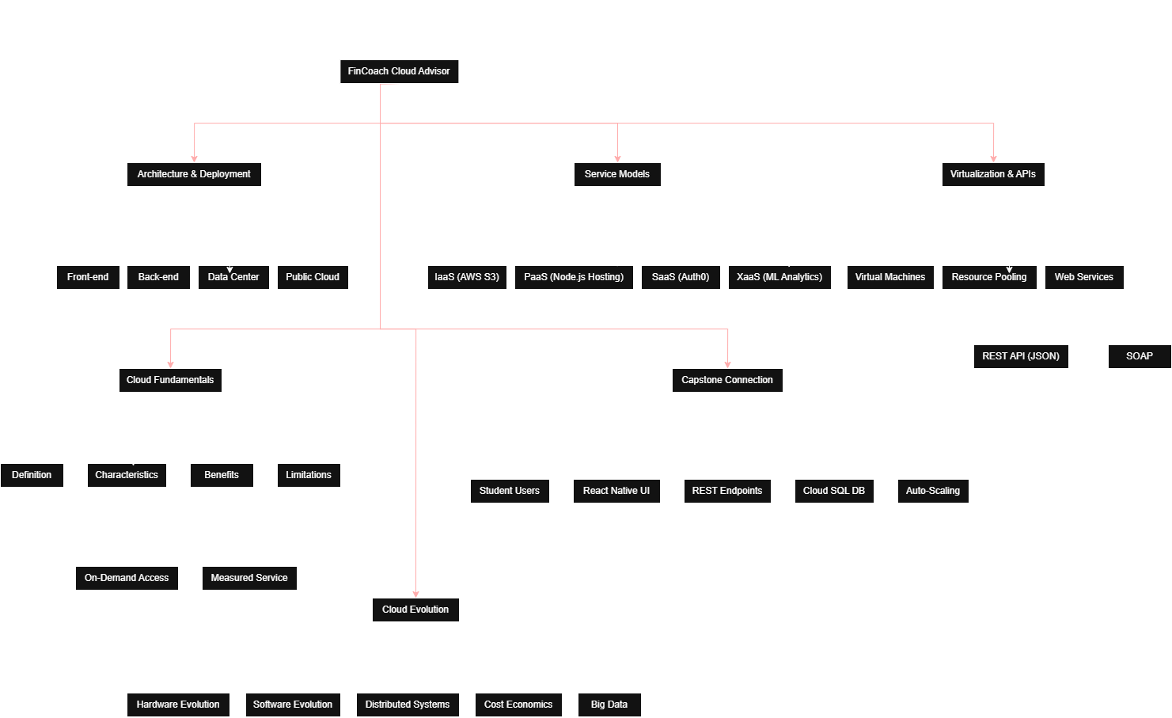
Paste exported concept map image / screenshot here. Resize neatly within this white space.

Brief explanation of your concept map: explain the most important nodes, link labels, hierarchy, and capstone connection.
The concept map centers on FinCoach Cloud Student Finance Advisor with Behavioral Budget Analytics. It connects cloud fundamentals, deployment and service models, virtualization, REST APIs, databases, analytics and scalability. Link labels such as 'uses', 'stores', 'analyzes', and 'scales through' show relationships. The hierarchy starts from cloud concepts and ends with budget analytics, user dashboard and cloud backend.

Task 2 - Service Model Matrix
Complete the matrices by making technical decisions for your capstone project. Select only the rows that are relevant to your capstone design. If a row is not used, write a short technical reason instead of leaving it blank.
Your answer should show how responsibility shifts between cloud provider and student development team, and how the chosen services support the capstone workflow, API design, storage, security, scalability, and evidence submission.

Task 2A - Service Model Responsibility Matrix
Service Model | Capstone Role / Module | Provider Responsibility | Student Responsibility | Evidence to Submit
IaaS | Virtual machines, networking | Infrastructure, VMs, storage | Deploy backend & configure | GitHub screenshots
PaaS | Backend APIs, hosting | Runtime, autoscaling | Develop app & APIs | Source code
SaaS | Firebase/Auth | Availability | Configure users | Console
XaaS / Specialized Service | AI analytics API | Managed service | Integrate behavior analytics | API demo

Task 2B - Capstone Cloud Service Decision Matrix
Cloud Layer / Function | Selected Tool or Service | Data / Resource Handled | API or Integration Path | Security / Scaling Note
Client access and UI | Flutter Web/Mobile | UI | REST API | HTTPS
API / backend logic | Spring Boot | Finance data | REST | Auto-scale
Authentication and identity | Firebase Auth | Users | SDK | JWT
Database / structured records | Cloud Firestore | Transactions | Firestore API | Rules
File / object storage | Firebase Storage | Reports | Storage API | Encrypted
Monitoring / logs / usage metrics | Cloud Logging | Logs | Cloud | Monitoring
Analytics / reporting output | Looker Studio | Analytics | Connector | Read only
Technical justification: Explain why the selected cloud service pattern fits your capstone project's users, data, API flow, scalability, and security needs.
This architecture provides secure authentication, scalable APIs, managed database services and analytics suitable for student budgeting.

Task 3 - Capstone Cloud Flow Mapping
Study the sample architecture-flow template below. Redraw it in draw.io / diagrams.net using your own capstone architecture. Replace every generic label with your actual user role, screen, API endpoint, backend logic, cloud storage, analytics output, security control, and scalability or elasticity decision.
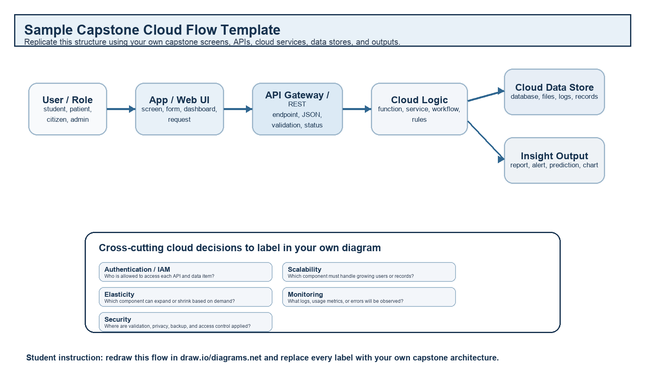
Student Drawing Requirement
Do not copy the sample as it is. Use it as a layout model, then create your own capstone-specific flow diagram with meaningful labels, arrows, data movement, API names, and cloud service choices.
Flow Component | Student Entry
User role and action | Student logs expenses
Frontend / app screen | Budget Dashboard
API endpoint and method | POST /api/expenses
Backend processing rule | Validate, categorize and predict
Cloud database / storage operation | Store in Firestore
Response, alert, report, or dashboard output | Dashboard with alerts
Security, scalability, and elasticity labels added in diagram | HTTPS, Auto Scaling
Paste your redrawn capstone cloud-flow diagram here.
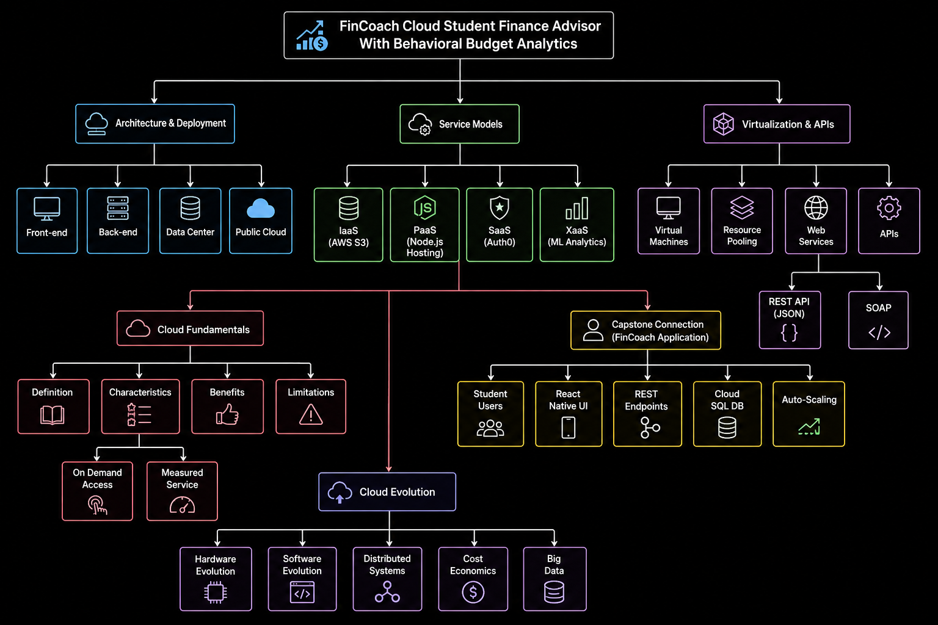
Brief explanation: explain one complete request-response path from user action to cloud response.

The student submits expense data through the app. REST APIs validate and store it in Firestore. Analytics generate spending insights and personalized budget recommendations shown on the dashboard.

Task 4 - Individual Reflection
Answer the following from your own perspective. Avoid team-common wording.
1. What is the strongest cloud concept represented in your capstone project?
Elasticity is the strongest concept. Student financial activity is highly cyclical—peaking around
month-end or loan disbursements, while remaining low mid-month. Leveraging serverless
computing ensures that our API and analytics layers scale dynamically to meet bursts of traffic
without incurring idle costs.
2. Where will elasticity or scalability become important in your capstone product?
Scalability will be vital in the database and data processing layer. As the user base grows and
historical transaction data accumulates, the system must efficiently query and analyze massive
datasets. Vertical scaling in our RDS instances and distributed analytics will be needed to
generate accurate behavioral budget insights quickly.
3. Which API or web-service idea is most relevant to your project and why?
REST APIs utilizing JSON payloads are the most relevant. They perfectly decouple our full-stack
React frontend from the backend data science services. This stateless, secure communication
layer is critical for transmitting sensitive financial transaction data while keeping the client
application lightweight.
4. What did you personally understand better after preparing this concept map and matrix?
I developed a much clearer understanding of the shared responsibility model. Preparing this
matrix highlighted that while cloud providers manage the physical infrastructure and
virtualization, I remain completely responsible for application-level security, API design, and
protecting the sensitive financial data schemas.

Evaluation Rubric - 100 Marks
Criteria | Marks | Expected Standard
Concept identification | 20 | Major CO1 concepts are accurately identified: cloud fundamentals, characteristics, evolution, service models, deployment models, virtualization, web services, SOAP/REST, APIs, elasticity, and scalability.
Relationship mapping | 20 | Links between concepts are accurate, meaningful, and labeled. The map should explain how concepts depend on, enable, consume, provide, scale, or control one another.
Hierarchy and organization | 15 | Concepts are arranged in a logical hierarchy with clear grouping, readable flow, and no disconnected keyword clusters.
Technical relevance | 15 | The map strongly reflects cloud course content and avoids decorative or generic non-technical content.
Service model matrix | 15 | IaaS, PaaS, SaaS, and XaaS are compared with provider responsibility, user responsibility, examples, capstone usage, and risks or limitations.
Capstone alignment and individual reflection | 10 | The student's own capstone interpretation is visible in the concept map, flow mapping, justification, and reflection. Team-common answers are avoided.
Visual clarity and digital evidence | 5 | Diagram is neat, readable, exported properly, and supported with GitHub evidence including source and exported files.

Faculty Evaluation Record
Evaluator Name |  | Marks Awarded
Observation |  | Signature

