**OOPs concepts in Java – 2**

Practical 2

1. Write a program to implement the concepts of Inheritance and Method overriding.

Filename: Main.java

Code:

//Parent class

**class** Vehicle {

// Method in the parent class

**void** display() {

System.***out***.println("This is a vehicle.");

}

}

//Child class inheriting from the Vehicle class

**class** Car **extends** Vehicle {

// Method overriding - redefining the display() method of the parent class

**void** display() {

System.***out***.println("This is a car.");

}

}

//Main class

**public** **class** Main {

**public** **static** **void** main(String[] args) {

// Creating objects of both parent and child class

Vehicle vehicle = **new** Vehicle();

Car car = **new** Car();

// Calling the display() method of both parent and child class

vehicle.display(); // Output: This is a vehicle.

car.display(); // Output: This is a car.

}

}

Output: This is a vehicle.

This is a car.

1. Write a program to implement the concepts of Abstract classes and methods

**Filename: OneString.java**

**public** **class** OneString {

**public** String stradd(String str1, String str2) {

**return** str1 + str2;

}

}

**Filename: AddString.java**

**public** **abstract** **class** AddString {

**abstract** **void** stradd(String str1, String str2);

}

**Filename: MainString.java**

**public** **class** MainString {

**public** **static** **void** main(String[] args) {

OneString adder = **new** OneString();

String result = adder.stradd("Hello ", "World");

System.***out***.println(result);

}

}

Output:

Hello World

1. Write a program to implement the concept of interfaces

To Create interface got to package and right click the following

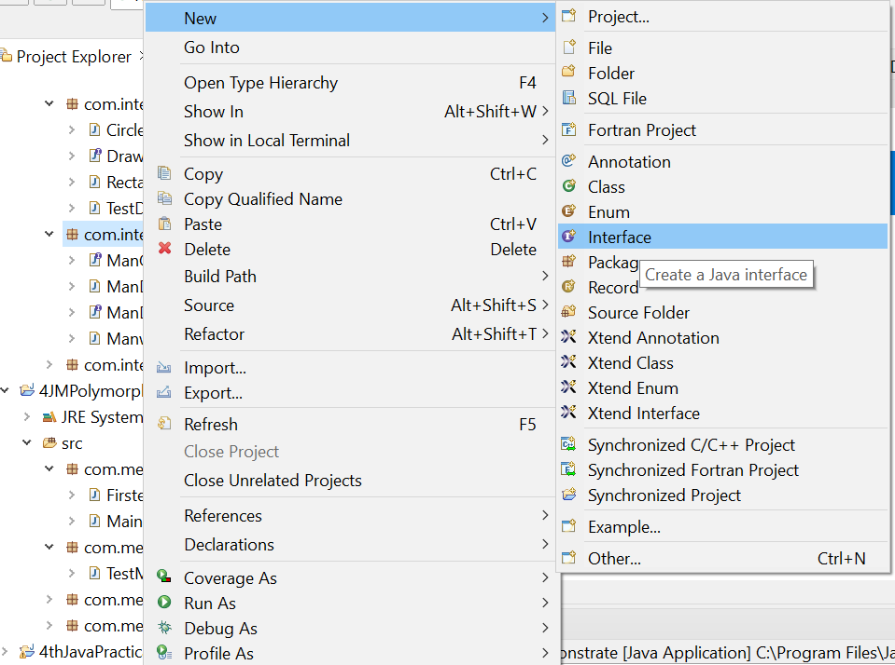

**Filename: ManWork.java**

**public** **class** Manwork **implements** ManClimb,ManDrive {

**public** **void** climbing() {

System.***out***.println("Man is Climbing");

}

**public** **void** driving() {

System.***out***.println("Man is driving");

}

}

**Filename: ManClimb.java**

**public** **interface** ManClimb {

**void** climbing();

}

**Filename: ManDrive.java**

**public** **interface** ManDrive {

**void** driving();

}

**Filename: ManDemonstrate.java**

**public** **class** ManDemonstrate {

**public** **static** **void** main(String[] args) {

Manwork mn=**new** Manwork();

mn.climbing();

mn.driving();

}

}

**Output:**

Man is Climbing

Man is driving