Auto Ticket Classification using Flow Designer
Technology Stack & Solution Architecture
Prepared from the project details available in this conversation and the supplied template archive. Unknown details are marked rather than assumed.

Project details
Project Name: Auto Ticket Classification using Flow Designer
Team ID: Not provided
Date: 01 October 2026

Architecture overview
User/helpdesk operator → ServiceNow Incident Workflow form → record-created trigger → Flow Designer condition/If-Else branches → Update Record (Category/Subcategory) → Send Email to Caller.Email. Configuration is stored in the ServiceNow platform and was exported through a Local Update Set XML.

Components and technologies
User interface: ServiceNow form / platform UI.
Workflow logic: ServiceNow Flow Designer.
Data store: ServiceNow platform database (managed by platform; underlying implementation not configured by this project).
Custom data model: Incident Workflow table with Number, Caller, Category, Subcategory, Short Description, Description, State, Assigned Group, Assigned to.
Notification: Flow Designer Send Email action using caller email reference.
Deployment artifact: Local Update Set exported as XML.

Application characteristics
Open-source frameworks: None specified/used.
Security: ServiceNow roles and ACLs; specific ACL configuration is included in the exported update set where configured.
Scalability: Add branches and choice values as requirements expand; actual capacity is governed by the ServiceNow instance.
Availability: Depends on ServiceNow instance availability.
Performance: Keyword conditions and a record update; no measured throughput/latency benchmark was supplied.

Data flow
1. Caller/helpdesk enters ticket details. 2. Record is created. 3. Flow triggers when Category is empty. 4. Flow evaluates the short description. 5. Matching branch updates Category and Subcategory. 6. Email action sends confirmation to Caller.Email. 7. Operator can verify the saved record and email preview.

Diagram (text representation)
[Caller / Helpdesk] → [Incident Workflow Form] → [Record Created]
↓
[Flow: Category is Empty]
↓
[Keyword branches: Wi-Fi/Network | Projector | Forgot password | Slow Computer]
↓
[Update Category + Subcategory]
↓
[Send confirmation email]

Actual Project Screenshot
The screenshot in this section is taken from the submitted project PDF and shows the actual ServiceNow Flow Designer configuration.
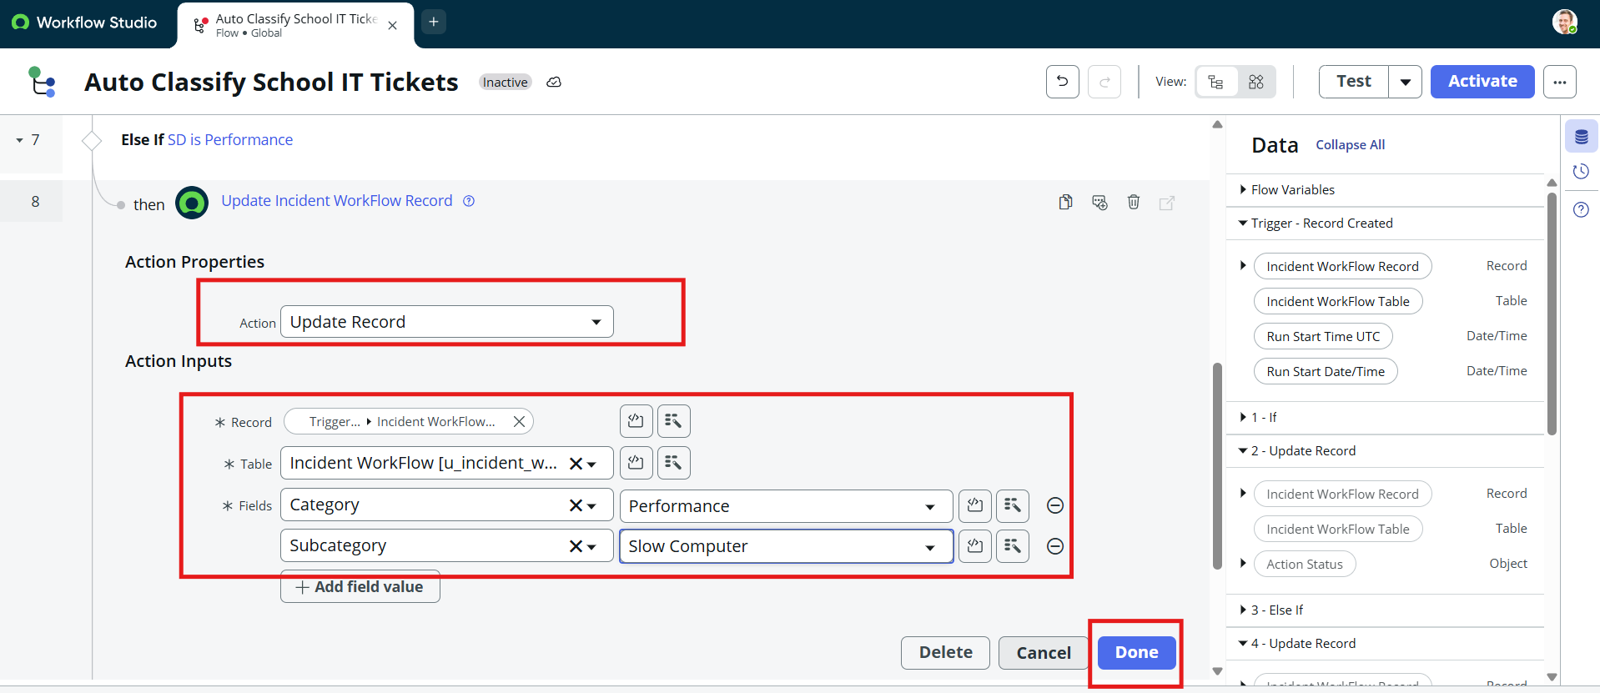
Actual Flow Designer Screenshot

