Auto Ticket Classification using Flow Designer
Development Phase – Functional & Performance Testing
Prepared from the project details available in this conversation and the supplied template archive. Unknown details are marked rather than assumed.

Project details
Project Name: Auto Ticket Classification using Flow Designer
Date: 01 October 2026
Environment: ServiceNow PDI instance dev428996 (as shown in the user-provided screenshot; status was Online on 28-Sep-2026).

Functional test cases
TC-01 Wi-Fi: Create ticket with Short Description “WiFi not working in library”. Expected: Network / Wi-Fi and confirmation email generated. Actual: User reported test completed; email preview/record was inspected. Result: Passed as reported.
TC-02 Projector: Short Description “Projector not turning on”. Expected: Hardware / Projector. Actual: User reported test completed. Result: Passed as reported.
TC-03 Password: Short Description containing “Forgot password”. Expected: Access / Forgot Password. Actual: User reported test completed. Result: Passed as reported.
TC-04 Slow computer: Short Description containing “Slow Computer”. Expected: Performance / Slow Computer. Actual: User reported test completed. Result: Passed as reported.

Email verification
An email record was inspected with Type=send-ready, Target=Incident Workflow: INC0001044, Notification type=SMTP, subject “Your Request for the issue has been submitted”, recipient abraham.lincoln@example.com. Preview showed “Ticket confirmation message”. This confirms email generation/preview in the instance; external mailbox delivery was not independently verified.

Performance testing
No response-time, throughput, concurrency, or load-test measurements were supplied. Performance is therefore documented qualitatively only; do not claim a numeric benchmark.

Known limitations
Matching relies on configured keywords and may not classify synonyms or misspellings. User-provided test outcomes are recorded as reported, not independently rerun in this document.

Actual Project Screenshots
The screenshots in this section are taken from the submitted project PDF and show the actual ServiceNow project configuration and testing evidence.
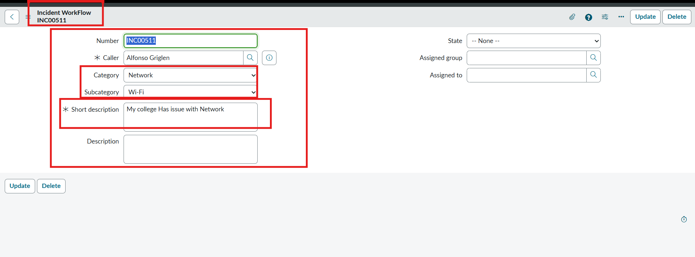
Actual Test Result Screenshot
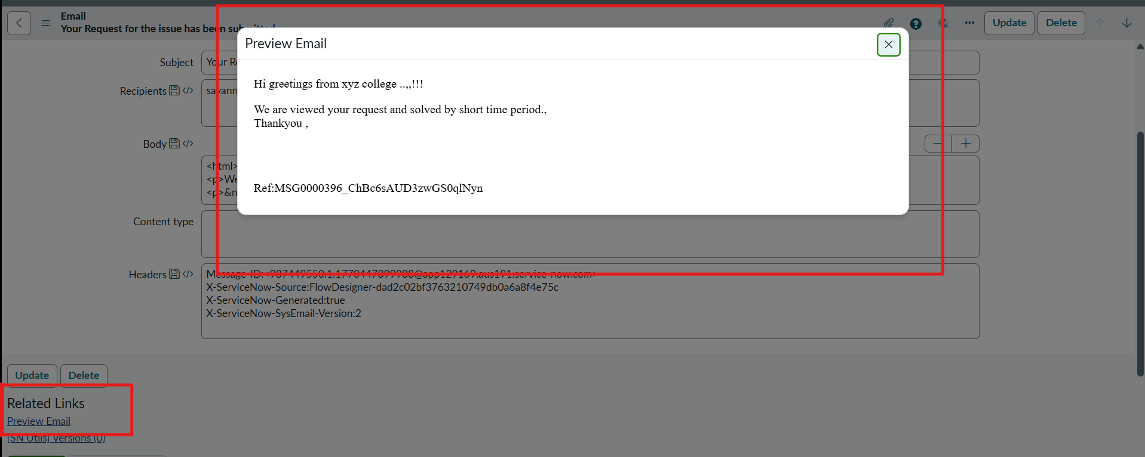
Actual Email Preview Screenshot

