Auto Ticket Classification using Flow Designer
User Acceptance Testing (UAT) Report
Prepared from the project details available in this conversation and the supplied template archive. Unknown details are marked rather than assumed.

Project overview
Project Name: Auto Ticket Classification using Flow Designer
Description: ServiceNow workflow to classify common school IT tickets and send confirmation email.
Version: Project Update Set exported to XML; version number not supplied.
Testing period: Exact dates not supplied.

Testing scope
Ticket creation, automatic category/subcategory population for four configured issue types, and confirmation email generation/preview.

Testing environment
ServiceNow PDI instance dev428996. Credentials intentionally omitted; do not include passwords in project documents.

UAT test cases
UAT-01 Wi-Fi ticket: create “WiFi not working in library”; expected Network/Wi-Fi and email. User reported completed.
UAT-02 Projector ticket: “Projector not turning on”; expected Hardware/Projector. User reported completed.
UAT-03 Password ticket: “Forgot password”; expected Access/Forgot Password. User reported completed.
UAT-04 Slow computer ticket: “Slow Computer”; expected Performance/Slow Computer. User reported completed.
UAT-05 Email check: inspect generated email and preview. Preview showed configured message; external delivery not confirmed.

Bug tracking
No unresolved defects were reported in the available project notes. Formal defect IDs/severity/sign-off were not supplied.

Sign-off
Tester name/signature and product-owner approval were not supplied. Complete these fields with the actual authorized names if required by the institution.

Actual Project Screenshots
The screenshots in this section are taken from the submitted project PDF and show the actual ServiceNow project configuration and testing evidence.
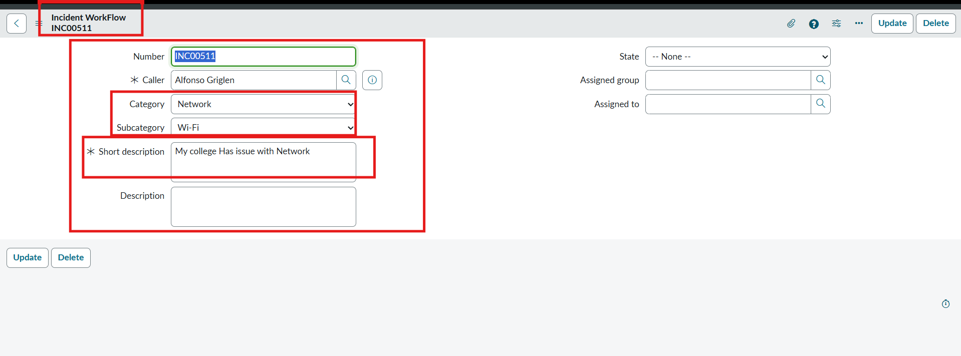
Actual Test Result Screenshot
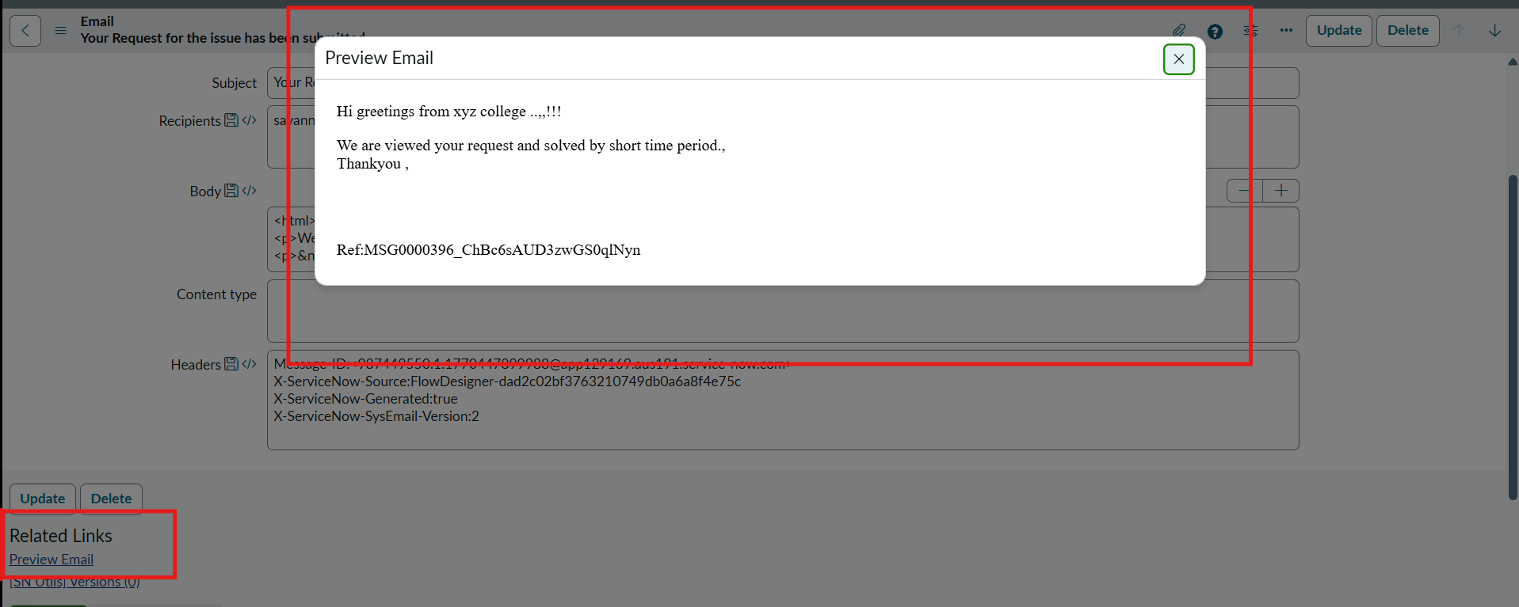
Actual Email Preview Screenshot

