Auto Ticket Classification using Flow Designer
Final Project Report & FSD Documentation
Prepared from the project details available in this conversation and the supplied template archive. Unknown details are marked rather than assumed.

Introduction
Project Title: Auto Ticket Classification using Flow Designer
Platform: ServiceNow
Team members: Not provided.

Project overview
Purpose: Automate classification of common school IT helpdesk tickets at creation and generate a caller confirmation email.
Features: Custom Incident Workflow table; category/subcategory choices and dependency; Flow Designer record-created automation; four classification branches; email action; testing; update set XML export.

System design
Table: Incident Workflow. Fields: Number (Auto Number), Caller (Reference sys_user), Category (Choice: Network, Hardware, Access, Performance), Subcategory (Choice: Wi-Fi, Projector, Forgot Password, Slow Computer), Short Description (String), Description (String), State (Choice: New, In progress, On hold, Resolved, Closed), Assigned Group (Reference sys_user_group), Assigned to (Reference sys_user). Subcategory depends on Category.

Flow specification
Flow name: Auto Classify School IT Tickets. Application: Global. Trigger: Record Created on Incident Workflow. Entry condition: Category is Empty. Branches: Short description contains Wi-Fi OR Network → Network/Wi-Fi; contains Projector → Hardware/Projector; contains Forgot password → Access/Forgot Password; contains Slow Computer → Performance/Slow Computer. Email action: To Caller.Email; subject “Your Request for the issue has been submitted”; body “Ticket confirmation message”.

Setup / deployment
The project was built in a ServiceNow Personal Developer Instance. The Project Update Set was changed to Complete and exported using Related Links → Export to XML. The XML is the configuration/deployment artifact. No credentials are included.

Testing
Four classification scenarios were reported completed. Email record and preview were inspected. The evidence supports generation/preview, not independent proof of external mailbox delivery.

Screenshots / demo
Insert actual screenshots and the actual demo-video URL here. No demo URL was provided in the available information.

Known issues and future enhancements
Known limitation: exact keyword matching may not cover synonyms or spelling variations. Future enhancements: broader keyword coverage, fallback/manual review, assignment-group routing, analytics, and formal load testing.

Conclusion
The configured workflow automates classification for the four defined ticket types and creates a confirmation email action. The completed update set was exported to XML for retention/submission.

Actual Project Screenshots
The screenshots in this section are taken from the submitted project PDF and show the actual ServiceNow project configuration and testing evidence.
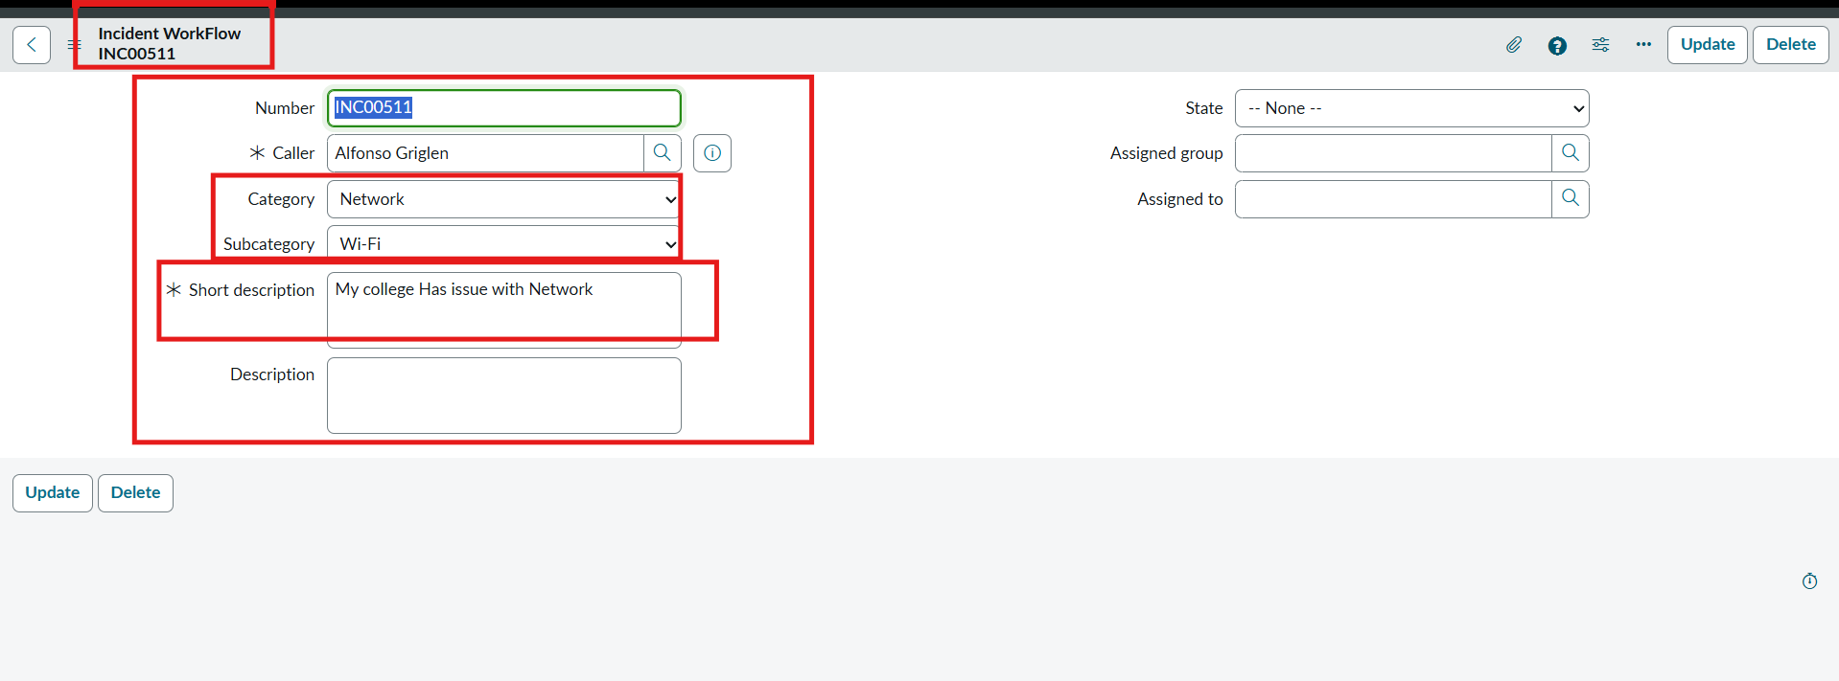
Actual Ticket Form Screenshot
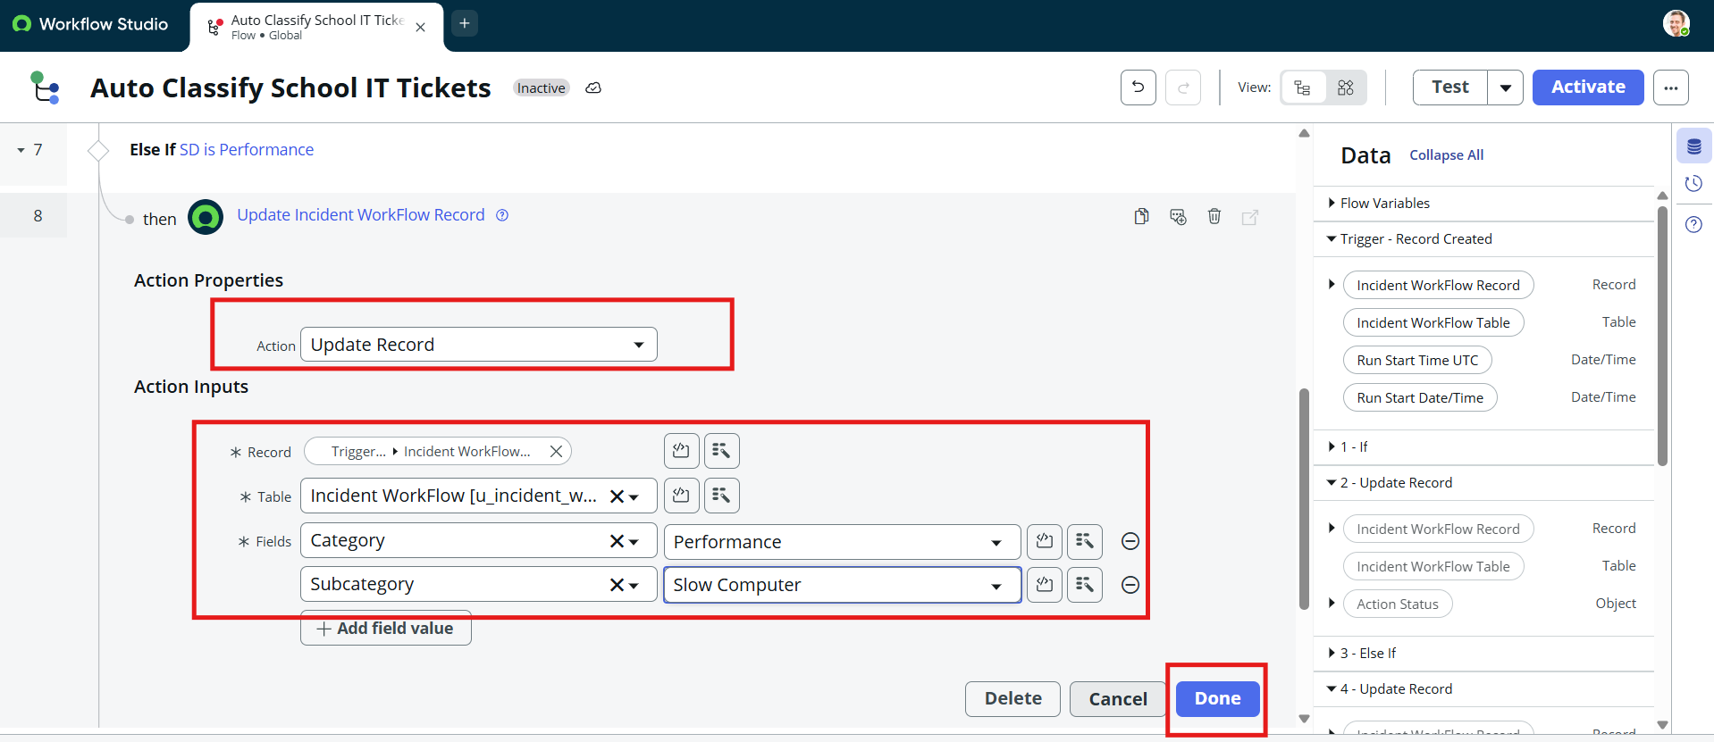
Actual Flow Designer Screenshot
Actual Test Result Screenshot
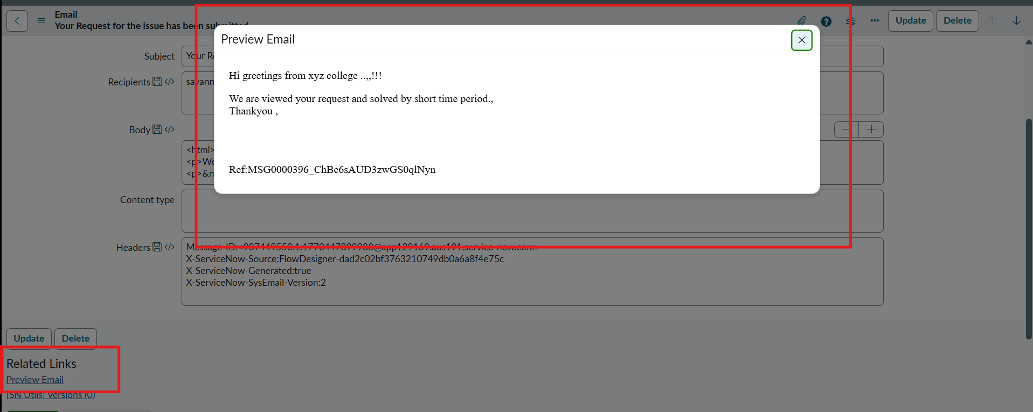
Actual Email Preview Screenshot

