Buit an AI Powered Customer Complaint Workflow in n8n
This manual guides you through a complete workflow that receives a food delivery complaint, asks an AI model to classify it, records the result, emails the support team, and sends a Telegram alert when the complaint is high priority.
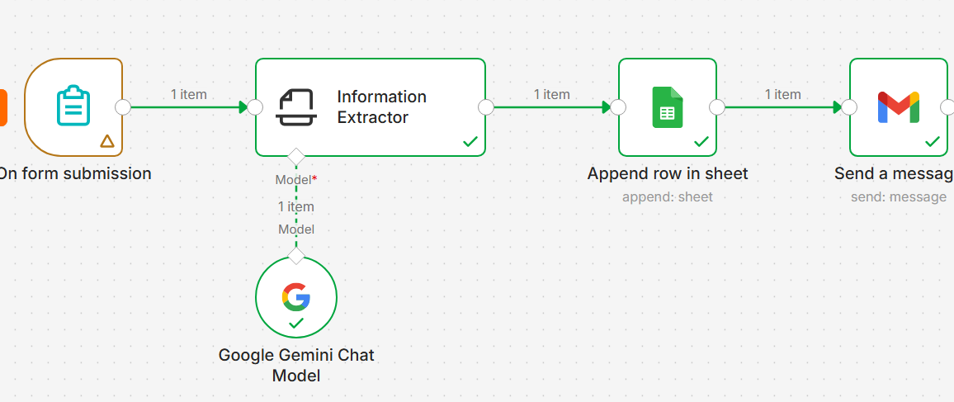

What you will build
- An n8n form that collects a complaint
- A structured AI analysis with summary category priority and reason
- A Google Sheets complaint log and an email notification
- A condition that sends urgent complaints to Telegram
Allow 45 to 60 minutes for the main workflow. The HTTP Request and AI Agent exercises take another 10 to 15 minutes each.

Before You Begin
Create or sign in to an n8n Cloud account. The labels in your screen may vary slightly as n8n updates its interface, but the node names and settings in this guide remain the same.

Accounts and materials
- An n8n Cloud account
- A Google account for Google Sheets and Gmail
- A Telegram account for the optional urgent alert
- Access to an AI chat model inside n8n
- A blank browser tab for testing the form

Workflow structure
Stage | n8n node | Purpose
Collect | On form submission | Receive customer and complaint data
Analyse | Information Extractor plus Chat Model | Return four structured fields
Record | Google Sheets | Append one complaint row
Notify | Gmail | Email the complaint analysis
Route | If | Check whether priority equals High
Escalate | Telegram | Alert only on the True path

Part 1 Create the Complaint Form

Step 1 Create a workflow
From the n8n home screen, choose Build a workflow. Rename it Customer Complaint Triage.

Step 2 Add the form trigger
Select Add first step, search for n8n Form Trigger, and choose On form submission.

Step 3 Set the form details
Setting | Value
Authentication | None
Form Title | Customer Complaint Form
Form Description | Tell us about the problem with your food order.
Respond When | Form Is Submitted

Step 4 Add the form elements
Label | Custom Field Name | Element Type | Required
Customer Name | customer_name | Text | Yes
Email | customer_email | Email | Yes
Order ID | order_id | Text | Yes
Complaint | complaint | Textarea | Yes

Step 5 Submit test data
Click Test this trigger or Execute step. Open the Test URL, complete the form, and submit it. Use a simple complaint for the first test.
Customer Name: Demo Customer
Email: your test email
Order ID: 12345
Complaint: There was too much salt in the food.
A green check mark and one output item confirm that n8n received the form submission. The output should include customer_name, customer_email, order_id, complaint, submittedAt, and formMode.

Part 2 Add Structured AI Analysis

Step 1 Add Information Extractor
Close the form node, click its output plus sign, search for Information Extractor, and add it.

Step 2 Choose the complaint text
In the Text field, switch to Expression and enter:
{{ $json.complaint }}
This expression reads the complaint field from the item received from the previous node.

Step 3 Define the output structure
Set Schema Type to Generate From JSON Example. Paste this example:
{
"summary": "One-sentence summary",
"category": "Other",
"priority": "Low",
"reason": "Reason for the priority"
}
The values are examples. The property names define the four fields that the node must return.

Step 4 Add the analysis instructions
Open Options, add System Prompt Template, and paste:
Analyse customer complaints for a food-delivery company.
Create a concise one-sentence summary.
Choose exactly one category:
Delivery Delay, Missing Item, Damaged Item, Incorrect Order,
Payment Issue, Food Quality, or Other.
Choose exactly one priority:
High, Medium, or Low.
High: safety concern, contamination, major leakage or damage,
payment charged incorrectly, multiple affected items, or an urgent unresolved issue.
Medium: one significant service failure requiring attention.
Low: minor inconvenience, taste preference, or general feedback.
Do not invent information. Use only the submitted complaint.

Part 3 Connect and Test the Chat Model

Step 1 Attach a chat model
From the Model connector below Information Extractor, choose OpenAI Chat Model or another included chat model available in your n8n account.

Step 2 Select the included credential
If n8n shows Gateway credits, select that credential. Choose gpt-5-mini if it is available and leave Use Responses API on. Do not add built-in tools for this extractor.
A ChatGPT Plus subscription and OpenAI API billing are separate. This exercise does not require you to buy API credit. Use the included n8n credits and keep test runs limited.

Step 3 Execute the extractor
Open Information Extractor and click Execute step. With the salt complaint, a reasonable result is:
Field | Expected result
summary | The food contained too much salt
category | Food Quality
priority | Low
reason | A taste or food quality issue without a safety concern

The wording may differ. Check that the category and priority use one of the permitted values and that the model does not invent facts.

How the data changed
Node | Data received | Data produced
Form trigger | Customer fields and complaint | One submission item
Information Extractor | Complaint text | output.summary, output.category, output.priority, output.reason

Part 4 Append the Complaint to Google Sheets

Step 1 Prepare the spreadsheet
Create a Google Sheet named Customer Complaint Log. In Sheet1, enter these headers in row 1:
submitted_at | customer_name | customer_email | order_id | complaint | summary | category | priority | reason

Step 2 Add the Google Sheets node
After Information Extractor, add Google Sheets. Sign in with Google and allow the requested access.

Step 3 Choose the operation
Setting | Value
Resource | Sheet Within Document
Operation | Append Row
Document | Customer Complaint Log
Sheet | Sheet1
Mapping Column Mode | Map Each Column Manually

Step 4 Map each column
Sheet column | Expression
submitted_at | {{ $('On form submission').item.json.submittedAt }}
customer_name | {{ $('On form submission').item.json.customer_name }}
customer_email | {{ $('On form submission').item.json.customer_email }}
order_id | {{ $('On form submission').item.json.order_id }}
complaint | {{ $('On form submission').item.json.complaint }}
summary | {{ $json.output.summary }}
category | {{ $json.output.category }}
priority | {{ $json.output.priority }}
reason | {{ $json.output.reason }}

Manual mapping is safer here because the original form fields come from an earlier node and the AI fields are nested inside output. Automatic mapping works best when incoming top-level field names exactly match the sheet headers.

Step 5 Test the append
Click Execute step. Confirm that a new row appears in Google Sheets and that every column contains the expected value.

Part 5 Send an Email Notification

Step 1 Add Gmail
After Google Sheets, add Gmail. Connect your Google account, then select Message and Send.

Step 2 Set the recipient
For classroom testing, send the message to your own email address.

Step 3 Create the subject
New {{ $('Information Extractor').item.json.output.priority }}-priority complaint - Order {{ $('On form submission').item.json.order_id }}

Step 4 Create the message body
A new customer complaint has been received.
Customer: {{ $('On form submission').item.json.customer_name }}
Order ID: {{ $('On form submission').item.json.order_id }}
Complaint:
{{ $('On form submission').item.json.complaint }}
AI Summary:
{{ $('Information Extractor').item.json.output.summary }}
Category:
{{ $('Information Extractor').item.json.output.category }}
Priority:
{{ $('Information Extractor').item.json.output.priority }}
Reason:
{{ $('Information Extractor').item.json.output.reason }}

Step 5 Test the email
Execute the Gmail node. Check the inbox and spam folder. Confirm that the subject and body contain data from both the form and Information Extractor.

