
Programme: B.Tech IT
Course Code: CSA1107
Course Name: Object Oriented Analysis and Design (OOAD)
Duration: 1:30 Hr Date: Max Marks: 50 Marks
CONTINUOUS INTERNAL ASSESSMENT 2
Course Outcomes
On successful completion of the course, students will be able to:
CO | Course Outcome Statement
CO3 | Analyze system requirements using object-oriented analysis, classification, object relationships, attributes, methods, and use case models.
CO4 | Apply object-oriented design principles, patterns, object responsibilities, access/view layers, and OODBMS integration.
Answer all the Questions
- An online railway reservation system lets passengers book tickets (with a concession if eligible) and pay through a payment gateway. Passengers or railway clerks can cancel a ticket and the amount is refunded; clerks also check PNR status; the administrator manages train schedules. Analyze the requirements and identify the actors and use cases. Develop a Use Case Diagram showing at least one «include» and one «extend» relationship, and write a use case description for “Cancel Ticket”. Explain the steps followed to build the use case model and how primary and alternate scenarios are used in object-oriented analysis.
(10) (CO3) (BL4)
- In a university, students register online for course offerings in a semester. The system checks the prerequisites and the seats left before confirming a registration. Each course belongs to a department, is offered in one or more semesters and each offering is taught by one faculty member. Use the CRC (Class–Responsibility–Collaborator) technique to identify the main classes, and classify the classes using common class patterns. Identify the relationships with multiplicities and develop the class diagram with attributes and methods.
(10) (CO3) (BL4)
- A banking design has an Account class whose balance attribute is public and is modified directly by several classes. SavingsAccount and CurrentAccount repeat the deposit and withdraw code, and Account also contains 25 unrelated methods including report printing. State how the design axioms and corollaries guide class design. Design the Account class by showing its attributes, methods, visibility (private, protected, public) and class protocol, and draw the class hierarchy with Customer and Transaction.
(10) (CO4) (BL4)
- A document management application must create PDF, Word or text documents according to the user’s choice. It must also reuse an existing legacy bank API, LegacyBankApi.makeTransfer(account, paise), although the new code expects a PaymentProcessor interface with pay(amount). Select suitable design patterns and justify them. Develop class diagrams for the Factory Method and Adapter patterns, and apply responsibility-driven design to identify the responsibilities and collaborators of DocumentCreator.
(10) (CO4) (BL4)
- A hospital stores Patient records, and Patient has the subclasses Inpatient (ward, admit date) and Outpatient (visit date). The designers must choose between an Object-Oriented DBMS and a relational DBMS. Compare an OODBMS with an RDBMS. Explain how the Access layer integrates the business objects with each kind of database. Show three ways of mapping the Patient generalization to tables and recommend one.
(10) (CO4) (BL4)

1. Online Railway Reservation System – Use Case Model

A. Requirements and actors
The system lets passengers search trains, book tickets, receive a concession when eligible, pay through a payment gateway and cancel tickets. Railway clerks book or cancel tickets and check PNR status on behalf of passengers. The administrator manages train schedules. The system calculates fares and refunds, updates ticket status and records payment results.
Actor | Role / use cases
Passenger (primary) | Search Trains, Book Ticket, Cancel Ticket, Check PNR Status.
Railway Clerk (primary) | Book Ticket, Cancel Ticket and Check PNR Status on behalf of passengers.
Administrator (primary) | Manage Train Schedule (add, update or cancel schedules).
Payment Gateway (secondary, external system) | Authorizes payments, processes refunds and returns the transaction status.

Use cases identified: Search Trains, Book Ticket, Check Availability, Calculate Fare, Apply Concession, Pay Fare, Cancel Ticket, Calculate Refund, Check PNR Status, Manage Train Schedule.

B. Use case diagram
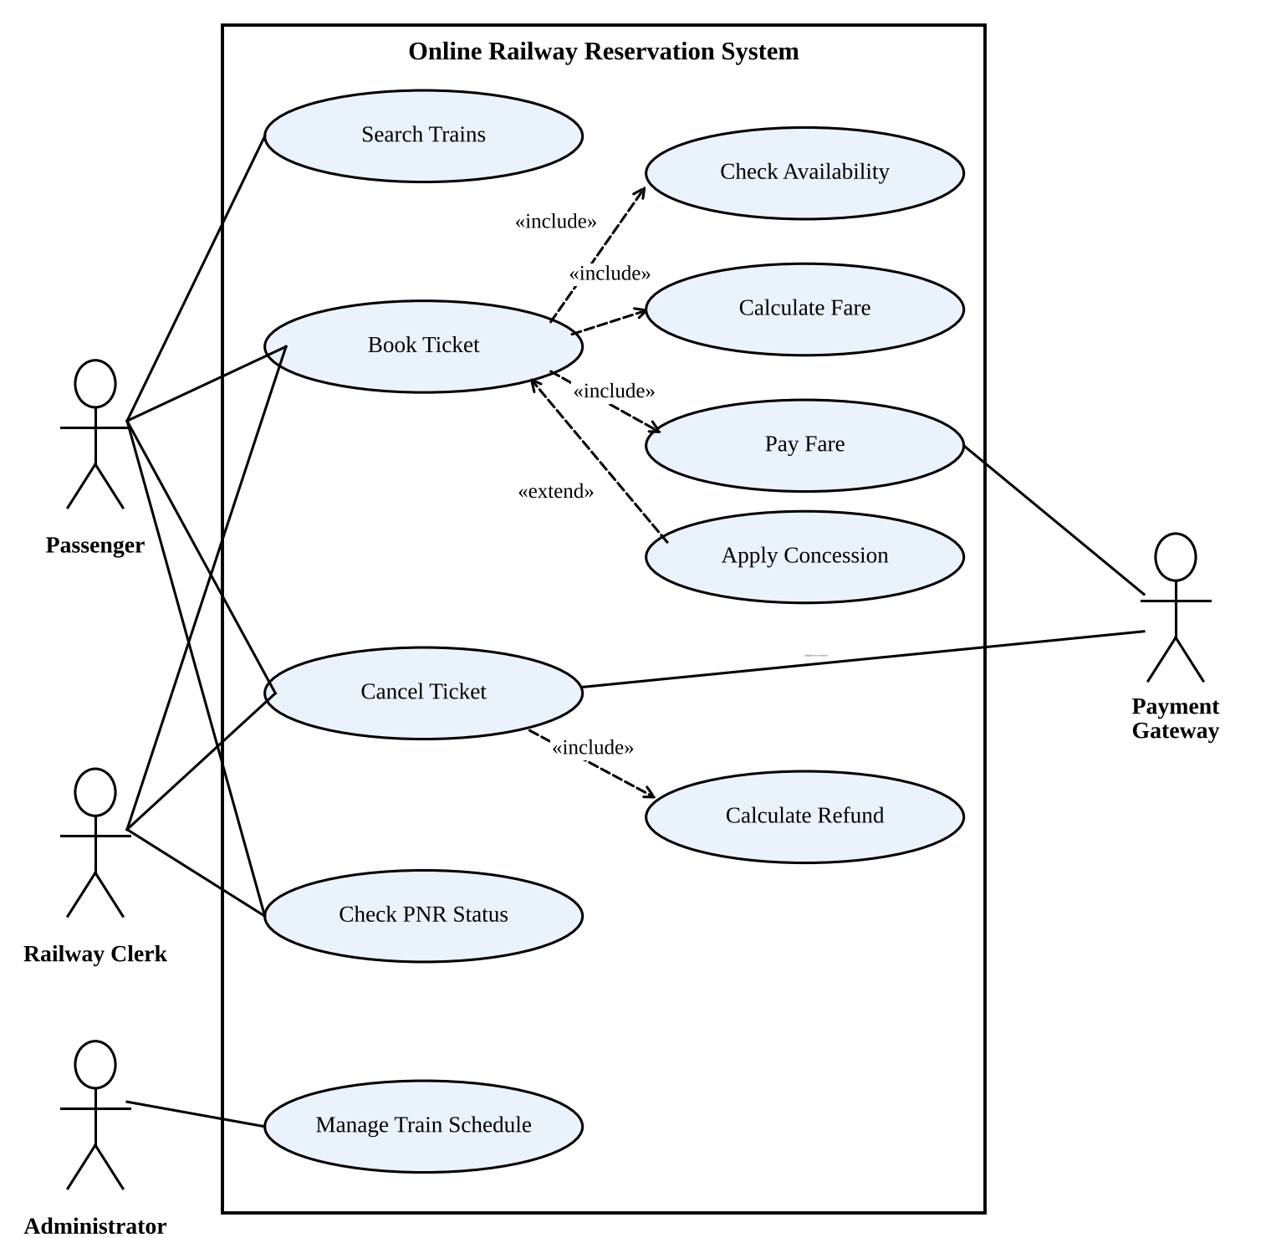
- «include» – mandatory reused behaviour: Book Ticket includes Check Availability, Calculate Fare and Pay Fare; Cancel Ticket includes Calculate Refund.
- «extend» – optional, conditional behaviour: Apply Concession extends Book Ticket only when the passenger is eligible for a concession.

C. Use case description – Cancel Ticket
Field | Description
Use case name | Cancel Ticket
Primary actors | Passenger or Railway Clerk
Secondary actor | Payment Gateway
Goal | Cancel an existing ticket and arrange the eligible refund.
Preconditions | A valid PNR exists; the actor is authorized; cancellation is allowed under the rules.
Trigger | The passenger chooses Cancel Ticket, or the clerk requests a cancellation.
Main (primary) scenario | 1. Actor enters or selects the PNR.  2. System retrieves and displays the ticket details and cancellation terms.  3. Actor confirms the cancellation.  4. System marks the ticket (or passenger segment) as cancelled.  5. System calculates the refund (includes Calculate Refund).  6. System requests the refund through the payment gateway.  7. System displays confirmation and stores the transaction reference.
Alternate scenarios | A. Invalid PNR – system shows an error and asks for valid details.  B. Cancellation not permitted – system explains the rule and does not cancel.  C. Gateway unavailable – system records the cancellation and marks the refund as Pending for later processing.  D. Actor declines at step 3 – no change is made.
Postconditions | Ticket status and seat inventory are updated; the refund status is recorded.

D. Steps to build the use case model
- Define the system boundary and scope – decide which railway functions are inside the reservation system.
- Gather requirements from passengers, clerks, administrators and the payment service.
- Identify actors – people and external systems that interact with the system.
- Identify actor goals and name use cases as verb–noun phrases such as Book Ticket and Check PNR Status.
- Draw the diagram – place use cases inside the boundary and connect each actor to its use cases.
- Add relationships – «include» for mandatory shared behaviour, «extend» for conditional behaviour, generalization where needed.
- Write detailed use case descriptions, validate them with stakeholders and derive test cases.

E. Primary and alternate scenarios in object-oriented analysis
The primary scenario (main success path) describes the normal flow, for example entering a valid PNR, confirming the cancellation and receiving the refund confirmation. Alternate scenarios describe variations and exceptions, such as an invalid PNR, cancellation outside the permitted period or a gateway failure. In object-oriented analysis, scenarios help to discover objects and classes (Ticket, Refund, Train), their responsibilities and operations, the messages exchanged, state changes (Confirmed → Cancelled) and exception handling. Each scenario also becomes a test case for validating the design.
Conclusion: The use case model captures the users, their goals and both normal and exceptional interactions with the system.

2. University Course Registration – CRC and Class Diagram

A. CRC technique
A CRC card records a Class, its Responsibilities (what it knows or does) and its Collaborators (the classes it works with). Reading the scenario, the nouns give candidate classes: Student, Course, Department, Semester, CourseOffering, Faculty, Registration and Prerequisite.
Class | Responsibilities | Collaborators
Student | Request registration; maintain student details and completed courses. | Registration, CourseOffering
Course | Store course code, title and credits; know its prerequisite courses. | Department, CourseOffering
CourseOffering | Represent a course in a semester; track capacity and seats left; reserve a seat. | Course, Semester, Faculty, Registration
Registration | Store date and status; confirm or cancel a registration. | Student, CourseOffering
Department | Own and manage its courses and department details. | Course
Faculty | Store faculty details; teach assigned offerings. | CourseOffering
Semester | Store term, year and dates. | CourseOffering
Prerequisite | Represent and verify the required prior courses (rule). | Course, Student

B. Classification using common class patterns
Pattern | Classes | Reason
Entity / concept | Course, CourseOffering, Semester | Hold persistent domain information.
Role / party | Student, Faculty | People who take part in the process.
Event / transaction | Registration | Records the business event of a student enrolling in an offering.
Organization | Department | University unit responsible for courses.
Rule / policy | Prerequisite | Encapsulates the eligibility rule.

C. Relationships and multiplicities
Relationship | Multiplicity | Meaning
Department – Course | 1 to 0..* | A course belongs to one department.
Course – CourseOffering | 1 to 0..* | An offering is of exactly one course.
Semester – CourseOffering | 1 to 0..* | An offering belongs to one semester.
Faculty – CourseOffering | 1 to 0..* | Each offering is taught by one faculty member.
Student – Registration | 1 to 0..* | A registration belongs to one student.
CourseOffering – Registration | 1 to 0..* | A registration refers to one offering.
Course – Course (prerequisite) | 0..* to 0..* | Self-association: a course may need other courses.

D. Class diagram
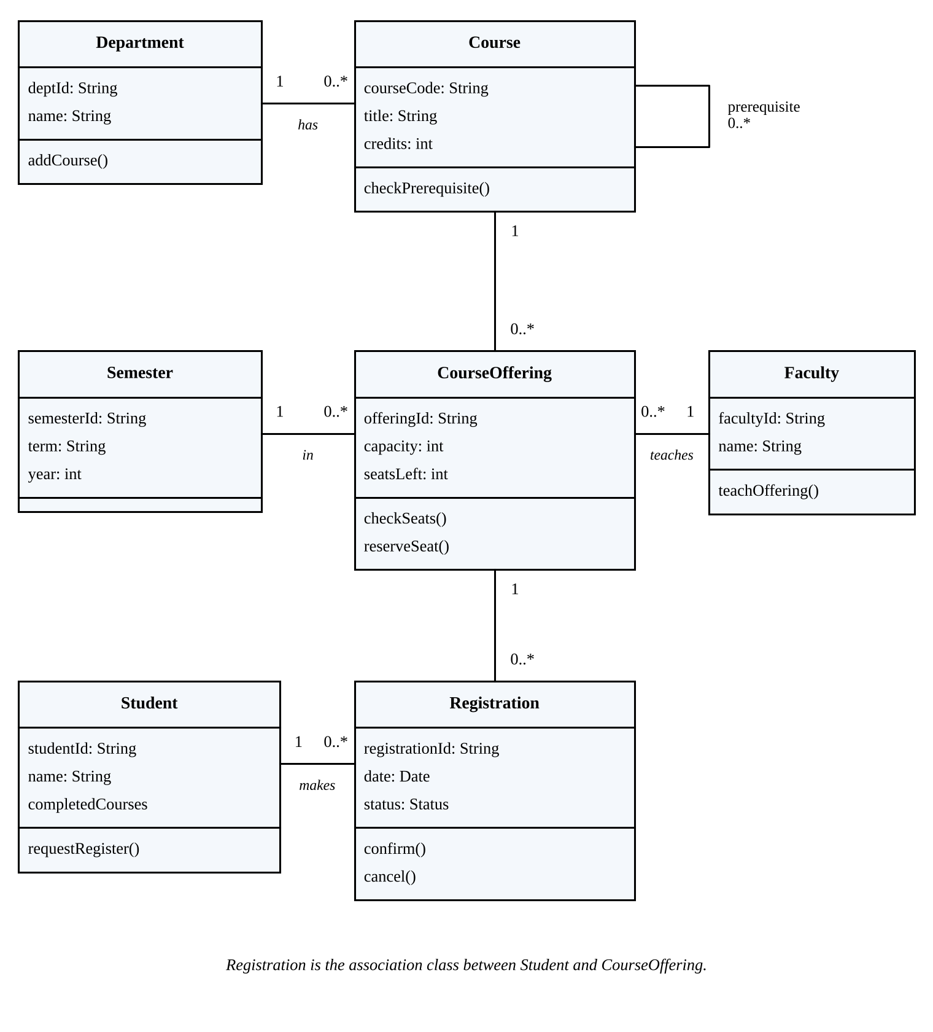

E. Registration logic
- register(student, offering) checks that the student has completed every prerequisite of the course.
- It checks that seatsLeft is greater than zero.
- If both pass, a Registration with status Confirmed is created and seatsLeft is decreased by one.
- Otherwise the request is rejected and the reason is shown.
Conclusion: CRC cards clarify responsibilities before coding, and the class diagram captures the structure, relationships and multiplicities.

3. Banking Account Design – Axioms and Class Design

A. Problems in the given design
- Public balance modified directly by many classes – poor encapsulation and high coupling.
- Duplicated deposit and withdraw code in SavingsAccount and CurrentAccount.
- 25 unrelated methods (including report printing) in Account – low cohesion; hard to test and maintain.

B. Design axioms and corollaries
Principle | How it guides the Account design
Axiom 1 – Independence | Keep classes independent. Other classes must not change Account.balance directly; they call deposit() or withdraw().
Axiom 2 – Information | Minimize the information content of the design: a small, simple public interface.
Corollary 1 – Uncoupled design with less information | Hide the balance and expose only a few messages, which lowers coupling.
Corollary 2 – Single purpose | Each class and method does one thing. Report printing moves to a separate ReportService.
Corollary 3 – Large number of simple classes | Split Account, Customer, Transaction, ReportService instead of one large class.
Corollary 4 – Strong mapping | Classes map directly to real objects: Account, Customer, Transaction.
Corollary 5 – Standardization | Use standard names and protocols (deposit, withdraw, getBalance) in all account types.
Corollary 6 – Design with inheritance | Put common deposit and withdraw behaviour in Account; subclasses add only different rules (interest, overdraft).

C. Account class design
Attributes
Attribute | Type | Visibility | Purpose
accountNo | String | private (-) | Unique account number.
balance | Decimal | private (-) | Changed only through deposit/withdraw.
status | AccountStatus | protected (#) | Active, frozen or closed.
customer | Customer | protected (#) | Owner of the account.

Methods
Method | Visibility | Purpose
deposit(amount): void | public (+) | Add money after validating the amount.
withdraw(amount): Boolean | public (+) | Subtract money if validation succeeds.
getBalance(): Decimal | public (+) | Read-only access to the balance.
transferTo(target, amount): void | public (+) | Withdraw here and deposit in the target.
validateWithdrawal(amount): Boolean | protected (#) | Rule hook that subclasses override.
updateBalance(amount): void | private (-) | Internal change of the balance.

D. Class protocol
The class protocol is the set of public messages that other objects may send to Account: deposit(), withdraw(), getBalance() and transferTo(). Other classes cannot assign balance. The private updateBalance() changes the balance internally, and the protected validateWithdrawal() can be specialized by SavingsAccount and CurrentAccount.

E. Class hierarchy with Customer and Transaction
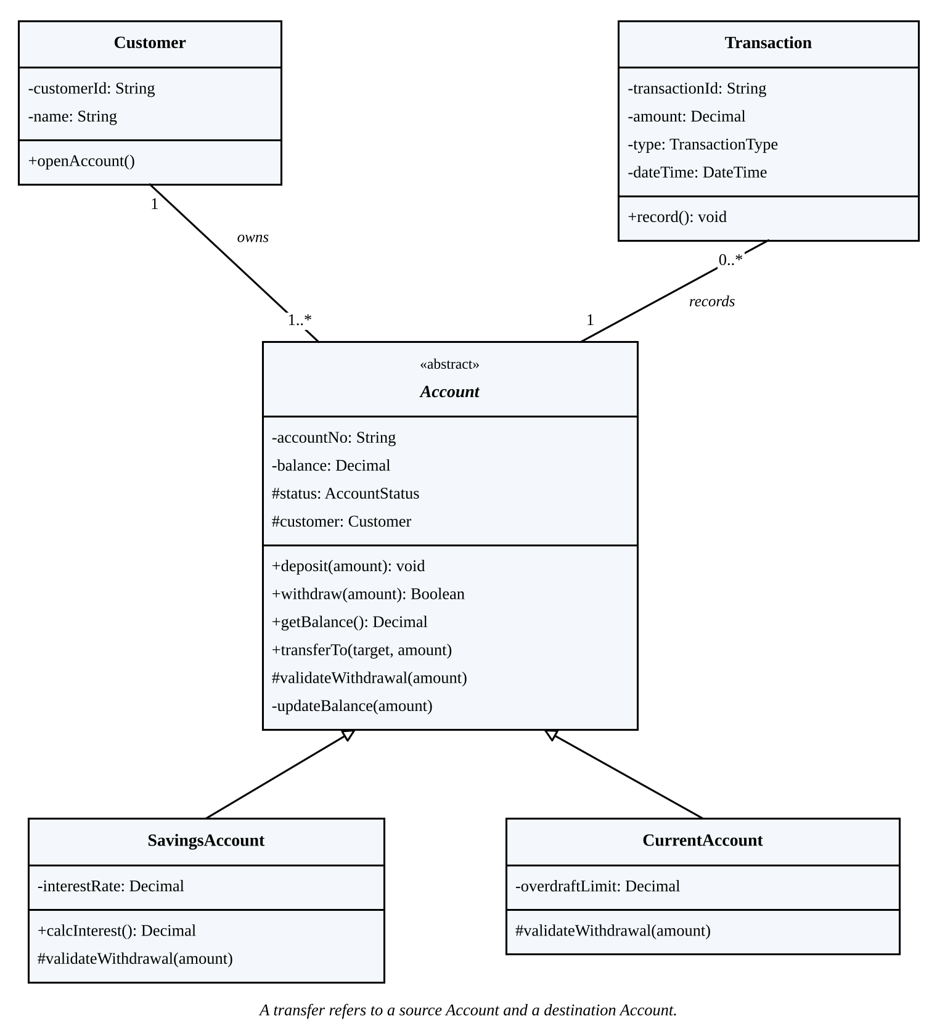

F. Justification
- Private balance protects integrity and removes uncontrolled updates.
- Inheritance removes the duplicate code; SavingsAccount adds interest, CurrentAccount adds the overdraft rule.
- Transaction records every deposit, withdrawal and transfer.
- ReportService handles reports, so Account stays cohesive.
Conclusion: Encapsulation, low coupling, high cohesion and inheritance make the banking design safer and easier to maintain.

4. Document Creation and Legacy Bank API – Design Patterns

A. Suitable patterns and justification
Pattern | Application | Justification
Factory Method | Create PDF, Word or text documents according to the user’s choice. | Separates object creation from client code; each concrete creator returns its own Document; new formats are added without changing the client.
Adapter | Make LegacyBankApi.makeTransfer(account, paise) usable as PaymentProcessor.pay(amount). | Converts the new interface to the legacy one without changing legacy code and lets the application depend only on PaymentProcessor.

B. Factory Method class diagram
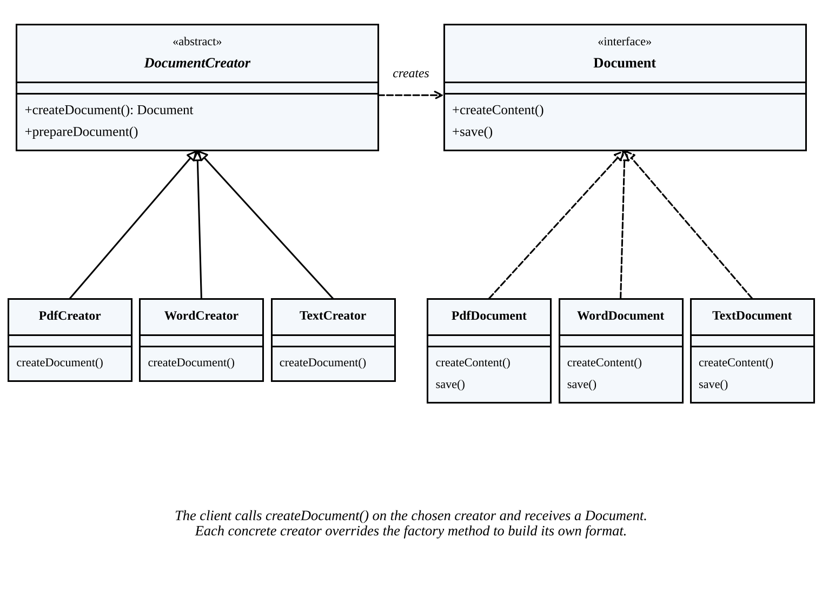

C. Adapter class diagram
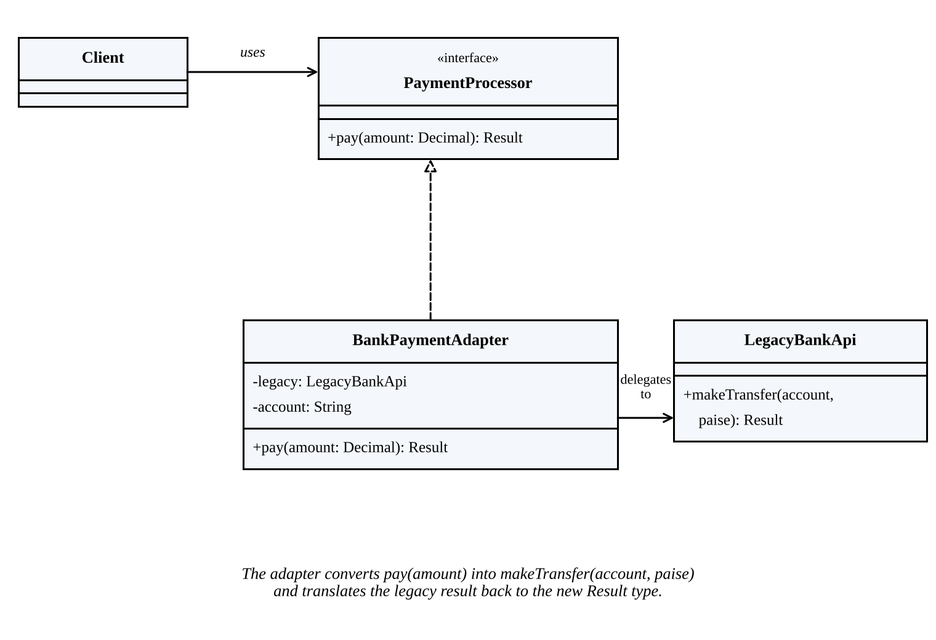
In BankPaymentAdapter.pay(amount), the amount is converted to paise (amount × 100, rounded with proper currency precision), the stored account is supplied, makeTransfer(account, paise) is called, and the legacy result is translated into the Result expected by the client.

D. Responsibility-driven design: DocumentCreator
Responsibility | Collaborator
Declare the factory operation createDocument() that returns a Document. | Document interface
Coordinate common preparation (prepareDocument()) without format-specific code. | Document
Let each concrete creator build its own product. | PdfCreator, WordCreator, TextCreator
Use the user’s format choice to select the right creator. | Format selector / creator registry
Return the created document for content entry and saving. | Client / application service
DocumentCreator must not contain PDF, Word and text formatting code; it only defines and coordinates creation, so its responsibilities stay focused.

E. Benefits
- Factory Method reduces dependency on concrete document classes and makes adding formats easy.
- Adapter reuses the legacy bank service without modifying its source code.
- Both improve flexibility, testability and maintainability.
Conclusion: Factory Method solves document creation, while Adapter resolves the incompatible payment interface.

5. Hospital Patient Records – OODBMS, RDBMS and Mapping

A. OODBMS versus RDBMS
Aspect | OODBMS | RDBMS
Data model | Persistent objects with identity, attributes and references. | Tables of rows and columns.
Inheritance / complex objects | Supported directly (product dependent). | Mapped to tables and keys; behaviour stays in application code.
Relationships | Object references and nested structures. | Primary keys, foreign keys and joins.
Query | Object query language / API, often product-specific. | Standard SQL with widely available tools.
Strength | Natural fit for complex object graphs. | Mature transactions, constraints, reporting and interoperability.
Limitation | Fewer standard tools and skills; vendor-specific. | Object-relational mapping and joins add complexity.

B. Access layer integration
The Access layer isolates business objects from database technology. The business layer uses Patient, Inpatient and Outpatient through repository/DAO interfaces and never issues database commands directly.
- With an OODBMS: the access layer stores and retrieves Patient and subtype objects through the database’s object API; identity and references are preserved directly.
- With an RDBMS: the access layer maps attributes to columns and relationships to primary/foreign keys; SQL or an ORM/DAO reads rows and rebuilds Patient, Inpatient or Outpatient objects.
- In both cases it manages transactions, connections and persistence errors, so the business code does not change when the database changes.

C. Three ways to map the Patient generalization
1. Single table for the whole hierarchy
Table | Columns
PATIENT | patient_id (PK), name, date_of_birth, contact, patient_type, ward (NULL), admit_date (NULL), visit_date (NULL)
Advantage: simple, no joins. Disadvantage: many NULL columns; subtype constraints are hard to enforce.
2. Parent table plus one table per subclass
Table | Columns
PATIENT | patient_id (PK), name, date_of_birth, contact
INPATIENT | patient_id (PK, FK → PATIENT), ward, admit_date
OUTPATIENT | patient_id (PK, FK → PATIENT), visit_date
Advantage: common data stored once; subtype data kept separate. Disadvantage: a join is needed to read a full subtype record.
3. One table per concrete subclass
Table | Columns
INPATIENT | patient_id (PK), name, date_of_birth, contact, ward, admit_date
OUTPATIENT | patient_id (PK), name, date_of_birth, contact, visit_date
Advantage: no join for a subtype. Disadvantage: inherited columns are duplicated and queries over all patients need UNION.

D. Recommendation
Use Mapping 2 (parent table plus subclass tables). It stores shared patient data once, keeps ward/admission and visit data separate, and preserves foreign-key integrity. The only cost is a join, which is acceptable for a structured transactional hospital system. The final choice should also consider query volume, reporting needs and the team’s skills.
Conclusion: An OODBMS maps complex objects directly, while an RDBMS offers mature SQL and constraints. The Access layer separates business logic from storage, and class-table inheritance is a balanced mapping for the Patient hierarchy.

