
Programme: B.Tech IT
Course Code: CSA1107
Course Name: Object Oriented Analysis and Design (OOAD)
Duration: 1:30 Hr Date: Max Marks: 50 Marks
CONTINUOUS INTERNAL ASSESSMENT 1
Course Outcomes
On successful completion of the course, students will be able to:
CO | Course Outcome Statement
CO1 | Apply object-oriented systems development principles, object basics, life cycle models, and methodologies to software design and development.
CO2 | Design UML diagrams to model system requirements, including use case, class, interaction, state transition, activity, package, component, and deployment diagrams.
Answer all the Questions
1. A city transport authority plans to develop a Smart Bus Ticketing and Tracking System for passengers, conductors and administrators. Analyze how Object-Oriented Systems Development can break the project into manageable stages. Explain how the object basics (abstraction, encapsulation, class, object, message passing and polymorphism) can be used to model the major entities. Evaluate how the Object-Oriented Systems Development Life Cycle supports reuse and incremental delivery, and discuss one risk of skipping the prototyping phase.
(10) (CO1) (BL4)
2. A ride-hailing start-up needs to build a platform for riders, drivers and administrators with frequently changing requirements. Analyze the Booch, Rumbaugh (OMT) and Jacobson (OOSE) methodologies and compare them in terms of their analysis and design emphasis. Explain how the Unified Approach (UA) and the Unified Process phases (inception, elaboration, construction, transition) help to manage this project. Evaluate which methodology you would adopt and justify your decision.
(10) (CO1) (BL4)
3. A hotel needs a Room Reservation System in which guests can search rooms, book, cancel and pay, receptionists can check guests in and out, and managers can view occupancy reports. Analyze the requirements and identify actors and use cases. Develop a Use Case Diagram showing at least one «include» and one «extend» relationship, and write a brief use case description for "Cancel Reservation" including an alternate flow. Construct a Class Diagram showing attributes, operations, multiplicities, and an aggregation or composition relationship. Justify how the class structure supports the use cases.
(10) (CO2) (BL4)
4. An online examination system lets a student log in, attempt a timed test and submit it for automatic evaluation. Analyze the scenario and develop a Sequence Diagram showing the interaction among Student, Exam Portal, Question Bank, Timer and Evaluator objects, including the case where the time expires before submission. Draw a State Transition Diagram for the "Exam Attempt" object (for example, Not Started, In Progress, Submitted, Evaluated, Expired) with events, guard conditions and actions. Analyze how these two diagrams complement each other.
(10) (CO2) (BL4)
5. A university wants to automate its student admission process involving Applicant, Admission Office, Department and Accounts. Develop an Activity Diagram with swimlanes showing application submission, document verification, merit list generation, fee payment and admission confirmation, including decision nodes and parallel activities. Draw a Package Diagram to group the system's classes into logical packages with dependencies. Develop a Component Diagram showing at least four components with their provided and required interfaces, and a Deployment Diagram showing the nodes and artifacts. Justify the benefits of these diagrams for the development team.
(10) (CO2) (BL4)

ANSWERS
1. Smart Bus Ticketing and Tracking System
Object-Oriented Systems Development (OOSD) divides a large software project into stages and represents the real-world system as interacting objects. For a smart bus system, the main users are passengers, conductors and administrators.
A. Manageable stages of OOSD
- Requirements analysis: collect needs such as route search, ticket booking, QR-ticket validation, live bus tracking, fare calculation and report generation.
- Object-oriented analysis: identify important objects such as Passenger, Bus, Route, Trip, Ticket, Payment and User. Define their responsibilities and relationships.
- Object-oriented design: decide classes, attributes, methods, interfaces, database interaction and system architecture. Prepare UML use-case, class and sequence diagrams.
- Implementation: develop the classes and connect the mobile application, conductor device, GPS service and administration portal.
- Testing: test individual classes, object interactions, ticket payments, GPS updates, security and complete user workflows.
- Deployment and maintenance: release the system in stages, monitor performance, fix defects and add new features.
B. Use of object basics
Object concept | Application in the bus system
Abstraction | Passenger sees route, fare and booking options without needing to know internal payment or GPS processing.
Encapsulation | Ticket stores ticketId, fare and status; methods such as validate() and cancel() control access to its data.
Class | Passenger, Conductor, Bus, Route, Trip, Ticket and Payment are classes that define common data and behaviour.
Object | A particular passenger, such as Passenger P101, or a specific bus, such as Bus B12, is an object created from a class.
Message passing | Passenger sends bookTicket() to the booking service; the service sends processPayment() to the payment object.
Polymorphism | A common pay() operation can be implemented differently by UPI, card and wallet payment classes.
C. Reuse and incremental delivery
OOSD supports reuse through reusable classes, components and services. For example, the Payment class can be reused for ticket purchases and pass renewals. Inheritance and interfaces also allow different user types or payment methods to share common behaviour. Incremental delivery allows the authority to release route search and ticket booking first, then add live tracking, digital passes and analytics in later versions. Feedback from each release can guide the next increment.
D. Risk of skipping prototyping
If a prototype is skipped, the team may misunderstand how passengers or conductors will use the system. For example, the conductor may need ticket validation to work quickly even when network connectivity is weak. Discovering this late can require major redesign, increase cost and delay deployment. A prototype helps validate screens, device workflows and usability before full development.
Conclusion: OOSD makes the bus project easier to understand, develop, test and extend by dividing it into stages and modelling its real-world entities as reusable objects.

2. Ride-Hailing Platform: Methodology Comparison
A ride-hailing platform has riders, drivers, administrators, trips, fares, payments, ratings and location services. Since requirements change frequently, the development method should support clear modelling, feedback and repeated releases.
A. Booch, Rumbaugh (OMT) and Jacobson (OOSE)
Methodology | Main emphasis | Strength for ride-hailing
Booch method | Detailed object-oriented design, object structure, behaviour and implementation architecture. | Useful for designing robust classes, interactions and system architecture.
Rumbaugh – OMT | Object model, dynamic model and functional model; focuses strongly on analysing data/objects and system behaviour. | Useful for modelling riders, drivers, trips, states and business processes.
Jacobson – OOSE | Use-case-driven development; captures how actors interact with the system. | Useful for changing user requirements and validating rider, driver and admin workflows.
B. Unified Approach (UA)
The Unified Approach combines useful ideas from Booch, OMT and OOSE. It uses use cases to capture user goals, object-oriented analysis to identify classes, and iterative design to refine the architecture. For this platform, use cases include Request Ride, Accept Ride, Track Driver, Complete Trip, Make Payment and Manage Users. The use cases guide the analysis and help ensure that important user needs are not missed.
C. Unified Process phases
Phase | Work in the ride-hailing project
Inception | Define project scope, key actors, business case, major features and risks. Create an initial use-case model.
Elaboration | Refine requirements and architecture; address high-risk areas such as GPS tracking, payment security and driver matching.
Construction | Build and test the platform in iterations, delivering rider, driver, payment, tracking and admin features.
Transition | Deploy to users, migrate required data, train support staff, collect feedback and fix release issues.
D. Recommended methodology and justification
I would adopt the Unified Process using the Unified Approach, with OOSE-style use cases as the starting point. The platform has several actor types and requirements that may change after users test the product. Use cases make those requirements visible, while object modelling and Booch-style design help create a maintainable architecture. Iterative construction allows early releases, and the four phases provide checkpoints for risk management. This combination is more suitable than relying on only one modelling emphasis.
Conclusion: The Unified Process provides a structured but iterative framework that can accommodate changing requirements without losing architectural control.

3. Hotel Room Reservation System – UML Models
A. Requirements, actors and use cases
The system must allow guests to search available rooms, reserve rooms, cancel reservations and pay. Receptionists manage check-in and check-out. Managers view occupancy reports.
Actor | Main use cases
Guest | Search Rooms, Make Reservation, Pay, Cancel Reservation
Receptionist | Check In Guest, Check Out Guest, View Reservation
Manager | View Occupancy Report
Payment Gateway (external) | Authorize Payment, Process Refund
B. Use Case Diagram
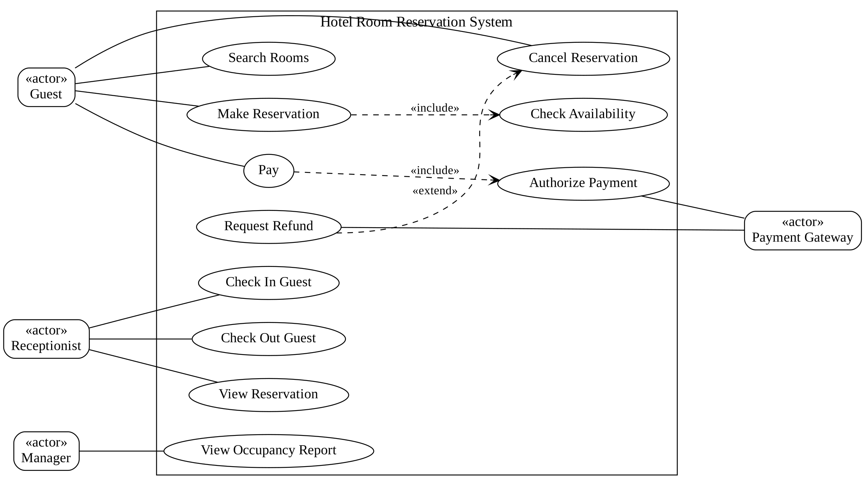
Use Case Diagram – Hotel Room Reservation System
Note: «include» is mandatory reused behaviour (Make Reservation always includes Check Availability; Pay always includes Authorize Payment). «extend» is optional or conditional behaviour (Request Refund extends Cancel Reservation only if payment was completed).
C. Use case description – Cancel Reservation
Item | Description
Use case | Cancel Reservation
Primary actor | Guest
Precondition | Guest has a valid reservation and is authenticated or provides the booking reference.
Main flow | 1. Guest selects the reservation.  2. System displays booking details and cancellation terms.  3. Guest confirms cancellation.  4. System changes status to Cancelled.  5. System updates room availability.  6. System displays confirmation.
Alternate flow | If the reservation is non-refundable or the cancellation deadline has passed, the system displays the applicable policy and any fee. The guest may confirm cancellation with the stated charge or choose to keep the reservation.
Postcondition | Reservation status and room availability are updated; a refund request is created when policy permits.
D. Class Diagram
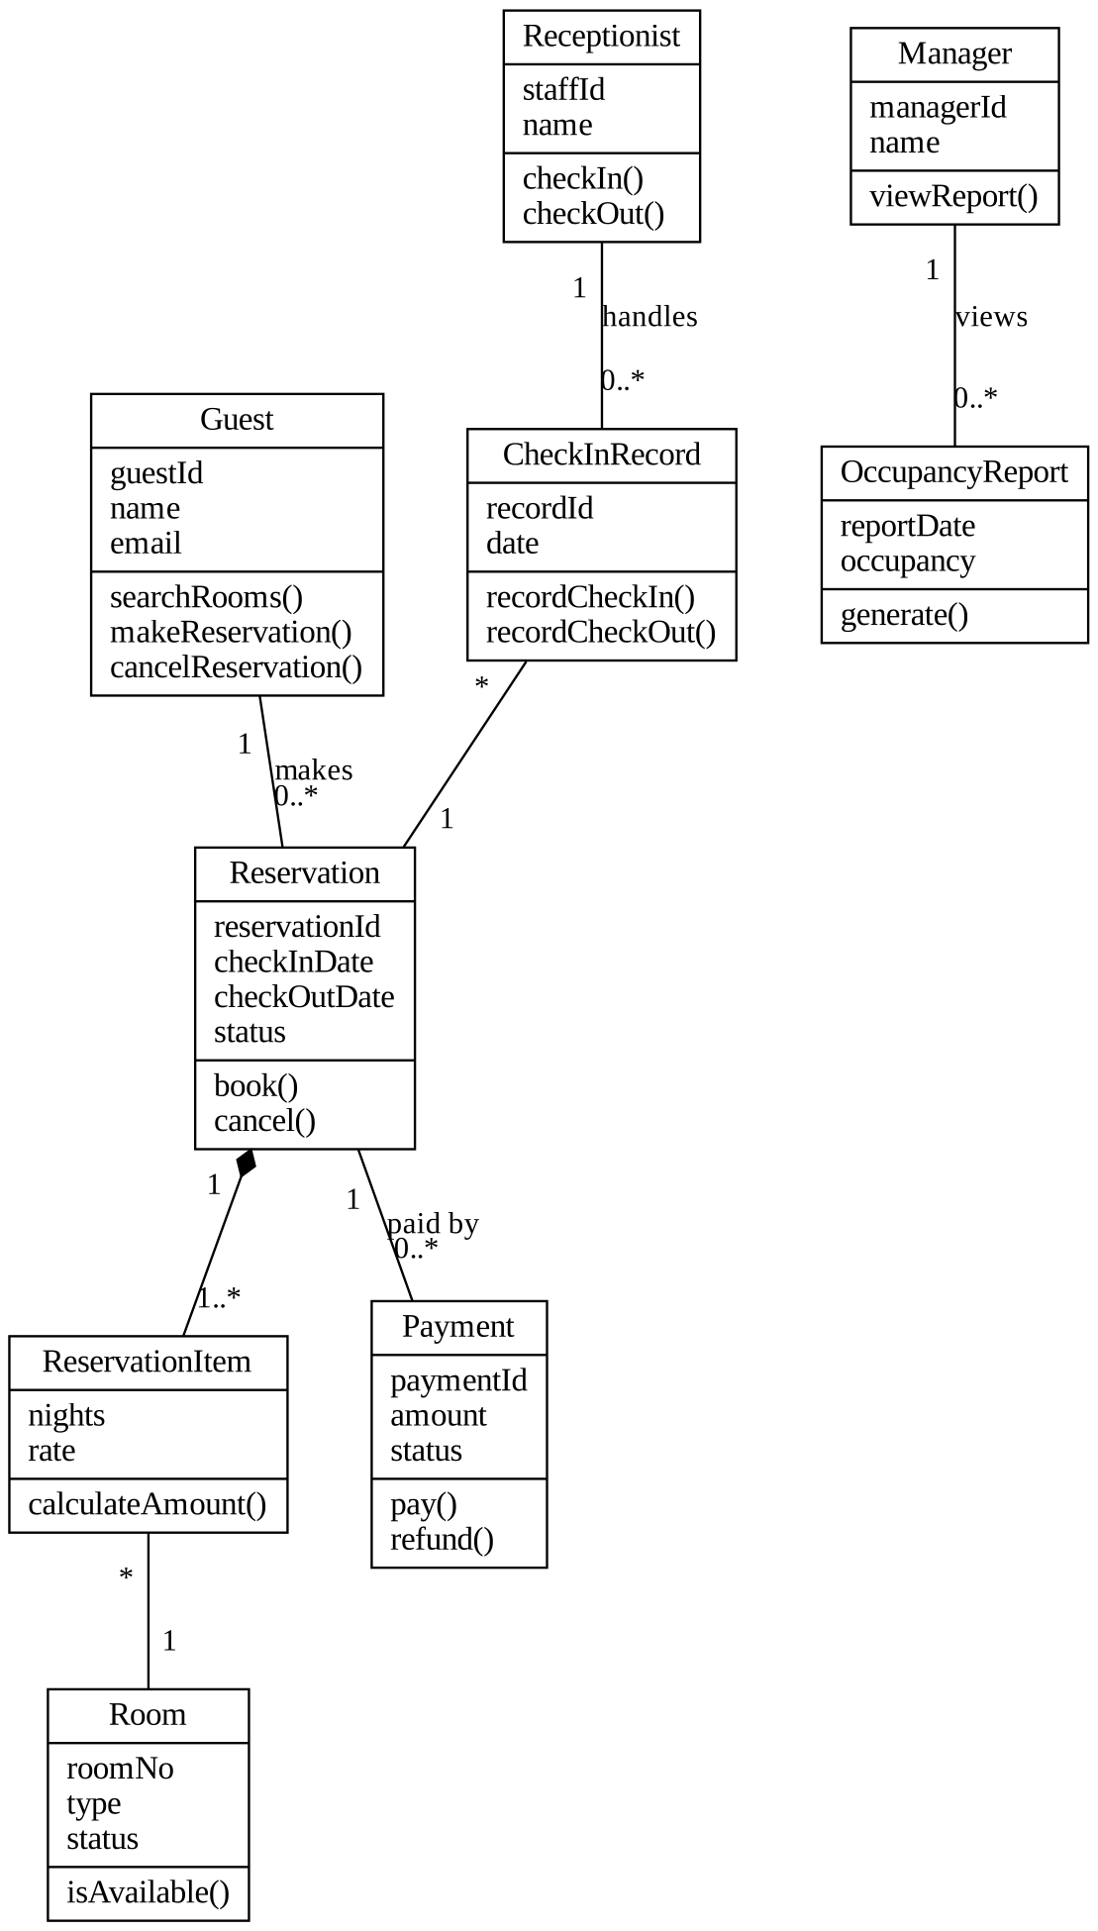
Class Diagram – Hotel Room Reservation System
Multiplicities: one Guest can have many Reservations; each Reservation contains one or more ReservationItems; each ReservationItem refers to one Room. A Reservation owns its ReservationItems (composition, shown by the filled diamond).
E. Justification
The Guest class supports searching, booking and cancellation. Reservation stores dates and status, while ReservationItem links a booking to the selected Room. Payment handles charges and refunds. Receptionist and CheckInRecord support arrival and departure activities. Manager and OccupancyReport support reporting. Multiplicities represent real hotel relationships, and composition ensures reservation items belong to their reservation. Therefore, the class structure provides the data and operations required by the use cases.

4. Online Examination System – Sequence and State Diagrams
A. Sequence Diagram
The sequence diagram shows the time-ordered messages exchanged by the Student, Exam Portal, Question Bank, Timer and Evaluator. If the Timer sends a timeout before the student submits, the Exam Portal auto-submits the saved answers to the Evaluator and marks the attempt as Expired according to exam policy; the Evaluator returns the result and the portal records the final status.
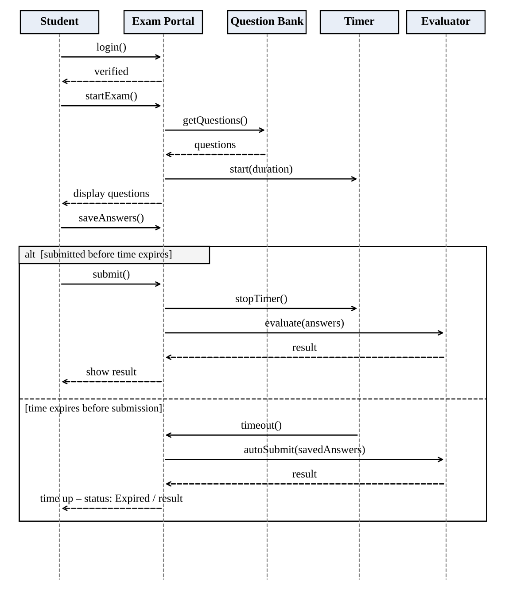
Sequence Diagram – Online Examination System
B. State Transition Diagram – Exam Attempt
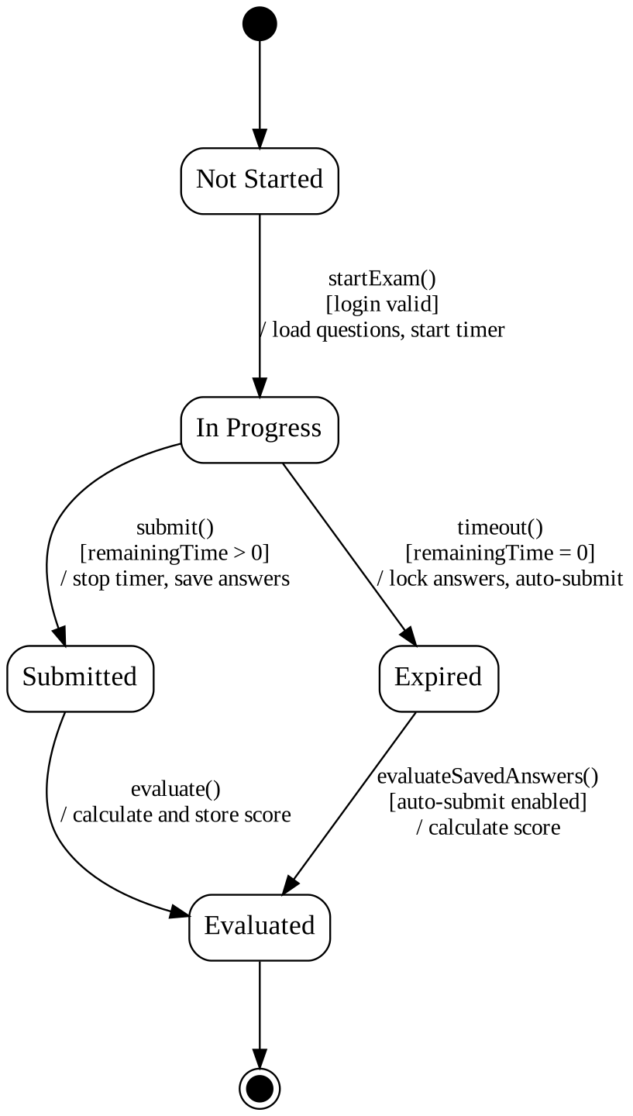
State Transition Diagram – Exam Attempt
Guard conditions are shown in [ ]; actions are shown after /.
C. How the diagrams complement each other
- The sequence diagram explains how objects communicate and the order in which messages occur during an exam.
- The state diagram explains the lifecycle of one Exam Attempt and the valid states it can enter.
- The sequence diagram shows who sends the timeout-related message; the state diagram shows that timeout changes the attempt from In Progress to Expired.
- Together, they help developers check both interaction logic and state rules, reducing errors such as accepting answers after the deadline.
Conclusion: Sequence and state diagrams provide complementary views—one focuses on object communication, while the other focuses on the lifecycle and permitted transitions of an exam attempt.

5. University Student Admission – UML Diagrams
The admission process involves an Applicant submitting information, the Admission Office verifying documents and preparing a merit list, the Department reviewing eligibility, and Accounts confirming fee payment.
A. Activity Diagram with swimlanes
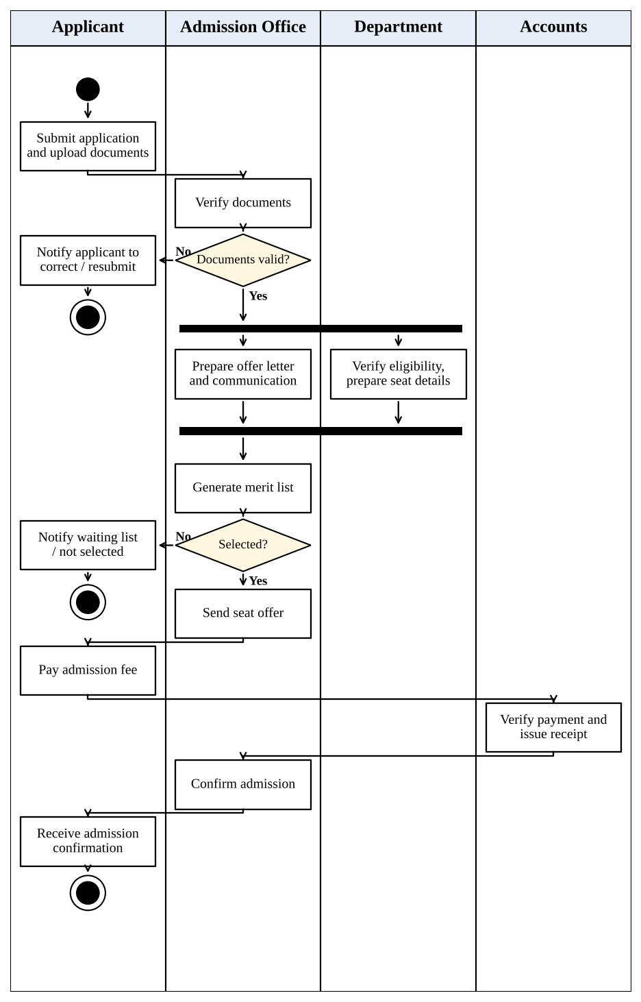
Activity Diagram with Swimlanes – Admission Process
Parallel activity: after documents are found valid, the Department verifies eligibility and prepares seat/section details while the Admission Office prepares the offer and student communication; both join before the merit list is generated.
B. Package Diagram
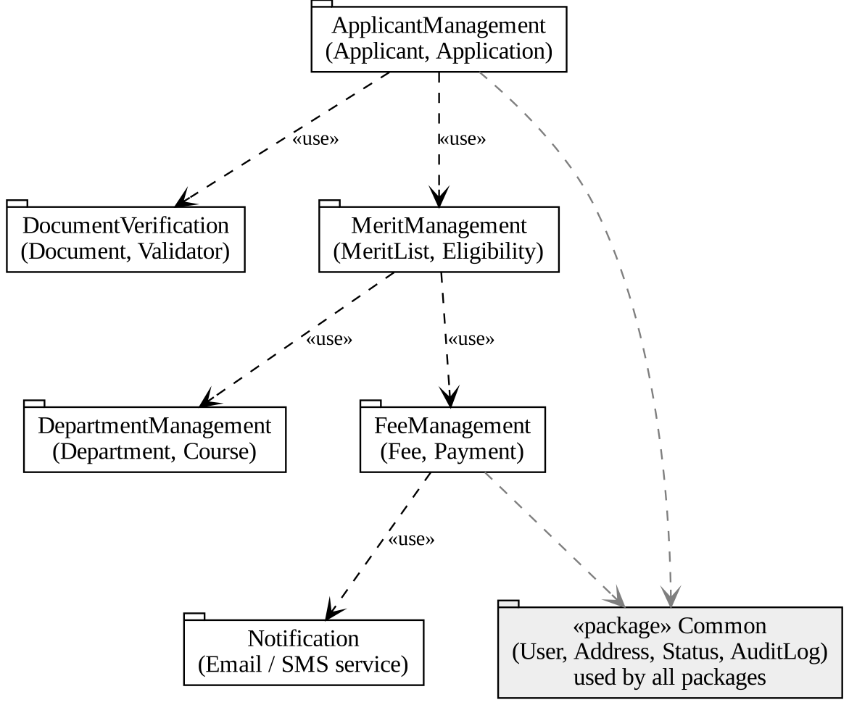
Package Diagram – Admission System
C. Component Diagram
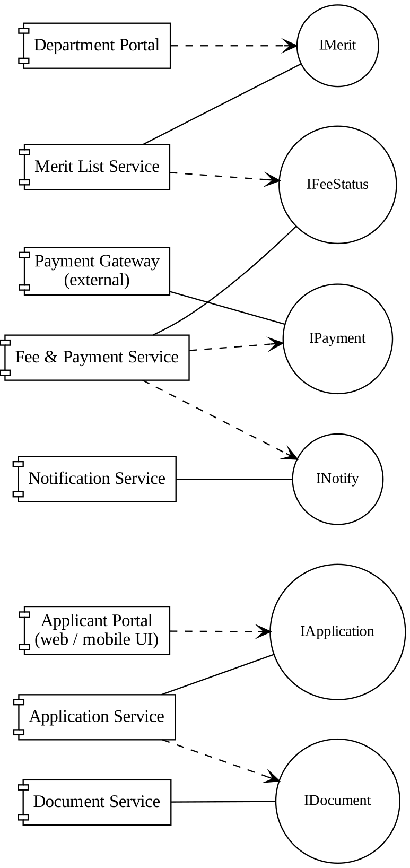
Component Diagram – Admission System
Solid lines ending in a circle are provided interfaces; dashed arrows are required interfaces. Interfaces: IApplication, IDocument, IMerit, IFeeStatus, IPayment, INotify.
D. Deployment Diagram
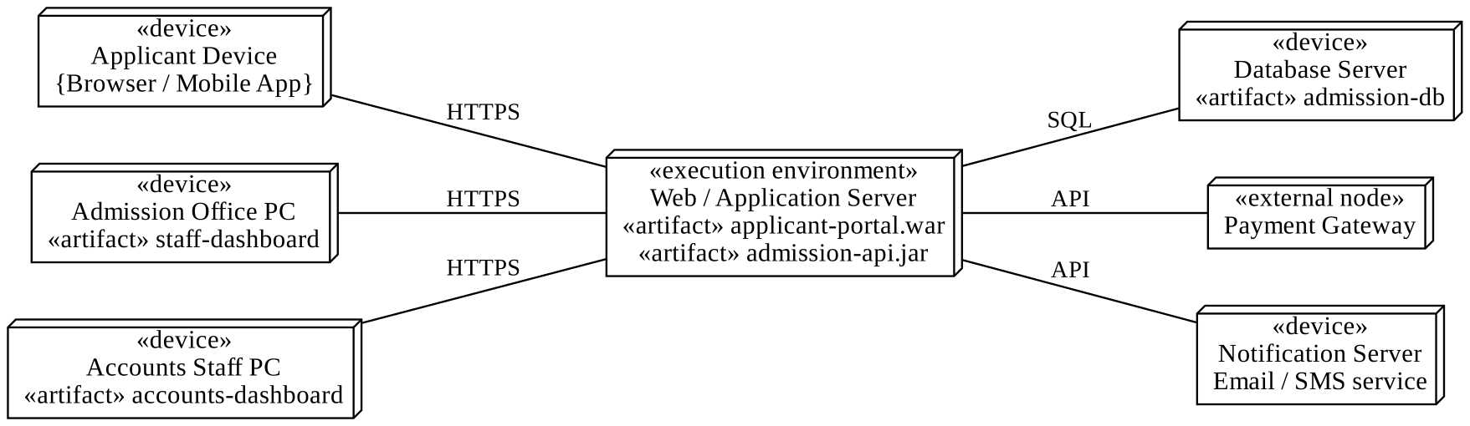
Deployment Diagram – Admission System
Artifacts: applicant-portal.war, admission-api.jar, admission-db, staff-dashboard, accounts-dashboard.
E. Benefits for the development team
- Activity diagram: clarifies workflow, responsibility of each department, decision points and parallel tasks.
- Package diagram: organizes classes into manageable modules and shows dependencies, making parallel development easier.
- Component diagram: identifies deployable software parts and the interfaces they provide or require, supporting integration and testing.
- Deployment diagram: shows the physical/runtime environment, servers, devices, network links and deployed artifacts, helping infrastructure planning.
Together, the diagrams give business users, developers, testers and system administrators a shared view of process, structure, interfaces and deployment.
Conclusion: These UML diagrams reduce ambiguity, clarify responsibilities and help the team build and integrate the admission system in a structured way.

