Algorithmic Credit Scoring Using Behavioral and Transactional Data
Day 1 — Data Integration and Preprocessing (ETL): Technical Report
Domain: Finance | Dataset: Semi_Unclear_Finance_Dataset_5000.xlsx (adapted as Master_Finance_Data.xlsx)

1. Objective
Acquire, clean, and integrate the raw transaction-level export into a single, analysis-ready master dataset, structured as a star schema, so it can support every downstream stage of the credit-scoring project (EDA, segmentation, fraud flagging, dashboards, forecasting).

2. Data Source Overview
The raw file contains a single sheet, "Transactions", with 5,000 rows and 15 columns, spanning transaction dates from 1 Jan 2025 to 25 Jun 2026 across 801 distinct customers (multiple transactions per customer).
Column | Description
CustomerID / TransactionID | Customer identifier (repeats) and unique transaction identifier
TransactionDate | Date of the transaction
Age, Gender, Occupation, Region | Demographic attributes recorded at the time of the transaction
Income | Reported income at the time of the transaction (frequently missing)
TransactionAmount, MerchantCategory, PaymentMethod | Transaction-level details
BehaviorScore | Behavioral score (0–100 scale)
LoanAmount, CreditScore, DefaultFlag | Credit variables: outstanding loan amount, credit score (300–900 scale), and default indicator (1 = defaulted)

3. Methodology

3.1 Extract
The Transactions sheet was loaded in full (5,000 rows × 15 columns) using pandas / openpyxl. No rows were excluded at extraction.

3.2 Transform — Cleaning Steps Applied
Issue Found | Resolution | Rows Affected
Whitespace inconsistency in Region ('South ' vs 'South') | Trimmed whitespace on all text columns; 'South ' merged into 'South', reducing Region from 5 to 4 categories | 56 rows
TransactionDate stored as text | Parsed to a proper datetime type; Year, Month, MonthName, Quarter derived | 5,000 rows
Income missing | ~50% missing. Too large a share to safely impute as a point estimate; original left null, IsIncomeMissing flag added, and a separate segment-median Income_Imputed column supplied for charting only (not for modelling) | 2,501 rows (50.0%)
TransactionAmount missing | Imputed using the median TransactionAmount for the same MerchantCategory; IsTransactionAmountMissing flag retained | 49 rows (0.98%)
Duplicate records | Checked on TransactionID (business key) and on full-row basis | 0 found
Out-of-range / invalid values | Validated Income ≥ 0, TransactionAmount ≥ 0, CreditScore ∈ [300,900], Age ∈ [18,100] | 0 found
Business-rule consistency | Verified no row has LoanAmount = 0 with DefaultFlag = 1 (cannot default with no loan) | Rule holds (0 violations)

3.3 Load — Star Schema Design
A modelling decision was required before building the schema: profiling showed that Age, Gender, Occupation, Region, Income and CreditScore are NOT stable per CustomerID — they vary across a given customer's own transactions (verified for all 801 customers). Rather than force a conventional one-row-per-customer Dim_Customer, which would silently overwrite genuine point-in-time variation such as a customer's CreditScore changing between transactions, these fields are kept as point-in-time attributes on the fact row. CustomerID remains on the fact table as a degenerate dimension. This preserves the credit-relevant history that the later modelling stages depend on.
The resulting schema:
- Fact_Transactions — grain: one row per TransactionID (5,000 rows). Contains the FKs below plus measures: Age, Income, TransactionAmount, BehaviorScore, LoanAmount, CreditScore, DefaultFlag, and data-quality flags.
- Dim_Date — 541 distinct dates, with Year / Month / Quarter / DayOfWeek attributes.
- Dim_MerchantCategory — 6 categories (Groceries, Bills, Shopping, Travel, Dining, Fuel).
- Dim_PaymentMethod — 4 methods (UPI, NetBanking, Cash, Card).
- Dim_Occupation — 5 occupations (Retired, Student, Salaried, Unemployed, Self-Employed).
- Dim_Region — 4 regions (East, North, South, West) after cleaning.
- Dim_Gender — 2 categories (F, M).
Every fact row joined successfully to all six dimensions with zero orphaned foreign keys (referential integrity check passed).

4. Data Quality Findings — Summary
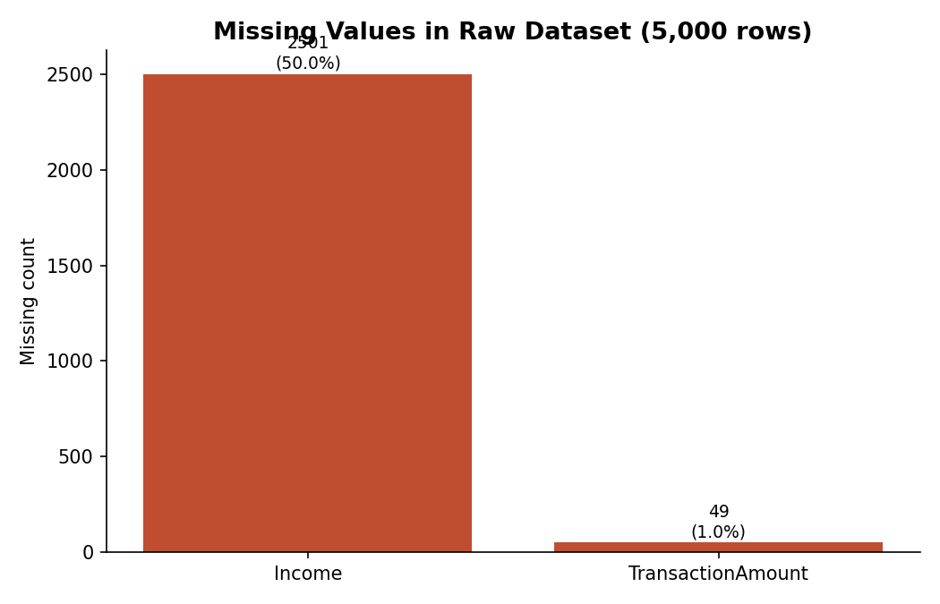
Income is the dominant data-quality gap (50.0% missing), spread evenly across occupation segments rather than concentrated in one group — consistent with values simply not being captured at the point of transaction. TransactionAmount had a small, easily-imputed gap (0.98%).
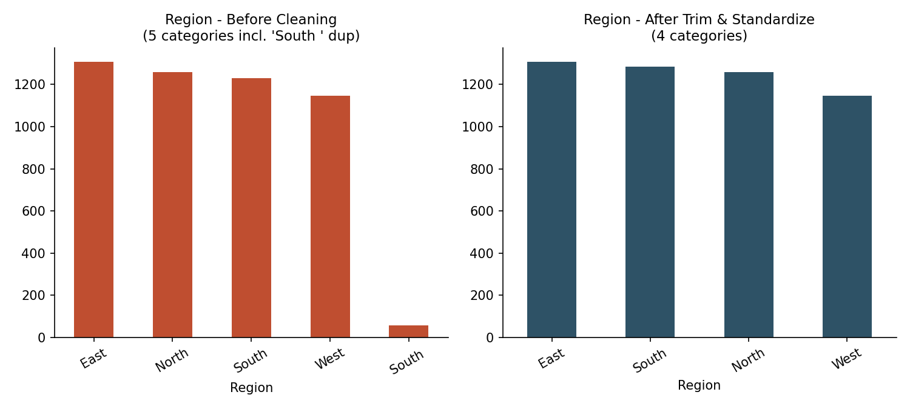
Region contained a whitespace-only duplicate ('South ' vs 'South'); trimming text fields resolved this and every other categorical column checked clean.

5. Visual Overview of the Cleaned Data
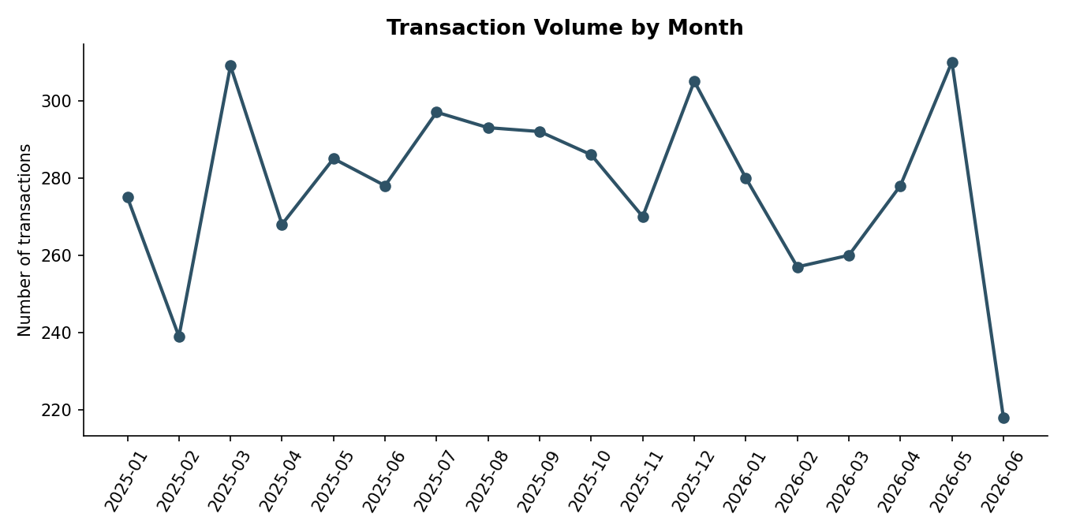
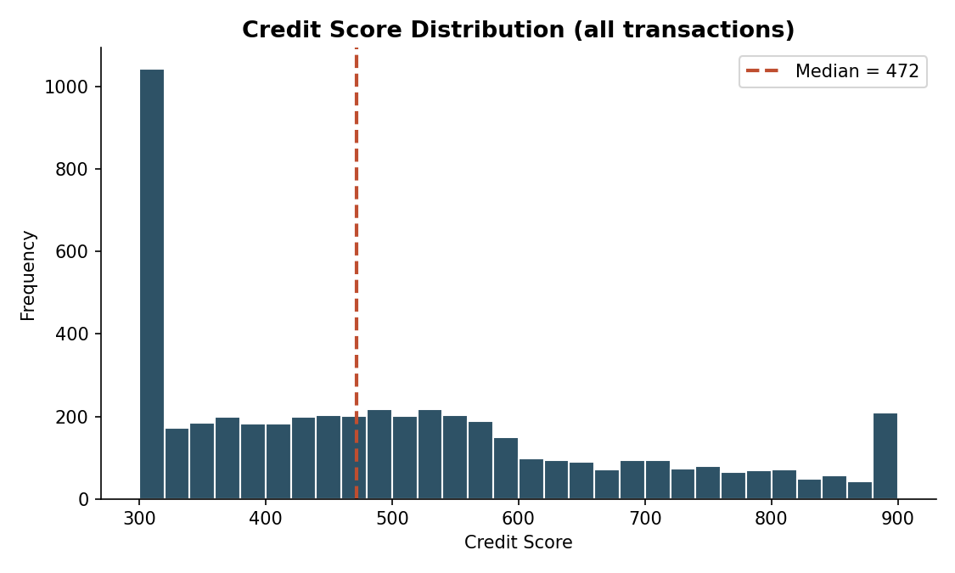
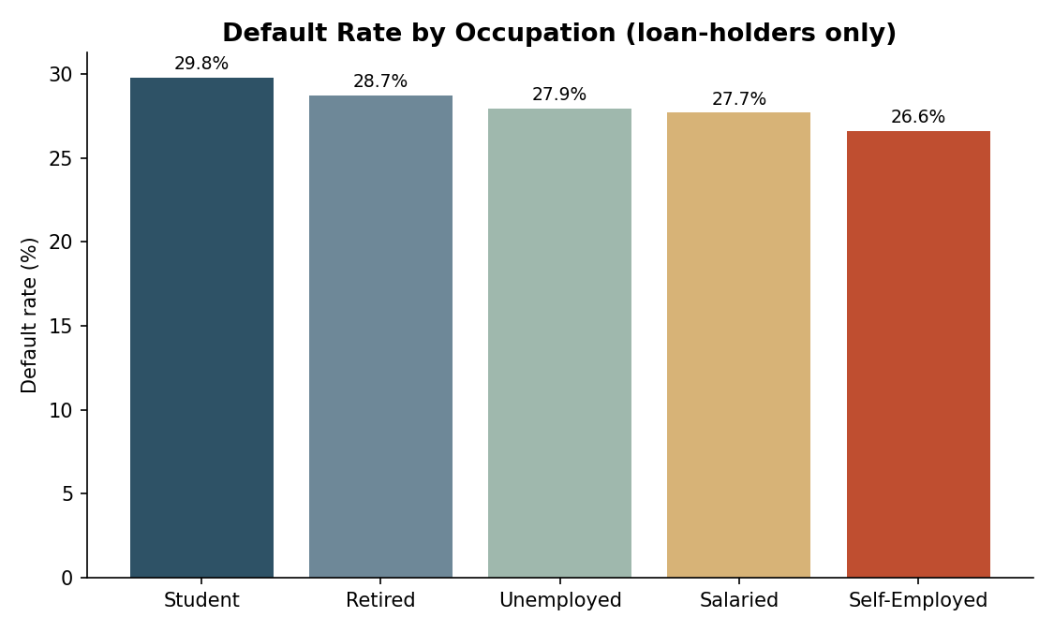
These charts (and two more — Region before/after, Income by Occupation) are reproduced at full size on the Dashboard tab of Master_Finance_Data_Cleaned.xlsx.

6. Deliverables
Deliverable | File
Technical report | Day1_Technical_Report.docx (this document)
Cleaned & processed dataset | Master_Finance_Data_Cleaned.xlsx — Cleaned_Flat_Table, 6-table star schema (Fact_Transactions + 6 dimensions), Data_Quality_Log
Visualization / dashboard | Dashboard tab inside Master_Finance_Data_Cleaned.xlsx (6 charts)
Code scripts | etl_star_schema.py (ETL + star schema build), make_charts.py, add_dashboard.py, format_sheets.py

7. Assumptions & Limitations
- Income_Imputed (segment-median by Occupation) is provided strictly for descriptive charting. It should not be fed into the credit-scoring model as if it were observed income without explicitly flagging IsIncomeMissing as a feature or excluding those rows, since 50% imputation can materially distort a risk model.
- CreditScore in this dataset uses a 300–900 scale (not the standard FICO 300–850); this is treated as the project's internal scale and used consistently as-is.
- Because customer attributes are time-variant, any customer-level aggregation performed in later days (e.g. RFM segmentation) should be built from Fact_Transactions directly (e.g., most recent transaction per customer) rather than from an implied static customer profile.
- No rows were removed during cleaning; all 5,000 transactions are retained in both the flat cleaned table and the star schema.

