Algorithmic Credit Scoring Using Behavioral and Transactional Data
Day 2 — Descriptive Statistics & Exploratory Data Analysis: Technical Report
Domain: Finance | Input: Master_Finance_Data_Cleaned.xlsx (Day 1 output)

1. Objective
Perform a comprehensive exploratory analysis on the cleaned dataset to understand distributions, identify outliers, and quantify which variables are most associated with DefaultFlag — the target the whole project is ultimately built around.

2. Methodology
- Descriptive statistics (count, mean, median, std dev, quartiles, skew) computed for all 7 numeric fields.
- Frequency distributions computed for all 5 categorical fields.
- Outlier scan using the standard IQR method (1.5× interquartile range) on 6 numeric fields.
- Pearson correlation matrix across all numeric fields, including DefaultFlag.
- Default-rate cuts by Occupation, Region and Income bracket for early risk profiling.

3. Distributions
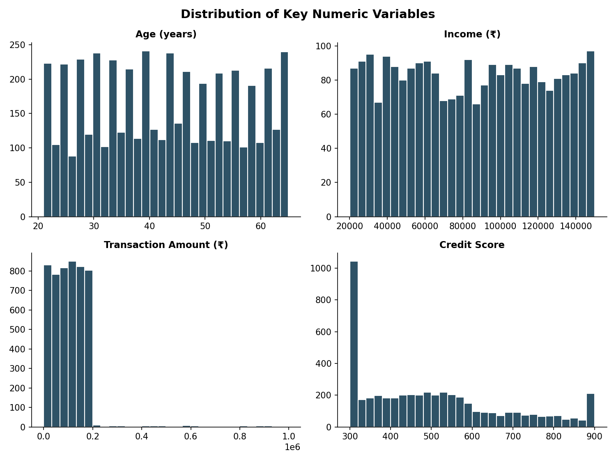
Age and CreditScore are close to uniformly spread across their ranges. Income is right-skewed, as expected for income data. TransactionAmount shows a similar right skew with a long tail toward high-value transactions.

4. Outlier Scan
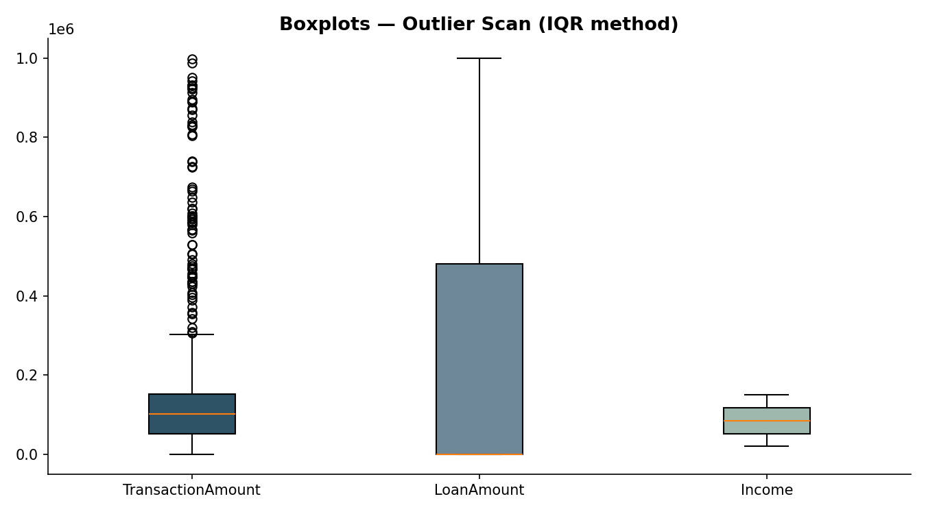
The IQR (1.5×) method found meaningful outliers in only one field: TransactionAmount, with 76 values (1.52%) above the upper bound of ₹304,732 — large but plausible transactions, not data errors, given the dataset's realistic range up to ~₹998K. Income, LoanAmount, BehaviorScore, CreditScore and Age all came back with 0 IQR outliers; their bounded, evenly-spread ranges (e.g. CreditScore 300–900, BehaviorScore 20–100) don't produce classic long-tail outliers.

5. Correlation Analysis
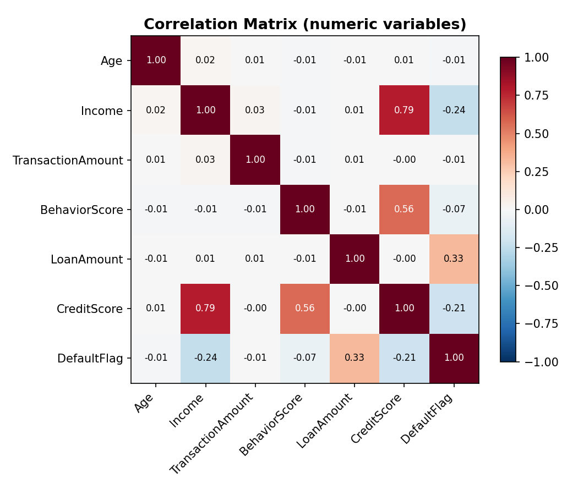
Ranked by absolute correlation with DefaultFlag: LoanAmount is the strongest correlate (r=0.326, positive — larger loans associate with more defaults), followed by Income (r=-0.242, negative — higher income associates with fewer defaults) and CreditScore (r=-0.208, negative, as expected for a credit score). BehaviorScore, Age and TransactionAmount show only weak correlation with default (|r|<0.07), suggesting they carry limited standalone predictive signal for default risk in this dataset.
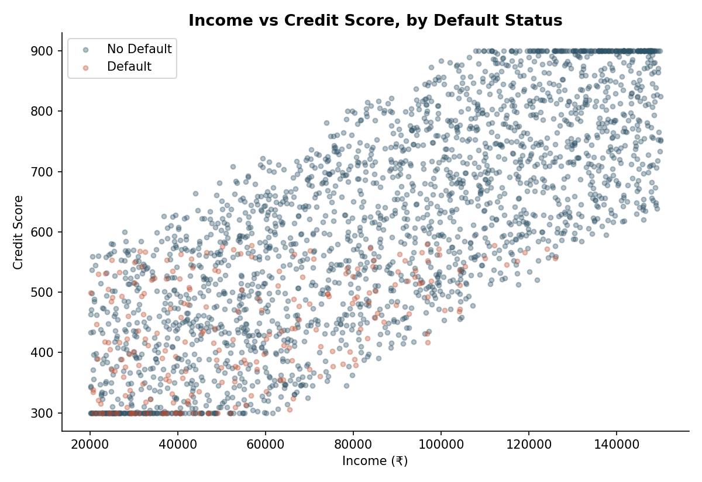
Plotting Income against CreditScore and coloring by DefaultFlag shows defaults (red) scattered broadly rather than confined to one corner — consistent with the modest correlation strengths above; no single pair of variables cleanly separates defaulters from non-defaulters.

6. Segment-Level Default Rates
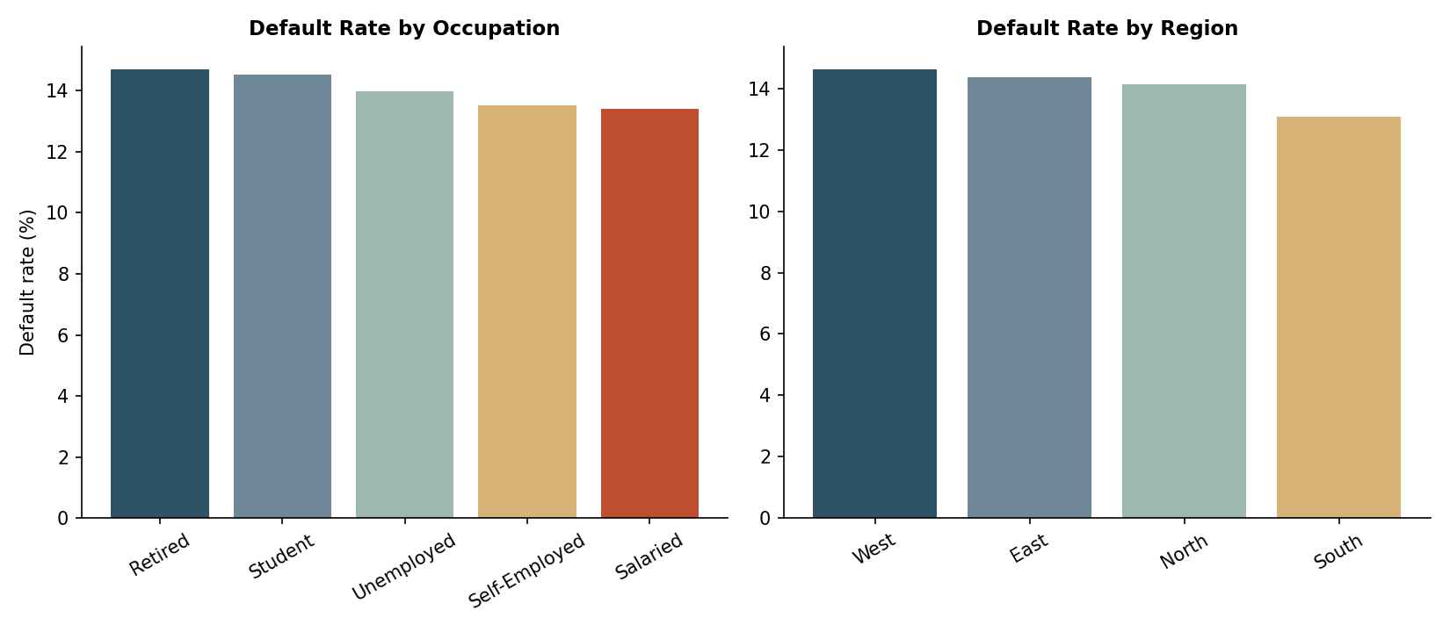
Default rate by Occupation is fairly flat (13.4%–14.7%), with Retired customers highest (14.7%) and Salaried lowest (13.4%) — occupation alone is a weak differentiator of risk, consistent with the low correlation of Age/BehaviorScore with default seen above.

7. Category Frequencies
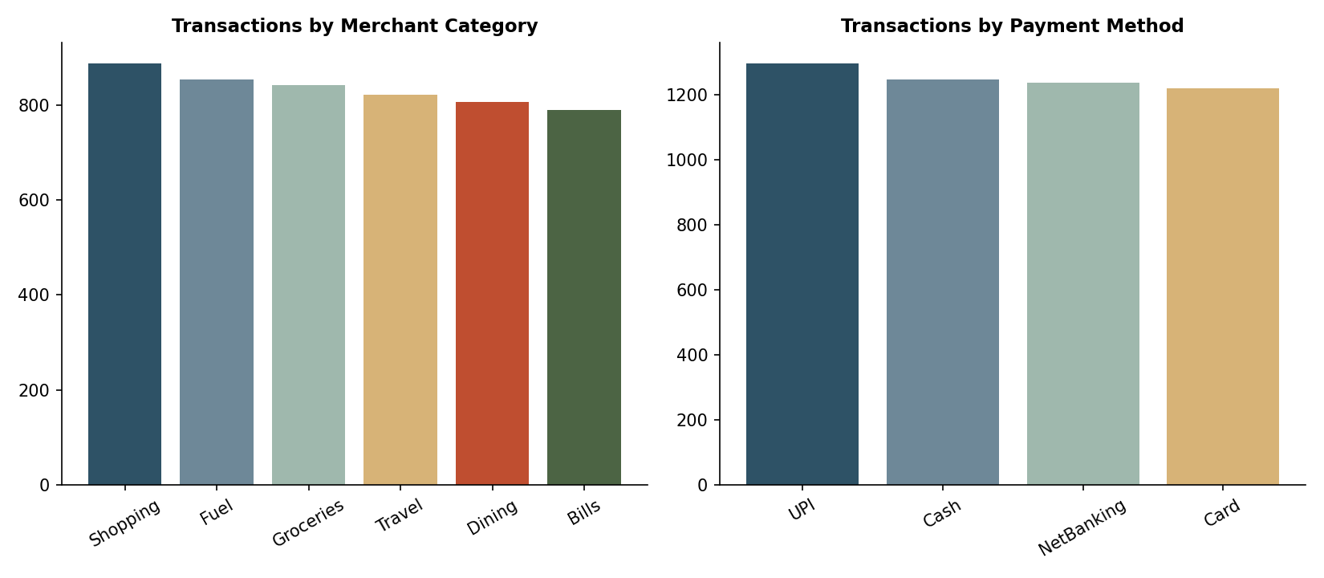
Merchant category and payment method volumes are reproduced on the Dashboard tab for reference; both are close to evenly distributed across their categories, with no single category dominating transaction volume.

8. Key Takeaways for Later Days
- LoanAmount, Income and CreditScore are the three variables most worth prioritizing in any predictive/risk-scoring work later in the project — they carry the clearest (if still moderate) relationship with DefaultFlag.
- TransactionAmount is the only field with a notable outlier tail (1.52%) — worth revisiting if a model proves sensitive to extreme transaction values.
- Occupation and Region show limited standalone power to separate default risk; they may still help in combination with other features but shouldn't be treated as strong risk signals on their own.

9. Deliverables
Deliverable | File
Technical report | Day2_Technical_Report.docx (this document)
Cleaned & processed dataset | Master_Finance_Data_EDA.xlsx — Descriptive_Numeric, Descriptive_Categorical, Outlier_Scan, Correlation_Matrix, Correlation_vs_Default, Default_by_Occupation, Default_by_Region, Default_by_IncomeBracket, Methodology_Log
Visualization / dashboard | Dashboard tab inside Master_Finance_Data_EDA.xlsx (6 charts)
Code scripts | eda_analysis.py (statistics + correlation build), make_charts.py, add_dashboard.py, format_sheets.py

10. Assumptions & Limitations
- Correlation is Pearson (linear) only; non-linear relationships between variables and DefaultFlag are not captured by this pass and would need a model-based feature-importance check later in the project.
- Income used for the income-bracket cut is Income_Imputed (segment-median fill for the 50% missing rows carried over from Day 1) — bracket-level default rates for the imputed portion should be read as indicative, not exact.
- IQR outlier detection assumes roughly unimodal distributions; it is less meaningful for CreditScore and BehaviorScore, which are closer to uniform by design in this dataset.

