Algorithmic Credit Scoring Using Behavioral and Transactional Data
Day 3 — Customer Segmentation using RFM Analysis: Technical Report
Domain: Finance | Input: Master_Finance_Data_Cleaned.xlsx (Day 1 output)

1. Objective
Segment the project's 801 customers using RFM (Recency, Frequency, Monetary) behavioral analysis, then connect each segment to credit-risk indicators (average CreditScore, default rate, BehaviorScore) so the segmentation is directly useful for credit-scoring decisions, not just marketing.

2. Methodology

2.1 Why aggregate from Fact_Transactions, not a customer master table
As established in Day 1, a customer's Age, Income and CreditScore are point-in-time values that change across their own transactions — there is no single stable 'customer record' to pull from. RFM metrics are therefore computed by aggregating all of Fact_Transactions per CustomerID directly, and CreditScore / BehaviorScore are summarized as an AVERAGE across a customer's transaction history rather than taken from one arbitrary row.

2.2 RFM metric definitions
Metric | Definition
Recency (R) | Days between each customer's most recent transaction and the reference date (26 Jun 2026, one day after the latest transaction in the dataset). Lower = more recently active.
Frequency (F) | Total count of transactions per customer over the full 1 Jan 2025 – 25 Jun 2026 window.
Monetary (M) | Sum of TransactionAmount across all of a customer's transactions.

2.3 Scoring and segmentation
Each of R, F and M was split into quartiles and scored 1 (lowest) to 4 (highest), with Recency reversed so that a score of 4 always means 'good' (most recent, most frequent, highest spend). Frequency ties were broken with a stable rank before quartiling so quartiles remained evenly sized. The three digit scores were combined into an RFM_Score (e.g. '432') and an RFM_Total (sum, 3–12), and each customer was assigned to one of 8 behavioral segments using standard RFM heuristics (e.g. R≥4,F≥4,M≥4 → Champions; R≤2,F≤2,M≤2 → Hibernating).

3. Segment Results
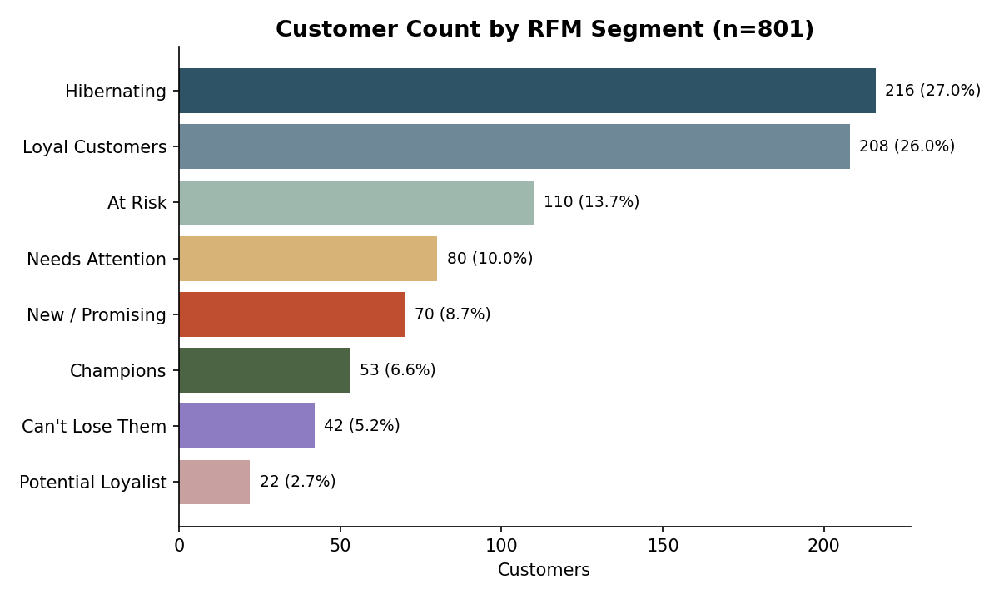
Hibernating (216, 27%) and Loyal Customers (208, 26%) are the two largest groups, together over half the base. Champions — the highest-value, most engaged customers — make up 53 customers (6.6%), and Potential Loyalist is the smallest segment at 22 (2.7%).
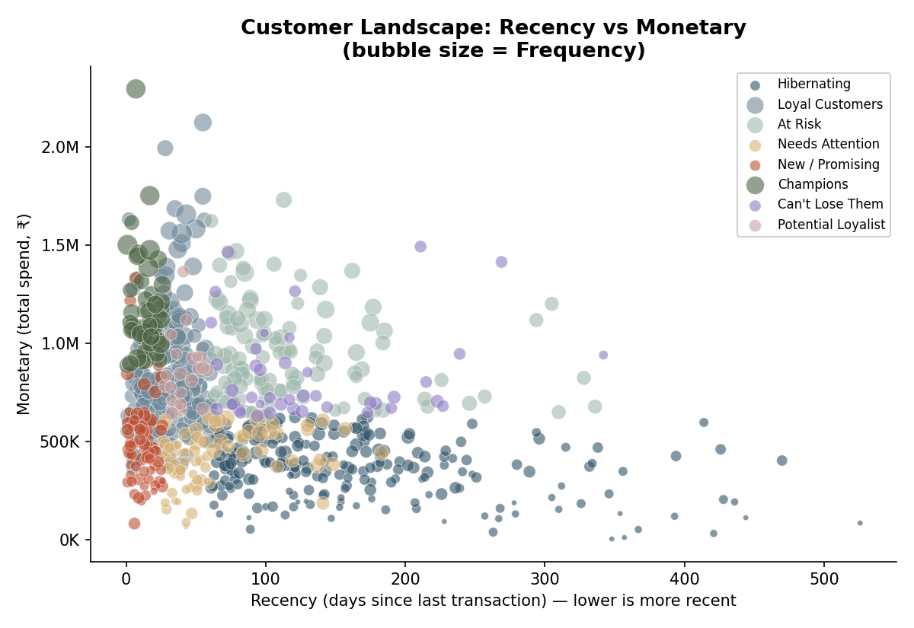
The Recency-vs-Monetary view (bubble size = Frequency) shows Champions clustered at low recency / high monetary with large bubbles (high frequency), while Hibernating customers sit at high recency (inactive) with small, low-value bubbles — the segmentation is behaving as expected.
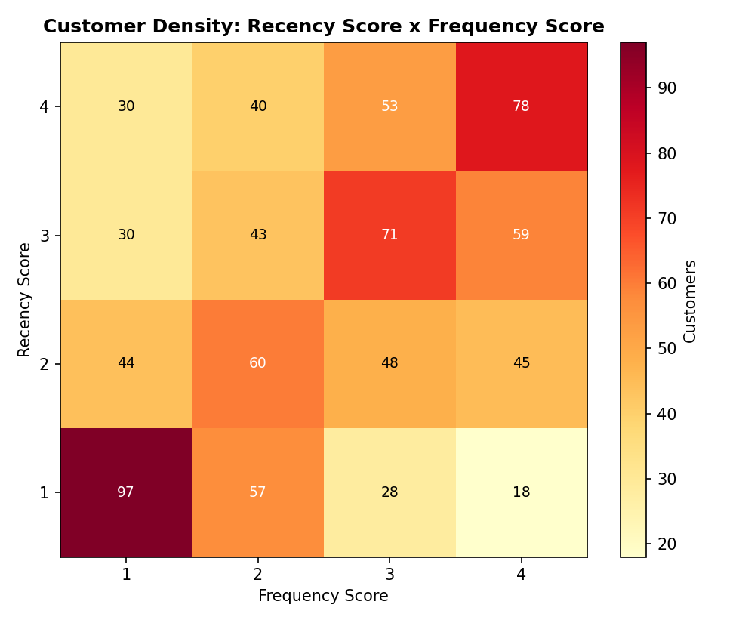
The Recency-score x Frequency-score density heatmap shows the customer base is not evenly spread — there is a concentration at low R / low F (disengaged) and a separate cluster at high R / mid-high F (engaged), rather than a smooth continuum.

4. Credit-Risk Overlay
Because this is a credit-scoring project, each segment's average CreditScore and default rate were also computed, to test whether engagement behavior lines up with credit risk.
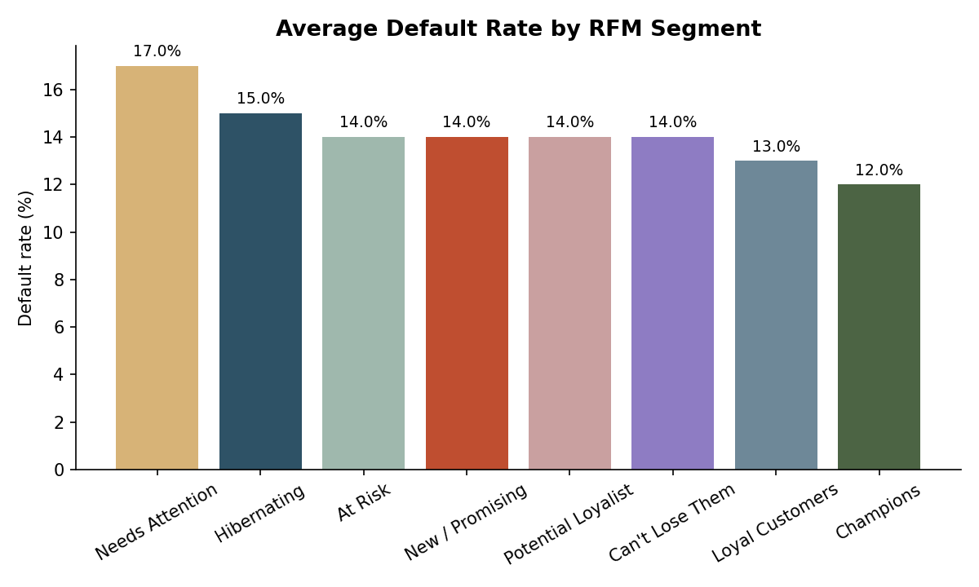
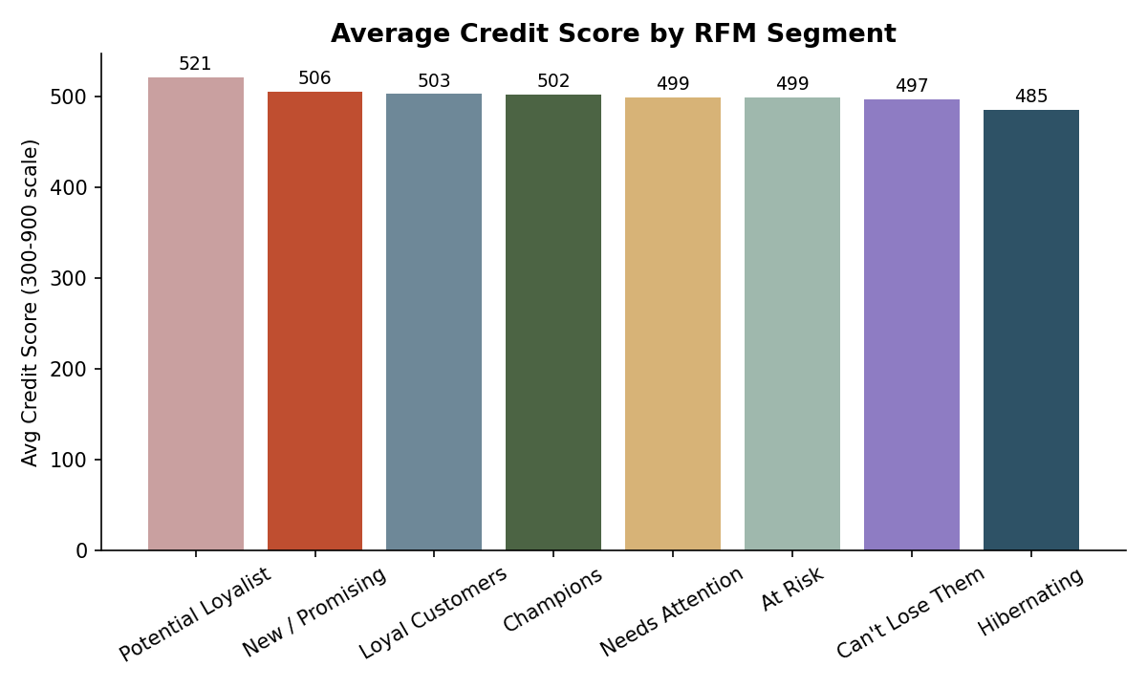
Default rates are fairly close across segments (12%–17%), with Needs Attention highest (17.1%) and Champions lowest (11.7%). Average CreditScore is also fairly flat across segments (485–521), with Potential Loyalist notably higher (521) despite being the smallest segment. This suggests engagement/spend behavior (RFM) and credit risk are only weakly related in this dataset — RFM segments should be treated as a behavioral/engagement view, not a substitute for a dedicated credit-risk score.

5. Segment Profile Table
Segment | Customers | Avg Recency (days) | Avg Frequency | Avg Monetary (₹) | Avg CreditScore | Avg Default Rate
Hibernating | 216 | 167.6 | 3.92 | 367,460 | 485 | 15.0%
Loyal Customers | 208 | 31.1 | 7.92 | 831,571 | 503 | 13.0%
At Risk | 110 | 120.3 | 8.05 | 946,403 | 499 | 14.0%
Needs Attention | 80 | 64.1 | 5.29 | 424,544 | 499 | 17.1%
New / Promising | 70 | 12.2 | 4.59 | 505,567 | 506 | 14.0%
Champions | 53 | 14.3 | 10.13 | 1,160,585 | 502 | 11.7%
Can't Lose Them | 42 | 133.0 | 5.26 | 841,069 | 497 | 14.0%
Potential Loyalist | 22 | 41.8 | 5.41 | 850,489 | 521 | 14.0%

6. Deliverables
Deliverable | File
Technical report | Day3_Technical_Report.docx (this document)
Cleaned & processed dataset | Customer_RFM_Segments.xlsx — Customer_RFM (801 rows), Segment_Profile (8 segments), Methodology_Log
Visualization / dashboard | Dashboard tab inside Customer_RFM_Segments.xlsx (5 charts)
Code scripts | rfm_segmentation.py (RFM build), make_charts.py, add_dashboard.py, format_sheets.py

7. Assumptions & Limitations
- RFM quartile cut points are relative to this dataset only (801 customers); segment boundaries would shift on a different customer base or time window.
- CreditScore/BehaviorScore per customer are averages across all of that customer's transactions, smoothing over any real point-in-time change — appropriate for a general standing view, but not a substitute for the point-in-time CreditScore used in fraud/default modelling on individual transactions.
- Default rate here is computed only over transactions that carried a loan (LoanAmount > 0 rows contribute the DefaultFlag signal); customers with very few loan-bearing transactions have noisier default-rate estimates.
- The weak link observed between RFM segment and credit risk means engagement-based segments (this report) and risk-based segments (to be built in later days) should be used as complementary views, not interchangeably.

