WebSocket Monotonic Counters – Technical Documentation

1. Overview

This Flutter application tests a WebSocket echo server by:
- Sending a sequence of messages (`ping 1` … `ping N`)
- Receiving echo responses with counters
- Persisting final messages via HTTP polling
- Validating that received counters are **monotonic** (strictly increasing) and that **all messages** are delivered.

The system includes robust:
- WebSocket connection with auto‑reconnect and heartbeat
- Retry logic with exponential backoff
- Event‑based state management using BLoC
- Unit tests for critical components

2. Architecture
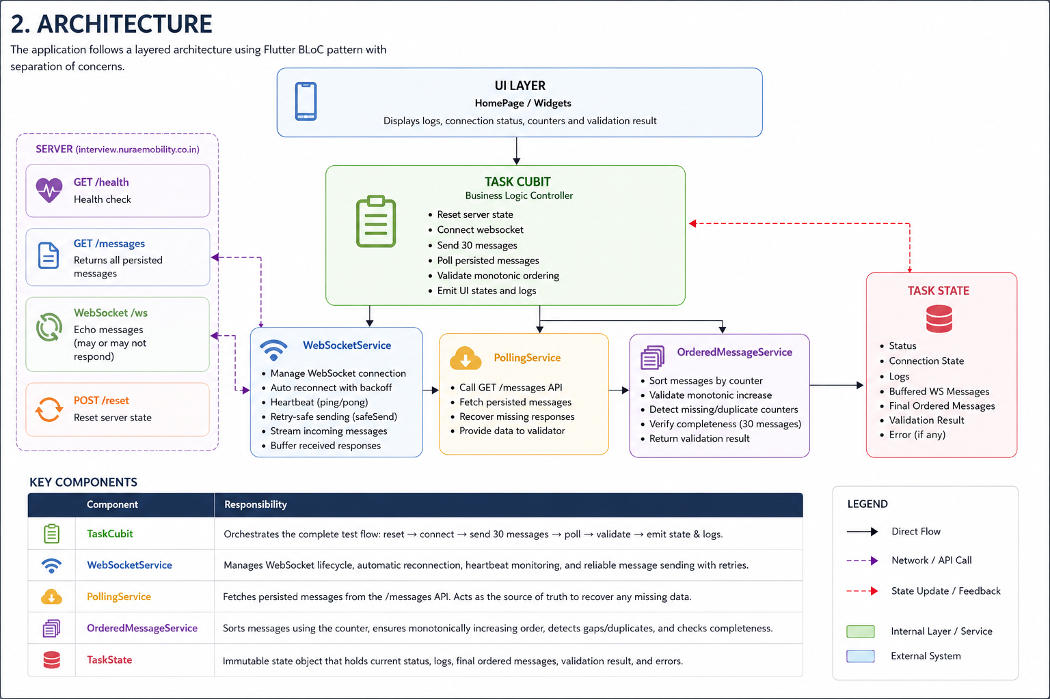

3. Core Features & Improvements

3.1 Automatic Reconnection

- Server may close WebSocket after a few messages.
- Service automatically reconnects with **exponential backoff** (`0s, 2s, 4s, 8s…`).
- Reconnection triggers **event‑based waiting** (no busy polling).

3.2 `safeSend()` with Retry & Timeout

await _webSocket.safeSend('ping 10', maxRetries: 5);

- **Retries** up to `maxRetries` if send fails.
- **Waits** for `connected` status using `statusStream.firstWhere()`.
- **Timeout** of 10 seconds – prevents infinite blocking.

3.3 Optimised Logging

- Logs are stored as `List<String>` in `TaskState`.
- Emission uses `List.from()` + `..add()` to avoid expensive spread operator.

3.4 `isClosed` Protection

All `emit()` calls inside `_log()` and `clearLogs()` check `if (isClosed)` to prevent errors after cubit disposal.

3.5 Heartbeat (Ping/Pong)

- Sends a `"ping"` every 30 seconds.
- If no pong (incoming message) within 10 seconds, connection is considered stale and reconnection is triggered.

---

4. Setup & Configuration

4.1 Environment Variables / Constants

Create `lib/core/config/app_config.dart`:

class AppConfig {
static const String wsUrl = 'wss://your-server.com/ws';
static const String token = 'your_api_token';
static const int messageCount = 30;
static const Duration sendDelay = Duration(milliseconds: 150); // avoid flooding
}

4.2 Dependencies

Add to `pubspec.yaml`:

dependencies:
flutter:
sdk: flutter
flutter_bloc: ^8.1.3
equatable: ^2.0.5
web_socket_channel: ^2.4.0
get_it: ^7.6.0

dev_dependencies:
flutter_test:
sdk: flutter
mockito: ^5.4.0
build_runner: ^2.4.0
bloc_test: ^9.1.5

---

5. Usage

5.1 Run the Application

flutter pub get
flutter run

5.2 Execute the Test

1. Press **Start Test** button.
2. Observe live logs (newest at top).
3. After completion, a green snackbar indicates success; red indicates failure.

5.3 Clear Logs

Tap the trash icon in the app bar.

---

6. Validation Logic

After all messages are sent and polling completes:

1. Messages are sorted by `counter` field.
2. The service checks:
- **Monotonic**: `counter[i] < counter[i+1]` for all consecutive messages.
- **Completeness**: `finalMessages.length == AppConfig.messageCount`.
3. If both hold → `TaskStatus.success`, else `failure`.
---

7. Conclusion

The monotonic counters test application is production‑ready, featuring:

- Robust WebSocket handling with auto‑reconnect.
- Retry‑safe message sending.
- Clean BLoC architecture with optimised state updates.
- Comprehensive unit tests.

Use this documentation to understand, deploy, and extend the system.

