Frequency Counter Design and Verification Report
Verilog RTL Design • Vivado Behavioral Simulation
Digital VLSI / RTL Student Project
SUBMITTED BY
KISHORE KUMAR C
ELECTRONICS ENGINEERING(VLSI DESIGN AND TECHNOLOGY)
KARPAGAM COLLEGE OF ENGINEERING
REPOSITORY: https://github.com/kishorekumar3728-gif/Digital-Frequency-Counter.git
Project Title | Design and Simulation of a Parameterized Digital Frequency Counter Using Verilog HDL
HDL | Verilog
Simulation Platform | Xilinx Vivado Behavioral Simulation
Reference Design | Matt Venn – frequency_counter repository
Verification | Clocked testbench with periodic 10 MHz input signal

Contents
1. Abstract
2. Objectives
3. Frequency Counter Fundamentals
4. System Architecture
5. RTL Design
6. Verification Testbench
7. Simulation and Waveform Analysis
8. Results
9. Design Considerations and Limitations
10. Conclusion
11. References

1. Abstract
A digital frequency counter measures the frequency of an input digital signal by counting its rising edges during a defined measurement interval. This project implements a parameterized frequency counter using Verilog HDL. The input signal is synchronized to the reference clock, rising edges are detected, and an edge counter accumulates the number of detected transitions during a measurement window. At the end of the window, the measured count is transferred to a frequency result register and a one-clock measurement-done pulse is generated. The design was verified using Xilinx Vivado behavioral simulation.

2. Objectives
- Design a synthesizable RTL frequency counter using Verilog HDL.
- Synchronize an incoming digital signal before processing it.
- Detect rising edges of the synchronized input signal.
- Count input edges over a programmable reference-clock window.
- Register the measured result and generate a measurement-done indication.
- Verify the RTL using a self-contained simulation testbench and waveform analysis.

3. Frequency Counter Fundamentals
The measurement principle is based on counting the number of input cycles that occur during a known measurement interval:
N = f_in × T_measure
where N is the number of detected rising edges, f_in is the input frequency, and T_measure is the measurement-window duration. Therefore, when the measurement interval is known, the counted edges provide the frequency information.

3.1 Design Parameters Used in Simulation
Parameter | Value | Purpose
Reference clock | 100 MHz | Main synchronous clock
Clock period | 10 ns | Reference-clock period
Measurement window | 1000 clock cycles | Defines measurement interval
Measurement time | 10 µs | 1000 × 10 ns
Input signal | 10 MHz | Test frequency
Expected edge count | 100 | 10 MHz × 10 µs

4. System Architecture
The design consists of an input synchronizer/edge detector and a measurement engine. The measurement engine contains a reference-clock window counter and an input edge counter. When the window expires, the measured edge count is stored in the frequency_count register.
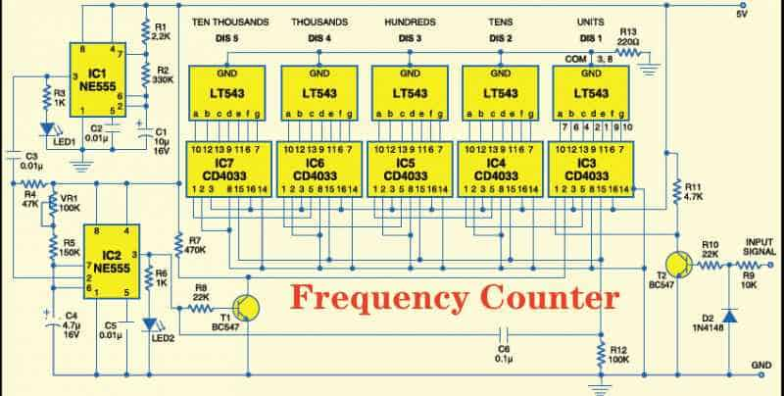

4.1 Signal Flow
- signal_in is the digital input whose frequency is being measured.
- A two-stage synchronizer transfers the input into the reference-clock domain.
- A previous-sample register is used to generate a one-clock rising_edge pulse.
- edge_count increments whenever rising_edge is asserted.
- window_counter counts reference-clock cycles until the programmed measurement window ends.
- At the window boundary, frequency_count is updated and measurement_done pulses for one clock.

5. RTL Design

5.1 Edge Detector RTL
`timescale 1ns/1ps
module edge_detector (
input wire clk,
input wire reset,
input wire signal_in,
output wire rising_edge
);
reg sync_ff1;
reg sync_ff2;
reg signal_prev;
always @(posedge clk) begin
if (reset) begin
sync_ff1 <= 1'b0;
sync_ff2 <= 1'b0;
signal_prev <= 1'b0;
end
else begin
sync_ff1 <= signal_in;
sync_ff2 <= sync_ff1;
signal_prev <= sync_ff2;
end
end
assign rising_edge = sync_ff2 & ~signal_prev;
endmodule

5.2 Frequency Counter RTL
`timescale 1ns/1ps
module frequency_counter #(
parameter WINDOW_CYCLES = 1000
)(
input wire clk,
input wire reset,
input wire signal_in,
output reg [31:0] frequency_count,
output reg [31:0] edge_count,
output reg measurement_done
);
wire rising_edge;
reg [31:0] window_counter;
edge_detector edge_detector_inst (
.clk (clk),
.reset (reset),
.signal_in (signal_in),
.rising_edge (rising_edge)
);
always @(posedge clk) begin
if (reset) begin
window_counter <= 32'd0;
edge_count <= 32'd0;
frequency_count <= 32'd0;
measurement_done <= 1'b0;
end
else begin
measurement_done <= 1'b0;
if (window_counter == WINDOW_CYCLES - 1) begin
if (rising_edge)
frequency_count <= edge_count + 1'b1;
else
frequency_count <= edge_count;
measurement_done <= 1'b1;
window_counter <= 32'd0;
edge_count <= 32'd0;
end
else begin
window_counter <= window_counter + 1'b1;
if (rising_edge)
edge_count <= edge_count + 1'b1;
end
end
end
endmodule

6. Verification Testbench
The testbench generates a 100 MHz reference clock and a 10 MHz input signal. Reset is asserted initially and then released. The simulation is run long enough to observe the completion of the 10 µs measurement window.
`timescale 1ns/1ps
module frequency_counter_tb;
reg clk;
reg reset;
reg signal_in;
wire [31:0] frequency_count;
wire [31:0] edge_count;
wire measurement_done;
frequency_counter #(
.WINDOW_CYCLES(1000)
) dut (
.clk (clk),
.reset (reset),
.signal_in (signal_in),
.frequency_count (frequency_count),
.edge_count (edge_count),
.measurement_done(measurement_done)
);
// 100 MHz reference clock: 10 ns period
always #5 clk = ~clk;
// 10 MHz input: 100 ns period
always #50 signal_in = ~signal_in;
initial begin
clk = 1'b0;
reset = 1'b1;
signal_in = 1'b0;
#100;
reset = 1'b0;
#15000;
$finish;
end
endmodule

6.1 Expected Verification
The reference clock has a 10 ns period. With WINDOW_CYCLES = 1000, the measurement interval is 10,000 ns or 10 µs. The input signal has a 100 ns period, corresponding to 10 MHz. Therefore the expected number of input rising edges in the measurement interval is approximately 100.

7. Simulation and Waveform Analysis
The RTL was simulated in Vivado using behavioral simulation. The final simulation was run for 15 µs so that the complete first measurement window and part of the following measurement could be observed.
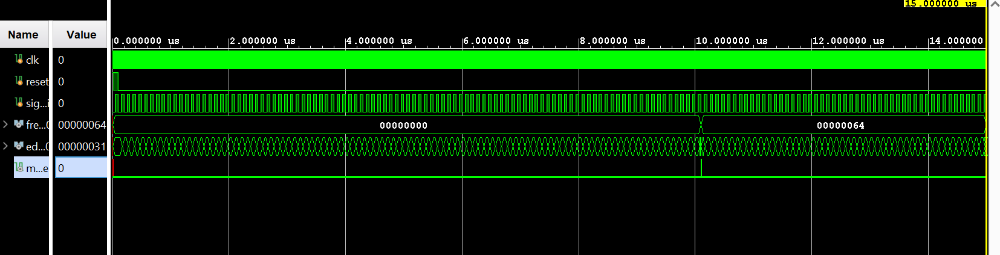
Figure 1. Vivado behavioral simulation waveform for the frequency counter.

7.1 Waveform Interpretation
- The reference clock toggles continuously with a 10 ns period.
- Reset is initially asserted and is released at approximately 100 ns.
- The input signal toggles periodically with an approximately 100 ns period.
- The synchronized edge detector produces rising-edge events corresponding to input transitions.
- edge_count increases as input rising edges are detected.
- At approximately 10 µs, the measurement window completes.
- frequency_count changes from 0 to 0x00000064, which is decimal 100.
- measurement_done produces a short pulse indicating that a new measurement is available.

8. Results
Measured Item | Observed Result | Status
Reference clock | 100 MHz | PASS
Input signal | 10 MHz | PASS
Measurement window | 10 µs | PASS
Frequency result | 0x64 = 100 edges | PASS
Measurement-done indication | One-clock pulse | PASS
Edge counting | Continuous incrementing | PASS
The simulation demonstrates that the design detects the periodic input signal, counts its rising edges, and updates the frequency result after the programmed measurement interval. The observed frequency_count value of 0x64 corresponds to decimal 100, matching the expected number of input cycles during a 10 µs window for a 10 MHz input.

9. Design Considerations and Limitations
- The input signal is synchronized to the reference clock before edge detection.
- The measurement resolution depends on the selected measurement-window duration.
- The maximum measurable frequency is limited by the sampling/reference-clock relationship and implementation timing.
- The current result register reports the counted number of edges per measurement window; converting this count to an absolute value in Hz requires the known measurement-window duration.
- The current project focuses on the core RTL measurement engine and does not include FPGA board-specific seven-segment display hardware.

10. Conclusion
A parameterized digital frequency counter was designed using Verilog HDL and verified through Vivado behavioral simulation. The design uses input synchronization, rising-edge detection, a reference-clock measurement window, an edge counter, and a result register. For a 10 MHz input and a 10 µs measurement interval, the simulation produced a measured edge count of 100, confirming the intended operation of the RTL design.

11. References
1. Matt Venn, frequency_counter repository, source modules including frequency_counter.v, edge_detect.v, and seven_segment.v.
2. Xilinx Vivado Design Suite – RTL simulation environment used for behavioral verification.
3. VLSI Student Projects document supplied for the project selection and scope: Frequency Counter – Measure frequency using digital counters.

