**CSYE 7245 Big Data Systems and Intelligence Analytics**

**Assignment - 07**

**Neural Networks**



***Submitted by,*  
Kishore Kumar Mohan (001664859)**

Q-1. Please fit Neural Network to "Semeion Handwritten Digit Data Set". (https://archive.ics.uci.edu/ml/datasets/Semeion+Handwritten+Digit)  
Make sure you randomly sample the data into train and test datasets.

* You need to find the optimum number of hidden layers and related nodes for each model.
* You may use dimension reduction.
* Submit your code and a brief report.
* Your work is expected to be original and not copy

**Approaches:**

1. Running neural nets without image dimensionality reduction
2. Running neural nets with image dimensionality reduction

**Running neural nets without image dimensionality reduction (16x16 images = 256 pixels):**

**Step-1:** Image read as 16x16 matrix and the complete set (1593 rows) is saved under the folder “images” with the name “row_<rownum>_num_<actualnum>.png”

Actual Images:

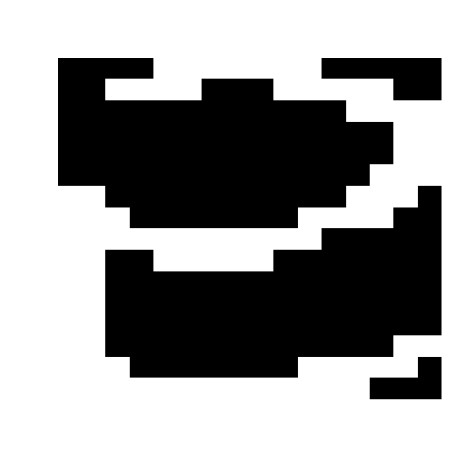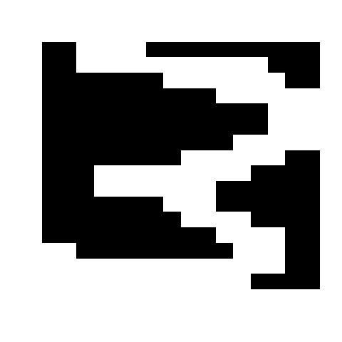

**Step-2:** Images are flattened to 256 individual pixels and 75% images fed to neural network with hidden layers of dimension - 312,128,64,32,16,10

Code: 

**Step-3:** The remaining 25% is validated with the model and a final accuracy of 47% is obtained.

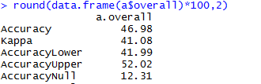

Confusion Matrix:

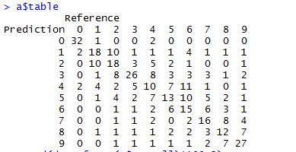

**Running neural nets with image dimensionality reduction (8x8 images = 64 pixels):**

**Step-1:** Image reduced to 8x8 and the complete reduced set (1593 rows) is saved under the folder “red_images” with the name “row_<rownum>_num_<actualnum>.png”

Reduced Images:

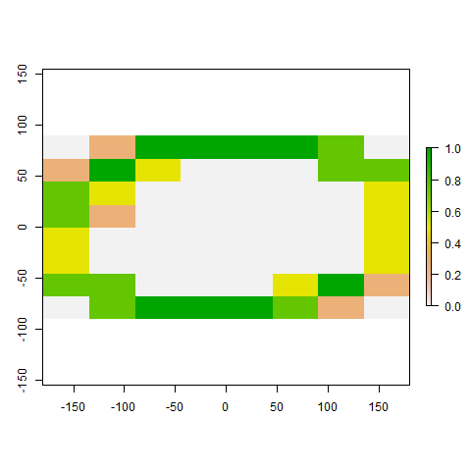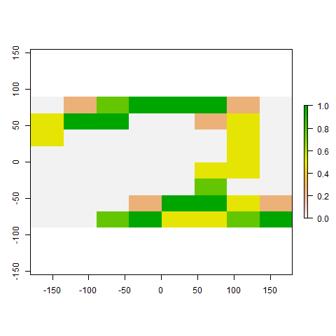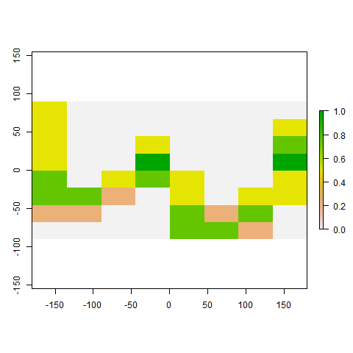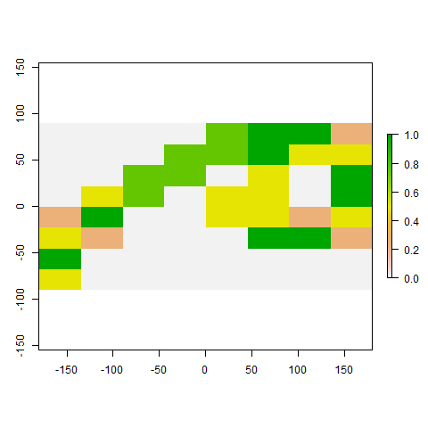

**Step-2:** Images are flattened to 64 individual pixels and 75% images fed to neural network with hidden layers of dimension - 128,64,32,16,10

Code: 

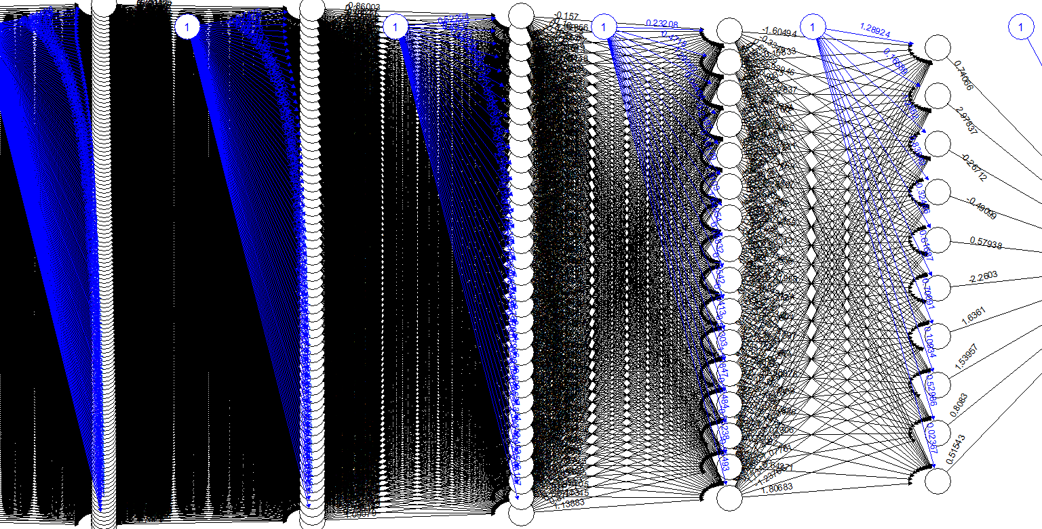

**Step-3:** The remaining 25% is validated with the model and a final accuracy of 65% is obtained.

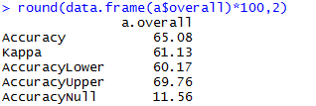

Confusion Matrix:

