|  |  |  |  |  |  |
| --- | --- | --- | --- | --- | --- |
| **S.No** | **Component** | **Qty** | **Description / Use** | **Unit Price (₹)** | **Total (₹)** |
| 1 | Step-down Transformer (12V, 1A) | 1 | Mains isolated step-down (use fuse on primary) | 150 | 150 |
| 2 | 1N4007 Diode | 6 | Rectifier diode, 1A general purpose (spares included) | 2 | 12 |
| 3 | LED – Red | 3 | 3mm/5mm standard | 3 | 9 |
| 4 | LED – Yellow | 3 | 3mm/5mm standard | 3 | 9 |
| 5 | LED – Green | 3 | 3mm/5mm standard | 3 | 9 |
| 6 | Electrolytic Capacitor 10000 µF / 25V | 1 | For rectifier filter | 80 | 80 |
| 7 | Resistor 1 kΩ | 3 | For LEDs, pull-downs | 1 | 3 |
| 8 | Resistor 330 Ω | 6 | LED series | 1 | 6 |
| 9 | Resistor 100 Ω | 3 | General purpose | 1 | 3 |
| 10 | Resistor 220 Ω | 3 | General purpose | 1 | 3 |
| 11 | Resistor 360 Ω | 3 | General purpose | 1 | 3 |
| 12 | 7805 Regulator | 1 | Fixed +5V output | 30 | 30 |
| 13 | LM317 Adjustable Regulator | 1 | Adjustable output (1.5A) | 60 | 60 |
| 14 | 7812 Regulator | 1 | Fixed +12V output | 30 | 30 |
| 15 | Heatsink for regulators | 3 | TO-220 type | 80 | 240 |
| 16 | PIC16F877A Microcontroller | 1 | 8-bit MCU, DIP40 | 250 | 250 |
| 17 | ESP8266-01 | 1 | Wi-Fi module for IoT (choose NodeMCU for easy dev) | 300 | 300 |
| 18 | Air Quality Sensor (MQ-135) | 1 | Detects CO2, NH3, Benzene, etc. | 400 | 400 |
| 19 | DHT11 | 1 | Temperature & humidity | 150 | 150 |
| 20 | LCD 16x2 | 1 | Display sensor data | 120 | 120 |
| 21 | Crystal Oscillator (20 MHz) | 1 | PIC clock | 20 | 20 |
| 22 | 22pF Capacitors | 2 | For crystal oscillator | 2 | 4 |
| 23 | Push Buttons | 3 | Reset & control | 5 | 15 |
| 24 | Dotted PCB | 1 | Prototyping | 150 | 150 |
| 25 | Connectors, Wires, Headers | 1 set | Jumper wires, female headers for ESP-01,40pin ic base, 2 pin screw terminal connector | 100 | 100 |
| 26 | Soldering Lead | 1 | For soldering joints | 80 | 80 |
| 27 | Rainbow Wire | 1 set | 10-pin flat ribbon cable for clean connections | 50 | 50 |
| 28 | Logic Level Converter (5V ↔ 3.3V) | 1 | For interfacing PIC/NodeMCU safely | 70 | 70 |
| 29 | PM2.5 Sensor (DSM501A/GP2Y1010AU0F) | 1 | Low-cost dust/PM2.5 sensor | 350 | 350 |
| 30 | 5V Buzzer | 1 | For alarm/alerts | 20 | 20 |
| 31 | Potentiometer 10kΩ | 1 | Adjustable resistance (e.g. LCD contrast, testing) | 15 | 15 |
| 32 | 12V Cooling Fan | 1 | Small DC fan for cooling system | 120 | 120 |
| 33 | Relay 12V | 1 | For switching loads | 40 | 40 |
| 34 | BC547 Transistor | 2 | NPN general purpose transistor (for relay/buzzer driving) | 5 | 10 |
| 35 | DPDT Self-Lock Push Switch | 2 | Double Pole Double Throw self-locking type | 40 | 80 |

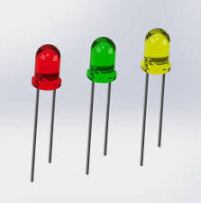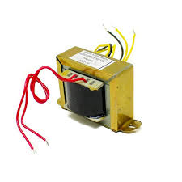1.

3,4,5.

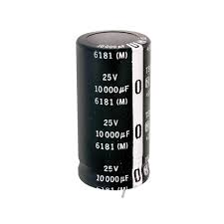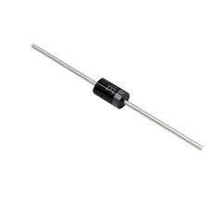2. 6.

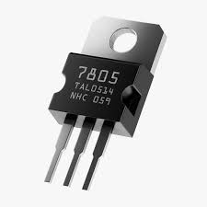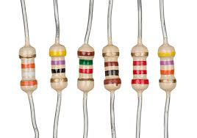7,8,9,10,11. 12.

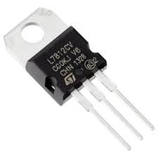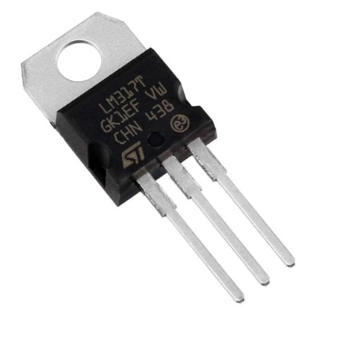13. 14.

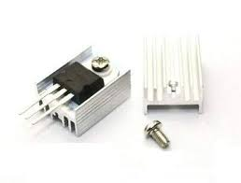

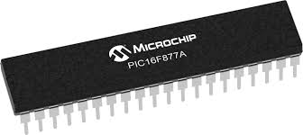15. 16.

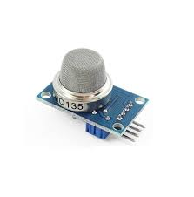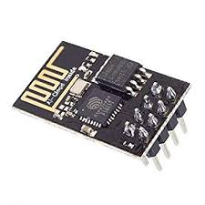17. 18.

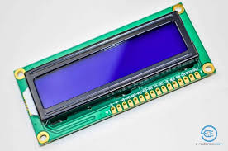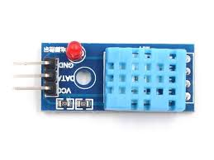19. 20.

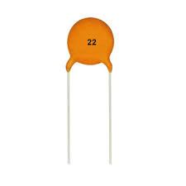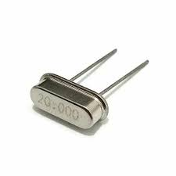

21. 22.

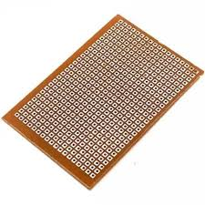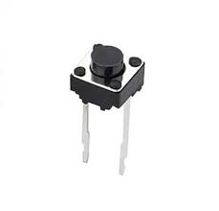

23. 24.

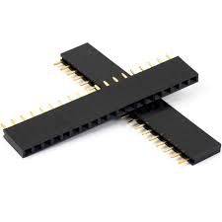

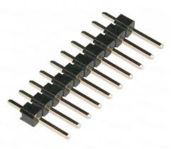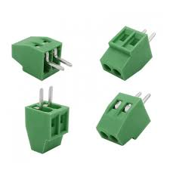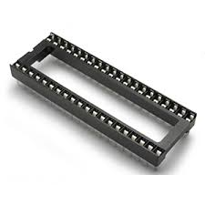25.

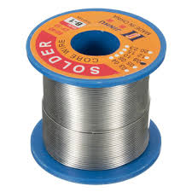26. 27.

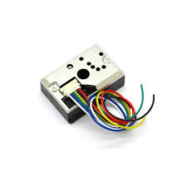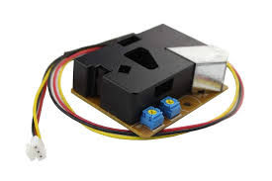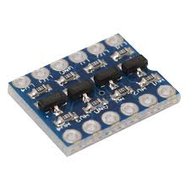28. 29.

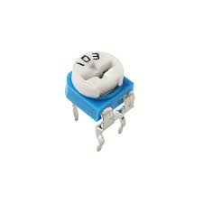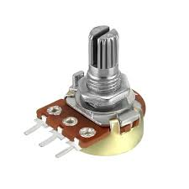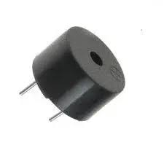

30. 31.

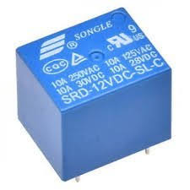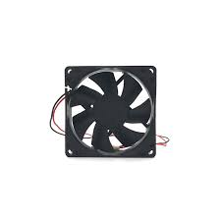32. 33.

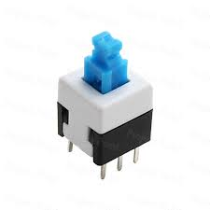

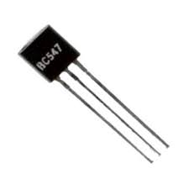34. 35.