EQUITY RESEARCH / INDIA
ITC LIMITED
A high-cash-generating franchise at a tobacco tax turning point
INITIATING COVERAGE | FOUNDATION REPORT
LAST TRADED CLOSE | BLENDED MODEL REFERENCE | DCF / SOTP | FY27E GROUP EPS
₹268.90 | ₹254.67 | ₹182.98 / ₹311.76 | ₹13.12
RESEARCH CUT-OFF
28 September 2026 • Financials through quarter ended 30 June 2026 • Last completed price session: 25 September 2026
NSE: ITC | BSE: 500875 | ISIN: INE154A01025 | Reporting currency: INR; ₹ crore unless shown otherwise
CENTRAL RESEARCH QUESTION Can the non-cigarette portfolio compound quickly enough to offset a sharp increase in the tax burden borne by the cigarette business?

DOCUMENT STATUS Independent model-based study; illustrative equity values, not a brokerage rating, investment advice, or company-issued guidance.
All 24 exhibits in this document are reproduced from the same linked data ranges used by the 24 native, editable Excel charts. See source notes and valuation limitations before using any output.

RESEARCH SNAPSHOT
The financial model contains historical FY25–FY26 statutory standalone results, FY27 Q1 actuals, forecasts through FY31, three linked scenario cases, an explicit cigarette-excise bridge, group ownership adjustments and three independent valuation lenses. The reference value below is a mechanical blend and not a trading recommendation.
REFERENCE / MODEL FACT | OBSERVATION | BASIS
ITC, 25 September 2026 close | ₹268.90 | Historical reference quotation [8]
FY26 standalone revenue from operations | ₹81,640 crore | Audited, excise-inclusive [1]
FY26 standalone continuing PAT | ₹20,286 crore | Audited [1]
FY26 standalone CFO / capex | ₹17,095 / ₹2,069 crore | Audited cash flow [1]
FY27E standalone ex-excise revenue | ₹64,641 crore | Base-case analyst estimate
FY27E standalone continuing PAT | ₹15,351 crore | Base-case analyst estimate
FY27E group owners’ PAT | ₹16,447 crore | Consolidated overlay model
FY27E share count used in model | 1,254 crore shares | Diluted analyst assumption
WACC / terminal growth | 12.08% / 4.0% | Valuation assumptions
Blended reference price / quote gap | ₹254.67 / −5.3% | 40% DCF + 45% SOTP + 15% peers

Our analytical framing
ITC combines one mature, high-margin and highly regulated business with a portfolio of consumer goods, agricultural operations, paper products and technology services. This combination can create cash flows with different cycles and capital needs, but profits remain heavily concentrated in cigarettes. That concentration makes the new indirect-tax structure the first variable to examine in any earnings model.
The case for more resilient cash generation rests on price/mix and product-portfolio responses in cigarettes, margin improvement in FMCG-Others, paper capacity added by the Century acquisition and measured allocation of cash to dividends, acquisitions and reinvestment. The adverse case involves price-sensitive smokers migrating away from legal branded cigarettes, weaker volumes or margins, acquired paper capacity earning less than expected, and insufficient cash conversion to support past distribution patterns.
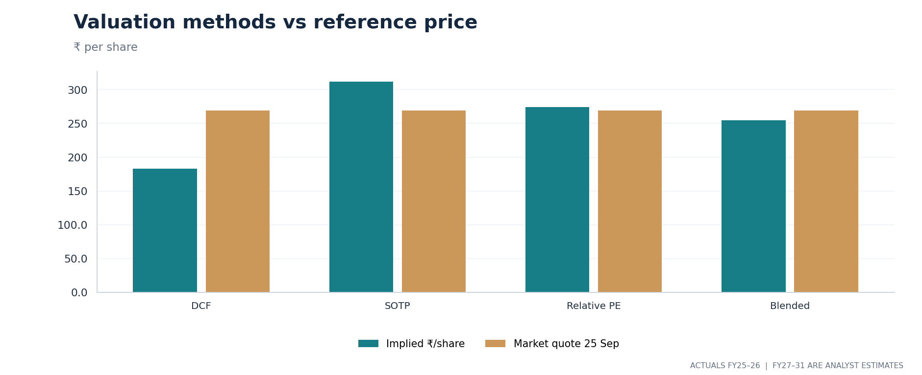
EXHIBIT 19. Value per share from DCF, SOTP and relative methods versus the 25 September 2026 quotation. Values are illustrative; methods deliberately disagree.

VALUATION METHOD BRIDGE
METHOD | ₹ / SHARE | ASSUMPTION / BOUNDARY
FCFF discounted cash flow | 182.98 | Five-year operating cash flow; 12.08% WACC, 4% terminal growth; add separately valued assets
Sum-of-the-parts | 311.76 | FY27 segment PBIT × judgmental multiples, group businesses, quoted hotels holding, net liquid assets
Relative peer cross-check | 274.56 | Trailing peer P/E applied to FY27 model owner EPS; not matched forecast periods
Blended reference (40/45/15%) | 254.67 | Analyst-chosen weights; no statistical confidence meaning
ITC closing reference | 268.90 | 25 September 2026 quote, not a live executable price

DCF and SOTP span ₹128.78 per share. The DCF value is sensitive to the longer-run cash yield on the tobacco franchise, while SOTP applies different capitalization assumptions to segments and owned assets. The size of this divergence is itself material evidence about model uncertainty. Selecting one headline number should not erase it.

CONTENTS
CHAPTER | RESEARCH QUESTION
01 | Business architecture | What businesses are inside ITC after the hotel demerger?
02 | Industry and competition | Where do business cycles and competitive pressures differ?
03 | Cigarette tax reset | How do tax accounting, realizations and earnings interact?
04 | Cigarettes | What underpins the profit engine and what could change it?
05 | FMCG-Others | Can brand growth bring better profit conversion?
06 | Agri Business | How material are crop prices, sourcing and export cycles?
07 | Paperboards and Century | What is the likely return from the capacity step-up?
08 | Technology / Hotels interests | How should ownership and proposed combinations be treated?
09 | FY26 and Q1 FY27 review | What is actually reported versus accounting noise?
10 | FY27–FY31 model | What growth, margin and cash assumptions drive forecasts?
11 | Cash flow and capital allocation | How far does free cash flow support dividends?
12 | Discounted cash flow | Where do time value, terminal value and WACC matter?
13 | SOTP and relative checks | What value is attributed to each operating franchise?
14 | Scenarios and sensitivities | Which outcomes change when assumptions change?
15 | Risks, governance and ESG | Where are the principal failure points?
16 | Monitoring checklist and conclusion | What evidence could confirm or challenge the model?
Appendices | Historical, forecast and sensitivity schedules; definitions; sources

How to use the companion model: open “Read Me”, select Base / Bull / Bear in cell D8 and review “Valuation_Summary”, “Model_Checks” and “Charts”. Input cells are blue, inter-sheet links green and local formulas black. Historical data and current price sources are retained in “Source Register”.

01 Business architecture
An operating business plus subsidiaries and a separately listed hotel associate
ITC Limited operates across five principal standalone segment lines: cigarettes; FMCG-Others; agricultural products and services; paperboards, paper and packaging; and a small residual category. The consolidated group also contains subsidiaries, notably ITC Infotech and Surya Nepal, while ITC Hotels is an equity-accounted associate after the hotel demerger effective 1 January 2025. This legal perimeter is essential. An operating-segment value, an investment value and a consolidated PAT number are not interchangeable. [1, 4, 6]
Cigarettes generate the largest part of segment profit and produce cash to fund dividends and expansion elsewhere. FMCG-Others spans foods, personal care, education and lifestyle products; its brands are distributed through traditional retail and growing modern and digital channels. Agri supplies traded commodities as well as inputs to ITC’s own packaged goods. Paperboards and packaging serve internal and external demand, and the Century Pulp and Paper purchase broadens the physical production base. The technology subsidiary operates under a very different talent- and contract-led economic model. [2, 5, 6]
This structural mix is useful only when profits and invested capital are examined separately. The earning power of a cigarette brand is not the same as a paper mill or a low-margin commodity trading operation. A group average operating margin obscures both the defensive and cyclical parts of ITC. Our forecast, therefore, builds segment turnover and PBIT before adding central items, taxes, working-capital movements and the subsidiary overlay.
FY26 STANDALONE SEGMENT | REVENUE (₹ CR) | PBIT (₹ CR) | PBIT MARGIN
Cigarettes | 37,099.65 | 21,051.12 | 56.7% of gross segment revenue*
FMCG-Others | 24,209.75 | 1,802.63 | 7.45%
Agri Business | 20,296.40 | 1,496.46 | 7.37%
Paperboards, paper, packaging | 8,765.61 | 796.71 | 9.09%
Others | 341.79 | −8.06 | Negative
Total before elimination | 90,713.20 | 25,138.86 | 27.7%

*The cigarette reported segment-revenue margin is not a durable operating ratio because booked excise rose significantly beginning February 2026. The report uses cigarette ex-excise revenue as a supplementary diagnostic, not a company-certified category metric. [1, 2]
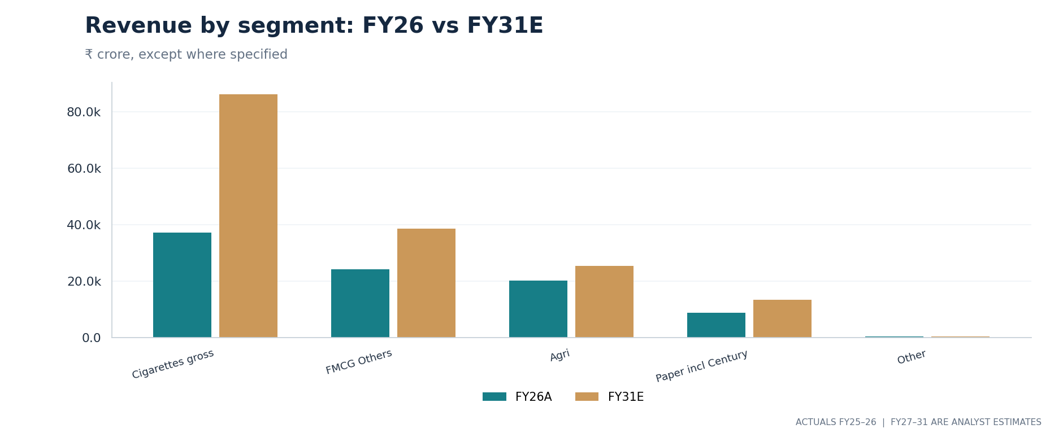
EXHIBIT 03. FY26 actual segment revenue versus FY31 analyst projection, shown before intersegment elimination; cigarette projections are excise-inclusive.
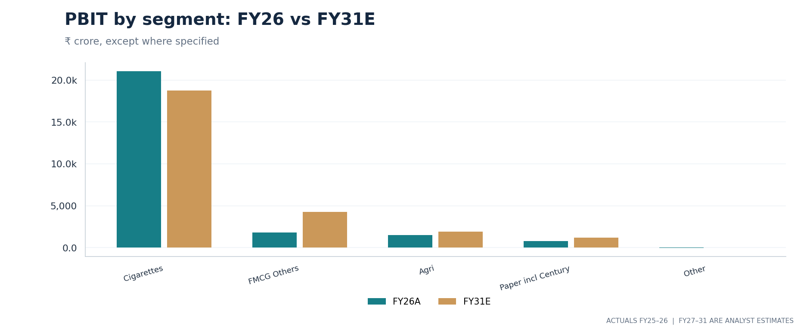
EXHIBIT 04. Segment profit comparison highlights that large reported turnover does not translate to proportionate business value.

02 Industry and competition
Five operating categories, five sets of competitors and demand drivers
In cigarettes, duty, retail price points, distribution and the risk of product substitution dominate. The principal listed Indian comparison names are Godfrey Phillips India and VST Industries, although business portfolios and traded valuations differ. FMCG-Others meets branded food, personal care and staples competition from multinational and domestic groups, including Hindustan Unilever, Nestlé India, Britannia, Dabur and Tata Consumer. Paper competes in markets that are exposed to pulp prices, energy and imports. The agri business is influenced by crop quality, inventories, weather and cross-border demand. Technology services compete for multi-year budgets and highly skilled employees. [2, 7]
The competitive forces point in opposite directions. Brand loyalty and scale can support pricing or distribution in packaged goods; aggressive offers and smaller pack sizes can absorb margins. Working capital and manufacturing utilization matter more in agri and paper. Contracted services may grow in IT while pricing and staffing costs limit margin gains. A single revenue-growth driver would imply the same economics across these activities and be analytically weak.
Management described FY27 Q1 FMCG-Others segment revenue as growing 12% year on year and segment PBIT 21%, alongside 9% paper revenue growth and 38% paper PBIT growth. These are company-reported comparisons, not the projected long-term trajectories used in our model. Management also adjusted its reported agri comparison for shipment timing and disruptions linked to West Asia. [2]
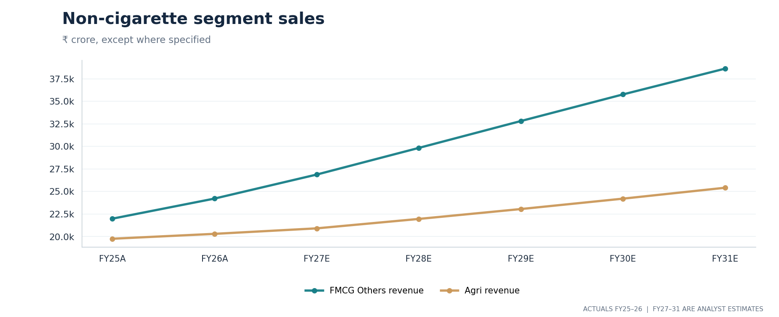
EXHIBIT 07. The model separates FMCG-Others and Agri revenue growth rather than assuming a uniform non-cigarette trajectory.
A useful stress test is to ask whether the combined non-cigarette profit pool could support a higher group multiple independently of cigarettes. FMCG-Others has the clearest margin opportunity, but it starts from a much lower absolute PBIT. Even successful double-digit segment growth may take several years to materially change the group profit mix.

03 The cigarette tax reset
The first issue in reconciling ITC’s gross revenue with its economic sales
Effective 1 February 2026, changes to the cigarette tax framework moved the GST rate to 40% of retail selling price and sharply increased excise duties, replacing the prior GST compensation-cess framework. ITC’s statutory reporting includes excise in reported gross sales and also reports excise as an expense. A rise in excise-inclusive cigarettes revenue can therefore occur while after-excise operating revenue and profit weaken. This is the central accounting issue in the model. [1, 2, 3]
The audited FY26 standalone P&L recorded revenue from operations of ₹81,640 crore and ₹9,656 crore of excise, yielding an after-excise operating measure of ₹71,984 crore. Q1 FY27 alone recorded ₹10,036 crore of excise on reported operating revenue of ₹26,943 crore, leaving ₹16,908 crore net of excise. Comparing a quarter with most of FY26 under the prior regime without the excise bridge produces false conclusions about underlying demand. [1, 3]
Our workbook starts with ex-excise cigarette turnover, projects tax amounts separately, and then combines the two into booked segment turnover. As a simplifying diagnostic, the full corporate excise expense is allocated to cigarettes. That is an analyst proxy, not a management-disclosed per-stick series. No implicit assumption is made that tax-inclusive revenue growth equals cigarette volume growth.
WHY THE DISTINCTION MATTERS A tax collected in a selling price can make reported sales larger without making the underlying franchise more profitable.

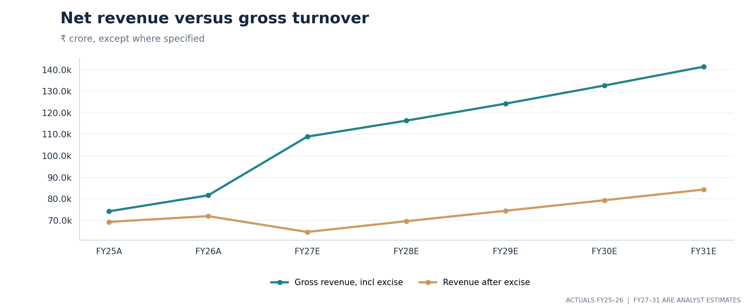
EXHIBIT 01. Historical and forecast gross-to-net bridge, ₹ crore. FY27E onward are illustrative and incorporate the new excise structure.
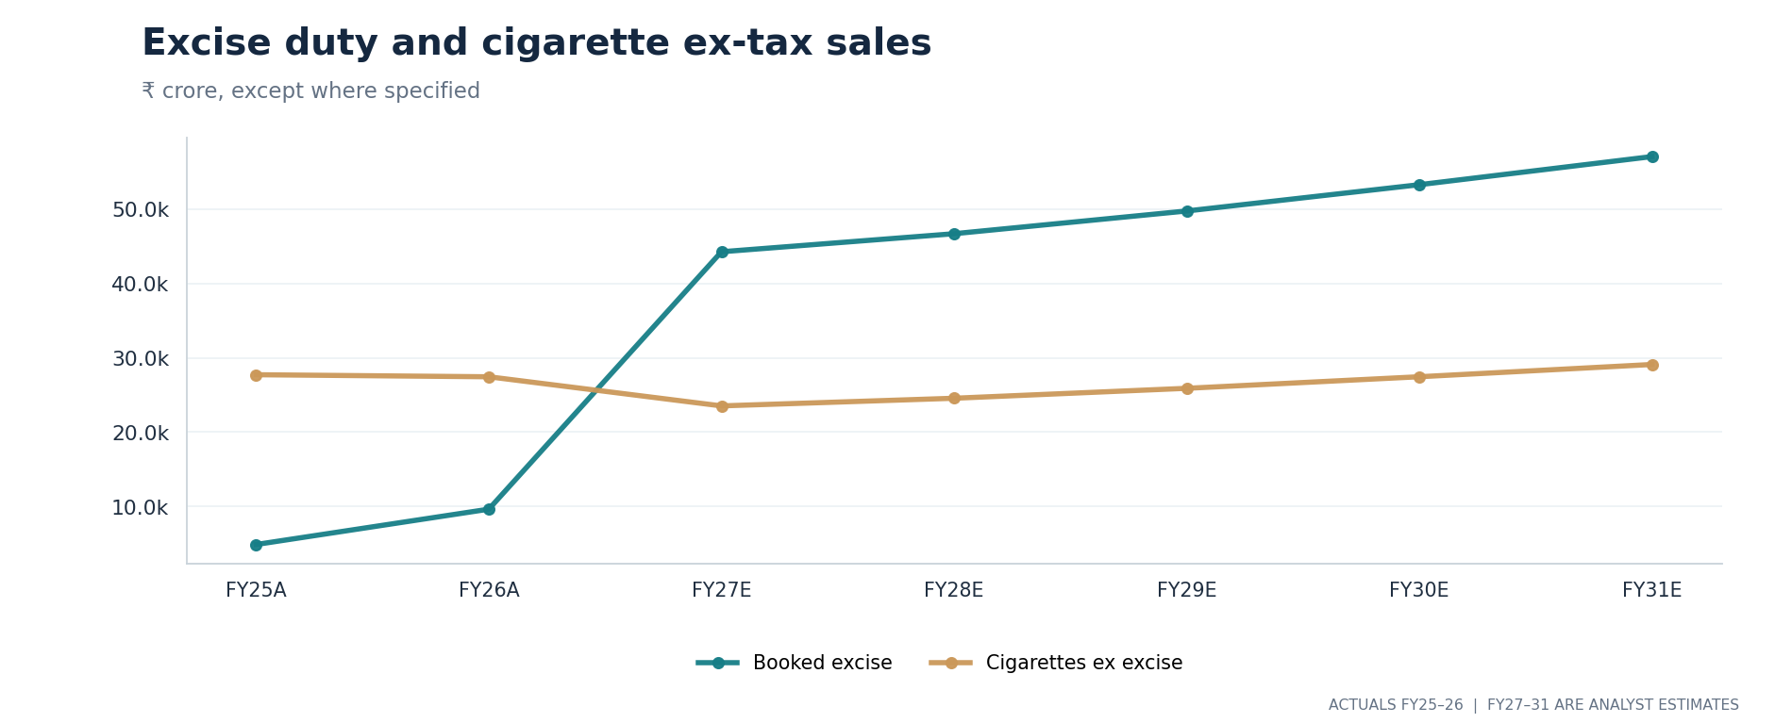
EXHIBIT 02. The relative scale of booked excise and cigarette ex-tax revenue changes after the February 2026 tax reset.
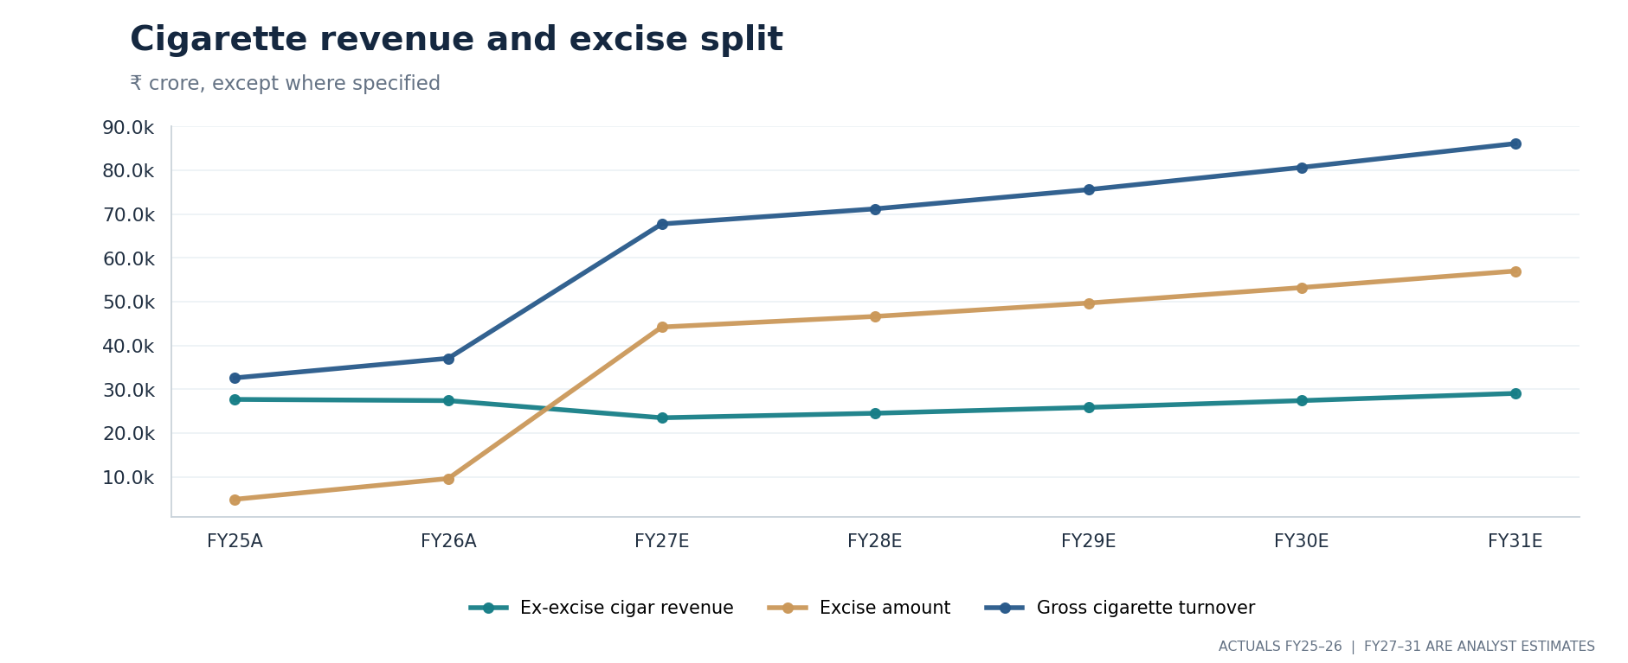
EXHIBIT 05. An alternative three-line view of cigarette net sales, tax expense and booked gross cigarette turnover.

04 Cigarettes
High contribution to profit; unusually concentrated tax and demand sensitivity
Cigarettes accounted for approximately 83.7% of ITC standalone segment PBIT in FY26. Q1 FY27’s cigarette profit contribution was about 76.1%, as the company implemented staggered prices and portfolio changes in response to higher taxes. These are company financial percentages; they do not by themselves prove a lasting change in domestic market share or smoker behaviour. [1, 3]
The main economic questions are cigarette-stick volume, product mix, real price realization after excise, direct product costs and the capacity of the legal market to retain consumers when prices rise. Management reports over 30 actions around portfolio architecture and price points, and says staggered actions are intended to limit movement into illicit trade. The illicit-trade risk should be presented as the company’s claim and a scenario risk rather than a verified volume estimate. [2]
FY27 base-case ex-excise cigarette revenue is forecast at ₹23,531 crore, below FY26’s approximate ₹27,443 crore; cigarette PBIT is forecast at ₹14,471 crore versus FY26’s ₹21,051 crore. The forecast therefore does not assume that nominal sales inflation from excise translates into profitability. Later years assume gradual stabilization, not immediate reversion to the previous profit level. These numbers are scenario inputs and computed outputs, not management forecasts.
Even under a stabilization path, tobacco-linked cash flows remain exposed to further duties, packaging rules, public-health policy, tax enforcement, distribution economics, price elasticity and illicit supply. Changes in the regulatory framework can alter both current profit and the earnings multiple investors assign. A sensitivity analysis should stress operating profits and the discount rate, rather than varying one alone.
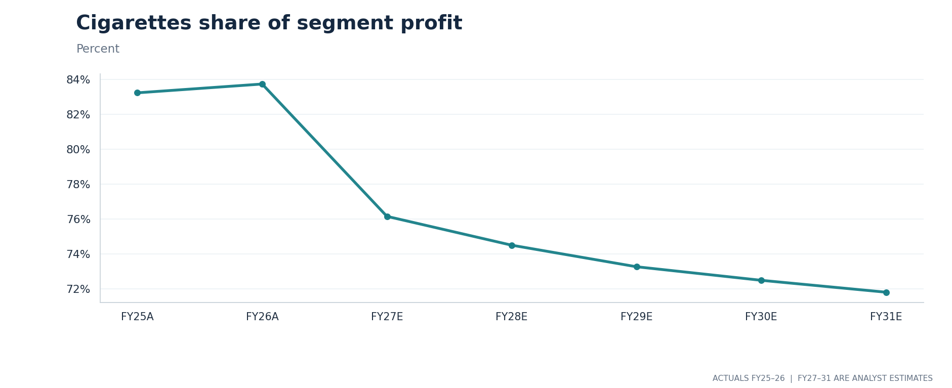
EXHIBIT 06. Share of overall standalone segment PBIT attributed to cigarettes; FY27 onward is modelled.
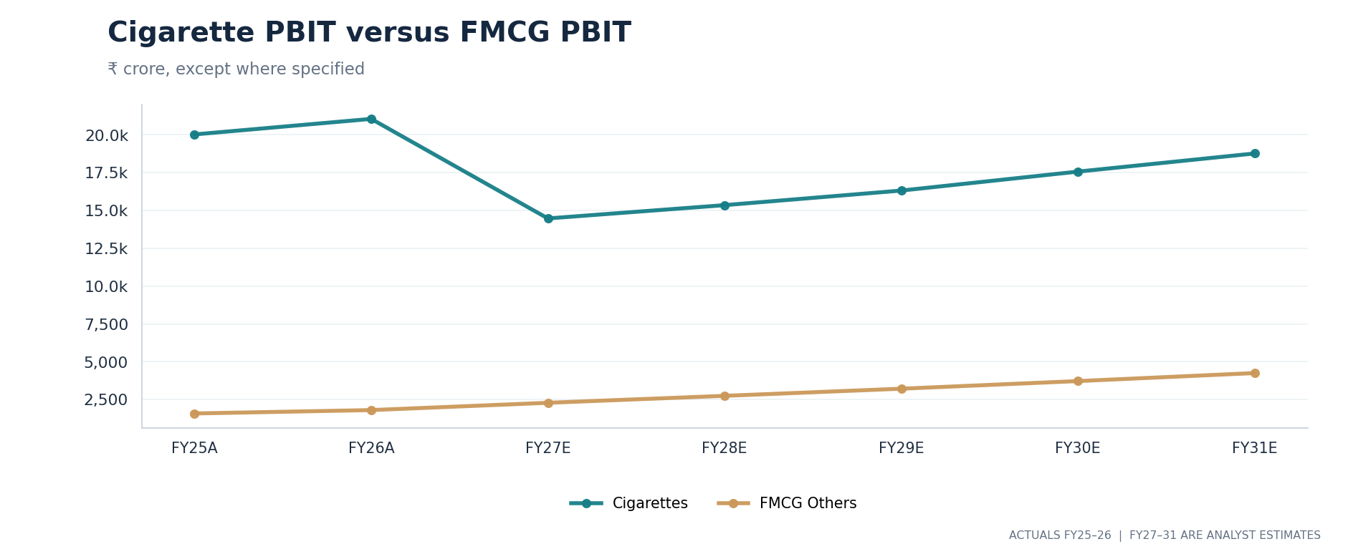
EXHIBIT 09. Contrasting FY27–FY31 PBIT trajectories for cigarettes and FMCG-Others under the Base case.

05 FMCG-Others
Growth brands create a potential second earnings engine, but margin conversion is the test
ITC’s packaged consumer brands include Aashirvaad, Sunfeast, Bingo!, YiPPee!, Classmate, Savlon, Fiama, Sunrise, Yoga Bar and 24 Mantra. Distribution reach and established consumer recognition are advantages, while sustained advertising, product development, trade spending and price competition mean that a rupee of FMCG revenue earns far less than a rupee of cigarette revenue. [2, 6]
The FY26 FMCG-Others standalone segment generated ₹24,210 crore in revenue and ₹1,803 crore in PBIT, a 7.45% margin. Management reported FY27 Q1 segment revenue of ₹6,482 crore and PBIT of ₹479 crore; on its reported basis FMCG sales rose 12% and PBIT 21% year over year. This supports a near-term margin-recovery question but not an assumption that margins must rise every year. [1, 2, 3]
The Base model forecasts FMCG-Others revenue of ₹26,873 crore in FY27 and ₹38,626 crore in FY31, with segment PBIT moving from ₹2,284 crore to ₹4,249 crore. This relies on an expanding product mix and a gradual rise in margin despite competitive intensity. A negative scenario would use slower sales growth combined with higher promotional costs, rather than only lowering volume.
For ongoing monitoring, look at growth outside staple commodities, contribution from newly consolidated brands, operating leverage, direct-to-consumer and quick-commerce economics, and the difference between management’s EBITDA and PBIT definitions. Faster growth is not automatically value creation if the incremental margin and cash conversion are weak.
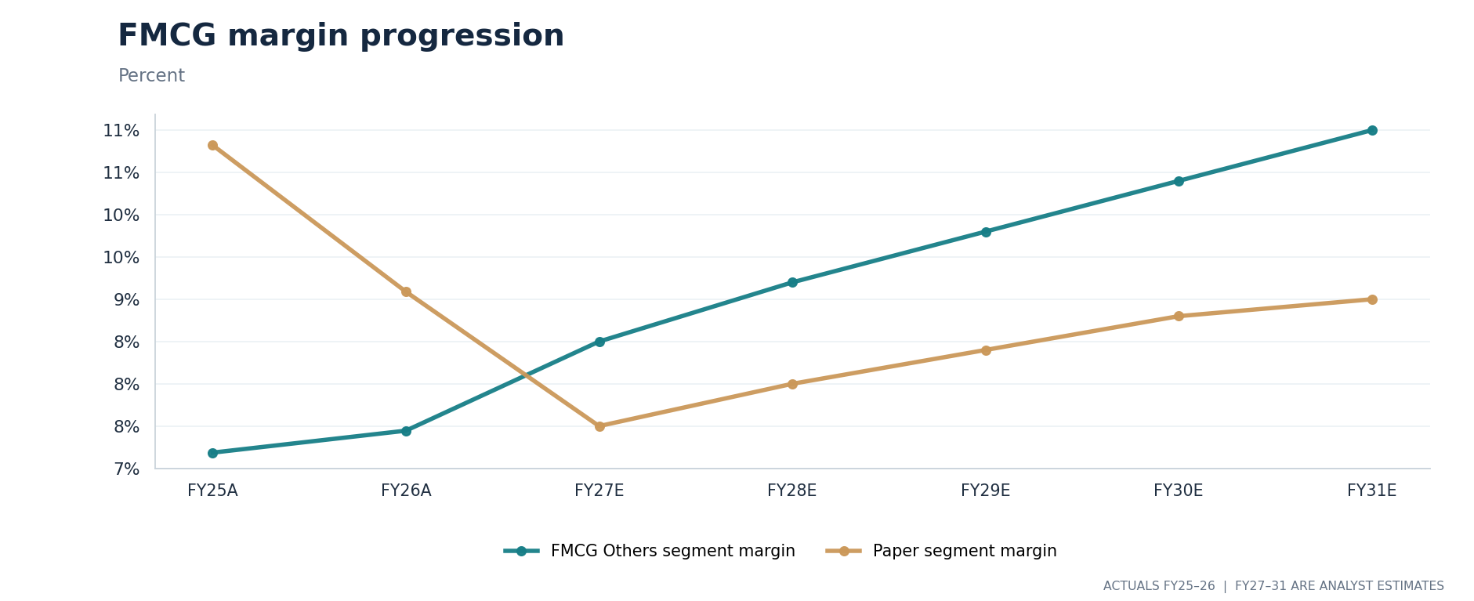
EXHIBIT 10. FMCG-Others PBIT margin path versus paper margin, illustrating differing profitability assumptions.
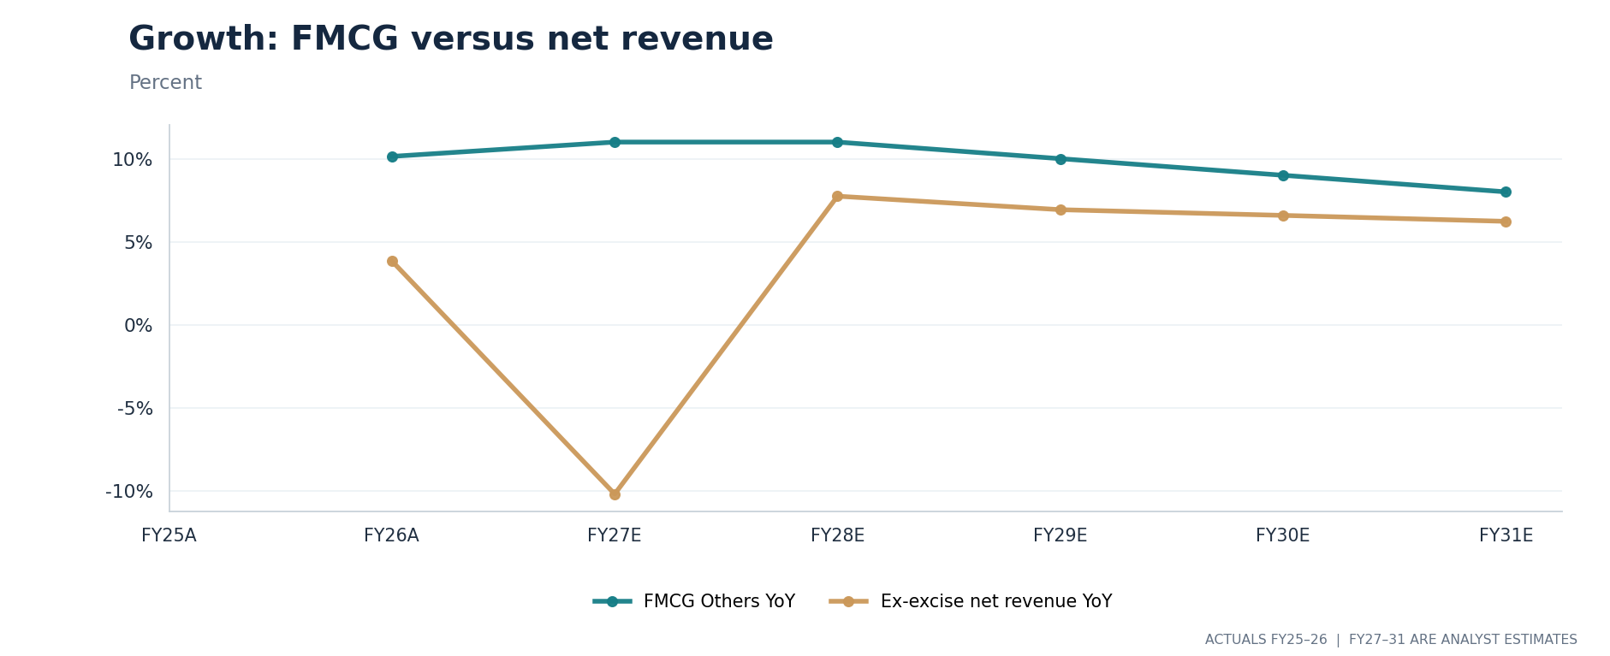
EXHIBIT 11. Growth in FMCG-Others compared with revenue after excise, with the cigarette tax reset visible in the group comparison.

06 Agri Business
Commodity exposure and strategic supply, with working-capital consequences
The agri business sources and trades agricultural products and supplies inputs for ITC’s own packaged-food operations. Its earnings depend on price spreads, crop availability, export policy, customer demand, inventories and timing of shipments. It should not be priced or forecast as if it were a branded food company. [1, 2]
FY26 agri segment revenue of ₹20,296 crore generated ₹1,496 crore of PBIT. Q1 FY27 reported ₹8,082 crore of agri segment revenue and ₹354 crore of PBIT; management separately referred to 9% underlying growth after adjusting for the timing of some sales and disruptions affecting West Asian trade. A clean volume/price comparison requires more disclosure than the segment topline provides. [1, 2, 3]
The Base forecast uses gradual revenue growth, from ₹20,905 crore in FY27 to ₹25,411 crore in FY31, with PBIT reaching approximately ₹1,906 crore. The expected profit increase is modest relative to cigarette earnings, but the working-capital need can be material. Higher inventories in a commodity upcycle can absorb operating cash even when accounting profit looks stable.
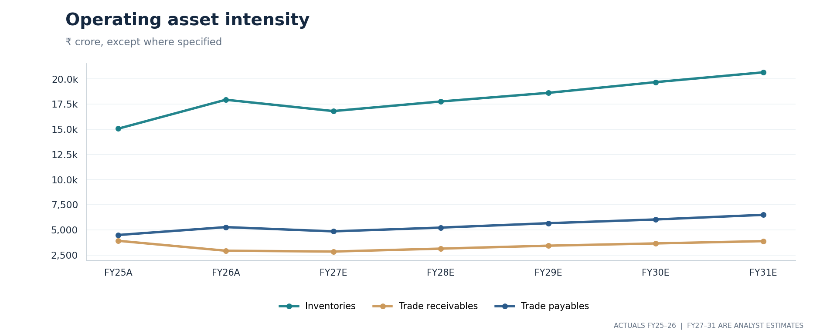
EXHIBIT 16. Inventories, receivables and trade payables across actual and forecast years show the model’s funding burden.

07 Paperboards and Century
A physical capacity step-up introduces both operating upside and capital risk
ITC’s paperboards, paper and packaging business serves consumer and industrial applications, often linked to pulp, wood, energy and competing imports. FY26 revenue was ₹8,766 crore and PBIT ₹797 crore, down from the FY25 PBIT reported in the segment note. FY27 Q1 management reported revenue growth of 9% and a 38% PBIT increase as conditions improved. These changes may reflect pricing, volume and raw materials; they should not be mechanically annualized. [1, 2]
In August 2026 ITC completed the purchase of Century Pulp and Paper from Aditya Birla Real Estate. The previously announced consideration was about ₹3,498 crore and the site adds approximately 480,000 tonnes of annual production capacity. The acquired operation did not contribute for a full period to ITC’s FY26 audited accounts or June-quarter results. Our model therefore adds a separate Century line from FY27, with ₹1,500 crore of illustrative FY27 incremental turnover rising to ₹2,700 crore by FY31. [5]
The transaction provides more capacity and categories, but value depends on utilization, selling prices, raw-material procurement, integration costs and sustaining capex. An acquisition creates no free cash flow merely because reported group revenue increases. The valuation removes the ₹3,498 crore consideration from a pro forma liquid-assets bridge and includes future expected paper profits through operating forecasts, avoiding a second separate valuation of the acquired plant.
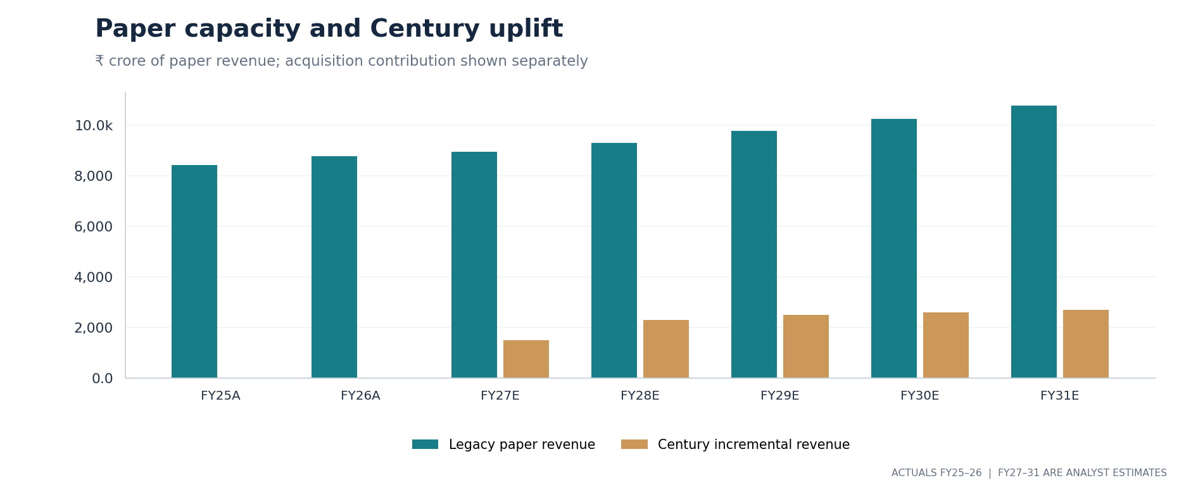
EXHIBIT 08. Legacy paper revenue versus Century-added revenue, modeled separately to avoid retroactive historical contribution.

08 Technology, hotels and group perimeter
Investments should be valued only once, and pending deals should not appear as completed profits
ITC Infotech is a wholly owned technology services subsidiary in the current group. On 31 August 2026, it announced a proposal to acquire roughly 22.1% of Happiest Minds from promoter-related holders for an aggregate consideration of about ₹1,330 crore, followed by an amalgamation and stock-market listing of the combined entity. The released structure anticipates that ITC would hold about 73.4% of the combined enterprise, subject to approvals. Happiest Minds shareholders would receive 25 ITC Infotech shares per 81 Happiest Minds shares. [6]
The parties referred to combined FY26 pro forma revenue of approximately ₹7,033 crore and an ambition to exceed US$1 billion revenue in FY28. That ambition is not booked revenue, a signed customer contract or a certain deal outcome. The base financial forecast excludes the proposed merger completion and acquisition financing, while valuing existing group-only subsidiary earnings separately. A future approved transaction would require an updated ownership, minority interest, debt and profit bridge. [6]
ITC Hotels became a separately listed company following its demerger, with ITC retaining an associate holding. The valuation input uses 39.85% (the later disclosed holding) rather than the original demerger holding of about 39.88%, applies a 5% illustrative holding discount and uses a dated equity market capitalization. The model does not add all of ITC’s non-current investments again, as that would count associate/subsidiary interests twice. [4, 8]
After the corporate actions, “ITC revenue”, “ITC group profit”, “operating enterprise value” and “value of owned investments” answer different questions. Clean attribution to owners matters most for an equity valuation; group-only profits, minority shares, quoted hotel investments and financial investments need one consistent set of adjustments.

09 Historical earnings and Q1 FY27
A reported profit bridge matters more than a superficial year-on-year comparison
FY26 audited standalone revenue from operations grew to ₹81,640 crore, while continuing PAT was ₹20,286 crore. On a statutory continuing-business basis FY25 PAT was ₹20,092 crore. FY25’s larger as-reported PAT includes discontinued hotel operations and demerger-related non-recurring effects; the model does not use unadjusted FY25 headline PAT to extrapolate earnings. [1, 4]
ITC generated ₹17,095 crore operating cash flow and spent ₹2,069 crore on physical capex in FY26, giving a simple ₹15,026 crore pre-acquisition, pre-investment cash proxy. The cash dividend paid in the fiscal year was approximately ₹17,968 crore. This exceeds that narrow CFO-less-PPE measure; investments, balance-sheet liquidity, dividend timing and other investing flows must be understood before judging the sustainability of distributions. [1]
AUDITED / REPORTED ITEM | FY25A | FY26A | Q1 FY27A
Reported revenue from operations | 74,236 | 81,640 | 26,943
Excise duty expensed | 4,913 | 9,656 | 10,036
After-excise operating revenue | 69,324 | 71,984 | 16,908
Continuing standalone PAT | 20,092 | 20,286 | 3,579
Cigarettes segment PBIT | 20,025 | 21,051 | 3,341
FMCG-Others segment PBIT | 1,580 | 1,803 | 479
Paper segment PBIT | 911 | 797 | 224

Source: audited standalone year to March 2025 and March 2026; unaudited standalone June 2026 quarter. Crore values rounded. FY25 historical values follow the source-and-normalization definitions documented in the workbook. [1, 3, 4]
In Q1 FY27 gross revenue rose 28% from a year earlier while management disclosed 14% lower net revenue, 28% lower standalone EBITDA and 27% lower standalone PAT. The opposite gross and net movements reflect the new tax mechanics and differing economics. Its consolidated first-quarter profit contained a one-time non-cash fair-value gain relating to Sproutlife Foods; our recurring earnings forecasts do not extrapolate that gain. [2, 3]
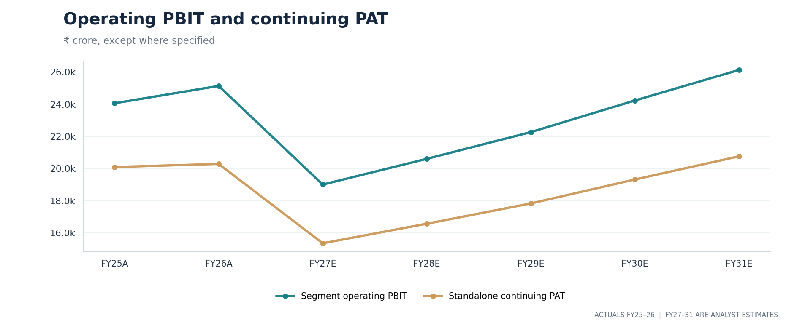
EXHIBIT 12. Operating segment PBIT and continuing standalone PAT on a consistent annual historical and forecast basis.

10 FY27–FY31 operating model
Five-year segmented assumptions; forecasts are conditional, not management promises
The Base case is deliberately cautious on first-year cigarettes after excise, then assumes gradual normalization of non-excise turnover and operating contribution. FMCG-Others grows at 11% in FY27 and FY28 before slower rates later; the paper segment includes a new Century line; the agri business rises more gradually. The model deducts intersegment sales, reports excise separately and applies central items and taxes to reach continuing standalone PAT. [Model: Assumptions, Segments, Income_Statement]
The revenue bridge matters quantitatively. Estimated FY27 gross revenue from operations is ₹108,879 crore, but estimated excise expense is ₹44,238 crore, leaving ₹64,641 crore of after-excise revenue. That is below FY26’s corresponding ₹71,984 crore despite higher gross reported turnover. The year-on-year economic signal should be read from ex-excise revenue, not from the top line including duties.
FY27 segment PBIT in the Base case is ₹19,002 crore and continuing PAT ₹15,351 crore. Standalone cash from operations is modeled at ₹17,335 crore before ₹2,600 crore of capex and the separate Century cash consideration. FY31 standalone after-excise revenue reaches about ₹84,311 crore and segment PBIT approximately ₹26,132 crore. These outputs change with the Base/Bull/Bear control, so a single line of historical extrapolation is inadequate.
SELECTED MODEL OUTPUT (₹ CR) | FY26A | FY27E | FY29E | FY31E
Cigarette ex-excise turnover | 27,443 | 23,531 | 25,894 | 29,094
FMCG-Others revenue | 24,210 | 26,873 | 32,812 | 38,626
Agri turnover | 20,296 | 20,905 | 23,048 | 25,411
Paper including acquired assets | 8,766 | 10,441 | 12,263 | 13,464
Excise-inclusive revenue | 81,640 | 108,879 | 124,185 | 141,336
After-excise revenue | 71,984 | 64,641 | 74,469 | 84,311
Total segment PBIT | 25,139 | 19,002 | 22,264 | 26,132

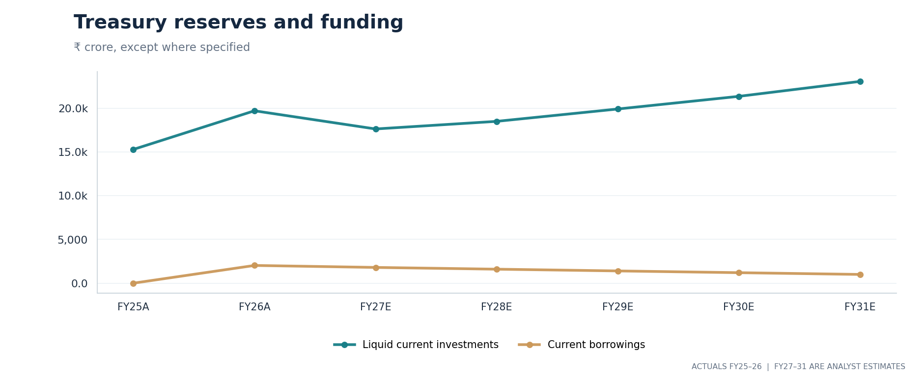
EXHIBIT 15. Liquidity-reserve assumptions and short-term borrowings; current investments are shown separately from cash equivalents.

11 Cash conversion and capital allocation
Dividend history, investments, acquisitions and the need for sustained reinvestment
A positive accounting profit does not guarantee distributable cash in the same period. For ITC, the gap can arise from excise duties, inventory purchases, receivables, capex, investment-security purchases and dividend payment timing. In FY26, operating cash flow less fixed-asset capex was ₹15,026 crore against cash dividends paid of ₹17,968 crore. This is a useful coverage warning, not proof that dividends can never be sustained. Current and non-current financial investments are material, but not all balances are immediately available to shareholders. [1]
The forecast makes working capital explicit and distinguishes capex from cash paid for Century Pulp and Paper. The acquired undertaking consumes cash at completion; subsequent paper revenue is treated as operating activity. This avoids the common error of adding acquired earnings while leaving the purchase consideration out of the equity bridge.
The model projects stable operating cash conversion after an unsettled FY27. An investor should track the ratio of operating cash to recurring profit, the annual reinvestment bill, dividends in cash (rather than dividend per share declared in a different period), and the financial assets already included in enterprise-to-equity adjustments. The cost of maintaining capacity may rise if paper raw materials or environmental compliance require additional spending.
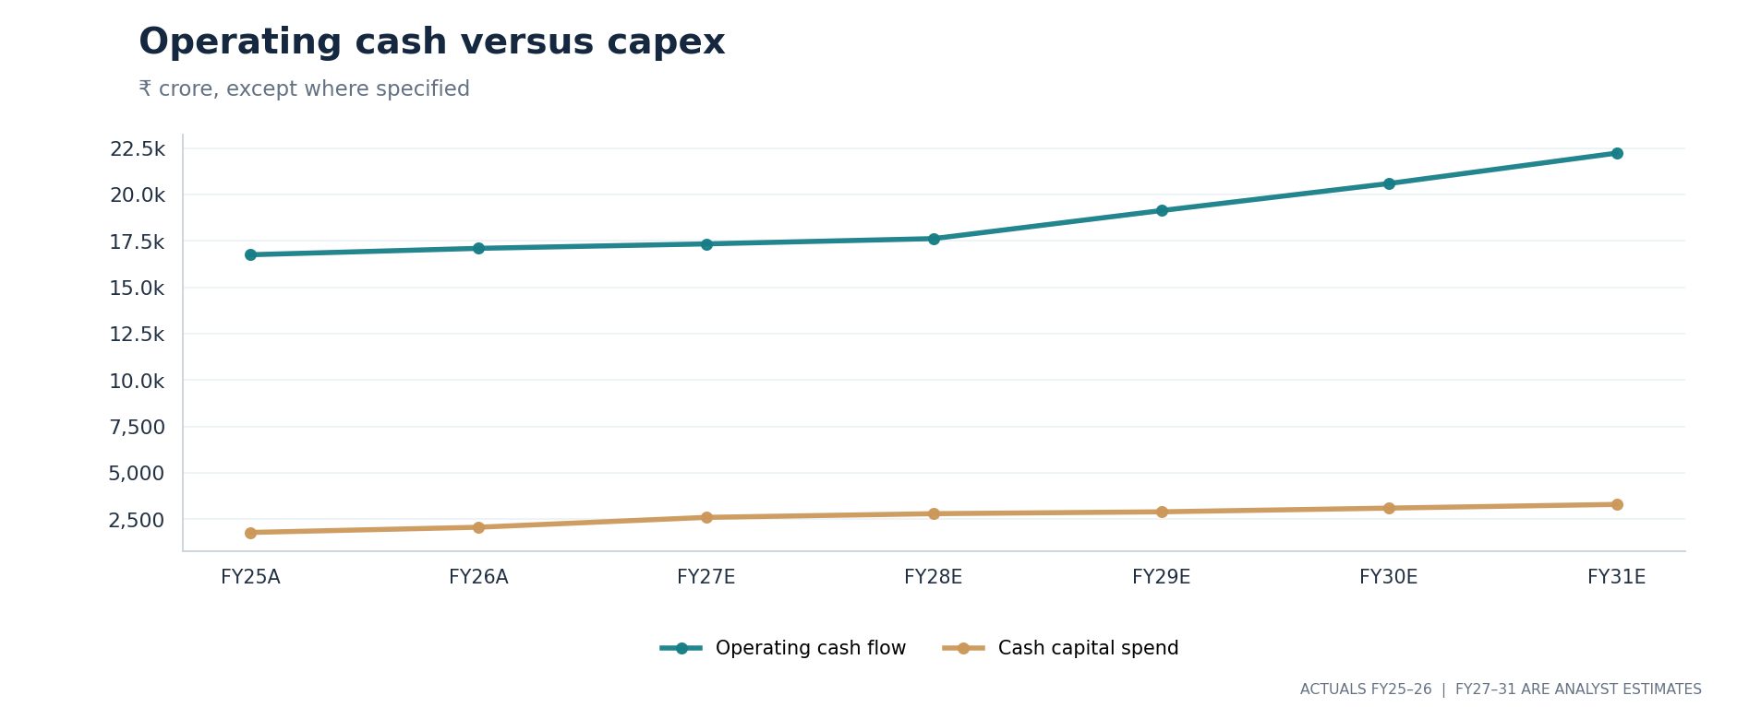
EXHIBIT 13. Historical and forecast operating cash flow compared with annual physical capital expenditure.
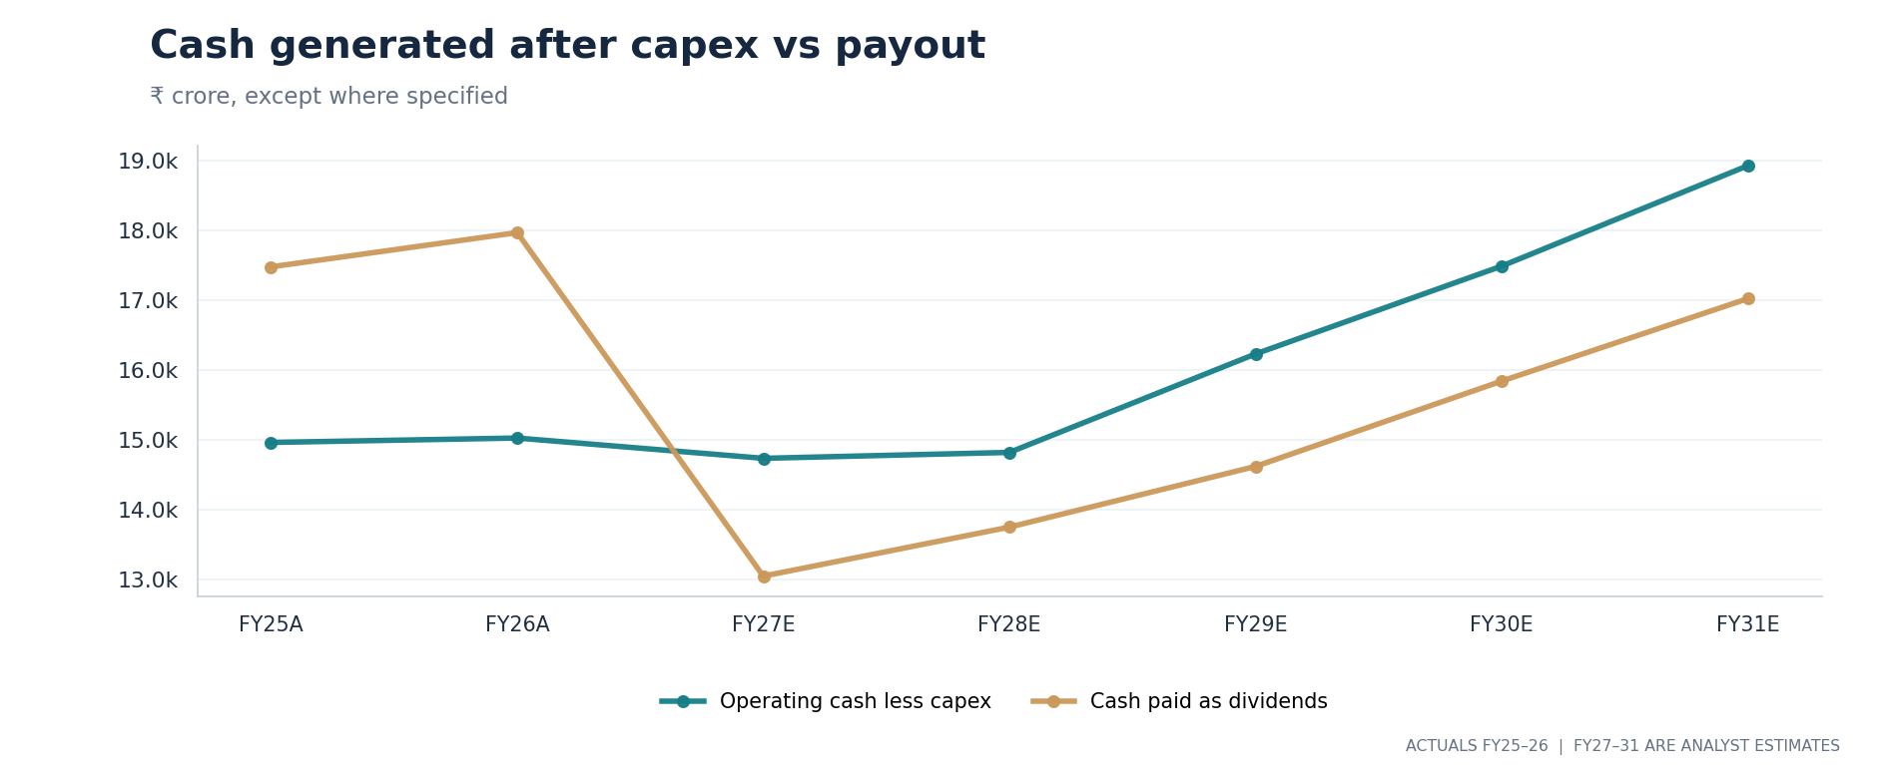
EXHIBIT 14. Pre-acquisition CFO less PPE spending versus cash dividend paid; a liquidity interpretation requires balance-sheet context.
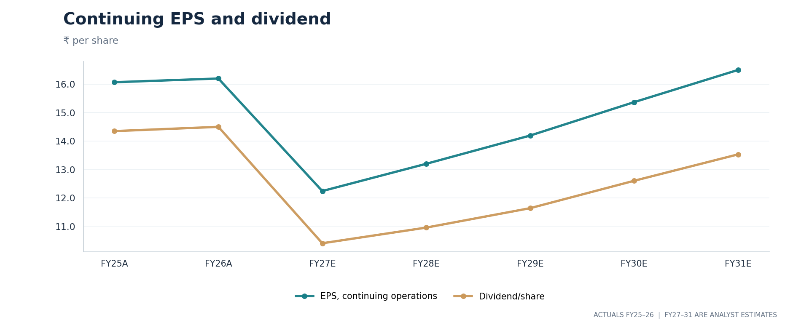
EXHIBIT 17. Continuing earnings per share versus declared dividend per share on the full-year timeline.
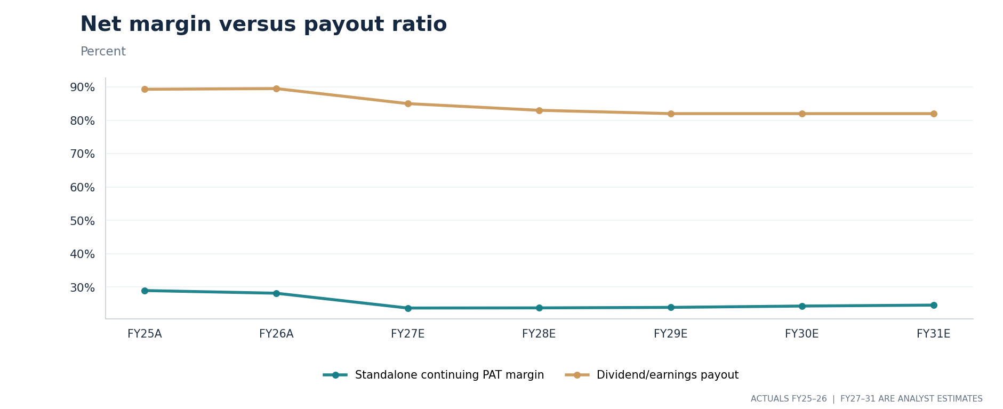
EXHIBIT 18. Payout measures and continuing net margins; dividend-to-earnings is not identical to cash dividend coverage.

12 Discounted cash flow
Discount expected free cash flow to the firm, then bridge to equity value
The DCF values standalone operating activity through FY31 based on PBIT after tax, plus depreciation, less capital spending and incremental working-capital needs. The estimated first forecast cash flow is discounted with a half-year stub adjustment because the valuation date is partway into FY27. Each later full year is discounted for its corresponding horizon. Terminal value is estimated using a nominal 4% growth perpetuity from FY31 normalized free cash flow.
Its key discount inputs are 7.07% as an observed historical proxy for a risk-free yield, 6.0% equity-risk premium, 0.85 beta, 8.5% debt rate, 25.2% tax rate and a near-equity capital structure (98.5% equity). The computed WACC is approximately 12.08%. These are analyst choices and reference-date proxies, not objectively fixed constants. [Model: Valuation_Inputs and Cost_Of_Capital]
The operating franchise DCF enterprise value is ₹187,241 crore, of which ₹136,448 crore is discounted terminal value (approximately 72.9%). The group-only subsidiary proxy adds ₹16,430 crore, the discounted quoted ITC Hotels stake adds ₹12,767 crore, and the liquid-financial-assets less debt and Century purchase adjustment adds ₹13,019 crore. In total the DCF equity estimate is ₹229,456 crore, or ₹182.98 a diluted forecast share.
Terminal value is the largest source of uncertainty. Perpetuity growth is a mathematical shortcut: it cannot capture every future excise, health or legal change. A modest WACC change moves the answer significantly even when annual forecasts remain constant. Use the valuation as one description of the model, not as a price prediction.
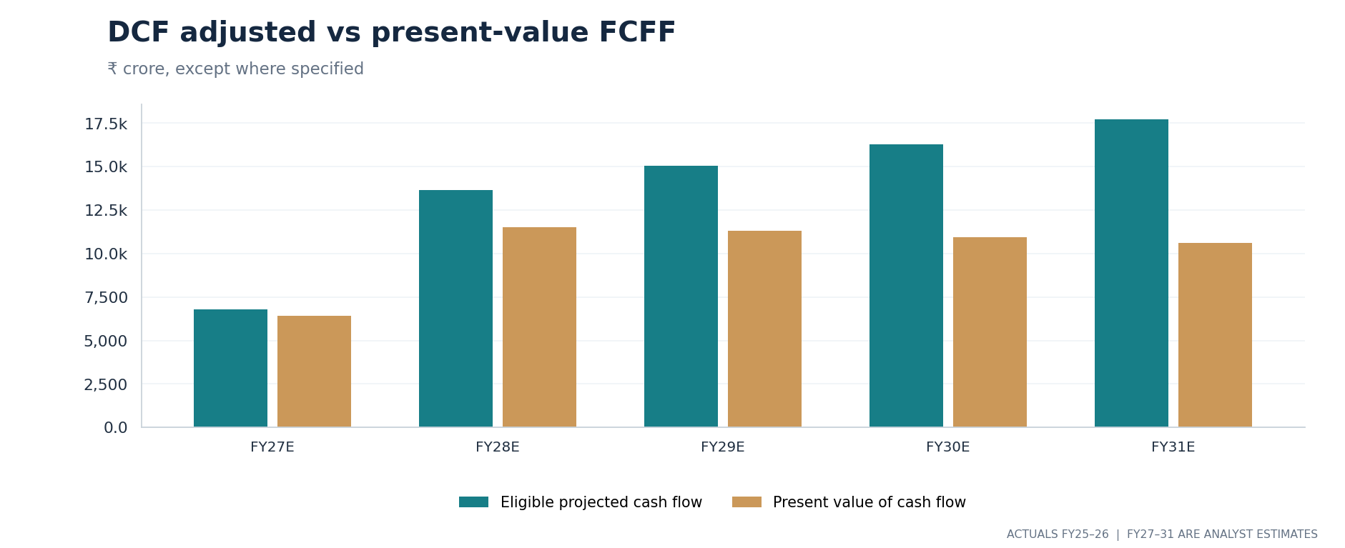
EXHIBIT 21. First-stage eligible cash flow versus discounted cash flow; the stub-year adjustment is included in the workbook.
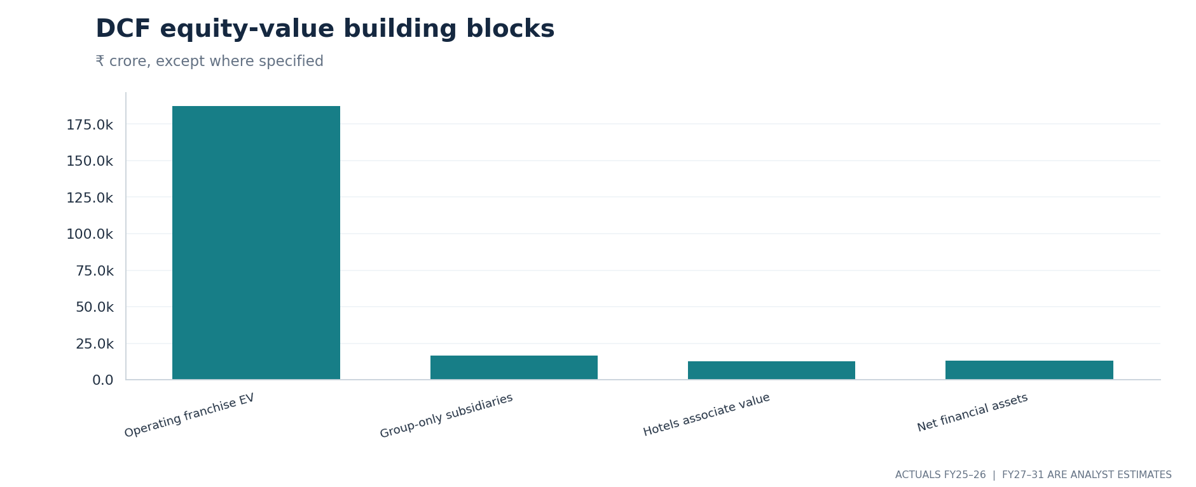
EXHIBIT 22. DCF equity bridge: standalone franchise value plus separately valued owned assets and pro-forma liquid balances.
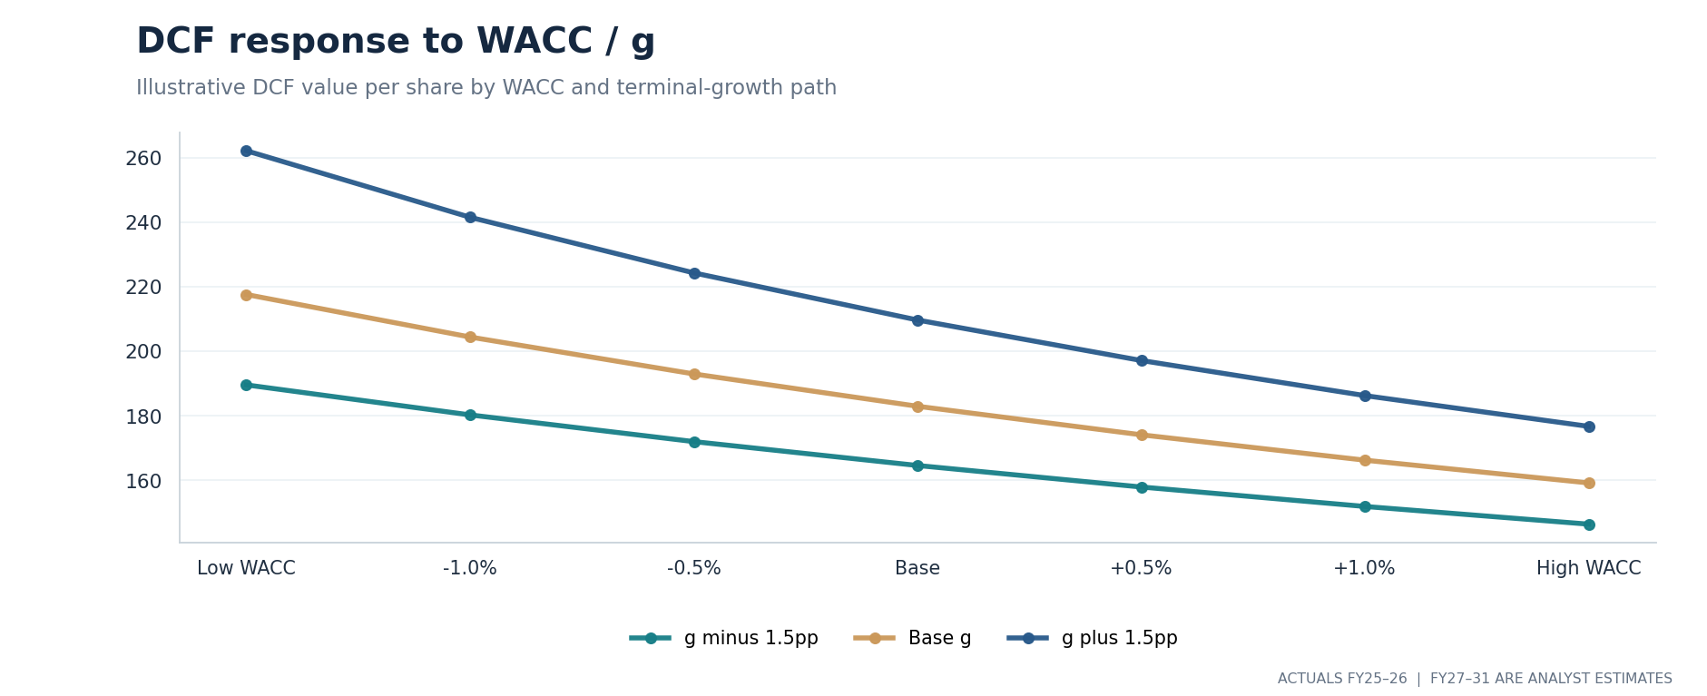
EXHIBIT 24. Sensitivity of DCF per-share output to the cost of capital across several terminal-growth assumptions.

13 Sum-of-the-parts and peer checks
Alternative capitalization frameworks reveal which valuation assumptions matter
The SOTP applies segment-specific valuation multiples to FY27 estimated PBIT and adds separately valued group-only earnings, ITC Hotels and certain net financial assets. The major assumed EBIT capitalization proxies are 17.5× cigarettes, 30× FMCG-Others, 12× Agri and 12× Paper. These are judgmental PBIT multiples presented on an earnings-style basis; they are not formal P/E of after-tax segment net earnings and should not be mistaken for standard, precisely matched EV/EBITDA multiples.
Under those assumptions, cigarette PBIT contributes approximately ₹253,251 crore of standalone business value, FMCG-Others ₹68,526 crore, Agri ₹17,560 crore and Paper ₹9,397 crore. The group-only businesses add ₹16,430 crore, the Hotels stake roughly ₹12,767 crore and the net financial adjustments ₹13,019 crore. The aggregate is ₹390,949 crore or ₹311.76 a share, substantially above the DCF result. [Model: SOTP]
The relative valuation method offers a third perspective: trailing P/E data from listed businesses in relevant segments are contribution-weighted and applied to the model’s FY27 consolidated attributable earnings. The resulting blended multiple is about 20.93×, applied to FY27 group EPS of ₹13.12, producing ₹274.56 a share. This comparison intentionally mixes trailing peer multiples with forward ITC earnings; it is a cross-check only, not a strict year-matched peer study. [Model: Peer_Snapshot, Relative_Valuation]
SOTP should not be presented as a higher-certainty “true value” merely because it exceeds DCF. The segment multiple method could overstate equity when it treats EBIT as if it were already after-tax owner earnings; the DCF can understate or overstate value when terminal cash flows are poorly specified. The research keeps both visible and reports exactly how assumptions create the difference.
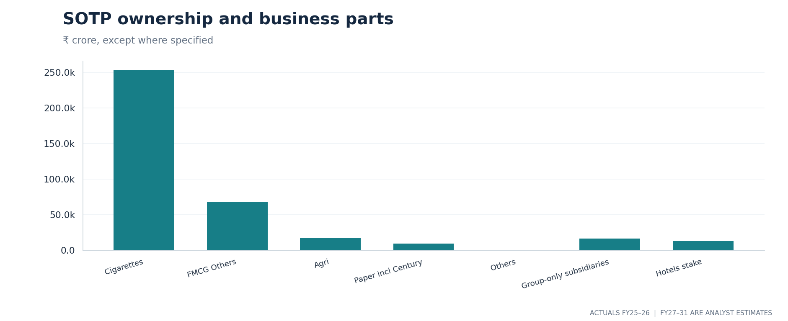
EXHIBIT 20. SOTP components in ₹ crore. The cigarette earnings proxy dominates estimated standalone business value; the Hotels holding and liquid-asset bridge are shown separately.
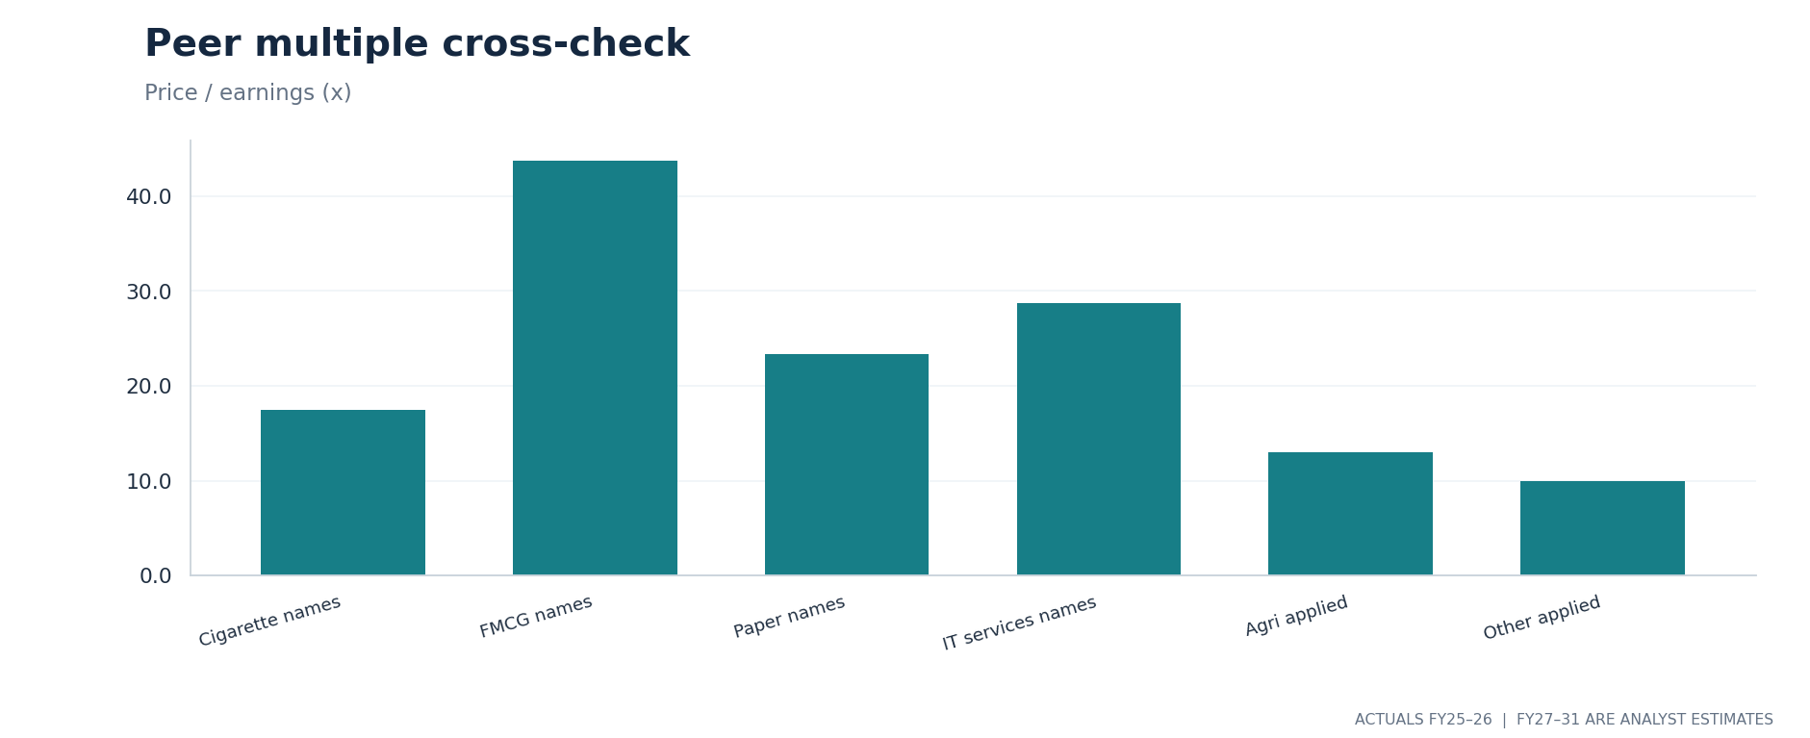
EXHIBIT 23. Contribution-weighted peer and assumed multiples, by sector bucket; peer dates and direct URLs are in the workbook.

14 Scenarios and sensitivities
A broad range is more defensible than an unqualified point estimate
The Base case assumes gradual adaptation to the new cigarette duty regime, sustained packaged-consumer growth, moderate paper contribution from Century and relatively stable treasury balances. The Bull case flexes selected volume, realization and margin assumptions in a favourable direction; the Bear case adjusts them in an adverse direction. The workbook changes its segment forecasts, financial statements and all three valuation methods when the scenario selector is changed.
SCENARIO | BLENDED VALUE | GAP VS ₹268.90 | INTERPRETATION
Bear | ₹216.16 | −19.6% | More adverse operating assumptions and weaker future cash conversion
Base | ₹254.67 | −5.3% | Central internally consistent assumptions
Bull | ₹291.24 | +8.3% | Stronger volume and margin assumptions; not a probability-weighted result

The blended value is constructed from analyst-selected weights: 40% DCF, 45% SOTP and 15% relative valuation. No probability has been assigned to the three operating scenarios. Differences from the historical share price express model sensitivity at the selected reference date, not predicted stock returns. Dividends, taxes, timing and market-price volatility are excluded from those arithmetic gaps.
An important two-variable stress table looks at DCF across weighted average cost of capital and terminal growth. At the model’s 12.08% WACC and 4% growth, the DCF estimate is ₹182.98; a change in either input alters terminal cash flow value. The SOTP matrix separately varies cigarette and FMCG multiples: its center is ₹311.76 under 17.5× cigarettes and 30× FMCG. Neither sensitivity substitutes for an operating-volume shock.
SENSITIVITY TEST | LOWER / HIGHER REFERENCE | IMPACT ON INTERPRETATION
DCF WACC | 12.08% ± 1.5 percentage points | A lower discount rate raises the present value of later cash flows
DCF perpetuity growth | 4.0% ± 1.5 percentage points | A higher growth rate raises terminal value if g < WACC
SOTP cigarette PBIT multiple | 17.5× ± 3.0× | Tax uncertainty can affect the capitalization multiple as well as PBIT
SOTP FMCG PBIT multiple | 30.0× ± 7.5× | Brand revenue growth does not remove margin and cash risk

15 Risks, governance and ESG
Material risks are operational, regulatory, accounting, financial and public-health related

Regulatory and public-health exposure
Tobacco products carry documented public-health harms. Changes in excise, GST, advertising, packaging, product regulation and enforcement can reduce legal cigarette consumption, reshape purchasing patterns or influence valuation discount rates. Investors applying tobacco exclusions for ethical or sustainability reasons may value ITC differently from investors assessing only financial cash flows. This is a real business characteristic, not a generic ESG label. [1–3]

Demand, cost and margin risks
FMCG faces commodity prices, price competition, distribution spending and brand adoption risk. Agri profits and inventory funding can be volatile with crop cycles and import/export rules. Paper profitability depends on machine use, fiber input cost, power and competition from imported products. Century adds execution and integration work. IT services are exposed to technology-spending cycles, labour costs and customer concentration, while the proposed Happiest Minds combination depends on regulatory and shareholder decisions.

Accounting and model-construction risk
Year-on-year comparison can be distorted by higher excise inclusion in booked revenue, hotel discontinued-operations gains, reclassification of subsidiaries, exceptional fair-value gains and changes in group scope. The model distinguishes consolidated owner earnings from standalone profits; nevertheless, its separate group-only value is a simplified earnings proxy. Where granular segment net-income or September interim balance-sheet detail is not available, assumptions remain judgmental rather than verified facts.

Governance and capital allocation
The annual report and exchange filings, not percentage claims from third-party stock screens, are the appropriate starting point for ownership, auditor opinions, related-party transactions and capital allocation disclosures. ITC has no officially declared controlling “promoter” class in the relevant stock-exchange shareholding format, despite large institutional block holders. Share counts, group investments, proposed share exchanges and potential future dilution should be refreshed each reporting date. [1, 6]
CAPITAL ALLOCATION TEST The question is not only what profits ITC reports; it is what cash remains after taxes, reinvestment, acquisitions and commitments to shareholders.

16 Monitoring checklist and conclusion
What new evidence would alter the model most quickly?
The next quarterly cigarette PBIT, price and product mix commentary, excise expense and after-excise group revenue will test whether the FY27 profit reset has stabilized. Cigarette segment gross revenue alone is not an adequate indicator. Another important check is whether FMCG-Others maintains its reported combination of sales growth and profit growth without consuming disproportionate working capital.
Paper monitoring should separate legacy operation recovery from the newly acquired Century contribution, including one-off integration costs, capex and capacity utilization. ITC Infotech and Happiest Minds disclosures should be updated only on formal deal milestones. A revised ITC Hotels shareholding and contemporaneous stock price are also necessary for the quoted stake value. Treasury assets, dividend cash spending, and capex will determine the cash bridge.
At the 25 September 2026 historical reference quotation of ₹268.90, the three models do not converge: DCF values the shares at ₹182.98, SOTP at ₹311.76 and peer-relative at ₹274.56, with the chosen blend at ₹254.67. Their divergence reflects uncertain cigarette economics, different treatments of enterprise versus equity value, and the importance of terminal cash flows and earnings multiples. It should be tracked as uncertainty rather than compressed into a directional market call.
ITC is best understood as a cash-generating tobacco franchise under a new regulatory regime, accompanied by multiple consumer, industrial and technology assets whose financial characteristics vary sharply. The key analytical discipline is to isolate the operating business, measure the new tax burden and cash conversion, and attribute separately held assets to shareholders only once. This report offers an auditable framework for further independent judgment, not a claim about future share-price direction.

APPENDIX A | FINANCIAL SCHEDULES
These schedules are taken from cached values in the linked financial workbook saved in Base mode on 28 September 2026. Historical figures are sourced from exchange-filed accounts; forecasts are analyst assumptions. Values are rounded to the nearest crore.
STANDALONE OPERATING BRIDGE | FY25A | FY26A | FY27E | FY28E | FY31E
Gross revenue from operations | 74,236 | 81,640 | 108,879 | 116,307 | 141,336
Excise duty | 4,913 | 9,656 | 44,238 | 46,662 | 57,025
After-excise operating revenue | 69,324 | 71,984 | 64,641 | 69,644 | 84,311
Cigarette PBIT | 20,025 | 21,051 | 14,471 | 15,349 | 18,766
FMCG-Others PBIT | 1,580 | 1,803 | 2,284 | 2,744 | 4,249
Agri PBIT | 1,478 | 1,496 | 1,463 | 1,580 | 1,906
Paper PBIT | 911 | 797 | 783 | 928 | 1,212
Total segment PBIT | 24,058 | 25,139 | 19,002 | 20,602 | 26,132
Standalone continuing PAT | 20,092 | 20,286 | 15,351 | 16,566 | 20,759

Note: FY25/FY26 historical and FY27–FY31 forecasts are formula-linked to the workbook. Operating PBIT is not EBITDA and does not equal consolidated owner earnings. Historical share counts change modestly year to year.

Historical operating cash and balance-sheet markers
SELECTED STATUTORY ITEM (₹ CRORE) | FY25A | FY26A
Operating cash flow | 16,751 | 17,095
Physical capital expenditure | 1,789 | 2,069
CFO less PPE capex | 14,962 | 15,026
Cash dividends paid | 17,477 | 17,968
Inventories | 15,061 | 17,932
Trade receivables | 3,911 | 2,926
Current investments | 15,286 | 19,702
Current borrowings | 2 | 2,026
Total equity | 67,900 | 69,929
Total assets | 84,009 | 88,916

APPENDIX B | VALUATION & OWNERSHIP SCHEDULES
VALUE BRIDGE | ₹ CRORE | ₹ / SHARE
DCF operating franchise enterprise value | 187,241 | —
DCF group-only subsidiary value | 16,430 | —
DCF ITC Hotels quoted holding value | 12,767 | —
DCF net liquid/cash adjustment | 13,019 | —
DCF equity value | 229,456 | 182.98
SOTP cigarettes | 253,251 | —
SOTP FMCG-Others | 68,526 | —
SOTP Agri | 17,560 | —
SOTP Paper | 9,397 | —
SOTP equity value | 390,949 | 311.76
Peer-relative implied value | — | 274.56
Weighted composite share value | — | 254.67

Important: SOTP capitalization uses PBIT proxies with earnings-like multiples, not after-tax net profit P/E or enterprise EV/EBITDA. It is presented as a sensitivity tool. No ownership interest in ITC Hotels is added again through non-current investments; the financial-asset bridge uses liquid balances from audited FY26, haircut for liquidity and adjusted for the Century consideration. [Model: SOTP, DCF]

DCF sensitivity, ₹/share
TERMINAL g / WACC | 10.58% | 11.08% | 11.58% | 12.08% | 12.58%
2.5% | 189.6 | 180.3 | 172.0 | 164.6 | 158.0
3.0% | 197.7 | 187.3 | 178.2 | 170.1 | 162.8
3.5% | 207.0 | 195.3 | 185.1 | 176.1 | 168.1
4.0% | 217.6 | 204.4 | 193.0 | 183.0 | 174.1
4.5% | 230.0 | 214.9 | 202.0 | 190.7 | 180.9
5.0% | 244.7 | 227.1 | 212.3 | 199.5 | 188.5
5.5% | 262.2 | 241.5 | 224.3 | 209.7 | 197.2

APPENDIX C | TERMS, ACCOUNTING BOUNDARIES AND CAUTIONS

Fiscal-year labels
FY26A covers the twelve months ended 31 March 2026; FY27E refers to the forecast year ending 31 March 2027. A=actual; E=estimate.

Standalone and consolidated
Standalone refers to the parent operating entity; consolidated combines qualifying subsidiaries and includes accounting for associates and non-controlling shareholders. It is not valid to add separate investment value to a consolidated earnings multiple without reconciling existing recognition.

Revenue after excise
Book revenue from operations less the company-reported excise expense. This is an economic comparison measure; segment cigarette ex-excise turnover is approximated by assigning all company excise to cigarette segment turnover.

PBIT
Profit before interest and tax reported by business segment; not equal to EBITDA, after-tax net income, or attributable earnings. SOTP PBIT multiple is an analyst earnings-proxy valuation, not a strict P/E.

Owner earnings
Consolidated profit attributable to ordinary equity shareholders, excluding profit belonging to non-controlling interests. The model separately excludes the Q1 Sproutlife fair-value gain from ongoing forecasts.

Cash flow to the firm
Operating profit after tax plus depreciation and amortization less capital expenditure and changes in operating working capital. Financing and investor distributions are considered in moving from enterprise value to equity value.

WACC and terminal growth
Weighted average cost of capital is the assumed hurdle rate for operating free cash flows; the perpetuity growth rate applies after the final explicit forecast year. Terminal value is highly sensitive to both.

Scenario cases
Bear, Base and Bull are internally coherent sets of assumptions. They are not probability intervals, market forecasts or investment recommendations.

Source hierarchy
Company exchange filings and dated corporate announcements determine actual accounting figures and legal transaction status. Market prices and peer values are historical snapshots and should be refreshed before decisions.

Transaction treatment
Century is booked as acquired in August 2026; the proposed ITC Infotech–Happiest Minds combination remains contingent in this cut-off and is excluded as if it had closed.

SOURCES & DOCUMENTATION
All actual financial figures come from dated primary filings or public company releases. Quoted market values and peer snapshots are external public-data observations retained with their exact as-of dates inside “Source Register” and “Peer_Snapshot” in the companion workbook. The bibliography below identifies the principal sources for the research narrative. Model estimates are the author’s mechanical assumptions and are not published ITC guidance.
[1] NSE — FY26 audited standalone financial results
https://nsearchives.nseindia.com/corporate/ixbrl/INTEGRATED_FILING_INDAS_159755_21052026183213_iXBRL_WEB.html
[2] ITC — Q1 FY27 press release, 31 July 2026
https://itcportal.com/media-centre/press-releases/media-statement-financial-results-for-the-quarter-ended-30th-june-2026.html
[3] NSE — Q1 FY27 standalone financial results
https://nsearchives.nseindia.com/corporate/ixbrl/INTEGRATED_FILING_INDAS_181204_31072026172335_iXBRL_WEB.html
[4] NSE — FY25 financial results and demerger reporting
https://nsearchives.nseindia.com/corporate/ixbrl/INTEGRATED_FILING_INDAS_92862_22052025181843_iXBRL_WEB.html
[5] ITC — announced Century Pulp and Paper transaction
https://itcportal.com/media-centre/press-releases/itc-announces-strategic-acquisition-of-pulp---paper-undertaking-0.html
[5a] Business Standard — August 2026 completion disclosure
https://www.business-standard.com/companies/news/itc-completes-century-pulp-acquisition-expands-paper-business-scale-126080301416_1.html
[6] ITC — proposed Infotech and Happiest Minds combination, 31 August 2026
https://itcportal.com/media-centre/press-releases/strategic-combination-of-itc-infotech-and-happiest-minds-technologies-to-create-a-scaled-future-ready-ai-first-global-technology-services-enterprise-with-us-dollar-1-billion-revenue-by-fy28.html
[7] ITC — Annual Report and Accounts FY2026
https://itcportal.com/investors/itc-reports-and-accounts/itc-report-and-accounts-2026.html
[8] ITC & ITC Hotels historical market closes
https://stockanalysis.com/quote/nse/ITC/history/
[8a] ITC Hotels quotation
https://stockanalysis.com/quote/nse/ITCHOTELS/history/
[9] NSE — audited FY26 consolidated result
https://nsearchives.nseindia.com/corporate/ixbrl/INTEGRATED_FILING_INDAS_159756_21052026183229_iXBRL_WEB.html
[10] ITC — Q1 FY27 investor presentation
https://itcportal.com/content/dam/itc-corporate/pdfs/financial-result/quarterly-results-2026-2027/june-2026/ITC-Quarterly-Result-Presentation-Q1-FY2027.pdf
[11] ITC — FY26 financial results press release
https://itcportal.com/media-centre/press-releases/media-statement-financial-results-for-the-quarter-and-year-ended-31st-march-2026.html

Model audit and disclosure note
The companion Excel file contains 25 worksheets, 24 native editable charts and documented formula-based links. The “Read Me” scenario control should be set to Base to reproduce the numerical exhibits in this report. Manual changes to forecast assumptions, valuations, share prices or scenario controls will change the workbook output while this fixed-date Word report remains unchanged. Before relying on values for a later market date, update prices, corporate actions, financial filings, shares outstanding, holding percentages and all key valuation assumptions.
Material data limits include missing per-grade cigarette volume data, segment owner net-income allocation and post-August updated treasury balances. This document is for research and financial education. It does not provide a recommendation to purchase, sell or hold any security. Cash-flow valuation is highly dependent on assumptions; the base, upside and downside scenarios are not probabilities or predictions.

