EMPLOYEE ATTRITION ANALYSIS USING HR DATA
A Descriptive Analytics Study and Interactive Dashboard
Project Research Paper | October 2026

Abstract
Employee attrition can affect organizational continuity, recruitment costs, and team experience. This project examines a supplied human-resources dataset containing 1,470 employee records and 32 fields. The analysis uses descriptive statistics and group-level attrition rates to explore patterns by overtime status, department, job role, satisfaction, age, and tenure. In the dataset, 237 records are labelled as attrition, corresponding to 16.12% of records. The observed attrition rate is 30.5% among employees recorded as working overtime and 10.4% among those not recorded as working overtime. These are descriptive associations, not evidence of causation. An accompanying Streamlit application allows users to filter the data, inspect visual summaries, and export filtered records. The project demonstrates a reproducible HR analytics workflow while emphasizing privacy, limitations, and responsible use.

Keywords
Employee attrition, human resources analytics, exploratory data analysis, data visualization, Streamlit, workforce retention

1. Introduction
Employee attrition refers to employees leaving an organization during a defined period. Understanding how attrition varies across job groups and work patterns can help HR teams identify topics for further investigation and evaluate retention initiatives. Data analysis can summarize patterns, but the numbers must be interpreted in context and should not replace conversations with employees or qualitative evidence.

2. Objectives
- Measure the overall proportion of records labelled as attrition.
- Compare group-level attrition rates by overtime, department, and job role.
- Explore how attrition relates descriptively to satisfaction and tenure fields.
- Build an interactive dashboard for filtering, visualization, and CSV export.
- Document limitations and responsible-use considerations.

3. Dataset Description
The input was the workbook supplied for this project. Its “Raw Data” sheet contains 1,470 employee records and 32 columns after the header row is interpreted. Variables include age, department, job role, overtime, job satisfaction, monthly income, total working years, years at company, and attrition. The target field is `Attrition` (1 = Yes, 0 = No); `AttritionLabel` provides the corresponding Yes/No text label. There are 237 attrition-positive records and 1,233 non-attrition records. The class distribution is therefore imbalanced, so an overall accuracy score alone would be insufficient for evaluating any predictive model. This paper uses descriptive analysis rather than a predictive model.

4. Methodology
- Data preparation: read the Raw Data worksheet using its actual header row and preserve the provided fields.
- Target interpretation: treat Attrition = 1 as Yes/left and Attrition = 0 as No/stayed.
- Descriptive analysis: calculate counts, group-wise leaver counts, and attrition rate = leaver count / group size × 100.
- Visualization: create bar charts for attrition status, department, job role, overtime, and supporting workforce indicators.
- Interactive implementation: build a Streamlit dashboard with department, job role, overtime, and age filters, plus CSV downloads.
- Interpretation: report associations only; no causal inference or individual employee scoring is performed.

5. Results

5.1 Overall attrition
Of 1,470 records, 237 are labelled Yes and 1,233 are labelled No. The overall attrition proportion is 16.12%. This figure describes this dataset and should not be interpreted as a current organization-wide rate without confirming the data source, population, and time period.

5.2 Overtime
The recorded attrition rate is 30.53% for employees with overtime (n=416) and 10.44% for employees without overtime (n=1054). The difference is notable and may justify investigating workload, scheduling, staffing, and employee feedback. The dataset alone cannot establish overtime as the cause.
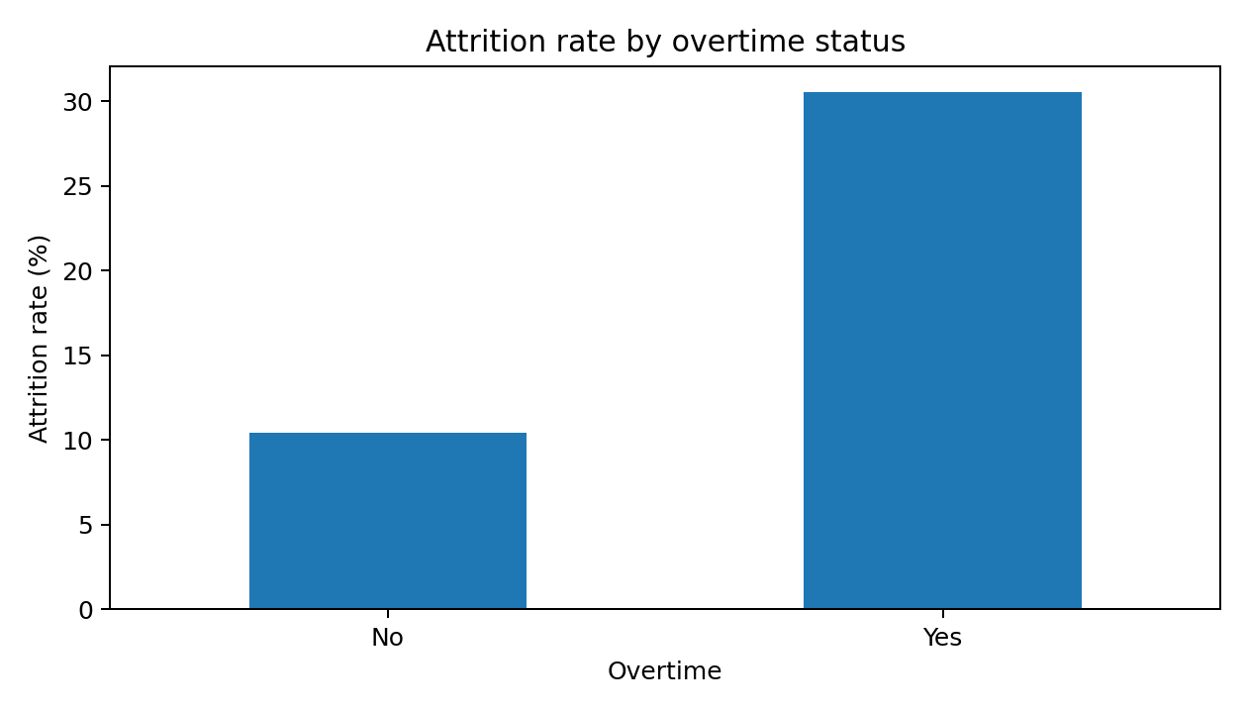

5.3 Department patterns
- Sales: 92 of 446 records marked attrition; rate 20.63%.
- Human Resources: 12 of 63 records marked attrition; rate 19.05%.
- Research & Development: 133 of 961 records marked attrition; rate 13.84%.

5.4 Job-role patterns
- Sales Representative: 33 of 83 records marked attrition; rate 39.76%.
- Laboratory Technician: 62 of 259 records marked attrition; rate 23.94%.
- Human Resources: 12 of 52 records marked attrition; rate 23.08%.
- Sales Executive: 57 of 326 records marked attrition; rate 17.48%.
- Research Scientist: 47 of 292 records marked attrition; rate 16.10%.
- Manufacturing Director: 10 of 145 records marked attrition; rate 6.90%.
- Healthcare Representative: 9 of 131 records marked attrition; rate 6.87%.
- Manager: 5 of 102 records marked attrition; rate 4.90%.
- Research Director: 2 of 80 records marked attrition; rate 2.50%.
Rates for small groups can fluctuate substantially. Role-level comparisons should therefore be reviewed alongside group size, work context, and other relevant evidence.

5.5 Satisfaction and tenure
Average years at the company are 5.13 among records marked attrition and 7.37 among records marked non-attrition. These averages are descriptive and can be affected by how the dataset captures employees who have left. The dashboard also enables users to explore job-satisfaction categories without assuming that satisfaction alone explains an employee's decision.

6. Proposed Recommendations
- Review overtime distribution and ask employees about workload, recovery time, scheduling, and staffing adequacy.
- Use department and job-role rates as prompts for further investigation, not as a ranking of managers or teams.
- Explore retention conversations, onboarding quality, career progression, manager support, and compensation fairness using multiple evidence sources.
- Track attrition consistently over time and document the population, date range, and definitions behind every rate.
- Protect employee privacy: restrict access, minimize identifiable fields, and report aggregated results where possible.

7. Application Design
The Streamlit application contains four views: Overview, Departments & roles, Work patterns, and Data & notes. Users can filter by department, job role, overtime, and age range; review summary metrics and charts; display filtered records; and download filtered or complete CSV data. The application is intended as a demonstration of descriptive analytics, not a deployed production HR decision system.

8. Limitations and Ethics
- The supplied workbook does not, by itself, establish a representative population, collection period, or current business context.
- Observed group differences do not prove causal relationships; confounding variables may explain some patterns.
- Some categories may have relatively few records, making their rates unstable.
- Historical HR data may contain measurement errors, missingness, or biases in how variables were collected.
- Employment data is sensitive. Users should have authorization to process it and avoid using this dashboard to automate high-impact decisions or target individual employees.

9. Conclusion
This project turns the supplied employee dataset into a reproducible descriptive analytics workflow and interactive dashboard. The dataset shows an overall attrition proportion of 16.12% and a higher observed attrition rate in the overtime group than in the non-overtime group. Department and role-level rates offer additional avenues for investigation. The most appropriate next step is to combine these descriptive signals with employee feedback and organizational context, then evaluate retention actions over time. The results should be treated as exploratory and not causal.

References
1. Supplied project workbook: Employee_Attrition_Full_Project(1).xlsx, Raw Data worksheet. Dataset provenance and collection period were not independently verified for this paper.
2. Streamlit documentation. https://docs.streamlit.io/ (application framework documentation; accessed for project implementation guidance).
3. pandas documentation. https://pandas.pydata.org/docs/ (data processing library documentation).

Appendix A: Reproduction
Install dependencies with `pip install -r requirements.txt`, then run `streamlit run app.py`. See README.md for online deployment steps. All reported numeric results were calculated from the supplied workbook's Raw Data sheet.

