https://www.facebook.com/profile.php?id=61552296176009&mibextid=9R9pXO



# Continue as Prkishorer

**Not you?**

**Log In**



prcrackers

**0** likes **0** followers



**Follow**

Posts About Photos Mentions

# Details

**Page** · Supermarket/Convenience store

Not yet rated (0 reviews)

**prcrackers** updated their proﬁle picture.

11 Oct 2023



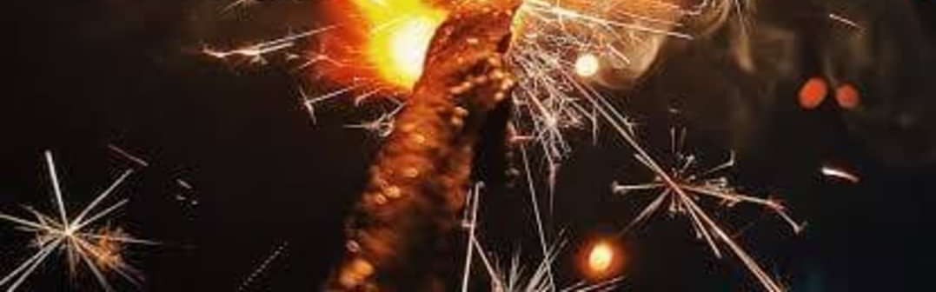

**Continue as Prkishorer**

**Log In**

**Not you?**

**prcrackers** updated their cover photo.

11 Oct 2023



**prcrackers** updated their cover photo.

11 Oct 2023

