https://crackers.my.canva.site/

PR Crackers

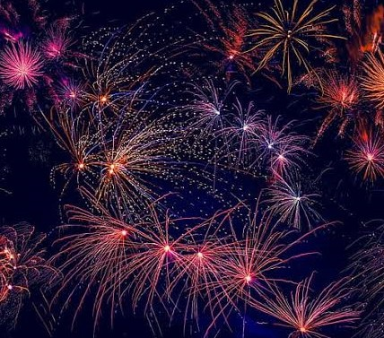

Contact:

Email [id:prcrakerspadalur@gmail.com](mailto:prcrakerspadalur@gmail.com) Ph.no:7550376553

Shine your memories, with our crackers.

Bright & Breezy



See a sky , with colourful eyes





Colour Crackers

Diwali Sale

**25% off**

Terms & Support [Designed with](https://www.canva.com/)