**RFID BASED HOSTEL ENTRY SYSTEM**

**Abstract:** This paper proposes a prototype system design, implementation and description of required tools and technologies to develop an RFID (Radio Frequency Identification) based hostel entry system to facilitate hassle free and quick entry of hostel records of students.

**Problem Statement:** Entering our names, roll numbers and room numbers every time we leave or come back into our hostels is quite a tedious task and sometimes even leads to crowding thus wasting our time. It isn’t foolproof either as many students make fake entries hence making the tasks of authorities harder. Having to scan the entire register for students who haven’t made it back to the hostel doesn’t make the work any easier either. In this age of technology, this time consuming traditional method isn’t necessary at all.

**Solution:** To solve this problem we are proposing a mechanism that uses RFID to facilitate automatic entries. Each student will be provided a unique RFID card which will be scanned by our RFID reader to make their entry every time they leave or enter the hostel. It also displays the image of the card bearer on scanning the card to prevent fake entries. These RFID cards will be updated with their unique names, roll numbers and room numbers.

**Components Required:**

* NodeMCU
* Raspberry Pi
* MFRC522 RFID Sensor Module
* RFID Tags
* Jumper Wires
* Breadboard
* Soldering Iron
* LCD Monitor
* Power Supply for NodeMCU, Raspberry Pi and LCD Monitor.

**Software and Tools Required:**

* Mosquitto MQTT broker
* NodeRED
* Arduino IDE

**Working:**

* Connect the MFRC522 RFID Reader with the NodeMCU as shown below.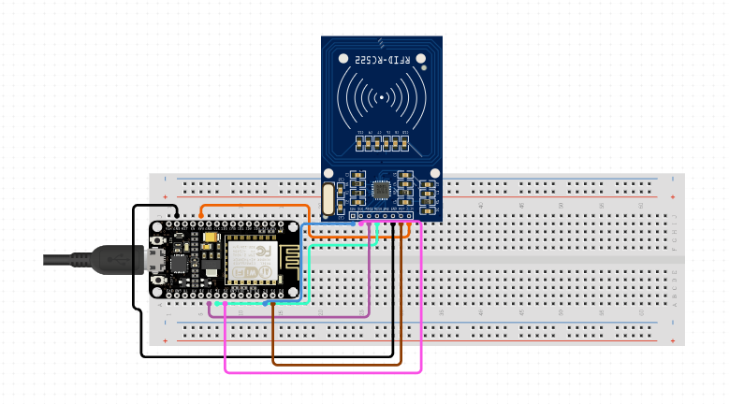
* Writing student info to RFID Cards:-
  1. Upload the rfid_write_student_info.ino sketch that we wrote, to the NodeMCU board using the Arduino IDE.
  2. Scan the RFID card into the MFRC522 RFID Sensor.
  3. Open Serial Monitor and enter student info according to instructions displayed on Serial Monitor.

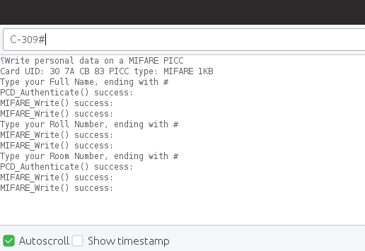

* 1. The student info gets written into the RFID Card.
* Upload the mysketch.ino sketch that we wrote into the NodeMCU board. This sketch will be used to read student into from RFID Card and send it to the Raspberry Pi Server using MQTT protocol. It uses the PubSubClient library to access the MQTT protocol.
* Set up Raspberry Pi with display as shown below.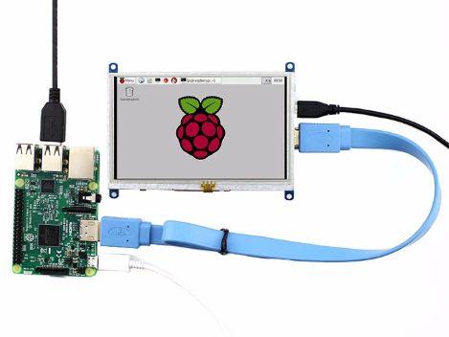
* Open WiFi hotspot from Raspberry Pi, NodeMCU automatically connects to the hotspot.
* Scan the RFID Card into the MFRC522 RFID Sensor. Open the serial monitor to see connection status.

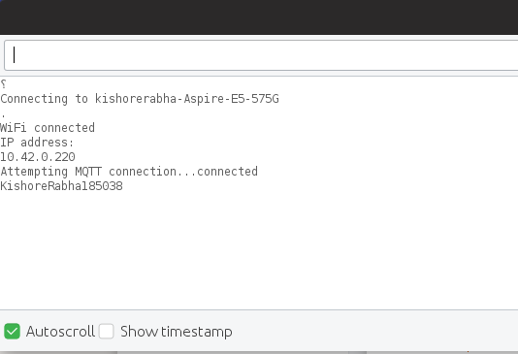

* The Mosquitto MQTT broker will subscribe to the messsages published by the NodeMCU and publish them to the NodeRED server which is set up in the Raspberry Pi. NodeRED comes built-in with Raspberry Pi.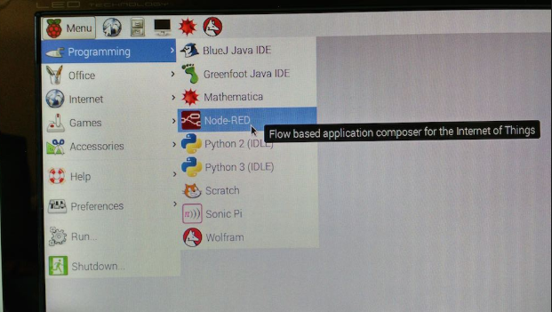
* The NodeRED server receives the data and then logs the entry of the student into a log.txt file.

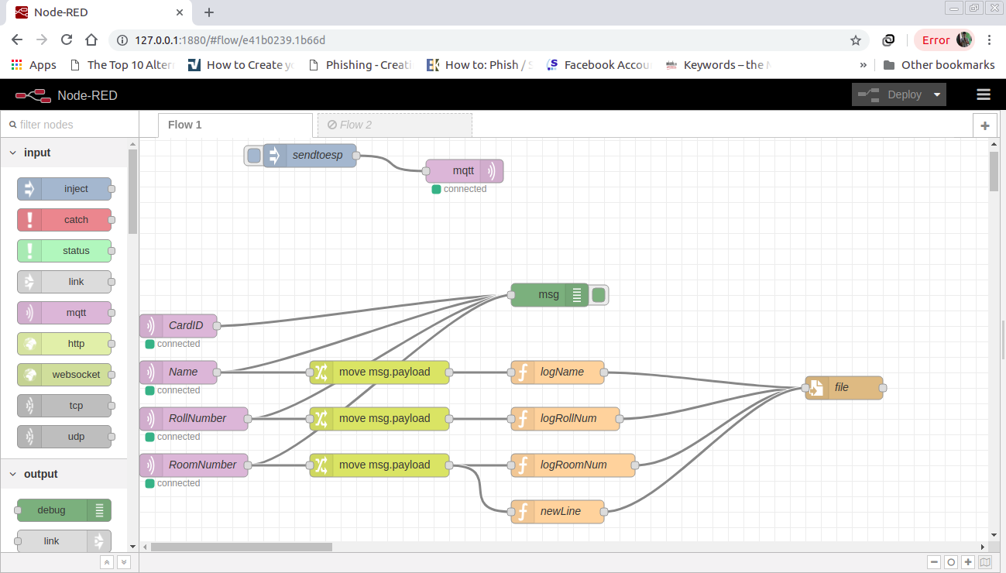

* Then we run a Python script to read the log.txt file and display the student entry info. The Python script provides the option to display the info of students who haven’t closed their entries.
* The student info can be updated on the RFID Cards using the rfid_write_student_info.ino sketch as per need for new students every year.

**Innovations:**

* Automated Entries.
* Time Saving.
* Foolproof and effective.
* Usage of simple and cost-effective RFID technology.
* Usage of NodeMCU and Raspberry Pi makes this project easy to setup and replicate for as many hostels as needed.