# ABSTRACT

Public transport is the great importance in day to day life. Citizens who use buses they waste a time for wait the bus at bus stop. In daily operation of bus system, the gesture of bus is affects by unknown situations as the day progresses such as traffic or dispatching buses at irregular time from the depot. The peoples are travelling by bus get exact location of bus and the count of passengers in bus it will increases the trustworthiness in public transport. The system design is prepared. Specifically, DFD (Data Flow Diagram), architectural design, block design and use case design of our system is prepared. This project proposes a system to track public bus using GPS, tell the count of number of passengers in bus and also the status of the bus. The location of bus passenger count, bus status, bus routes and bus timing can be access by public using IoT technology. All these details of particular bus are accessed by simply scanning QR code of link in smart phone.this system is very secure and smart assisted. It’s more secure, smart and advanced. The system is smart and advanced as it has various features GPS tracking, IoT acknowledgement.

# INTRODUCTION

With the increasing population in city, cities are facing a difference range of issue such as suffer traffic fully air quality, increasing road accidents, and burst growth in number of private vehicle. And the same time decreasing share of public transport. With the development of Information technology, Internet of Things is becoming reality. IoT can assist in the co-ordinate of communication, control and information processing present in the public transport system.

The inspiration for this project was to limit and curtail the difficulties and issues related with public transport framework in India. India is a developing country. Here, we face many issues in our daily life. Citizens who use local travel in day-to-day life, local travels don’t show exact timing of bus and numbers of passengers in the bus. We developed a project with GPS system for exact location of bus and develop a circuit for count the number of passengers in the bus. The passenger simply scans the QR code which is placed in every bus stop and they get bus details in webpage. It is helpful for passenger like students and job employee. They can use it to arrive in time. As well as using the website passenger can see where the bus is how many passengers are present in bus and how long it will take for the bus to reach there.[1]

These are helpful in daily to develop, such as traffic congestions, unexpected delays, irregular vehicle dispatching time, other happens. It provides more easily with publics and provide exactly time and bus location so that they may not get late. The proposed system requires a ellipse that is open source software environment. The IDE is used in android development in order to make it quick. This platform is multitasking. It is useful for workers and students.

# METHODOLOGY

The system is placed in every bus the system built around Arduino nano. When system turns on, the LCD and GSM Module is initialized. The GSM module is used to accessed wireless internet in the bus. GPS is used to get the latitude and longitude that is exact position of bus. Arduino reads the position continuously. Ignition is checked. If ignition is on then the GPS co-ordinates that is latitude and longitude are read by Arduino nano. Arduino nano sends GPS co-ordinates, passenger count to webpage. IR sensors are placed at the entry and exit doors of bus to count the number of passengers in bus. If ignition is off then output of IR sensors at the entry and at exit is sensed by Arduino nano. If the IR sensor at the entry, senses passenger then Arduino nano increments passenger count by 1. If the IR sensor at the exit, senses passenger then Arduino nano decrements

passenger count by 1. Arduino sends all these details of bus continuously to a webpage through internet connection the web page also contains the details of bus like bus number, bus route, bus timing which is manually uploaded by authority. Public access all these details of bus on visiting to that particular web page. For simplicity to access webpage, the QR code of link of webpage is attached to every bus stop.

# LITERATURE SURVEY

In past works given in SeokJuLee[1], they have actualized transport vehicle tracking for UCSI University, kuala Lumpur, Malaysia. It is developed for settled course, giving the candidates with status of bus after determined time period utilizing LED panel smart phone application. Technique used is Ardunio microcontroller Atmega328 based Arduino UNOR3 microcontroller. GPS, GSM or GPRS module a similar controller is used. Program to control them is composed in C programming language, compiled and saved in microcontroller's flash memory. The testing results in this paper give; testing in-vehicle module, testing web server and database, testing smart phone app.

In PengfeiZhou[2], foreseeing transport entry time with cell phones is given. Innovation utilized is participatory detecting of users. This model framework with various sorts of Android based cell phones and thoroughly explores different avenues regarding the NTU grounds carry transports and in addition Singapore transports over a 7-week time span, then taken after by London in 4-weeks. The proposed framework is arrangement is all the more for the most part accessible and is vitality agreeable. The assessment comes about recommend that the proposed framework accomplishes extraordinary expectation exactness contrasted and those operator initiated and GPS based solutions. The model framework predicts transport entry time with average tolerance of 80 sec.

In Maman Abdurohman[3], versatile tracking framework is utilized to monitor vehicles position and in uncommon cases there are much helpful data can be studied, for example, speed, cabin temperature and no. of passenger. This monitoring procedure is done utilizing GPS module, and sending the information to a server through GSM modem. It is proposed machine to machine communication from which Open Machine Type Communication as correspondence platform for collecting and preparing area information. The google outline shows the area. The Open MTC platform that is produced by Fraunhofer FOKUS in view of ETSI M2M Rel.1 specification.

# MODELING AND DESIGING

Waterfall model control the system. Schedule is set for deadlines all stages of development and projects can process by using the development process model stage one by one.

## Requirement Gathering and Analysis: -

The passible requirement of system is developed in phase. In our project there are two types of requirements namely hardware and software requirements.

* Firstly, the connection between GSM module and webpage should be established. This connectivity will take place through internet. To establish this connectivity, required commands are sent to GSM module by the controller. Hence, TCP connection with UBIDOTS server is linked.
* Once the proposed required of our system TCP connection is linked, it is analyzed and used to send the data to webpage.

## System Design: -

* The specifications from the first phase are studied in this phase and the system design is prepared. Specifically, DFD (Data Flow Diagram), architectural design, block design and use case design of our system is prepared which helps to specify hardware and software requirement and helps in defining the overall system infrastructure.
* DFD (Data Flow Diagram): - Signifies the exact flow of data in the system.

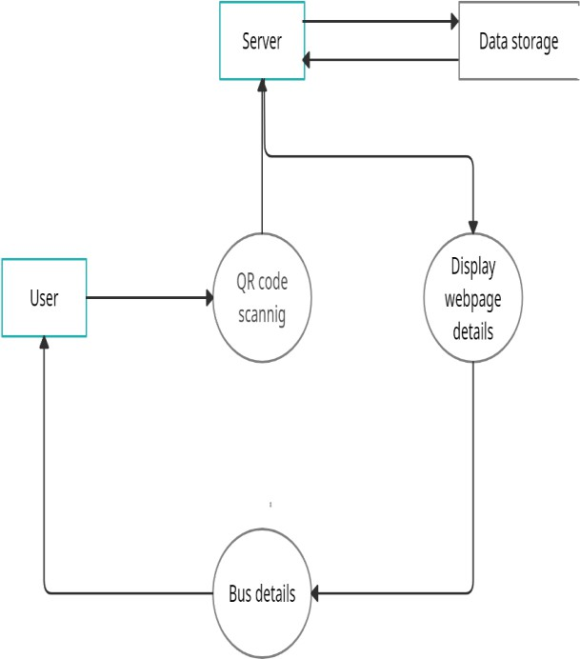

This is the Data flow diagram of our project, first user scans the QR code after that request sends to the server access the data from cloud then the server displays the whole details of bus, that is route of the bus, real time location of bus, bus number and exact count the number of passenger in bus.

* Architecture design: - It makes the architecture of system understandable.

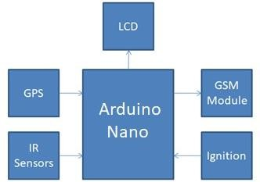

* Block design: - It helps to clarify the controlling functionalities of the system.

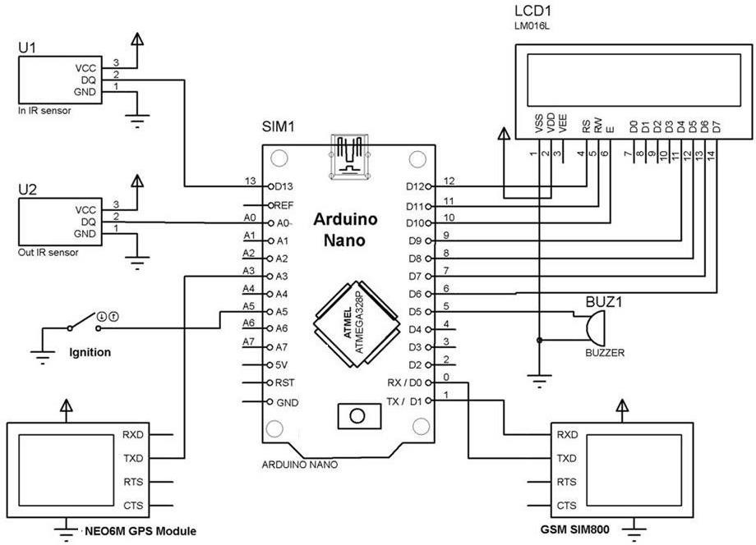

This system is placed on every bus. The system built around Arduino nano. GPS module, GSM module IR sensor and LCD are connected to the Arduino nano. The GSM is used to accesses wireless internet in the bus. GPS is used to get the latitude and longitude that is position of bus. Arduino read the position continuously. IR sensors are placed at the entry and exit doors of bus to count the total number of passengers in the bus.

The ignition of the bus is connected to Arduino to get the status of bus that is whether bus is on or off. Arduino sends all these details of bus continuously to a web page though internet connection. The web page also contains the details of bus like bus number, bus routes, bus timings which is manually uploaded by authority. Public access all these details of bus on visiting to that particular web page. For simplicity to access web page, the QR code of link of web page is attached to every bus stop.

* Use case design: -User end functionalities is shown in our system.

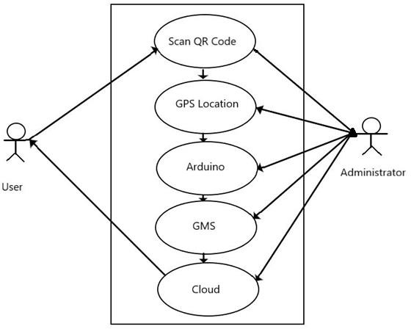

We proposing QR code . User can scan QR code, open the website, after scan the QR code. User get the bus details like bus route, Changing count of passenger present in bus.

## Implementation:

* Inputs from the system design, the system is first develop in small program called units such as reading GPS data, Establishment of connectivity using GSM module, sending data to webpage are integrated in next phase. the unit is develop as per its significant functionality.

## Testing:

* All the units developed in the implementation phase are integrated into a system after confirming functionalities of each unit is in a proper manner. After integration the entire system is tested before it is deployed. The reading of GPS data that is latitude and longitude readings, connectivity to internet through GSM module, IR sensors at the in and out doors are tested.

## Deployment:

* Once the system has been tested, the full functional system is deployed in the customer environment. User will use it to make sure either the system is correctly functioning or not.

## Maintenance:

* There are some issues which come up in the user environment such as in connectivity. Also, to enhance the product some better versions of the system will be released.

# RESULT AND DISCUSSION

In this output shows the first output before passengers enters in bus and the status of ignition. Shows the status of bus that is bus is on or off.

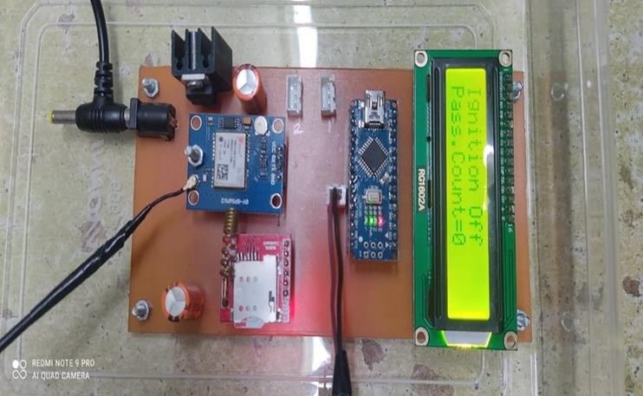

This shows the output of our project. and shows count of passengers which is increasing one by one.as well as the status of ignition.

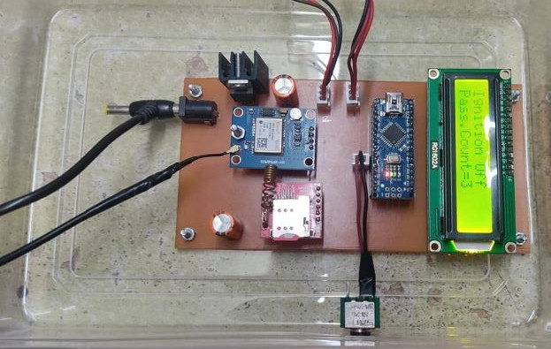

This shows the output of our project. and shows count of passengers which is increasing one by one.as well as the status of ignition.it is very useful for students and job employee to get exact location and time of bus. And shows the real time location of bus.

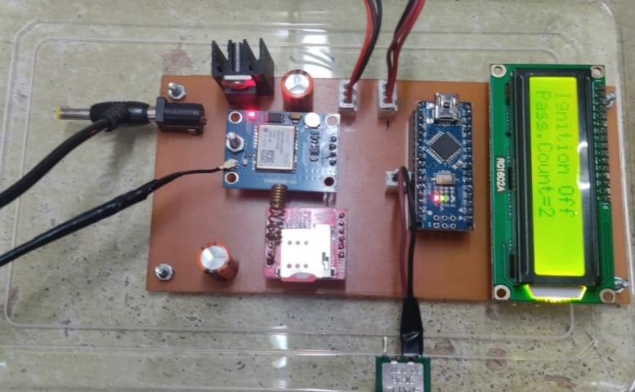

# CONCLUSION

This system is very secured and smart assisted transport. It’s more secure, smart and advanced. The system is smart and advanced as it has various features GPS tracking, IoT acknowledgement.[4] The objectives of this are, to design a system that will get the position of bus using GPS module, count the number of passengers in the bus, count the number of passengers in the bus, count the number of passengers in the bus. To design a system that will update all the data of the bus to the web page.

# REFERENCES

1. SeoJuLee, GirmaTewolde, Jaerock kwon, IEEE world Forum on Internet of Things (WF-IoT), March 2014, Seoul “Design and Implementation of Vehicle Tracking System using GPS/GSM/GPRS Technology and Smartphone Application”.
2. IEEE,“ How Long to Wait the bus? Predicting Bus Arrival Time with Mobile Phone Based a Participator Sensing”,IEEE Transactions on Mobile Computing, Pengfei Zhou, Student Member, IEEE, YuanqingZheng, Student Member, IEEE, and Mo Li, Member, vol.13, no. 6, June 2014.
3. “Mobile Tracking System Using Open MTC Platform Based on Event Driven Method”, MamanAbdurohman, Anton Herutomo, Vera Suryani, AsmaElmangoush, Thomas Magedanz, 1st IEEE International Workshop on Machine-to-Machine Communications Interfaces.
4. Minoru Sakairi, “Water-Cluster-Detectiang Breath Sensor and Applications in Cdars for Detecting Drunk or Drowsy Driving”, IEEE Sensors Journal, vol.12, no. 5, May 2012.