After importing from github, add the below external jars to the project :

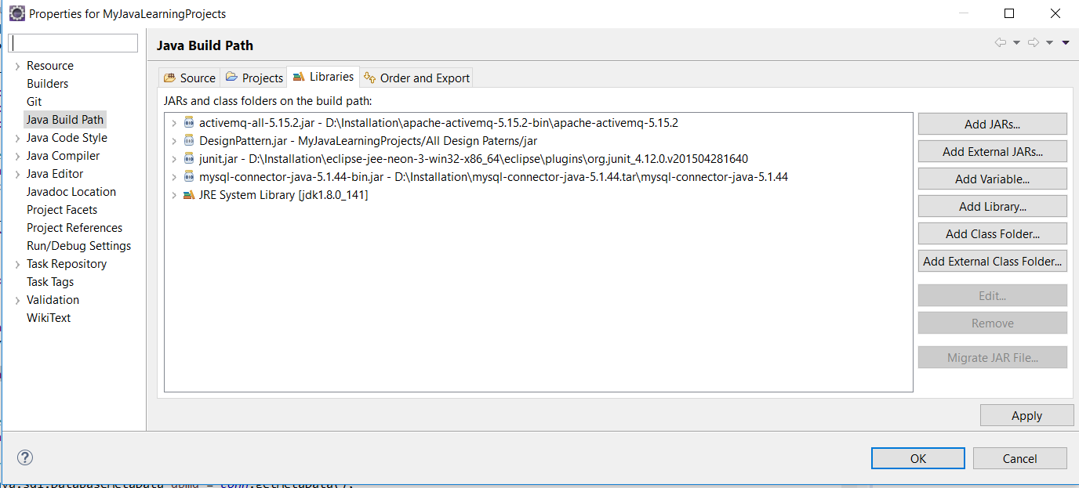

The Junit test cases while running were giving this error :

So have to add this external jar - hamcrest-core-1.3.jar.

java.lang.NoClassDefFoundError: org/hamcrest/SelfDescribing at java.lang.ClassLoader.defineClass1(Native Method) at java.lang.ClassLoader.defineClass(ClassLoader.java:763) at java.security.SecureClassLoader.defineClass(SecureClassLoader.java:142) at java.net.URLClassLoader.defineClass(URLClassLoader.java:467) at java.net.URLClassLoader.access$100(URLClassLoader.java:73) at java.net.URLClassLoader$1.run(URLClassLoader.java:368) at java.net.URLClassLoader$1.run(URLClassLoader.java:362) at java.security.AccessController.doPrivileged(Native Method) at java.net.URLClassLoader.findClass(URLClassLoader.java:361) at java.lang.ClassLoader.loadClass(ClassLoader.java:424) at sun.misc.Launcher$AppClassLoader.loadClass(Launcher.java:335) at java.lang.ClassLoader.loadClass(ClassLoader.java:357) at org.junit.internal.builders.JUnit4Builder.runnerForClass(JUnit4Builder.java:10) at org.junit.runners.model.RunnerBuilder.safeRunnerForClass(RunnerBuilder.java:59) at org.junit.internal.builders.AllDefaultPossibilitiesBuilder.runnerForClass(AllDefaultPossibilitiesBuilder.java:26) at org.junit.runners.model.RunnerBuilder.safeRunnerForClass(RunnerBuilder.java:59) at org.junit.internal.requests.ClassRequest.getRunner(ClassRequest.java:33) at org.eclipse.jdt.internal.junit4.runner.JUnit4TestLoader.createUnfilteredTest(JUnit4TestLoader.java:84) at org.eclipse.jdt.internal.junit4.runner.JUnit4TestLoader.createTest(JUnit4TestLoader.java:70) at org.eclipse.jdt.internal.junit4.runner.JUnit4TestLoader.loadTests(JUnit4TestLoader.java:43) at org.eclipse.jdt.internal.junit.runner.RemoteTestRunner.runTests(RemoteTestRunner.java:444) at org.eclipse.jdt.internal.junit.runner.RemoteTestRunner.runTests(RemoteTestRunner.java:678) at org.eclipse.jdt.internal.junit.runner.RemoteTestRunner.run(RemoteTestRunner.java:382) at org.eclipse.jdt.internal.junit.runner.RemoteTestRunner.main(RemoteTestRunner.java:192) Caused by: java.lang.ClassNotFoundException: org.hamcrest.SelfDescribing at java.net.URLClassLoader.findClass(URLClassLoader.