AngularJs Get Started

For all the examples here we use the following url of github, a example of schema is also show below.

<https://api.github.com/users/kishoretvk>

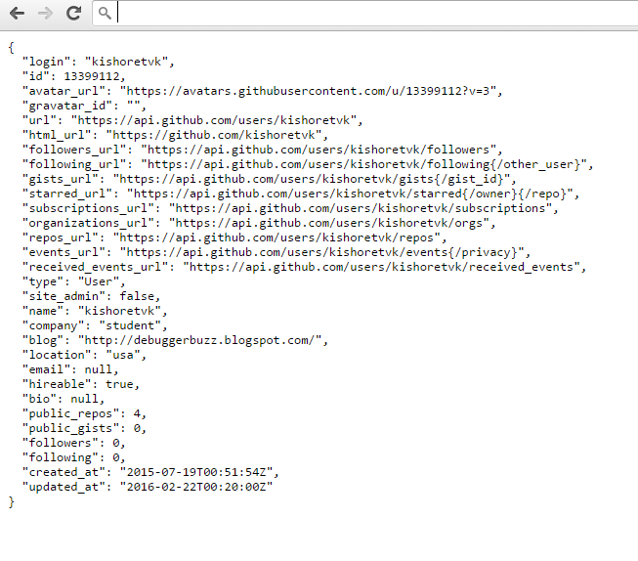

Angular, we say hello here . to understand angular, we have to first understand basic OOPS.

Try to recall a method inside a class. The more methods we have in a class the class has more functionality. We can access all public methods from a class by its object.

Object.methodname.

Similar way we have to pick angular controller. Which is a class and ng-app is a namespace, an analogus to .net. any models which we create inside a controller are analogus to methods in side a class.

Where as class is analogs to controller in any object oriented language

The $scope is similar to a object. And we accesss the methods with an object.methodname.

So we access $scope.modelname.

NG-Controller and Ng-App:

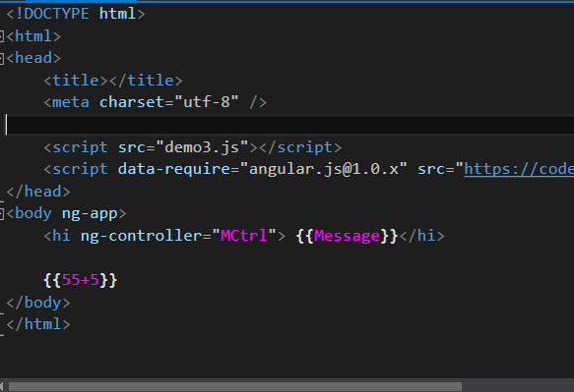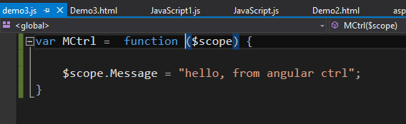

Controller in Action directly with a javascript object inside.

A javascript object is a collection of key value pair. Similar to any other collection like list, dictionary etc.

NG-APP Expressions Evaluation

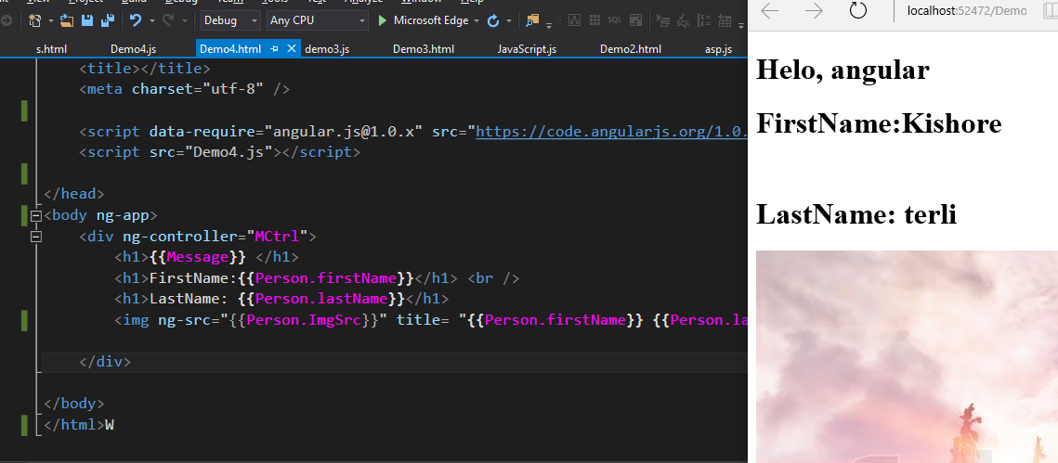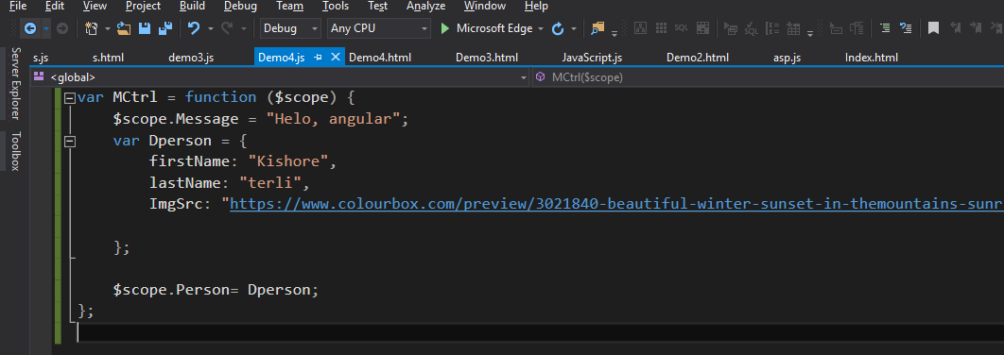

Html is a super fast consumer where as angular kicks in only at the end so any hmtl kind of tag is first evaluationed and kept as error if angular is involved partially. Angular comes in once html is rendered and then it chages the html.

“src ” is tag in html, if angular is involved in the source, htmls shows it as 404 error but the content is only revaled after ng-app starts working.

Angular is error prone as it not strongly typed and it doesn’t come with intellisense, however this error will not stop other tags from binding data.

APi Calls:

Lets use github for http service.

A simple api call to github api is as below.

Api.github.com/users in your browser will give you a json formatted data. 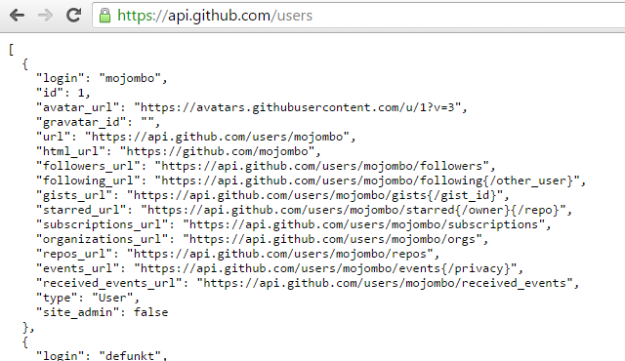

This shows the key : value pair of json object sent from website.

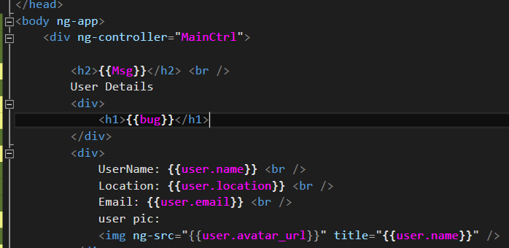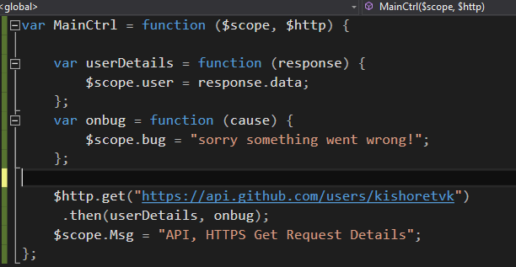

Isort by ascending and descending:

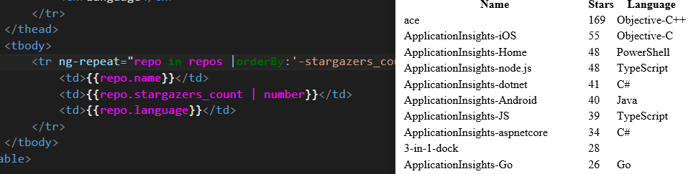 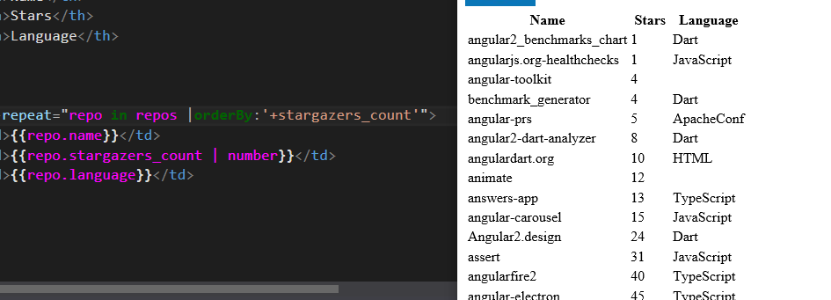

The + and – sign before a model variable makes the loop or any section ascending or descending.

Expression evaluation in angular:

We can give expressions in angular just as we do in other javascripts, ng-controller will look at them after the html is loaded and then they will be evaluated once.

The following example will show how do we enter first name, last name and also insert a picture.

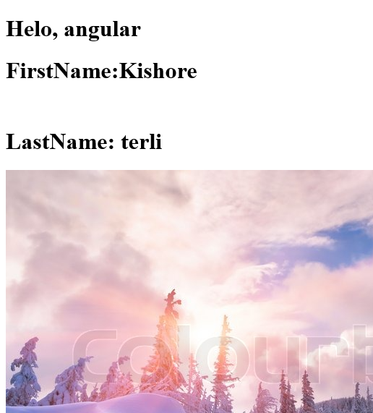

Attributes are kept in {{}} and for a html source tag, we use ng-src. This is because, if we keep an expression inside a html tag, browser will try to convert it with html which will trhow a 404 error.

Use ng-src will make sure that it is a angular tag and html will not ry to manipulate

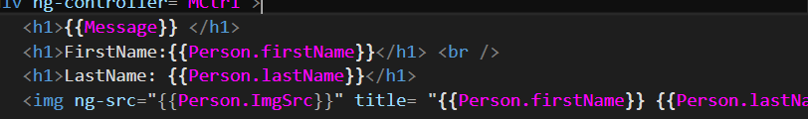

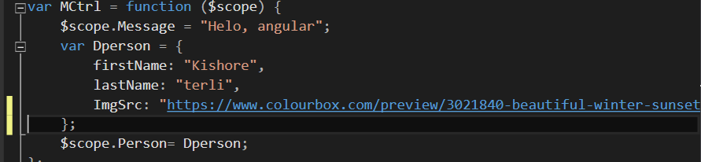

Inside the js file we create a controller which has a javascript object called person. This has few properties such as first name, last name and image.

Module:

A module is a block of code which is dealth by a controller and a model in other worlds, it helps in deaing with separation of concenrs.

Service:

A service in angular can be similar to the same in ajax, $http, is the key word which has get, put, delete, post.

The methods gives a promise when first accessed and then the result, the result is fed to a javascript object.

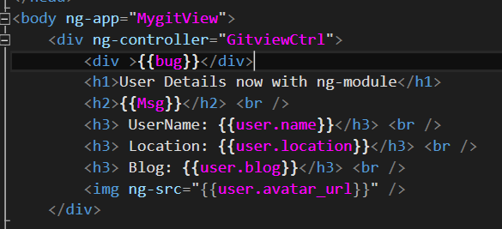

The moduel is a kind of layered architechture or helps in implementing a separation of concerns.

Ng-app is the main app and inside then we can have separate modules which have their work done separately. With out other module involvement.

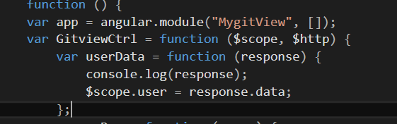

Module has been registered with $http. This will enable the module to use http service in ng-app or the controller.

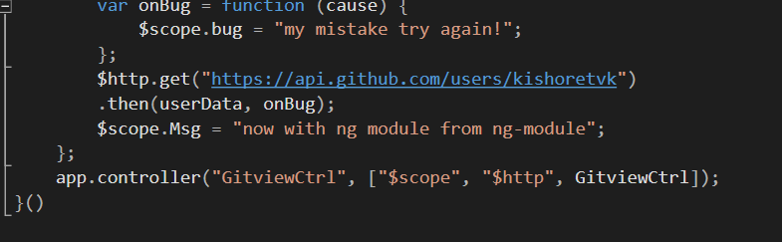

The .then function shows a promise come back from the url but positive shke hand. To chec this promise, add a scope with a success and error function. Error function has capabilities to log erors as to console or to html page or to another service where we can get feedback for maintainance

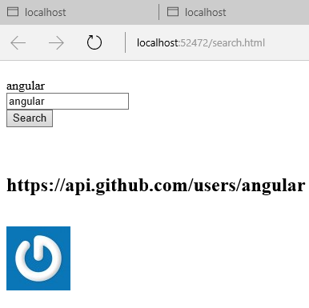

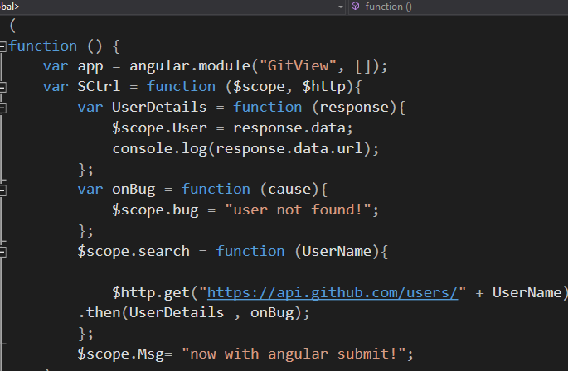

The search function is created to search any user from github, this will help in making ajax calls to website and get data from http.get. these data will help this sample will help in creating single page application.

NG-Include directive:

The ng-include has made it possible to include a complete index.html or any html page, inside another document just as any html directive 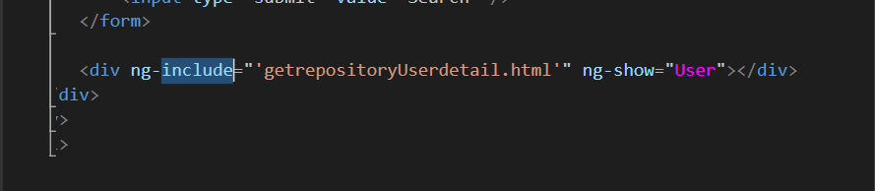

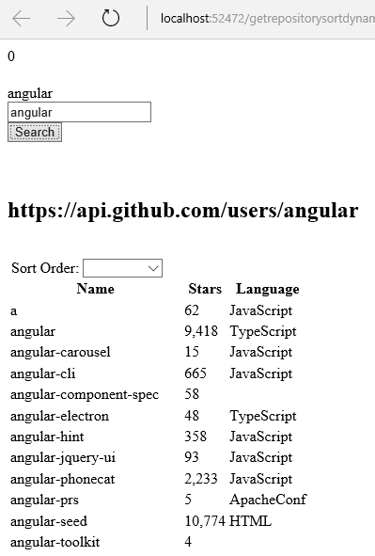

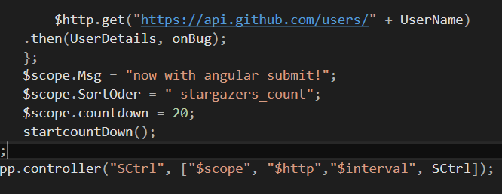

The line app.controller is used to register services with controller. When we add a new service they have to be added as either as arrary to controller. This helps in reducing the code for minification.

Counter.

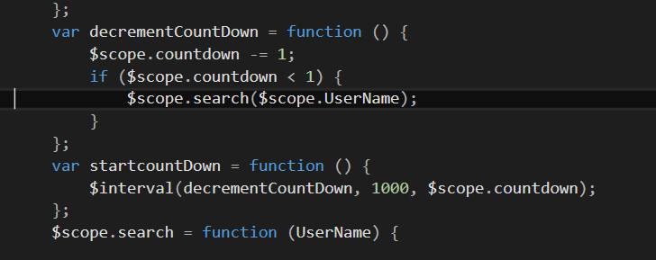

A counter is used is much similar to the interval in javascript. We create function to count each interval of 1000 ms and then this Is to be called until a count, if not we can end up in infinite loop.

Just as we have ng-include, similar weay we can also separate code from the controller. It can be used create a separate service so that, it can be included into other modules as well to make code reusability.

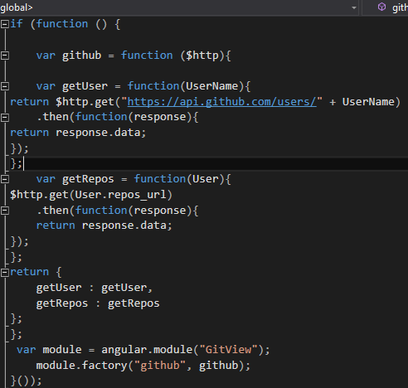

Thus this here we can call each method by github.getuser or github.getRepos.