TinyCorp Ecommerce Event-Driven Microservices Design Document
Version 1.0 | Generated on 2026-04-22 13:56

1. Executive Summary
This document describes the architecture, design decisions, runtime flows, deployment model, data model, API contracts, and operational guidance for the TinyCorp ecommerce event-streaming platform. The system demonstrates a production-style microservices architecture built using Spring Boot, Apache Kafka, Maven, H2, and a dashboard UI.

2. Business Goals and Scope
- Demonstrate asynchronous event streaming for ecommerce order lifecycle.
- Separate bounded contexts into independent microservices.
- Provide both API and UI-based order creation paths.
- Enable operational visibility through metrics, logs, and dashboards.
- Offer a one-command local deployment using Docker Compose.
Out of scope for this demo: authentication/authorization, distributed tracing backend, persistent production databases, and external payment providers.

3. Non-Functional Requirements
- Availability: Services should start in dependency order and recover via container restarts.
- Scalability: Kafka decouples producers and consumers; stateless services can be replicated.
- Observability: Actuator health endpoints, service logs, and Kafka UI provide operational insight.
- Maintainability: Maven multi-module structure with shared event contracts.
- Portability: Full stack can run locally via Docker Compose.

4. High-Level Architecture
Pattern: Event-driven microservices with choreography over Kafka.

4.1 Services
- product-service (8081): Product catalog and inventory reservation.
- order-service (8082): Order creation, stock reservation, order state transitions.
- payment-service (8083): Payment simulation and payment status publication.
- notification-service (8084): Notification audit log from payment/fulfillment events.
- dashboard-ui (8080): Aggregated metrics dashboard and manual order placement UI.
- common-events: Shared Java event records for Kafka payload contracts.
- kafka (9092): Event backbone.
- kafka-ui (8090): Topic and consumer visibility.

4.2 Context Diagram (Textual)
User -> Dashboard UI -> Order Service -> Product Service (sync stock reserve) -> Kafka topics -> Payment Service/Order Service/Notification Service consumers.

5. Event Choreography and Sequence
- Dashboard/API sends Create Order request to order-service.
- order-service validates request and synchronously reserves stock from product-service.
- order-service persists order as PAYMENT_PENDING and publishes orders.created.
- payment-service consumes orders.created, simulates payment result, persists transaction, publishes payments.processed.
- order-service consumes payments.processed and updates order state (FULFILLED or PAYMENT_FAILED).
- If successful, order-service publishes orders.fulfilled.
- notification-service consumes payments.processed and orders.fulfilled, storing notification logs.

6. Kafka Topic Design
- orders.created: Producer=order-service, Consumer=payment-service.
- payments.processed: Producer=payment-service, Consumers=order-service, notification-service.
- orders.fulfilled: Producer=order-service, Consumer=notification-service.
All events use shared JSON contract records from common-events to reduce schema drift between services.

7. Data Model

7.1 product-service
- Product(id, sku, name, category, price, stock)

7.2 order-service
- CustomerOrder(id, orderNumber, customerName, customerEmail, totalAmount, status, createdAt, updatedAt)
- OrderItem(id, productId, productName, quantity, unitPrice, order_id)

7.3 payment-service
- PaymentTransaction(id, orderNumber, amount, paymentMethod, status, reference, processedAt)

7.4 notification-service
- NotificationLog(id, eventType, recipient, message, status, createdAt)

8. API Design (Representative Endpoints)

8.1 Product Service
- GET /api/products
- GET /api/products/{id}
- POST /api/products/{id}/reserve?quantity={q}
- GET /api/products/metrics

8.2 Order Service
- POST /api/orders
- GET /api/orders
- GET /api/orders/metrics

8.3 Payment and Notification Services
- GET /api/payments/metrics
- GET /api/notifications/metrics

8.4 Dashboard Service APIs
- GET /api/dashboard/metrics
- GET /api/dashboard/products
- POST /api/dashboard/orders
- POST /api/dashboard/demo-orders?count=10

9. UI/UX Design
- Metrics cards for products, orders, payments, notifications.
- Order status and payment outcome visual charts.
- Order form with dynamic line items (add/remove rows).
- Live line-item subtotal and cart total.
- Client-side stock validation before order submission.

10. Seed Data Strategy
- product-service: 300 products.
- order-service: 180 historical orders.
- payment-service: 220 historical payments.
- notification-service: 160 historical notifications.
- Total > 860 records for realistic dashboard behavior.

11. Deployment Architecture
Docker Compose deploys Kafka, Kafka UI, and all Spring services in one network. Services communicate by service DNS names (e.g., http://product-service:8081).

11.1 Health and Startup Orchestration
- Kafka has a broker healthcheck using kafka-broker-api-versions.
- Spring services expose /actuator/health and are probed via curl healthchecks.
- depends_on uses condition: service_healthy to enforce startup ordering.

12. Observability and Operations
- Spring Boot actuator health endpoints for readiness checks.
- Service logging (root=INFO, com.tinycorp=DEBUG).
- Kafka UI for topic/consumer visibility.
- Smoke test script for end-to-end health validation.

13. Security Considerations
- Current demo uses no auth; production should add OAuth2/JWT and RBAC.
- Kafka currently PLAINTEXT; production should enable TLS/SASL.
- Input validation is present; add rate limiting and WAF at gateway layer.

14. Risks and Mitigations
- Risk: Event contract drift between services. Mitigation: shared contract module, evolve with versioning.
- Risk: Duplicate processing in consumer retries. Mitigation: idempotency keys and dedup tables.
- Risk: Service startup race. Mitigation: compose healthchecks with service_healthy dependencies.
- Risk: In-memory DB data loss on restart. Mitigation: persistent DB for production.

15. Scalability and Future Enhancements
- Introduce API Gateway + service discovery.
- Adopt outbox pattern for guaranteed event publication.
- Add dead-letter topics and retry policies.
- Add OpenTelemetry tracing and centralized log aggregation.
- Replace H2 with PostgreSQL/MySQL for persistence.
- Introduce integration tests using Testcontainers.

16. Runbook (Quick Operations)
- Start stack: docker compose up --build -d
- Check status: docker compose ps
- Run smoke test: ./scripts/smoke-test.ps1
- View logs: docker compose logs -f
- Stop stack: docker compose down
- Reset stack: docker compose down -v

17. Conclusion
The TinyCorp platform demonstrates a clean and practical blueprint for event-driven ecommerce microservices. The solution balances educational simplicity and production-like structure, making it suitable for interviews, demos, training, and iterative platform hardening.

APPENDIX A:
How to run this application outside docker (or without using docker compose)?
From the project root C:\00_INTERVIEW\TinyCorpLaptopTracker:

Start Kafka only (plus Kafka UI) with Docker:
docker compose up -d kafka kafka-ui
Build once locally:
mvn -DskipTests clean package
Run each service in a separate terminal:
mvn -pl product-service spring-boot:run
mvn -pl order-service spring-boot:run
mvn -pl payment-service spring-boot:run
mvn -pl notification-service spring-boot:run
mvn -pl dashboard-ui spring-boot:run
Open:
Dashboard: http://localhost:8080
Kafka UI: http://localhost:8090
Optional quick check:
powershell -ExecutionPolicy Bypass -File .\scripts\smoke-test.ps1

APPENDIX B: Running smoke test
Expected: all services PASS
powershell -ExecutionPolicy Bypass -File .\scripts\smoke-test.ps1
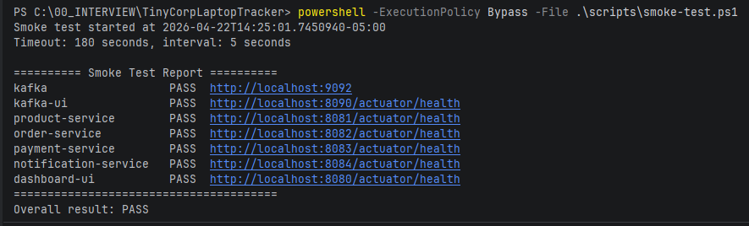

APPENDIX C: Run the application and how to test it test

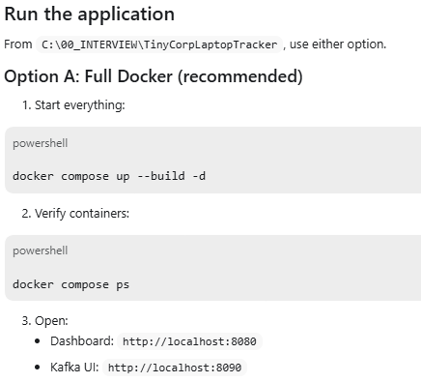
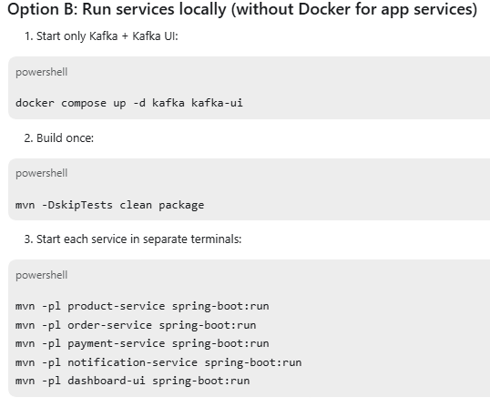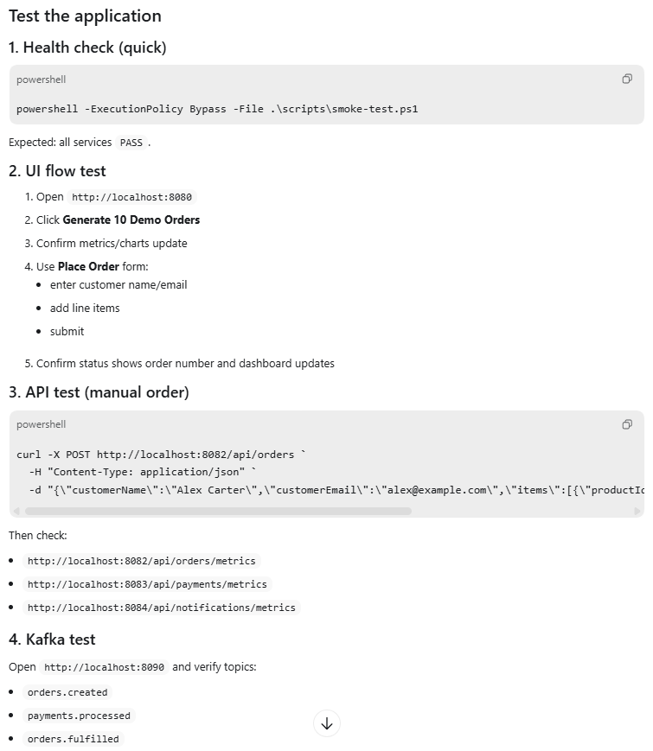

API test (manual order)

curl -X POST http://localhost:8082/api/orders `
-H "Content-Type: application/json" `
-d "{\"customerName\":\"Alex Carter\",\"customerEmail\":\"alex@example.com\",\"items\":[{\"productId\":1,\"quantity\":1},{\"productId\":2,\"quantity\":2}]}"
