1. Creating and Renaming Files/Directories

Create a directory named test_dir using mkdir.

Inside test_dir, create an empty file called example.txt.

Rename example.txt to renamed_example.txt using mv  
  
**Implementation - Commands and explanation.**

Commands used   
  
1. **mkdir test_dir** # Creating directory named test_dir

2. **touch test_dir/example.txt** # Creating an empty file named example.txt under test_dir

3. **mv example.txt renamed_example.txt #** command to change the name example.txt to renamed_example.txt using mv

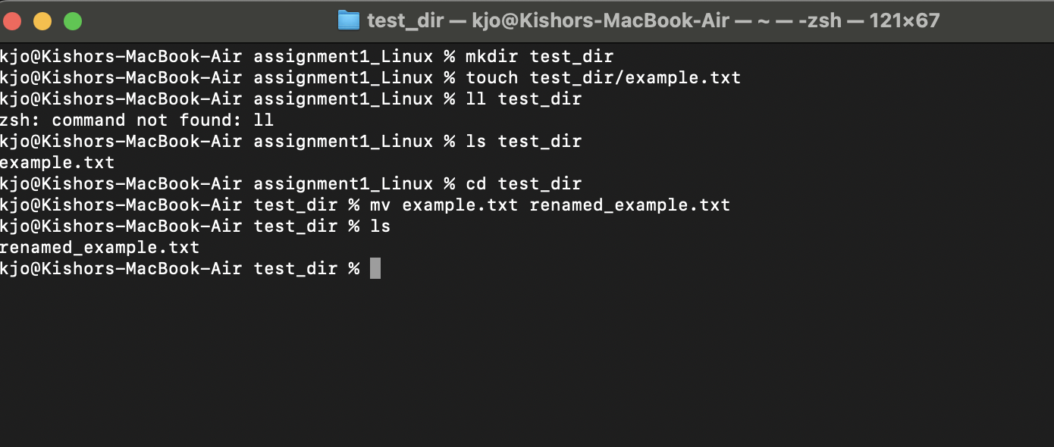

2. Viewing File Contents

Use cat to display the contents of /etc/passwd.

Display only the first 5 lines of /etc/passwd using head.

Display only the last 5 lines of /etc/passwd using tail.

**Implementation - Commands and explanation.**

1. **Cat to display the content of /etc/passwd -** cat /etc/passwd

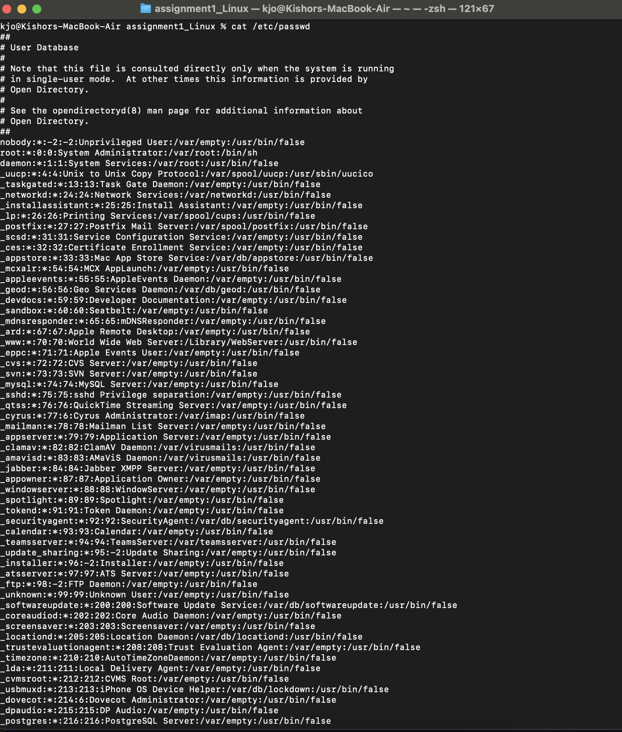

1. **Display only the first 5 lines of /etc/passwd using head command. -** head -n 5 /etc/passwd

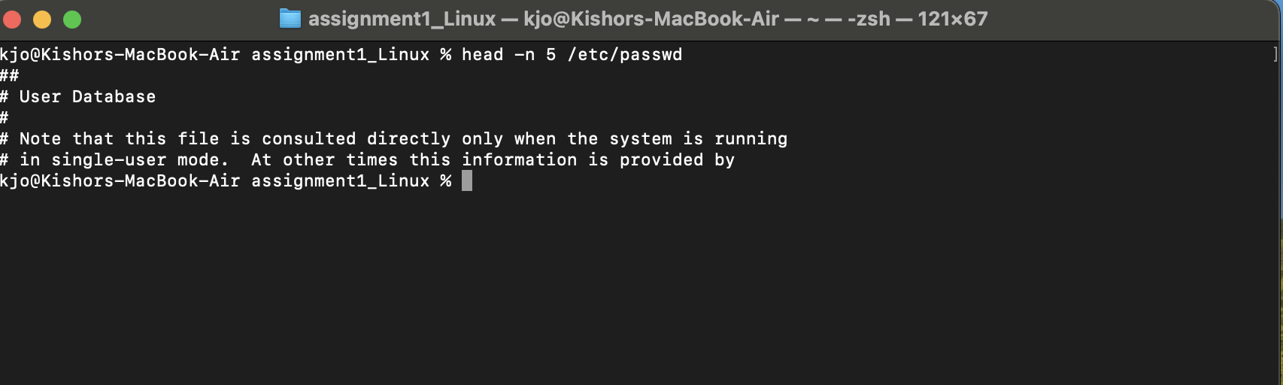

1. **Display only the last 5 lines of /etc/passwd using tail. -** tail -n 5 /etc/passwd 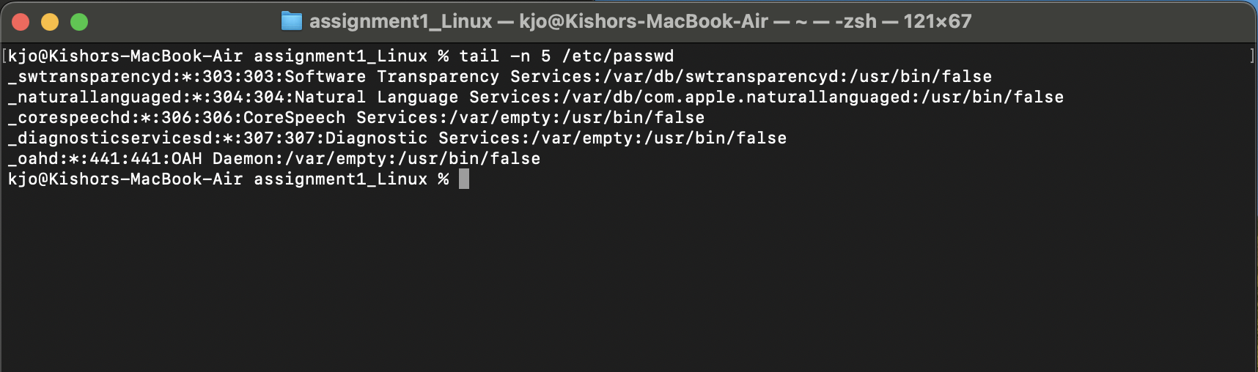

3.Searching for Patterns

Use grep to find all lines containing the word "root" in /etc/passwd.

**Implementation - Commands and explanation.**

**Command used -** grep “root” /etc/passwd

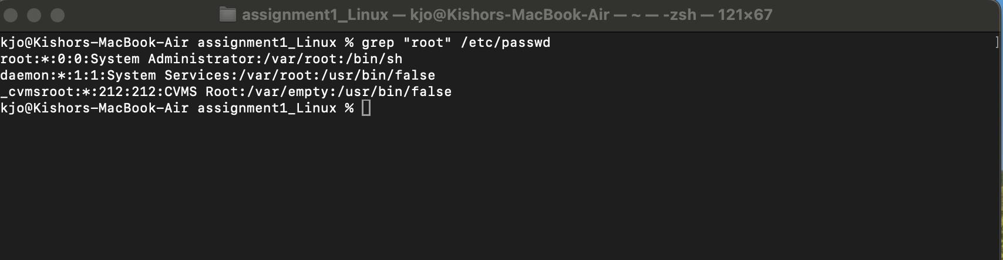

4. Zipping and Unzipping

Compress the test_dir directory into a file named test_dir.zip using zip.

Unzip test_dir.zip into a new directory named unzipped_dir.  
  
**Implementation - Commands and explanation.**

1. Compress the test_dir directory into a file named test_dir.zip using zip.

**zip -r test_dir.zip test_dir  
Note:** -r is used here to recursively full directory zipped with all its contents  
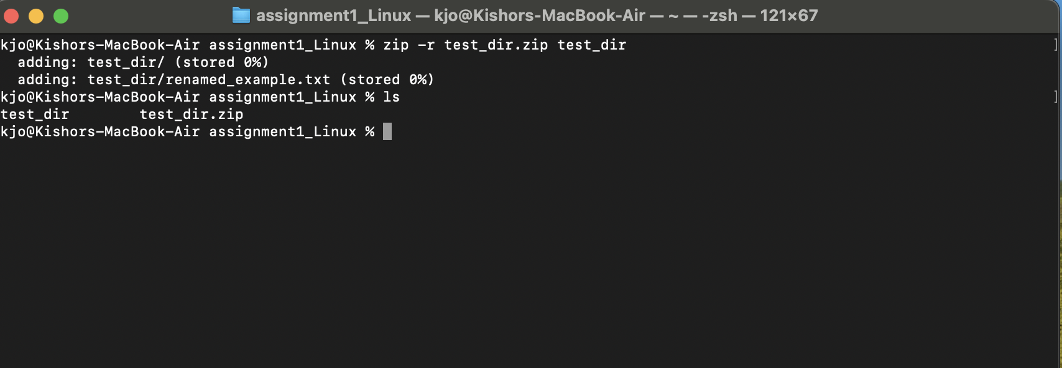

1. Unzip test_dir.zip into a new directory named unzipped_dir.  
   **unzip test_dir.zip -d unzipped_dir**

note: -d is used here for clean extraction into a specific folder

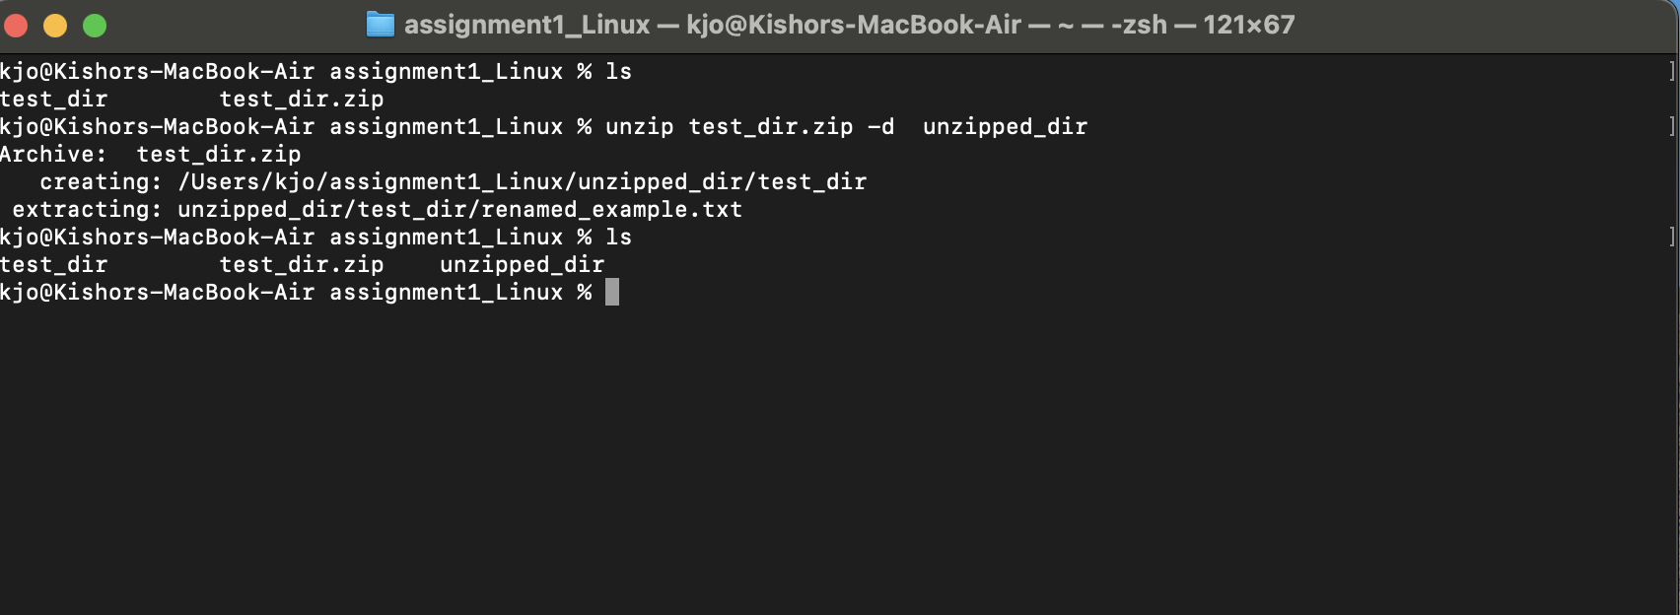

5. Downloading Files

Use wget to download a file from a URL (e.g., <https://example.com/sample.txt>).

Command used: **wget https://en.wikipedia.org/robots.txt**  
  
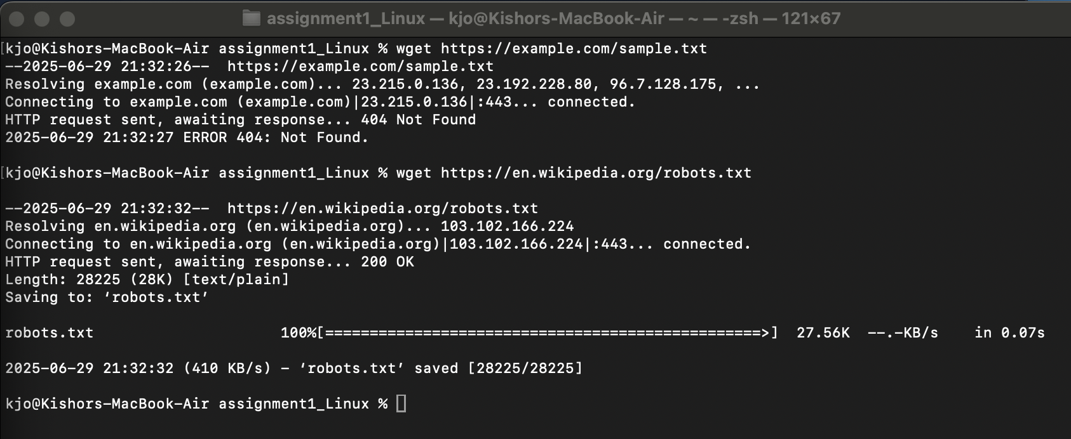

6. Changing Permissions

Create a file named secure.txt and change its permissions to read-only for everyone using chmod.  
  
**Commands used: touch secure.txt**

**Chmod 444 secure.txt**  
  
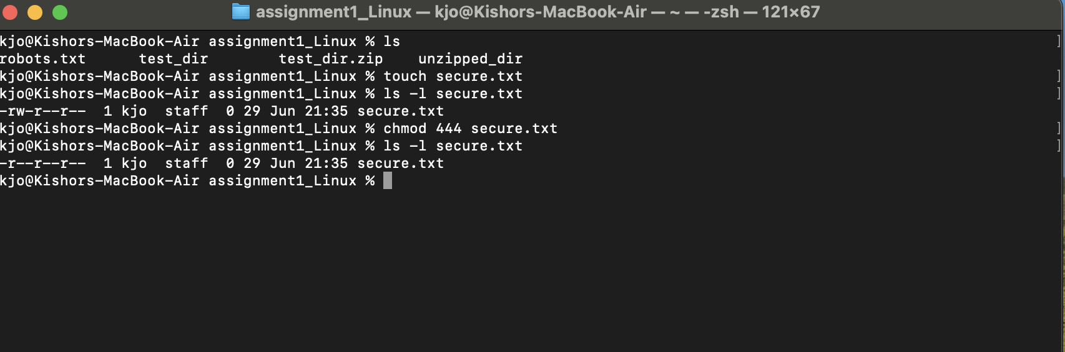

7. Working with Environment Variables

Use export to set a new environment variable called MY_VAR with the value "Hello, Linux!".  
  
Command used : **export MY_VAR=Hello_Linux** and **echo $MY_VAR**  
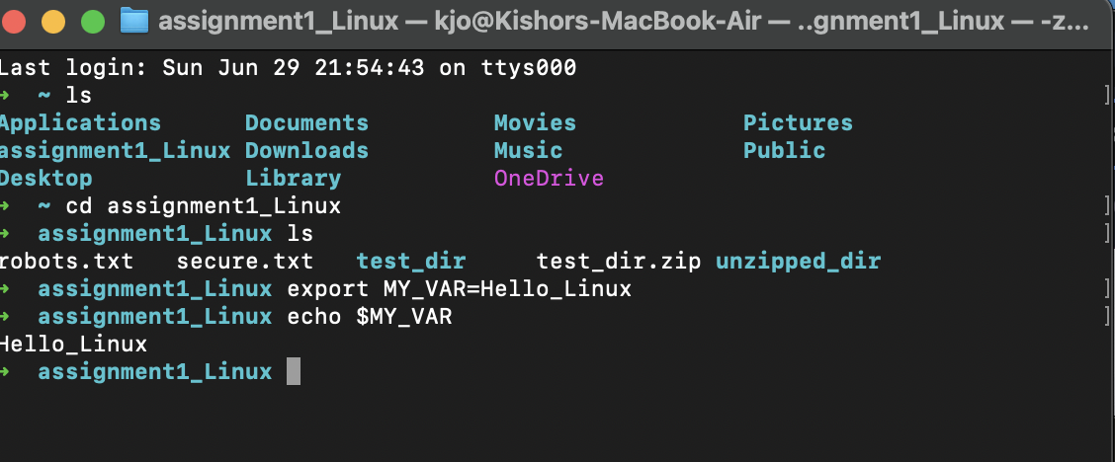

**Submission Guidelines -:** Attach Screenshots or command along with explanation and submit in doc(google doc or microsoft doc) format also attach github repo link