Online-Learning Humidity Control with Model-Based Fault Detection for a Low-Cost Terrarium: A Hardware Evaluation Against Hysteresis Control
Anonymous Authors
Submitted for double-blind review

Abstract—Low-cost terrarium controllers regulate humidity with a fixed hysteresis rule that does not adapt to the enclosure or notice a failed part. We present a controller built on one small physics-shaped model, six weights updated online by dual-timescale recursive least squares in absolute humidity, which plans each mist burst and detects faults from prediction residuals followed by an active quiet-then-mist test. Its state is about 2 kB, sized for the ESP32 already in the enclosure. We evaluated it on a real acrylic enclosure with an ultrasonic mist maker and two BME280 sensors, logging at 1 Hz, in more than 6 h of closed-loop runs that alternated with the enclosure's production rule (mist below 75 % RH, 300 s cap, 180 s rest). On a dry enclosure the learning controller held the 75–90 % band 74 % and 99 % of the time against the rule's 66 % and 91 % in paired blocks, by starting earlier and resting less between bursts. Its model adapted online: within one burst cycle the leak estimate rose 2.3 to 4.1 times and the planner matched its bursts to the enclosure. On a tight enclosure its model-sized first bursts were 120 to 155 s against the rule's 300 s. When the lid was removed, the controller flagged an anomaly within 1 s and named a leak after 400 s, and it withdrew a false alarm caused by a drying sensor after testing it for 6.5 min.

Keywords—adaptive control, recursive least squares, fault detection, humidity control, ultrasonic misting, ESP32
I. Introduction
Tropical terrarium plants such as Fittonia need relative humidity (RH) held in a narrow band, typically 75 to 90 %. Low-cost controllers achieve this with an on/off rule: mist when RH falls below a lower threshold and stop at an upper threshold or after a fixed burst. The rule is simple and robust, but its settings are fixed by the installer, so it cannot follow the enclosure it is attached to, and it cannot tell whether its actions work: a dead mister, an empty tray, an open lid and a stuck sensor all end with the controller misting into an enclosure that does not respond.
This paper shows how one small learned model can address both weaknesses on the hardware such enclosures already have. The model predicts the next change in absolute humidity from the mist command and the current state with six weights, each tied to a physical part of the enclosure, and is updated online by recursive least squares (RLS) at two timescales: a fast learner that tracks the present and a slow learner that remembers the healthy enclosure. The same model plans each mist burst and, by comparing prediction with measurement, raises a suspicion that an active quiet-then-mist test resolves into a named fault or a false alarm. Its state is about 2 kB, and each 5 s step costs a few hundred multiplications.
The approach builds on adaptive predictive greenhouse climate control and model-based fault diagnosis [1]–[3]. The contributions are: (i) a six-weight, dual-timescale model and a suspect-then-test diagnosis sized for a microcontroller and applied to ultrasonic misting; (ii) a hardware evaluation in alternating blocks against the rule the enclosure actually ran, on dry, humid and tight enclosures, with a burst-level account of how the controller achieves its results; (iii) hardware evidence of online adaptation, leak detection and self-withdrawn false alarms; and (iv) firmware safeguards for low-cost sensors and microcontrollers developed during the hardware runs.
II. Related Work
Boughamsa and Ramdani [1] regulated greenhouse temperature and humidity through heating and ventilation with a model predictive controller whose Takagi–Sugeno fuzzy model had its consequent parameters adapted by RLS, evaluated in simulation. Linker et al. [2] developed robust model-based failure detection and identification for greenhouses, and Singhal et al. [3] combined residual-based fault detection, isolation and recovery with model predictive temperature control, updating the controller's model once an actuator fault was isolated, in simulated scenarios. Combining an adaptive model, prediction and diagnosis is therefore established for full-size greenhouses, with heating and ventilation actuators and, in [1] and [3], evaluation in simulation. Small models on microcontrollers for greenhouse climate are also established: temperature forecasting on edge devices [4], a 151-parameter network mapping sensor readings to actuator actions [5], and a k-nearest-neighbour replacement for thresholds on an ESP32 that includes a mist maker [6]; these are trained offline, frozen and scored on accuracy rather than on climate outcome. On-device training exists in TinyOL [7], in concept-drift-aware TinyML [8], which names sensor and actuator faults as a source of drift but tests on image and audio data, and in TyBox [9], all on classification tasks. Reinforcement learning and model predictive control have been compared for greenhouse climate in simulation [10], and simple heuristics remain competitive with machine-learning anomaly detection in industrial IoT [11], which motivates a linear model and a comparison against the plain rule. Against this background, the present work contributes a microcontroller-sized dual-timescale model for a misted enclosure, measured on real hardware against the rule such enclosures run.
III. System
A. Hardware and Firmware
The enclosure is an acrylic box of about 28 × 23 × 8 cm with one 5 V ultrasonic mist maker (DIY-4-1) in a water tray, switched through an opto-isolated MOSFET channel from an ESP32 DevKit V1 [13] (Fig. 1). Two BME280 sensors [12] share one I2C bus: the control sensor (0x76) is mounted high inside the box under a small droplet shield, and a reference sensor (0x77) sits on the bench about 30 cm away. The lid was propped open on one edge, by 1 cm or 4 cm, to give the enclosure a drying path; closed, it loses under 2 % RH in 20 min in a 75 % RH room. No plants were present. A laboratory firmware samples both sensors at 1 Hz in forced mode, streams RH to 0.01 %, temperature and pressure over USB, rejects implausible readings, re-probes a lost sensor every 5 s and has a 15 s task watchdog. Its rule mode reproduces the enclosure's production controller: mist below 75 % RH, stop at 90 % or after 300 s, then rest 180 s.
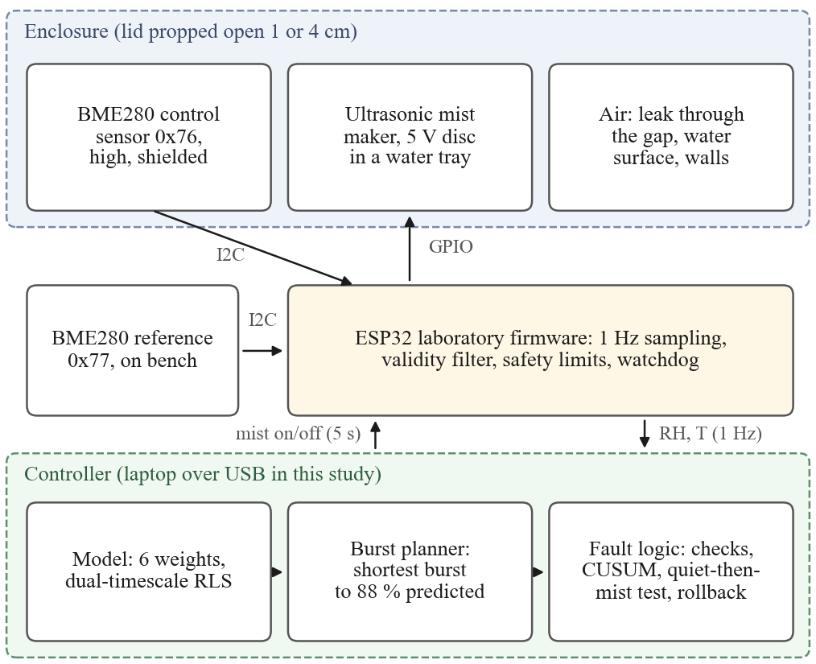
Fig. 1. System. In this study the controller ran on a laptop connected to the ESP32 over USB.
B. Model and Learning
Humidity is modelled as absolute humidity x (vapour density, g m⁻³) computed from RH and temperature with the Magnus formula, which removes most of the temperature dependence of RH. With a 5 s step k,
Δx(k) = θ^{T}φ(k) (1)
φ(k) = [ g m₁, g m₂, a, f a, f, 1 ]^{T} (2)
where m₁ and m₂ are the mist command u filtered with time constants of 5 s and 30 s, g = max(0.02, 1 − RH/100) models slower evaporation near saturation, a = x − 20 g m⁻³, and f is the fan state (no fan was fitted here). The weights stand for mister strength (θ₁, θ₂), leakage (θ₃), fan (θ₄, θ₅) and background gain (θ₆). After each step both learners apply RLS with forgetting factor λ,
K = Pφ / (λ + φ^{T}Pφ), θ ← θ + K e (3)
P ← (P − Kφ^{T}P) / λ (4)
with e the prediction error clipped to three running standard deviations; λ = 0.998 (about 40 min of memory) for the fast learner and 0.9998 (about 7 h) for the slow one. P is kept symmetric, floored and capped; the weights are constrained so that the mister can only add water and the enclosure can only remove it; and the fast weights are pulled 0.2 % per step toward the slow ones, which keeps them physically meaningful under closed-loop data.
C. Burst Planning
When the control reading falls below 77 % RH, the controller simulates bursts of 5 to 300 s ten minutes ahead with the slow model and picks, by bisection, the shortest whose predicted peak reaches 88 %; after the burst it rests 60 s. During a declared fault it plans with the fast model toward 84 %. The 77 % trigger and 60 s rest are fixed settings, and the burst length is chosen by the model.
D. Fault Detection
Faults are detected in three layers (Table I). A missing or frozen reading marks the sensor lost or stuck. A part check after every 2 min of misting compares the humidity gained with the slow model's expectation, after subtracting the background drain measured while the enclosure was quiet. A cumulative-sum (CUSUM) test on the normalised prediction error z detects humidity falling faster than the healthy model allows and raises a suspect-loss state; since a leak and a dead mister both look like too fast a fall, suspicion triggers an active test of 4 min without misting followed by misting. A leak drains in both phases, a dead mister fails only while misting, and an enclosure that behaves normally in both is a false alarm. During a fault the slow learner is frozen so that a broken part is not learned as normal, and a snapshot of the slow weights is restored if they change without learning or predict twice as badly for 30 min. Table I also states how each path was verified.
TABLE I. Fault Logic and How Each Path Was Verified
Detector | Verdict | Response | Verified on
No reading, or 12 identical readings | sensor lost / stuck | replay the learned misting rhythm | simulation
Gain after 2 min of misting < 0.3 of expected, twice | main mister dead | switch to the second channel | simulation
Removal after a fan run < 0.3 of expected, twice | fan stalled | alarm; control with fast model | simulation (no fan)
CUSUM on z below −20 | suspect loss | freeze slow learner; quiet watch, then mist test | hardware: 1 s after lid removal
Mist test: loss in both phases | lid open / leak | alarm; control with fast model | hardware: 400 s
Mist test: loss only while misting | main mister dead | as above | simulation
Mist test: normal in both phases | false alarm | clear, resume learning | hardware: 6.5 min
Weights changed without learning, or 2× worse for 30 min | corrupted model | restore snapshot | simulation

E. Execution Platform in This Study
In this study the model, planner and fault logic ran in Python on a laptop. Every 5 s the program read the latest control sample from the firmware's 1 Hz stream, executed one controller step and sent the mist command back, which the firmware executed under its own limits. The code uses fixed-size arrays for a direct port to C on the ESP32, the next step of this work. At the start of every run the weights were seeded by a least-squares fit of the same features to the closed-box step test of Section IV-A, so each learning block began with a model of the closed enclosure and adapted to the opened one online.
IV. Experiments
All runs used the enclosure of Section III-A and logged both sensors at 1 Hz; only samples flagged valid were analysed, and in every run reported here all samples were valid.
A. Step Test
With the lid closed, a script ran three rounds of 5 min quiet, mist until the control reading stopped rising (under 0.3 % over 60 s, after at least 90 s) and 20 min off, 80 min in total. Mister strength was taken from the absolute-humidity slope over the first 60 s of each burst divided by g.
B. Injected Faults
With the lid propped 1 cm, the rule ran for 15 min and the learning controller for 47 min, during which the lid was removed for 8.6 min and, later, a wet tissue was held on the control sensor for 3.7 min. Delays were measured from marker lines written into the log.
C. Alternating Sessions
With the lid propped 4 cm, the controllers alternated in 30 min blocks in two sessions: at night, with the room at 71 to 73 % RH, in the order rule, learning, rule, learning; and the next evening, with the room at 69 %, in the order learning, rule, learning, rule. Blocks were sequential, so each started from the state the previous one left; Table IV lists the starting RH. The metrics are the fraction of samples inside the 75 to 90 % band and below it, mist minutes as a proxy for water, and the number of bursts.
D. Dry-Start Test with a Matched Rule
To examine burst sizing where the 88 % target is reachable, the lid was set to 1 cm, where the enclosure holds about 80 % by itself. Each cycle began with the lid removed until the control reading fell to 73 %; the lid was then replaced at 1 cm and one controller ran for 20 min, either the learning controller or a rule matched to its settings (mist below 77 %, stop at 88 % or after 300 s, rest 60 s). Two pairs were run, with the mist tray refilled between them.
V. Results
A. Enclosure Characterisation
Table II gives the step test. The mister raised the control reading to a ceiling of 89.5 ± 0.4 % RH in 104 ± 7 s; its dry-air strength was 0.098 ± 0.012 g m⁻³ s⁻¹. The closed enclosure lost 1.7 ± 0.4 % RH in 20 min. The air warmed 0.2 to 0.4 °C while the disc ran and cooled about 0.5 °C below the start as the fog evaporated. Two consequences for the production rule follow: its 300 s cap is about three times longer than needed to reach the ceiling, and its 90 % stop is never reached, so every rule burst in this study ran to the cap.
TABLE II. Step Test, Lid Closed, One Mist Maker
Round | Start %RH | Peak %RH | Mist s | Strength g/m³/s | Drop 20 min
1 | 83.0 | 89.0 | 110 | 0.086 | 1.8 %
2 | 86.9 | 89.5 | 97 | 0.110 | 2.0 %
3 | 87.1 | 89.9 | 104 | 0.099 | 1.2 %
mean ± sd |  | 89.5 ± 0.4 | 104 ± 7 | 0.098 ± 0.012 | 1.7 ± 0.4 %
B. Injected Faults
Table III summarises the responses and Fig. 2 the traces. The rule's single burst ran to the 300 s cap (70.8 to 88.2 %), and in the next 25 min the learning controller had no reason to mist; over that time its slow leak weight rose from 0.036 to 0.131 per step, a re-fit of the opened enclosure without any misting data. When the lid was removed the CUSUM raised suspect-loss 1 s after the marker; after the quiet watch the controller ran three test bursts of 10 to 40 s toward the lowered 84 % target, sized by the fast model, and declared lid open / leak 400 s after the marker, keeping the enclosure in the band meanwhile. Holding a wet tissue on the control sensor disturbed the I2C bus; the chip restarted and both sensors were reading again within 6 s. When the tissue was removed the reading fell from 90 to 74 % in 40 s as the sensor dried; the controller raised suspect-loss, ran its test and withdrew the alarm as a false alarm 6.5 min later. Over the session the rule held the band 96.5 % of its 15 min with 5.0 mist-minutes, and the learning controller 95.4 % of its 37 min with 1.1 mist-minutes while handling the lid fault.
TABLE III. Injected Faults and the Controller's Response
Event | Response
Lid fully off | suspect loss after 1 s; 4 min quiet watch; test bursts of 10–40 s; “lid open / leak” after 400 s; band held meanwhile
Lid back, 1 cm gap | fault kept until the enclosure matched the healthy model for 10 min
Wet tissue on sensor | bus disturbed; chip restarted, both sensors reading again within 6 s
Tissue removed | reading fell 90 to 74 % in 40 s; suspect loss; tested; withdrawn as a false alarm after 6.5 min
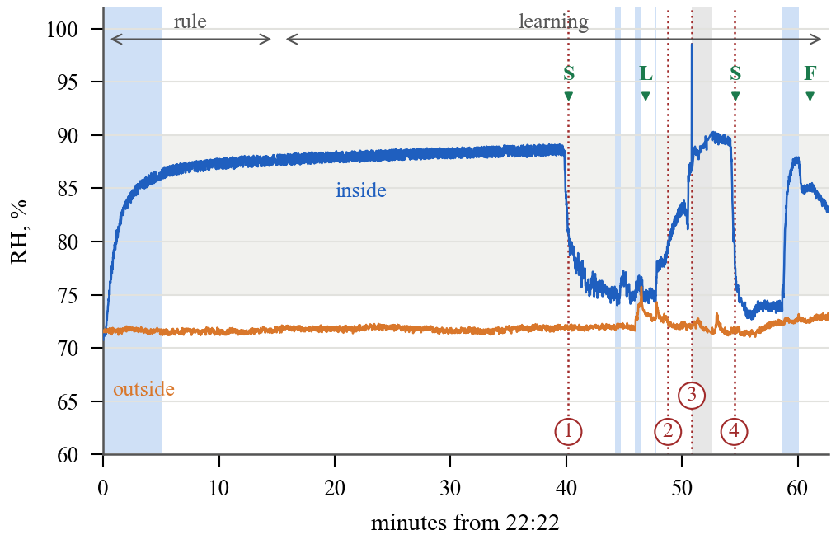
Fig. 2. Fault session, lid 1 cm (blue shading: mist on; grey band: 75–90 %). Events: 1 lid off, 2 lid back, 3 wet tissue on, 4 tissue removed. Verdicts: S suspect loss, L lid open / leak, F false alarm withdrawn. The grey span after event 3 is the controller restart.
C. Alternating Sessions
Table IV gives both sessions. At night the enclosure stayed within the band largely by itself: the rule misted four times for 14.6 min and held the band 99.4 % of its hour, and the learning controller held it 100 % of its hour without misting. In the evening the enclosure's passive level was about 74 %, just below the band, and with the 4 cm gap one mister could lift it to about 82 %, so both controllers misted most of the time. In the pair with similar starting points (21:03 and 21:33, starting at 76.8 and 76.2 %) the learning controller held the band 99.4 % of the time against 90.9 %, and in the pair that began from the dry enclosure 74.3 % against 65.6 %. Fig. 3 shows the evening traces.
TABLE IV. Alternating 30 min Blocks, Lid 4 cm
Block (start time) | Start %RH | In 75–90 % | Below 75 % | Mist min | Bursts
Night, room 71–73 % RH
Rule (00:55) | 72.6 | 98.9 % | 1.1 % | 10.2 | 3
Learning (01:25) | 79.3 | 100 % | 0.0 % | 0.0 | 0
Rule (01:55) | 79.7 | 99.9 % | 0.1 % | 4.4 | 1
Learning (02:25) | 87.6 | 100 % | 0.0 % | 0.0 | 0
Evening, room 69 % RH
Learning (20:03) | 69.3 | 74.3 % | 25.7 % | 24.1 | 6
Rule (20:33) | 77.8 | 65.6 % | 34.4 % | 18.2 | 4
Learning (21:03) | 76.8 | 99.4 % | 0.6 % | 24.0 | 6
Rule (21:33) | 76.2 | 90.9 % | 9.1 % | 16.3 | 4
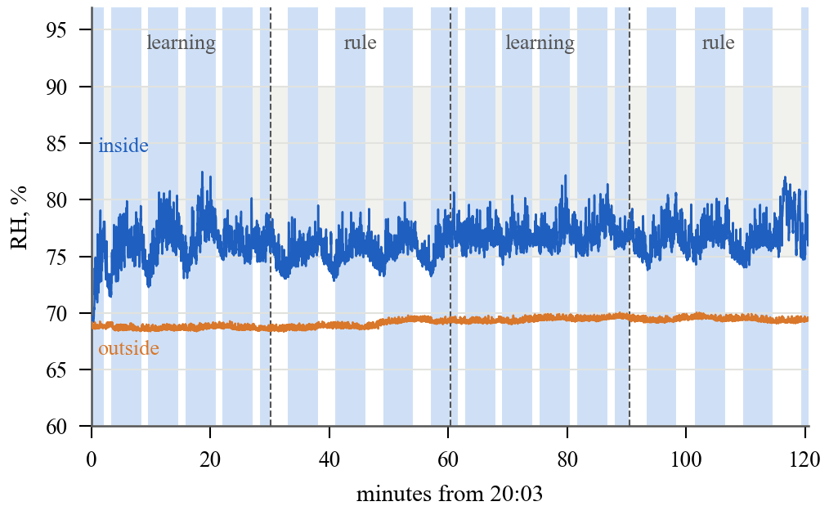
Fig. 3. Evening session on the dry enclosure, lid 4 cm (blue shading: mist on). The learning controller's earlier trigger and shorter rest keep the enclosure in the band from below.
D. How the Controller Achieved These Results
The burst logs show how these results arose. On the dry evening enclosure the 88 % target was beyond the mister's reach, and the planner recognised this: after the first burst of each block it planned the maximum 300 s bursts, while the controller's 77 % trigger and 60 s rest kept the enclosure in the band from below, where the rule's 180 s rest let it fall below 75 % in each cycle. The model adapted quickly: each block began with the closed-box seed, which predicted that 80 to 125 s would reach 88 %; within 2.5 to 3 min, one burst cycle, the fast leak estimate rose 2.3 to 4.1 times and the planner moved to the longer bursts the opened enclosure needed. At night the rule misted when its 75 % trigger was reached after its own bursts decayed, while the learning controller's 77 % trigger was not reached during its blocks. During the lid fault the fast model sized short test bursts of 10 to 40 s.
E. Dry-Start Test
Table V gives the four cycles. The model sized the first bursts at 155 and 120 s, against the rule's 300 s cap, and in pair 1 the learning controller used about half the mist while both cycles settled near the enclosure's own level of about 80 %. The mister's delivered strength, estimated from the absolute-humidity rise in the first minute of each burst, varied between cycles (Table V) and shaped the mist use and peak humidity of each cycle.
TABLE V. Dry-Start Cycles, Lid 1 cm, Matched Rule vs. Learning
Pair, controller | Start %RH | Mist s | Peak %RH | End %RH | In band | Mister g/m³/s
1, rule | 72.4 | 300 | 87.7 | 80.2 | 98.1 % | 0.20
1, learning | 70.6 | 155 | 82.4 | 79.7 | 94.5 % | 0.09
2, rule | 70.4 | 1021 | 83.2 | 77.3 | 78.8 % | 0.04–0.10
2, learning | 74.4 | 726 | 87.8 | 85.9 | 97.9 % | 0.13–0.17

F. Simulation
Before the hardware runs the controller was exercised on a simulated enclosure for 76 h with slow disc wear, a memory corruption and four injected faults, with the simulator's constants later replaced by the measured values of Section V-A. In that setting it held the band 99.2 percent of healthy hours against 93.1 percent for the rule, used 20 percent less mist time, named every fault correctly on seven random seeds without false alarms, and rolled back its corrupted weights in the same step. The simulation served as a logic check of the fault paths before hardware testing.
VI. Discussion and Future Work
The measurements show that a six-weight model updated online can run a real misted enclosure, hold the humidity band as well as or better than the production rule in the alternating sessions, re-fit a changed enclosure within minutes, detect and name a leak, and withdraw a false alarm by testing. On a tight enclosure its model-sized first bursts were shorter than the rule's. The hardware work also produced two firmware safeguards. After a bus glitch the BME280's humidity setting can be cleared, and the sensor library then reports a steady, plausible value; the firmware now reads the raw humidity register and verifies the setting after initialisation, so this state is treated as a lost sensor and the mist is stopped. When the ESP-IDF I2C driver stalled after a bus disturbance, the task watchdog restarted the chip and control resumed within about 20 s.
Future work will port the controller from the laptop to the ESP32, run longer trials with plants, measure water volume and the mister's output directly, add a direct actuator signal such as the mist maker's supply current, and exercise the remaining fault paths (backup mister, stuck sensor, stalled fan, model rollback) on hardware, as they were in simulation.
VII. Conclusion
A six-weight model updated online at two timescales ran a low-cost misted enclosure, re-learned the enclosure within one burst cycle, detected and named a leak and withdrew its own false alarm by testing, with a state small enough for the enclosure's microcontroller. On real hardware it held the humidity band as well as or better than the production hysteresis rule, and on a tight enclosure it planned shorter first bursts than the rule. The next steps are the port to the ESP32, longer runs with plants, measured water and mister output, and direct actuator sensing.
Acknowledgment
The authors used an AI assistant (Anthropic Claude) to help write the firmware, logging, analysis and controller code and to draft parts of this text from the recorded data. All experiments and measurements are the authors' own, and the authors take full responsibility for the content.
References
[1] M. Boughamsa and M. Ramdani, “Adaptive fuzzy control strategy for greenhouse micro-climate,” Int. J. Autom. Control, vol. 12, no. 1, 2018, doi: 10.1504/IJAAC.2018.088604.
[2] R. Linker, P.-O. Gutman, and I. Seginer, “Robust model-based failure detection and identification in greenhouses,” Comput. Electron. Agric., vol. 26, no. 3, pp. 255–270, 2000, doi: 10.1016/S0168-1699(00)00079-X.
[3] R. Singhal, R. Kumar, and S. Neeli, “Residual-based fault detection isolation and recovery of a greenhouse,” Int. J. Autom. Control, vol. 16, no. 3/4, 2022, doi: 10.1504/IJAAC.2022.122599.
[4] G. Codeluppi, L. Davoli, and G. Ferrari, “Forecasting air temperature on edge devices with embedded AI,” Sensors, vol. 21, no. 12, Art. no. 3973, 2021, doi: 10.3390/s21123973.
[5] I. Ihoume, R. Tadili, N. Arbaoui, M. Benchrifa, A. Idrissi, and M. Daoudi, “Developing a multi-label tinyML machine learning model for an active and optimized greenhouse microclimate control from multivariate sensed data,” Artif. Intell. Agric., vol. 6, pp. 129–137, 2022, doi: 10.1016/j.aiia.2022.08.003.
[6] A. I. Sukowati, N. Marliza, and D. Saptono, “Edge AI–based threshold-free control for mushroom farming using K-NN on ESP32,” J. Nas. Tek. Elektro Teknol. Inf., vol. 15, no. 3, pp. 239–248, 2026, doi: 10.22146/jnteti.v15i3.25532.
[7] H. Ren, D. Anicic, and T. A. Runkler, “TinyOL: TinyML with online-learning on microcontrollers,” in Proc. Int. Joint Conf. Neural Netw. (IJCNN), 2021, pp. 1–8, doi: 10.1109/IJCNN52387.2021.9533927.
[8] S. Disabato and M. Roveri, “Tiny machine learning for concept drift,” IEEE Trans. Neural Netw. Learn. Syst., vol. 35, no. 6, pp. 8470–8481, 2024, doi: 10.1109/TNNLS.2022.3229897.
[9] M. Pavan, E. Ostrovan, A. Caltabiano, and M. Roveri, “TyBox: An automatic design and code generation toolbox for TinyML incremental on-device learning,” ACM Trans. Embed. Comput. Syst., vol. 23, no. 3, pp. 1–27, 2024, doi: 10.1145/3604566.
[10] B. Morcego, W. Yin, S. Boersma, E. van Henten, V. Puig, and C. Sun, “Reinforcement learning versus model predictive control on greenhouse climate control,” Comput. Electron. Agric., vol. 215, Art. no. 108372, 2023, doi: 10.1016/j.compag.2023.108372.
[11] B. Bicski, K. Farkas, and A. Pekar, “Simple heuristics as a viable alternative to machine learning-based anomaly detection in industrial IoT,” IEEE Internet Things Mag., vol. 6, no. 3, pp. 104–109, 2023, doi: 10.1109/IOTM.001.2200232.
[12] Bosch Sensortec, “BME280: Combined humidity and pressure sensor,” Datasheet BST-BME280-DS002, Reutlingen, Germany.
[13] Espressif Systems, “ESP32 series datasheet,” Shanghai, China. [Online]. Available: https://www.espressif.com/en/support/documents/technical-documents

