2D Shapes Date: Time Taken: Wrongs: Sign:
If s is the length of a side of a square then what is its Area and Perimeter.  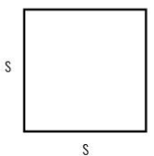 Area: Parimeter:  If a is the length of a side, b is the base and h is the height what is the Area and Perimeter of a parallelogram.  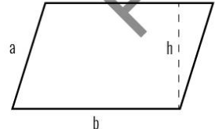 Area: Parimeter:  If a, c are the lengths of the sides of a trapezoid, b1 and b2 are two parallel bases and h is the height then what is the Area and Perimeter of the trapezoid.  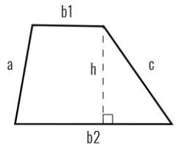 Area: Parimeter:  If r is the radius, d is the diameter and =3.14 what is the Area and Circumference of a semicircle (d=2r)  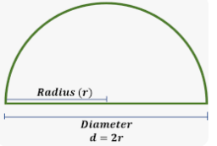 Area: Circumference: | If l is the length and w is the width of a rectangle then what is its Area and Perimeter.  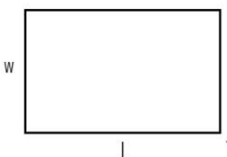 Area: Parimeter:  If a, c are the sides of a triangle, b is the base and h is the height, what is the Area and Perimeter. of the triangle.  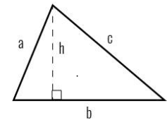 Area: Parimeter:  If r is the radius and =3.14 what is the Area and Circumference of a circle  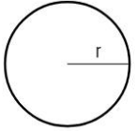 Area: Circumference:  If r is the radius , d is the diameter and =3.14 what is the Area and Circumference of a quarter circle (d=2r)  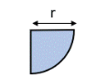 Area: Circumference:

3D Shapes Date: Time Taken: Wrongs: Sign:
If a is the length of one side of a cube find the below.
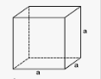 | volume: | curved surface area / lateral surface area | total surface area
If l is the length, w is the width and h is the height find the below.
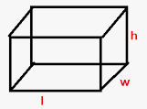 | volume: | curved surface area / lateral surface area | total surface area
If r is the radius and h is the height find the below.
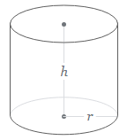 | volume: | curved surface area / lateral surface area | total surface area
If r is the radius and h is the height find the below.

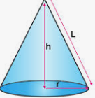 | volume: | curved surface area / lateral surface area | total surface area
If r is the radius, find the below.
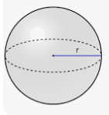 | volume: | curved surface area / lateral surface area | total surface area
If r is the radius, find the below.
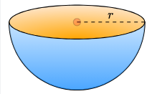 | volume: | curved surface area / lateral surface area | total surface area

