Acknowledgement
This project documentation was completed in April 2026 and represents the result of three months of collaborative effort, dedication, and learning. Throughout this period, we encountered challenges that tested our technical and problem-solving abilities, but also gained valuable insights into software development, system design, and modern work management practices. Working together as a team on this full-stack web application enriched our understanding of real-world software architecture and development workflows.
We express our sincere gratitude to Gomendra Multiple College for giving us the opportunity to develop this project titled Contractor Business Management System. We are especially thankful to our supervisor, Mr. Kushal Niroula, for his expert guidance, encouragement, and continuous support throughout the course of this project. We also extend our appreciation to all faculty members of the Faculty of Science and Technology and the Department of Computer Science, whose teachings and mentorship have played a critical role in shaping our academic foundation and skills.
We would like to thank our Principal, Dr. Rupak Khanal, for providing a supportive academic environment that enabled us to complete this project successfully. Our heartfelt thanks also go to our classmates and friends who supported us by sharing ideas, providing feedback, and motivating us during this journey. Lastly, we thank Purbanchal University for introducing a course structure that fosters innovation, teamwork, and practical learning-essential qualities for our future careers in the field of technology.

Abstract
This project focuses on the design and development of a web-based application that aims to simplify and improve the way users interact with digital systems. Many existing solutions are either too complex or fail to provide a smooth and efficient user experience. To address these challenges, this project introduces a system that is simple, responsive, and user-friendly.
The application is built using modern development tools and follows a structured approach to ensure scalability and maintainability. It allows users to perform core operations efficiently while maintaining data accuracy and security. Special attention has been given to creating an intuitive interface so that even non-technical users can easily navigate and use the system.
Throughout the development process, various software engineering practices such as modular design, testing, and version control were followed. This project not only demonstrates technical implementation but also highlights problem-solving skills and real-world application development experience.

Table of Content
Acknowledgement i
Abstract ii
List of Figures iii
List of Tables iv
Abbreviations v
Chapter 1: Introduction 1
1.1 Background of the project 1
1.2Problem statement 1
1.3 Contractor Business Management System 1
1.4 Objectives of the Project 2
1.4.1 General Objective 2
1.4.2 Specific Objective 2
1.5Scope of the Project 3
1.6 Limitations of the Project 4
Chapter 2 Literature Review 5
2.1 Study of Existing System 5
2.2 Drawbacks of the Existing System 5
2.3 Proposed System 6
2.4 Advantage of the Proposed System 6
Chapter 3: System Analysis 8
3.1 Feasibility Study 8
3.1.1 Technical Feasibility 8
3.1.2 Economic Feasibility 8
3.1.3 Operational Feasibility 9
3.1.4 Schedule Feasibility 9
3.1.5 Legal Feasibility 9
3.2 System Requirements 10
3.2.1 Hardware Requirements 10
3.2.2 Software Requirements: 11
3.2.3 Functional Requirements 11
3.2.4 Non-Functional Requirements 14
3.2.5 System Flow/Workflow 16
3.3 Use-Case Diagram 16
Chapter 4: System Design 18
4.1 System Architecture 18
4.1.1 Presentation Layer (Frontend) 18
4.1.2 Application Layer (Business Logic Layer) 18
4.1.3 Data Layer (Database Layer) 18
4.2 ER Diagram 19
4.3 Schema Diagram 20
4.4 DFD 21
4.5 Sequence Diagram 23
Chapter 5: Implementation 24
5.1 Development Environment Setup 24
5.2 Coding Conventions and Best Practices 24
5.2.1 Naming Conventions 24
5.2.2 Best Practices Applied 25
5.3 Security Practices 25
5.3.1 Authentication and Password Security 25
5.3.2 Input Validation and Access Control 25
5.4 Testing 26
5.7 Project Scheduling 27
5.8 Gantt Chart 28
5.9 System in Action 28
Chapter 6: Limitations and Future Enhancements 29
6.1 Current Limitations 29
6.1.2 Feature Scope 29
6.1.3 Performance 30
6.1.4 Code Quality 30
6.2 Future Enhancements 30
6.2.1 Security Improvements 30
6.2.2 Reporting and Analytics 31
6.2.3 Developer Experience 31
Chapter 7: Conclusion 32
7.1 Summary 32
7.2 Key Achievements 32
7.2.1 Technical Accomplishments 32
7.2.2 Learning Outcomes 33
7.3 Future Directions 33
Chapter 8: References and Bibliography 34
8.1 References 34
8.2 Bibliography 34

List of Figures

Figure 1: Use Case Diagram 17
Figure 2: ER Diagram 19
Figure 3: Database Schema Diagram 20
Figure 4: Level 0 DFD 21
Figure 5: Level 1 DFD 21
Figure 6: Level 2 DFD 22
Figure 7: Sequence Diagram 23
Figure 8: Project Scheduling 21
Figure 9: Gantt Chart 28
Figure 10: Dashboard 28

List of Tables

Table 1: Tools and Platform 24
Table 2: Testing Methodology 26

Abbreviations

2FA - Two-Factor Authentication
API- Application Programming Interface
ASP.NET- Active Server Pages .NET
CSRF- Cross-Site Request Forgery
CSS- Cascading Style Sheets
CRUD- Create, Read, Update, Delete
DXA- Document eXtent Unit (1440 = 1 inch)
EF- Entity Framework
ERP- Enterprise Resource Planning
HTML- Hyper-Text Markup Language
HTTPS- Hyper-Text Transfer Protocol Secure
IDE- Integrated Development Environment
JWT- JSON Web Token
MVC- Model-View-Controller
ORM-Object-Relational Mapping
PAN-Permanent Account Number
RBAC-Role-Based Access Control
SMTP-Simple Mail Transfer Protocol
SQL-Structured Query Language
UI-User Interface
UX-User Experience
XSS-Cross-Site Scripting

Chapter 1: Introduction

1.1 Background of the project
In today’s digital age, managing work efficiently is crucial for every organization. Traditional paper-based methods are often time-consuming, error-prone, and lack of transparency. This project aims to develop a reliable and easy-to-use web application – CBMS (Contractor Business Management System) – to simplify the work process for an organization. The system leverages modern technologies to offer secure access, real-time validation, and accurate reporting, helping institutions transition from manual to automated task systems.

1.2Problem statement
Work tracking is an essential component of an organization’s management, yet traditional paper-based methods are often inefficient, error-prone, and time-consuming. Administrators spend valuable time taking and maintaining records, and manual systems provide limited transparency and accessibility for an organization. Moreover, inconsistencies due to redundant entries, missed records, and limited real-time insight into work trends further highlight the need for a digital solution.

1.3 Contractor Business Management System
The Contractor Business Management System (Thekdar) is a web application that digitizes the process of work management. It supports work-wise tracking, login-based user roles for admin and users, real-time validation against their works. With an intuitive interface and efficient Postgres database interaction via ASP.net, Thekdar ensures a streamlined, accurate, and secure work system.

1.4 Objectives of the Project

1.4.1 General Objective
The main objective of this project is to develop a Contractor Business Management System (Thekdar) that simplifies and digitizes the process of managing work within an organization. The system aims to replace traditional manual methods with an efficient, secure, and user-friendly web-based solution that improves productivity, accuracy, and transparency in day-to-day operations.

1.4.2 Specific Objective
- To design and implement a user-friendly system that allows users to easily manage and track their assigned work without confusion or complexity.
- To develop a secure login and role-based access system, ensuring that administrators and general users have appropriate levels of control and access.
- To enable efficient work tracking, allowing users to mark tasks as completed and monitor progress in real time.
- To minimize errors and duplication by implementing real-time validation and data consistency mechanisms.
- To create a centralized database system using PostgreSQL, ensuring safe storage, easy retrieval, and proper management of all data.
- To provide dashboard and reporting features that help users and administrators quickly understand work status and overall performance.
- To reduce the dependency on paper-based systems, thereby improving efficiency, reliability, and record management.
- To ensure the system is scalable and maintainable, so it can be improved or expanded in the future as requirements grow.
- To implement strong security practices, including password encryption and protection against common vulnerabilities like SQL injection.

1.5Scope of the Project
The scope of the Contractor Business Management System (CBMS) focuses on developing a web-based application that simplifies and digitalizes the process of managing work within an organization. The system is designed to provide a structured and efficient way to handle tasks, users, and reports in a centralized environment.
The project covers the following areas:
- The system will provide a secure login and authentication mechanism for both administrators and general users, ensuring controlled access to the application.
- It will support role-based access control, where administrators can manage users and tasks, while general users can view and update their assigned work.
- The application will allow users to track and manage tasks (works), including marking them as completed and monitoring their current status.
- A dashboard interface will be included to give users a clear overview of work progress and important updates.
- The system will integrate with a PostgreSQL database to store and manage all user and task-related data efficiently.
- It will include basic reporting features, enabling users and administrators to view summaries and performance-related information.
- The system will ensure data validation and consistency, reduce duplication and improve accuracy.
- Security features such as password encryption and protection against SQL injection will be implemented to safeguard user data.

1.6 Limitations of the Project
While CBMS is designed to be as practical as possible, there are certain limitations that the user should be aware of:
- The system will be developed as a web-based application only, and will not include a mobile application in this phase.
- Advanced features such as AI-based predictions or analytics are not included in the current scope.
- The system is designed for small to medium-scale organizations, and large-scale enterprise-level optimization is beyond the current scope.
- Integration with external systems (like payment gateways or third-party APIs) is not included in this version.

Chapter 2 Literature Review

2.1 Study of Existing System
The existing system for managing work in many organizations is largely based on manual methods such as paper records, registers, or basic spreadsheets. While these methods are simple to use, they are time-consuming, prone to human errors, and lack proper data security and transparency. Retrieving and updating information is often difficult, and there is a high risk of data loss or duplication.
Some organizations have adopted basic digital solutions; however, these systems often lack user-friendliness, proper role-based access control, and real-time validation features. They may also be costly or not tailored to specific organizational needs.
Overall, the limitations of both manual and existing digital systems highlight the need for a more efficient, secure, and user-friendly solution, which the proposed Contractor Business Management System aims to address.

2.2 Drawbacks of the Existing System
- Steep learning curves and non-intuitive interfaces.
- Limited offline functionality.
- Redundancy issues.
- Weak integration with secure databases or role-based systems.

2.3 Proposed System
The proposed system is developed to overcome the challenges found in traditional and existing digital systems. Instead of complex and hard-to-use platforms, this system focuses on simplicity, clarity, and ease of use.
It provides users with a smooth interface where they can perform tasks quickly without confusion. The system automates many processes that were previously done manually, reducing errors and saving time. It also ensures that data is handled properly and can be accessed whenever needed.
The design of the system is flexible, allowing future improvements and additional features to be added easily. By combining usability with functionality, the proposed system offers a practical solution for real-world use.

2.4 Advantage of the Proposed System
The Proposed System offers several advantages as compared to the existing systems.
The major advantages are listed below:
- User-Friendly Interface:
The system is designed with simplicity in mind, making it easy for users to navigate and perform tasks without needing advanced technical knowledge. This reduces confusion and improves overall user experience.
- Time Efficiency:
By automating many manual processes, the system saves time and allows users to complete tasks quickly and efficiently. This leads to increased productivity.
- Improved Accuracy:
The system minimizes human errors by handling calculations and data processing automatically. This ensures more reliable and consistent results.
- Real-Time Data Access:
Users can access updated information instantly, which helps in making better and faster decisions without delays.
- Data Security:
The system includes basic security features such as authentication and controlled access, ensuring that sensitive data is protected from unauthorized users.

Chapter 3: System Analysis

3.1 Feasibility Study
The feasibility study is conducted to evaluate whether the proposed system is practical, achievable, and beneficial. It helps in understanding if the project can be successfully developed within the given constraints such as time, cost, and available resources.

3.1.1 Technical Feasibility
The proposed system is technically feasible as it is developed using widely used and well-supported technologies. The tools, frameworks, and programming languages required for development are easily available and well-documented.
The development environment (such as code editors, version control systems, and databases) is accessible and familiar, making it easier to build and maintain the system. Additionally, the system does not require any highly specialized hardware or complex infrastructure.
Therefore, the project can be successfully implemented using the current technical knowledge and resources.

3.1.2 Economic Feasibility
The project is economically feasible as it requires minimal cost for development. Most of the tools and technologies used are open-source or freely available.
There is no need for expensive hardware or paid software licenses. The main investment involves time and effort during development.
Since the system helps reduce manual work and improves efficiency, it can also save costs in the long run, making it a cost-effective solution.

3.1.3 Operational Feasibility
The proposed system is user-friendly and designed to be easily understood by users with basic computer knowledge. It simplifies tasks and reduces complexity, making it suitable for everyday use.
Users do not require special training to operate the system, as the interface is intuitive and straightforward. This ensures smooth adoption and effective usage in real-world scenarios.

3.1.4 Schedule Feasibility
The project is feasible within the given time frame. The development process follows a structured approach, allowing tasks to be completed in phases such as planning, design, implementation, and testing.
By using an iterative (Agile-like) approach, the system can be developed step by step, ensuring timely completion without compromising quality.

3.1.5 Legal Feasibility
The system does not violate any legal regulations or policies. It uses standard technologies and follows general data handling practices.
All data used in the system is managed responsibly, and no copyrighted or restricted content is used without permission.

3.2 System Requirements
The system requirements define the essential hardware and software environment, along with the functional and non-functional capabilities required for the successful development and operation of the Contractor Business Management system.

3.2.1 Hardware Requirements
The hardware requirements specify the minimum and recommended physical components needed to develop and use the system effectively.
Client-Side (User Device):
        - Smartphone or computer with GPS capability
        - Minimum 4 GB RAM (8 GB recommended)
        - Processor: Dual-core or higher
        - Storage: At least 500 MB free space
        - Internet connectivity (Wi-Fi/4G/5G)
Server-Side:
        - Processor: Quad-core CPU or higher
        - RAM: Minimum 8 GB (16 GB recommended)
        - Storage: SSD with at least 50 GB free space
        - Reliable internet connection for API communication

3.2.2 Software Requirements:
The software requirements include all tools, frameworks, platforms, and technologies used to build and run the system.
      - Operating System: Windows, Linux, or macOS
      - Frontend Technologies: Razor Views, Bootstrap,
      - Backend Technologies: ASP.NET Core MVC (.NET 8), C#
      - Database: PostgreSQL
      - Development Tools: Rider (IDE), Git (Version Control)

3.2.3 Functional Requirements
The functional requirements define the core features and operations that the system must perform. Some of the requirements are:
User Authentication & Account Management
- The system shall allow new contractors to register an account.
- The system shall allow users to log in using email and password.
- The system shall support email-based two-factor authentication (2FA).
- The system shall allow users to reset passwords via email verification.
- The system shall allow users to update their profile and profile picture.
- The system shall allow users to enable or disable 2FA.
Role-Based Access Control
- The system shall support two roles: Admin and Contractor.
- The system shall restrict access to features based on user roles.
- The system shall allow admins to manage all data in the system.
- The system shall allow contractors to manage only their own workers, jobs, and payroll.
Worker (Employee) Management
- The system shall allow users to add new workers with details such as name, contact, and daily wage.
- The system shall allow users to edit worker information.
- The system shall allow users to upload worker documents (PAN, profile image).
- The system shall allow admins to soft delete and reactivate workers.
- The system shall ensure unique worker records (no duplicate phone/email/PAN).
Job Management
- The system shall allow users to create new jobs with details like client name, address, and schedule.
- The system shall allow users to edit and delete jobs.
- The system shall allow users to view job details and status.
- The system shall support a two-stage job completion process:
- Contractor marks job as complete
- Admin confirms completion
Worker Assignment to Jobs
- The system shall allow users to assign workers to jobs.
- The system shall allow users to remove or reassign workers.
- The system shall send email notifications to workers when assigned to a job.
- The system shall track assignment details such as role, duration, and status.
Payroll and Wage Management
- The system shall allow users to calculate wages based on work period and daily rate.
- The system shall allow users to preview payroll before saving.
- The system shall allow users to save payroll records.
- The system shall generate Pay slip for workers.
- The system shall allow users to mark payroll as paid.
Payroll History and Statistics
- The system shall allow users to view payroll history.
- The system shall allow filtering by date and worker.
- The system shall provide payroll statistics and summaries.
Reporting System (Admin Only)
- The system shall allow admins to view reports for jobs, workers, and contractors.
- The system shall allow admins to view detailed dashboards.
- The system shall allow exporting reports in CSV format.
Dashboard & Overview
- The system shall provide a dashboard showing key statistics such as:
  - Total jobs
  - Active workers
  - Completed jobs
- The system shall display today’s scheduled jobs.
Email Notification System
- The system shall send emails for:
  - Two-factor authentication codes
  - Password reset links
  - Job assignment notifications
Data Validation & Security
- The system shall validate all user inputs before processing.
- The system shall enforce secure authentication using encrypted passwords.
- The system shall protect against unauthorized access using role-based restrictions.
Error Handling
- The system shall display custom error pages for:
  - 404 (Not Found)
  - 403 (Access Denied)
  - 500 (Server Error)

3.2.4 Non-Functional Requirements
Non-functional requirements define how the system performs rather than what it does. They focus on performance, usability, security, and overall system quality.
Performance Requirements
- The system should respond to user requests within a few seconds under normal conditions.
- The system should handle multiple users accessing features like dashboard, jobs, and payroll without significant delay.
- Database operations such as fetching jobs, workers, and payroll records should be optimized for fast retrieval.
Usability Requirements
- The system should provide a clean and user-friendly interface.
- Navigation should be simple so that users can easily access features like jobs, workers, and payroll.
- The system should be usable by users with basic computer knowledge without special training.
- Forms and inputs should be clear and easy to understand.

Security Requirements
- The system should ensure secure user authentication using encrypted passwords.
- The system should support two-factor authentication (2FA) for additional security.
- The system should implement role-based access control to restrict unauthorized actions.
- Sensitive data such as user credentials and payroll information should be protected.
- The system should prevent common threats like unauthorized access and data misuse.
Reliability Requirements
- The system should function correctly without frequent failures or crashes.
- Data should be stored safely and consistently in the database.
- The system should handle errors gracefully and provide meaningful error messages.
Scalability Requirements
- The system should be designed to handle an increasing number of users, jobs, and workers.
- New features and modules should be added easily without affecting existing functionality.
Maintainability Requirements
- The system should follow a modular architecture (MVC pattern), making it easier to maintain.
- Code should be structured and readable for future developers.
- Bugs and updates should be easy to fix and implement.
Availability Requirements
- The system should be available to users whenever required, with minimal downtime.
- It should support deployment in environments such as local server or cloud/Docker setup.

3.2.5 System Flow/Workflow
The system workflow describes how different components of the application interact with each other and how users perform tasks step by step within the system.
- User registers/logs in
- Access dashboard
- Manage workers and jobs
- Assign workers to jobs
- Calculate wages and generate payroll
- View reports and analytics (admin)

3.3 Use-Case Diagram
The Use Case Diagram of the Contractor Business Management system represents the interaction between different users and the system functionalities. The system has three actors: Admin, Contractor, and Worker. The Contractor is the main user who manages workers, jobs, and payroll. Admin has higher-level control, including managing system data, confirming job completion, and generating reports. The Worker is an external actor who receives notifications related to job assignments.

Figure 1:
Use Case Diagram
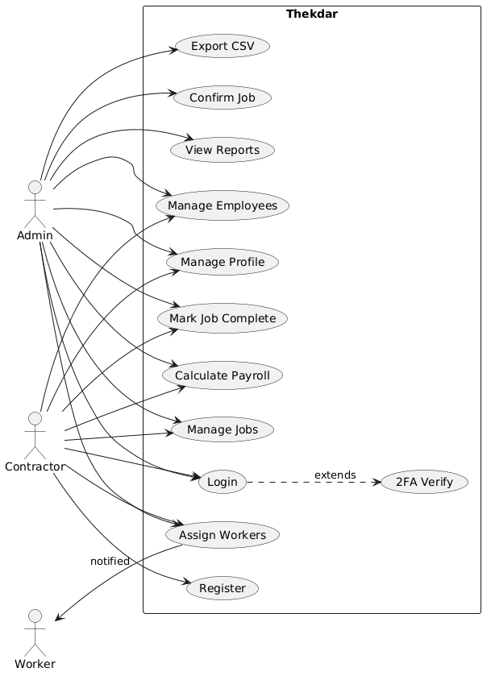

Chapter 4: System Design

4.1 System Architecture
The Contractor Business Management System follows a three-tier architecture (Layered Architecture) that separates the application into different layers for better organization, scalability, and maintainability.

4.1.1 Presentation Layer (Frontend)
This is the layer that interacts directly with the user.
- Built using HTML, CSS, JavaScript, and Razor Views
- Provides user interfaces such as:
  - Login/Register pages
  - Dashboard
  - Job and Worker management pages
  - Payroll and Reports

4.1.2 Application Layer (Business Logic Layer)
This layer contains the core logic of the system.
- Implemented using:
  - Controllers
  - Services (Business Logic)

4.1.3 Data Layer (Database Layer)
This layer manages all data storage and retrieval.
- Uses PostgreSQL database
- Managed through Entity Framework Core (ORM)

4.2 ER Diagram
The ER diagram of the Contractor Business Management system defines how data is organized and connected within the database. The system mainly consists of users, workers, jobs, and payroll management
Figure 2:
ER Diagram
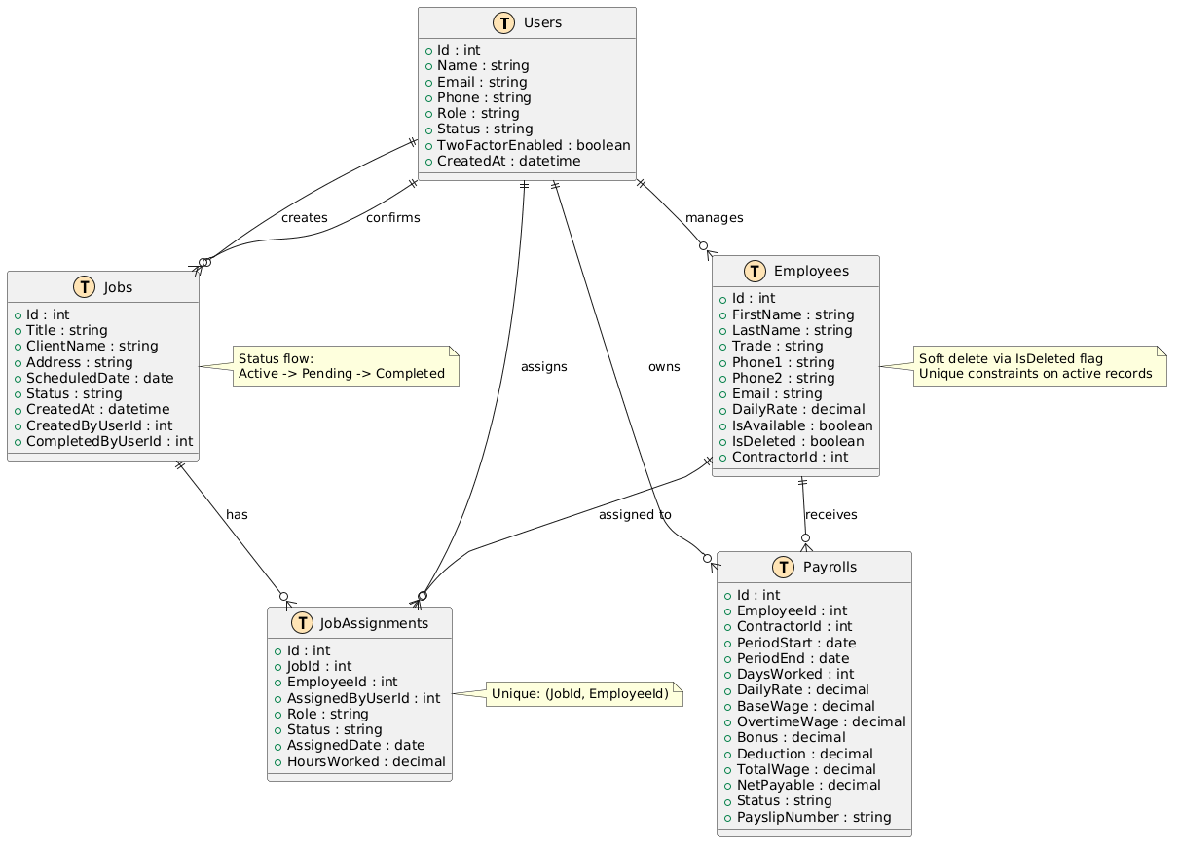

4.3 Schema Diagram
Figure 3:
Database Schema Diagram
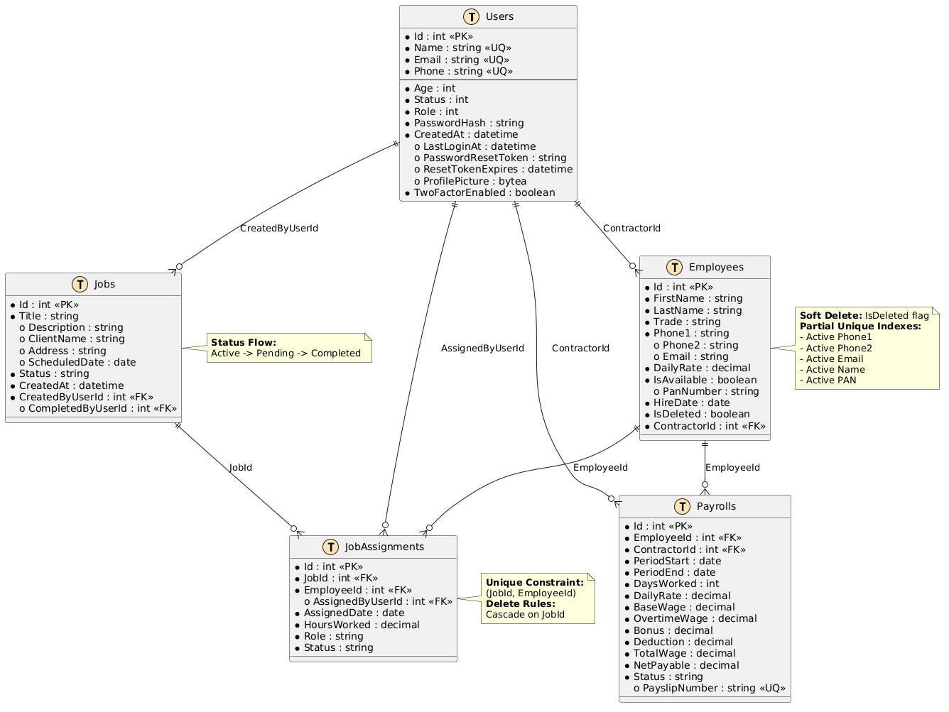

4.4 DFD
Figure 4:
Level 0 DFD
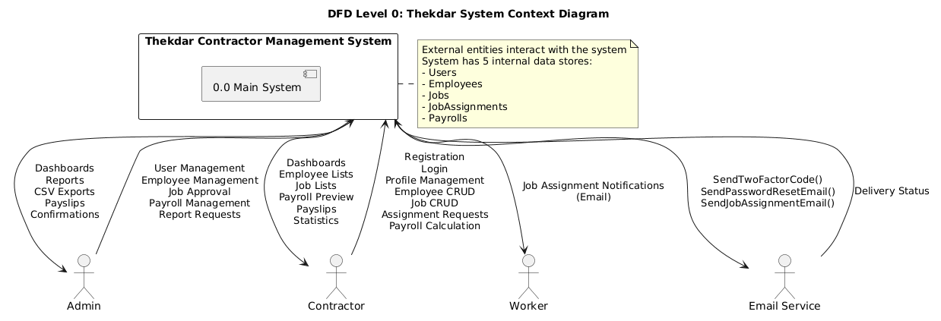
Figure 5:
Level 1 DFD
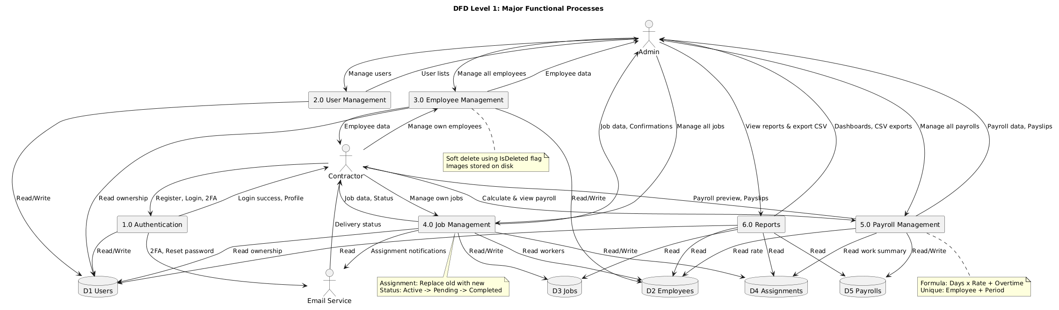

Figure 6:
Level 2 DFD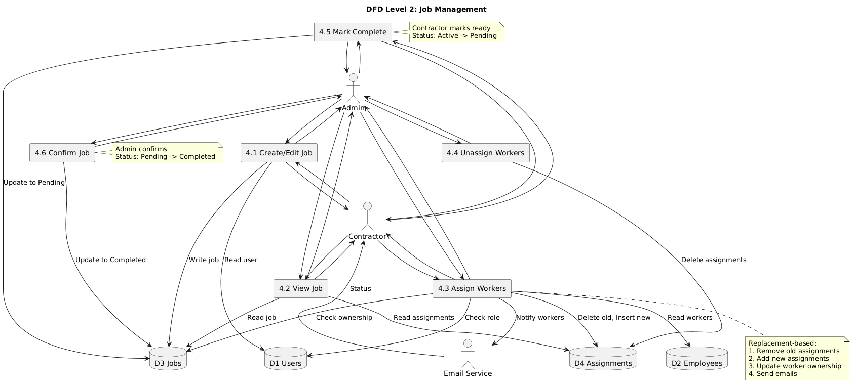

4.5 Sequence Diagram
Figure 7:
Sequence Diagram
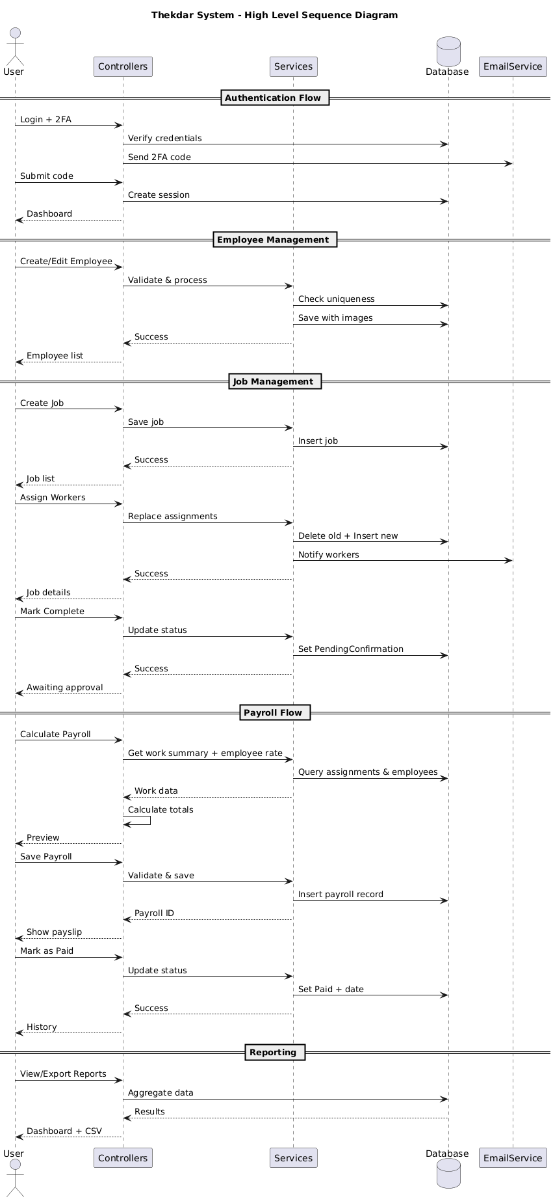

Chapter 5: Implementation
The implementation phase involves turning the design into a working model or system.

5.1 Development Environment Setup
Table 1:
Tools and Platforms
Tool | Version / Notes
.NET SDK | net8.0
PostgreSQL | 15 (via Docker or local installation)
IDE | JetBrains Rider / Visual Studio 2022 / VS Code
Version Control | Git (GitHub)
Docker | Docker Desktop with docker-compose
Browser | Chrome / Firefox / Brave (any modern browser)

5.2 Coding Conventions and Best Practices

5.2.1 Naming Conventions
- camelCase for local variables and method parameters.
- Pascal Case for class names, method names, and public properties.
- UPPER_SNAKE_CASE for constants.
- Descriptive file and folder names reflecting their content (e.g., Controllers, Services, View Models, Entities).

5.2.2 Best Practices Applied
- Nullable reference types enabled throughout the project.
- Implicit usings enabled to reduce boilerplate.
- Try-catch blocks for exception handling with logging.
- XML documentation comments on public service methods.
- LINQ used for readable database queries.

5.3 Security Practices

5.3.1 Authentication and Password Security
- Passwords are hashed using BCrypt.Net-Next before storage; plain text passwords are never persisted.
- Cookie authentication is configured with Http Only, Secure Policy. Always, and Same Site=Lax flags.
- Authentication cookies expire after 30 minutes of inactivity (sliding expiration) or 8 hours / 7 days for remember-me sessions.
- Two-factor authentication uses a six-digit code delivered by email, stored temporarily in Password Reset Token with a 10-minute expiry.

5.3.2 Input Validation and Access Control
- Data annotations and model validation are used on all View Models.
- Ownership checks are enforced in controllers using Forbid Unless Owns Employee and Forbid Unless Owns Job patterns.
- Admin-only endpoints are protected with role-based authorization attributes.
- Worker media files are stored under a contractor-scoped sub-directory to limit cross-access.

5.4 Testing
A multi-strategy testing approach was applied to validate the correctness, security, and usability of the Contractor Business Management System.
Table 2:
Testing Methodology
Test Type | Scope | Purpose
Unit Testing | Individual service methods | Verify correctness of isolated logic
Integration Testing | Controller-service-database pipeline | Ensure components work together correctly
Black-Box Testing | User-facing UI and API endpoints | Validate expected input/output behaviour
White-Box Testing | Internal code paths and branches | Achieve code coverage and test error paths
Security Testing | Auth, CSRF, input validation | Identify SQL injection, XSS, and access vulnerabilities

5.7 Project Scheduling
Figure 8:
Project Scheduling:

5.8 Gantt Chart
Figure 9:
Gantt Chart
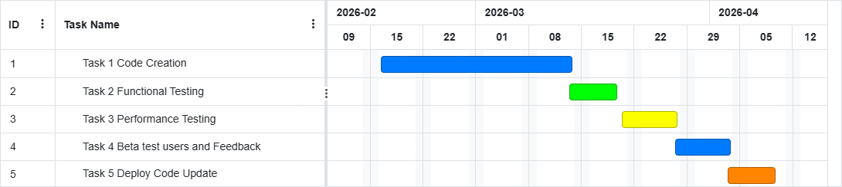

5.9 System in Action
Figure 10:
Dashboard
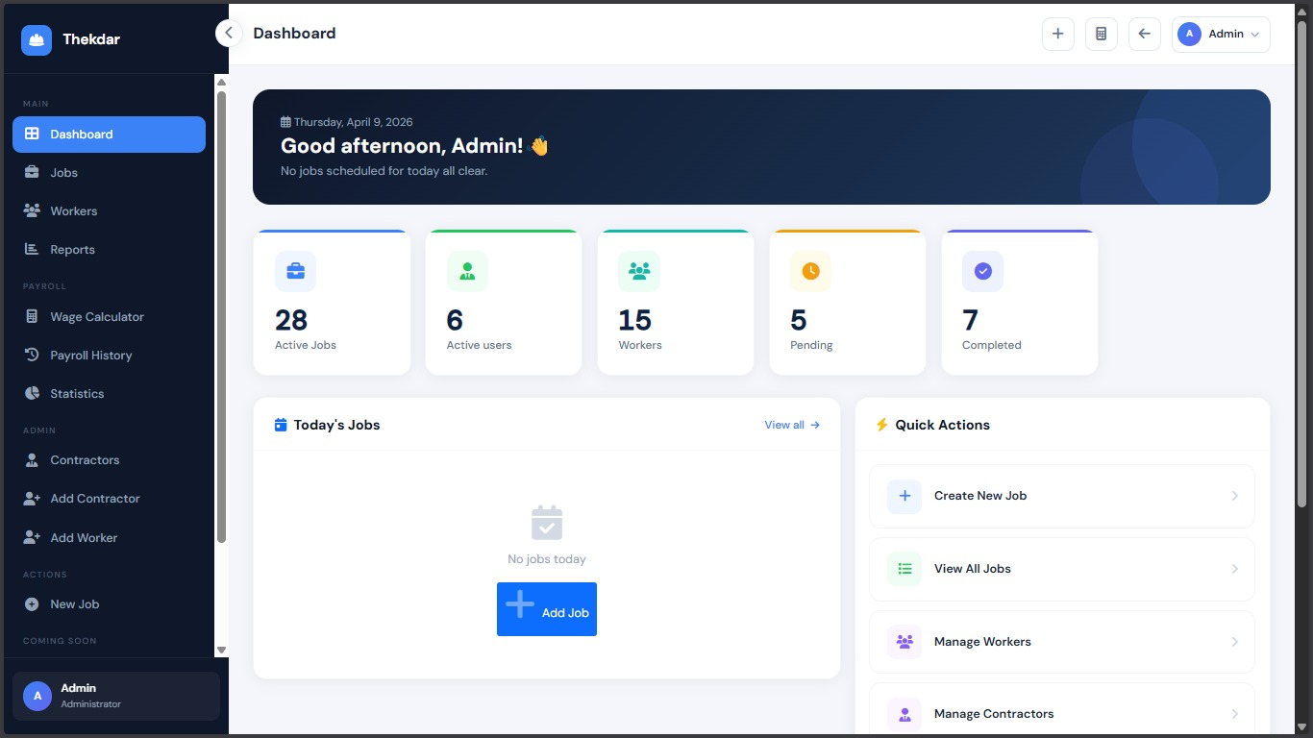

Chapter 6: Limitations and Future Enhancements

6.1 Current Limitations
- Credentials (database password, SMTP credentials, and seeded default account passwords) are committed directly to repository configuration files rather than injected via a secrets manager or environment variable vault.
- 2FA codes and password reset tokens share the same database columns (Password Reset Token / Reset Token Expires), which creates a potential collision risk if both flows are triggered simultaneously.
- Worker media files are stored under the static-file root, making them directly web-addressable if the file path is known, rather than protected behind an authorized serving endpoint.

6.1.2 Feature Scope
- The system currently supports only two roles — Admin and Contractor. Granular roles such as Site Supervisor, Accountant, or View-Only User are not yet implemented.
- Purchase order management, automated payroll scheduling, and recurring transaction support are not included in the current release.
- The pay slip view uses placeholder company information and statutory contribution values rather than configurable organization settings.
- The dashboard contractor count is based on active users rather than strictly active contractor-role accounts.

6.1.3 Performance
- Payroll statistics overdue classification is performed in-memory during statistics calculation, which may degrade performance as payroll records grow.
- The reporting dashboard bypasses the service layer and queries the database directly, limiting reusability and testability of report logic.
- No caching layer is implemented; all data is fetched from PostgreSQL on each request.

6.1.4 Code Quality
- The login flow is split between the controller and service: Auth Controller. Login handles the active login path directly while Auth Service. Login still exists but is unused, creating maintainability risk.
- Several source files contain visible character-encoding artefacts, indicating mixed encoding history in the repository.
- Large build output folders (build-audit, build-verify) are committed to the repository, inflating its size unnecessarily.

6.2 Future Enhancements

6.2.1 Security Improvements
- Move all credentials and secrets to environment variables or a secrets manager (e.g. AWS Secrets Manager, or .NET User Secrets).
- Separate the password reset token and 2FA code into distinct database columns.
- Serve worker media files through an authorized controller endpoint rather than exposing them under the static-file root.

6.2.2 Reporting and Analytics
- Implement customizable report templates with user-defined columns and groupings.
- Add predictive analytics for payroll forecasting and workforce utilization trends.
- Provide data export in multiple formats (Excel, JSON, PDF) in addition to CSV

6.2.3 Developer Experience
- Consolidate login logic entirely into Auth Service. Login and remove the duplicated controller path and add integration and unit test projects.

Chapter 7: Conclusion

7.1 Summary
The Contractor Business Management System successfully delivers a comprehensive, secure, and user-friendly web application for managing contractor operations. Developed using ASP.NET Core MVC (.NET 8), Entity Framework Core, PostgreSQL, and Bootstrap 5, the system provides a scalable foundation well-suited to the needs of small to medium-sized contracting businesses.
The project demonstrates practical application of full-stack web development, clean architecture, secure authentication, role-based access control, email integration, and containerized deployment — all developed and tested over the course of the sixth semester BCA project.

7.2 Key Achievements

7.2.1 Technical Accomplishments
- A clean three-layer architecture separating controllers, services, and data access, facilitating maintainability and future extension.
- Secure authentication with hashing, cookie management, optional email 2FA, and CSRF protection.
- A comprehensive data model covering users, workers, jobs, assignments, and payroll with EF Core migrations managing schema evolution.
- Automated email notifications for password reset, 2FA login, and worker assignment via Mail Kit.
- An admin reporting dashboard with CSV export providing actionable operational insights.

7.2.2 Learning Outcomes
- Deepened understanding of ASP.NET Core MVC patterns, Razor view rendering, and middleware pipeline configuration.
- Practical experience with Entity Framework Core Fluent API, migrations, global query filters, and partial uniqueness indexes.
- Applied knowledge of secure web application development including password hashing, session management, CSRF protection, and role-based authorization.
- Hands-on experience with Docker and docker-compose for containerized application deployment.
- Understanding of real-world software challenges including secrets management, encoding issues, and the importance of separating business logic from infrastructure.

7.3 Future Directions
The foundation established by Contractor Business Management System is well-positioned for further enhancement. Priority future directions include resolving committed-secret security risks, introducing additional user roles, adding a mobile-optimized interface for field workers, and implementing caching and background processing for improved performance at scale. Integration with accounting platforms and advanced analytics would further strengthen the system's value proposition for growing contracting businesses.

Chapter 8: References and Bibliography

8.1 References
Microsoft. (n.d.). ASP.NET MVC Documentation. Retrieved March 18, 2026,
from https://learn.microsoft.com/en-us/aspnet/mvc/
Microsoft. (n.d.). C# Documentation. Retrieved March 18, 2026,
from https://learn.microsoft.com/en-us/dotnet/csharp/
PostgreSQL Global Development Group. (n.d.). PostgreSQL Documentation. Retrieved
March 18, 2026, from https://www.postgresql.org/docs/
Entity Framework Core. (n.d.). EF Core Documentation. Retrieved March 18, 2026,
from https://learn.microsoft.com/en-us/ef/core/
W3Schools. (n.d.). SQL Tutorial. Retrieved March 18, 2026,
from https://www.w3schools.com/sql/
Bootstrap. (n.d.). Bootstrap Documentation. Retrieved March 18, 2026, from https://getbootstrap.com/docs/

8.2 Bibliography
Lerman, J., & Miller, R. (2019). Programming Entity Framework: DbContext (2nd ed.).
O'Reilly Media.
Freeman, A. (2022). Pro ASP.NET Core 6: Develop Cloud-Ready Web Applications Using
MVC, Blazor, and Razor Pages. Apress.

