VPN Access Models – Visual Learning Project

# 1. Basic VPN Tunnel – Remote Access

This diagram illustrates a typical remote work VPN connection. A VPN client on the user's device establishes an encrypted tunnel to the company's VPN server. Once connected, all internet or internal traffic flows securely through this tunnel, protecting data and access.

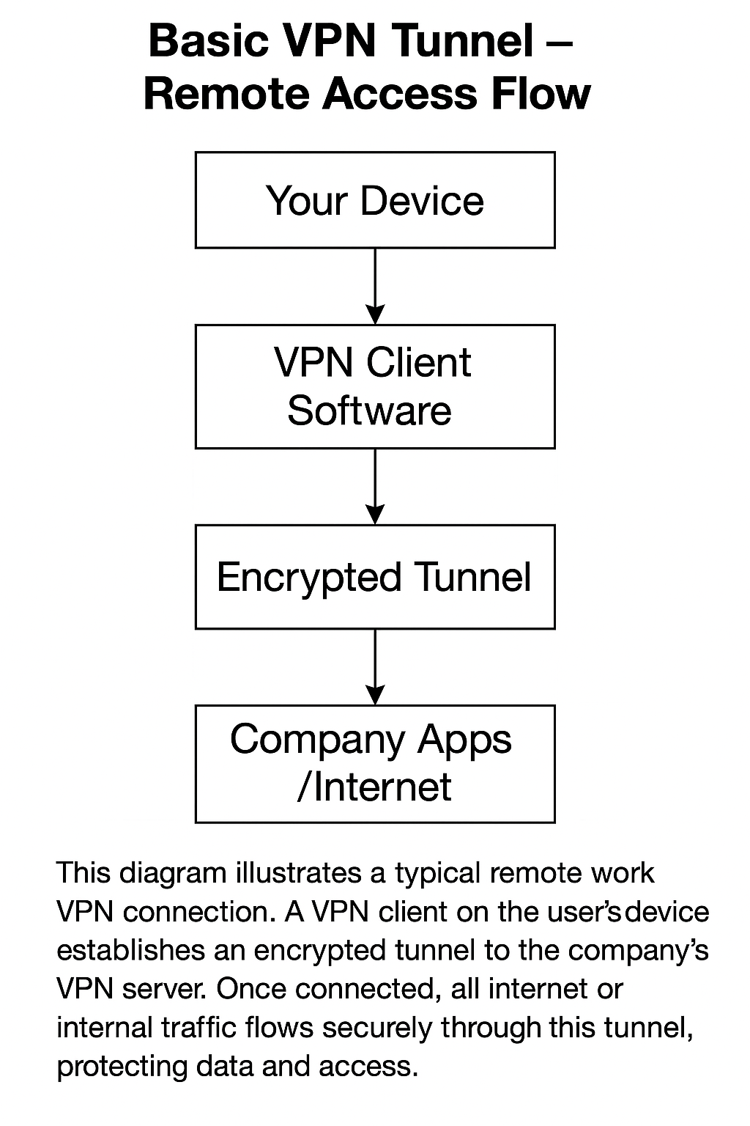

# 2. MFA + Firewall and Zero Trust Access Flows

This diagram compares two access models. In the first (top), access is granted via VPN using multi-factor authentication (MFA) followed by firewall filtering. In the second (bottom), Zero Trust principles require identity verification and make real-time access decisions per session, continuously monitoring behavior.

