Shell Script

**In Partial Fulfillment of**

**Bachelor of Computer Application** **(BCA)**



Gujarat University (2022-2023)

**(Third Year Bachelor of Computer Application)**

**Introduce By :-**

**Prajapati Brijeshkumar Jayeshbhai**



**Navgujarat BCA Collage , Nr. Main Shopping Center,**

**Sector – 28, Gandhinagar**

INDEX

|  |  |  |  |
| --- | --- | --- | --- |
| SR NO. | TITLE | PAGE NO | SIGN |
| 1. | PHP Basics and Form Handling |  |  |
| 2. | Problem Solving by Searching |  |  |
| 3. | AJAX and Validation |  |  |

UNIT-1

**1. Write a program in PHP to display "Learning PHP" in bold format.**

<?php

echo "Hello World";

echo "Learning PHP";

echo 123;

?>



**2. Write a program in PHP to demonstrate the use of comments, echo and print.**

<?php

echo("below line is in comment");

//echo("this is in single line comment");

print "Hello Asia";

print 100;

/*$age=35;

print "Payal Patel age is".$age;

print (this is multiline comment in program);*/

?>

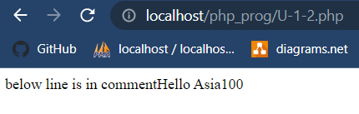

**3. Create a program in PHP to demonstrate the use of If … Else and switch statements.**

<html>

<head>

<meta charset="utf-8">

<title>Untitled Document</title>

</head>

<body>

<?php

$age="25";

$gender="f";

if($age>18)

{

if($gender=='M'||$gender=='m')

{

echo"Your are aligible for Vote and you are male candidate";

}

else

{

echo"Your are aligible for Vote and you are female candidate";

}

}

else

{

print("You are not aligible for Vote.....");

}

?>

</body>

</html>



**4. Create an array named $sub, assign five elements to it and display the elements assigned using for loop and foreach statement.**

<?php

$sub=array(1,2,3,4,5,55,66,77,88);

$cnt=count($sub);

echo $cnt;

for ($i=0;$i<$cnt;$i++)

{

echo "<br>arr[".$i."]=".$sub[$i];

}

foreach($sub as $val)

{

echo "<br>".$val;

}

$m=array("banan",11,333.333,'A');

print_r($m);

for($j=0;$j<count($m);$j++)

{

echo"<br>arr[".$j."]=".$m[$j];

}

?>

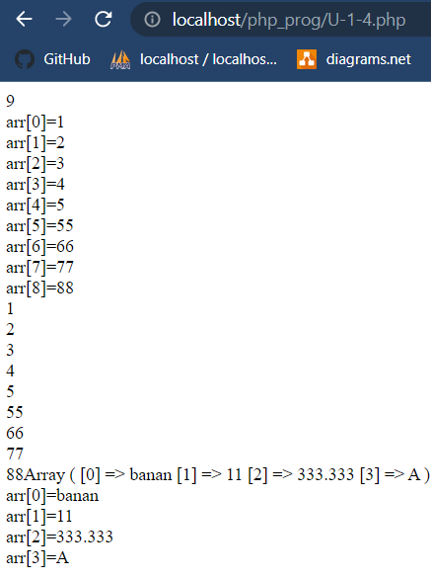

**5. Create an array named $student, that sores 5 element bounded to a different keys and access the same using the key element.**

<?php

$student=array("Name"=>"Hima Patel","Age"=>5,"Height"=>3.4,"City"=>"Ahmedabad");

echo $student["Name"]."<br>";

echo $student["Age"]."<br>";

echo $student["Height"]."<br>";

echo $student["City"]."<br>";

foreach($student as $key=>$val)

{

echo "<br>[".$key."]=".$val;

}

?>

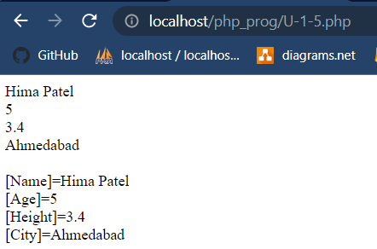

**6. Write a program in PHP to demonstrate the use of multidimensional arrays.**

<?php

$shop=array("mobile"=>array("samsung"=>"m12","mi"=>"note9 pro","apple"=>"i12"),"laptop"=>array("dell"=>"insp12","hp"=>"hp2200","lenovo"=>"Z350"));

echo $shop["mobile"]["samsung"]."<br>";

echo $shop["mobile"]["mi"]."<br>";

echo $shop["mobile"]["apple"]."<br>";

echo $shop["laptop"]["lenovo"]."<br>";

?>

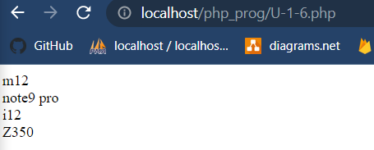

**7. Create two functions in PHP, parameterized and non parameterized for implementing string concatenation operation.**

post_data.php

<!doctypeHTML>

<html>

<head>

<title>Post data</title>

</head>

<body>

<form name="add" method="post" action="function.php">

<label for="n1">Fname</label><input type="text" name="fname" value=""/><br>

<label for="n2">Lname</label><input type="text" name="lname" value=""/><br>

<input type="submit" name="submit" value="submit"/>

</form>

</body>

function.php

<?php

function string_cat()

{

$fname=$_POST["fname"];

$lname=$_POST["lname"];

$fullname=$fname.$lname."<br>";

echo $fullname;

}

function str_cat($fname,$lname)

{

$flname=$fname.$lname;

echo $flname;

}

string_cat();

str_cat($_POST["fname"],$_POST["lname"]);

?>

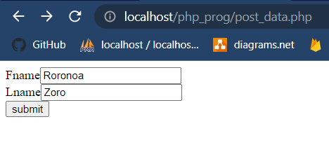

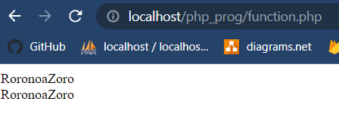

**8. Write a PHP program to display information of PHP in the browser.**

<?php

echo "php version=".phpversion();

Phpinfo();

phpinfo(INFO_MODULES);

?>



**9. Write a program in PHP to sort the array of given 5 numbers in ascending and descending order.**

<!doctype html>

<html>

<head>

<meta charset="utf-8">

<title>Untitled Document</title>

</head>

<body>

<?php

$arr=array(11,4,23,3,12,59,2,34);

echo ("\nbefore sorting array\n<br>");

for($i=0;$i<count($arr);$i++)

{

echo"arr[$i]=".$arr[$i]."<br>";

}

for($i=0;$i<count($arr);$i++)

{

for($j=$i+1;$j<count($arr);$j++)

{

if($arr[$i]>$arr[$j])

{

$tmp=$arr[$i];

$arr[$i]=$arr[$j];

$arr[$j]=$tmp;

}

}

}

echo ("<br>\nafter sorting array in Assending\n<br>");

for($i=0;$i<count($arr);$i++)

{

echo $arr[$i]."<br>";

}

for($i=0;$i<count($arr);$i++)

{

for($j=$i+1;$j<count($arr);$j++)

{

if($arr[$i]<$arr[$j])

{

$tmp=$arr[$i];

$arr[$i]=$arr[$j];

$arr[$j]=$tmp;

}

}

}

echo"<br>after sorting array in Decending<br>";

for($i=0;$i<count($arr);$i++)

{

echo $arr[$i]."<br>";

}

?>

</body>

</html>

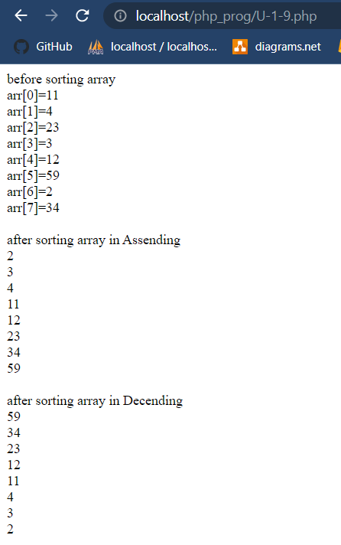

**10. Write a program to count the total number of times a specific value appears in an array.**

<?php

$cnt=0;

$match=1;

$arr=array(1,3,22,1,4,35,21,1,5,33);

for($i=0;$i<count($arr);$i++)

{

if($arr[$i]==$match)

{

$cnt++;

}

}

echo $match." is found <b>".$cnt."</b> time<br>";

$cnt=0;

$word="hello";

$string="hello student hello have a nice day";

$v=explode(" ",$string);

for($i=0;$i<count($v);$i++)

{

if($v[$i]==$word)

{

$cnt++;

}

}

echo $word." is found <b>".$cnt."</b> time";

?>

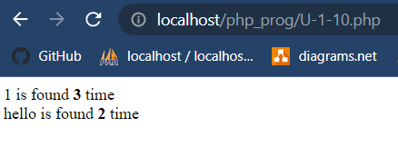

UNIT-2

**1. Create a form containing two input fields (Name, Email_ID) and a submit button. When the user clicks on submit button, the form data should be sent for processing to PHP file ,which should display the welcome message with the email_id on the PHP page. Form data should be sent by HTTP GET/POST method.**

prg1.php

<!doctype html>

<html>

<head>

<meta charser="utf-8">

<title>Unit-2</title>

</head>

<body>

<form action="prg1_submit.php" method="post">

<!--we can set method get also-->

<table>

<tr>

<td><label for="name">Name</label></td>

<td><input type="text" name="fullname"></td>

</tr>

<tr>

<td><label for="email">Email</label></td>

<td><input type="email" name="email"></td>

</tr>

<tr>

<td colspan="2"><input type="submit" name="Submit" value="Submit">

<input type="reset" name="reset" value="reset"></td>

</tr>

</table>

</form>

</body>

</html>

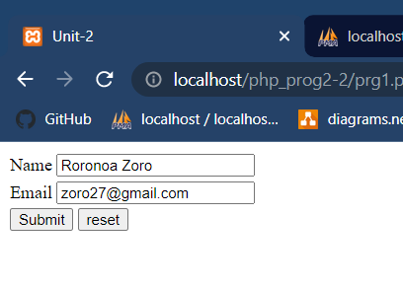

prg1_submit.php

<?php

$fullname=$_POST["fullname"];

$email=$_POST["email"];

echo "Form Submit Following Data<br>";

echo "Fullname=".$fullname."<br>";

echo "Email=".$email."<br>";

?>

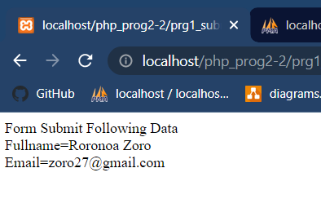

**2.Write a PHP script for that creates a database named "DB-1"in MySQL.**

connection.php

<?php

error_reporting();

$host="localhost";

$user="root";

$pass="";

$con=mysqli_connect($host,$user,$pass);

if($con)

{

echo "Connection Established<br>";

}

else

{

echo "Connection not Established<br>";

}

?>

prg2.php

<?php

include("connection.php");

$db_create="CREATE database db22";

$qry=mysqli_query($con,$db_create);

if($qry)

{

echo "Database CREATED SUCCESSFULLY";

}

else

{

echo "Database NOT CREATED";

}

?>

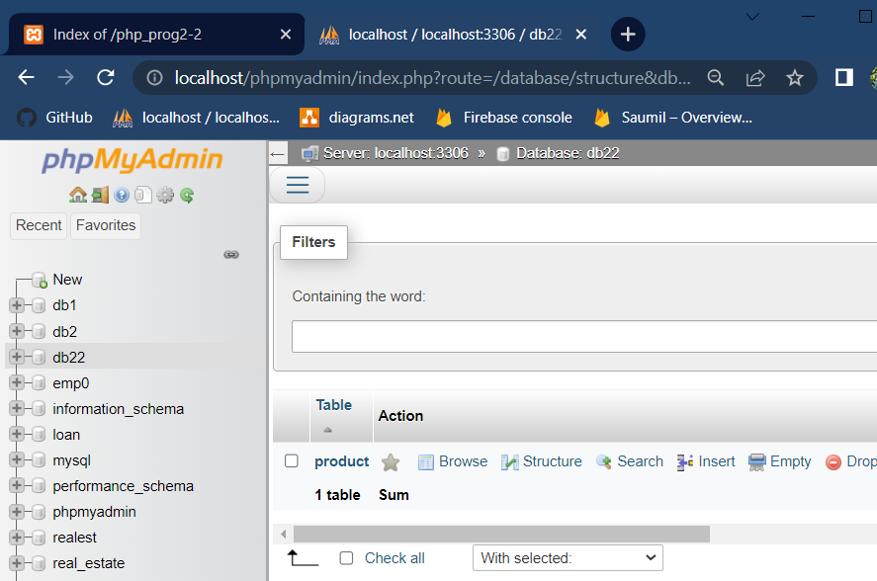

**3.Write a PHP script for creating a product table in the specified database with fields Pro_id, Pro_name, Pro_price, QOH. Also display an acknowledgement for the same.**

connection.php

<?php

error_reporting();

$host="localhost";

$user="root";

$pass="";

$dbname="db22";

$con=mysqli_connect($host,$user,$pass,$dbname);

if($con)

{

echo "Connection Established<br>";

}

else

{

echo "Connection not Established<br>";

}

?>

prg3.php

<?php

include("connection.php");

$db_create="CREATE TABLE product (Pro_Id INT(3)UNSIGNED AUTO_INCREMENT PRIMARY KEY,Pro_name VARCHAR(100)NOT NULL,Pro_price FLOAT(7,2)NOT NULL,QOH INT(5)NOT NULL)";

$qry=mysqli_query($con,$db_create);

if($qry)

{

echo "PRODUCT TABLE CREATED SUCCESSFULLY";

}

else

{

echo "PRODUCT TABLE NOT CREATED";

}

?>

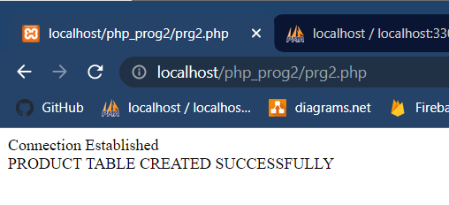

**4.Create a form contaning four input fields(Pro_id, Pro_name, Pro_price, QOH) and Submit button. When the user clicks on the submit button an PHP script should be executed which inserts the record in the product table.**

prg4.php

<?php

if(isset($_GET["msg"]))

{

echo $_GET["msg"];

}

?>

<!doctype html>

<html>

<head>

<meta charset="utf-8">

<title>Untitled Document</title>

</head>

<body>

<form action="product_query.php" method="post">

<table>

<caption><b>Add Product</b></caption>

<tr>

<td><label for="name">Productname</label></td>

<td><input type="text" name="Pro_name"></td>

</tr>

<tr>

<td><label for="email">Price</label></td>

<td><input type="number" name="Pro_price" step="0.01"></td>

</tr>

<tr>

<td><label for="email">Quality</label></td>

<td><input type="number" name="QOH"></td>

</tr>

<tr>

<td colspan="2"><input type="submit" name="Submit" value="Submit">

<input type="reset" name="reset" value="reset"></td>

</tr>

</table>

</form>

</body>

</html>

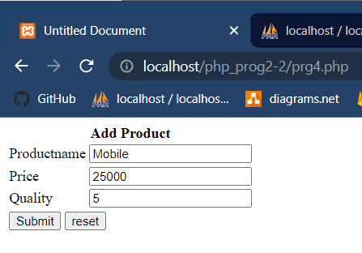

product_query.php

<?php

include("connection.php");

$productname=$_POST["Pro_name"];

$price=$_POST["Pro_price"];

$qoh=$_POST["QOH"];

if(!empty($productname)&&!empty($price)&&!empty($qoh))

{

$ins_qry="insert into product(Pro_name,Pro_price,QOH)values('$productname','$price','$qoh')";

$res=mysqli_query($con,$ins_qry);

if($res)

{

header("location:product_record.php");

}

}

else

{

header("location:prg4.php?msg=Please Try Again");

}

?>

product_record.php

<?php

include("connection.php");

$sel_qry="select * from product";

$res=mysqli_query($con,$sel_qry);

?>

<!doctype html>

<html>

<head>

<meta charset="utf-8">

<title>Untitled Document</title>

</head>

<body>

<h3><a href="prg4.php">+Add New Record</a></h3>

<table border="1">

<tr bgcolor="#6699FF">

<th>Product Id</th>

<th>Product Name</th>

<th>Product Price</th>

<th>Product Quantity</th>

<th>Edit</th>

</tr>

<?php

while($row=mysqli_fetch_array($res))

{

?>

<tr bgcolor="#FFCC33">

<td><?php echo $row["Pro_Id"];?></td>

<td><?php echo $row["Pro_name"];?></td>

<td><?php echo $row["Pro_price"];?></td>

<td><?php echo $row["QOH"];?></td>

<td><?php echo "<a href=prg6.php?pid=$row[Pro_Id] style=text-decoration:none>Edit</a>"?></td>

</tr>

<?php

}

?>

</table>

</body>

</html>

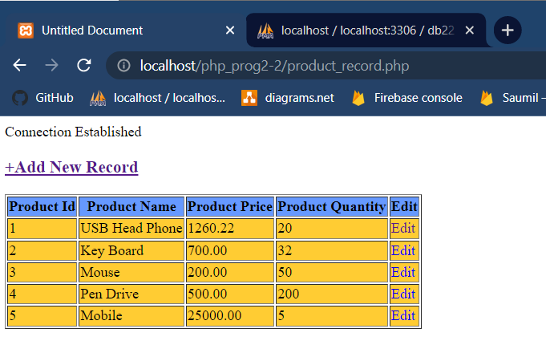

**5.Create a form contaning one input field(Pro_id) and a search button. When the user clicks on the Search button a PHP script should get executed and should display the details of the product for the Pro_id specified.**

prg5.php

<?php

include("connection.php");

if(!empty($_POST["search_product"]))

{

$search=$_POST["search_product"];

$sel_qry="select * from product where Pro_Id=$search";

$res=mysqli_query($con,$sel_qry);

}

else

{

$sel_qry="select * from product";

$res=mysqli_query($con,$sel_qry);

}

?>

<!doctype html>

<html>

<head>

<meta charset="utf-8">

<title>Untitled Document</title>

</head>

<body>

<div style="float:left;width:150px;margin-right:100px;">

<form action="<?php $_SERVER["PHP_SELF"];?>" method="post">

<table>

<tr>

<td>

<select name="search_product">

<option value="">Please Select</option>

<?php

$sel_qry_search="select * from product";

$res_search=mysqli_query($con,$sel_qry_search);

while($row_search=mysqli_fetch_array($res_search))

{

?>

<option value="<?php echo $row_search["Pro_Id"];?>">

<?php echo $row_search["Pro_name"];?>

</option>

<?php

}

?>

</select>

</td>

<td><input type="submit" name="submit" value="Search"></td>

</tr>

</table>

</form>

</div>

<div style="margin-top:50px;margin-left:200px;float:left;">

<table border="1">

<caption><b>Product Detail</b></caption>

<tr bgcolor="#6699FF">

<th>Product Id</th>

<th>Product Name</th>

<th>Product Price</th>

<th>Product Quantity</th>

</tr>

<?php

while($row=mysqli_fetch_array($res))

{

?>

<tr bgcolor="#FFCC33">

<td><?php echo $row["Pro_Id"];?></td>

<td><?php echo $row["Pro_name"];?></td>

<td><?php echo $row["Pro_price"];?></td>

<td><?php echo $row["QOH"];?></td>

</tr>

<?php

}

?>

</table>

</div>

</body>

</html>

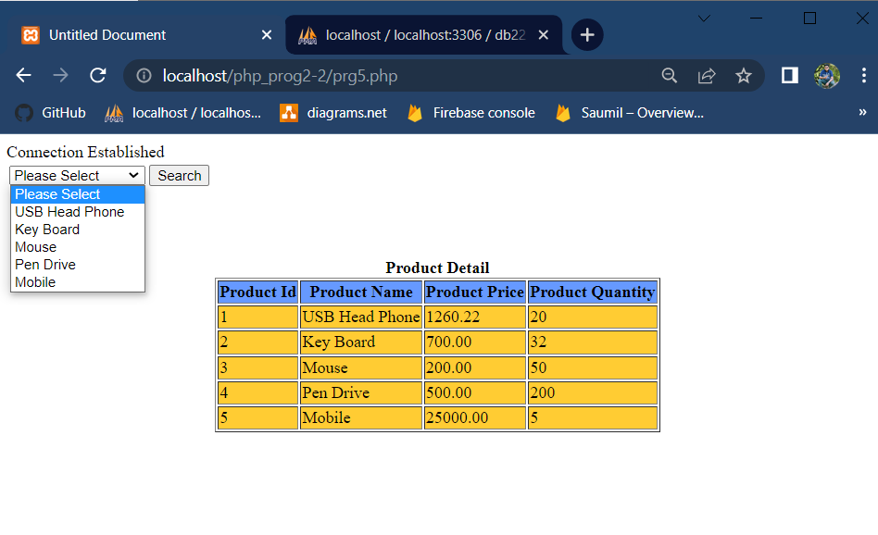

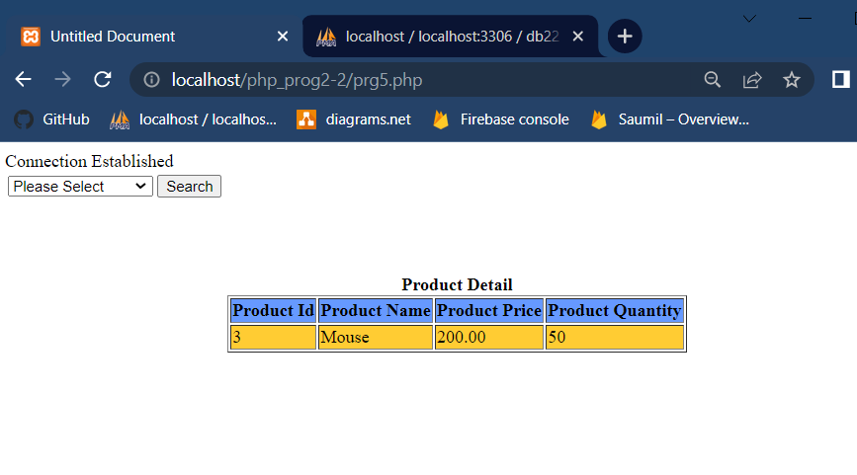

**6. Create a form contaning two input fields (Pro_id, QOH) and Update button. When the user clicks on the Update button the quantity of the Pro_id specified should get updated using a PHP script.**

prg6.php

<?php

include("connection.php");

$pro_id=$_GET["pid"];

$sel_product="select * from product where Pro_Id=$pro_id";

$res_product=mysqli_query($con,$sel_product);

$row_product=mysqli_fetch_array($res_product);

$pid=$row_product["Pro_Id"];

$qty=$row_product["QOH"];

if(isset($_GET["msg"]))

{

echo $_GET["msg"];

}

?>

<!doctype html>

<html>

<head>

<meta charset="utf-8">

<title>Untitled Document</title>

</head>

<body>

<form action="product_update.php" method="post">

<table>

<caption>Product Update</caption>

<tr>

<td><label for="product">Product Name</label></td>

<td>

<select name="Pro_Id">

<option value="">Please Select</option>

<?php

$sel_product="select * from product order by Pro_name ASC";

$qry=mysqli_query($con,$sel_product);

while($row_search=mysqli_fetch_array($qry))

{

?>

<option value="<?php echo $row_search["Pro_Id"];?>"

<?php if($row_search["Pro_Id"]==$pid){echo"selected";}else{echo"";}?>>

<?php echo $row_search["Pro_name"];?>

</option>

<?php

}

?>

</select>

</td>

</tr>

<tr>

<td><label for="quantity">Quantity</label></td>

<td><input type="number" name="QOH" value="<?php echo $qty;?>"></td>

</tr>

<tr>

<td colspan="2"><input type="submit" name="Submit" value="Submit">

<input type="reset" name="reset" value="reset"></td>

</tr>

</table>

</form>

</body>

</html>

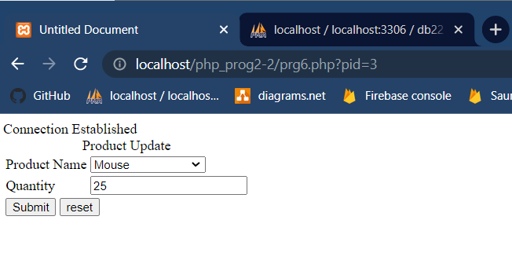

product_update.php

<?php

include("connection.php");

echo $Pro_Id=$_POST["Pro_Id"];

echo $qoh=$_POST["QOH"];

if(!empty($qoh))

{

echo $update_qry="update product set QOH=$qoh where Pro_Id=$Pro_Id";

$update_res=mysqli_query($con,$update_qry);

if($update_res)

{

header("location:product_record.php");

}

}

else

{

header("location:prg6.php?msg=Please Try Again");

}

?>

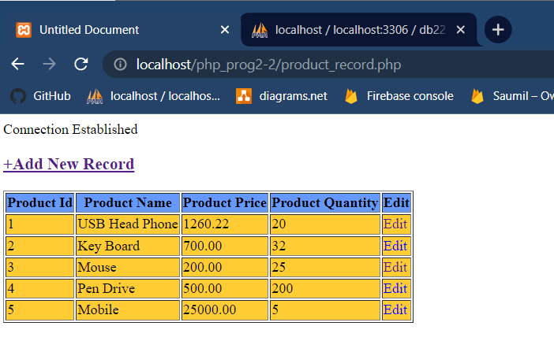

**7.Create a form contaning one input field(Pro_id) and a Delete button. When the user clicks on the Delete button a PHP script should get executed and should delete the record of the product for the Pro_id specified.**

product_record.php

<?php

include("connection3.php");

if(!empty($_POST["search_producct"]))

{

$search=$_POST["search_product"];

$sel_qry="select * from product where Pro_Id=$search";

$res=mysqli_query($con,$sel_qry);

}

else

{

$sel_qry="select * from product";

$res=mysqli_query($con,$sel_qry);

}

?>

<!doctype html>

<head>

<meta charset="utf-8">

<title>Prg 7</title>

</head>

<body>

<div style="float:left;width:150px;">

<h3><a href="prg4.php">+Add New Record</a></h3></div>

<div style="float:right;width:150px;">

<form action="<?php $_SERVER["PHP_SELF"];?>" method="post">

<table>

<tr>

<td>

<select name="search_product">

<option value="">Please Select</option>

<?php

$sel_qry_search="select * from product";

$res=mysqli_query($con,$sel_qry_search);

while($row_search=mysqli_fetch_array($res_search))

{

?>

<option value="<?php echo $row_search["Pro_Id"];?>">

<?php echo $row_search["Pro_name"];?>

</option>

<?php

}

?>

</select>

</td>

<td><input type="submit" name="submit" value="search"></td>

</tr>

</table>

</form>

</div>

<div style="margin-top:50px;margin-left:200px;float:left;">

<table border="1">

<caption><b>Product Detail</b></caption>

<tr color="#6699FF">

<th>Product Id</th>

<th>Product Name</th>

<th>Product Price</th>

<th>Product Quantity</th>

<th>Edit</th>

<th>Delete</th>

</tr>

<?php

while($row==mysqli_fetch_array($res))

{

?>

<tr bgcolor="#FFCC33">

<td><?php echo $row["Pro_Id"];?></td>

<td><?php echo $row["Pro_name"];?></td>

<td><?php echo $row["Pro_price"];?></td>

<td><?php echo $row["QOH"];?></td>

<td><?php echo "<a href=prg6.php?pid=$row[Pro_Id]style=text-decoration:none>Edit</a>"?></td>

<td><?php echo "<a href=prg7.php?pid=$row[Pro_Id]style=text-decoration:none>Delete</a>"?></td>

</tr>

<?php

}

?>

</table>

</div>

</body>

</html>

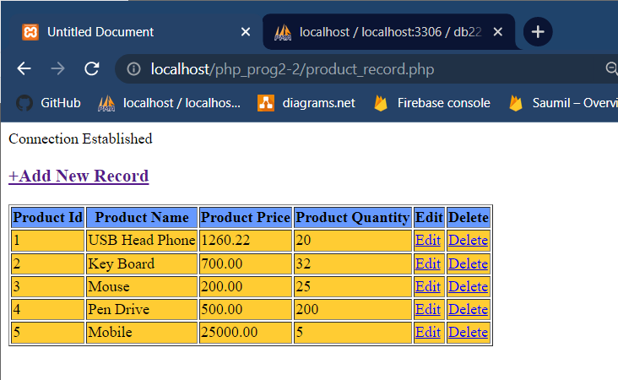

prg7.php

<?php

include("connection3.php");

echo $Pro_Id=$_GET["pid"];

if(!empty($Pro_Id))

{

echo $delete_qry="delete from product where Pro_Id=$Pro_Id";

$delete_res=mysqli_query($con,$delete_qry);

if($delete_res)

{

header("location:product_record7.php");

}

}

else

{

header("location:prg7.php?msg=Please Try Again");

}

?>

UNIT-3

**1.Create a form containing one input field (Name). When the user enters his/her name and as any key is released , the form should display a welcome message for the user. Implement using AJAX.**

form_data.php