Ramkishore Dhakad ramdhakad20@iitk.ac.in

Solid Mechanics and Design

Department of Mechanical Engineering

Indian Institute of Technology Kanpur, Uttar Pradesh, India.



**Contents:**

Introduction

Functions:

1. Primary Function
2. Secondary function
3. Tertiary Function

Objectives

Constraints

Free variables

Material Index between Density and Properties of material:

1. Strength and Density
2. Young’s Modulus and Density
3. Shear Modulus and Density
4. Fracture Toughness and Density
5. Fatigue strength (endurance strength) and density
6. Toughness (U):
7. Thermal expansion coefficient and density
8. Elongation of Vertical shaft:
9. Machinability and Density

10.Hardness and Density

Material Index between any two Properties of material:

1. Fracture Toughness and Young’s modulus:
2. Mechanical loss coefficient and Young’s Modulus
3. Young’s Modulus and Strength:
4. Specific Strength and Specific Modulus:
5. Shear modulus and shear strength:
6. Machinability:
7. Wear rate constant and Hardness:
8. Thermal conductivity and
9. Mechanical loss coefficient and Young’s Modulus and Density
10. Relative cost and material class:
11. Modulus and relative cost:

Conclusion

References

**Introduction:**

**Defination:**

Material Selection:

A very wide range of material is available to us.

Selecting a material for particular device or component is a very tedious job.

To select material for any component, first we need to a detailed analysis of that component.

The interaction between function, material, shape, and process lies at the heart of the material selection process.

In this Document Author tried to select the best possible material for the Shaft.

Shaft:

A shaft is a rotating machine element, usually circular in cross section, which is used to transmit power from one part to another, or from a machine which produces power to a machine which absorbs power [3].

Types [3]:

They are mainly classified into two types.

Transmission shafts are used to transmit power between the source and the machine absorbing power; e.g. counter shafts and line shafts.

Machine shafts are the integral part of the machine itself; e.g. crankshaft.

Axle shaft.

Spindle shaft.

The following stresses are induced in the shafts.

Shear stresses due to the transmission of torque (due to torsional load).

Bending stresses (tensile or compressive) due to the forces acting upon the machine elements like gears and pulleys as well as the self-weight of the shaft [1].

Stresses due to combined torsional and bending loads.

**Primary Function:**

**Yield Strength of material:**

Primary function of the shaft is to transmit torque and carry power transmission element because of torque torsional stresses developed and because of the weight of shaft and power transmission element bending stresses developed in the shaft. Hence shaft is subjected to combined loading. To withstand these stresses shaft material must have higher yield strength.

shaft is generally made of ductile material and hence Tressa or Von-Misses criteria can be used for design of shaft.

According to the Tressa theory the shear strength and tensile strength is related as follows:

Von-Misses criteria the shear strength and tensile strength is related as follows:

Hence higher the tensile yield strength of material higher will be the yield strength in shear.

**Bending stiffness**

Bending stiffness is a measure of resistance to bending deformation of a beam. It is measure of amount of a beam will deform under a given load. Higher the bending stiffness laser will be the deformation.

shaft is subjected to the radial loading perpendicular to the axis of the shaft and hence bending deformation of the shaft takes place.

in general bending stiffness is given as follows:

deflection of beam with both ends fixed and a point load acting at the center is given by:

and from this equation we can see that deflection is inversely proportional to the bending stiffness.

**Torsional stiffness**

It is defined as the torque required to produce a twist of unit radian.

The torsional stiffness is given by:

Using torsional equation:

Shaft is subjected to different amount of torque at different cross section along the length and hence there is possibility of twisting of the shaft along the length the twist in the shaft should be minimum during the working period.

Higher the torsional stiffness laser will be the angular twist for given amount of torque on shaft.

**Fracture Toughness:**

Fracture toughness is a measure of resistance offered by material against the propagation of crack. Higher the fracture toughness of material laser will be the chance of propagation of crack inside or on the surface of material.

Depending upon the manufacturing process of shaft like casting, welding or machining there is a possibility of presence of cracks inside or on the surface of the components.

During casting because of the gas defect and in welding because of the non-uniform heating and cooling of component can cause crack can generate inside the component.

The chances of propagation of crack on the shaft is verify because the shaft is subjected to the completely reversed loading in which the mean stress is zero and only amplitude stress is exist. Therefore, shaft material with higher fracture toughness is needed.

Y: a geometric factor

E: Young's modulus

: Tensile stress at which crack will propagate

: fracture toughness

2c: Crack length

**Toughness:**

It is very important property when component subjected to the impact loading or any kind of jerk. A tough material means material is having high strength and high ductility.

Toughness is defined as the area under stress strain curve.

It is also defined as the amount of energy per unit volume that a material can absorb before rupturing.

shaft used in some places like in Automobile, wind turbine sometime subjected to sudden loading and hence to avoid failure of the shaft, material of the shaft must be tough.

Mathematically toughness can be defined as:

**Density:**

Higher the density of material higher will be the mass of shaft. It is preferred to have less density of material. Specially in space application like the shaft used in compressor and turbine this is a very important parameter.

**Secondary Function**

**Fatigue strength (Endurance strength)**:

It is defined as the highest stress that material can withstand for given number of cycles without breaking of shaft.

Shaft is subjected to cyclic loading that is magnitude of stress at a point change from positive stress to zero and then it becomes negative stress of same magnitude, This happens in every single rotation of the shaft.

Since the loading on the shaft is dynamic and hence the design of the shaft is done using endurance strength of material.

For safest design Soderberg criteria is used:

For

Endurance strength is defined is the highest value of completely reversed bending stress that a material can withstand for infinite number of cycles without any sign of crack. Generally, 10^7 cycles are considered as sufficient to calculate fatigue strength.

**Mechanical loss coefficient:**

The *mechanical loss-coefficient* also called *damping factor* measures the degree to which a material dissipates vibrational energy.

In some special application of shaft like in racing car, shaft used in machine tool in which vibration can affect the tolerance of component during machine it becomes important to consider loss coefficient.

If a material subjected to elastic loading of ,then it stores elastic energy per unit volume U:

If the material is then unloaded, it dissipates an energy:

The loss coefficient is

The value of usually depends on the frequency of cycling. Damping can also measure by

1. specific damping capacity
2. The logarithmic decrement,

Where are successive amplitudes of natural vibrations.

1. The phase-lag, , between stress and strain, and the " "-factor or resonance factor, Q.

When damping is small these measures are related by

For large damping above relations are not valid. Damping for case of shaft design is considered small while for case of spring Design it considered large.

Loss Tangent is defined as:

Storage modulus:

Loss Modulus:

Hookean Elastic solid  
. Viscaclastic paterual  
 viscousliquid.  
tress strain

**Machinability:**

Machinability is not a property of material. It is a process parameter. In the selection of material, it is also important to consider the process parameter so that we can machine component easily in a desired shape.

Machinability refers to the ease with which a material can be machined to an acceptable surface finish

machinability is measured in terms of following parameters:

1. Tool wear during machining.
2. Form of chip produced during machining continuous or discontinuous chip),Ductile material produces continuous chip while the brittle material produces discontinuous chip.
3. Surface finish
4. Cutting force required.

Note: Most of the time ductile material having better machinability than brittle material.

Linear coefficient of thermal expansion:

linear coefficient of thermal expansion is defined as the change in length of material per unit rise in temperature.

It measures the extent to which material expands upon heating.

when shaft used in high temperature application such as in steam turbine gas turbine it becomes very important to consider coefficient of thermal expansion during selection of materials.

**Hardness**:

hardness is a quick measure of strength of material. hardness can be defined as resistance to wear, scratch or indentation. it is also defined as resistance to localized plastic deformation of material

hardness is measured by prancing indenter on the surface of material and then calculating the indentation on surface.

Based on different shape of indenter we have following different hardness numbers:

1. Brinell hardness number
2. Rockwell hardness number
3. Vicker hardness number

The value of constant is very from material to material. For ferrous materials:

It has units of MPa. Hardness is most usually reported in other units, Vickers Hv scale with units of kg/mm2. It is related to H by:

**Cost:**

**Tertiary Function:**

**Coefficient of thermal expansion**:

**Thermal Diffusivity:**

T is the ratio of thermal conductivity

**Objectives:**

**Primary Objectives:**

1. Maximize the strength of shaft.
2. Maximize specific strength.
3. Maximize specific modulus
4. Minimize the weight
5. Minimize the deflection of shaft due to various kind of loading on the shaft
6. Maximize the bending stiffness of the shaft.
7. Minimize the torsional rigidity of the Shaft
8. Minimize the angle of Twist of shaft due to Torque acting on it.

**Secondary Objectives:**

1. Maximize the fracture toughness of shaft.
2. Maximize the toughness of shaft.
3. Maximize the linear coefficient of thermal expansion
4. minimize the cost

**Tertiary Objectives:**

1. Selection of materials with higher machinability.
2. Minimizing the bending strain of shaft.
3. Maximize the mechanical loss coefficient
4. Maximize the thermal diffusivity of shaft material

**Constraints:**

1. Length L specified
2. Bending Stiffness: must not deflect too much under design loads
3. Torsional Stiffness: must not twist too much under design Torque
4. Strength: must not fail under design load
5. Fracture toughness:

**Free Variable:**

Selection of Material.

Radius of the shaft.

Note: In most of the chart the young’s modulus taken > 150Gpa

**Material Indexes using material property/Characteristics and Density:**

1. **Strength and Density:**

Torsion Equation:

Thus, performance index given by

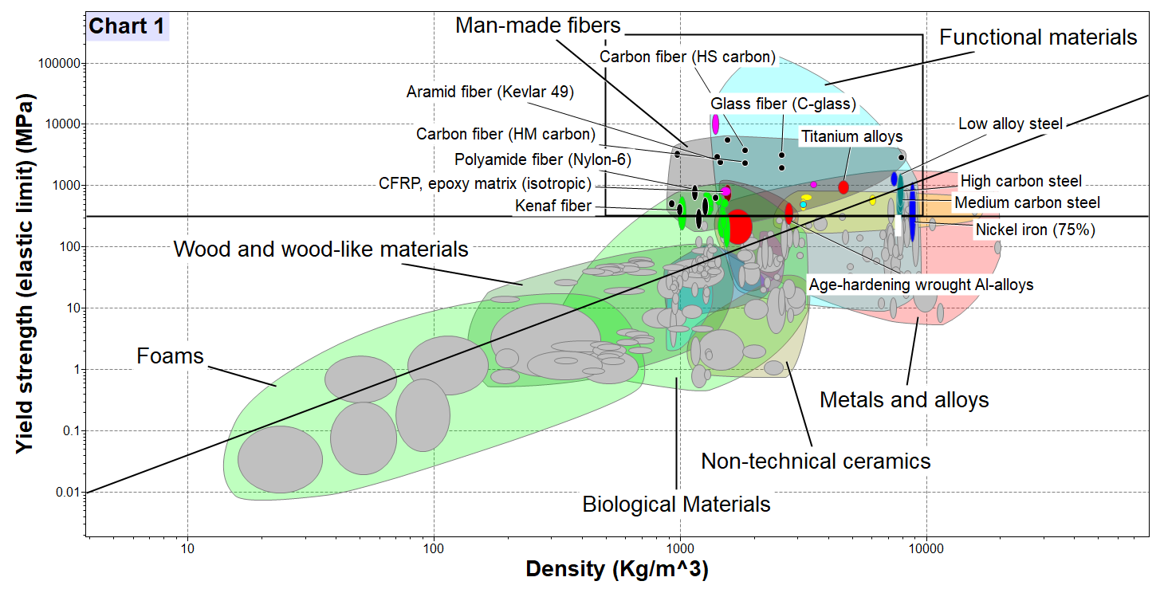

|  |  |  |  |
| --- | --- | --- | --- |
| **Material** |  |  |  |
| Carbon fiber (HS carbon) | 3870 | 1.82 | 135.4 |
| Carbon fiber (Hm carbon) | 2400 | 1.82 | 98.5 |
| Glass fiber ( C - glass) | 3250 | 2.57 | 85.4 |
| CFRP (epoxy matrix) | 760 | 1.55 | 53.7 |
| Titanium alloys | 949 | 4.6 | 21.0 |
| High carbon steel | 680 | 7.85 | 9.9 |
| Medium carbon steel | 591 | 7.8 | 9.0 |
| Stainless steel | 541 | 7.74 | 8.6 |
| Nickle alloy | 377 | 8.772 | 5.9 |

Taking log on both side of performance index we get equation of line with slope 1.5.

a horizontal line at Young's modulus 210GPa is drawn.

material above both lines will be the good material for this index.

from chart Carbon fibre (high strength) is having maximum performance index while Nickel alloys having lowest performance index

1. **Young’s Modulus and Density:**

Bending Equation:

Bending Stiffness:

Combining above two equations

Thus, performance index given by

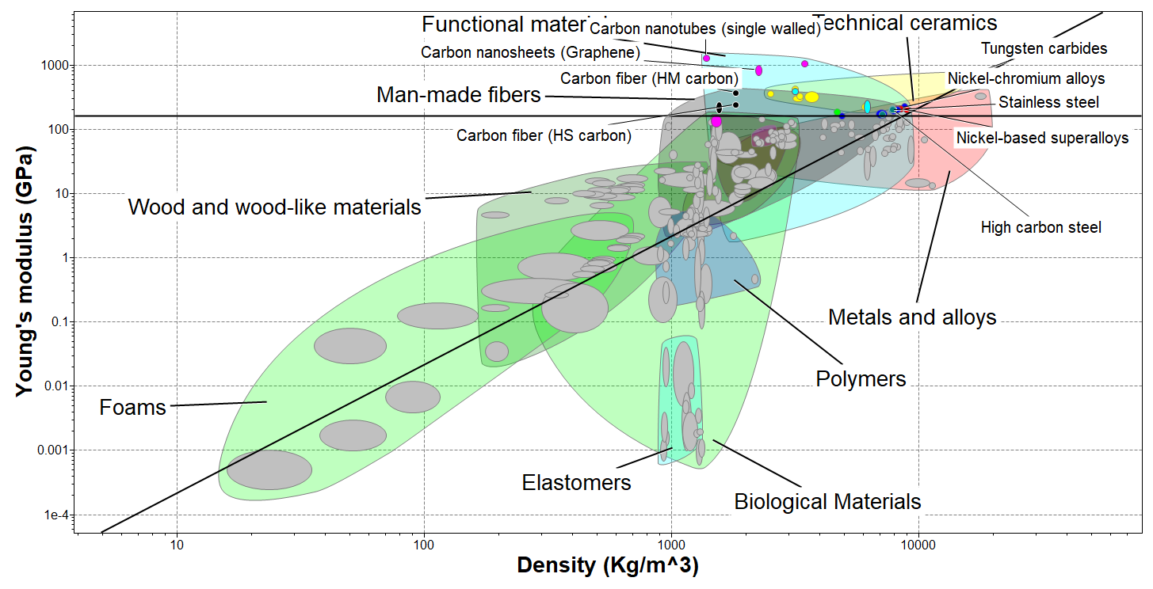

|  |  |  |  |
| --- | --- | --- | --- |
| **material** |  |  |  |
| Carbon fiber (HM cabon) | 380 | 1.82 | 10.71 |
| Carbon fiber (HS cabon) | 242 | 1.82 | 8.55 |
| High carbon steel | 207 | 7.85 | 1.83 |
| Stainless steel | 200 | 7.74 | 1.83 |
| Nickle based super alloy | 210 | 8.27 | 1.75 |
| Nickle chromium alloy | 210 | 8.4 | 1.73 |

Taking log on both side of performance index we get equation of line with slope 2.

a horizontal line at Young's modulus 200GPa is drawn.

material above both line will be the good material for this index.

from chart abain Carbon fibre ( high strength) is having maximum performance index while Nickel alloys having lowest performance index

1. **Shear Modulus and Density:**

Torsional Equation:  
Torsional stiffness:

Thus, performance index given by

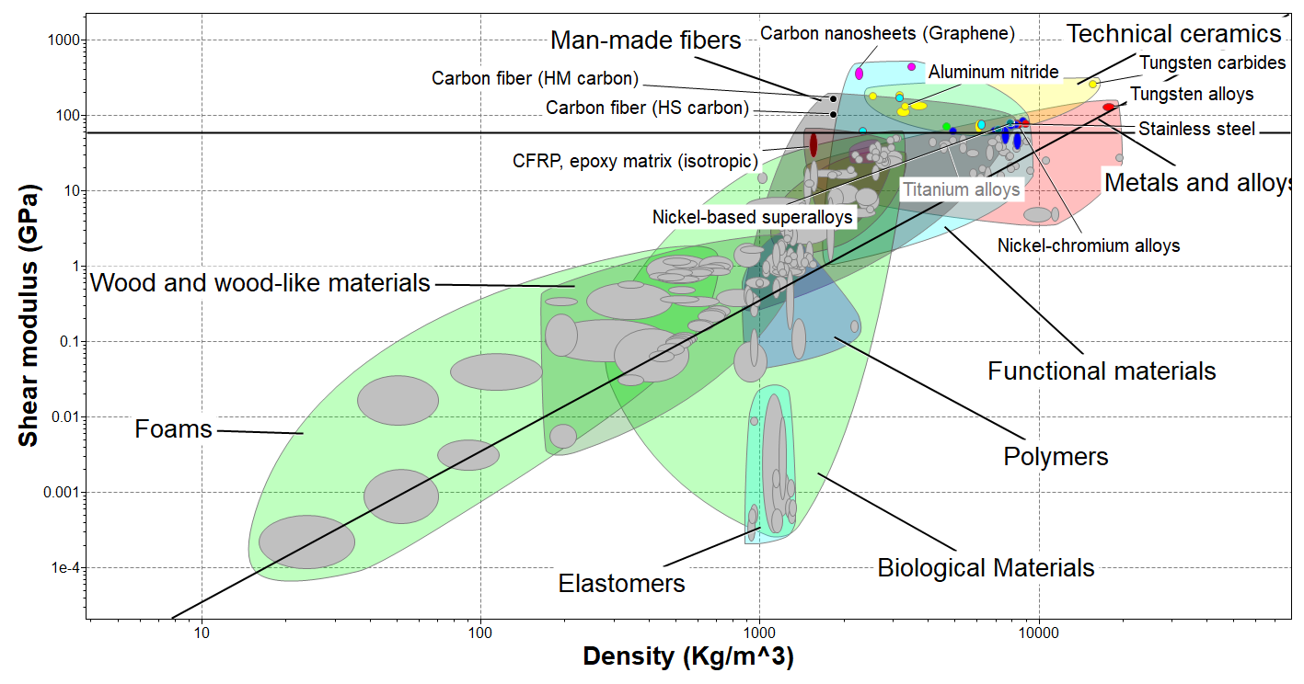

|  |  |  |  |
| --- | --- | --- | --- |
| **Material** |  |  |  |
| Carbon fibre (HM carbon) | 170 | 1.82 | 7.2 |
| Carbon fibre (HS carbon) | 105 | 1.82 | 5.6 |
| CFRP (epoxy matrix) | 60 | 1.55 | 5.0 |
| Titanium alloys | 42.4 | 4.6 | 1.4 |
| Stainless steel | 77.9 | 7.74 | 1.1 |
| Nickle chromium alloy | 76.8 | 8.4 | 1.0 |
| Tungsten alloy | 130 | 17.7 | 0.6 |

Taking log on both side of performance index we get equation of line with slope 2.

a horizontal line at Shear modulus 75GPa (shear modulus of steel) is drawn.

material above both line will be the good material for this index.

from chart again Carbon fibre ( high strength) is having maximum performance index while Tungsten alloy having lowest performance index

1. **Fracture Toughness and Density:**

(1)

(2)

(4)

Then equation (2) becomes,

(5)

From equation (1),

(6)

is constant.

Thus, performance index given by

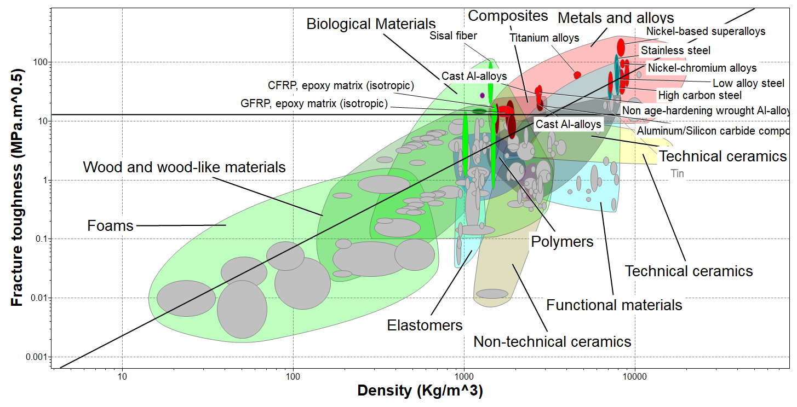

|  |  |  |  |
| --- | --- | --- | --- |
| **material** |  |  |  |
| Nickle based super alloy | 179 | 8.27 | 3874 |
| Stainless steel | 88.4 | 7.74 | 1010 |
| Titanium alloys | 62 | 4.6 | 836 |
| Low alloy steel | 56.4 | 7.8 | 408 |
| Non age hardning alluminium alloy | 31.6 | 2.66 | 375 |
| High carbon steel | 49.8 | 7.85 | 316 |
| cast Al Alloy | 24.2 | 2.71 | 216 |
| CFRP (epoxy matrix) | 11.1 | 1.55 | 79 |

Taking log on both side of performance index we get equation of line with slope 1.5.

a horizontal line at **Fracture Toughness** (>15Mpa.m^0.5) is drawn.

material above both lines will be the good material for this index.

from chart Nickle alloy is having maximum performance index while CFRP composite is having lowest performance index

1. **Fatigue strength (endurance strength) and density:**

For safest design Soderberg criteria is used:

For

M: Bending moment

From shear stress formula,

Where, (equivalent fatigue torque) =

are combined shock and fatigue factor applied to bending moment and torque respectively

(Polar moment of inertia) = &

Thus, performance index given by

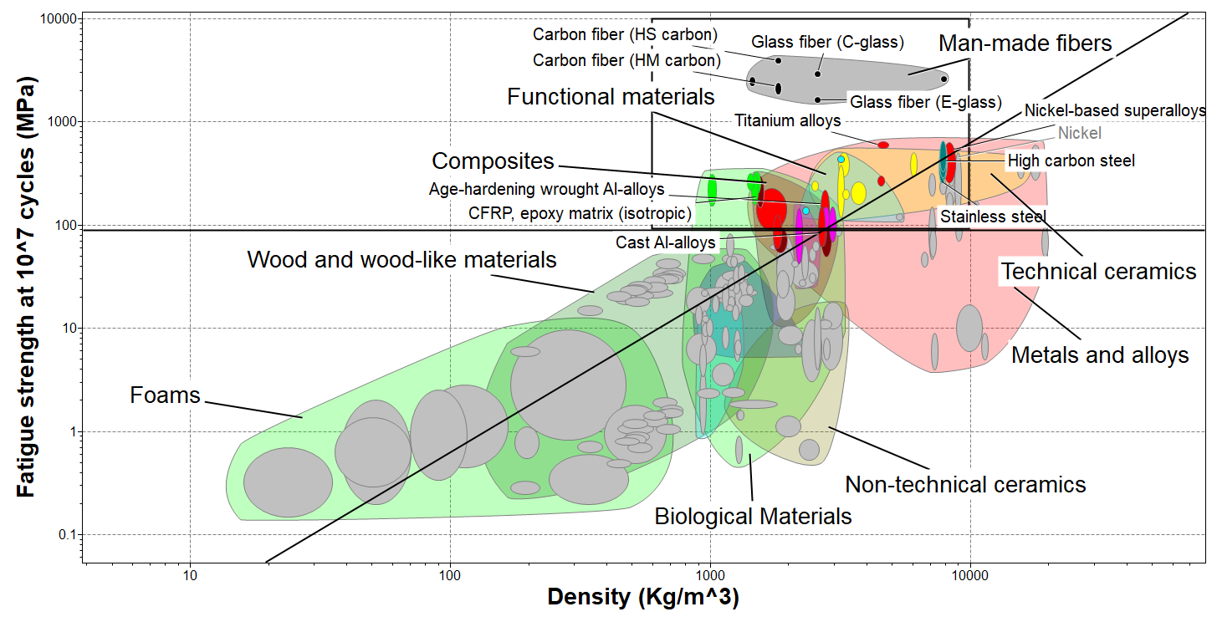

|  |  |  |  |
| --- | --- | --- | --- |
| **Material** |  |  |  |
| Carbon fibre (HS carbon) | 3950 | 1.82 | 137.3 |
| Glass fibre (C - glass) | 2920 | 2.57 | 79.5 |
| Titanium alloys | 603 | 4.6 | 15.5 |
| Age hardening wrought AL Alloy | 148 | 2.75 | 10.2 |
| Stainless steel | 372 | 7.74 | 6.7 |
| Nickel based super alloy | 405 | 8.27 | 6.6 |
| CFRP (epoxy matrix) | 212 | 1.55 | 22.9 |
| Carbon fibre (Hm carbon) | 2120 | 1.82 | 90.7 |

Taking log on both side of performance index we get equation of line with slope 1.5.

a horizontal line at **endurance strength** (>100 Mpa) is drawn.

material above both lines will be the good material for this index.

from chart High strength carbon fiber is having maximum performance index while high modulus carbon fibre is having lowest performance index

1. **Toughness (U)**:

Using equation (6) of fracture toughness from last derivation:

Thus, performance index given by

Taking log on both side of performance index we get equation of line with slope 1.5.

a horizontal line at **endurance strength** (>100 Mpa) is drawn.

material above both lines will be the good material for this index.

from chart High strength carbon fiber is having maximum performance index while high modulus carbon fibre is having lowest performance index

1. **Thermal expansion coefficient and density:**

Shaft is of fixed length thus temperature rise will increase the stress:

Using (1) and (2)

Thus, performance index given by

|  |  |  |  |
| --- | --- | --- | --- |
| **material** |  |  |  |
| Age hardening wrought Al Alloy | 1820 | 2.75 | 662 |
| Stainless steel | 2670 | 7.74 | 345 |
| High carbon steel | 2530 | 7.85 | 322 |
| Low alloy steel | 2450 | 7.8 | 314 |
| Nickle based super alloy | 2570 | 8.27 | 311 |
| CFRP (epoxy matrix) | 429 | 1.55 | 277 |
| Titanium alloys | 1060 | 4.6 | 230 |
| Tungsten alloy | 1670 | 17.7 | 94 |

Taking log on both side of performance index we get equation of line with slope 1.

material on right of vertical line and above horizontal will be the good material for this index.

from chart Age hardening wrought Al Alloy is having maximum performance index while Tungsten alloy is having lowest performance index.

1. **Elongation of Vertical shaft:**

Elongation of shaft due to self-weight,

(1)

Where, W is self-weight of the shaft.

(2)

Put the value from equation (2) in (1),

is constant.

Thus, performance index given by

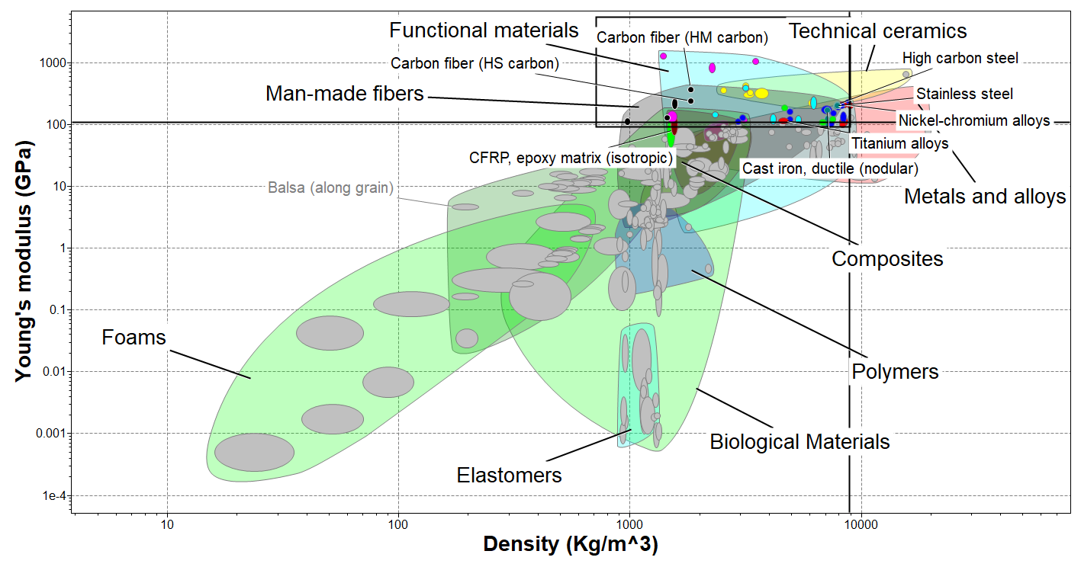

|  |  |  |  |
| --- | --- | --- | --- |
| **material** |  |  |  |
| Carbon fibre (HM carbon) | 380 | 1.82 | 208.8 |
| Carbon fibre (HS carbon) | 242 | 1.82 | 133.0 |
| CFRP (epoxy matrix) | 150 | 1.55 | 96.8 |
| High carbon steel | 207 | 7.85 | 26.4 |
| Stainless steel | 200 | 7.74 | 25.8 |
| Titanium alloys | 115 | 4.6 | 25.0 |
| Nickle chromium alloy | 210 | 8.4 | 25.0 |

Taking log on both side of performance index we get equation of line with slope 1.

material on left of vertical line and above horizontal line (E>100GPa) will be the good material for this index.

from chart Carbon fibre (HM carbon) is having maximum performance index while Nickle chromium alloy is having lowest performance index.

1. **Machinability and Density:**

machinability is not a property of material. It is a process parameter. In the selection of material, it is also important to consider the process parameter so that we can machine component easily in a desired shape.

There is no direct empirical relation between the machinability and the density of the material. We can consider two separate material indexes. we need to maximize machinability and minimize the density.

Thus, performance index given by

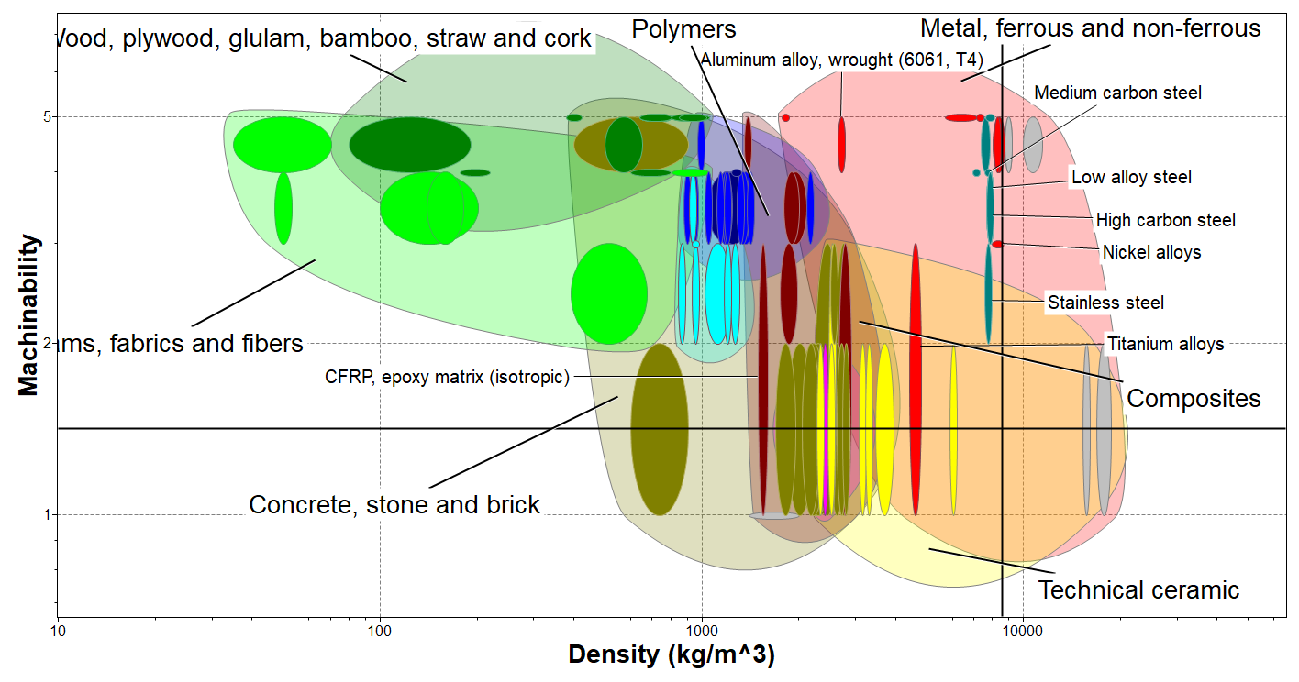

**Note:** For the Machinability of the material, rating is given from one to five, one means very difficult to machining and five means having Excellent machining.

Based on this machinability index is calculated for different materials.

|  |  |  |  |
| --- | --- | --- | --- |
| **Material** | **Machinability Index** | **Density** |  |
| Aluminium Alloy | 4.47 | 2.71 | 1.6494 |
| CFRP (epoxy matrix) | 1.73 | 1.55 | 1.1161 |
| High Carbon Steel | 3.46 | 7.8 | 0.4436 |
| Medium Carbon Steel | 3.46 | 7.8 | 0.4436 |
| Low Alloy Steel | 3.46 | 7.8 | 0.4436 |
| Titanium alloys | 1.73 | 4.61 | 0.3753 |
| Nickle Alloy | 3 | 8.32 | 0.3606 |
| Stainless steel | 2.45 | 7.8 | 0.3141 |
| Tungsten Alloys | 1.41 | 17.7 | 0.0797 |

Taking log on both side of performance index we get equation of line with slope 1.

material on left of vertical line and above horizontal line (Machinability index>1.75 ) will be the good material for this index.

from chart Aluminium Alloy is having maximum performance index while Tungsten Alloys is having lowest performance index.

1. **Hardness and Density:**

Hardness is a quick measure of strength of material. hardness can be defined as resistance to wear, scratch or indentation. it is also defined as resistance to localized plastic deformation of material.

We need to maximize the hardness and minimize the density.

Thus, performance index given by

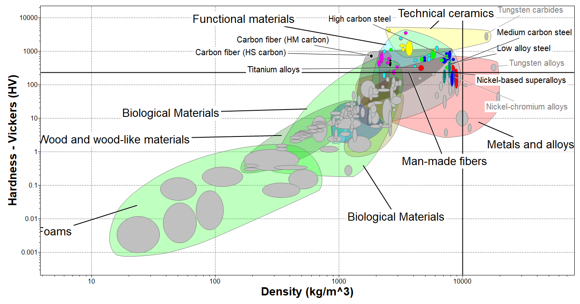

|  |  |  |  |
| --- | --- | --- | --- |
| **Material** |  |  |  |
| Carbon fibre (HM carbon) | 731 | 1.82 | 401.6 |
| Carbon fibre (HS carbon) | 731 | 1.82 | 401.6 |
| Titanium alloys | 319 | 4.6 | 69.3 |
| Low alloy steel | 333 | 7.8 | 42.7 |
| High carbon steel | 322 | 7.85 | 41.0 |
| Medium carbon steel | 276 | 7.8 | 35.4 |
| Nickle based super alloy | 253 | 8.27 | 30.6 |

Taking log on both side of performance index we get equation of line with slope 1.

material on left of vertical line and above horizontal line (H>210) will be the good material for this index.

from chart Carbon fibre (HM carbon) is having maximum performance index while Nickle based super alloy is having lowest performance index.

**Material Indexes using Two material property/Characteristics:**

**Fracture Toughness and Young’s modulus:**

Toughness of material in terms of the fracture toughness, young’s modulus and poison ratio is expressed as follows [1]

If we want to maximize U ,we can Maximize the right hand side of index.



|  |  |  |  |
| --- | --- | --- | --- |
| **Material** |  |  |  |
| Nickle based Super alloy | 179 | 274 | 117 |
| Tungsten Alloys | 134 | 433 | 41 |
| Nickle chromium Alloy | 93.8 | 275 | 32 |
| Stainless steel | 88.4 | 255 | 31 |
| Titanium Alloy | 62 | 156 | 25 |
| Low Alloy Steel | 56.4 | 263 | 12 |
| Age hardening wrought Al Alloy | 32.5 | 96 | 11 |
| High Carbon Steel | 49.8 | 267 | 9 |
| Medium carbon steel | 48 | 270 | 9 |
| CFRP epoxy matrix | 11.1 | 133 | 1 |

Taking log on both side of performance index we get equation of line with slope .

material on left of vertical line and above horizontal line (Fracture toughness>15MPa.m^0.5) will be the good material for this index.

from chart Nickle based Super alloy is having maximum performance index while CFRP epoxy matrix is having lowest performance index.

**Mechanical loss coefficient and Young’s Modulus**:

The *mechanical loss-coefficient* also called *damping factor* measures the degree to which a material dissipates vibrational energy.

If a material subjected to elastic loading of ,then it stores elastic energy per unit volume U:

If the material is then unloaded, it dissipates an energy:

The loss coefficient is

The value of usually depends on the frequency of cycling. Damping can also measure by

1. specific damping capacity
2. The logarithmic decrement,

Where are successive amplitudes of natural vibrations.

1. The phase-lag, , between stress and strain, and the " "-factor or resonance factor, Q.

When damping is small all of the above related by:

For large damping above relations are not valid. Damping for case of shaft design is considered small while for case of spring Design it considered large.

for

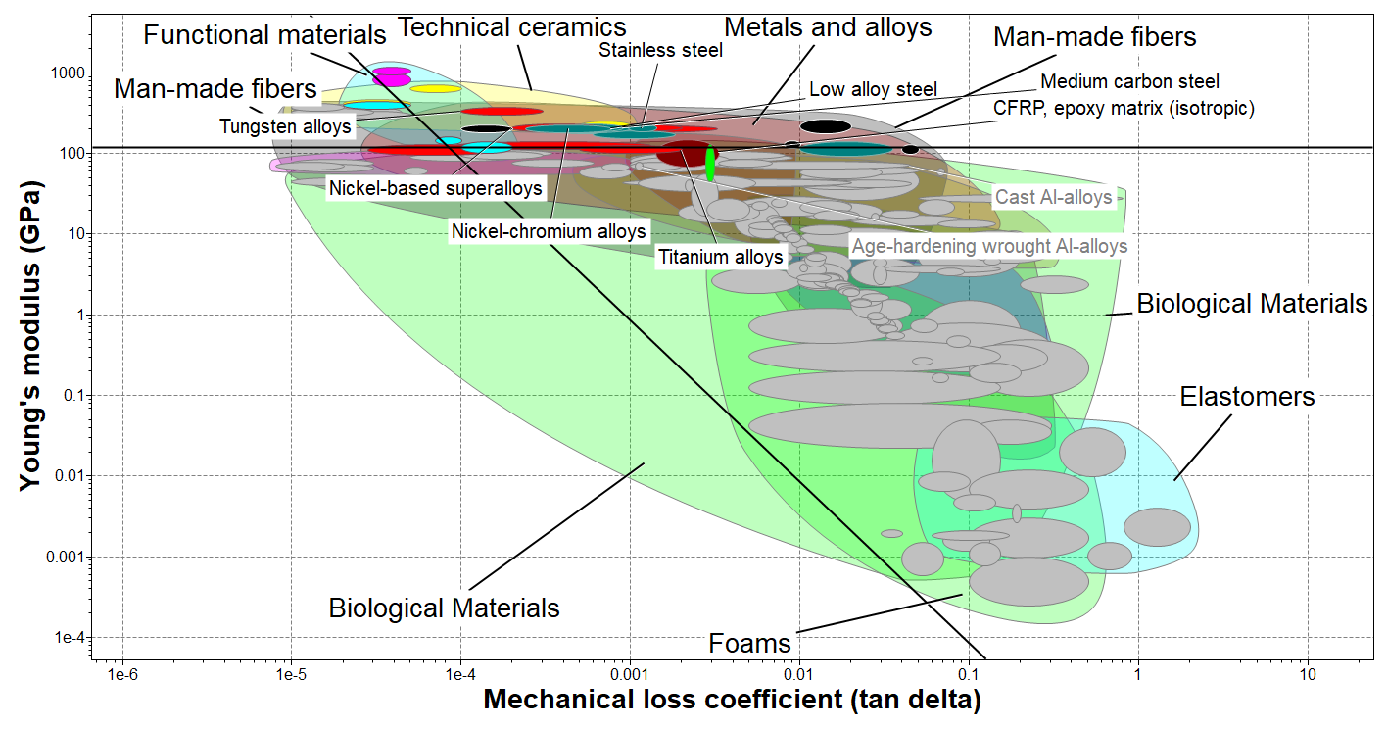

|  |  |  |  |
| --- | --- | --- | --- |
| **Material** |  |  |  |
| CFRP epoxy matrix | 102 | 21.5 | 217 |
| Nickle chromium Alloy | 210 | 8.94 | 130 |
| Titanium Alloy | 115 | 10 | 107 |
| Stainless steel | 200 | 6.1 | 86 |
| Medium carbon steel | 210 | 5.89 | 85 |
| Low Alloy Steel | 205 | 4.27 | 61 |
| Nickle based Super alloy | 210 | 3.79 | 55 |
| Tungsten Alloys | 339 | 1.73 | 32 |

Taking log on both side of performance index we get equation of line with slope .

material on left of vertical line and above horizontal line (Fracture toughness>15MPa.m^0.5) will be the good material for this index.

from chart CFRP epoxy matrix is having maximum performance index while Tungsten Alloys is having lowest performance index.

**Young’s Modulus and Strength:**

Bending strain:

Bending equation

For linear elastic isotropic material

From bending equation

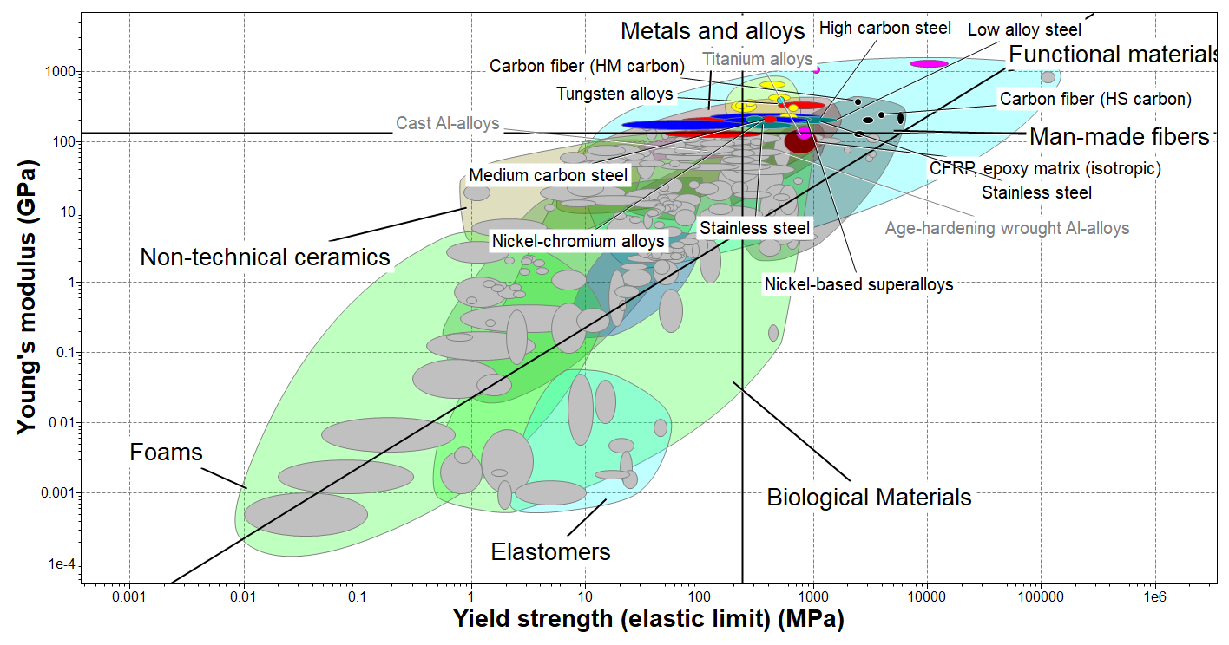

|  |  |  |  |
| --- | --- | --- | --- |
| **Material** |  |  |  |
| Nickle chromium Alloy | 210 | 410 | 0.5122 |
| Tungsten Alloys | 339 | 776 | 0.4369 |
| Nickle based Super alloy | 210 | 496 | 0.4234 |
| Stainless steel | 200 | 541 | 0.3697 |
| Medium carbon steel | 210 | 591 | 0.3553 |
| High Carbon Steel | 207 | 680 | 0.3044 |
| Low Alloy Steel | 205 | 866 | 0.2367 |
| Carbon fiber (HM Carbon) | 380 | 2400 | 0.1583 |
| CFRP epoxy matrix | 102 | 760 | 0.1342 |
| Titanium Alloy | 115 | 949 | 0.1212 |
| Carbon fiber (HS Carbon) | 242 | 3870 | 0.0625 |

**Specific Strength and Specific Modulus:**

Bending equation

For linear elastic isotropic material

From bending equation

Young’s modulus and the yield strength of material is divided by density individually:

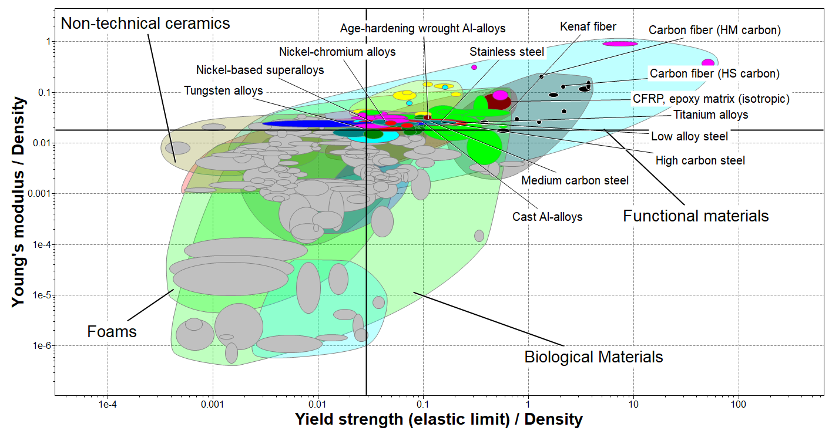

|  |  |  |  |
| --- | --- | --- | --- |
| **Material** |  |  |  |
| Nickle chromium Alloy | 0.025 | 0.0488 | 0.5123 |
| Tungsten Alloys | 0.0191 | 0.0438 | 0.4361 |
| Nickle based Super alloy | 0.0254 | 0.0599 | 0.4240 |
| Stainless steel | 0.0258 | 0.0699 | 0.3691 |
| Medium carbon steel | 0.0269 | 0.0758 | 0.3549 |
| High Carbon Steel | 0.0264 | 0.0866 | 0.3048 |
| Low Carbon Steel | 0.0263 | 0.111 | 0.2369 |
| Age hardening wrought Al Alloy | 0.0261 | 0.129 | 0.2023 |
| CFRP epoxy matrix | 0.0657 | 0.491 | 0.1338 |
| Titanium Alloy | 0.025 | 0.206 | 0.1214 |
| Carbon fibre (HS Carbon) | 0.133 | 2.13 | 0.0624 |

Taking log on both side of performance index we get equation of line with slope 1.

from chart Nickle chromium Alloy is having maximum performance index while Carbon fibre (HS Carbon)is having lowest performance index.

**Shear modulus and shear strength:**

**Angle of twist of shaft:**

Torsion Equation:

Angle of twist:

Using von mises criterion:

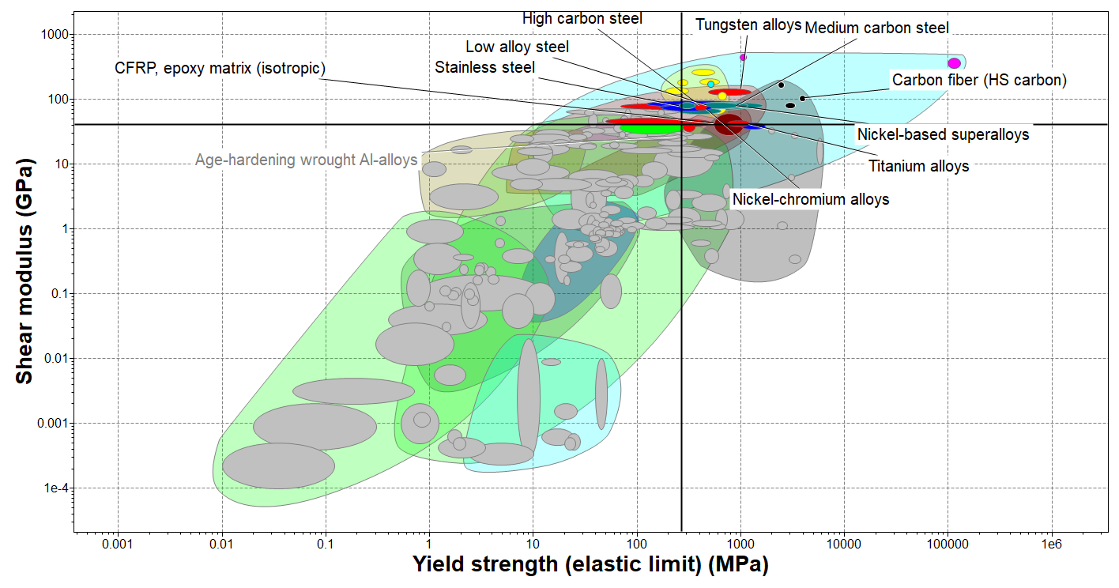

|  |  |  |  |
| --- | --- | --- | --- |
| **MAterial** |  |  |  |
| Nickle chromium Alloy | 76.8 | 410 | 0.1873 |
| Tungsten Alloys | 130 | 776 | 0.1675 |
| Nickle based Super alloy | 79.2 | 496 | 0.1597 |
| Stainless steel | 77.9 | 541 | 0.1440 |
| Medium carbon steel | 80.9 | 591 | 0.1369 |
| High Carbon Steel | 80.4 | 680 | 0.1182 |
| Low Carbon Steel | 80.9 | 866 | 0.0934 |
| CFRP epoxy matrix | 41 | 760 | 0.0539 |
| Titanium Alloy | 42.4 | 949 | 0.0447 |
| Carbon fibre (HS Carbon) | 105 | 3870 | 0.0271 |

Taking log on both side of performance index we get equation of line with slope 1.

from chart Nickle chromium Alloy is having maximum performance index while Carbon fibre (HS Carbon)is having lowest performance index.

**Machinability:**

For the Machinability of the material, rating is given from one to five, one means very difficult to machining and five means having Excellent machining.

Based on this machinability index is calculated for different materials.

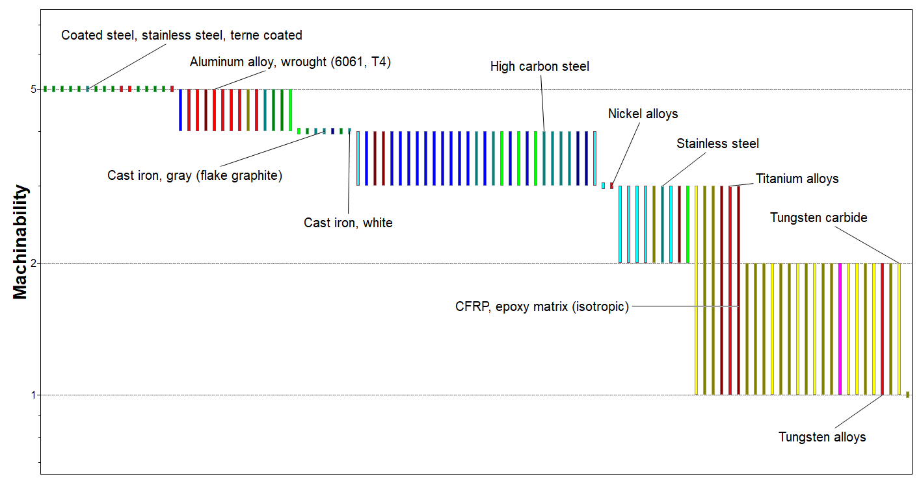

|  |  |
| --- | --- |
| **Material** | **Machinability Index** |
| Aluminium Alloy, wrought | 4.47 |
| High Carbon Steel | 3.46 |
| Medium Carbon Steel | 3.46 |
| Low Alloy Steel | 3.46 |
| Nickle Alloy | 3 |
| Stainless steel | 2.45 |
| CFRP (epoxy matrix) | 1.73 |
| Titanium alloys | 1.73 |
| Tungsten Alloys | 1.41 |

from chart Aluminium Alloy is having maximum performance index while Tungsten Alloys is having lowest performance index

**Wear rate constant and Hardness:**

When one surface slides over another surface they wear. During wear, from both surfaces material is lost.

Wear rate is defined as:

It has unit of

Specific wear rate:

Multiply and divide by

Where

It measures relative wear with respect to bearing pressure higher the wear constant more we be the wear for given bearing pressure.

maximum bearing pressure can be related to Hardness as follows:

C is a constant

Equation of multiply and divide by we got:

lowest value of the product is required for best wear resistance surface.

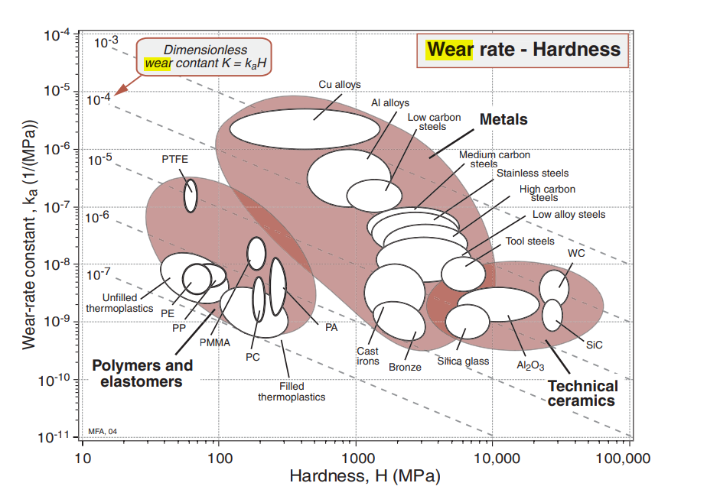

Note: It was difficult for me to get exact values of wear rate constant for each material and hence table is not given for this case.

But from ashby chart we can easily select the material which is having lower value of



In this chart rating is given to different material based on their wear resistance.

**Thermal conductivity and**

Maximize the thermal diffusivity of material

.

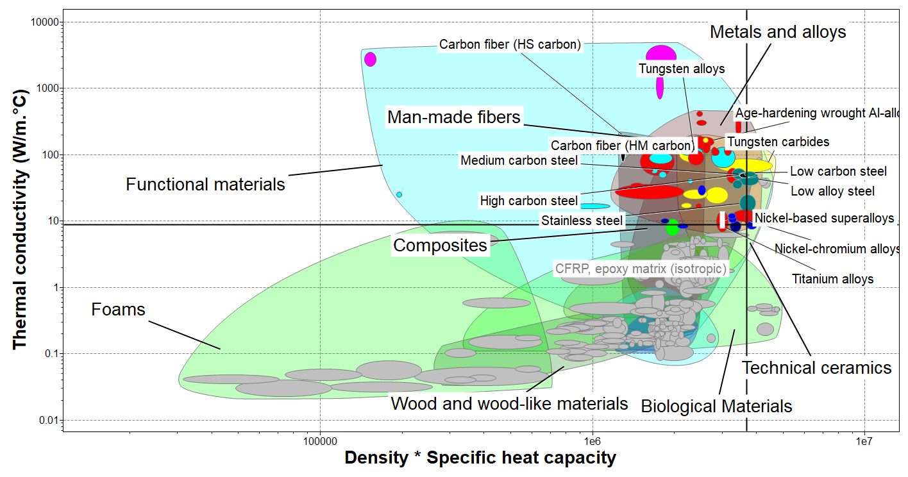

|  |  |  |  |
| --- | --- | --- | --- |
| **Material** |  |  |  |
| Carbon fiber (HM Carbon) | 126 | 1.29 | 98 |
| Age hardening wrought Al Alloy | 158 | 2.58 | 61 |
| Tungsten Alloys | 90.9 | 2.39 | 38 |
| Medium carbon steel | 50.4 | 3.68 | 14 |
| High Carbon Steel | 49.9 | 3.72 | 13 |
| Stainless steel | 18.7 | 3.71 | 5 |
| Nickle based Super alloy | 12.1 | 3.62 | 3 |
| Titanium Alloy | 9.9 | 2.99 | 3 |
| Nickle chromium Alloy | 11.6 | 3.69 | 3 |
| CFRP epoxy matrix | 1.82 | 1.5 | 1 |

**Mechanical loss coefficient and Young’s Modulus and Density**: The *mechanical loss-coefficient* also called *damping factor* measures the degree to which a material dissipates vibrational energy.

If a material subjected to elastic loading of ,then it stores elastic energy per unit volume U:

If the material is then unloaded, it dissipates an energy:

The loss coefficient is

The value of usually depends on the frequency of cycling. Damping can also measure by

1. specific damping capacity
2. The logarithmic decrement,

Where are successive amplitudes of natural vibrations.

1. The phase-lag, , between stress and strain, and the " "-factor or resonance factor, Q.

When damping is small all of the above related by:

For large damping above relations are not valid. Damping for case of shaft design is considered small while for case of spring Design it considered large.

for

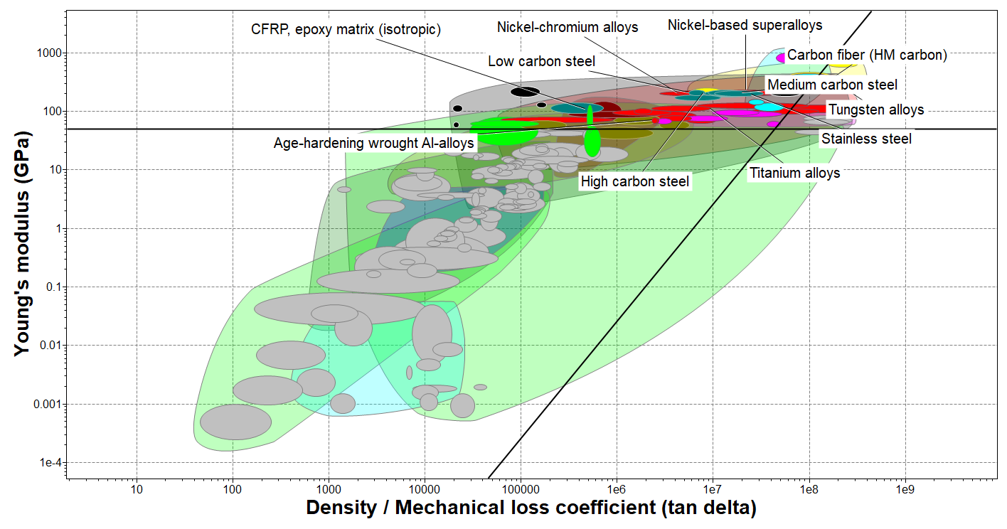

|  |  |  |  |
| --- | --- | --- | --- |
| **Material** |  |  |  |
| CFRP epoxy matrix | 102 | 0.721 | 14.0076 |
| Stainless steel | 200 | 1.27 | 11.1355 |
| Age hardning wrought Al Alloy | 71.9 | 2.5 | 3.3918 |
| Titanium Alloy | 115 | 4.6 | 2.3313 |
| Nickle chromium Alloy | 210 | 9.39 | 1.5433 |
| Medium carbon steel | 210 | 13.2 | 1.0978 |
| High Carbon Steel | 207 | 14.5 | 0.9922 |
| Nickle based Super alloy | 210 | 22.1 | 0.6557 |
| Tungsten Alloys | 339 | 102 | 0.1805 |
| Carbon fiber (HM Carbon) | 380 | 129 | 0.1511 |

**Relative cost and material class:**

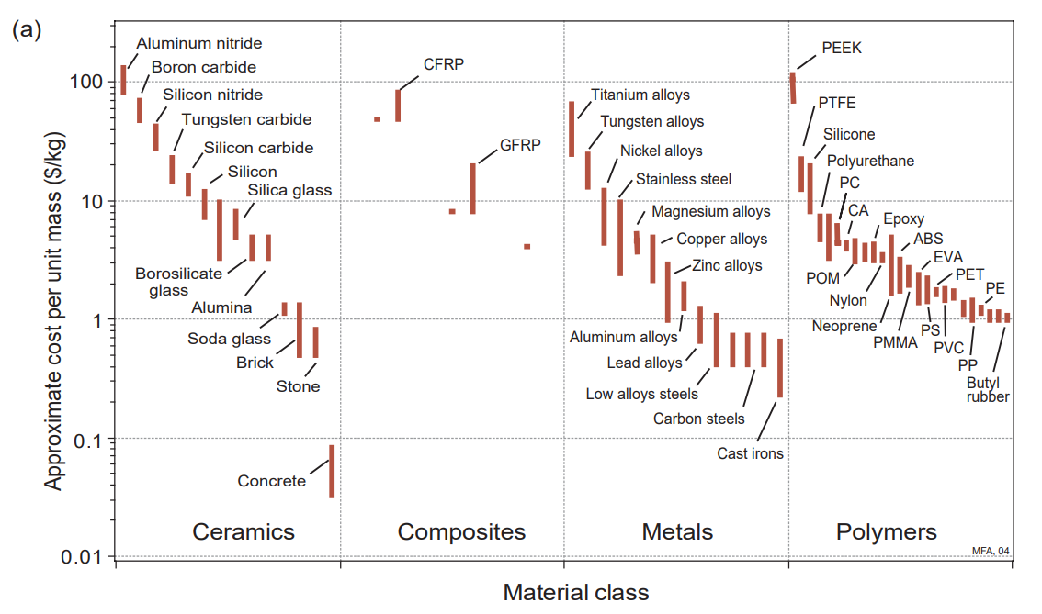

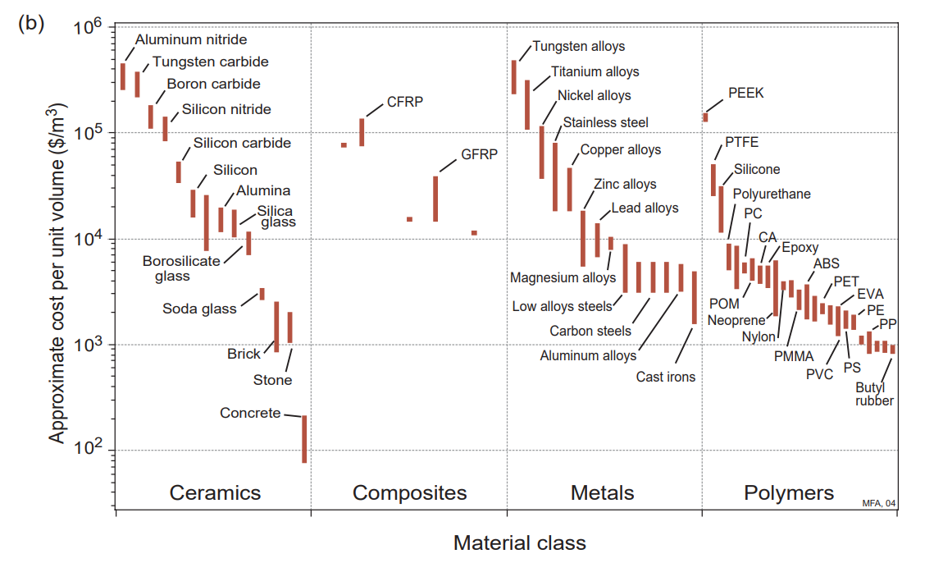

**Modulus and relative cost:**

1. **Young’s Modulus and Density:**

Bending Equation:

Bending Stiffness:

Combining above two equations

Thus, performance index given by

Dividing by relative cost:

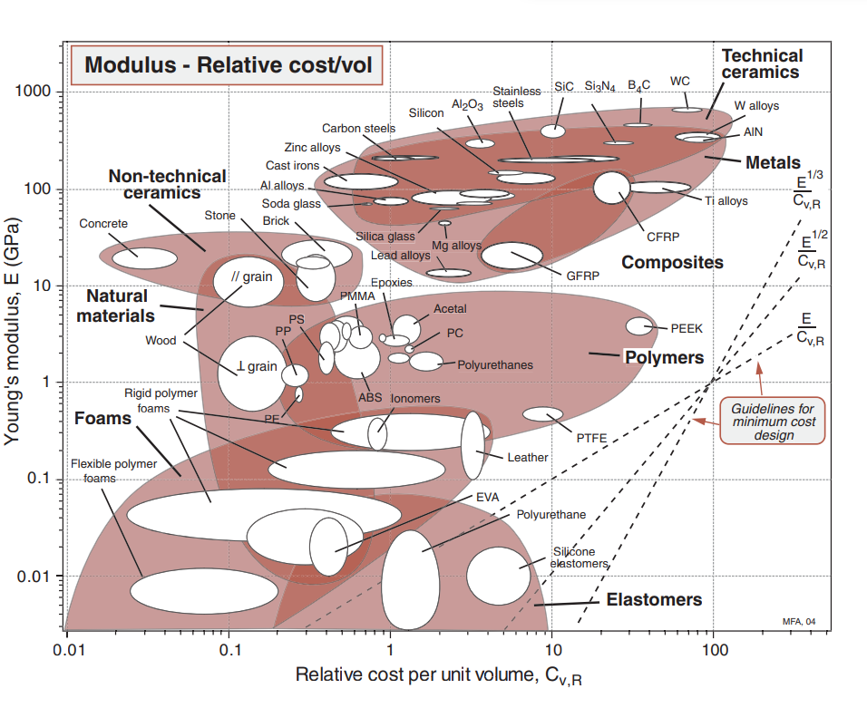

**Conclusion:**

The most important conclusion drawn is that a specific class of material is suitable for particular application and since the function of the component is same hence by changing the performance index there is only change in sequence of that class of material only and no new material going to add while chan ging the performance index.

Below is given a class of material for the shaft.

|  |
| --- |
| Carbon fiber (HS carbon) |
| Carbon fiber (Hm carbon) |
| Glass fiber ( C - glass) |
| CFRP (epoxy matrix) |
| Titanium alloys |
| High carbon steel |
| Medium carbon steel |
| Stainless steel |
| Nickle alloy |

Based on different application of shaft above materials are used at different places

Reference:

[1] class notes

[2] Ces Edupack software

[3] <https://en.wikipedia.org/wiki/Shaft_(mechanical_engineering)>

[4]Material selection in mechanical design book by Ashby