**Task1** - *to input strings and print it.*

**Program:**

**using System;**

**class HelloWorld {**

**static void Main() {**

**Console.WriteLine("Hello World");**

**int n=Convert.ToInt32(Console.ReadLine());**

**int i;**

**string[] arr=new string[n];**

**for (i=0;i<n;i++)**

**{**

**arr[i]=Console.ReadLine();**

**}**

**for(i=0;i<n;i++)**

**{**

**Console.WriteLine(arr[i]);**

**}**

**}**

**}**

Output:

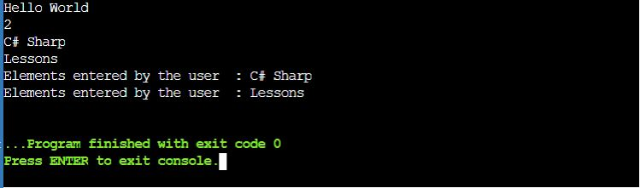

**Task2** - *to input integers and print it.*

**Program:**

**using System;**

**class HelloWorld {**

**static void Main() {**

**Console.WriteLine("Hello World");**

**int n=Convert.ToInt32(Console.ReadLine());**

**int i;**

**int[] arr=new int[n];**

**for (i=0;i<n;i++)**

**{**

**arr[i]=Convert.ToInt32(Console.ReadLine());**

**}**

**for(i=0;i<n;i++)**

**{**

**Console.WriteLine("Elements entered by the user : {0}", arr[i]);**

**}**

**}**

**}**

Output:

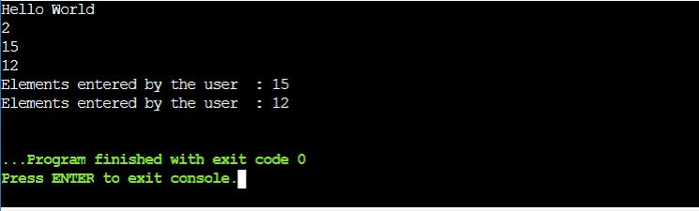

**Task3** - *to input a string and print it in letter with Array.*

**Program:**

**using System;**

**class HelloWorld {**

**static void Main() {**

**Console.WriteLine("Enter the String");**

**string value = Console.ReadLine();**

**char[] arr = value.ToCharArray();**

**for (int i = 0; i < arr.Length; i++)**

**{**

**char alpha = arr[i];**

**Console.Write( "{0} ", alpha);**

**}**

**}**

**}**

Output:

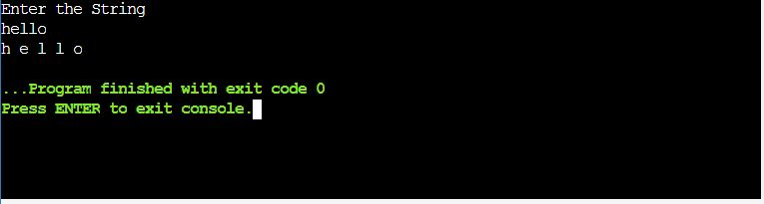

**Task4** - *to input numbers in array. Add,sub,multipy and divide it..*

**Program:**

**using System;**

**class HelloWorld {**

**static void Main() {**

**Console.WriteLine("Hello World");**

**int n=Convert.ToInt32(Console.ReadLine());**

**int i,add=0,sub=0,mul=1,div=1;**

**int[] arr=new int[n];**

**for (i=0;i<n;i++)**

**{**

**arr[i]=Convert.ToInt32(Console.ReadLine());**

**}**

**for(i=0;i<n;i++)**

**{**

**add +=arr[i];**

**sub -=arr[i];**

**mul *= arr[i];**

**div *= arr[i]/5;**

**}**

**Console.WriteLine("Sum of all elements stored in the array is : {0}", add);**

**Console.WriteLine("Sum of all elements stored in the array is : {0}", sub);**

**Console.WriteLine("Sum of all elements stored in the array is : {0}", mul);**

**Console.WriteLine("Sum of all elements stored in the array is : {0}", div);**

**}**

**}**

Output:

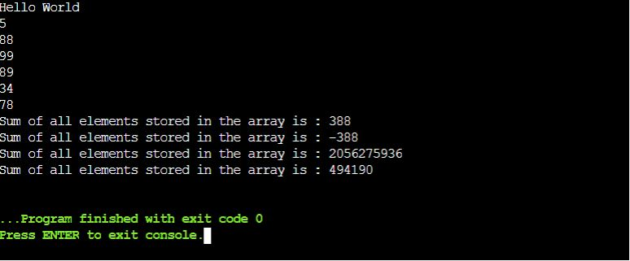

**Task5** - *to print star pattern with user input*

**Program:**

**using System;**

**class HelloWorld {**

**static void Main() {**

**Console.WriteLine("Hello World");**

**{**

**int i, j;**

**Console.WriteLine("Enter the value :");**

**int n = Convert.ToInt32(Console.ReadLine());**

**for ( i=1; i<=n;i++)**

**{**

**for (j= n; j>= i; j--)**

**{**

**Console.Write("*");**

**}**

**Console.WriteLine();**

**}**

**Console.ReadLine();**

**}**

**}**

**}**

Output:

