**Task1** - *to input a string and print it.*

*Input the string : Welcome, w3resource*

*Expected Output : The string you entered is : Welcome, w3resource*

*Length: Length of the string is : 15*

*separate individual characters from a string.*

*Expected Output : w 3 r e s o u r c e . c o m*

**Program:**

**using System;**

**namespace MyApplication**

**{**

**class Program**

**{**

**static void Main(string[] args)**

**{**

**Console.WriteLine("Input the string");**

**string txt=(Console.ReadLine());**

**Console.WriteLine("The string you entered is : " + txt);**

**Console.WriteLine("Length of the txt string is : " + txt.Length);**

**int value1=0;**

**while (value1 <= txt.Length -1)**

**{**

**Console.Write("{0} ", txt[value1]);**

**value1++;**

**}**

**}**

**}**

**}**

Output:

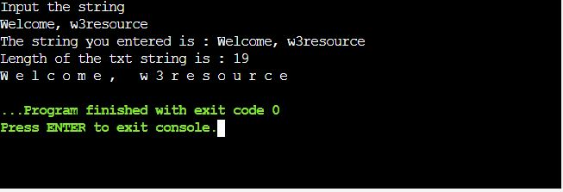

**Task-2** - *to count the number of alphabets, digits and special characters in a string.*

*Test Data :*

*Input the string : Welcome to w3resource.com*

*Expected Output :*

*Number of Alphabets in the string is : 21*

*Number of Digits in the string is : 1*

*Number of Special characters in the string is : 4*

**Program:**

**using System;**

**class HelloWorld**

**{**

**static void Main()**

**{**

**string txt;**

**int alp, digit, splch, i,length1;**

**alp = digit = splch = i = 0;**

**Console.Write("Input the string : ");**

**txt = Console.ReadLine();**

**length1=txt.Length;**

**while(i<length1)**

**{**

**if((txt[i]>='a' && txt[i]<='z') || (txt[i]>='A' && txt[i]<='Z'))**

**{**

**alp++;**

**}**

**else if(txt[i]>='0' && txt[i]<='9')**

**{**

**digit++;**

**}**

**else**

**{**

**splch++;**

**}**

**i++;**

**}**

**Console.WriteLine("Number of Alphabets in the string is : {0}", alp);**

**Console.WriteLine("Number of Digits in the string is : {0}", digit);**

**Console.WriteLine("Number of Special characters in the string is : {0}", splch);**

**}**

**}**

Output:

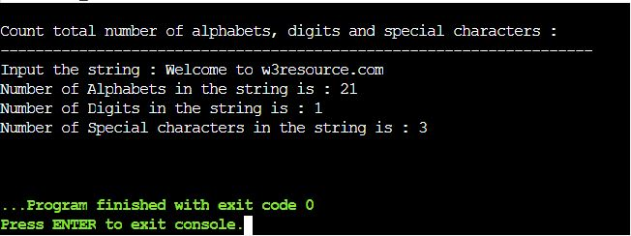

Task-3

**Program:**  *to count the number of vowels or consonants in a string.*

*Test Data :*

*Input the string : Welcome to w3resource.com*

*Expected Output :*

*The total number of vowel in the string is : 9*

*The total number of consonant in the string is : 12*

**using System;**

**class HelloWorld**

**{**

**public static void Main()**

**{**

**string txt;**

**int i, length1, vowel, cons;**

**Console.Write("Input the string : ");**

**txt = Console.ReadLine();**

**vowel = 0;**

**cons = 0;**

**length1 = txt.Length;**

**for(i=0; i<length1; i++)**

**{**

**if(txt[i] =='a' || txt[i]=='e' || txt[i]=='i' || txt[i]=='o' || txt[i]=='u' || txt[i]=='A' ||txt[i]=='E' || txt[i]=='I' || txt[i]=='O' || txt[i]=='U')**

**{**

**vowel++;**

**}**

**else if((txt[i]>='a' && txt[i]<='z') || (txt[i]>='A' && txt[i]<='Z'))**

**{**

**cons++;**

**}**

**}**

**Console.WriteLine("The total number of vowel in the string is : {0}", vowel);**

**Console.WriteLine("The total number of consonant in the string is : {0}", cons);**

**}**

**}**

Output:

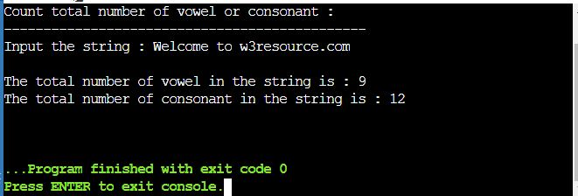

Task-5 -

*Sum of Digit*

*i/p 1234*

*o/p 10*

**Program:**

**using System;**

**namespace LogicalPrograms**

**{**

**public class Program**

**{**

**static void Main(string[] args)**

**{**

**Console.Write("Enter the Number : ");**

**int number = Convert.ToInt32(Console.ReadLine());**

**int sum = 0, reminder;**

**while (number > 0)**

**{**

**reminder = number % 10;**

**sum = sum + reminder;**

**number = number / 10;**

**}**

**Console.WriteLine($"The Sum of Digits is : {sum}");**

**Console.ReadKey();**

**}**

**}**

**}**

Output:

