**Task1**– *to program in C# Sharp to print Floyd's Triangle.*

**Program:**

**using System;**

**class HelloWorld**

**{**

**static void Main()**

**{**

**int i,j,n,p,q;**

**Console.Write("Print the Floyd's Triangle:\n");**

**Console.Write("Input number of rows : ");**

**n= Convert.ToInt32(Console.ReadLine());**

**for(i=1;i<=n;i++)**

**{**

**if(i%2==0)**

**{ p=1;q=0;}**

**else**

**{ p=0;q=1;}**

**for(j=1;j<=i;j++)**

**if(j%2==0)**

**Console.Write("{0}",p);**

**else**

**Console.Write("{0}",q);**

**Console.Write("\n");**

**}**

**}**

**}**

Output:

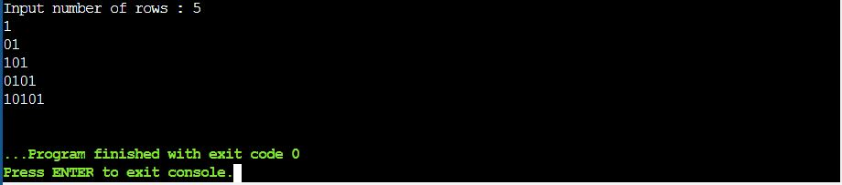

**Task2**– *to displays the n terms of square natural numbers and their sum.*

**Program:**

**using System;**

**class HelloWorld**

**{**

**static void Main()**

**{**

**int i,n,sum=0;**

**Console.WriteLine("Input the number of terms : ");**

**n= Convert.ToInt32(Console.ReadLine());**

**Console.WriteLine ("The square natural upto {0} terms are :",n);**

**for(i=1;i<=n;i++)**

**{**

**Console.Write("{0} ",i*i);**

**sum+=i*i;**

**}**

**Console.Write("\nThe Sum of Square Natural Number upto {0} terms = {1} \n",n,sum);**

**}**

**}**

Output:

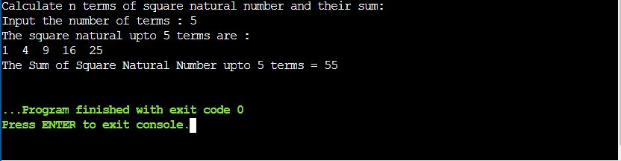

**Task3**– *to display the first n terms of Fibonacci series.*

**Program:**

**using System;**

**class HelloWorld**

**{**

**static void Main()**

**{**

**int num1 = 0, num2 = 1, num3, numberOfElements;**

**Console.Write("Enter the number of elements to Print : ");**

**numberOfElements = int.Parse(Console.ReadLine());**

**if (numberOfElements < 2)**

**{**

**Console.Write("Please Enter a number greater than two");**

**}**

**else**

**{**

**Console.Write(num1 + " " + num2 + " ");**

**for (int i = 2; i < numberOfElements; i++)**

**{**

**num3 = num1 + num2;**

**Console.Write(num3 + " ");**

**num1 = num2;**

**num2 = num3;**

**}**

**}**

**}**

**}**

Output:

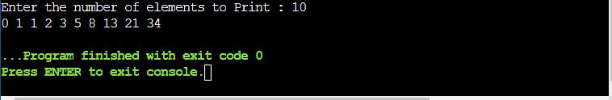

**Task4**– *to display a number in reverse order.*

**Program:**

**using System;**

**class HelloWorld**

**{**

**static void Main()**

**{**

**int num,r,sum=0,t;**

**Console.Write("Display the number in reverse order:\n");**

**Console.Write("Input a number: ");**

**num = Convert.ToInt32(Console.ReadLine());**

**for(t=num;t!=0;t=t/10)**

**{**

**r=t % 10;**

**sum=sum*10+r;**

**}**

**Console.Write("The number in reverse order is : {0} \n",sum);**

**}**

**}**

Output:

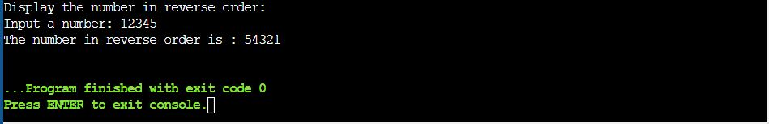

**Task5**– *to check whether a number is a palindrome or not.*

**Program:**

**using System;**

**class HelloWorld**

**{**

**static void Main()**

**{**

**int num,r,sum=0,t;**

**Console.Write("Check whether a number is a palindrome or not:\n");**

**Console.Write("Input a number: ");**

**num = Convert.ToInt32(Console.ReadLine());**

**for(t=num;num!=0;num=num/10){**

**r=num % 10;**

**sum=sum*10+r;**

**}**

**if(t==sum)**

**Console.Write("{0} is a palindrome number.\n",t);**

**else**

**Console.Write("{0} is not a palindrome number.\n",t);**

**}**

**}**

Output:

