**Task1**– *to display such a pattern for n number of rows using a number starting with the number 1. The first and last number of each row will be 1.*

**Program:**

**using System;**

**class HelloWorld**

**{**

**static void Main()**

**{**

**int i,j,n;**

**Console.Write(" Display the pattern in which first and last number of each row will be 1:\n");**

**Console.Write("Input number of rows : ");**

**n = Convert.ToInt32(Console.ReadLine());**

**for(i=0;i<=n;i++)**

**{**

**for(j=1;j<=n-i;j++)**

**{Console.Write(" ");}**

**for(j=1;j<=i;j++)**

**{ Console.Write("{0}",j);}**

**for(j=i-1;j>=1;j--)**

**{ Console.Write("{0}",j);}**

**Console.Write("\n");**

**}**

**}**

**}**

Output:

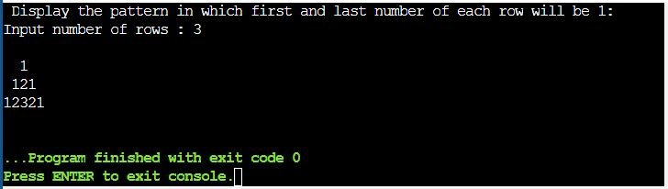

**Task3**– *to convert a decimal number into binary without using an array.*

*.*

**Program:**

**using System;**

**class HelloWorld**

**{**

**static void Main()**

**{**

**int n, i, j, binno=0,dn;**

**Console.Write("Convert a decimal number to binary without using array:\n");**

**Console.Write("Enter a number to convert : ");**

**n = Convert.ToInt32(Console.ReadLine());**

**dn=n;**

**i=1;**

**for(j=n;j>0;j=j/2)**

**{**

**binno=binno+(n%2)*i;**

**i=i*10;**

**n=n/2;**

**}**

**Console.WriteLine("The Binary of {0} is {1}.",dn,binno);**

**}**

**}**

Output:

