**Task1** - to print Hello and your name in a separate line

**Program:**

using System;

namespace HelloWorld

{

class Program

{

static void Main(string[] args)

{

Console.WriteLine("Hello ");

Console.WriteLine("Kishor Kumar ");

}

}

}

Output:

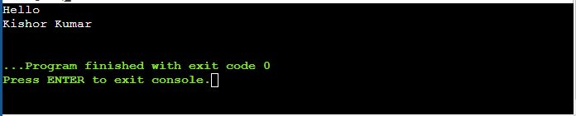

**Task2**Program: to print the sum of two numbers

using System;

class HelloWorld {

static void Main() {

Console.WriteLine("Enter the First Num");

int no1=Convert.ToInt32(Console.ReadLine());

Console.WriteLine("Your First No. is: " + no1);

Console.WriteLine("Enter the Second Num");

int no2=Convert.ToInt32(Console.ReadLine());

Console.WriteLine("Your Second No. is: " + no2);

int sum= no1 + no2;

Console.WriteLine ("Sum is: " + sum);

}

}

Output:

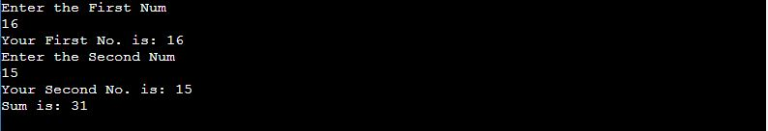

**Task3**Program: to print the output of the multiplication of three numbers entered by the user

using System;

class HelloWorld {

static void Main() {

Console.WriteLine("Enter the First Num");

int no1=Convert.ToInt32(Console.ReadLine());

int no2=Convert.ToInt32(Console.ReadLine());

int no3=Convert.ToInt32(Console.ReadLine());

Console.WriteLine("Your Third No. is: " + no3);

int multiply= no1 * no2 * no3;

Console.WriteLine ("multiplication is: " + multiply);

}

}

Output:

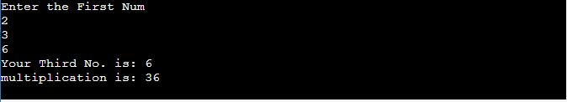

**Task4**Program: to print on screen the output of adding, subtracting, multiplying and dividing two numbers entered by the user.

using System;

class HelloWorld {

static void Main() {

Console.WriteLine("Enter the First Num");

int no1=Convert.ToInt32(Console.ReadLine());

Console.WriteLine("Enter the Second Num");

int no2=Convert.ToInt32(Console.ReadLine());

int add= no1 + no2 ;

Console.WriteLine ("addition is: " + add);

int sub= no1 - no2 ;

Console.WriteLine ("subtraction is: " + sub);

int multiply= no1 * no2 ;

Console.WriteLine ("multiplication is: " + multiply);

int div= no1 / no2 ;

Console.WriteLine ("divion is: " + div);

int mod= no1 % no2 ;

Console.WriteLine ("modulus is: " + mod);

}

}

Output:

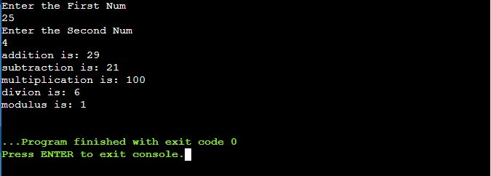

**Task5**Program: prints the multiplication table of a number as input.

using System;

class HelloWorld {

static void Main() {

Console.WriteLine("Enter the First Num");

int no1=Convert.ToInt32(Console.ReadLine());

Console.WriteLine("Enter the Second Num");

int no2=Convert.ToInt32(Console.ReadLine());

int multiply0= no1 * no2 ;

Console.WriteLine ("multiplication is: no1. * no2.(0 or 1)" + multiply0);

no2++;

int multiply1= no1 * no2 ;

Console.WriteLine ("multiplication is: " + multiply1);

no2++;

int multiply2= no1 * no2 ;

Console.WriteLine ("multiplication is: " + multiply2);

no2++;

int multiply3= no1 * no2 ;

Console.WriteLine ("multiplication is: " + multiply3);

no2++;

int multiply4= no1 * no2 ;

Console.WriteLine ("multiplication is: " + multiply4);

no2++;

int multiply5= no1 * no2 ;

Console.WriteLine ("multiplication is: " + multiply5);

no2++;

int multiply6= no1 * no2 ;

Console.WriteLine ("multiplication is: " + multiply6);

no2++;

int multiply7= no1 * no2 ;

Console.WriteLine ("multiplication is: " + multiply7);

no2++;

int multiply8= no1 * no2 ;

Console.WriteLine ("multiplication is: " + multiply8);

no2++;

int multiply9= no1 * no2 ;

Console.WriteLine ("multiplication is: " + multiply9);

no2++;

int multiply10= no1 * no2 ;

Console.WriteLine ("multiplication is: no1. * no2.(10 or 11) " + multiply10);

}

}

Output:

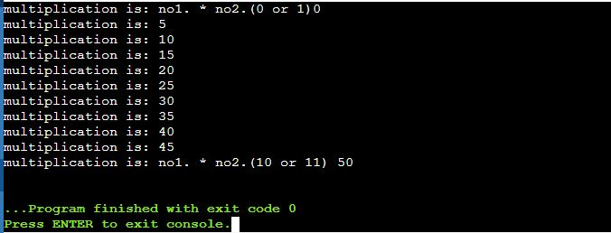

**Task6**Program: to check whether a given number is even or odd.

using System;

class HelloWorld {

static void Main() {

Console.WriteLine("Enter the Num");

int num1=Convert.ToInt32(Console.ReadLine());

int div= num1 / 2 ;

Console.WriteLine (div);

int mod= num1 % 2 ;

Console.WriteLine (mod);

if (mod==0)

{

Console.WriteLine("Value is Even ");

}

else

Console.WriteLine("Value is odd ");

}

}

Output:

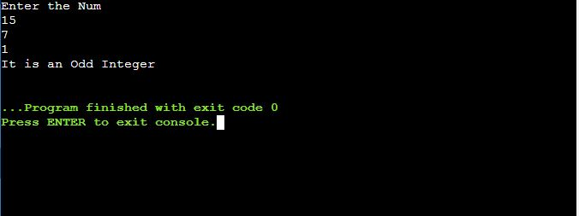

**Task7**Program: to accept two integers and check whether they are equal or not.

using System;

class HelloWorld {

static void Main() {

Console.WriteLine("Enter the Num");

int num1=Convert.ToInt32(Console.ReadLine());

Console.WriteLine("Enter the Num");

int num2=Convert.ToInt32(Console.ReadLine());

int mod= num1 % num2;

if (mod==0)

{

Console.WriteLine("Value are same");

}

else

Console.WriteLine("Value are not same");

}

}

Output:

