**Task2**– *to display the following pyramid pattern using the alphabet.*

*.*

**Program:**

**using System;**

**class HelloWorld**

**{**

**static void Main()**

**{**

**int i, j;**

**char alph = 'A';**

**int n;**

**int ctr = 1;**

**Console.Write("Display the pattern like pyramid using the alphabet:\n");**

**Console.Write("\n\n");**

**Console.Write("Input the number of Rows : \n");**

**n = Convert.ToInt32(Console.ReadLine());**

**for (i = 1; i <= n; i++) {**

**for (j = 0; j <= (ctr / 2); j++)**

**{**

**Console.Write("{0} ", alph++);**

**}**

**alph--;**

**alph--;**

**for (j = 0; j < (ctr / 2); j++) {**

**Console.Write("{0} ", alph--);**

**}**

**ctr = ctr + 2;**

**alph = 'A';**

**Console.Write("\n");**

**}**

**}**

**}**

Output:

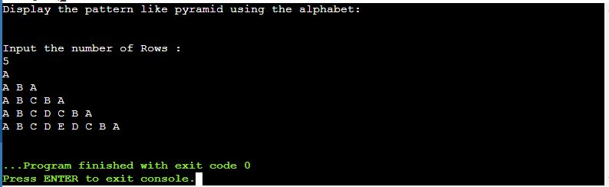

**Task4**– *to find the largest of the entered numbers.*

*.*

**Program:**

**using System;**

**class HelloWorld**

**{**

**static void Main()**

**{**

**int i;**

**int[] a = new int[30];**

**Console.Write("Enter the Number of values to find the Largest Number: ");**

**int n = Convert.ToInt16(Console.ReadLine());**

**for (i = 1; i <= n; i++)**

**{**

**Console.Write("Enter the No " + i + ":");**

**a[i] = Convert.ToInt16(Console.ReadLine());**

**}**

**for (i = 1; i <= n; i++)**

**{**

**for (int j = 1; j <= n - 1; j++)**

**{**

**if (a[j] > a[j + 1])**

**{**

**int temp = a[j];**

**a[j] = a[j + 1];**

**a[j + 1] = temp;**

**}**

**}**

**}**

**Console.WriteLine("The Largest Value is " + a[n]);**

**}**

**}**

Output:

