**Task1**– *to print the pattern like a pyramid with numbers increasing by 1.*

**Program:**

**using System;**

**class HelloWorld**

**{**

**static void Main()**

**{**

**int i,j,spc,n,k,t=1;**

**Console.Write("Display the pattern like pyramid with numbers increased by 1:\n");**

**Console.Write("input number of rows : ");**

**n= Convert.ToInt32(Console.ReadLine());**

**spc=n+4-1;**

**for(i=1;i<=n;i++)**

**{**

**for(k=spc;k>=1;k--)**

**{**

**Console.Write(" ");**

**}**

**for(j=1;j<=i;j++)**

**Console.Write("{0} ",t++);**

**Console.Write("\n");**

**spc--;**

**}**

**}**

**}**

Output:

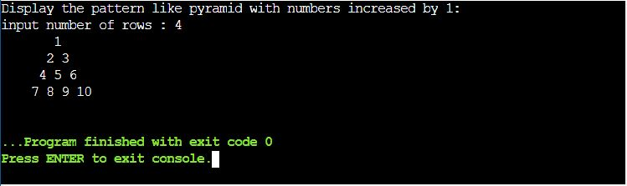

**Task2** – *to check whether the number is Prime or Not.*

**Program:**

**using System;**

**class HelloWorld**

**{**

**static void Main()**

**{**

**int num,i,ctr=0;**

**Console.WriteLine("Check whether a given number is prime or not:");**

**Console.WriteLine("Input a number: ");**

**num= Convert.ToInt32(Console.ReadLine());**

**for(i=2;i<=num/2;i++){**

**if(num % i==0){**

**ctr++;**

**break;**

**}**

**}**

**if(ctr==0 && num!= 1)**

**Console.Write("{0} is a prime number.",num);**

**else**

**Console.Write("{0} is not a prime number",num);**

**}**

**}**

Output:

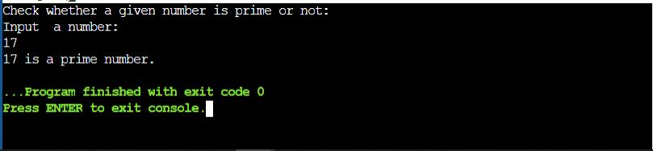

**Task3** – *to print the Pascal's triangle.*

**Program:**

**using System;**

**class HelloWorld**

**{**

**static void Main()**

**{**

**int n,c=1,sp,i,j;**

**Console.WriteLine("Display the Pascal's triangle:");**

**Console.WriteLine("Input number of rows: ");**

**n = Convert.ToInt32(Console.ReadLine());**

**for(i=0;i<n;i++)**

**{**

**for(sp=1;sp<=n-i;sp++)**

**Console.Write(" ");**

**for(j=0;j<=i;j++)**

**{**

**if (j==0||i==0)**

**c=1;**

**else**

**c=c*(i-j+1)/j;**

**Console.Write("{0} ",c);**

**}**

**Console.Write("\n");**

**}**

**}**

**}**

Output:

