**Neural Network Deep Learning**

Assignment – 1

Name: Kishor Kumar Andekar

Student ID: 700744713

Github Link : <https://github.com/kishorreyansh/Neural-Network-Deep-Learning/tree/main/Assignment-1>

1. Write a python program for the following: – Input the string “Python” as a list of characters from console, delete at least 2 characters, reverse the resultant string and print it.

Sample input: •python

•Sample output: •ntyp

In the below code snippet, we are accepting input characters from the console and deleting at least two characters before reversing the resultant string.

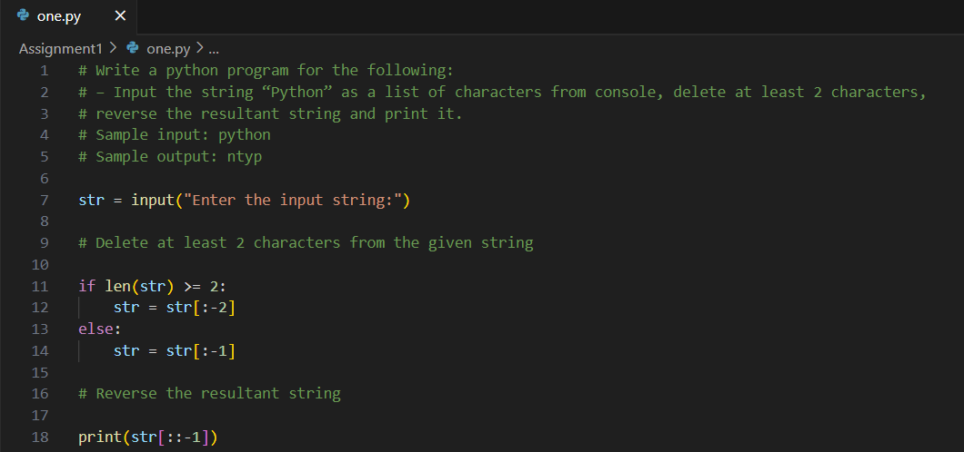

Output:

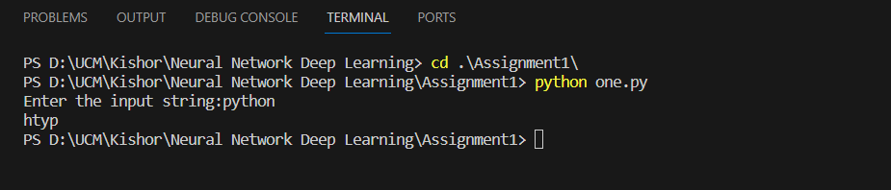

– Take two numbers from user and perform at least 4 arithmetic operations on them.

In the below Code snippet, we are performing basic arithmetic operations on two input numbers given from the console.

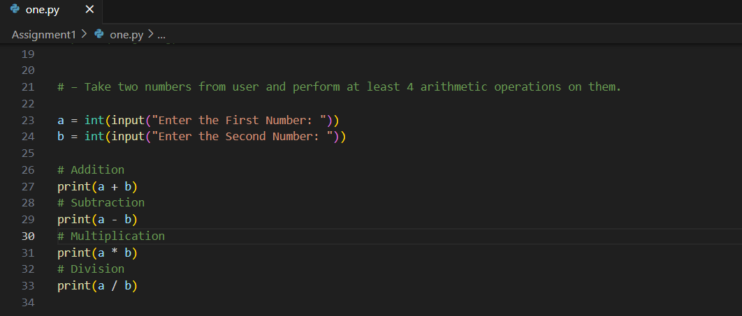

Output:

1. Write a program that accepts a sentence and replace each occurrence of ‘python’ with ‘pythons’.

•Sample input: •I love playing with python

•Sample output: •I love playing with pythons

In the below Code snippet, we are replacing python with pythons

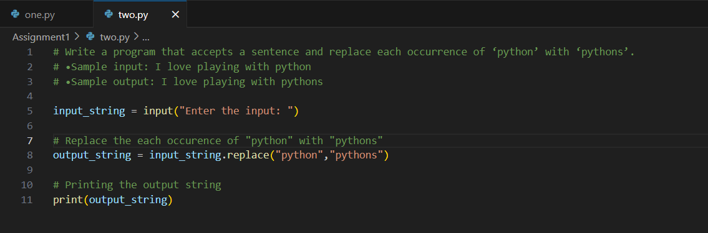

Output:

1. Use the if statement conditions to write a program to print the letter grade based on an input class score. Use the grading scheme we are using in this class.

In the below Code snippet, we are calculating the grade based on marks entered in the console using conditional statements.

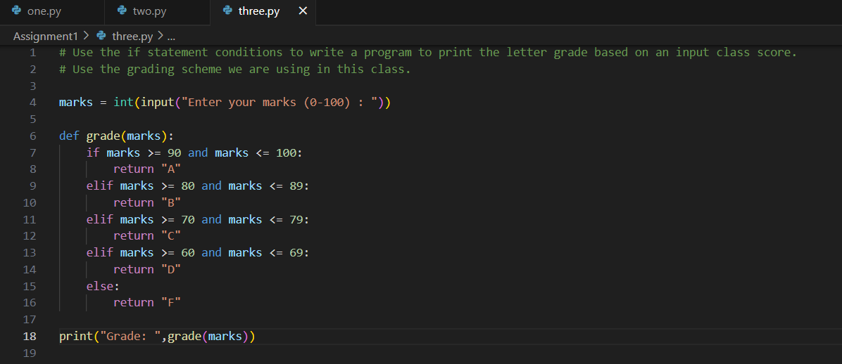

Output:

