**Neural Network Deep Learning**

Assignment – 3

Name: Kishor Kumar Andekar

Student ID: 700744713

Github Link : [https://github.com/kishorreyansh/Neural-Network-Deep-Learning/tree/main/Assignment-3](https://github.com/kishorreyansh/Neural-Network-Deep-Learning/tree/main/Assignment-2)

1. Create a class Employee and then do the following

• Create a data member to count the number of Employees

• Create a constructor to initialize name, family, salary, department

• Create a function to average salary

• Create a Fulltime Employee class and it should inherit the properties of Employee class

• Create the instances of Fulltime Employee class and Employee class and call their member functions.

In the below code snippet, we are defining Employee class and sub class as FullTimeEmployee to get employee data. Employee Class has one class variable ‘noOfEmployees’ which initialized to zero. This variable will display total no of employees.Also, Employee class has constructor __init__ and it has 4 parameters i.e., name,family,salary and department. It initializes instance variables to store employee data and increment ‘noOfEmployee’ by 1 when each time new employee is created. Next, average_salary function invoked to calculate average salary of all the created employees in the list. Then, FullTimeEmployee class is created which inherits the Employee class but it doesn’t add any new attributes or methods. Also, I am validating salary input whether it is digit or anything else. If it is other than digit returning 0 as salary to that employee. Next, creating one function ‘create_employee’ and ‘create_fulltime_employee’ which accepts all details of employee from console. To create Employee object based on noofemployee input iterating and creating objects and appending to the ‘listofallemployees’ and similar for FullTimeEmployee object as well. Finally, Printing Total no of employees and calling average_salary function to display average salary of all the employees available in the list.

First Approach:

Second Approach:

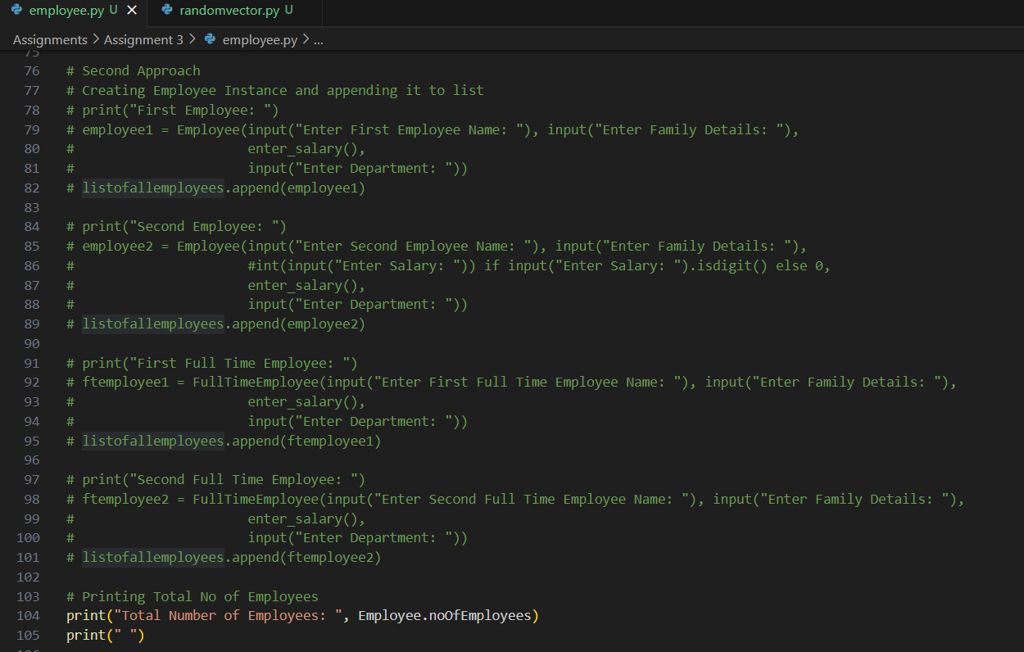

Output:

1. Numpy

Using NumPy create random vector of size 20 having only float in the range 1-20.

Then reshape the array to 4 by 5

Then replace the max in each row by 0 (axis=1)

(you can NOT implement it via for loop)

In the below Code snippet, Python program uses the NumPy library to perform operations on a randomly generated vector. First I import the NumPy library, then I Generate a random vector of 20 elements using NumPy's 'random.uniform' function, with values ranging between 1 and 20. This vector is stored in the variable 'randomVector',then I print the 'randomVector'. Next, I Reshape the 'randomVector' into a 4 by 5 matrix (a 2-dimensional array) using the 'reshape' method. This reshaped matrix is stored in the variable 'reshapeArray' and print it. Then Using NumPy functions I identify the index of the maximum value in each row of 'reshapeArray'. I do this by first using 'numpy.argmax' along 'axis=1' to find the column index with the maximum value for each row and store it in maxValue, and then uses 'numpy.arange' to generate row indices, then i replace this max value to zero and print the modified array.

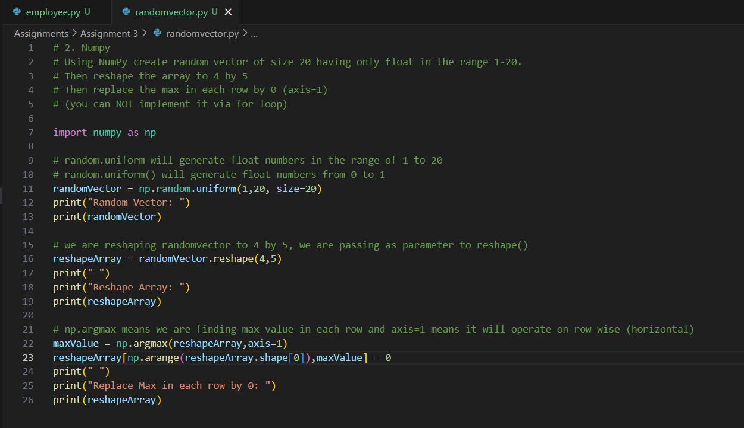

Output:

