Git and GitHub Tutorial
https://git-scm.com/
We can downloads either Windows or macOS.
Desktop> mkdir project // It creates a directory
Desktop> cd project //change directory means going to that particular folder.
Desktop> git init //Initialized empty Git repository.
project git:(master) ls
project git:(master) ls -a //here a means shows all hidden files, any file starts with . is hidden
project git:(master) ls .git //we are checking what is inside .git folder
project git:(master) touch names.txt //creating a new txt file using touch in linux command
How to check what files are changed/modified/created/deleted in the project that are not currently saved?
project git:(master): git status //tells changes not in the history
project git:(master): git add . //all files in directory kept in staging area
project git:(master): git commit -m “names.txt files added” //m means message
project git:(master): cat names.txt //display the contents of names.txt file
project git:(master): git restore - -staged names.txt //remove from staging from commit. It will be outside the stage
project git:(master): git log //check entire history of the project
project git:(master): rm -rf names.txt //deleting the file
project git:(master): git reset commitId // we can take commit id from git log , it will remove/delete from above the mentioned commit id and those changes will go to unstage area.
How do I save my work without saving in separate commit or history in the project or don’t want to lose it and need for future reference?
project git:(master): git stash
project git:(master): git stash pop //changes will come to staging area
project git:(master): git stash clear //changes not committed will be deleted.
Hosting our own project to GitHub?
Create a new repository
Repository URL to attach to my local project
project git:(master): git remote add origin repositoryurl
//remote means working with urls
// add means adding new url
// origin means name of the url you are going to add
project git:(master): git remote -v //it will show all urls attached to it.
project git:(master): git push origin master //changes pushed to branch.
Branches:
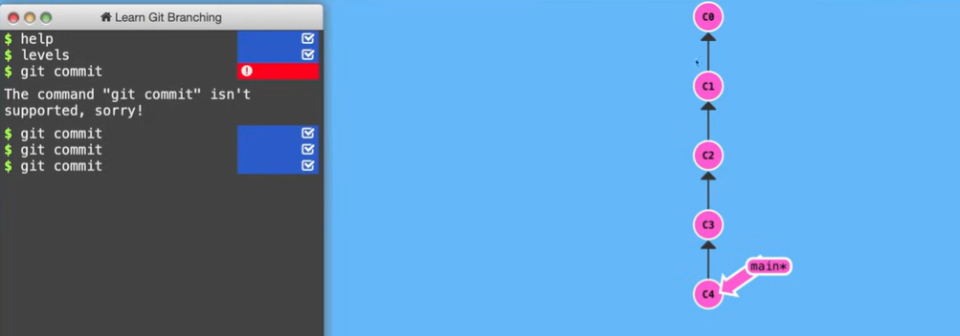
By default, the name of the branch is main and previously it was master. Above one is Directed Acyclic Graph.
What is the use of branch?
When we are working with new features / resolving any issue always create a new branch.
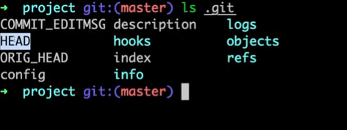
You should never commit on main branch because it is an open source project example react.
$ git branch feature
$ git checkout feature // we are moving to feature branch
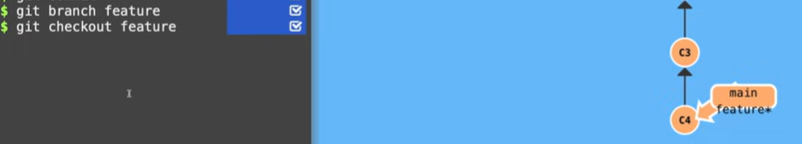
HEAD: It is a pointer that all new commits made will be added on HEAD. Head is now feature branch.
$ git merge feature //merging our changes to main branch.
$ git push origin master //pushing changes to master branch
What is the way to contribute to other’s repository without having access?
Create a copy of this project in your own account -> Click Fork -> Clone
$ git clone projecturl
$ git remote add upstream https://github.com/.....
// We cannot push to upstream branch because you don’t have access to it. We can do via origin branch.
Upstream means from where I fork the url by convention.
Origin url is your own account.
What is Pull Request?
Merge feature branch to main branch via Pull Request. Never commit to the main branch it will be difficult to preview your changes. Always create a new pull request to avoid conflicts.
One branch can open only One Pull Request. For every new feature always try to create new feature branch.
$ git reset commidId
$ git push origin featurebranch – f //force push
Click Fetch upstream:
Main branch is behind your feature branch.
(main) $ git fetch - - all - - prune //prune means deleted also fetched
(main) $ git reset - - hard upstream/main //Always be careful while using hard
// Above commands syntax is to make same code from upstream and main branch
(main) $ git pull upstream main //it internally does the same thing as when we click Fetch upstream button.
// New branch is created from HEAD branch
Merge all commits at one point
(temp) $ git rebase – i //interactive environment
S squash means it will do into one single commit which has Pick
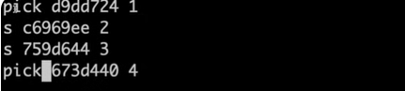
Pick means taking the commit and squash means above all s whichever has pick it will be one single commit.
Merge Conflicts:
We need to manually resolve the merge conflicts. Mark as resolve -> Resolve conflicts.

