Using Kinesis to Process Log Data:

Login to EC2 instance and setup Access key and Secret Key:

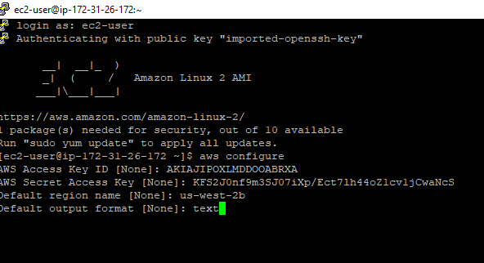

Create kinesis shrads by running necessary commands.

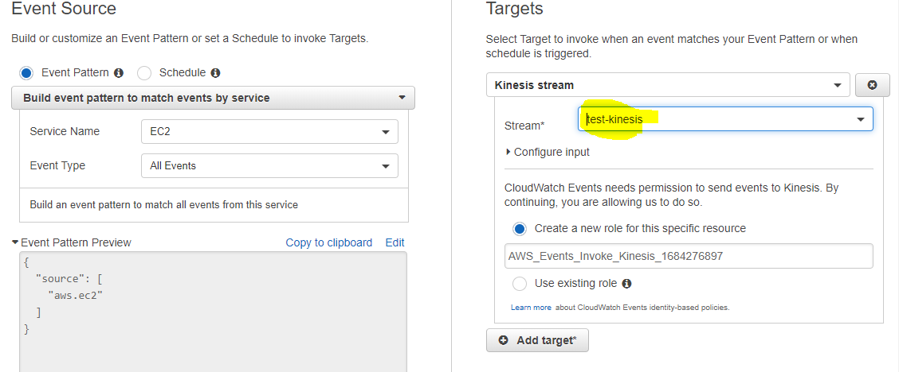

Stop the instance and go to cloudwatch event rules:

