𝐈𝐦𝐚𝐠𝐢𝐧𝐞 𝐲𝐨𝐮 𝐡𝐚𝐯𝐞 𝐚 𝐥𝐚𝐫𝐠𝐞 𝐝𝐚𝐭𝐚𝐬𝐞𝐭 𝐥𝐨𝐚𝐝𝐞𝐝 𝐢𝐧𝐭𝐨 𝐒𝐩𝐚𝐫𝐤 𝐚𝐧𝐝 𝐚𝐟𝐭𝐞𝐫 𝐩𝐞𝐫𝐟𝐨𝐫𝐦𝐢𝐧𝐠 𝐬𝐨𝐦𝐞 𝐭𝐫𝐚𝐧𝐬𝐟𝐨𝐫𝐦𝐚𝐭𝐢𝐨𝐧𝐬, 𝐭𝐡𝐞 𝐝𝐚𝐭𝐚 𝐢𝐬 𝐫𝐞𝐩𝐚𝐫𝐭𝐢𝐭𝐢𝐨𝐧𝐞𝐝 𝐢𝐧𝐭𝐨 𝟐𝟎 𝐩𝐚𝐫𝐭𝐢𝐭𝐢𝐨𝐧𝐬. 𝐘𝐨𝐮 𝐧𝐨𝐰 𝐰𝐚𝐧𝐭 𝐭𝐨 𝐩𝐫𝐢𝐧𝐭 𝐭𝐡𝐞 𝐩𝐚𝐫𝐭𝐢𝐭𝐢𝐨𝐧 𝐈𝐃𝐬 𝐚𝐥𝐨𝐧𝐠 𝐰𝐢𝐭𝐡 𝐭𝐡𝐞𝐢𝐫 𝐜𝐨𝐫𝐫𝐞𝐬𝐩𝐨𝐧𝐝𝐢𝐧𝐠 𝐝𝐚𝐭𝐚. 𝐀𝐝𝐝𝐢𝐭𝐢𝐨𝐧𝐚𝐥𝐥𝐲, 𝐲𝐨𝐮 𝐧𝐞𝐞𝐝 𝐭𝐨 𝐫𝐞𝐦𝐨𝐯𝐞 𝐭𝐡𝐞 𝐝𝐚𝐭𝐚 𝐟𝐫𝐨𝐦 𝐩𝐚𝐫𝐭𝐢𝐭𝐢𝐨𝐧𝐬 𝟏𝟔 𝐭𝐨 𝟐𝟎.  
𝐈𝐬 𝐭𝐡𝐢𝐬 𝐩𝐨𝐬𝐬𝐢𝐛𝐥𝐞 𝐢𝐧 𝐒𝐩𝐚𝐫𝐤? 𝐈𝐟 𝐬𝐨, 𝐡𝐨𝐰 𝐰𝐨𝐮𝐥𝐝 𝐲𝐨𝐮 𝐩𝐫𝐢𝐧𝐭 𝐭𝐡𝐞 𝐩𝐚𝐫𝐭𝐢𝐭𝐢𝐨𝐧 𝐈𝐃𝐬 𝐚𝐧𝐝 𝐫𝐞𝐦𝐨𝐯𝐞 𝐭𝐡𝐞 𝐝𝐚𝐭𝐚 𝐟𝐫𝐨𝐦 𝐩𝐚𝐫𝐭𝐢𝐭𝐢𝐨𝐧𝐬 𝟏𝟔 𝐭𝐨 𝟐𝟎 𝐮𝐬𝐢𝐧𝐠 𝐏𝐲𝐒𝐩𝐚𝐫𝐤? 𝐏𝐥𝐞𝐚𝐬𝐞 𝐞𝐱𝐩𝐥𝐚𝐢𝐧 𝐭𝐡𝐞 𝐩𝐫𝐨𝐜𝐞𝐬𝐬 𝐚𝐧𝐝 𝐩𝐫𝐨𝐯𝐢𝐝𝐞 𝐚 𝐬𝐚𝐦𝐩𝐥𝐞 𝐜𝐨𝐝𝐞 𝐭𝐨 𝐚𝐜𝐡𝐢𝐞𝐯𝐞 𝐭𝐡𝐢𝐬.  
  
In Apache Spark, when you work with large datasets, Spark splits the data into multiple partitions for parallel processing. Each partition is processed by different nodes of the cluster. While you can view the number of partitions and their IDs, direct access to specific partitions (such as deleting or modifying data from specific partitions) is not straightforward.  
  
𝐖𝐞 𝐜𝐚𝐧 𝐮𝐬𝐞 𝐭𝐡𝐞 𝐟𝐨𝐥𝐥𝐨𝐰𝐢𝐧𝐠 𝐚𝐩𝐩𝐫𝐨𝐚𝐜𝐡 𝐭𝐨 𝐚𝐜𝐡𝐢𝐞𝐯𝐞 𝐭𝐡𝐞 𝐭𝐚𝐬𝐤:  
  
View the Partition IDs: You can view the partition IDs of the data using rdd.glom() or similar methods to print out the content of each partition.,  
  
Delete Data in Specific Partitions: Spark doesn't allow directly deleting rows from specific partitions. However, you can manipulate the data by filtering out the unwanted partitions by applying a custom function based on the partition index.  
  
𝐒𝐭𝐞𝐩𝐬 𝐟𝐨𝐫 𝐏𝐫𝐢𝐧𝐭𝐢𝐧𝐠 𝐏𝐚𝐫𝐭𝐢𝐭𝐢𝐨𝐧 𝐈𝐃𝐬 𝐚𝐧𝐝 𝐃𝐞𝐥𝐞𝐭𝐢𝐧𝐠 𝐃𝐚𝐭𝐚 𝐢𝐧 𝐏𝐚𝐫𝐭𝐢𝐭𝐢𝐨𝐧𝐬 𝟏𝟔 𝐭𝐨 𝟐𝟎:  
  
1. View Partition IDs:  
In order to view the partition IDs and the data within each partition, we can use the glom() method that groups the data within each partition into a list.  
  
2. Deleting Data from Partitions 16 to 20:  
Spark doesn't provide direct APIs for deleting specific partitions. However, we can manipulate the data by filtering out the data from the desired partitions (in this case, partitions 16-20). Here's the step-by-step approach:  
Read and View Data Partitions: First, read the data into Spark and check how it is partitioned.  
  
Use mapPartitionsWithIndex: This is a transformation that allows you to access the index of each partition and the corresponding data.  
Filter out Partitions 16 to 20: Based on the partition index, we can filter out the unwanted partitions.  
  
Repartition: If necessary, repartition the data after filtering out the partitions you don't need.

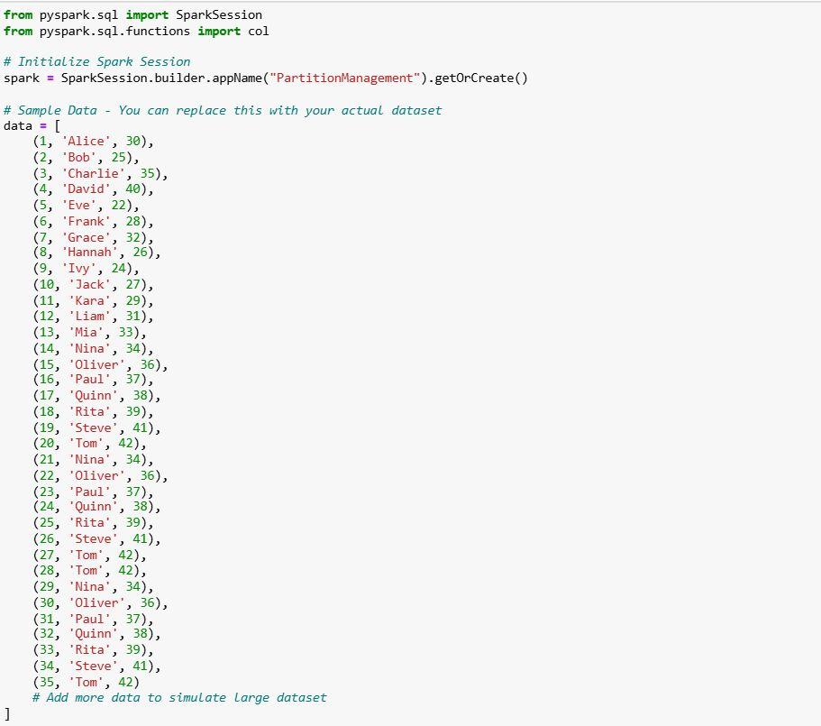

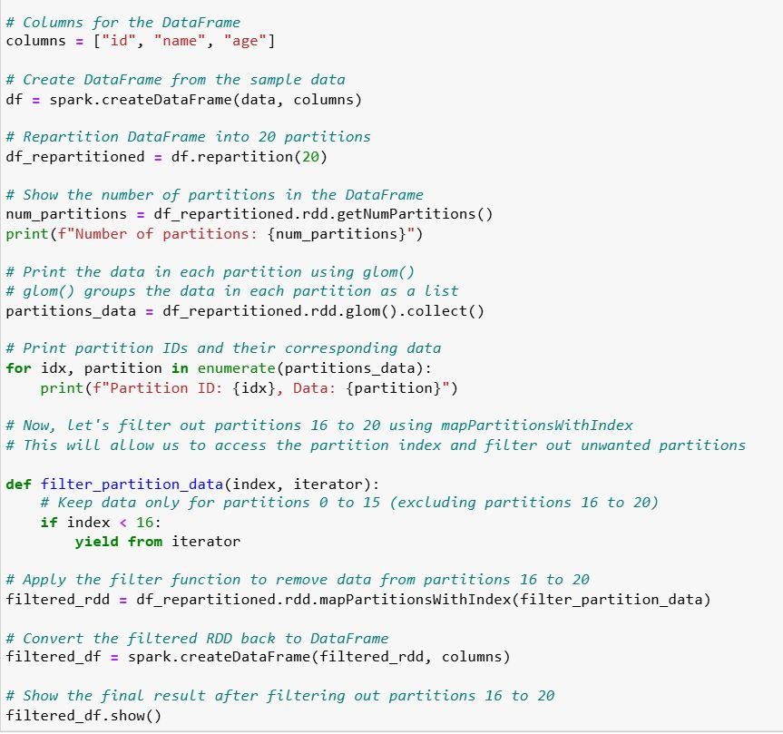

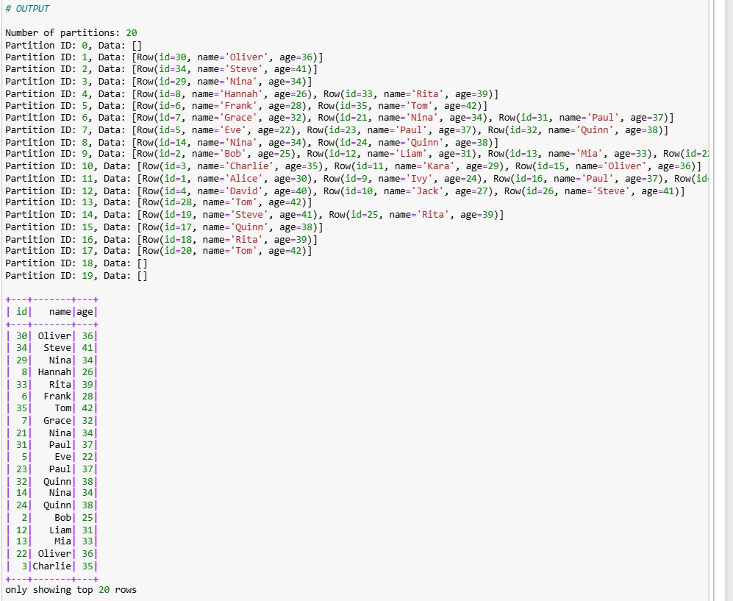

𝐇𝐨𝐰 𝐰𝐨𝐮𝐥𝐝 𝐲𝐨𝐮 𝐡𝐚𝐧𝐝𝐥𝐞 𝐦𝐢𝐬𝐬𝐢𝐧𝐠 𝐨𝐫 𝐢𝐧𝐯𝐚𝐥𝐢𝐝 𝐝𝐚𝐭𝐚 𝐢𝐧 𝐚 𝐝𝐚𝐭𝐚 𝐩𝐢𝐩𝐞𝐥𝐢𝐧𝐞 𝐮𝐬𝐢𝐧𝐠 𝐩𝐲𝐬𝐩𝐚𝐫𝐤?  
  
𝐊𝐞𝐲 𝐇𝐚𝐧𝐝𝐥𝐢𝐧𝐠 𝐓𝐞𝐜𝐡𝐧𝐢𝐪𝐮𝐞𝐬:  
  
1, Dropping Missing Values  
2, Filling Missing Values  
3, Replacing Invalid Data  
4, Handling Invalid Data Types  
  
𝐄𝐱𝐩𝐥𝐚𝐧𝐚𝐭𝐢𝐨𝐧 𝐨𝐟 𝐃𝐚𝐭𝐚 𝐇𝐚𝐧𝐝𝐥𝐢𝐧𝐠:  
  
𝐃𝐫𝐨𝐩𝐩𝐢𝐧𝐠 𝐌𝐢𝐬𝐬𝐢𝐧𝐠 𝐕𝐚𝐥𝐮𝐞𝐬 (𝐝𝐫𝐨𝐩𝐧𝐚):  
df.dropna(): This removes rows with any null values. It's useful when you don't want to include any incomplete records in your dataset.  
  
𝐅𝐢𝐥𝐥𝐢𝐧𝐠 𝐌𝐢𝐬𝐬𝐢𝐧𝐠 𝐕𝐚𝐥𝐮𝐞𝐬 (𝐟𝐢𝐥𝐥𝐧𝐚):  
df.fillna({"age": 0, "salary": 3000, "name": "Unknown"}): Here, we're filling missing values with a default value. You can specify the column names and their respective replacement values. For instance, missing ages are filled with 0, missing salaries with 3000, and missing names with "Unknown".  
  
𝐑𝐞𝐩𝐥𝐚𝐜𝐢𝐧𝐠 𝐈𝐧𝐯𝐚𝐥𝐢𝐝 𝐃𝐚𝐭𝐚 (𝐰𝐡𝐞𝐧, 𝐨𝐭𝐡𝐞𝐫𝐰𝐢𝐬𝐞):  
df.withColumn("salary", when(col("salary") < 0, 0).otherwise(col("salary"))): This checks for invalid data, such as negative salaries, and replaces them with a valid value (in this case, 0). The when clause checks the condition, and otherwise defines what should be done if the condition is false.  
  
𝐇𝐚𝐧𝐝𝐥𝐢𝐧𝐠 𝐈𝐧𝐯𝐚𝐥𝐢𝐝 𝐃𝐚𝐭𝐚 𝐓𝐲𝐩𝐞𝐬 (𝐜𝐚𝐬𝐭):  
df.withColumn("age", when(col("age").cast("int").isNotNull(), col("age")).otherwise(0)): Here, we are casting the age column to an integer. If it's not a valid integer (e.g., None or a string), it gets replaced with 0.  
  
𝐂𝐨𝐮𝐧𝐭𝐢𝐧𝐠 𝐍𝐮𝐥𝐥 𝐕𝐚𝐥𝐮𝐞𝐬 𝐁𝐞𝐟𝐨𝐫𝐞 𝐚𝐧𝐝 𝐀𝐟𝐭𝐞𝐫 𝐇𝐚𝐧𝐝𝐥𝐢𝐧𝐠:  
We check the count of null values in the DataFrame before and after handling the missing data. This helps in ensuring that our cleaning operations have been successful.

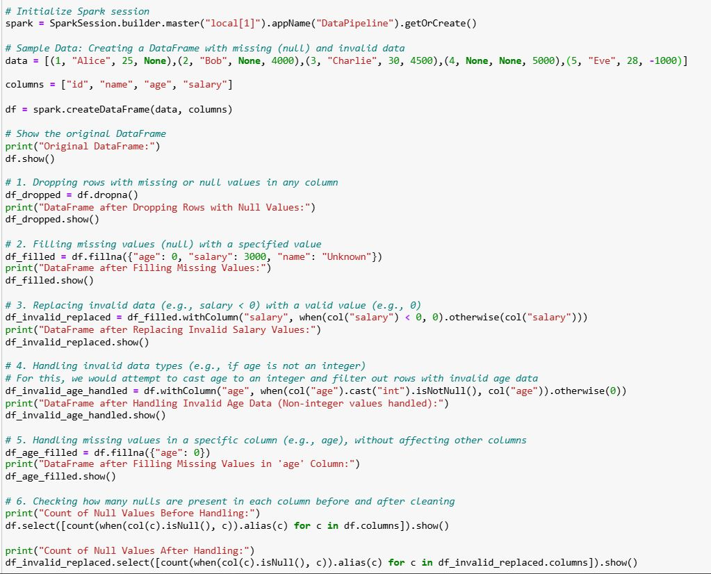

𝐖𝐡𝐚𝐭 𝐢𝐬 𝐭𝐡𝐞 𝐢𝐦𝐩𝐨𝐫𝐭𝐚𝐧𝐜𝐞 𝐨𝐟 𝐩𝐚𝐫𝐭𝐢𝐭𝐢𝐨𝐧𝐢𝐧𝐠 𝐢𝐧 𝐒𝐩𝐚𝐫𝐤, 𝐚𝐧𝐝 𝐡𝐨𝐰 𝐝𝐨 𝐲𝐨𝐮 𝐝𝐞𝐜𝐢𝐝𝐞 𝐭𝐡𝐞 𝐩𝐚𝐫𝐭𝐢𝐭𝐢𝐨𝐧𝐢𝐧𝐠 𝐬𝐭𝐫𝐚𝐭𝐞𝐠𝐲 𝐟𝐨𝐫 𝐚 𝐣𝐨𝐛?   
  
𝐈𝐦𝐩𝐨𝐫𝐭𝐚𝐧𝐜𝐞 𝐨𝐟 𝐏𝐚𝐫𝐭𝐢𝐭𝐢𝐨𝐧𝐢𝐧𝐠 𝐢𝐧 𝐒𝐩𝐚𝐫𝐤  
  
Partitioning in Apache Spark plays a critical role in how data is distributed and processed across a cluster. It is fundamental for achieving parallelism and distributed computing, which are core strengths of Spark.  
  
Parallelism: Partitioning enables Spark to divide the work into smaller chunks (partitions), which are distributed across multiple nodes (executors) in a cluster. Each node processes its assigned partition independently, allowing for parallel execution of tasks.  
  
Data locality: Proper partitioning ensures that data that is needed together (e.g., during shuffling or joins) is located on the same node or partition, reducing the need for expensive data movement between nodes (network I/O).  
  
Shuffling optimization: Spark often performs operations that require data to be shuffled between nodes (e.g., groupBy(), join()). Optimizing partitioning helps minimize the shuffle, reducing both network traffic and computation time.  
  
Memory optimization: The partitioning strategy can influence how much data each partition holds. If a partition is too large, it could cause out-of-memory errors. Similarly, too many partitions with small data can increase overhead.  
  
𝐇𝐨𝐰 𝐭𝐨 𝐃𝐞𝐜𝐢𝐝𝐞 𝐭𝐡𝐞 𝐏𝐚𝐫𝐭𝐢𝐭𝐢𝐨𝐧𝐢𝐧𝐠 𝐒𝐭𝐫𝐚𝐭𝐞𝐠𝐲  
When choosing the partitioning strategy for a job, consider the following factors:  
  
Size of the data: Large datasets may require more partitions to ensure even distribution and avoid skew. For smaller datasets, fewer partitions might be more efficient.  
  
Available cluster resources: The number of available executors and cores will influence the number of partitions. Ideally, the number of partitions should be a multiple of the number of available cores to maximize parallelism.  
  
Shuffle-heavy operations: Operations like join(), groupBy(), and reduceByKey() require shuffling. Before these operations, repartitioning might be necessary to optimize performance, ensuring that data is co-located where possible.  
  
Partitioning by key: For operations like joins, partitioning by a key (e.g., using partitionBy()) can reduce shuffle by ensuring that data with the same key is processed in the same partition.  
  
𝐑𝐞𝐩𝐚𝐫𝐭𝐢𝐭𝐢𝐨𝐧 𝐯𝐬. 𝐂𝐨𝐚𝐥𝐞𝐬𝐜𝐞:  
Use repartition() when you want to increase the number of partitions, particularly before wide transformations (like joins).  
  
Use coalesce() to reduce the number of partitions, typically after narrow transformations (like filter()).

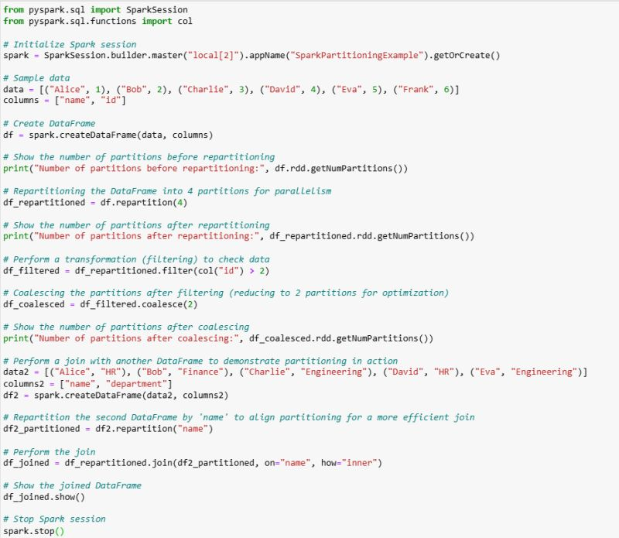

𝐖𝐡𝐚𝐭 𝐚𝐫𝐞 𝐭𝐡𝐞 𝐝𝐢𝐟𝐟𝐞𝐫𝐞𝐧𝐭 𝐰𝐫𝐢𝐭𝐞 𝐦𝐨𝐝𝐞𝐬 𝐚𝐯𝐚𝐢𝐥𝐚𝐛𝐥𝐞 𝐢𝐧 𝐏𝐲𝐒𝐩𝐚𝐫𝐤, 𝐚𝐧𝐝 𝐡𝐨𝐰 𝐝𝐨 𝐭𝐡𝐞𝐲 𝐡𝐚𝐧𝐝𝐥𝐞 𝐞𝐱𝐢𝐬𝐭𝐢𝐧𝐠 𝐝𝐚𝐭𝐚 𝐢𝐧 𝐭𝐡𝐞 𝐭𝐚𝐫𝐠𝐞𝐭 𝐥𝐨𝐜𝐚𝐭𝐢𝐨𝐧?  
  
In PySpark, when writing data to external storage (like HDFS, S3, or a local file system), you can specify different "write modes". These modes determine how Spark should handle situations where the destination already exists. The most common write modes are:  
  
overwrite: If data exists at the specified location, it will be overwritten with the new data.  
  
append: If data exists at the specified location, the new data will be appended to the existing data.  
  
ignore: If data exists at the specified location, the new data will not overwrite or append. The existing data will remain unchanged.  
  
error (or errorifexists): This is the default mode. If data exists at the specified location, an error will be thrown, and the data will not be written.  
  
  
𝐄𝐱𝐩𝐥𝐚𝐧𝐚𝐭𝐢𝐨𝐧 𝐨𝐟 𝐭𝐡𝐞 𝐖𝐫𝐢𝐭𝐞 𝐌𝐨𝐝𝐞𝐬:  
𝐨𝐯𝐞𝐫𝐰𝐫𝐢𝐭𝐞:  
If files already exist in the target location (output_data/overwrite), they will be deleted and replaced with the new data.  
  
𝐚𝐩𝐩𝐞𝐧𝐝:  
If files already exist in the target location (output_data/append), the new data will be added at the end of the existing files without removing or modifying the old data.  
  
𝐢𝐠𝐧𝐨𝐫𝐞:  
If files already exist in the target location (output_data/ignore), no data will be written, and the operation will silently ignore the new data.  
  
𝐞𝐫𝐫𝐨𝐫:  
If files already exist in the target location (output_data/error), Spark will throw an error and abort the operation without writing the new data. This is the default mode.

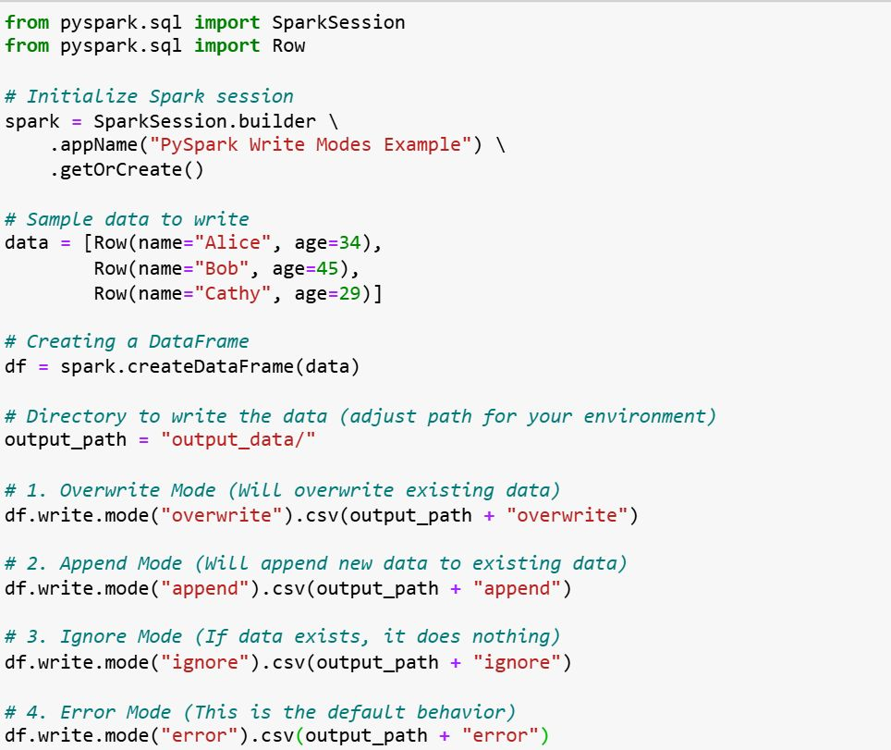

𝐇𝐨𝐰 𝐜𝐚𝐧 𝐲𝐨𝐮 𝐡𝐚𝐧𝐝𝐥𝐞 𝐧𝐮𝐥𝐥 𝐯𝐚𝐥𝐮𝐞𝐬 𝐢𝐧 𝐏𝐲𝐒𝐩𝐚𝐫𝐤 𝐃𝐚𝐭𝐚𝐅𝐫𝐚𝐦𝐞𝐬?  
  
Handling null values is a crucial part of data preprocessing in PySpark. Null values can arise due to missing data or errors during data collection, and they can impact the quality of your analysis and processing. PySpark provides several functions to manage null values, such as dropna() to remove rows with nulls, fillna() to replace null values with specified defaults, and filter() to select rows based on the presence of nulls. You can also use conditional expressions like when() to replace null values with different values depending on certain conditions. Proper handling of null values ensures better data integrity and more accurate results in your Spark processing pipeline.  
  
DataFrame Creation: A sample dataset with some null values is created, including columns like Name, Subject, Mark, and Attendance.  
  
𝐅𝐢𝐥𝐭𝐞𝐫𝐢𝐧𝐠 𝐑𝐨𝐰𝐬 𝐰𝐢𝐭𝐡 𝐍𝐨𝐧-𝐍𝐮𝐥𝐥 𝐕𝐚𝐥𝐮𝐞𝐬:  
  
isNotNull(): Filters the DataFrame to retain only rows where the specified column does not have null values (for example, the Mark column).  
  
𝐅𝐢𝐥𝐭𝐞𝐫𝐢𝐧𝐠 𝐑𝐨𝐰𝐬 𝐰𝐢𝐭𝐡 '𝐎𝐑' 𝐂𝐨𝐧𝐝𝐢𝐭𝐢𝐨𝐧:  
  
| (OR operator): Filters the DataFrame where either Mark or Attendance has non-null values.  
  
𝐃𝐫𝐨𝐩𝐩𝐢𝐧𝐠 𝐑𝐨𝐰𝐬 𝐰𝐢𝐭𝐡 𝐍𝐮𝐥𝐥 𝐕𝐚𝐥𝐮𝐞𝐬:  
  
dropna(): Drops any row where any column contains a null value.  
  
𝐑𝐞𝐩𝐥𝐚𝐜𝐢𝐧𝐠 𝐍𝐮𝐥𝐥 𝐕𝐚𝐥𝐮𝐞𝐬 𝐰𝐢𝐭𝐡 𝐚 𝐃𝐞𝐟𝐚𝐮𝐥𝐭 𝐕𝐚𝐥𝐮𝐞:  
  
fillna(value): Replaces null values in all columns with a specified default value, such as 0 for numerical columns.  
  
𝐑𝐞𝐩𝐥𝐚𝐜𝐢𝐧𝐠 𝐍𝐮𝐥𝐥 𝐕𝐚𝐥𝐮𝐞𝐬 𝐢𝐧 𝐒𝐩𝐞𝐜𝐢𝐟𝐢𝐜 𝐂𝐨𝐥𝐮𝐦𝐧𝐬:  
  
fillna({"column_name": value}): Replaces null values in specific columns with defined values (e.g., Mark replaced with 0, Attendance replaced with "Unknown").  
  
𝐃𝐫𝐨𝐩𝐩𝐢𝐧𝐠 𝐑𝐨𝐰𝐬 𝐁𝐚𝐬𝐞𝐝 𝐨𝐧 𝐍𝐮𝐥𝐥 𝐢𝐧 𝐒𝐩𝐞𝐜𝐢𝐟𝐢𝐜 𝐂𝐨𝐥𝐮𝐦𝐧𝐬:  
  
dropna(subset=[column_name]): Drops rows where a specific column (e.g., Mark) has a null value.  
  
𝐑𝐞𝐩𝐥𝐚𝐜𝐢𝐧𝐠 𝐍𝐮𝐥𝐥 𝐕𝐚𝐥𝐮𝐞𝐬 𝐰𝐢𝐭𝐡 𝐃𝐢𝐟𝐟𝐞𝐫𝐞𝐧𝐭 𝐕𝐚𝐥𝐮𝐞𝐬 𝐟𝐨𝐫 𝐃𝐢𝐟𝐟𝐞𝐫𝐞𝐧𝐭 𝐂𝐨𝐥𝐮𝐦𝐧𝐬:  
  
fillna({"column_name": value}): Allows replacing null values in each column with different values.

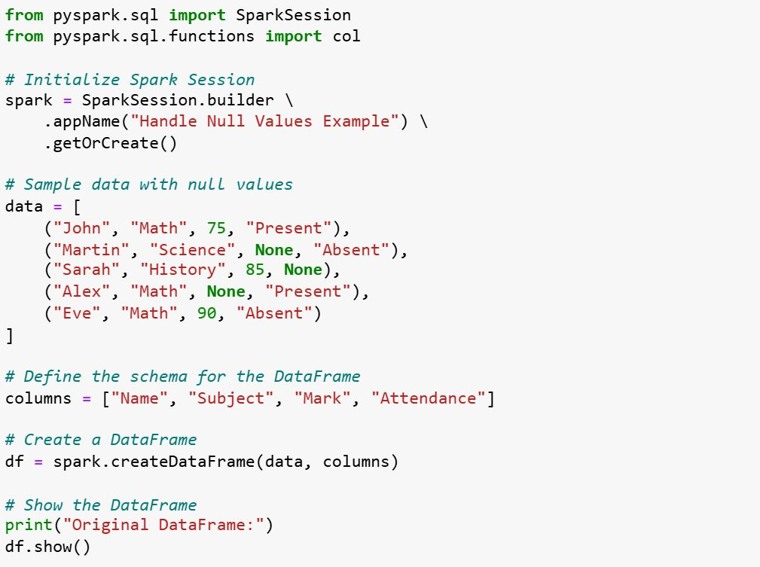

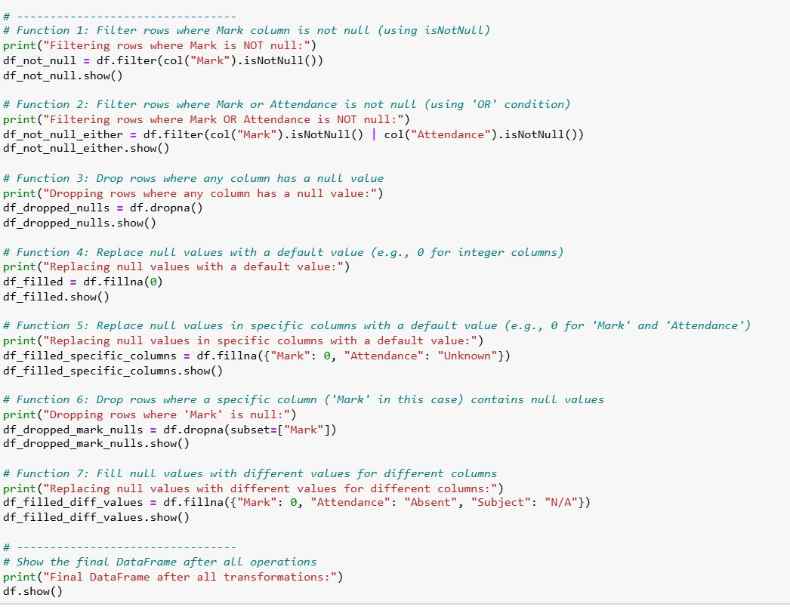

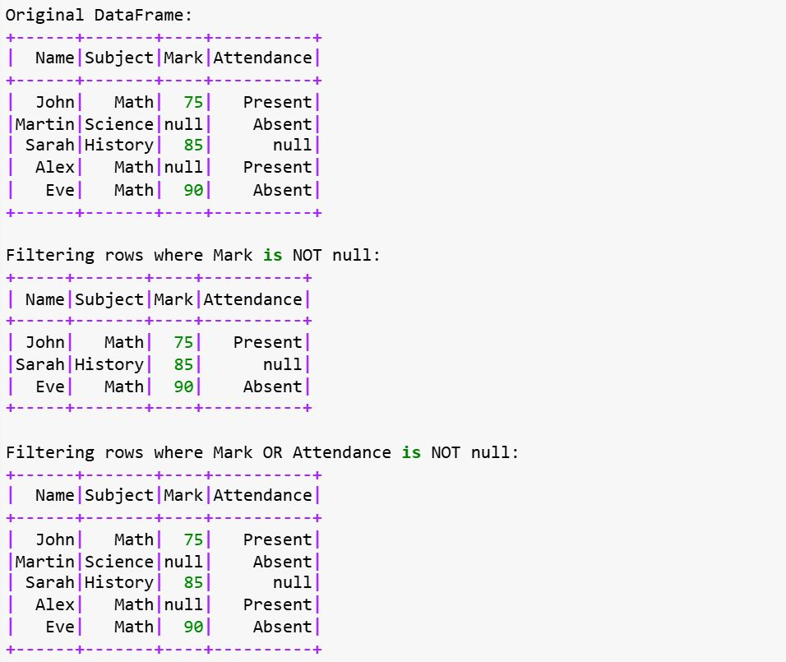

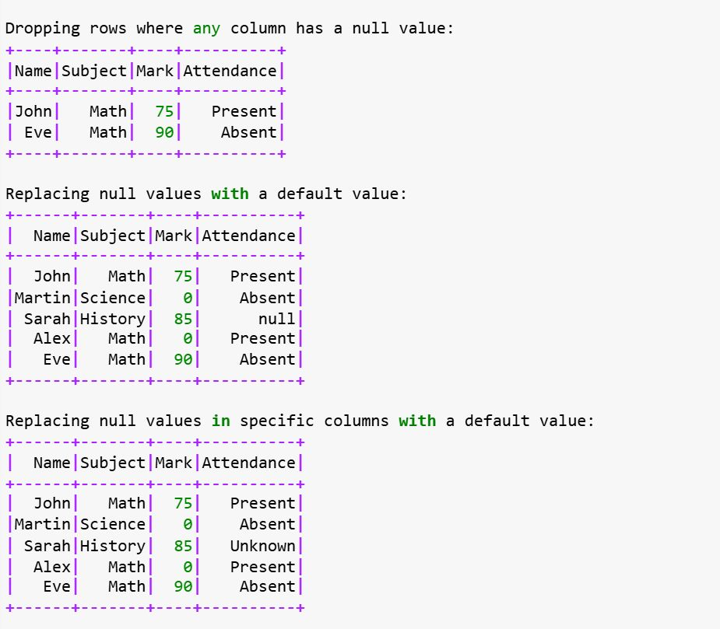

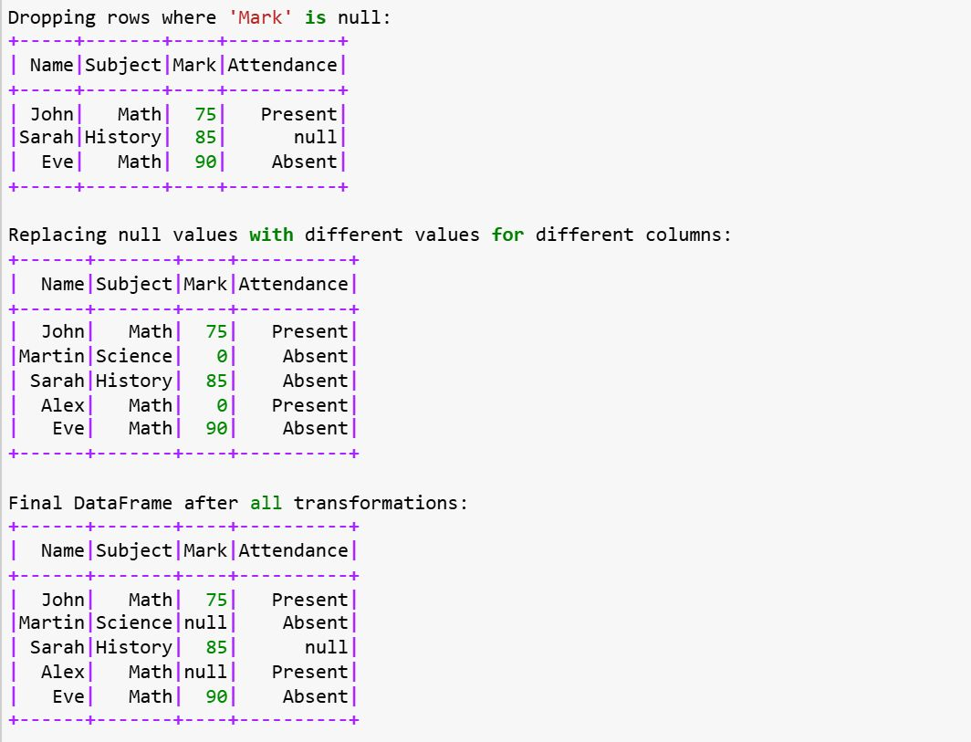

𝐃𝐨𝐧'𝐭 𝐬𝐚𝐲 𝐲𝐨𝐮'𝐫𝐞 𝐚 𝐝𝐚𝐭𝐚 𝐞𝐧𝐠𝐢𝐧𝐞𝐞𝐫 𝐢𝐟 𝐲𝐨𝐮 𝐜𝐚𝐧'𝐭 𝐚𝐧𝐬𝐰𝐞𝐫 𝐭𝐡𝐢𝐬 𝐪𝐮𝐞𝐬𝐭𝐢𝐨𝐧s 𝐢𝐧 𝐚𝐧 𝐢𝐧𝐭𝐞𝐫𝐯𝐢𝐞𝐰  
  
How does Spark handle distributed joins, and what factors affect performance?  
  
What’s the difference between shuffle and no-shuffle operations in Spark?  
  
How does Spark handle skewed data in aggregation operations like groupBy?  
  
Explain how Spark’s Catalyst Optimizer works in query optimization?  
  
How do you ensure fault tolerance in Spark for long-running jobs?  
  
How does Spark manage memory, and how can you optimize memory usage?  
  
What is the role of a Spark executor in task execution within a cluster?  
  
How does Spark’s Tungsten engine enhance performance?  
  
What is Spark’s dynamic allocation feature and how does it affect job execution?  
  
What techniques can reduce shuffle overhead in Spark jobs?  
  
What’s the difference between groupByKey and reduceByKey in Spark?  
  
How does the Catalyst Optimizer work in Spark SQL?  
  
What are the different types of transformations in Spark?  
  
How can you address out-of-memory (OOM) issues in Spark?  
  
What is a broadcast join and when is it preferred?  
  
What is the purpose of checkpointing in Spark?  
  
How does lazy evaluation work in Spark?  
  
What’s the difference between narrow and wide transformations in Spark?  
  
What’s the difference between persist() and cache() in Spark?  
  
How can you read a CSV file in Spark without specifying an external schema?  
  
What is the driver’s role in Spark architecture?  
  
What are the benefits of using Parquet files in Spark?  
  
When should you use repartition() vs coalesce() in Spark?  
  
What is the difference between DataFrame and Dataset in Spark?  
  
What are shared variables and how do they work in Spark?  
  
How do accumulators work in Spark?  
  
What’s the difference between global temp views and temp views in Spark?  
  
What are the different join strategies in Spark?  
  
How would you optimize a Spark job to handle large files (e.g., 10GB)?  
  
What’s the difference between OrderBy, SortBy, and ClusterBy in Spark?  
  
What are semi-joins and anti-joins in Spark SQL?  
  
How does Spark differ from Hadoop in terms of performance and flexibility?  
  
What are the main types of joins available in Spark?  
  
What’s the difference between map() and flatMap() in terms of output?  
  
How would you optimize Spark performance for large datasets?  
  
What are broadcast variables and when should they be used?  
  
How do you optimize Spark for large-scale data processing?  
  
How does Spark perform query optimization?  
  
How can you add or drop columns in a Spark DataFrame?  
  
How do Avro and ORC file formats compare in Spark? Which do you prefer?  
  
How can you convert a DataFrame to a Dataset in Spark?  
  
How does reduceByKey compare to groupByKey in terms of performance?  
  
How does Spark handle a large number of partitions? What issues arise?  
  
What are DAG and Lineage in Spark, and why are they important?  
  
What are the differences between Spark’s cluster and client deployment modes?

𝐖𝐡𝐚𝐭’𝐬 𝐭𝐡𝐞 𝐩𝐮𝐫𝐩𝐨𝐬𝐞 𝐨𝐟 𝐜𝐡𝐞𝐜𝐤𝐩𝐨𝐢𝐧𝐭𝐢𝐧𝐠 𝐢𝐧 𝐒𝐩𝐚𝐫𝐤, 𝐚𝐧𝐝 𝐰𝐡𝐞𝐧 𝐬𝐡𝐨𝐮𝐥𝐝 𝐢𝐭 𝐛𝐞 𝐮𝐬𝐞𝐝 𝐢𝐧 𝐣𝐨𝐛 𝐞𝐱𝐞𝐜𝐮𝐭𝐢𝐨𝐧 𝐩𝐢𝐩𝐞𝐥𝐢𝐧𝐞?  
  
Checkpointing in Apache Spark is a fault tolerance mechanism that allows you to persist intermediate RDD or DataFrame data to storage (like HDFS, S3, or local file systems). It is primarily used to handle failures during long-running jobs by saving the state of the computation at certain points. If the job fails or encounters a problem, Spark can recover from the checkpoint and continue from the saved state rather than restarting the entire computation.  
  
Checkpointing is important in long-running transformations or iterative algorithms (like machine learning models) where data is recomputed repeatedly. It helps reduce recomputation in case of failures and can also optimize the job performance by truncating long lineage chains.  
  
𝐖𝐡𝐞𝐧 𝐭𝐨 𝐔𝐬𝐞 𝐂𝐡𝐞𝐜𝐤𝐩𝐨𝐢𝐧𝐭𝐢𝐧𝐠:  
  
When the RDD/DataFrame lineage is too long: Long lineage chains increase the likelihood of failure. Checkpointing allows Spark to truncate the lineage after saving the data, reducing the risk of recomputation.  
  
For iterative algorithms: If you have an iterative process, such as in graph processing (e.g., PageRank) or machine learning, checkpointing can help save intermediate results between iterations.  
  
𝐂𝐨𝐝𝐞 𝐄𝐱𝐩𝐥𝐚𝐧𝐚𝐭𝐢𝐨𝐧:  
  
Checkpoint Directory: The checkpoint directory is set using sparkContext.setCheckpointDir(). This tells Spark where to save the checkpoint data (e.g., HDFS, S3, or local directory).  
  
DataFrame Transformations: A series of transformations (filter and withColumn) are applied to the DataFrame. These transformations are chained and might lead to a long lineage.  
  
Checkpointing: After transforming the data, we call .checkpoint() on the DataFrame to persist it to the checkpoint directory. This ensures that the lineage is truncated, and Spark does not have to recompute the transformations from scratch if the job fails.  
  
Job Failure Simulation: You can simulate a job failure (commented-out in the code) after the checkpointing step. In case of failure, Spark will attempt to recover from the checkpoint and continue execution.  
  
  
For fault tolerance: In long-running jobs or pipelines, checkpointing ensures that you can recover from failures without having to recompute everything from scratch.  
  
Large jobs with significant shuffling: It can help reduce the shuffle and recomputation overheads in such cases.

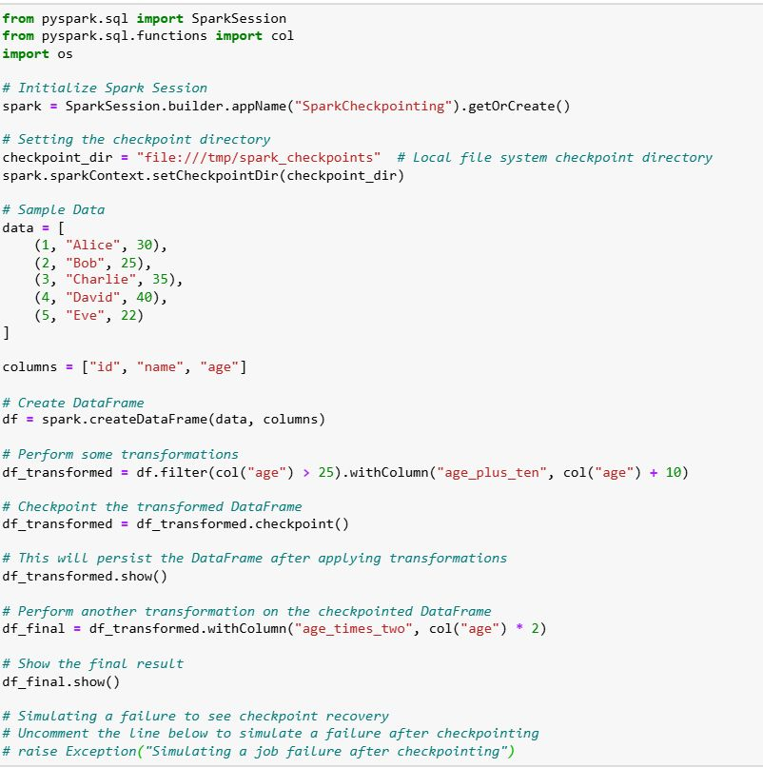

𝐇𝐨𝐰 𝐜𝐚𝐧 𝐲𝐨𝐮 𝐡𝐚𝐧𝐝𝐥𝐞 𝐧𝐮𝐥𝐥 𝐯𝐚𝐥𝐮𝐞𝐬 𝐢𝐧 𝐏𝐲𝐒𝐩𝐚𝐫𝐤 𝐃𝐚𝐭𝐚𝐅𝐫𝐚𝐦𝐞𝐬?  
  
Handling null values is a crucial part of data preprocessing in PySpark. Null values can arise due to missing data or errors during data collection, and they can impact the quality of your analysis and processing. PySpark provides several functions to manage null values, such as dropna() to remove rows with nulls, fillna() to replace null values with specified defaults, and filter() to select rows based on the presence of nulls. You can also use conditional expressions like when() to replace null values with different values depending on certain conditions. Proper handling of null values ensures better data integrity and more accurate results in your Spark processing pipeline.  
  
DataFrame Creation: A sample dataset with some null values is created, including columns like Name, Subject, Mark, and Attendance.  
  
𝐅𝐢𝐥𝐭𝐞𝐫𝐢𝐧𝐠 𝐑𝐨𝐰𝐬 𝐰𝐢𝐭𝐡 𝐍𝐨𝐧-𝐍𝐮𝐥𝐥 𝐕𝐚𝐥𝐮𝐞𝐬:  
  
isNotNull(): Filters the DataFrame to retain only rows where the specified column does not have null values (for example, the Mark column).  
  
𝐅𝐢𝐥𝐭𝐞𝐫𝐢𝐧𝐠 𝐑𝐨𝐰𝐬 𝐰𝐢𝐭𝐡 '𝐎𝐑' 𝐂𝐨𝐧𝐝𝐢𝐭𝐢𝐨𝐧:  
  
| (OR operator): Filters the DataFrame where either Mark or Attendance has non-null values.  
  
𝐃𝐫𝐨𝐩𝐩𝐢𝐧𝐠 𝐑𝐨𝐰𝐬 𝐰𝐢𝐭𝐡 𝐍𝐮𝐥𝐥 𝐕𝐚𝐥𝐮𝐞𝐬:  
  
dropna(): Drops any row where any column contains a null value.  
  
𝐑𝐞𝐩𝐥𝐚𝐜𝐢𝐧𝐠 𝐍𝐮𝐥𝐥 𝐕𝐚𝐥𝐮𝐞𝐬 𝐰𝐢𝐭𝐡 𝐚 𝐃𝐞𝐟𝐚𝐮𝐥𝐭 𝐕𝐚𝐥𝐮𝐞:  
  
fillna(value): Replaces null values in all columns with a specified default value, such as 0 for numerical columns.  
  
𝐑𝐞𝐩𝐥𝐚𝐜𝐢𝐧𝐠 𝐍𝐮𝐥𝐥 𝐕𝐚𝐥𝐮𝐞𝐬 𝐢𝐧 𝐒𝐩𝐞𝐜𝐢𝐟𝐢𝐜 𝐂𝐨𝐥𝐮𝐦𝐧𝐬:  
  
fillna({"column_name": value}): Replaces null values in specific columns with defined values (e.g., Mark replaced with 0, Attendance replaced with "Unknown").  
  
𝐃𝐫𝐨𝐩𝐩𝐢𝐧𝐠 𝐑𝐨𝐰𝐬 𝐁𝐚𝐬𝐞𝐝 𝐨𝐧 𝐍𝐮𝐥𝐥 𝐢𝐧 𝐒𝐩𝐞𝐜𝐢𝐟𝐢𝐜 𝐂𝐨𝐥𝐮𝐦𝐧𝐬:  
  
dropna(subset=[column_name]): Drops rows where a specific column (e.g., Mark) has a null value.  
  
𝐑𝐞𝐩𝐥𝐚𝐜𝐢𝐧𝐠 𝐍𝐮𝐥𝐥 𝐕𝐚𝐥𝐮𝐞𝐬 𝐰𝐢𝐭𝐡 𝐃𝐢𝐟𝐟𝐞𝐫𝐞𝐧𝐭 𝐕𝐚𝐥𝐮𝐞𝐬 𝐟𝐨𝐫 𝐃𝐢𝐟𝐟𝐞𝐫𝐞𝐧𝐭 𝐂𝐨𝐥𝐮𝐦𝐧𝐬:  
  
fillna({"column_name": value}): Allows replacing null values in each column with different values.











𝐄𝐱𝐩𝐥𝐚𝐢𝐧 𝐭𝐲𝐩𝐞𝐬 𝐨𝐟 𝐓𝐢𝐦𝐞 𝐖𝐢𝐧𝐝𝐨𝐰𝐬 𝐢𝐧 𝐒𝐩𝐚𝐫𝐤 𝐒𝐭𝐫𝐮𝐜𝐭𝐮𝐫𝐞𝐝 𝐒𝐭𝐫𝐞𝐚𝐦𝐢𝐧𝐠?  
  
𝐓𝐲𝐩𝐞𝐬 𝐨𝐟 𝐓𝐢𝐦𝐞 𝐖𝐢𝐧𝐝𝐨𝐰𝐬 𝐢𝐧 𝐒𝐩𝐚𝐫𝐤 𝐒𝐭𝐫𝐮𝐜𝐭𝐮𝐫𝐞𝐝 𝐒𝐭𝐫𝐞𝐚𝐦𝐢𝐧𝐠:  
  
𝐓𝐮𝐦𝐛𝐥𝐢𝐧𝐠 𝐖𝐢𝐧𝐝𝐨𝐰:  
  
A tumbling window is a fixed-size, non-overlapping window that divides the stream into distinct intervals. Each record belongs to exactly one window.  
  
The window duration is constant, and each window does not overlap with the next one.  
  
  
𝐒𝐥𝐢𝐝𝐢𝐧𝐠 𝐖𝐢𝐧𝐝𝐨𝐰:  
  
A sliding window is similar to a tumbling window but can overlap with other windows.  
  
You define both the window size and the slide duration (how often new windows are computed). For example, a 10-minute window with a 5-minute slide would create overlapping windows.  
  
𝐒𝐞𝐬𝐬𝐢𝐨𝐧 𝐖𝐢𝐧𝐝𝐨𝐰:  
  
A session window groups data based on inactivity time gaps. If events happen within a certain period of time (session), they are grouped together into a session window. If the time between two events exceeds a threshold, a new session is created.  
  
Session windows are dynamic and are based on the events themselves, rather than predefined time intervals.

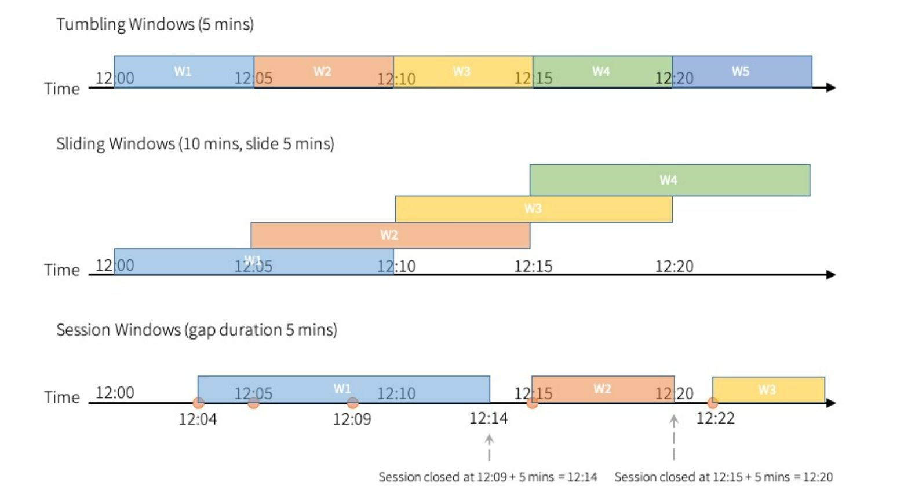

𝐃𝐢𝐟𝐟𝐞𝐫𝐞𝐧𝐜𝐞 𝐁𝐞𝐭𝐰𝐞𝐞𝐧 𝐒𝐡𝐮𝐟𝐟𝐥𝐞 𝐚𝐧𝐝 𝐍𝐨-𝐬𝐡𝐮𝐟𝐟𝐥𝐞 𝐎𝐩𝐞𝐫𝐚𝐭𝐢𝐨𝐧𝐬 𝐢𝐧 𝐒𝐩𝐚𝐫𝐤?  
  
Shuffle Operations: These operations involve redistributing data across different nodes or partitions. Common shuffle operations include groupBy, join, etc. Shuffling can be expensive because of disk I/O, network transfer.  
  
No-shuffle Operations: These operations do not require data to be moved between partitions or nodes. Examples include operations like map, filter, select, and flatMap. These are generally more efficient than shuffle operations.  
  
𝐇𝐨𝐰 𝐃𝐨𝐞𝐬 𝐒𝐩𝐚𝐫𝐤 𝐇𝐚𝐧𝐝𝐥𝐞 𝐒𝐤𝐞𝐰𝐞𝐝 𝐃𝐚𝐭𝐚 𝐢𝐧 𝐀𝐠𝐠𝐫𝐞𝐠𝐚𝐭𝐢𝐨𝐧 𝐎𝐩𝐞𝐫𝐚𝐭𝐢𝐨𝐧𝐬 𝐥𝐢𝐤𝐞 𝐠𝐫𝐨𝐮𝐩𝐁𝐲?  
  
Data Skew happens when certain keys in a groupBy operation have a disproportionate amount of data, leading to some tasks taking much longer than others.  
  
Spark's Approach to Handling Skew:  
  
Salting: This involves adding random prefixes to skewed keys to distribute data more evenly across partitions.  
  
Custom Partitioning: You can define your own partitioner to redistribute data more evenly.  
  
Broadcasting: In some cases, broadcasting the smaller dataset can help avoid shuffling the large dataset.  
  
Skewed Join Handling: Spark can automatically handle skewed joins using a skewedJoin optimization where the smaller dataset is broadcasted.  
  
𝐇𝐨𝐰 𝐃𝐨𝐞𝐬 𝐒𝐩𝐚𝐫𝐤’𝐬 𝐂𝐚𝐭𝐚𝐥𝐲𝐬𝐭 𝐎𝐩𝐭𝐢𝐦𝐢𝐳𝐞𝐫 𝐖𝐨𝐫𝐤 𝐢𝐧 𝐐𝐮𝐞𝐫𝐲 𝐎𝐩𝐭𝐢𝐦𝐢𝐳𝐚𝐭𝐢𝐨𝐧?  
  
Catalyst Optimizer is Spark’s query optimization engine that applies a series of transformations to SQL queries or DataFrame operations. It works in multiple stages:  
  
Parsing: The query is parsed into an unresolved logical plan.  
  
Analysis: The logical plan is resolved and validated.  
  
Optimization: A set of rule-based transformations (e.g., predicate pushdown, constant folding, etc.) is applied to optimize the query.  
  
Physical Planning: Multiple physical plans are generated, and the best one is chosen based on cost (e.g., selecting join strategies).  
  
Code Generation: Spark uses whole-stage code generation to create efficient JVM bytecode.  
  
𝐇𝐨𝐰 𝐃𝐨 𝐘𝐨𝐮 𝐄𝐧𝐬𝐮𝐫𝐞 𝐅𝐚𝐮𝐥𝐭 𝐓𝐨𝐥𝐞𝐫𝐚𝐧𝐜𝐞 𝐢𝐧 𝐒𝐩𝐚𝐫𝐤 𝐟𝐨𝐫 𝐋𝐨𝐧𝐠-𝐑𝐮𝐧𝐧𝐢𝐧𝐠 𝐉𝐨𝐛𝐬?  
  
RDDs in Spark are fault-tolerant due to lineage information, meaning Spark can recompute lost data if a partition is lost due to node failure.  
  
Checkpointing: For long-running jobs, especially iterative ones (like in machine learning), you can use checkpointing to save RDDs to disk at specific points in the lineage. This avoids recomputing the entire lineage in case of a failure.  
  
Replicating Data: Data can be replicated across different nodes to prevent data loss in case of node failure.  
  
Speculative Execution: Spark can launch backup copies of tasks on other nodes if it detects that a task is running slower than expected, improving fault tolerance for stragglers.

𝐃𝐢𝐟𝐟𝐞𝐫𝐞𝐧𝐜𝐞 𝐁𝐞𝐭𝐰𝐞𝐞𝐧 𝐃𝐚𝐭𝐚𝐅𝐫𝐚𝐦𝐞 𝐚𝐧𝐝 𝐃𝐚𝐭𝐚𝐬𝐞𝐭 𝐢𝐧 𝐒𝐩𝐚𝐫𝐤?  
  
DataFrame: A DataFrame in Spark is a distributed collection of data organized into named columns. It is similar to a table in a relational database or a data frame in R/Pandas. DataFrames can hold data of different types (integer, string, float, etc.) and are built on top of RDDs (Resilient Distributed Datasets). DataFrames are optimized using Spark's Catalyst optimizer.  
  
Dataset: A Dataset is a strongly-typed collection of data. It is similar to a DataFrame but with an added benefit: Datasets support compile-time type safety. This means that Datasets are capable of performing operations with type checks at compile time. Datasets can be considered an extension of DataFrames with type safety and a richer set of transformations. In Spark, Datasets provide both functional (using the DataFrame API) and relational operations (using the RDD API).   
  
𝐖𝐡𝐚𝐭 𝐀𝐫𝐞 𝐒𝐡𝐚𝐫𝐞𝐝 𝐕𝐚𝐫𝐢𝐚𝐛𝐥𝐞𝐬 𝐚𝐧𝐝 𝐇𝐨𝐰 𝐃𝐨 𝐓𝐡𝐞𝐲 𝐖𝐨𝐫𝐤 𝐢𝐧 𝐒𝐩𝐚𝐫𝐤?  
  
Shared Variables in Spark are variables that can be shared across different nodes in a distributed computation.   
  
Two types of shared variables:  
  
Broadcast Variables: These are used to distribute a large read-only variable across all worker nodes. They are efficient because instead of sending the same data to each task multiple times, they are sent once to all nodes and cached on them.  
  
Accumulators: These are variables used for aggregating values across tasks in a distributed way. They can be updated through operations and are primarily used for counters or summing up values. Spark provides the accumulable type for this purpose.  
  
𝐇𝐨𝐰 𝐃𝐨 𝐀𝐜𝐜𝐮𝐦𝐮𝐥𝐚𝐭𝐨𝐫𝐬 𝐖𝐨𝐫𝐤 𝐢𝐧 𝐒𝐩𝐚𝐫𝐤?  
  
Accumulators are a type of shared variable that allow tasks to add to their values in a distributed fashion. They are mainly used to aggregate values across multiple tasks, such as counting or summing.  
  
Functionality: Accumulators can only be added to and can’t be read from within the tasks themselves (i.e., only the driver program can read their value after all tasks are completed). Spark provides built-in support for accumulators, particularly useful in debugging or performance metrics.  
  
𝐃𝐢𝐟𝐟𝐞𝐫𝐞𝐧𝐜𝐞 𝐁𝐞𝐭𝐰𝐞𝐞𝐧 𝐆𝐥𝐨𝐛𝐚𝐥 𝐓𝐞𝐦𝐩 𝐕𝐢𝐞𝐰𝐬 𝐚𝐧𝐝 𝐓𝐞𝐦𝐩 𝐕𝐢𝐞𝐰𝐬 𝐢𝐧 𝐒𝐩𝐚𝐫𝐤?  
  
Global Temp View: A global temporary view is a table that can be accessed across all sessions (even across different Spark applications) as long as the Spark session is alive. It is registered with a global name and can be used in any subsequent Spark session.  
  
Temp View: A temporary view is a table that is session-scoped, meaning it only exists during the lifespan of the current Spark session. Once the session is terminated, the view disappears. It is created in a specific session and cannot be accessed outside that session.

𝐖𝐡𝐚𝐭 𝐢𝐬 𝐭𝐡𝐞 𝐝𝐫𝐢𝐯𝐞𝐫’𝐬 𝐫𝐨𝐥𝐞 𝐢𝐧 𝐒𝐩𝐚𝐫𝐤 𝐚𝐫𝐜𝐡𝐢𝐭𝐞𝐜𝐭𝐮𝐫𝐞?  
  
𝟏. 𝐀𝐩𝐩𝐥𝐢𝐜𝐚𝐭𝐢𝐨𝐧 𝐂𝐨𝐨𝐫𝐝𝐢𝐧𝐚𝐭𝐢𝐨𝐧:  
  
✅The driver is the entry point for a Spark application. It runs the main function of the application and is responsible for setting up the environment for Spark jobs.  
  
✅It creates the SparkContext or SparkSession, which is used to connect to the cluster and initiate the application’s execution.  
  
𝟐. 𝐉𝐨𝐛 𝐚𝐧𝐝 𝐒𝐭𝐚𝐠𝐞 𝐌𝐚𝐧𝐚𝐠𝐞𝐦𝐞𝐧𝐭:  
  
✅The driver is responsible for breaking down the application’s logic into jobs and stages.  
  
✅A job corresponds to an action (like collect(), save(), etc.) in Spark.  
  
✅A stage is a set of tasks that can be executed in parallel, divided based on transformations like shuffle.  
  
✅The driver decides how to schedule tasks, set up stages, and distribute them across the cluster workers.  
  
𝟑. 𝐓𝐚𝐬𝐤 𝐒𝐜𝐡𝐞𝐝𝐮𝐥𝐢𝐧𝐠 𝐚𝐧𝐝 𝐃𝐢𝐬𝐭𝐫𝐢𝐛𝐮𝐭𝐢𝐨𝐧:  
  
✅The driver coordinates task distribution by sending tasks to the executors on the worker nodes.  
  
✅It schedules tasks for the worker nodes (executors) based on the data partitioning and stage boundaries, ensuring parallel execution and fault tolerance.  
  
𝟒. 𝐂𝐥𝐮𝐬𝐭𝐞𝐫 𝐑𝐞𝐬𝐨𝐮𝐫𝐜𝐞 𝐌𝐚𝐧𝐚𝐠𝐞𝐦𝐞𝐧𝐭:  
  
✅The driver interacts with the Cluster Manager (such as YARN, Mesos, or Kubernetes) to request resources (CPU, memory) and manage how tasks are distributed across the cluster.  
  
✅It monitors the status of the cluster and adjusts execution plans if needed.  
  
𝟓. 𝐉𝐨𝐛 𝐄𝐱𝐞𝐜𝐮𝐭𝐢𝐨𝐧 𝐌𝐨𝐧𝐢𝐭𝐨𝐫𝐢𝐧𝐠:  
  
✅The driver tracks the status of the jobs and stages.  
  
✅It handles failures by retrying failed tasks or stages and ensures proper execution and completion of jobs.  
  
𝟔. 𝐑𝐞𝐬𝐮𝐥𝐭 𝐂𝐨𝐥𝐥𝐞𝐜𝐭𝐢𝐨𝐧:  
  
✅After executing the tasks, the driver collects results from the executors and, in some cases, performs final actions like collecting output or saving data to a file system.  
  
✅For actions that require returning the data to the user (e.g., collect() or count()), the driver gathers the results and delivers them to the client.  
  
𝟕. 𝐂𝐨𝐦𝐦𝐮𝐧𝐢𝐜𝐚𝐭𝐢𝐨𝐧 𝐰𝐢𝐭𝐡 𝐄𝐱𝐞𝐜𝐮𝐭𝐨𝐫𝐬:  
  
✅The driver communicates directly with the executors to request the execution of tasks and send data back to the client.  
  
✅The driver keeps track of the executors' progress and handles the distribution of tasks across them.

𝐖𝐡𝐚𝐭 𝐚𝐫𝐞 𝐭𝐡𝐞 𝐝𝐢𝐟𝐟𝐞𝐫𝐞𝐧𝐭 𝐰𝐫𝐢𝐭𝐞 𝐦𝐨𝐝𝐞𝐬 𝐚𝐯𝐚𝐢𝐥𝐚𝐛𝐥𝐞 𝐢𝐧 𝐏𝐲𝐒𝐩𝐚𝐫𝐤, 𝐚𝐧𝐝 𝐡𝐨𝐰 𝐝𝐨 𝐭𝐡𝐞𝐲 𝐡𝐚𝐧𝐝𝐥𝐞 𝐞𝐱𝐢𝐬𝐭𝐢𝐧𝐠 𝐝𝐚𝐭𝐚 𝐢𝐧 𝐭𝐡𝐞 𝐭𝐚𝐫𝐠𝐞𝐭 𝐥𝐨𝐜𝐚𝐭𝐢𝐨𝐧?  
  
In PySpark, when writing data to external storage (like HDFS, S3, or a local file system), you can specify different "write modes". These modes determine how Spark should handle situations where the destination already exists. The most common write modes are:  
  
overwrite: If data exists at the specified location, it will be overwritten with the new data.  
  
append: If data exists at the specified location, the new data will be appended to the existing data.  
  
ignore: If data exists at the specified location, the new data will not overwrite or append. The existing data will remain unchanged.  
  
error (or errorifexists): This is the default mode. If data exists at the specified location, an error will be thrown, and the data will not be written.  
  
  
𝐄𝐱𝐩𝐥𝐚𝐧𝐚𝐭𝐢𝐨𝐧 𝐨𝐟 𝐭𝐡𝐞 𝐖𝐫𝐢𝐭𝐞 𝐌𝐨𝐝𝐞𝐬:  
𝐨𝐯𝐞𝐫𝐰𝐫𝐢𝐭𝐞:  
If files already exist in the target location (output_data/overwrite), they will be deleted and replaced with the new data.  
  
𝐚𝐩𝐩𝐞𝐧𝐝:  
If files already exist in the target location (output_data/append), the new data will be added at the end of the existing files without removing or modifying the old data.  
  
𝐢𝐠𝐧𝐨𝐫𝐞:  
If files already exist in the target location (output_data/ignore), no data will be written, and the operation will silently ignore the new data.  
  
𝐞𝐫𝐫𝐨𝐫:  
If files already exist in the target location (output_data/error), Spark will throw an error and abort the operation without writing the new data. This is the default mode.



𝐄𝐱𝐩𝐥𝐚𝐢𝐧 𝐭𝐡𝐞 𝐝𝐢𝐟𝐟𝐞𝐫𝐞𝐧𝐜𝐞 𝐛𝐞𝐭𝐰𝐞𝐞𝐧 𝐠𝐫𝐨𝐮𝐩𝐁𝐲(), 𝐫𝐞𝐝𝐮𝐜𝐞𝐁𝐲𝐊𝐞𝐲(), 𝐚𝐧𝐝 𝐜𝐨𝐦𝐛𝐢𝐧𝐞𝐁𝐲𝐊𝐞𝐲() 𝐢𝐧 𝐏𝐲𝐒𝐩𝐚𝐫𝐤?  
  
𝟏, 𝐠𝐫𝐨𝐮𝐩𝐁𝐲():  
The groupBy() function in PySpark groups the data based on a given key, returning a new RDD where each key is associated with an iterable of values.  
  
✅ It performs a full shuffle across the cluster.  
✅ It's useful when you need to group elements by a complex function.  
✅ It's less efficient than reduceByKey() and combineByKey() because it doesn't combine values before shuffling (which can be expensive).  
  
𝟐. 𝐫𝐞𝐝𝐮𝐜𝐞𝐁𝐲𝐊𝐞𝐲():  
reduceByKey() is an operation that is specifically designed for aggregating data by key. It applies a reduce function to the values of each key.  
  
✅ It combines values locally on each partition before shuffling, which makes it more efficient than groupBy() in many cases.  
✅ It requires a commutative and associative operation (i.e., the order of operations doesn’t matter).  
✅ It performs a shuffle after the local combine to aggregate across the cluster.  
  
𝟑. 𝐜𝐨𝐦𝐛𝐢𝐧𝐞𝐁𝐲𝐊𝐞𝐲():  
combineByKey() is a more general-purpose operation for combining values by key. It allows for more fine-grained control over how values are combined.  
  
✅ It gives you three functions: one for initializing the value, one for combining values within a partition, and one for combining values across partitions.  
✅ It's more flexible and can handle cases where you want different combination logic for within and across partitions.  
✅ It can be more efficient than reduceByKey() for complex aggregation.

𝐖𝐡𝐚𝐭 𝐢𝐬 𝐭𝐡𝐞 𝐢𝐦𝐩𝐨𝐫𝐭𝐚𝐧𝐜𝐞 𝐨𝐟 𝐩𝐚𝐫𝐭𝐢𝐭𝐢𝐨𝐧𝐢𝐧𝐠 𝐢𝐧 𝐒𝐩𝐚𝐫𝐤, 𝐚𝐧𝐝 𝐡𝐨𝐰 𝐝𝐨 𝐲𝐨𝐮 𝐝𝐞𝐜𝐢𝐝𝐞 𝐭𝐡𝐞 𝐩𝐚𝐫𝐭𝐢𝐭𝐢𝐨𝐧𝐢𝐧𝐠 𝐬𝐭𝐫𝐚𝐭𝐞𝐠𝐲 𝐟𝐨𝐫 𝐚 𝐣𝐨𝐛?   
  
𝐈𝐦𝐩𝐨𝐫𝐭𝐚𝐧𝐜𝐞 𝐨𝐟 𝐏𝐚𝐫𝐭𝐢𝐭𝐢𝐨𝐧𝐢𝐧𝐠 𝐢𝐧 𝐒𝐩𝐚𝐫𝐤  
  
Partitioning in Apache Spark plays a critical role in how data is distributed and processed across a cluster. It is fundamental for achieving parallelism and distributed computing, which are core strengths of Spark.  
  
Parallelism: Partitioning enables Spark to divide the work into smaller chunks (partitions), which are distributed across multiple nodes (executors) in a cluster. Each node processes its assigned partition independently, allowing for parallel execution of tasks.  
  
Data locality: Proper partitioning ensures that data that is needed together (e.g., during shuffling or joins) is located on the same node or partition, reducing the need for expensive data movement between nodes (network I/O).  
  
Shuffling optimization: Spark often performs operations that require data to be shuffled between nodes (e.g., groupBy(), join()). Optimizing partitioning helps minimize the shuffle, reducing both network traffic and computation time.  
  
Memory optimization: The partitioning strategy can influence how much data each partition holds. If a partition is too large, it could cause out-of-memory errors. Similarly, too many partitions with small data can increase overhead.  
  
𝐇𝐨𝐰 𝐭𝐨 𝐃𝐞𝐜𝐢𝐝𝐞 𝐭𝐡𝐞 𝐏𝐚𝐫𝐭𝐢𝐭𝐢𝐨𝐧𝐢𝐧𝐠 𝐒𝐭𝐫𝐚𝐭𝐞𝐠𝐲  
When choosing the partitioning strategy for a job, consider the following factors:  
  
Size of the data: Large datasets may require more partitions to ensure even distribution and avoid skew. For smaller datasets, fewer partitions might be more efficient.  
  
Available cluster resources: The number of available executors and cores will influence the number of partitions. Ideally, the number of partitions should be a multiple of the number of available cores to maximize parallelism.  
  
Shuffle-heavy operations: Operations like join(), groupBy(), and reduceByKey() require shuffling. Before these operations, repartitioning might be necessary to optimize performance, ensuring that data is co-located where possible.  
  
Partitioning by key: For operations like joins, partitioning by a key (e.g., using partitionBy()) can reduce shuffle by ensuring that data with the same key is processed in the same partition.  
  
𝐑𝐞𝐩𝐚𝐫𝐭𝐢𝐭𝐢𝐨𝐧 𝐯𝐬. 𝐂𝐨𝐚𝐥𝐞𝐬𝐜𝐞:  
Use repartition() when you want to increase the number of partitions, particularly before wide transformations (like joins).  
  
Use coalesce() to reduce the number of partitions, typically after narrow transformations (like filter()).

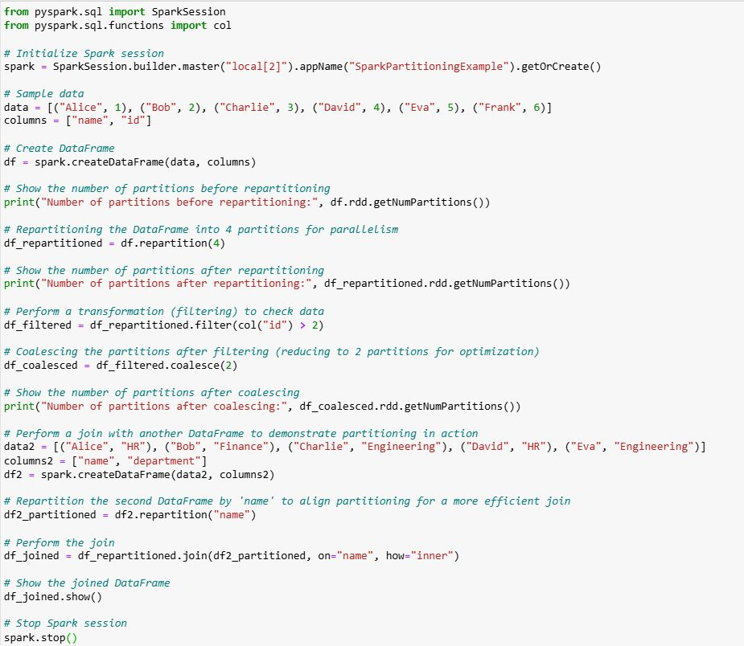

𝐃𝐢𝐟𝐟𝐞𝐫𝐞𝐧𝐜𝐞 𝐁𝐞𝐭𝐰𝐞𝐞𝐧 𝐏𝐲𝐒𝐩𝐚𝐫𝐤 𝐃𝐚𝐭𝐚𝐅𝐫𝐚𝐦𝐞 𝐚𝐧𝐝 𝐏𝐚𝐧𝐝𝐚𝐬 𝐃𝐚𝐭𝐚𝐅𝐫𝐚𝐦𝐞?  
  
𝐃𝐚𝐭𝐚 𝐒𝐭𝐫𝐮𝐜𝐭𝐮𝐫𝐞:  
PySpark DataFrame: A distributed collection of data that is organized into named columns. It is built on top of Apache Spark, designed to handle large-scale data processing in a distributed environment.  
  
Pandas DataFrame: A two-dimensional labeled data structure with columns of potentially different types, primarily designed for working with smaller datasets in a single-node, in-memory setup.  
  
  
𝐒𝐜𝐚𝐥𝐚𝐛𝐢𝐥𝐢𝐭𝐲:  
PySpark DataFrame: Handles large datasets that do not fit in memory. It can scale horizontally and is capable of distributed computation across multiple nodes (cluster-based computing).  
  
Pandas DataFrame: Operates entirely in memory and is suitable for smaller datasets that fit into a single machine’s memory. It does not scale well for large datasets.  
  
𝐏𝐞𝐫𝐟𝐨𝐫𝐦𝐚𝐧𝐜𝐞:  
PySpark DataFrame: Optimized for big data. It supports lazy evaluation, meaning operations are only computed when an action (e.g., collect()) is triggered. It also supports various optimizations like Catalyst and Tungsten for query optimization and execution.  
  
Pandas DataFrame: Works well with small-to-medium datasets and is optimized for in-memory operations. However, it is not designed for parallel or distributed computation, which can limit its performance with large datasets.  
  
𝐃𝐚𝐭𝐚 𝐇𝐚𝐧𝐝𝐥𝐢𝐧𝐠:  
PySpark DataFrame: Built for distributed data processing, can read data from multiple sources like HDFS, S3, JDBC, etc., and integrates with Spark’s ecosystem.  
  
Pandas DataFrame: Primarily for reading and processing data from local files like CSV, Excel, or SQL databases, and is not inherently built for distributed data.  
  
  
𝐀𝐏𝐈𝐬:  
PySpark DataFrame: The API is based on Spark SQL and RDDs, and it provides methods for distributed data processing like .join(), .groupBy(), .agg(), etc.  
  
Pandas DataFrame: The API is built around Python and provides methods for data manipulation such as .merge(), .groupby(), .pivot_table(), etc.  
  
𝐈𝐧𝐭𝐞𝐠𝐫𝐚𝐭𝐢𝐨𝐧:  
PySpark DataFrame: Can be used for distributed computation in Spark clusters, which is ideal for big data applications in production environments.  
  
Pandas DataFrame: Used mainly for data analysis and manipulation in a single-machine environment.

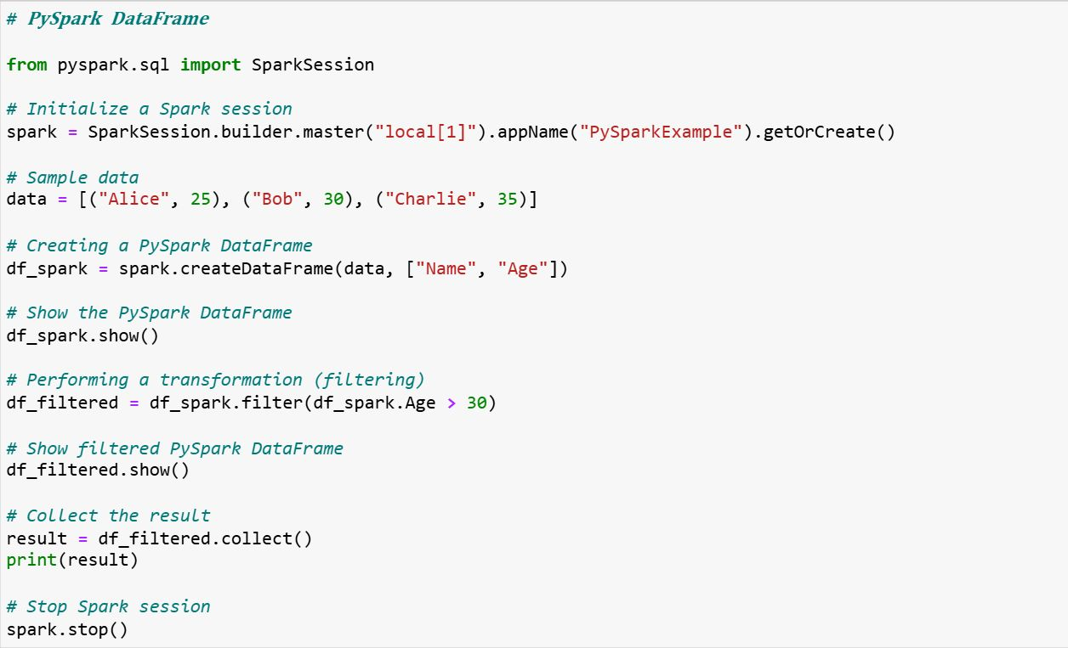

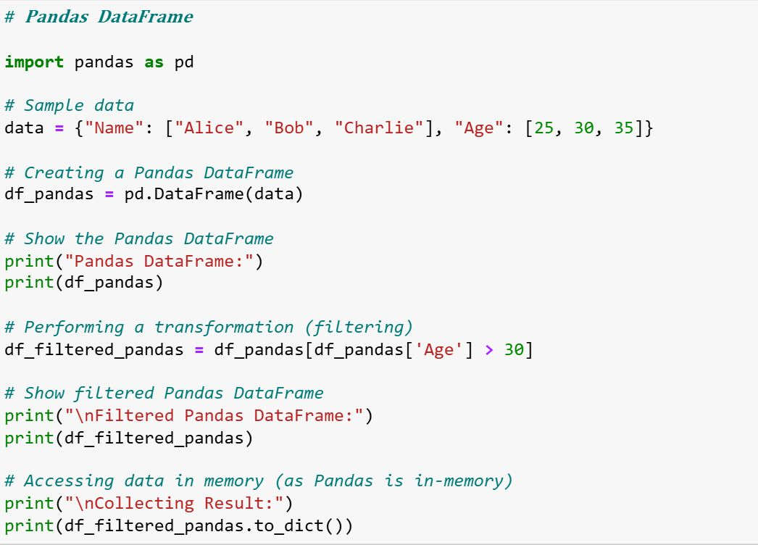

𝐇𝐨𝐰 𝐰𝐨𝐮𝐥𝐝 𝐲𝐨𝐮 𝐡𝐚𝐧𝐝𝐥𝐞 𝐦𝐢𝐬𝐬𝐢𝐧𝐠 𝐨𝐫 𝐢𝐧𝐯𝐚𝐥𝐢𝐝 𝐝𝐚𝐭𝐚 𝐢𝐧 𝐚 𝐝𝐚𝐭𝐚 𝐩𝐢𝐩𝐞𝐥𝐢𝐧𝐞 𝐮𝐬𝐢𝐧𝐠 𝐩𝐲𝐬𝐩𝐚𝐫𝐤?  
  
𝐊𝐞𝐲 𝐇𝐚𝐧𝐝𝐥𝐢𝐧𝐠 𝐓𝐞𝐜𝐡𝐧𝐢𝐪𝐮𝐞𝐬:  
  
1, Dropping Missing Values  
2, Filling Missing Values  
3, Replacing Invalid Data  
4, Handling Invalid Data Types  
  
𝐄𝐱𝐩𝐥𝐚𝐧𝐚𝐭𝐢𝐨𝐧 𝐨𝐟 𝐃𝐚𝐭𝐚 𝐇𝐚𝐧𝐝𝐥𝐢𝐧𝐠:  
  
𝐃𝐫𝐨𝐩𝐩𝐢𝐧𝐠 𝐌𝐢𝐬𝐬𝐢𝐧𝐠 𝐕𝐚𝐥𝐮𝐞𝐬 (𝐝𝐫𝐨𝐩𝐧𝐚):  
df.dropna(): This removes rows with any null values. It's useful when you don't want to include any incomplete records in your dataset.  
  
𝐅𝐢𝐥𝐥𝐢𝐧𝐠 𝐌𝐢𝐬𝐬𝐢𝐧𝐠 𝐕𝐚𝐥𝐮𝐞𝐬 (𝐟𝐢𝐥𝐥𝐧𝐚):  
df.fillna({"age": 0, "salary": 3000, "name": "Unknown"}): Here, we're filling missing values with a default value. You can specify the column names and their respective replacement values. For instance, missing ages are filled with 0, missing salaries with 3000, and missing names with "Unknown".  
  
𝐑𝐞𝐩𝐥𝐚𝐜𝐢𝐧𝐠 𝐈𝐧𝐯𝐚𝐥𝐢𝐝 𝐃𝐚𝐭𝐚 (𝐰𝐡𝐞𝐧, 𝐨𝐭𝐡𝐞𝐫𝐰𝐢𝐬𝐞):  
df.withColumn("salary", when(col("salary") < 0, 0).otherwise(col("salary"))): This checks for invalid data, such as negative salaries, and replaces them with a valid value (in this case, 0). The when clause checks the condition, and otherwise defines what should be done if the condition is false.  
  
𝐇𝐚𝐧𝐝𝐥𝐢𝐧𝐠 𝐈𝐧𝐯𝐚𝐥𝐢𝐝 𝐃𝐚𝐭𝐚 𝐓𝐲𝐩𝐞𝐬 (𝐜𝐚𝐬𝐭):  
df.withColumn("age", when(col("age").cast("int").isNotNull(), col("age")).otherwise(0)): Here, we are casting the age column to an integer. If it's not a valid integer (e.g., None or a string), it gets replaced with 0.  
  
𝐂𝐨𝐮𝐧𝐭𝐢𝐧𝐠 𝐍𝐮𝐥𝐥 𝐕𝐚𝐥𝐮𝐞𝐬 𝐁𝐞𝐟𝐨𝐫𝐞 𝐚𝐧𝐝 𝐀𝐟𝐭𝐞𝐫 𝐇𝐚𝐧𝐝𝐥𝐢𝐧𝐠:  
We check the count of null values in the DataFrame before and after handling the missing data. This helps in ensuring that our cleaning operations have been successful.  
  


You are provided with four tables in a retail business scenario: Customers, Orders, Products, and Payments.  
  
The Customers table contains: customer_id, name, and email.  
  
The Orders table contains: order_id, customer_id, product_id, and order_date.  
  
The Products table contains: product_id, product_name, and category.  
  
The Payments table contains: payment_id, order_id, amount, and payment_status.  
  
𝐖𝐫𝐢𝐭𝐞 𝐏𝐲𝐒𝐩𝐚𝐫𝐤 𝐜𝐨𝐝𝐞 𝐭𝐨:  
  
𝐉𝐨𝐢𝐧 𝐭𝐡𝐞𝐬𝐞 𝐭𝐚𝐛𝐥𝐞𝐬 𝐨𝐧 𝐜𝐮𝐬𝐭𝐨𝐦𝐞𝐫_𝐢𝐝, 𝐩𝐫𝐨𝐝𝐮𝐜𝐭_𝐢𝐝, 𝐚𝐧𝐝 𝐨𝐫𝐝𝐞𝐫_𝐢𝐝.  
  
𝐃𝐢𝐬𝐩𝐥𝐚𝐲 𝐜𝐨𝐥𝐮𝐦𝐧𝐬: 𝐧𝐚𝐦𝐞, 𝐞𝐦𝐚𝐢𝐥, 𝐨𝐫𝐝𝐞𝐫_𝐢𝐝, 𝐨𝐫𝐝𝐞𝐫_𝐝𝐚𝐭𝐞, 𝐩𝐫𝐨𝐝𝐮𝐜𝐭_𝐧𝐚𝐦𝐞, 𝐜𝐚𝐭𝐞𝐠𝐨𝐫𝐲, 𝐚𝐦𝐨𝐮𝐧𝐭, 𝐚𝐧𝐝 𝐩𝐚𝐲𝐦𝐞𝐧𝐭_𝐬𝐭𝐚𝐭𝐮𝐬.

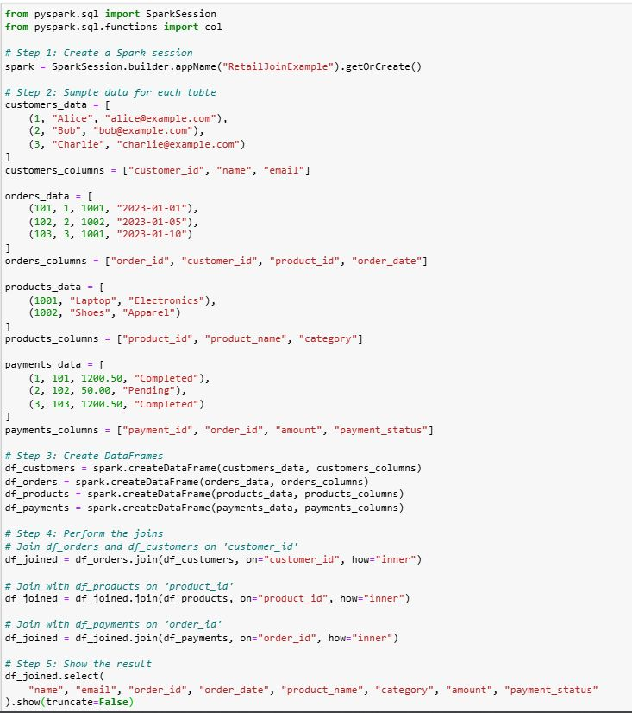

Dynamic partition pruning.